Predicting 30-Day Hospital Readmission for Patients With Diabetes
Residency Project Deliverable 1: Data Exploration, Preprocessing, and an Initial Model

Yogananda Atreya Chinthaluri (Student ID 53651)
Anil Kumar Abburi (Student ID 53405)
School of Computer Science and Information Technology, University of the Cumberlands
Python Application for Data Analytics in AI (PhDAI-733-M20)
Dr. Marwan Omar
October 31, 2026

Abstract
Thirty-day readmissions are costly, penalized, and partly preventable, and patients with diabetes are disproportionately affected. This deliverable builds the foundation for ranking diabetic inpatients by readmission risk at discharge. Using 101,766 encounters from 130 U.S. hospitals (Clore et al., 2014), the data were audited, cleaned, and engineered into a leakage-safe pipeline, then split by patient because 46% of encounters belong to repeat patients. A logistic regression reached a held-out ROC-AUC of .661, outperforming a default random forest and a prior-admissions heuristic, although the heuristic matched it among the highest-risk tenth. A preliminary grid search scored on ROC-AUC rather than accuracy raised the forest to .665. Discrimination was weaker for patients 65 and older, and women were flagged more often than men at equal risk. Deliverable 2 will calibrate scores, set capacity-based thresholds, and audit fairness.
Keywords: hospital readmission, diabetes, logistic regression, random forest, grouped validation, algorithmic fairness

Predicting 30-Day Hospital Readmission for Patients With Diabetes
Introduction and Problem Framing
Nearly one in five Medicare patients returns to the hospital within 30 days of discharge, at an estimated annual cost of $17.4 billion (Jencks et al., 2009), and the Hospital Readmissions Reduction Program now penalizes hospitals with excess readmissions (McIlvennan et al., 2015). Patients with diabetes are at elevated risk (Rubin, 2015), so the problem affects patients, who bear the harm of a return stay; hospitals, which bear the penalty; and payers, who bear the cost. Hospitals respond with care-transition programs such as follow-up calls and medication reconciliation, but those programs have limited capacity and must be targeted. This project therefore asks: using only information available at discharge, can routinely collected encounter data rank diabetic inpatients by 30-day readmission risk well enough to direct a capacity-limited intervention? Published readmission models discriminate only modestly (Kansagara et al., 2011), so success means outperforming a simple clinical heuristic rather than reaching high accuracy.
Dataset Exploration and Preprocessing
The analysis uses the Diabetes 130-US Hospitals dataset (Clore et al., 2014): 101,766 inpatient encounters from 71,518 patients at 130 U.S. hospitals between 1999 and 2008. Each encounter is a stay of one to 14 days with a diabetes diagnosis, laboratory testing, and medication (Strack et al., 2014). Its 50 columns cover demographics, admission and discharge codes, prior-year utilization, laboratory and procedure counts, three ICD-9 diagnoses, HbA1c and glucose results, and 23 diabetes medications. The target is readmission within 30 days, coded 1 against both later readmission and none, because only early returns trigger penalties; it occurs in 11.2% of encounters (Figure 1).
Figure 1
Data Audit: Missing Values, Outcome Classes, and Repeat Patients
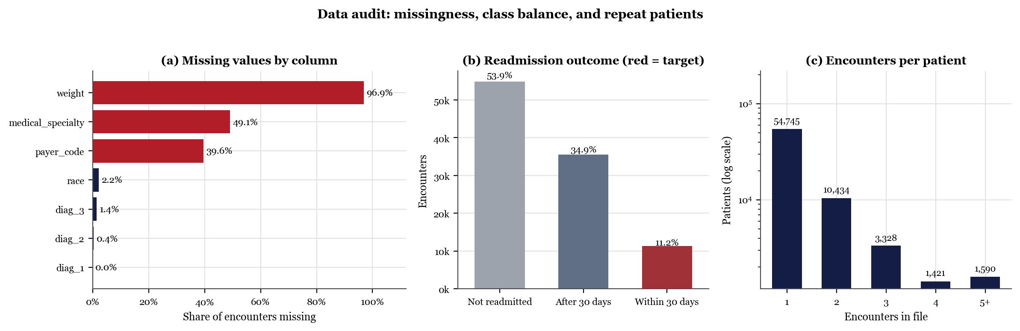
Note. Panel (a) shows the share of 101,766 raw encounters coded “?”; red bars exceed 30%. Panel (b) is a seaborn count plot of the three-class source outcome; red marks the target class. Panel (c) counts patients by number of encounters on a log scale.
The audit shaped the cleaning. No exact duplicates were found. Missing values were treated column by column rather than forward-filled, because adjacent rows belong to different patients: weight (96.9% missing) was dropped, and medical specialty (49.1% missing) became an explicit category, because an unrecorded specialty may signal a different admission pathway and is unlikely to be missing at random (Little & Rubin, 2019). The file also writes “None” for a test not performed, which pandas (McKinney, 2010) silently converts to missing by default; the loader preserves it as a category. Finally, 46.2% of encounters belong to repeat patients, so encounters are not independent and must be split by patient.
Figure 2, drawn with seaborn (Waskom, 2021), shows that the utilization counts are strongly right-skewed (prior emergency visits: skew = 22.9), so they enter the model as log(1 + count), which cut the skew of prior inpatient visits from 3.63 to 1.46. No two features are redundant, the strongest pair being length of stay and medications (ρ = .47), and no single feature correlates strongly with the outcome (largest ρ = .14), an early sign that discrimination will be modest. Figure 3 shows clearer gradients: the readmission rate rises from 8.6% with no prior-year admissions to 37.1% with five or more, and discharge to another facility (16.4%) exceeds discharge home (9.3%). Encounters with a measured HbA1c were readmitted less often (9.9% vs. 11.7%, p < .001), replicating Strack et al. (2014), although measurement more plausibly marks attentive care than causes the difference.
Figure 2
Distributions of Count Features by Outcome, and Their Correlations
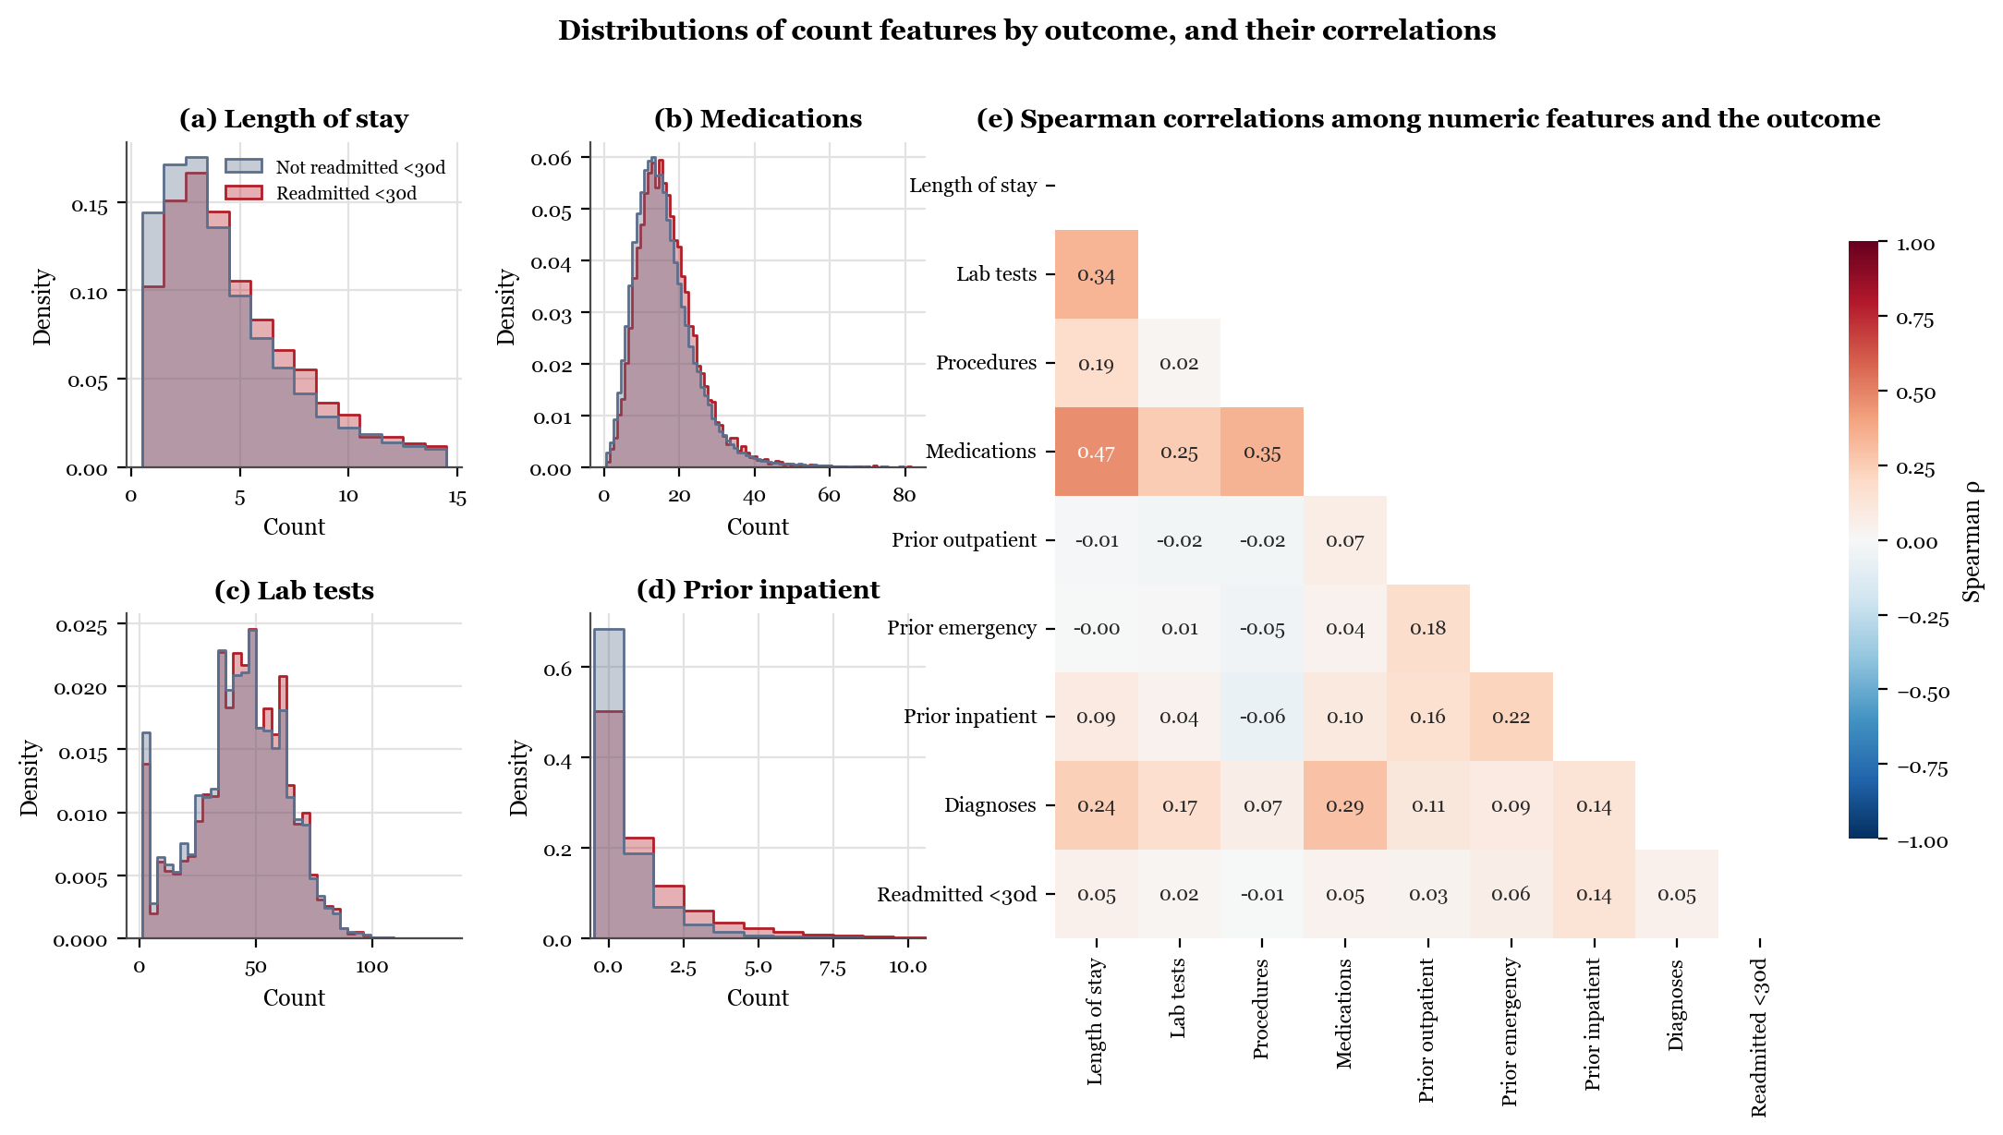
Note. Panels (a)–(d) are density-scaled histograms for readmitted and non-readmitted encounters. Panel (e) shows Spearman rank correlations, used because the counts are skewed; the last row is each feature's correlation with the outcome.
Figure 3
Observed 30-Day Readmission Rates by Encounter Characteristic
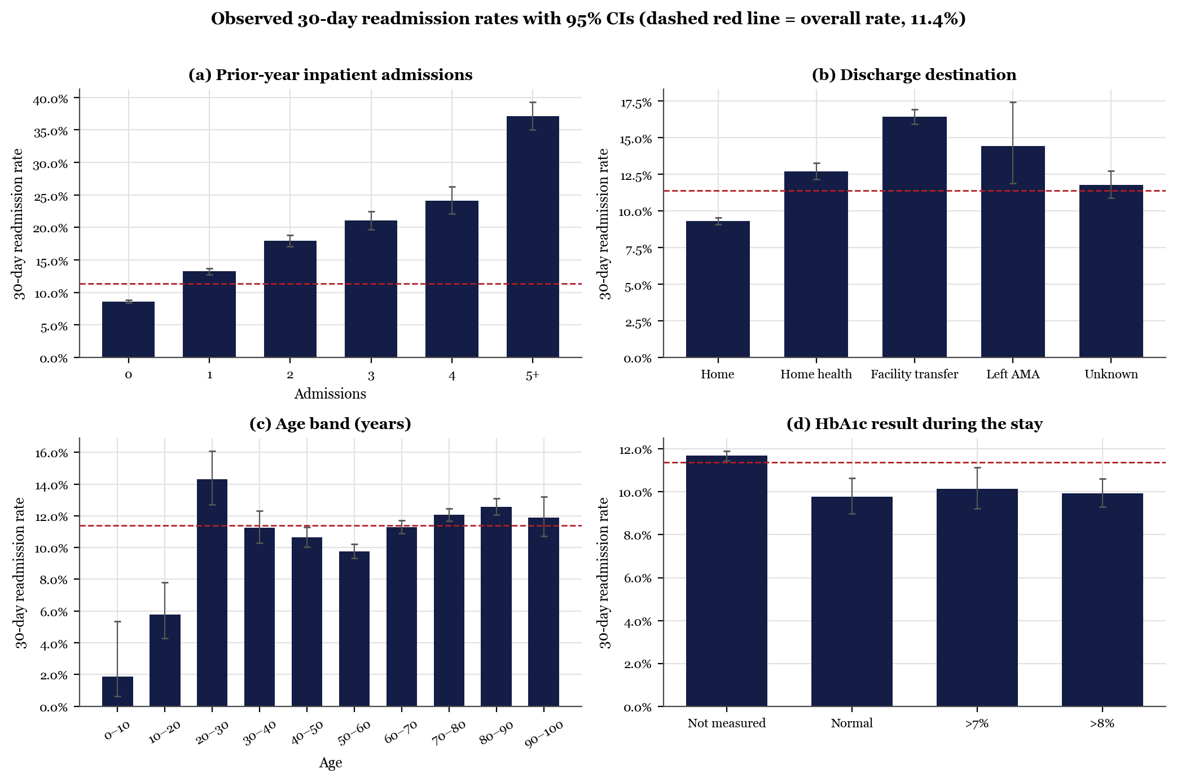
Note. Unadjusted rates for the 99,340 analyzed encounters with 95% Wilson confidence intervals. The dashed line marks the overall rate of 11.4%.
Table 1 lists the selected features and their treatment, and Table 2 logs each row-level step. Features were kept when available by discharge and clinically motivated or associated with the outcome. Deaths and hospice discharges were removed because readmission is impossible, leaving 99,340 encounters from 69,987 patients. The 915 ICD-9 codes were collapsed into nine groups so that rare codes do not each demand a parameter. Race, gender, and payer were excluded from the predictors and reserved for fairness checks. One-hot encoding and scaling were fit after the split, inside a scikit-learn pipeline (Pedregosa et al., 2011), because fitting them on all rows leaks test information into training (Kaufman et al., 2012), as Figure 4 shows.
Table 1
Selected Target and Features, With Preprocessing Treatment
Group | Variables | Treatment
Target | Readmitted (<30 days, >30 days, no) | Binary: <30 days = 1 (11.4%); source column removed
Prior utilization | Outpatient, emergency, and inpatient visits in the prior year | log(1 + count), standardized
Stay intensity | Length of stay; counts of lab tests, procedures, medications, and diagnoses | Standardized
Demographic | Age (10-year band) | Band midpoint, standardized
Administrative | Admission type, admission source, discharge disposition | Integer codes mapped to four or five categories; null and unmapped codes pooled as unknown
Diagnoses | Primary, secondary, and tertiary ICD-9 codes | 915 codes grouped into nine clinical groups (Strack et al., 2014)
Laboratory | HbA1c and maximum serum glucose results | “None” retained as a not-measured category
Specialty | Admitting physician specialty | Missing (49.1%) kept as a level; levels under 1% pooled
Medications | 8 of 23 diabetes drugs; regimen change; any diabetes medication | One-hot encoded; count of dose changes engineered
Excluded | Weight; encounter ID; 15 rarely used drugs | 96.9% missing; identifier; used in under 1% of encounters
Audit only | Race, gender, payer code | Held out of predictors; used for subgroup and fairness checks
Grouping | Patient number | Used only to split data by patient
Note. Final model matrix: 10 numeric and 19 categorical inputs, expanded to 102 columns. One-hot encoding and scaling are fit on training data only.
Table 2
Cleaning Ledger: Row-Level Steps and Their Effect
Step | Encounters | Patients | 30-day rate
Raw UCI file | 101,766 | 71,518 | 11.16%
Drop exact duplicate rows | 101,766 | 71,518 | 11.16%
Remove deaths and hospice discharges | 99,343 | 69,990 | 11.39%
Remove invalid gender codes | 99,340 | 69,987 | 11.39%
Note. Deaths and hospice discharges (disposition codes 11, 13, 14, and 19–21) cannot be followed by a readmission and are removed. No exact duplicate rows were found.
Figure 4
Colab Notebook Screenshot: Feature Lists, Grouped Split, and Pipeline
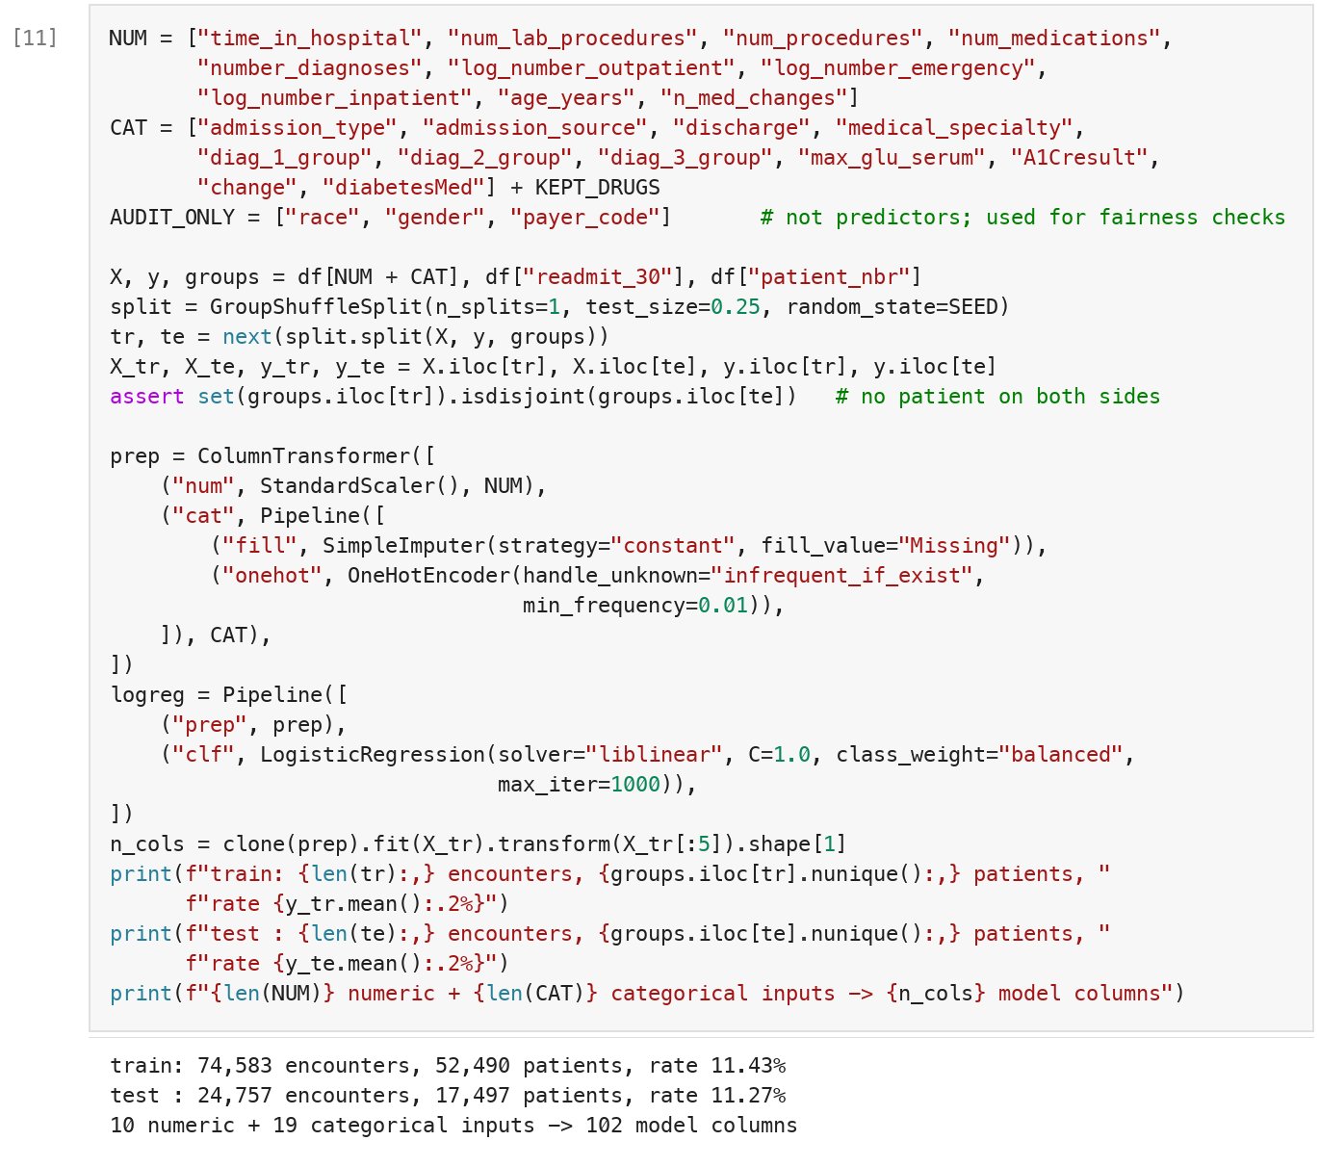
Note. Cell [11] of the notebook (Appendix A). The assertion verifies that no patient appears in both the training and test sets.
Initial Model Development
Model Selection and Initial Results
The initial model is an L2-regularized logistic regression with balanced class weights. It is the reference standard for clinical prediction (Steyerberg, 2019), its coefficients can be inspected when a score allocates care (Rudin, 2019), and established readmission indices such as LACE are themselves additive risk scores (van Walraven et al., 2010). A random forest (Breiman, 2001) at default settings serves as the nonlinear comparison the course guidance suggests. Data were split 75/25 by patient, five-fold stratified group cross-validation was run on the training set, and a prior-rate dummy and a prior-admissions heuristic anchor the results.
Table 3 and Figures 5 and 6 report the results. The logistic regression reached a cross-validated ROC-AUC of .656 (SD = .005) and a test AUC of .661 (95% CI [.650, .673]), typical of published models (Kansagara et al., 2011). The default forest ranked worse by .026 and exposed the accuracy trap: its 88.7% accuracy equals the dummy's, yet it caught 0.1% of readmissions, against 57% for the logistic regression. The model beat the heuristic by .056 AUC (95% CI [.048, .065]) but tied it in the top risk decile (lift 2.08 vs. 2.09) and pulled ahead only at 20% capacity (1.85 vs. 1.69). Prior admissions and discharge to a facility were among the largest effects (Figure 7). A random row split moved AUC by under .01 for both models, so patient overlap biases little here, but the grouped split is kept because it answers the deployment question of performance on new patients.
Table 3
Initial Model Performance Against Two Reference Scores
Model | CV ROC-AUC M (SD) | Test ROC-AUC | PR-AUC | Accuracy | Recall | Precision | Flagged | Lift, top 10% | Lift, top 20%
Logistic regression | .656 (.005) | .661 | .198 | .648 | .573 | .175 | 36.9% | 2.08 | 1.85
Random forest | .635 (.008) | .635 | .187 | .887 | .001 | .500 | 0.0% | 2.04 | 1.70
Prior-admissions heuristic | .608 (.006) | .605 | .177 | .669 | .490 | .168 | 32.9% | 2.09 | 1.69
Dummy (prior rate) | .500 (.000) | .500 | .113 | .887 | .000 | .000 | 0.0% | 1.00 | 1.00
Note. CV = five-fold stratified group cross-validation on 74,583 training encounters; test metrics use 24,757 encounters from 17,497 patients absent from training. Threshold metrics use each model's default decision (0.5), at least one prior admission for the heuristic, and no flags for the dummy. Lift is the readmission rate among the highest-risk share divided by the overall rate. The random forest uses default settings.
Figure 5
Colab Notebook Screenshot: Training Both Models and Their Classification Reports
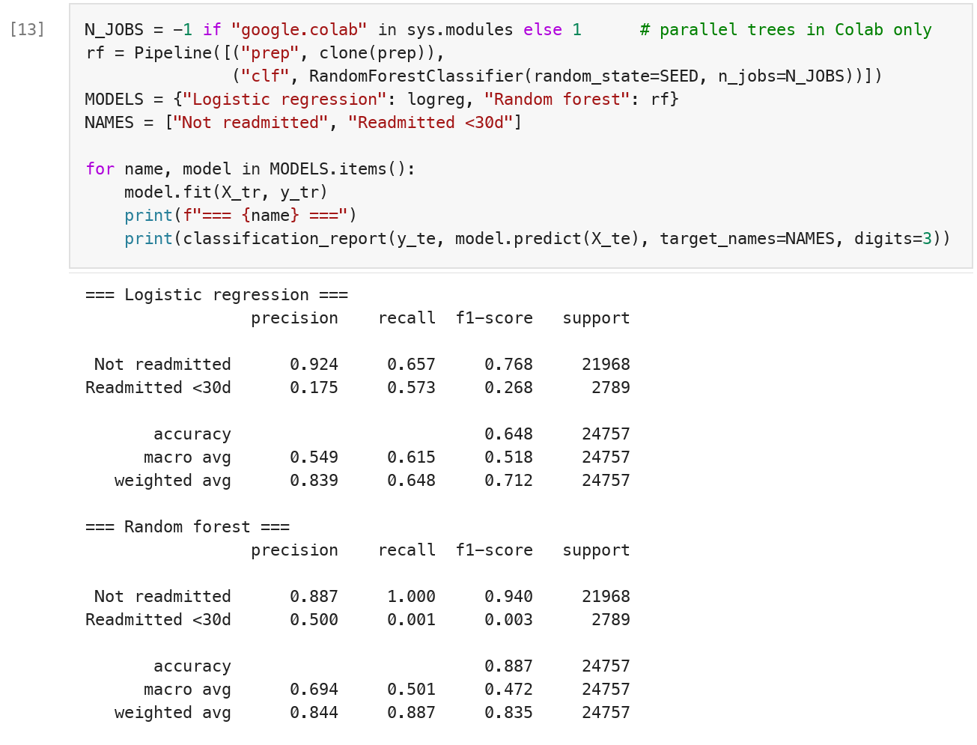
Note. Cell [13] of the notebook. Reports use the default 0.5 threshold on the patient-disjoint test set.
Figure 6
Discrimination and Confusion Matrices of the Initial Models
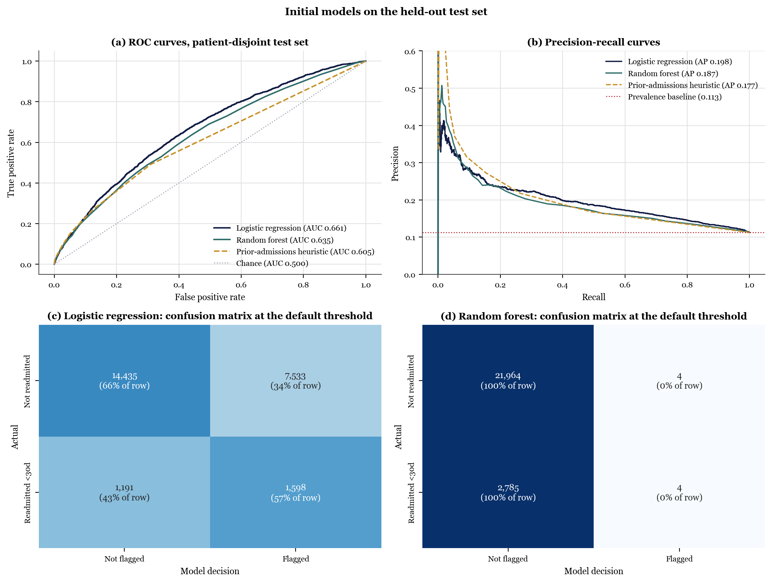
Note. Panels (a) and (b) compare both models with the prior-admissions heuristic on the test set; the dotted line in (b) is the prevalence baseline (.113). Panels (c) and (d) are seaborn heatmaps of the confusion matrices at the default threshold.
Figure 7
Largest Logistic Regression Effects, as Odds Ratios
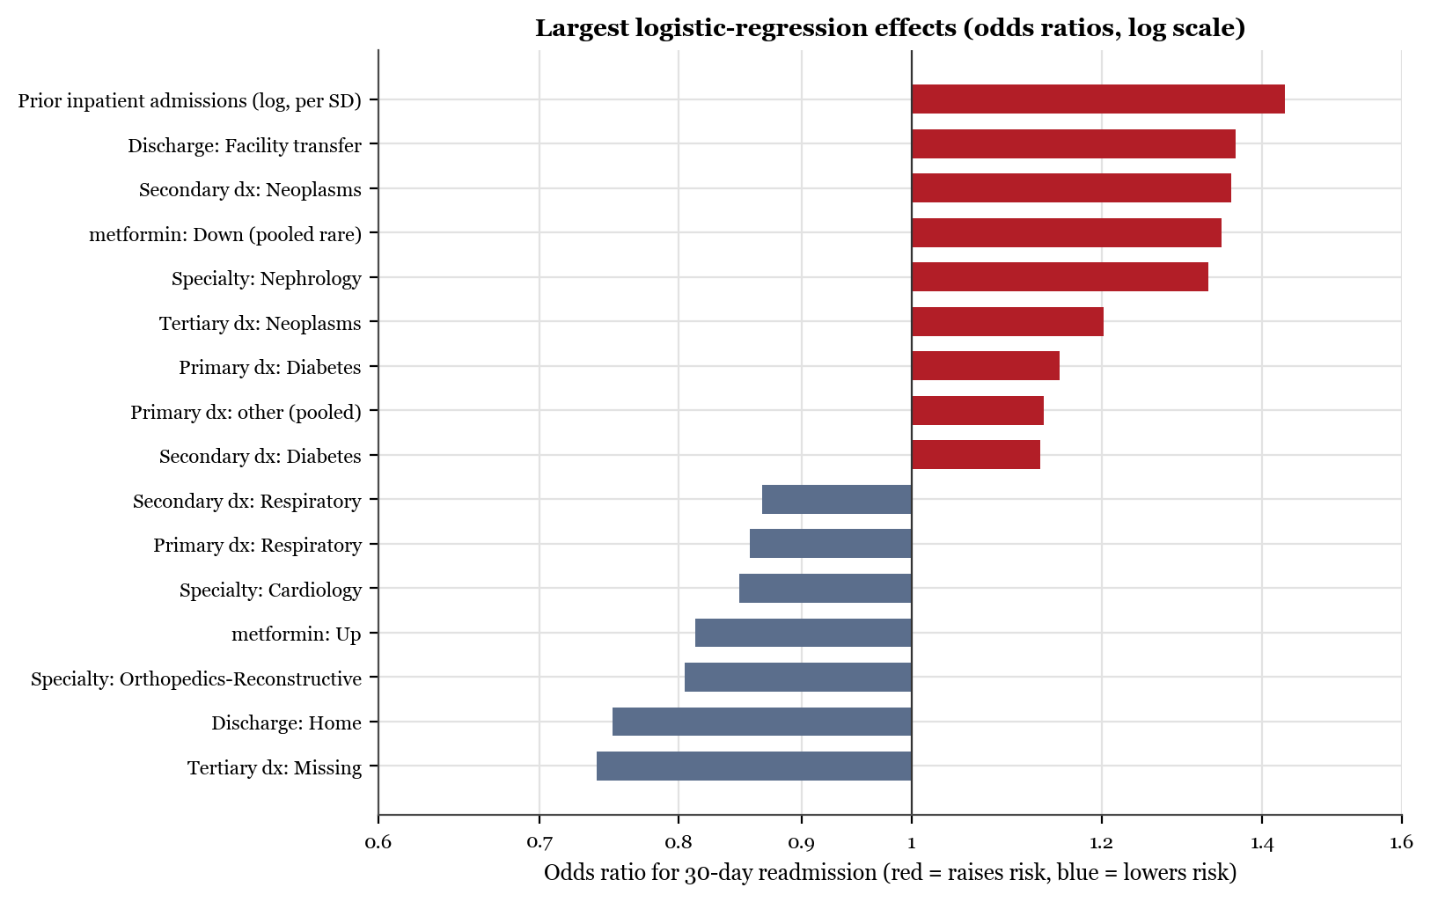
Note. Numeric effects are per standard deviation. Categories are one-hot coded without a reference level and shrunk by the L2 penalty, so their odds ratios indicate direction and rank rather than adjusted effects.
Preliminary Tuning
Following the course hints, GridSearchCV tuned both models (Table 4, Figure 8), with two corrections: folds were grouped by patient, and scoring used ROC-AUC, because accuracy rewards the do-nothing behavior shown above. Limiting tree depth raised the forest's test AUC from .635 to .665, whereas the logistic regression barely moved (.661 to .662), because its discrimination is nearly flat across the penalty grid. The tuned forest and the logistic regression are statistically indistinguishable (difference 95% CI [−.001, .008]), so the interpretable model remains the working choice (Rudin, 2019). Class weighting also inflated the mean predicted risk to .469 against an observed .113, so Deliverable 2 will calibrate scores and set thresholds from program capacity.
Table 4
Preliminary Grid Search: Default Versus Tuned Models
Model | Grid searched | Best setting | Grouped CV ROC-AUC | Test ROC-AUC, default → tuned | Test PR-AUC, tuned | Lift, top 10%, tuned
Logistic regression | C ∈ {0.01, 0.1, 1, 10} | C = 0.01 | .656 | .661 → .662 | .198 | 2.08
Random forest | n_estimators ∈ {100, 200}; max_depth ∈ {10, 20, None} | max_depth = 10, n_estimators = 200 | .661 | .635 → .665 | .212 | 2.16
Note. GridSearchCV with three patient-grouped, stratified folds and ROC-AUC scoring; the forest grid follows the course hints. Test metrics use the same patient-disjoint test set as Table 3.
Figure 8
Colab Notebook Screenshot: Grid Search Scored on ROC-AUC With Grouped Folds
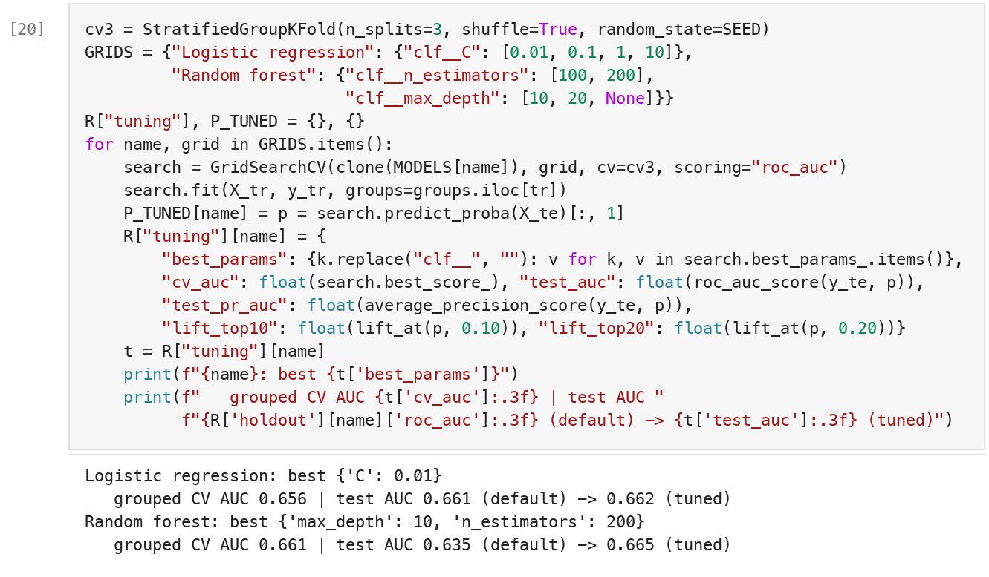
Note. Cell [20] of the notebook.
Ethical Considerations and Real-World Application
In practice the model would support, not replace, discharge planning: the care-transition team would receive each day's discharges ranked by risk and contact as many as capacity allows. At 10% capacity, per 1,000 discharges the team would reach about 23 of the 113 patients who will be readmitted, against about 11 by random selection. Four ethical issues bound that use. First, bias by proxy: prior admissions, the strongest predictor, measures access to care as well as need, so patients who struggle to reach a hospital may be under-flagged (Obermeyer et al., 2019); excluding race and payer as inputs does not remove such proxies. Table 5 shows nearly identical discrimination for the two largest race groups (AUC .658 and .661) but two gaps: women were flagged more often than men (38.8% vs. 34.6%) at nearly equal readmission rates, and discrimination was weaker for patients 65 and older (AUC .633 vs. .713), the Medicare population the penalty program targets. Deliverable 2 will test both gaps for miscalibration. Second, transparency: the coefficients in Figure 7 can be reviewed by clinicians. Third, error costs are asymmetric, since a missed patient loses support whereas a false alarm costs a phone call, which favors recall within capacity. Fourth, privacy: the public file holds no names or dates, and a deployed version would run under HIPAA.
Table 5
Preliminary Subgroup Check of the Logistic Regression on the Test Set
Group | n | Readmission rate | ROC-AUC | Flagged | Recall
Race: African American | 4,607 | 10.8% | .658 | 36.4% | .561
Race: Caucasian | 18,563 | 11.5% | .661 | 37.6% | .582
Race: Hispanic | 507 | 9.7% | .720 | 31.0% | .551
Race: Other | 361 | 11.1% | .651 | 28.8% | .425
Race: Missing | 561 | 8.0% | .622 | 28.5% | .444
Gender: Female | 13,395 | 11.2% | .667 | 38.8% | .610
Gender: Male | 11,362 | 11.3% | .655 | 34.6% | .530
Age: 65+ | 16,512 | 11.6% | .633 | 41.8% | .583
Age: <65 | 8,245 | 10.5% | .713 | 27.1% | .551
Note. Flags use the default 0.5 threshold. Groups with fewer than 30 readmissions are omitted because their estimates are unstable. Race, gender, and age group are not model inputs except age, which enters as a band midpoint.
Team Collaboration Process
The two members carry equal shares: each leads three rubric criteria and reviews the other's three (Table 6). In this deliverable, Chinthaluri led data exploration, preprocessing, modeling, and preliminary tuning, while Abburi led problem framing, ethical analysis, and the real-world application and independently re-ran the notebook in Google Colab to confirm every reported number. The roles rotate in Deliverable 2, where Abburi leads optimization and Chinthaluri leads the fairness audit, so each member leads the core modeling once. The code is tracked in a shared GitHub repository: each task is built on its own branch, assigned as an issue, and merged only after the other member approves the pull request, so the history records both authorship and review. The notebook, built with pandas, Matplotlib (Hunter, 2007), seaborn, and scikit-learn, opens in Colab from that repository. Decisions are logged with proposer and reviewer, the members meet weekly, and because the report is regenerated from the notebook's results file (Sandve et al., 2013), either member's change reaches every table automatically.
Table 6
Team Roles: Equal Leadership That Rotates Between Deliverables
Member | Student ID | Leads in Deliverable 1 | Reviews in Deliverable 1 | Leads in Deliverable 2
Yogananda Atreya Chinthaluri | 53651 | Dataset exploration and preprocessing; model development; preliminary tuning | Problem framing; ethics; real-world application | Fairness audit and mitigation; cost and capacity analysis
Anil Kumar Abburi | 53405 | Problem framing; ethical analysis; real-world application; Colab reproduction | Preprocessing, modeling, and tuning pull requests | Optimization: tuning, boosting, calibration, thresholds
Note. Each member leads three rubric criteria and reviews the other's three (Appendix A, Table A1); writing is shared, and both approve the final report. Repository: https://github.com/ychinthaluri53651/diabetes-readmission-residency-day-1

References
Breiman, L. (2001). Random forests. Machine Learning, 45(1), 5–32. https://doi.org/10.1023/A:1010933404324
Clore, J., Cios, K., DeShazo, J., & Strack, B. (2014). Diabetes 130-US hospitals for years 1999–2008 [Data set]. UCI Machine Learning Repository. https://doi.org/10.24432/C5230J
Hunter, J. D. (2007). Matplotlib: A 2D graphics environment. Computing in Science & Engineering, 9(3), 90–95. https://doi.org/10.1109/MCSE.2007.55
Jencks, S. F., Williams, M. V., & Coleman, E. A. (2009). Rehospitalizations among patients in the Medicare fee-for-service program. The New England Journal of Medicine, 360(14), 1418–1428. https://doi.org/10.1056/NEJMsa0803563
Kansagara, D., Englander, H., Salanitro, A., Kagen, D., Theobald, C., Freeman, M., & Kripalani, S. (2011). Risk prediction models for hospital readmission: A systematic review. JAMA, 306(15), 1688–1698. https://doi.org/10.1001/jama.2011.1515
Kaufman, S., Rosset, S., Perlich, C., & Stitelman, O. (2012). Leakage in data mining: Formulation, detection, and avoidance. ACM Transactions on Knowledge Discovery from Data, 6(4), Article 15. https://doi.org/10.1145/2382577.2382579
Little, R. J. A., & Rubin, D. B. (2019). Statistical analysis with missing data (3rd ed.). Wiley. https://doi.org/10.1002/9781119482260
McIlvennan, C. K., Eapen, Z. J., & Allen, L. A. (2015). Hospital readmissions reduction program. Circulation, 131(20), 1796–1803. https://doi.org/10.1161/CIRCULATIONAHA.114.010270
McKinney, W. (2010). Data structures for statistical computing in Python. In S. van der Walt & J. Millman (Eds.), Proceedings of the 9th Python in Science Conference (pp. 56–61). https://doi.org/10.25080/Majora-92bf1922-00a
Obermeyer, Z., Powers, B., Vogeli, C., & Mullainathan, S. (2019). Dissecting racial bias in an algorithm used to manage the health of populations. Science, 366(6464), 447–453. https://doi.org/10.1126/science.aax2342
Pedregosa, F., Varoquaux, G., Gramfort, A., Michel, V., Thirion, B., Grisel, O., Blondel, M., Prettenhofer, P., Weiss, R., Dubourg, V., Vanderplas, J., Passos, A., Cournapeau, D., Brucher, M., Perrot, M., & Duchesnay, É. (2011). Scikit-learn: Machine learning in Python. Journal of Machine Learning Research, 12, 2825–2830.
Rubin, D. J. (2015). Hospital readmission of patients with diabetes. Current Diabetes Reports, 15(4), Article 17. https://doi.org/10.1007/s11892-015-0584-7
Rudin, C. (2019). Stop explaining black box machine learning models for high stakes decisions and use interpretable models instead. Nature Machine Intelligence, 1(5), 206–215. https://doi.org/10.1038/s42256-019-0048-x
Sandve, G. K., Nekrutenko, A., Taylor, J., & Hovig, E. (2013). Ten simple rules for reproducible computational research. PLOS Computational Biology, 9(10), Article e1003285. https://doi.org/10.1371/journal.pcbi.1003285
Steyerberg, E. W. (2019). Clinical prediction models: A practical approach to development, validation, and updating (2nd ed.). Springer. https://doi.org/10.1007/978-3-030-16399-0
Strack, B., DeShazo, J. P., Gennings, C., Olmo, J. L., Ventura, S., Cios, K. J., & Clore, J. N. (2014). Impact of HbA1c measurement on hospital readmission rates: Analysis of 70,000 clinical database patient records. BioMed Research International, 2014, Article 781670. https://doi.org/10.1155/2014/781670
van Walraven, C., Dhalla, I. A., Bell, C., Etchells, E., Stiell, I. G., Zarnke, K., Austin, P. C., & Forster, A. J. (2010). Derivation and validation of an index to predict early death or unplanned readmission after discharge from hospital to the community. Canadian Medical Association Journal, 182(6), 551–557. https://doi.org/10.1503/cmaj.091117
Waskom, M. L. (2021). seaborn: Statistical data visualization. Journal of Open Source Software, 6(60), Article 3021. https://doi.org/10.21105/joss.03021

Appendix A
Google Colab Notebook, Rubric Map, and Course-Hints Map
Notebook link (view access for the instructor): [PASTE COLAB SHARE LINK]
The notebook (Diabetes_Readmission_D1_Chinthaluri.ipynb) is self-contained: on first run it downloads the UCI archive, then executes top to bottom and writes every figure and reported number. Table A1 maps each rubric criterion to where this report and the notebook address it, and Table A2 shows how each course hint was followed, including the three applied in corrected form.
Table A1
Project Rubric Criteria, Where Each Is Addressed, and Who Leads It
Criterion | Where in the report | Evidence | Lead / reviewer
Problem definition | Introduction and Problem Framing | Stakeholders, penalty context, and a capacity-limited question | Abburi / Chinthaluri
Dataset exploration | Dataset Exploration and Preprocessing | Figures 1–3; Tables 1 and 2; notebook Sections 2–6 | Chinthaluri / Abburi
Model development | Model Selection and Initial Results | Two justified models and two references; Table 3; Figures 5–7 | Chinthaluri / Abburi
Optimization and evaluation | Preliminary Tuning | Grouped GridSearchCV on ROC-AUC; Table 4; Figure 8; full optimization in Deliverable 2 | Chinthaluri / Abburi
Ethics and impact | Ethical Considerations and Real-World Application | Proxy bias, subgroup check (Table 5), transparency, error costs, privacy | Abburi / Chinthaluri
Real-world application | Ethical Considerations and Real-World Application | Daily ranked discharge list; 1,000-discharge worked example | Abburi / Chinthaluri
Teamwork and documentation | Team Collaboration Process | Table 6; pull-request reviews and Git history; decision log; README | Both / Both
Writing and structure | Whole report | APA 7th edition; build checks for citations, callouts, and spelling | Both / Abburi (proofread)
Table A2
Course Hints and How the Notebook Follows Them
Hint | Notebook section | How it is applied
1. Setup and imports | 1 | pandas, NumPy, Matplotlib, seaborn, scikit-learn, GridSearchCV; warnings suppressed
2. Uploading or accessing data | 2 | Downloaded by URL, with files.upload() as fallback
3. Exploration and cleaning | 3–4, 6 | shape, info(), describe(), countplot, histograms, heatmap, drop_duplicates(); missing values handled per column instead of forward fill, which would copy values between different patients
4. Feature engineering and preprocessing | 5, 7 | One-hot encoding and StandardScaler fit after the split inside a Pipeline, not on the full data, to prevent leakage
5. Train-test split | 7 | 75/25 with random_state = 42, grouped by patient
6. Model training and evaluation | 8–11 | Logistic regression and RandomForestClassifier; classification_report; confusion-matrix heatmaps
7. Hyperparameter tuning | 12 | GridSearchCV with the hint's forest grid, scored on ROC-AUC rather than accuracy
8. Ethical considerations | 13 | Markdown cell answering the hint's questions, plus a subgroup check

