Predicting 30-Day Hospital Readmission for Patients With Diabetes
Residency Project Deliverable 2: Improving and Evaluating the Readmission Model

Yogananda Atreya Chinthaluri (Student ID 53651)
Anil Kumar Abburi (Student ID 53405)
School of Computer Science and Information Technology, University of the Cumberlands
Python Application for Data Analytics in AI (PhDAI-733-M20)
Dr. Marwan Omar
November 1, 2026

Abstract
Deliverable 1 produced a logistic regression that ranked diabetic inpatients by 30-day readmission risk on held-out patients (ROC-AUC .661) but overstated risk about fourfold and ranked older patients less well. This deliverable widened tuning under patient-grouped cross-validation, added a gradient-boosting challenger, selected a random forest on cross-validation alone, calibrated it, and set flag thresholds from program capacity on training data. On held-out patients the final model improved every measure: ROC-AUC rose to .668 and the Brier score fell from .229 to .096. Predicted risks were accurate within every patient group, but patients 65 and older had fewer readmissions reached (recall .206 vs. .298). At 10% capacity, a care-transition team would reach about 26 of every 113 readmissions per 1,000 discharges and could spend up to about $670 per patient contacted before the program costs more than it saves.
Keywords: hospital readmission, diabetes, random forest, probability calibration, algorithmic fairness, decision thresholds

Predicting 30-Day Hospital Readmission for Patients With Diabetes
Deliverable 1 cleaned 99,340 encounters from the Diabetes 130-US Hospitals dataset (Clore et al., 2014) and built a logistic regression that ranks diabetic inpatients by 30-day readmission risk, tested on 17,497 patients it never saw. It left three problems: the model only tied a prior-admissions rule among the highest-risk tenth of patients, its class weights inflated the average predicted risk to .469 against an observed .113, and it ranked patients 65 and older less well. This deliverable addresses each problem on the same data, split, and notebook, which now has a second part (Appendix A).
Model Optimization
Deliverable 1 tuned one setting per model; this round widened the search and added a third model family (Table 1). The logistic regression now crosses seven penalty strengths with L1 and L2 penalties; the random forest (Breiman, 2001) varies tree depth, leaf size, and the share of features tried at each split; and gradient boosting (Friedman, 2001), which fits each tree to the errors of the trees before it, joins as a challenger. Figure 1 shows the search: every setting is scored by ROC-AUC on the same three patient-grouped folds, and the test set is not touched.
Table 1
Wider Hyperparameter Search Under Patient-Grouped Cross-Validation
Model | Grid searched | Settings | Best setting | ROC-AUC M (SD) | PR-AUC M (SD) | ROC-AUC, worst setting
Logistic regression | C ∈ {0.003, …, 3} × penalty ∈ {l1, l2} | 14 | C = 0.03, penalty = l1 | .657 (.008) | .199 (.005) | .653
Random forest | max_depth ∈ {12, None} × min_samples_leaf ∈ {10, 50} × max_features ∈ {sqrt, 0.2} | 8 | max_depth = None, max_features = 0.2, min_samples_leaf = 50 | .665 (.009) | .213 (.007) | .660
Gradient boosting | learning_rate ∈ {0.03, 0.1} × max_leaf_nodes ∈ {15, 31} × l2_regularization ∈ {0, 1} | 8 | l2_regularization = 0.0, learning_rate = 0.03, max_leaf_nodes = 15 | .663 (.008) | .209 (.006) | .647
Note. Three stratified folds grouped by patient on the 74,583 training encounters, the same folds as Deliverable 1's preliminary search; the test set was not used. The forest grows 300 trees and boosting runs 300 iterations. The random forest is the final model.
Figure 1
Colab Notebook Screenshot: The Wider Search, Scored on ROC-AUC With Grouped Folds
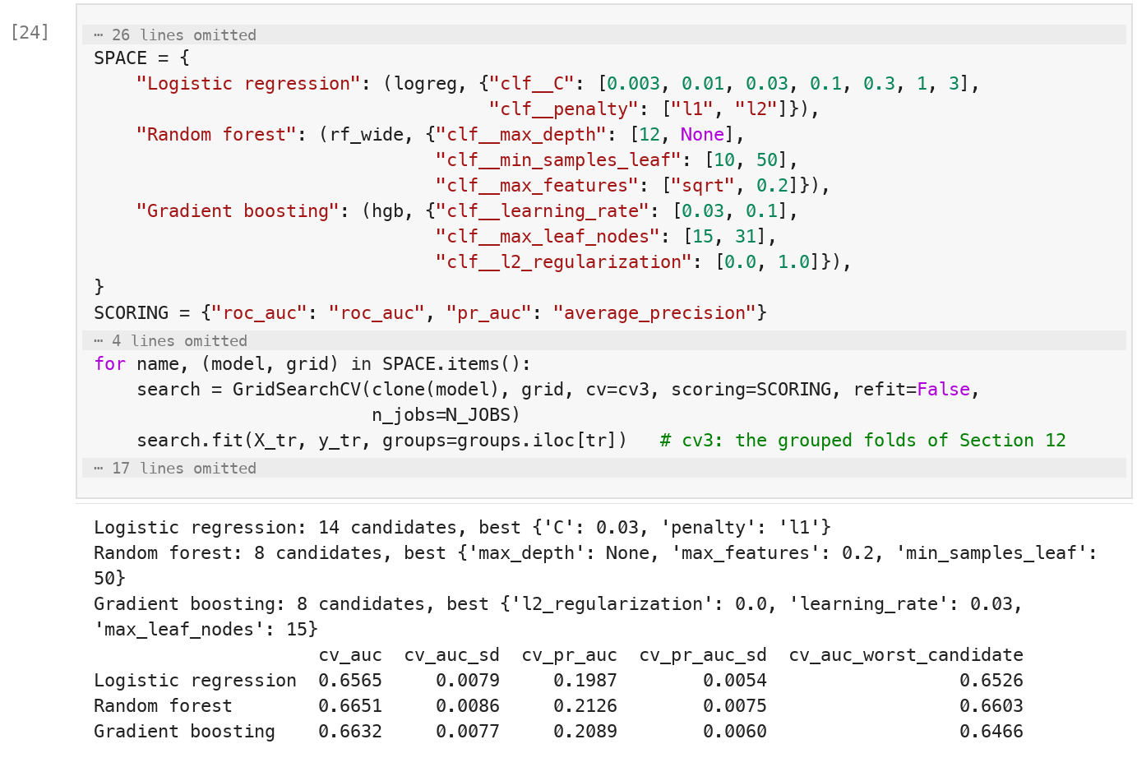
Note. Cell [24] of the notebook (Appendix A), Section 15. Excerpt; gray bars mark omitted lines (imports, the boosting pipeline, bookkeeping, and printing). The printed table gives each model's best setting under cross-validation, as in Table 1.
We fixed one rule in advance: a challenger replaces the logistic regression only if it gains at least .005 in cross-validated AUC, since a smaller gain does not justify giving up readable coefficients (Rudin, 2019). The forest won (.665 against .663 for boosting and .657 for the logistic regression), led in all three folds, and even its worst setting beat the best logistic regression. Its best setting grows trees to full depth but requires 50 encounters in every leaf, which keeps it from memorizing individual patients.
Final Model Evaluation
Before the final test, two steps turned the forest's scores into a decision (Figure 2). First, scikit-learn's calibration wrapper (Pedregosa et al., 2011) learned a map from score to probability on patient-grouped folds, and the sigmoid and isotonic maps (Niculescu-Mizil & Caruana, 2005) were compared by out-of-fold Brier score, the mean squared error of a probability (Brier, 1950). Isotonic was marginally best (.0972). Figure 3 shows why calibration mattered so much for the initial model (.229) and so little for the forest, which, trained without class weights, already followed the diagonal.
Figure 2
Colab Notebook Screenshot: Calibration and Capacity Thresholds From Training Data
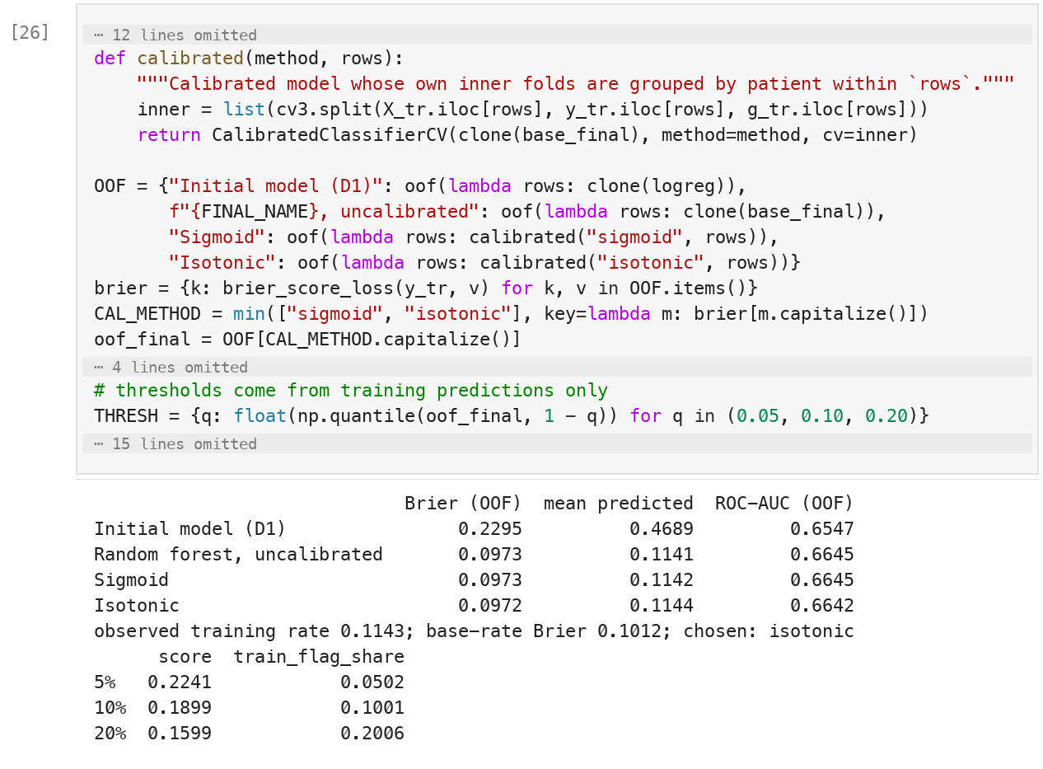
Note. Cell [26] of the notebook, Section 16, excerpt (gray bars mark omitted lines). Each candidate learns its probability map on folds grouped by patient; the printed output compares out-of-fold Brier scores and gives the capacity thresholds.
Figure 3
Calibration Before and After, and the Capacity Thresholds
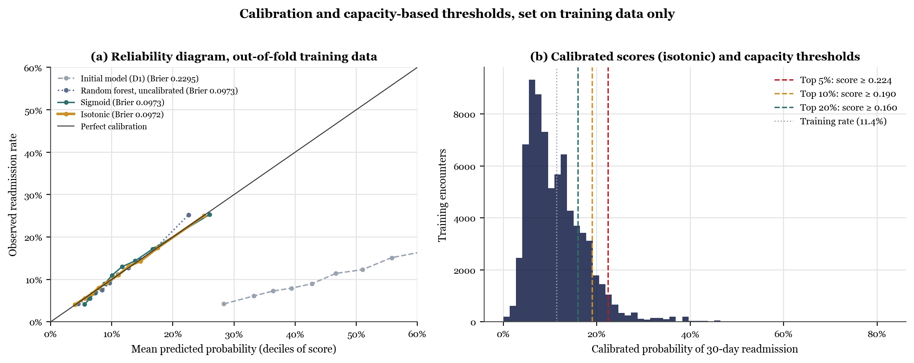
Note. Out-of-fold predictions on the training set. Panel (a) plots observed against predicted readmission rates by decile of score; points on the diagonal are well calibrated. Panel (b) shows the calibrated scores with the thresholds for 5%, 10%, and 20% capacity.
Second, the flag thresholds are the scores above which the top 5%, 10%, and 20% of out-of-fold training predictions fall (.224, .190, and .160), so the test set played no part in setting them (Kaufman et al., 2012).
Table 2 and Figure 4 compare the two models on the held-out patients, used once. The final model is better on every measure, and each 95% patient-bootstrap interval for the difference excludes zero. The largest change is in the probabilities: the Brier score fell from .229 to .096, and the mean predicted risk from .469 to .114 against an observed .113, so a predicted 20% can be read as about one patient in five (Van Calster et al., 2019).
Table 2
Final Versus Initial Model on the Patient-Disjoint Test Set
Measure | Initial model (Deliverable 1) | Final model | Difference, 95% CI
ROC-AUC | .661 | .668 | [.002, .012]
PR-AUC | .198 | .213 | [.008, .022]
Brier score (lower is better) | .229 | .096 | [−.136, −.130]
Mean predicted risk (observed .113) | .469 | .114 | —
Lift, top 10% | 2.08 | 2.21 | [0.01, 0.24]
Lift, top 20% | 1.85 | 1.91 | [0.01, 0.14]
Flagged at the 10% threshold | 9.9% | 10.8% | —
Recall at the 10% threshold | .207 | .235 | —
Precision at the 10% threshold | .235 | .245 | —
Note. 24,757 test encounters from 17,497 patients absent from training. Intervals are the 2.5th and 97.5th percentiles of 500 patient-level bootstrap resamples of the difference (final minus initial). Each model's 10% threshold comes from its own out-of-fold training scores, so the shares flagged differ slightly; lift compares the models at exactly equal shares.
Ranking improved modestly (ROC-AUC .668 vs. .661). At equal capacity the gain is clearer: lift in the top 10% rose from 2.08 to 2.21, ahead of the prior-admissions rule (2.09) that the initial model only tied, although the two still tie at 5% capacity. At the 10% threshold the model reached 23% of readmissions, and one flagged patient in four was readmitted (precision .245).
Permutation importance (Figure B1 in Appendix B) shows that prior inpatient admissions and discharge destination carry the model (AUC drops of .070 and .053; no other input exceeds .005), so the forest gains by combining known signals more flexibly, not by finding new ones. The result is a well-calibrated, modestly sharper model, not a breakthrough: at 10% capacity it still misses about three readmissions in four.
Figure 4
Final Model Against the Initial Model on the Held-Out Patients
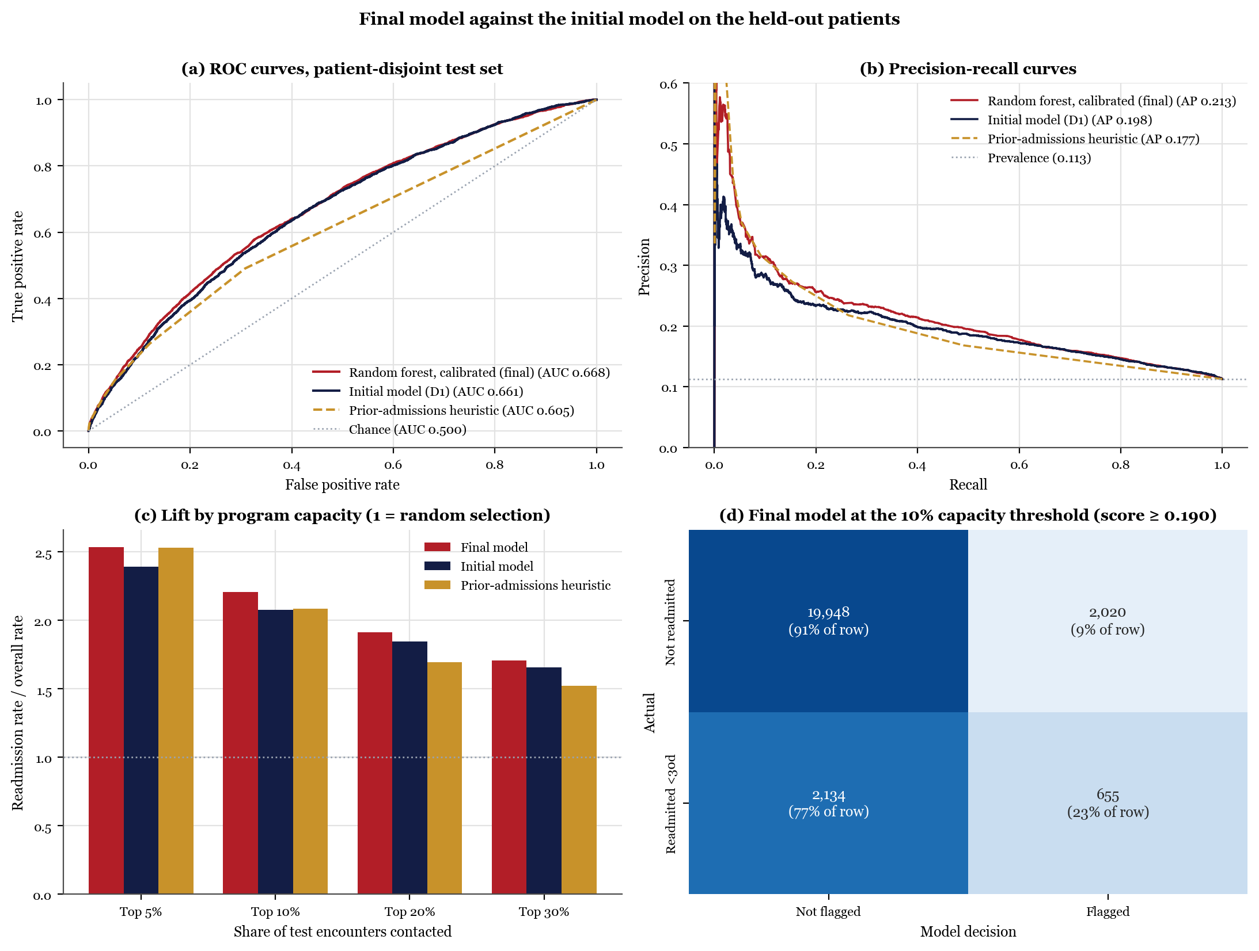
Note. Panels (a) and (b) include the prior-admissions rule; the dotted line in (b) is the test-set prevalence (.113). Panel (c) shows lift at 5% to 30% capacity. Panel (d) is the final model's confusion matrix at the 10% threshold.
Ethical Considerations
Figure 5 audits the final model at the 10% threshold by race, gender, age, and payer, none of which is a model input. Calibration held within groups: in every group of at least 1,000 test encounters, mean predicted risk was within 0.7 percentage points of the observed rate. Ranking did not. Patients 65 and older were ranked less well (AUC .641 vs. .715) and, though flagged as often, had fewer of their readmissions reached (recall .206 vs. .298; gap 95% CI [.042, .152]), while race and gender gaps were smaller, with overlapping intervals.
Figure 5
Fairness Audit of the Final Model at the 10% Capacity Threshold
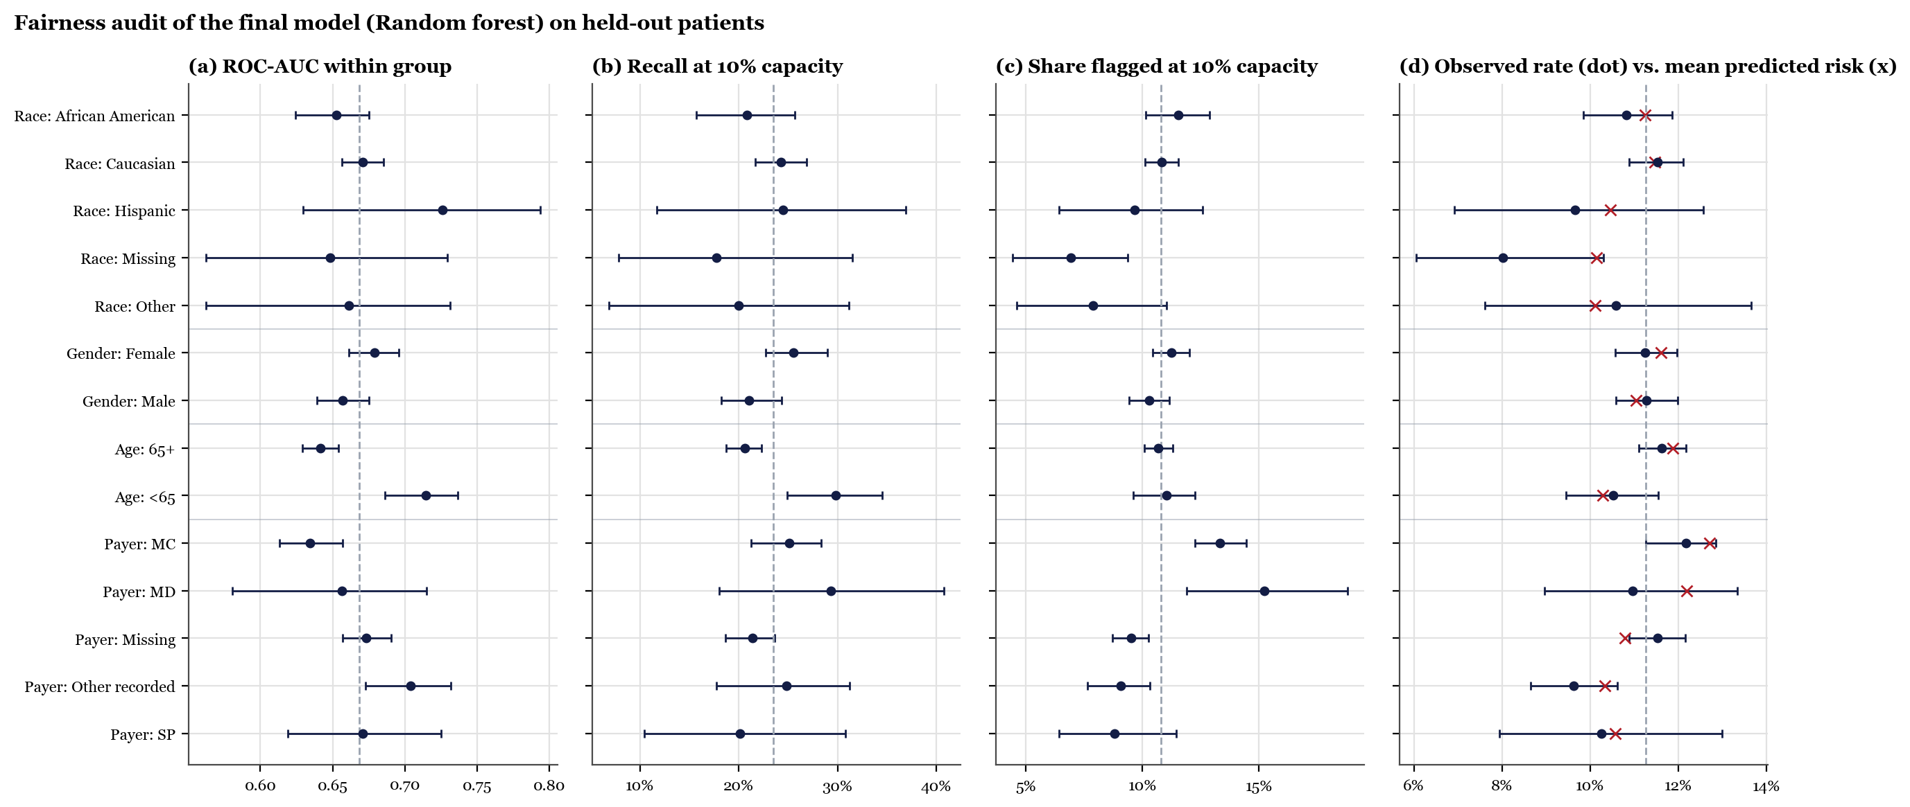
Note. Held-out patients. Dots are group estimates with patient-bootstrap 95% intervals (300 resamples); dashed lines mark the overall value. In panel (d), the cross marks the group's mean predicted risk. Groups with fewer than 30 readmissions are omitted; payer codes are shown as recorded because the file does not document them.
Separate age thresholds set on training data to equalize recall, the equal-opportunity standard (Hardt et al., 2016), closed most of the gap (Figure 6), but mainly by reaching fewer younger patients, and overall recall fell by .011, so we would not adopt them by default.
Other limits remain: prior admissions, the main input, reflects access to care as well as need (Obermeyer et al., 2019); data from 1999–2008 must be recalibrated before use; a deployed model would handle identifiable records, so access must be limited to the care team under HIPAA; and a confident score invites over-reliance (Goddard et al., 2012), which the safeguards below address.
Figure 6
Colab Notebook Screenshot: Testing Age-Specific Thresholds
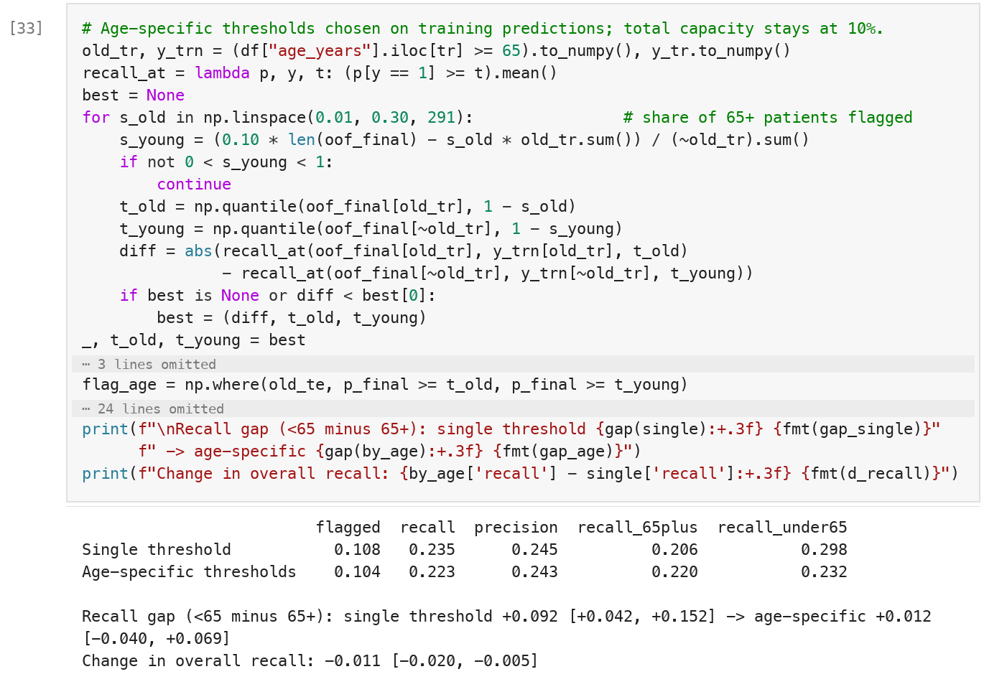
Note. Cell [33] of the notebook, Section 18. Excerpt (gray bars mark omitted lines). Thresholds for each age group are chosen on out-of-fold training predictions with total capacity held at 10%; the output compares the two policies on the test set, with patient-bootstrap 95% intervals.
Real-World Application
The model supports one recurring decision: which of the day's discharged patients with diabetes the care-transition team contacts first, for a follow-up call, medication reconciliation, and an early clinic visit. Its users are the team's nurses, who would receive each morning the previous day's discharges ranked by calibrated risk, with the two main drivers beside each name; the program manager sets capacity, and with it the threshold.
Table 3 and Figure 7 show the result per 1,000 discharges. At the 10% threshold the team contacts 108 patients and reaches 26 of the 113 who will be readmitted, against 12 by random selection, or one readmission for every four contacts.
Table 3
What a Care-Transition Team Would See per 1,000 Discharges
Per 1,000 discharges | 5% capacity | 10% capacity | 20% capacity
Patients contacted | 53 | 108 | 181
Readmissions reached, final model | 15.0 | 26.5 | 40.1
Readmissions reached, initial model | 14.1 | 24.8 | 38.5
Readmissions reached, prior-admissions rule | 14.9 | 24.9 | 35.6
Readmissions reached, random selection | 6.0 | 12.2 | 20.4
Share of all readmissions reached | 13% | 23% | 36%
Contacts per readmission reached | 3.5 | 4.1 | 4.5
Break-even spending per contact | $775 ($387–$1,162) | $670 ($335–$1,005) | $606 ($303–$909)
Note. Held-out patients, 113 readmissions per 1,000 discharges. Contacts use the final model's thresholds from training data; the other scores contact the same number of patients. Break-even spending = readmissions reached per contact × 18% relative reduction (Leppin et al., 2014; range from its 95% CI, 9% to 27%) × $15,200 per readmission (Weiss & Jiang, 2021). Random selection breaks even at $308.
Figure 7
Readmissions Reached and Affordable Spending as Capacity Grows
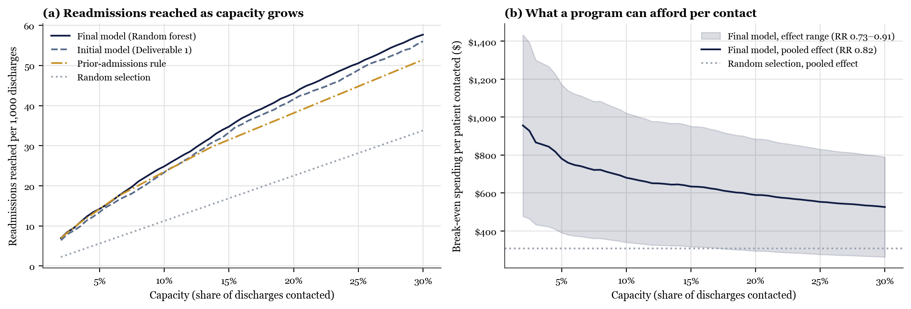
Note. Panel (a) counts readmissions among the patients each score ranks highest. Panel (b) shows the break-even spending per patient contacted for the final model; the band spans the trial evidence's 95% CI.
Transitional-care programs cut 30-day readmissions by about 18% (Leppin et al., 2014), and a readmission costs about $15,200 (Weiss & Jiang, 2021), so each contact is worth about $670 in avoided costs, against $308 for random selection; Figure 8 shows these inputs in the code.
Figure 8
Colab Notebook Screenshot: The Capacity Table and the Cost Inputs
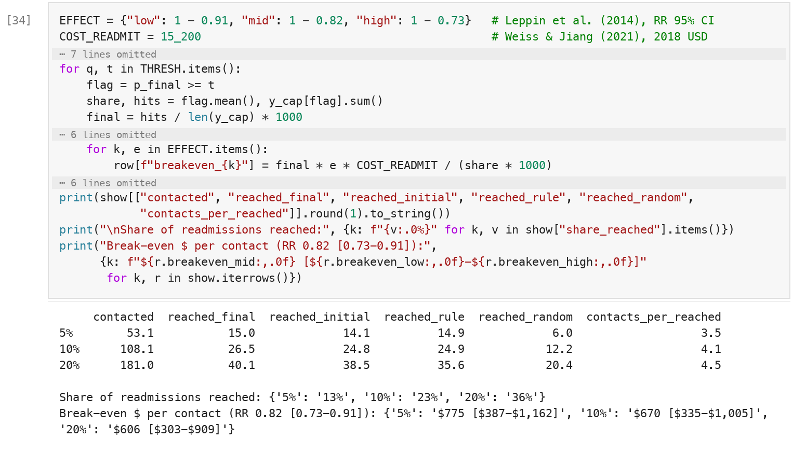
Note. Cell [34] of the notebook, Section 19, excerpt (gray bars mark omitted lines). The trial effect and the cost per readmission are set in the first two lines, so a hospital can substitute its own; the printed output gives the values in Table 3.
Two practical lessons follow. Thresholds set on past data miss their target (the 20% threshold flagged 18.1% of new patients), so the team should track its daily flag count; and at 5% capacity the prior-admissions rule does as well as the model, so a very small program could start with the rule.
Human review is part of the design. The list orders outreach but never withholds care, and a nurse can add any patient the model misses and record why, so overrides become evidence for the next version. Each flag shows a probability, with the reminder that 20% means one patient in five. Before going live, the model would run silently for a quarter, its scores compared with actual readmissions and recalibrated on local data (Van Calster et al., 2019). Once live, a named owner would review calibration, flag rates, and recall by age, gender, and race each month, and pause the model if any drifts past a preset limit (Rajkomar et al., 2018). Whether to use age-specific thresholds is a decision for clinical leadership, made with the trade-off above in view.
Conclusion
Three lessons stand out. First, getting the probabilities right mattered more than the choice of algorithm: dropping the class weights and checking calibration cut the Brier score by more than half, while ROC-AUC rose by only .007, and probabilities, not AUC, are what a care team reads. Second, honest evaluation shrinks claims but makes them usable: with patient-grouped folds, thresholds from training data, and a test set used once, the gain over Deliverable 1 is small but holds at every capacity a program would use. Third, a model can be well calibrated for every group and still serve one group worse, and a threshold fix closed the age gap only by leveling down. The next improvements follow from these limits. Discrimination near .67 is typical of readmission models built from administrative data (Kansagara et al., 2011), so further tuning will add little, whereas information recorded at discharge but missing from this file, such as functional status, support at home, and scheduled follow-up, could add more, especially for older patients. The model should then be validated and recalibrated on recent local data and evaluated prospectively, to measure the effect a program actually achieves instead of assuming the published average.
Team Collaboration
We again shared the work equally, with the roles rotated from Deliverable 1. Abburi led the model optimization, calibration, thresholds, and final evaluation (notebook Sections 15–17), and Chinthaluri led the fairness audit, the mitigation test, and the capacity and cost analysis (Sections 18–19). Each of us reviewed and approved the other's pull request in our shared GitHub repository before it was merged, and each methodological decision, including the model-selection rule, the calibration method, and the mitigation target, was logged with its proposer and reviewer. Because this report is generated from the notebook's results file (Sandve et al., 2013), every number in it matches the code in Appendix A.
References
Breiman, L. (2001). Random forests. Machine Learning, 45(1), 5–32. https://doi.org/10.1023/A:1010933404324
Brier, G. W. (1950). Verification of forecasts expressed in terms of probability. Monthly Weather Review, 78(1), 1–3. https://doi.org/10.1175/1520-0493(1950)078<0001:VOFEIT>2.0.CO;2
Clore, J., Cios, K., DeShazo, J., & Strack, B. (2014). Diabetes 130-US hospitals for years 1999–2008 [Data set]. UCI Machine Learning Repository. https://doi.org/10.24432/C5230J
Friedman, J. H. (2001). Greedy function approximation: A gradient boosting machine. The Annals of Statistics, 29(5), 1189–1232. https://doi.org/10.1214/aos/1013203451
Goddard, K., Roudsari, A., & Wyatt, J. C. (2012). Automation bias: A systematic review of frequency, effect mediators, and mitigators. Journal of the American Medical Informatics Association, 19(1), 121–127. https://doi.org/10.1136/amiajnl-2011-000089
Hardt, M., Price, E., & Srebro, N. (2016). Equality of opportunity in supervised learning. In D. D. Lee, M. Sugiyama, U. von Luxburg, I. Guyon, & R. Garnett (Eds.), Advances in Neural Information Processing Systems 29 (pp. 3315–3323). Curran Associates. https://papers.nips.cc/paper/6374-equality-of-opportunity-in-supervised-learning
Kansagara, D., Englander, H., Salanitro, A., Kagen, D., Theobald, C., Freeman, M., & Kripalani, S. (2011). Risk prediction models for hospital readmission: A systematic review. JAMA, 306(15), 1688–1698. https://doi.org/10.1001/jama.2011.1515
Kaufman, S., Rosset, S., Perlich, C., & Stitelman, O. (2012). Leakage in data mining: Formulation, detection, and avoidance. ACM Transactions on Knowledge Discovery from Data, 6(4), Article 15. https://doi.org/10.1145/2382577.2382579
Leppin, A. L., Gionfriddo, M. R., Kessler, M., Brito, J. P., Mair, F. S., Gallacher, K., Wang, Z., Erwin, P. J., Sylvester, T., Boehmer, K., Ting, H. H., Murad, M. H., Shippee, N. D., & Montori, V. M. (2014). Preventing 30-day hospital readmissions: A systematic review and meta-analysis of randomized trials. JAMA Internal Medicine, 174(7), 1095–1107. https://doi.org/10.1001/jamainternmed.2014.1608
Niculescu-Mizil, A., & Caruana, R. (2005). Predicting good probabilities with supervised learning. In Proceedings of the 22nd International Conference on Machine Learning (pp. 625–632). Association for Computing Machinery. https://doi.org/10.1145/1102351.1102430
Obermeyer, Z., Powers, B., Vogeli, C., & Mullainathan, S. (2019). Dissecting racial bias in an algorithm used to manage the health of populations. Science, 366(6464), 447–453. https://doi.org/10.1126/science.aax2342
Pedregosa, F., Varoquaux, G., Gramfort, A., Michel, V., Thirion, B., Grisel, O., Blondel, M., Prettenhofer, P., Weiss, R., Dubourg, V., Vanderplas, J., Passos, A., Cournapeau, D., Brucher, M., Perrot, M., & Duchesnay, É. (2011). Scikit-learn: Machine learning in Python. Journal of Machine Learning Research, 12, 2825–2830. https://jmlr.org/papers/v12/pedregosa11a.html
Rajkomar, A., Hardt, M., Howell, M. D., Corrado, G., & Chin, M. H. (2018). Ensuring fairness in machine learning to advance health equity. Annals of Internal Medicine, 169(12), 866–872. https://doi.org/10.7326/M18-1990
Rudin, C. (2019). Stop explaining black box machine learning models for high stakes decisions and use interpretable models instead. Nature Machine Intelligence, 1(5), 206–215. https://doi.org/10.1038/s42256-019-0048-x
Sandve, G. K., Nekrutenko, A., Taylor, J., & Hovig, E. (2013). Ten simple rules for reproducible computational research. PLOS Computational Biology, 9(10), Article e1003285. https://doi.org/10.1371/journal.pcbi.1003285
Van Calster, B., McLernon, D. J., van Smeden, M., Wynants, L., Steyerberg, E. W., & Topic Group “Evaluating diagnostic tests and prediction models” of the STRATOS initiative. (2019). Calibration: The Achilles heel of predictive analytics. BMC Medicine, 17, Article 230. https://doi.org/10.1186/s12916-019-1466-7
Weiss, A. J., & Jiang, H. J. (2021). Overview of clinical conditions with frequent and costly hospital readmissions by payer, 2018 (HCUP Statistical Brief No. 278). Agency for Healthcare Research and Quality. https://hcup-us.ahrq.gov/reports/statbriefs/sb278-Conditions-Frequent-Readmissions-By-Payer-2018.jsp
Appendix A
Google Colab Notebook
Notebook link (view access for the instructor):
https://colab.research.google.com/github/ychinthaluri53651/diabetes-readmission-residency-day-1/blob/main/Diabetes_Readmission_D2_Chinthaluri_Abburi.ipynb
The notebook (Diabetes_Readmission_D2_Chinthaluri_Abburi.ipynb) is self-contained: on first run it downloads the UCI archive, then executes top to bottom and writes every figure and reported number. Part 1 (Sections 1–14) reproduces Deliverable 1 unchanged. Part 2 holds this deliverable: model optimization (Section 15), calibration and thresholds (16), the final evaluation (17), the fairness audit and mitigation test (18), capacity and cost (19), and the saved results (20).
Appendix B
Supplementary Figure
Figure B1
Permutation Importance of the Final Model on the Test Set
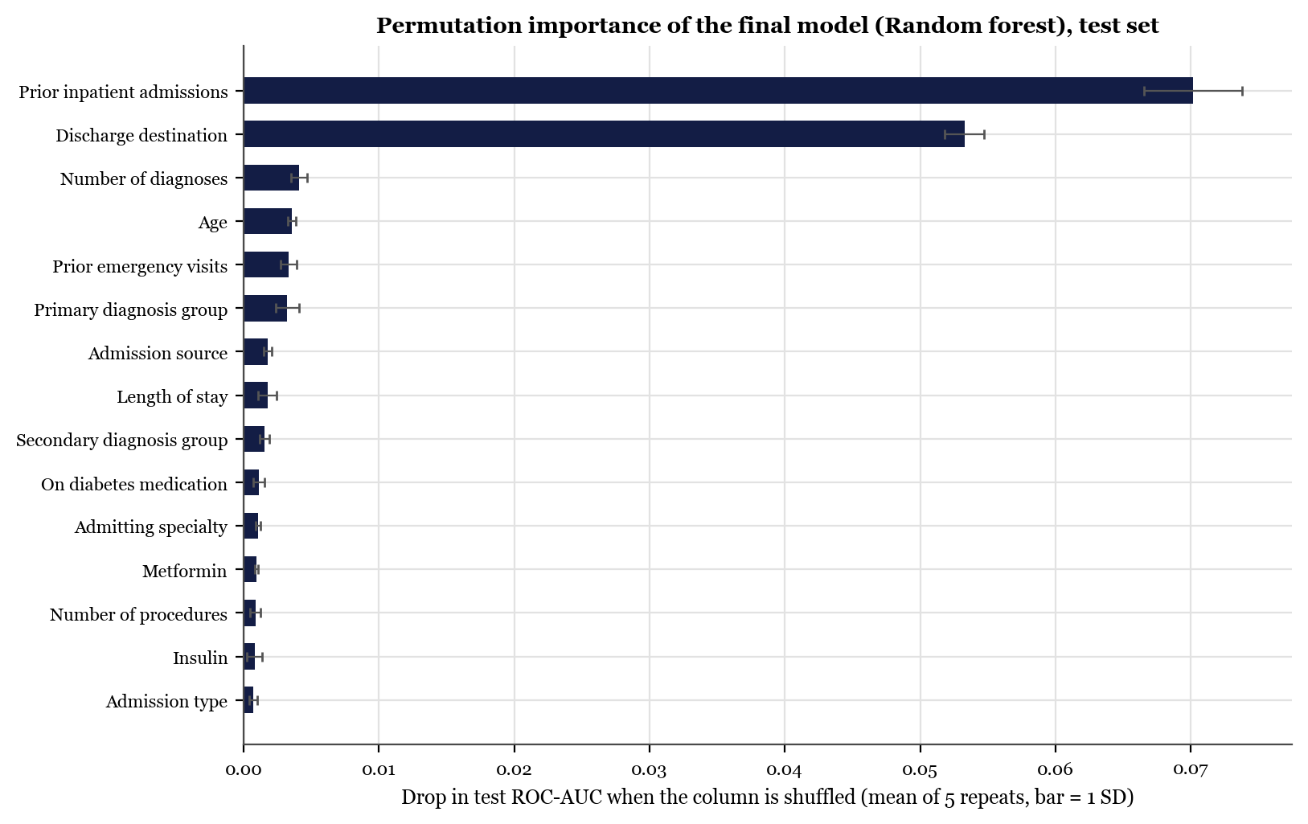
Note. Drop in test ROC-AUC when one input column is shuffled (mean of five repeats; bars show one standard deviation). Each bar covers all dummy columns of a categorical input.

