UNSW Business School

School of Information Systems and Technology Management
Individual Assessment Cover Sheet

Student Name: Chengjie Yuan
Student ZID: z5505108
Course Code: COMM2822
Course Name: Introduction to Databases for Business Analytics
Date Due: 05:00 pm (Sydney Time), Tuesday, 01 July 2025

I declare that this assessment item is my own work, except where acknowledged, and has not been submitted for academic credit elsewhere, and acknowledge that the assessor of this item may, for the purpose of assessing this item:
- Reproduce this assessment item and provide a copy to another member of the University; and/or,
- Communicate a copy of this assessment item to a plagiarism-checking service (which may then retain a copy of the assessment item on its database for the purpose of future plagiarism checking).
I certify that I have read and understood the University Rules in respect of Student Academic Misconduct.
Signed (this can be either your digital signature or simply type your Full Name):

___Chengjie Yuan_____________

Date: __29/6/2025______________

Table of Contents
Table of Contents 2
Assumption 3
Background information and ER Modeling summary 4
Description 4
Entity Relationship Model 6
References 7

Assumption
Assumptions are made in advance. I am not responsible for writing computer programs to collect data or handle business logic because these tasks are managed by other project teams. The interaction between computer programs and the database is not my concern. It is assumed to be handled by other teams. Coordination with other teams has been completed before I started database design. I don’t need to worry about how the data is collected. Data encryption is not within the scope of this task.

Background information and ER Modeling summary
In 2030, the world of motorsports has undergone a significant technological transformation. The newly launched electric vehicle racing series, the F1-EV Championship, has gained popularity due to its dual focus on speed and sustainability. This event has attracted fans and new sponsors from both Generation Z and Generation Alpha.
Currently, the F1-EV consortium has appointed me as a database specialist to develop an Entity-Relationship Diagram (ERD) for its VIP and hospitality system. I have used systems from the official F1 VIP package and experience websites as references to design the model. The scope of the design includes guest bookings, VIP package management, accommodation arrangements, race event displays, and exclusive VIP packages offering three options.

Description
This is an Entity-Relationship Diagram to describe F1-EV VIP and hospitality system. Starting from the Guest entity, each guest needs to give name, email, phone number, emergency contact and choose payment method like credit card, cash or mobile payment. The reason for requiring a passport number is that the F1-EV Championship follows a global touring format, with races hold across various countries. Therefore, collecting passport number helps ensure accurate identity verification and better protects guest rights throughout international events. The booking system can have one to more guests to enter while each guest is linked to only one booking record. The reason is based on common sense: a booking system is unlikely to be limited to just one guest. Therefore, it is reasonable to apply the same one-to-many logic to other relationships within this model. In the booking System, it will show the record created time, on what platform it was created like website or app, guide and recommendation on VIP package choosing. Each booking record in the Booking System can be used to purchase one or more F1-EV VIP Bookings, while each VIP booking must be associated with exactly one booking record.
In the F1-EV VIP Booking page, it will show order number, amount, booking date and special request. Special requests refer to additional guest preferences like providing an extra pair of slippers when staying in the hotel, or providing drinks with no alcohol. The F1-EV VIP Booking System interacts with the Display Board to present booking-related information on various screens, such as location, date and venue to the guest. The Display Board will show one or more bookings while each information group is related to one booking. The race event includes event name, the capacity of the venue, the track map and the promotional video. There can be one to more race events register on Display Board while each information group of race event is linked to one.
Next is the accommodation arrangement. In the hotel, there can be one to more bookings while each hotel order matches one booking. Guests will receive details about room type, like sea view room or deluxe room, floor, check in date and check out date.
Each VIP package can be associated with one to more booking orders, while each booking order selects only one VIP package. The VIP Package entity includes the package type, price, duration, and a detailed description. Duration refers to how long the entitlements associated with each package remain valid. The system provides three different tiers of VIP packages, each offering a distinct level of experience and service: Gold Series, Special Edition, and Enhancement Pack, priced in descending order. Each order can choose only one of them. Among the three tiers, the Enhancement Pack offers only marginal advantages over a standard ticket, such as earlier entry times and improved seating arrangements. Compared to the two higher-tier options, it provides similar benefits only in accommodation and access to race event displays, lacking substantial value-added services. As such, this package will not be discussed extensively at this stage. The focus will instead be on the Special Edition and Gold Series.
Special Edition (SE): Duration is two days. SE guests are provided with private rooms featuring floor-to-ceiling windows for viewing the F1-EV Championship. Meanwhile, the buffet restaurant will be open to SE guests, allowing them to enjoy a premium dining experience.
Gold Series (GS): Duration is three days. GS guests will be informed of visiting hours, follow guides to walk along the pit lane, and are allowed to take photos. After the F1-EV Championship, GS guests will have the opportunity to personally interview the racing drivers during a dedicated interview session.
At the end, staff will collect feedback from both SE and GS guests for future service improvements.

Entity Relationship Model
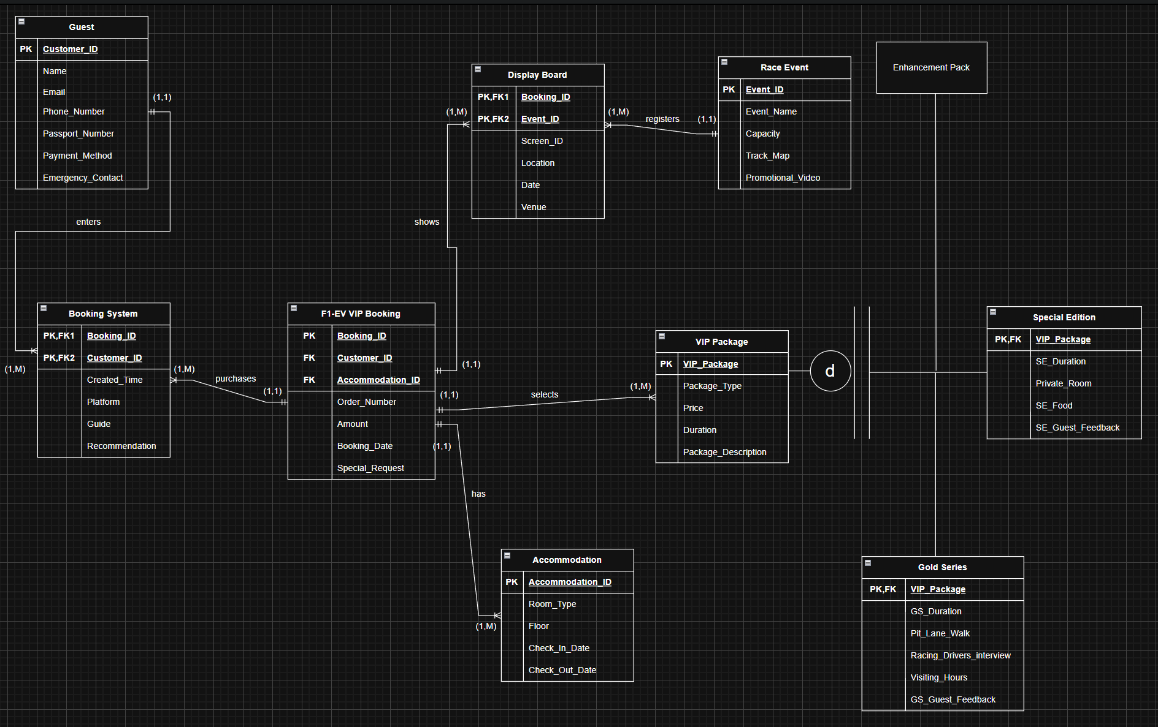

References
1.Formula Vagas, ‘VIP Packages’, Formula Vagas, accessed 28 June 2025, < Formula 1 Las Vegas | Race Schedules, Tickets, Hotels, & More | Formula.Vegas>
2.2025 Formula One World Championship Limited, ‘F1 experiences’, accessed 28 June 2025, < F1 Official Ticket & Travel Packages | F1 Experiences>
3. 2025 Formula One World Championship Limited, ‘Paddock Club’, accessed 28 June 2025, < F1 Paddock Club | F1 Experiences>

