Analytical Brief
Chengjie Yuan
Z5505108
INFS3822
Assessment 1

Executive Context
This analytical brief is a job report for GlobalStore. Its aim is to maintain environmental sustainability and improve customer satisfaction. I use Logistic Regression, Deep Neutral Network Confusion Matrix and Clustering to complete the return purchase problem analysis.

1. Data Preparation Summary (Structured Data)
GlobalStore aims to understand the reason why product is returned and give the dataset to me. To enable effective modelling, the dataset needs to be cleaned and transformed into a suitable format for analysis. Firstly, categorical variables such as customer_id, product_id, shipping_mode, and category cannot be used in model originally. Thus, they should be transformed and interpret to numeric data which can be used in following analysis. Therefore, I introduce a return ratio function to explain the relationship between a factor and all purchases records under this factor. For example, use customer_id as criteria, the return ratio for a customer represents the proportion of his or her returned purchases. This transformation allows categorical information to be converted into numerical signals. By introducing return ratios, these categorical data can be treated as numeric data. They also match the requirement of model training. Another consideration is that the level of relationship importance between each dataset and the reason for return is unknown. When I finish the ratio function program, I create a factor important figure to interpret. It illustrates that factors such as customer_id, product_id, and shipping_mode show stronger associations with return behaviour. Overall, these preparation steps ensure that the dataset is both analytically meaningful and suitable for modelling.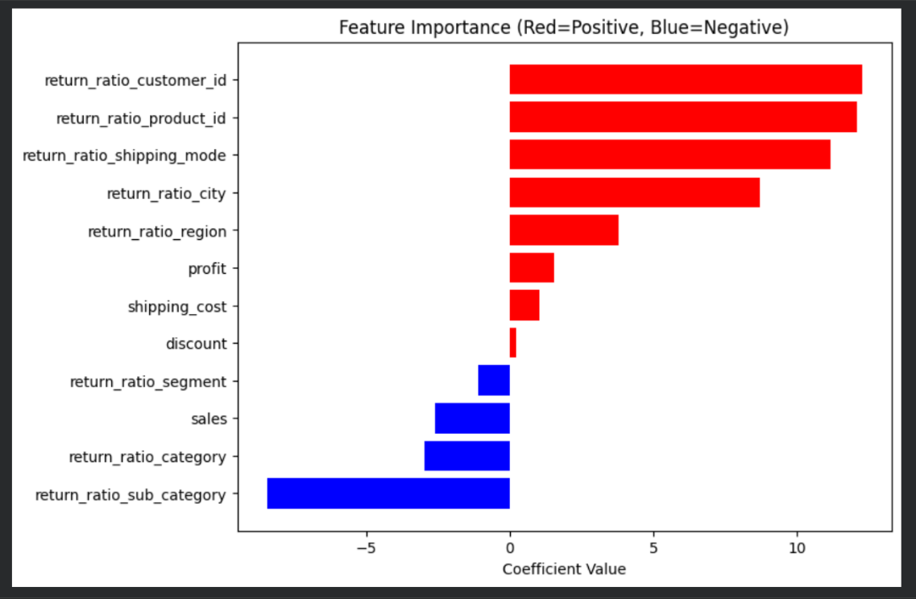

2. Model Outputs & Explanation

2.1 Structured Data: Return Prediction Models
I developed two supervised learning models. They are responsible for predicting return purchases: Logistic Regression and Deep Neural Network (MLPClassifier). Both models demonstrate strong predictive performance with ROC-AUC values close to 1. They both indicate a high ability to distinguish between returned and non-returned orders.
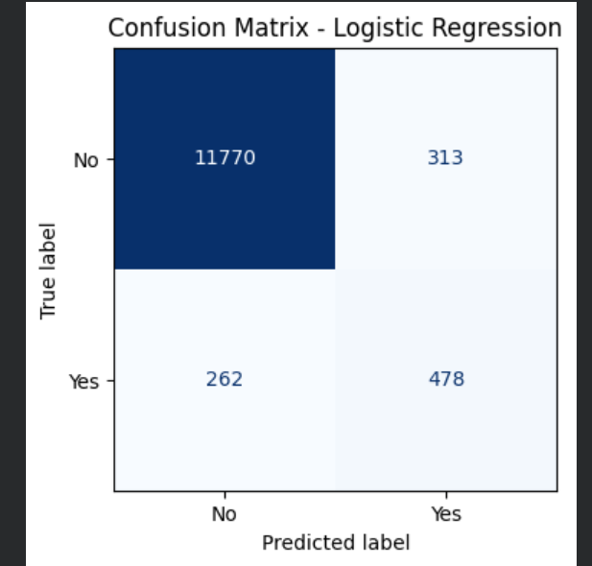
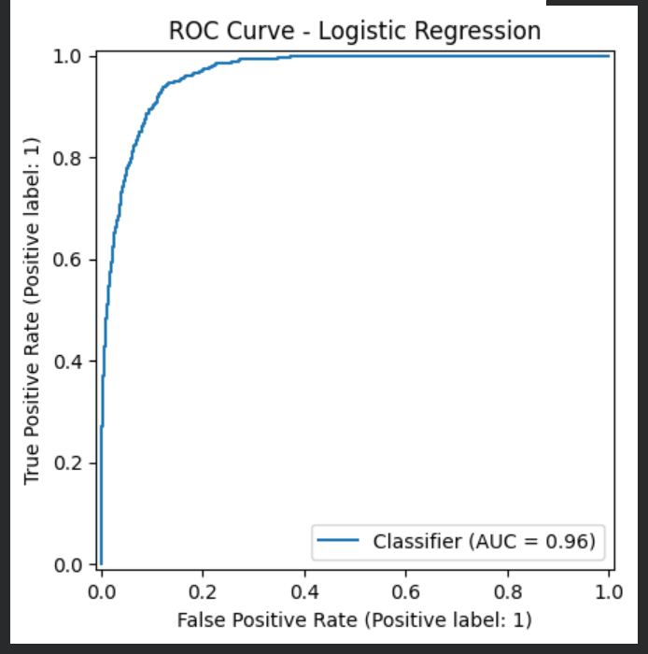
The confusion matrix of Logistic regression shows that it predicts most non-returned orders are correct. It is due to the imbalance between returned and non-returned in the dataset.
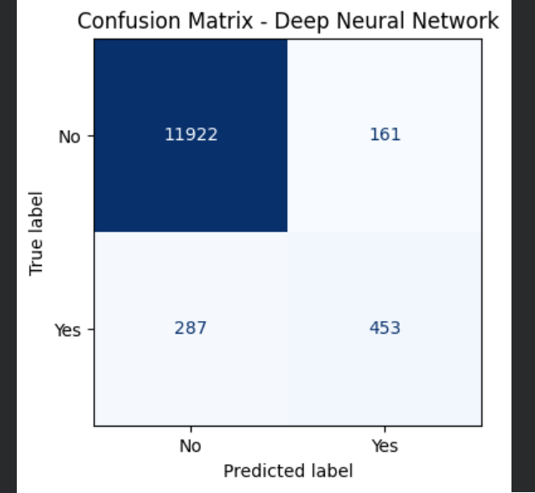
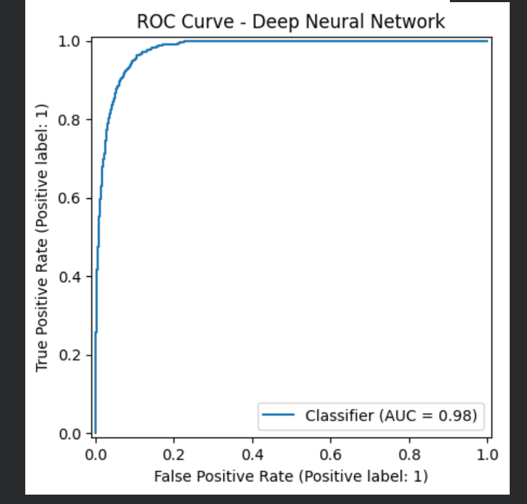
In contrast, the Deep Neural Network achieves a higher accuracy, precision, F1-score, and ROC-AUC so this model has a stronger overall predictive performance. The non-return purchases are more than the Logistic Regression’s predictions. Except ‘predict no but fact yes’ square is higher, other square numbers all lower than the Logistic Regression’s predictions.
The following sheet provides a clear comparison between two models. The most two significant differences are Precision and F1 Score. Precision means the ratio of return purchases in real world conditions. The higher number means lower risk to misjudge purchase are not originally to be returned. So the Deep Neural Network model is more precise in its predictions and identify lower number of incorrectly flagged returns. Another is F1 Score. F1 Score means a balance data reference between precision and recall. Apply to the case, a higher F1 score means when model identifies return purchases, it will be more balanced.
To sum up, both two supervised learning models are almost the same but still have differences in parameters. Logistic Regression achieves a higher recall which means that it is more effective at identifying returned orders. The key differences between the models lie in how they handle return cases. Logistic Regression is more suitable for identifying potential return risks while Deep Neural Network model provides more reliable and efficient predictions overall. Although Logistic Regression has a higher recall score, Deep Neural Network model achieves a greater balance in identifying return orders because of higher Precision. 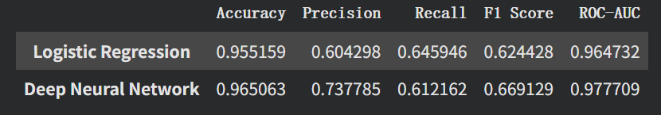

2.2 Unstructured Data: Supporting Image Evidence
I use KMeans in clustering the image zip file. When I completely run my code, the program divides images into two clusters. One cluster contains furniture items like chairs, while the other includes electronic appliances like microwaves. This image clustering results are based on physical shape and color of products.
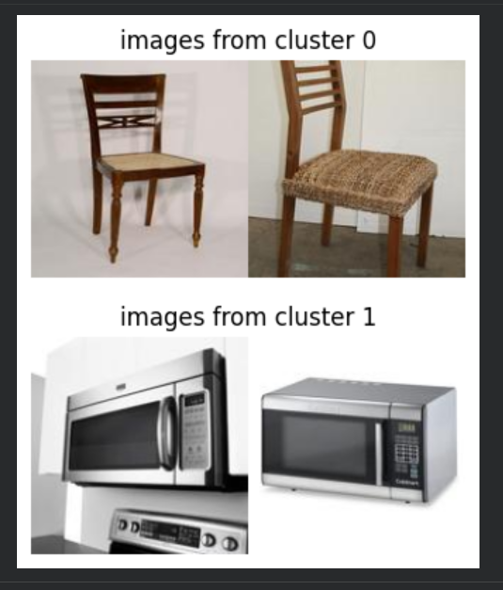

3. Business Insights
From running these models, results display that customer, product and shipping modes are key factors associated with return purchases problem. Logistic Regression shows stronger ability to identify return purchases; Deep Neural Network provides a more balanced performance in predicting overall. Supervised learning models can be used to identify risky orders. For customers, impulsive purchasing is an objective factor, especially happening in e-commerce market. Customers may make purchases without fully considering product necessity or return policies, and feel regretful after making purchases (Lazar R., 2023). Therefore, GlobalStore could enhance return conditions in customer policy, set a reminder message before customer checkout, encouraging them to review their purchase decisions. These actions can effectively avoid them from regretful after paying. For products, inaccurate or incomplete product descriptions can lead to misunderstanding and increase return rates (CORSO). GlobalStore should add more detailed information on furniture items. The company can choose to increase assembly instructions or state whether there is availability of installation services. Through these services, customer satisfaction will increase and GlobalStore will receive higher service feedback comments. For shipping modes, the analysis shows a strong relationship between it and return rates. However, the data does not indicate which specific shipping mode or factors drive these differences. GlobalStore may need further checks or research on its shipping mode flow path. Another question is that although category-level variables show negative relationships with return purchases, the images have no labels to distinguish returned or non-returned products. Clustering results only based on physical features. So GloabalStore may need further classifications on products.

4. Reflection on the Process
I met challenges in the data preparation stage. Initially, I assumed that all available variables should be directly used in their original form. However, categorical data such as customer_id, product_id, product_name and returned could not be meaningfully interpreted by the models without transformation. At first, I tried converting the return variable into binary form, but it did not provide sufficient explanation. I also tried to do a simple graph like shipping_cost, however, the sample has a huge capacity, so it is not a suitable way. At the initial stage I sometimes will deviate the core problem instead of analyzing it. I also considered dropping variables which are only identifiers like customer_id and product_id. However, when I aimlessly sort csv by returns, I found that the same customer could have both returned and non-returned orders so categorical data may still contain useful information. To address this challenge, I remembered study materials from previous course INFS2822, correlation matrix and secondary processing. I finally developed the return ratio feature, which captures the proportion of returns associated with each category. Through this process, I learned that please consider carefully the core problem, combined with learning materials. While the difficulty is to do secondary processing and finding features. This process also taught me there is no correct answer in business analysis, but I need to find the most suitable way to explain the problem.

References:
- Lazar R., 2023, ‘The Impact of Impulsivity on eCommerce Returns’, Returns Management & Customer Experience, RETURNGO, accessed 19 May 2026, < The Impact of Impulsivity on eCommerce Returns - ReturnGO>
- CORSO, ‘Reducing Returns With Accurate Product Information’, CORSO, accessed 19 May 2026, < Reducing Returns With Accurate Product Information>

Use of AI Tools

During this task, I ask ChatGPT and Gemini to support me to identify Python coding errors and give coding improvement suggestions.

Visual Evidence
1.Feature Importance ratio display
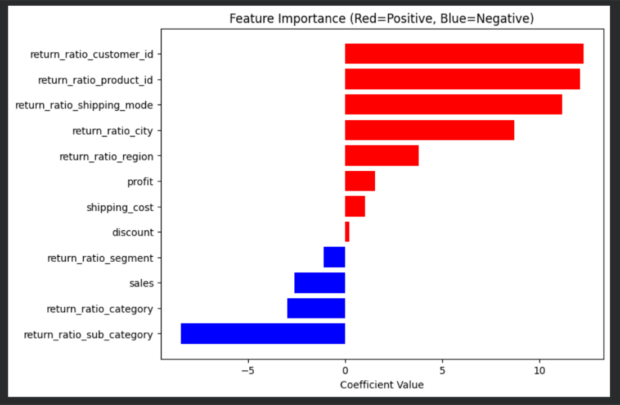
2. Logistic Regression Confusion Matrix


3. Logistic Regression ROC Curve

4. Deep Neural Network Confusion Matrix


5. Deep Neural Network ROC Curve

6. Parameter comparison between Logistic Regression and Deep Neural Network

7. Clustering result


