Consultancy Proposal
Chengjie Yuan
Z5505108
INFS3822
Assessment 2


Executive Summary
Gumtree Australia invite me to write a consultancy proposal. The company’s aim is to decide a fair price to do car sales. I use Sas Viya to do data exploration, analysis and modelling. Based on these results, give conclusions and insights.
Perspective
Gumtree Australia wants to determine a reasonable price in car sales. There are several perspectives need to be considered. I choose the functional perspective of Buyer Experience and Demand Matching to do further solution analysis.

Business problem
Buyers often face difficulty about how to find reasonable vehicle prices in a large amount of listing. Although they can use filters to restrict attributes such as body type, brand, and transmission, they do not fully support buyers to evaluate whether a vehicle is reasonably priced. Buyers need to compare multiple choices and interpret pricing information by themselves. This may lead to ignore highly cost-effective vehicles or spend more time searching. These behaviours will reduce customer satisfaction and engagement. They will receive an uncomfortable buying experience. For the platform this problem limits the efficiency in matching supply and demand. For the company, it also reduces its number of transaction records.
Dataset usage
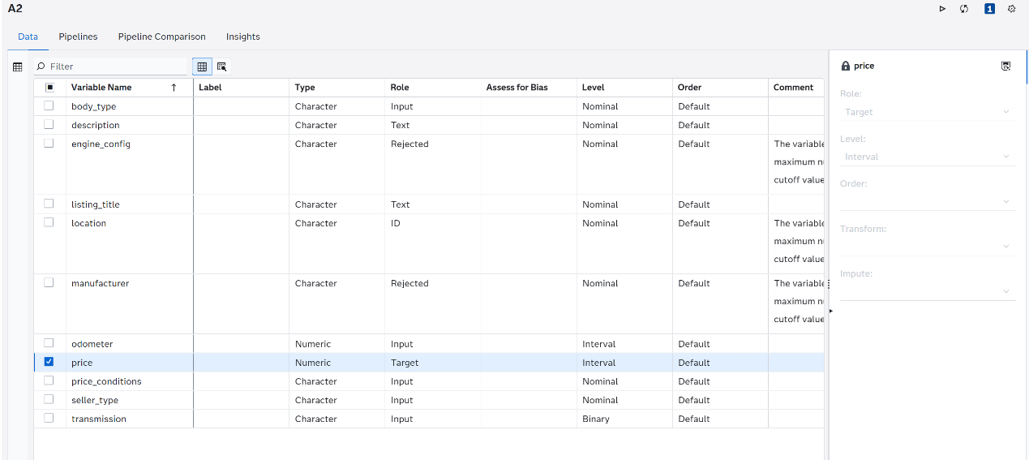 I use Sas Viya to do data analysis first. At the data exploration stage, I need to focus on variables which have close relationship or huge influence on price. To align with the business problem, I choose price as the target variable and run the pipeline.
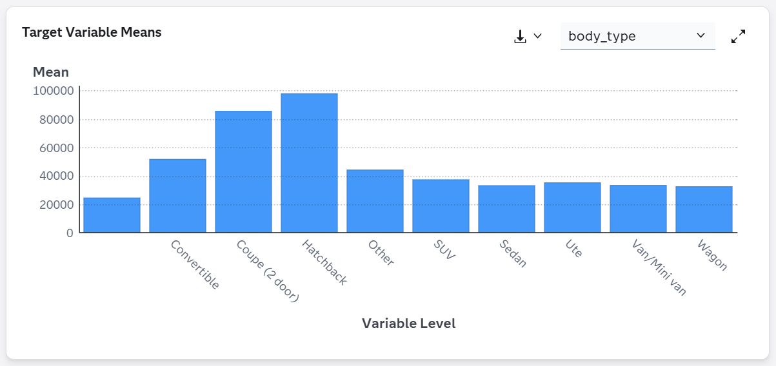
The Target Variable Means chart displays the average price of each body type. It indicates that each vehicle type has a different pricing position. For example, hatchbacks and coupes (2 door) have higher average prices, however, others such as sedans and wagons are priced lower.
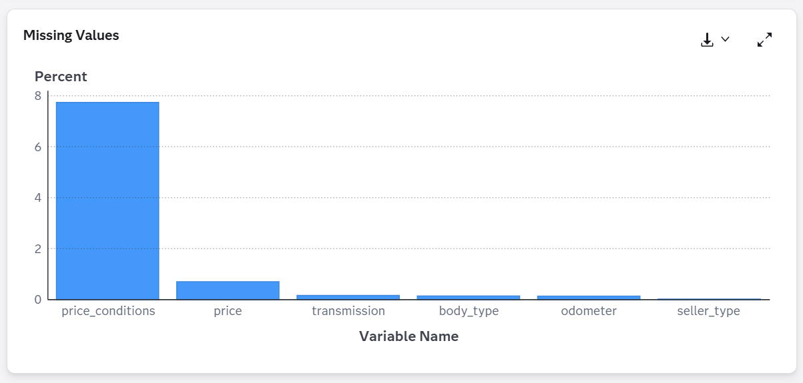
This is the missing values chart. It highlights the proportion of incomplete data in the dataset. Most variables such as odometer, transmission, and seller_type have very low levels of missing values They indicate that the dataset is mainly complete and reliable. However, the variable price_conditions shows a significant proportion of missing data, at approximately 8%. This suggests that information related to pricing conditions is not complete in a small proportion of provided listings. From a modelling perspective, missing values will reduce model accuracy and introduce bias if not properly handled. To handle this issue, an imputation step needs to be applied as part of the data preparation pipeline. Categorical variables such as price_conditions are imputed by using the most frequent category. In addition, numerical variables such as price and odometer, although they have only a small proportion of missing values, they are also processed during imputation to improve data integrity across the dataset. This step ensures that the dataset is complete and can be effectively used for subsequent modelling. This inconsistency may reflect differences in how sellers provide listing details. Thus, improving data collection and encouraging more complete listings can enhance data quality and support better pricing insights for buyers.
AI-driven solution design
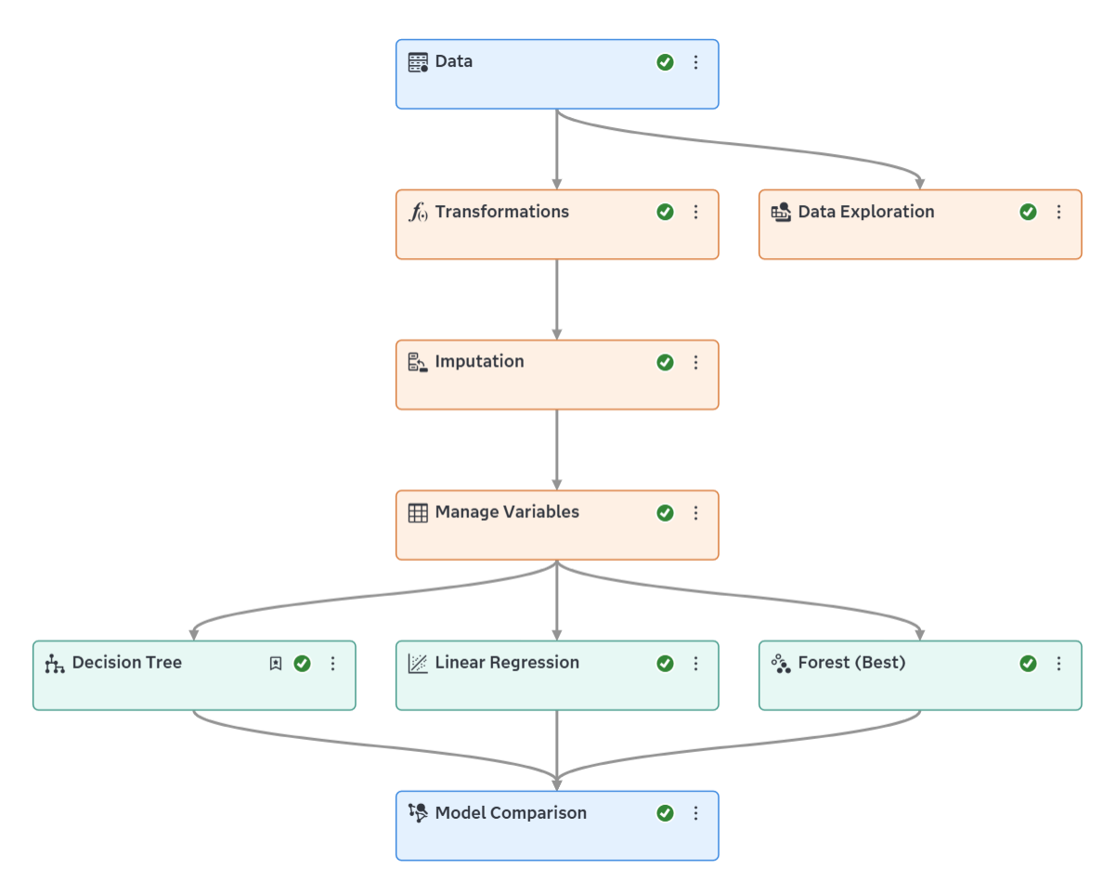
This is the AI solution design pipeline. My AI solution for buyers is to help them evaluate car prices at a reasonable stage. This will prevent them from wasting time on meaningless considerations and indecisiveness.
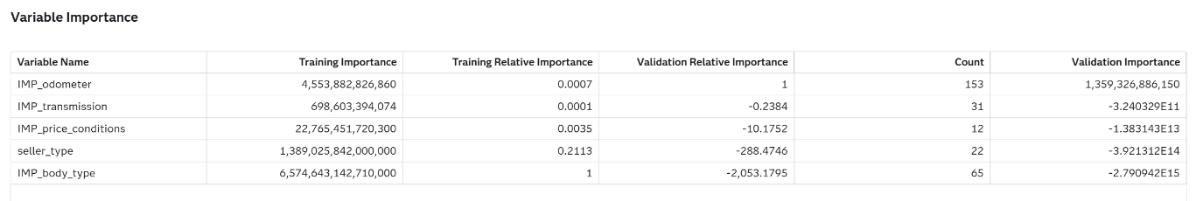
The decision tree results suggest that body type and odometer are both meaningful variables for understanding vehicle price, but they represent different types of value for buyer decision support. In the training results, body type appears highly important. It illustrates that vehicle category helps classify the market into different pricing segments. In other words, it is meaningful from a buyer experience perspective because buyers should not compare all cars in the same way. For example, SUVs, sedans and hatchbacks often belong to different price ranges and are associated with different usage needs. Therefore, body type can help buyers narrow their search and make more appropriate comparisons within a relevant category. By contrast, odometer becomes more important in validating results in the new data. It explains that odometer may provide a more practical and stable signal. It provides a clear guidance for buyers. From a business perspective, the relationship between price and odometer will be considered with higher importance in reasonableness. Combine these two variables together, these findings imply that a buyer tool supported by AI should not rely on a single variable. Instead, it should have some separate considerations on how to identify a reasonable price.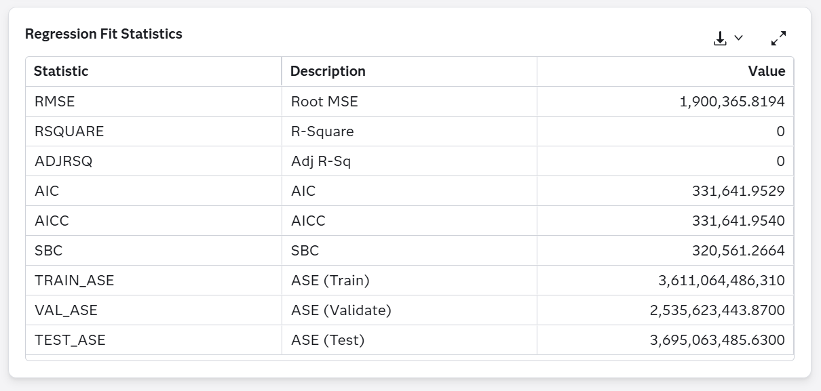
The linear regression model shows very poor performance because both R-squared and adjusted R-squared values equal to zero. This indicates that the model is unable to explain the relationship between variables and prices. The relatively high RMSE indicates that the model has large prediction error. Thus, the relationship between variables and price is more complex than linear.
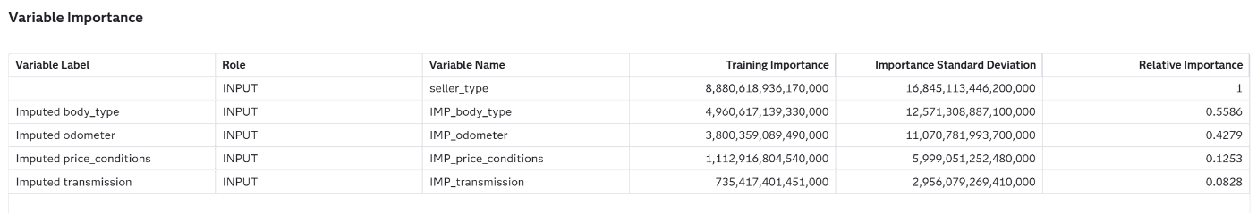
The variable importance results from the random forest model indicate that seller type is the most influential factor. It suggests that price is not only determine by vehicle conditions but also strongly influenced by how the vehicle is sold. From a business perspective, this reflects the strategy of pricing is higher related to seller types.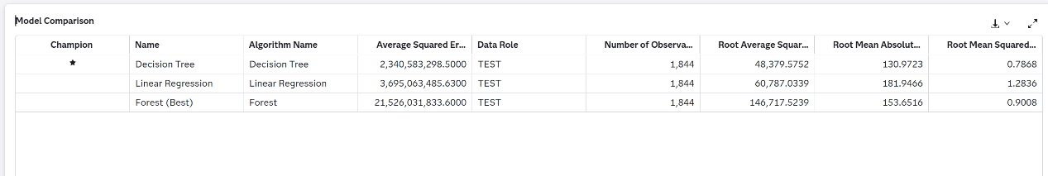
The performance of the three models was compared by RMSE. The decision tree achieved the lowest RMSE. It indicates the highest prediction accuracy among the models. However, the linear regression model fails to explain effectively. The random forest model also has a higher RMSE compared to the decision tree. Based on these results, the decision tree has the best performance. From a business perspective, this result suggests that the decision tree can predict price with the lowest deviation. It provides more interpretable and stable results which is the most comprehensive. While the random forest only highlights seller type but lacks further explanation. Linear regression shows that price has a non-linear relationship between other variables. To sum up, the decision tree model is the best to help buyers find reasonable vehicle price. It can reach a better customer satisfaction.
Considerations, Limitations and Business Insights
Three models all have limitations. The decision tree is sensitive to data change, then affect the stability of the results. The linear regression is limited by linear relationship assumptions which is not suitable. The random forest does not provide directional relationships or clear explanations. However, model only provides a reference, in real application, data incompleteness may affect the reliability of the results. It is important to ensure that present the results in a way that is easy to understand. For the company perspective, Gumtree Australia can use odometer as a key reference to provide guidance and body type to do segment listings. This helps users evaluate whether a listing is reasonably priced and improve decision efficiency. Seller type can be incorporated into the recommendation system to provide more information on price differences.

Use of AI Tools
I use ChatGPT for Sas Viya pipeline fix and assessment grammar check.
Appendix
- Data
- Data exploration - Target Variable Means
- Data exploration - Missing Values
- Pipeline
- Decision Tree - Variable Importance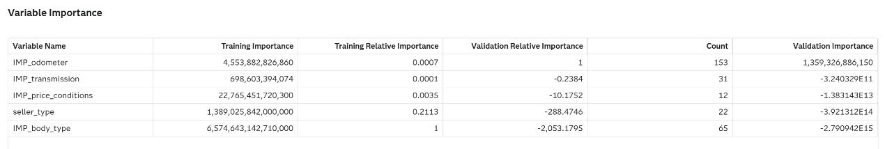
- Linear Regression - Regression Fit Statistics
- Forest (Best) - Variable Importance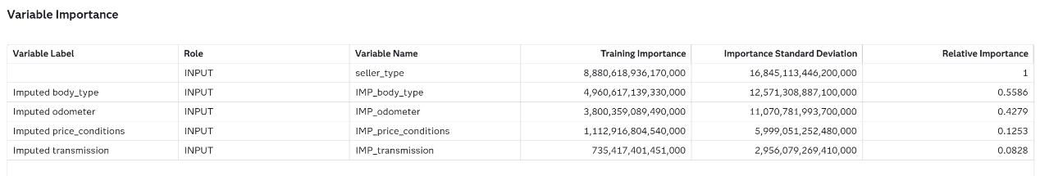
- Model Comparison