UNSW Business School
School of Information Systems and Technology Management
Assessment Cover Sheet
Group No: ______H18A-06__________________________
Group Leader Name:_Chengjie Yuan_______________________________
Course Code:_____ COMM2822______________
Course Name: Introduction to Databases for Business Analytics
Date Due: _____06 AUGUST 2025 9:AM AEST___________________________

We declare that this assessment item is our own work, except where acknowledged, and has not been submitted for academic credit elsewhere, and acknowledge that the assessor of this item may, for the purpose of assessing this item:

- Reproduce this assessment item and provide a copy to another member of the University; and/or,
- Communicate a copy of this assessment item to a plagiarism checking service (which may then retain a copy of the assessment item on its database for the purpose of future plagiarism checking).

We certify that we have read and understood the University Rules in respect of Student Academic Misconduct.

zID | Name | Signed | Date
z5508514_____ | _Yangyang Zhang___ | _Yangyang Zhang____ | _29/7/2025__
_z5505108____ | __Chengjie Yuan__ | __Chengjie Yuan__ | __2/8/2025___
__ z5537148____ | _ Boyu Zhang ____ | _ Boyu Zhang ____ | _2/8/2025___
z5530067 | Chuming Xiao | Chuming Ziao_ | 2/8/2025_

The cover sheet is to be provided with any print or digital submission of the assignment. Failure to include a signed cover sheet will lead to a 5% penalty of the total marks available for the assignment. No marks will be released until a signed cover sheet is received.

Usage of AI Tools
Write here how you have used AI tools and how you use and change the output in your assessment. Please be honest because Turnitin can detect the usage of AI tools. Words do not count towards your word limit.
ChatGPT is used for framing and evidence articles searching.
Mybib for Reference List generation.

Table of Contents
Usage of AI Tools 3
Table of Contents 4
Executive Summary 5
I.ERD Diagram for F1-VI Hospitality System Management 7
II.SQL For F1-V1 Hospitality System Management 13
Appendix 23
Reference List 21

Executive Summary
Regarding the explanation of the ERD diagram, our group partially followed the description provided by Boyu Zhang (z5537148) in his personal assignment. We mainly added some new entities, assumptions, and related descriptions.
This project presents the design and development of a backend database system for the E1-V1 VIP Hospitality System, which is intended to support high-end guest management during Formula 1 Electric Vehicle (F1-EV) events. The system focuses on delivering a seamless, secure, and premium experience for VIP attendees through efficient data organization and robust processing capabilities.
The core components of this assessment include the creation of an Entity Relationship Diagram (ERD) and the implementation of key SQL functions and queries. The ERD was developed to map out the structural relationships between essential entities such as guests, events, reservations, hospitality packages and ticketing. This visual representation of the database ensures data normalization, improves system scalability, and facilitates clear communication between development teams.
A suite of SQL operations was created to perform critical tasks such as guest registration, package assignment, check-in tracking, real-time reporting, and security measures like data masking and input validation. These SQL components automate business processes, maintain data integrity, and support future system enhancements.
By integrating ERD and SQL into the system’s architecture, this project lays a solid foundation for a data-driven VIP hospitality experience. The design emphasizes efficiency, scalability, and security, making it well-suited for the high expectations and complexity of an international electric racing event. This assessment highlights the importance of strong data modeling and query logic in building future-ready event management systems.

I. ERD Diagram for F1-VI Hospitality System Management

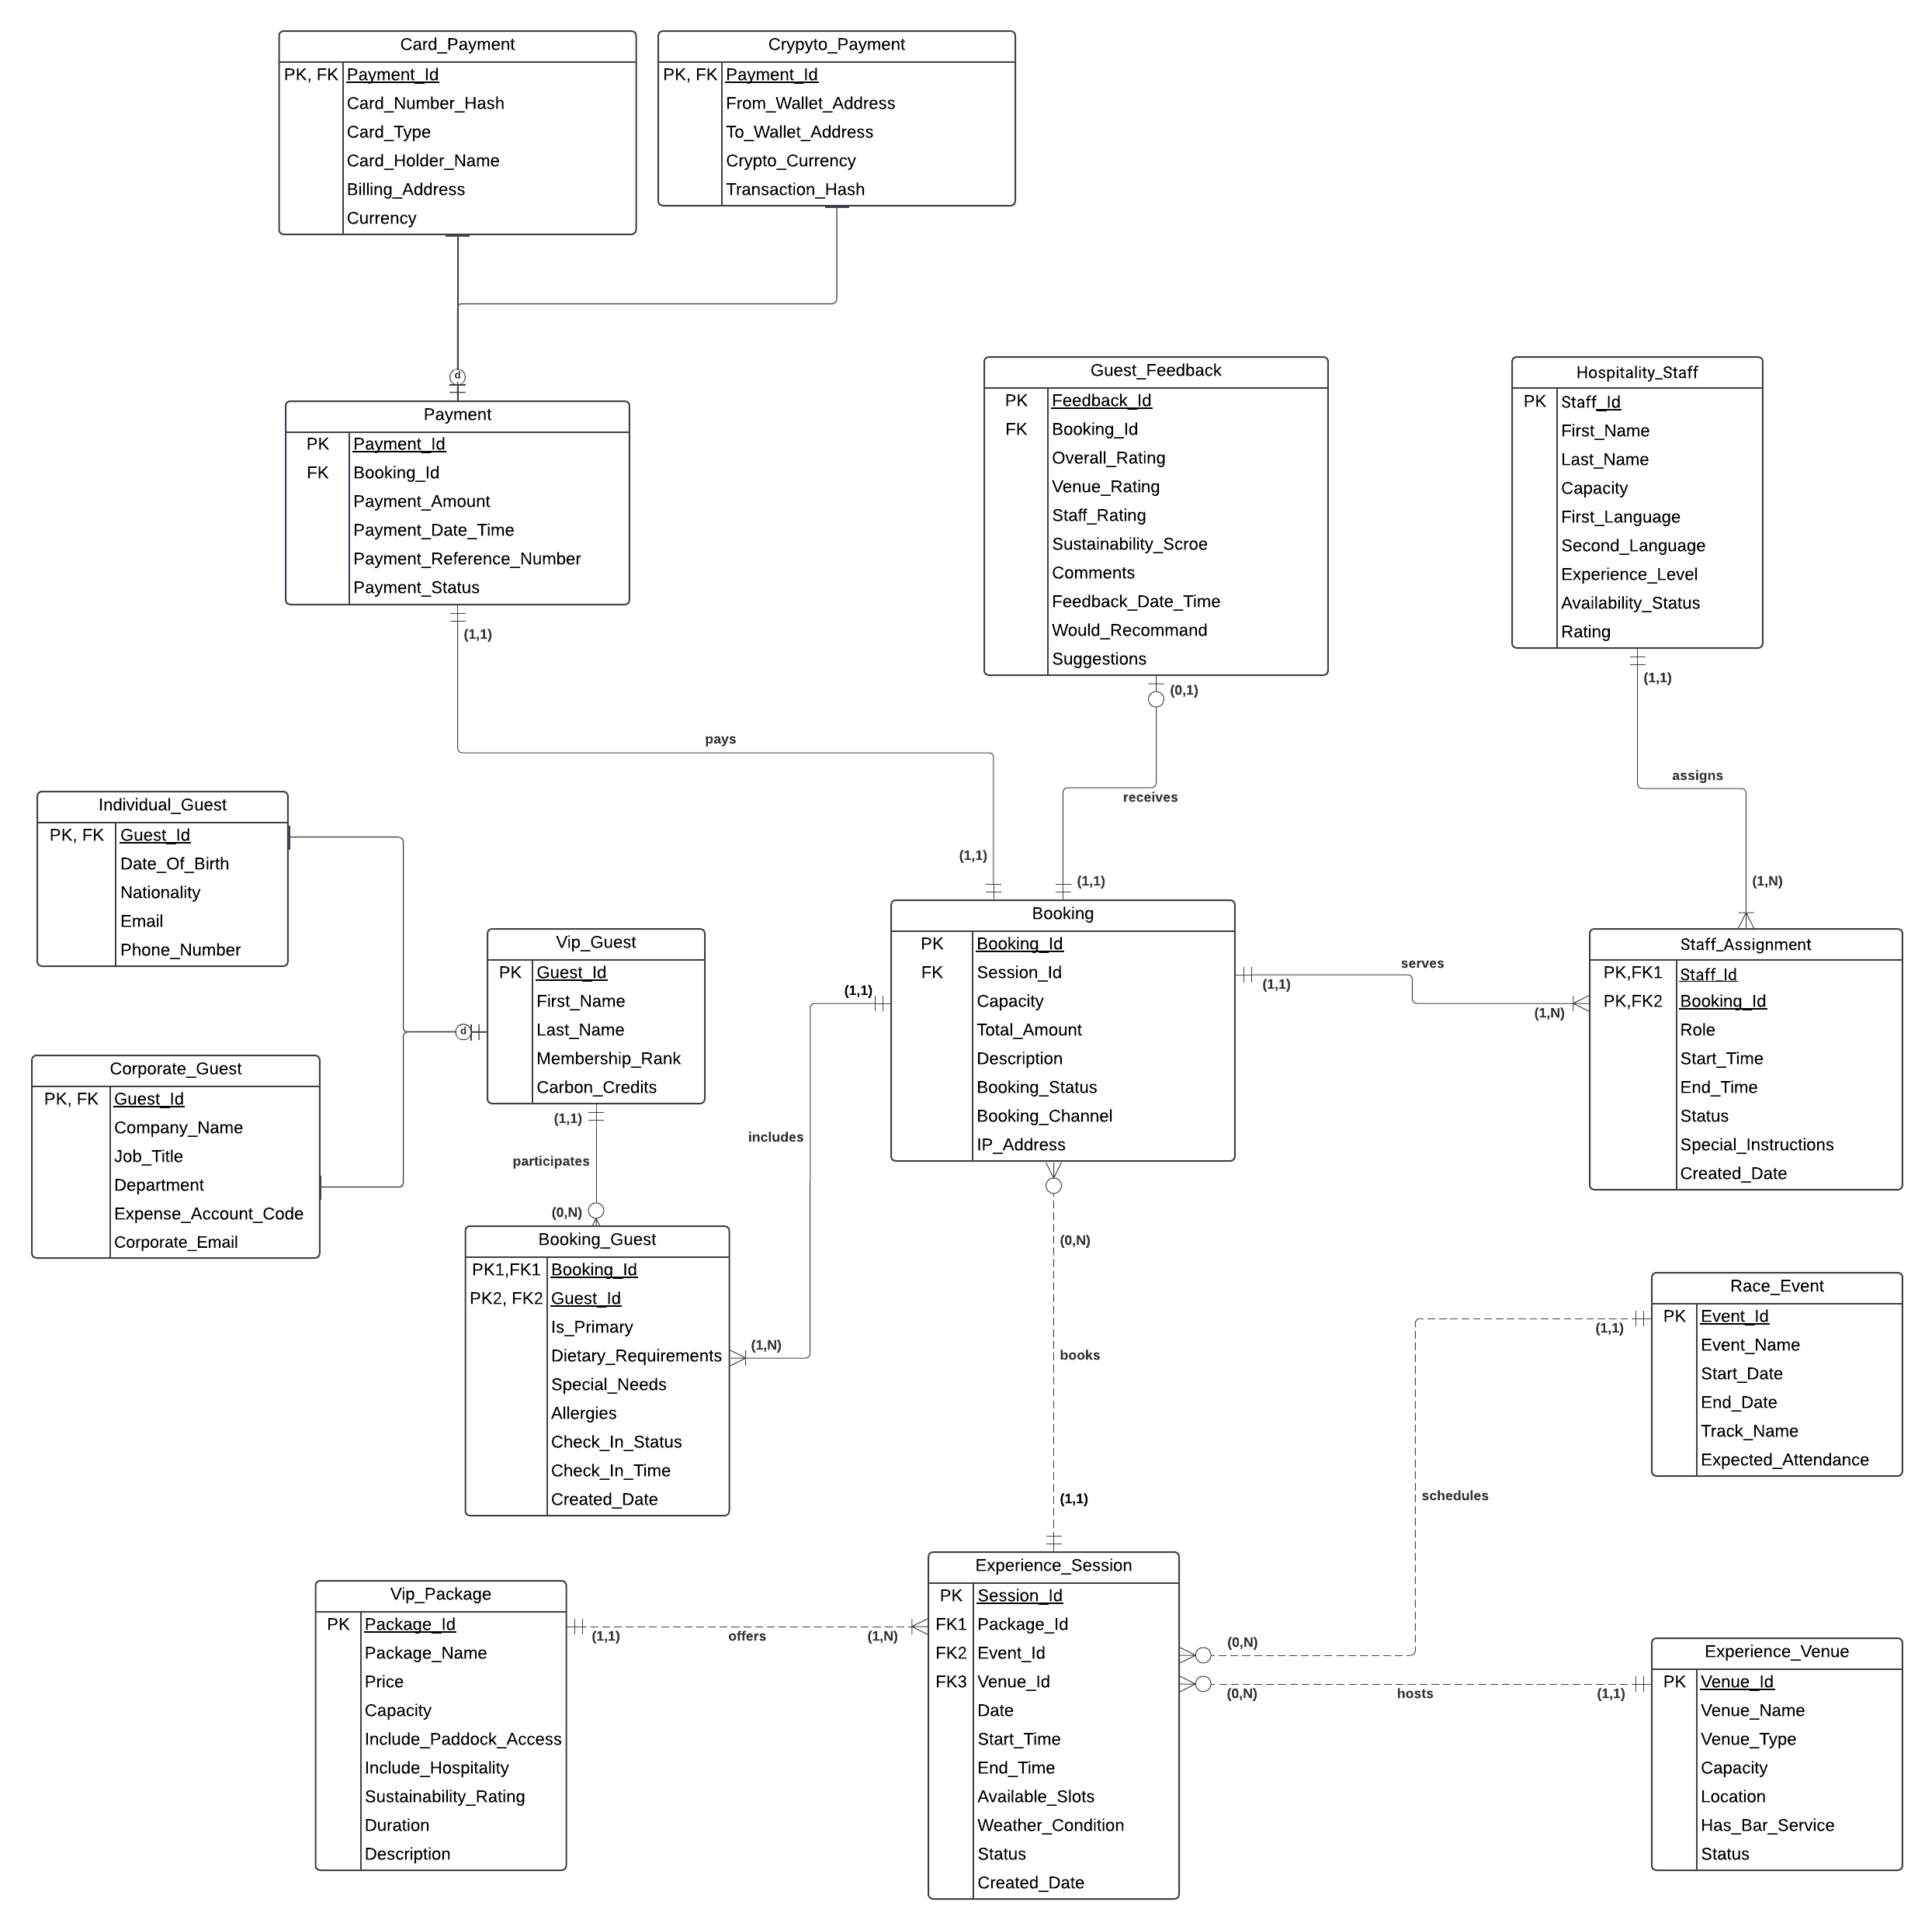
Figure1
1. Entity Design Justification
1.1 Core Business Entities
The system design starts with three core entities that serve as the foundation of the business.
Vip_Guest (primary key: Guest_Id) stores customer information, with the Membership_Rank attribute determining pricing tiers and service entitlements. Each guest may be associated with multiple bookings via the Booking_Guest table, creating a many-to-many relationship with the Booking entity. This setup supports group bookings while preserving individual preferences and requests.
To handle different customer types, Vip_Guest adopts a supertype/subtype structure: the supertype holds shared attributes, while subtypes capture specific details. Individual_Guest records personal information such as nationality, whereas Corporate_Guest manages company affiliations and expense accounts.
Vip_Package (primary key: Package_Id) defines the range of hospitality offerings, from standard to premium experiences. The key attribute Include_Paddock_Access introduces significant price differentiation (Formula.vegas, 2024). Each package is linked to multiple experience sessions.
Race_Event (primary key: Event_Id) represents all F1-EV race events. It is associated with zero or more Experience_Session records, allowing for flexible scheduling and event-specific pricing. Each Experience_Session must correspond to exactly one Race_Event, ensuring proper event management (f1experiences.com, n.d.).

1.2 Transactional Entities
While the core entities define the business structure, the following entities handle the dynamic aspects of customer interactions and bookings.
Booking (primary key: Booking_Id) links Vip_Guest through the Booking_Guest entity, and also connects to Experience_Session and Payment entities. While it includes foreign keys such as Session_Id, it maintains its own primary key to ensure flexibility in managing complex relationships.
Booking_Guest serves as an associative entity resolving the many-to-many relationship between VIP_Guest and Booking. Important attributes include Is_Primary, Dietary_Requiremrnts, Special_Needs, and guest status for each booking. This design supports group bookings and tracks individual guest requirements.
Experience_Session (primary key: Session_Id) represents an individual event session and manages specific time and venue allocations. It is associated with entities such as Race_Event, Experience_Venue, Vip_Package, and Booking, enabling capacity control and helping prevent overbooking—especially for limited premium experiences like paddock access. Each session can be associated with zero or more bookings.
Payment (primary key: Payment_Id) maintains a one-to-one relationship with Booking, ensuring financial traceability. It records details such as payment method, amount, reference number, status, and supports multiple currencies. Additionally, the entity adopts a hierarchical design to manage different payment methods (Formula.vegas, 2024). The supertype stores common transaction data, while the subtypes—Card_Payment and Crypto_Payment—capture method-specific information, in preparation for mixed payment models anticipated by 2030.
1.3 Operational Entities
Beyond transactions, the system also requires operational entities to support service delivery and quality management.
Experience_Venue (primary key: Event_Id) manages physical locations that can host multiple sessions, ranging from trackside suites to paddock areas, helping to improve venue utilization. By tracking capacity and availability status, the system can also prevent resource conflicts.
The many-to-many relationship between Hospitality_Staff and Booking is resolved through Staff_Assignment, which records role-specific details and enables multi-staff service delivery. This design supports language-based matching and skill-specific assignments.
Guest_Feedback (primary key: Feedback_Id) records post-experience evaluations with an optional one-to-one relationship to Booking. While feedback is not mandatory, it provides valuable insights for service improvement while respecting customer choice.

2. Interesting Design Aspects
Service quality loop: The system establishes a quality control mechanism through the integration of Staff_Assignment, Booking, and Guest_Feedback. By linking these entities, managers can identify high-rated bookings and staff, address service issues, and refine staff assignment strategies. This enhances overall service quality and enables personalized experiences for VIP guests (Jones, Byon and Huang, 2019).
Future-ready infrastructure: The system's support for crypto payments and digital verification prepares the platform for the technological landscape of 2030, while remaining compatible with traditional systems. The payment structure separates card and crypto transactions to ensure clarity and security. Card_Payment retains conventional payment information, with encrypted card numbers to enhance security. Crypto_Payment records wallet-related data, including From_Wallet_Address (sender’s wallet), To_Wallet_Address (F1-EV’s receiving wallet), transaction hashes, and cryptocurrency types (e.g., BTC, ETH). This design ensures that data from each payment method remains clean, organized, and traceable (Farawn et al., 2020).

3. Key Assumptions
The following assumptions are used in the ERD design:
• A newly registered VIP guest may not have any bookings yet, thus zero bookings is allowed.
• A booking can include multiple VIP guests (e.g. corporate group bookings), but only one guest under each booking_Id can be the main guest responsible for the booking, marked by Is_Primary in Booking_Guest table.
• Each guest must belong to individual or corporate type.
• Payment must be completed before booking is confirmed.
• Each booking can only have one payment, and refunds are handled by other system
• Booking cannot be transferred to others
• One experience session can only be at one venue
• All prices are in USD and converted when needed
• The system only supports the following payment methods:
• Card types: VISA, MASTERCARD, AMEX, DISCOVER
• Currencies for card payment: USD, EUR, GBP, AUD, CAD, CNY, JPY
• Cryptocurrencies: BTC, ETH, USDT, USDC
• Staff can be assigned to different bookings, and can only be assigned the following roles: WAITER, BARTENDER, HOST, SECURITY, CLEANER, OTHER
• Booking status is limited to: CONFIRMED, CANCELLED, PENDING, NO_SHOW
• Booking channel is limited to: ONLINE, PHONE, IN_PERSON, AGENCY, OTHER
• Check-in status is limited to: CHECKED_IN, NOT_ARRIVED, NO_SHOW
• Session status is limited to: SCHEDULED, IN_PROGRESS, COMPLETED, CANCELLED
• Venue status can only be AVAILABLE or UNAVAILABLE
• Binary options (Y/N) are used for: Is_Primary, Would_Recommed, Include_Paddock_Access, etc.
• All ratings use a 1-5 scale

II. SQL For F1-V1 Hospitality System Management
- Normalization Consideration and Table Constructions
All of the tables are designed in accordance with 3NF (V. Pang, 2024). In the Booking table, all attributes are fully dependent on the primary key Booking_Id, and there are no transitive dependencies between attributes. Aspects such as Sustainability_Rating, Booking_Status and Booking_Channel are directly related to each booking and do not depend on other attributes. The foreign key Session_Id is well-referenced to the table. Experience_Session and logically links booking to session. These structures help eliminate redundancy to ensure the schema is well-normalized.
We will use several tables as examples following to illustrate Table Constructions.
When creating tables, it is important to choose appropriate data types and apply constraints accordingly. For example, in the Booking table, using INT for the Booking_Capacity field is more precise than using NUM, as it clearly represents a whole number. Additionally, a constraint should be added to ensure that the capacity cannot be negative. For example, VIP_Package table is created as it contains the unique PK Package_ID，Individual_Guest and Corporate_Guest are created as second and third tables. They serve as sub-type tables for VIP_Package.
15 Tables are created. Each table contains their PK and FKs. Table Creation process follows the FK constraints logic.

- Data Constraints, Insertion logic
In this part, SQL data Insertion will be applied to demonstrate the demonstrating how data is entered and managed within the system. Data Insertion follows the foreign key constraints relationship. For the Tables created, VIP_Guest is populated with 30 real figures as a starting point. VIP_Guest works as super type of Individual_Guest and Corporate_Guest. Individual_Guest and Corporate_Guest are populated with each 15 data rows each to fulfill the amount number in VIP_Guest.. It specifies the columns wanted to retrieve and the table FROM Business School Pracle RDS which to retrieve them(Vincent, 2025).
Booking Table is populated with 30 rows of real data to match the VIP_Guest. It shows the overall booking situation for the event. Booking is the super-type of Booking_Guest. Booking_Guest contains 30 rows of real data to match Booking table, further include and explain the information for Booking process. Then, for the creation of Payment table,30 rows of data is populated to match the previous Booking table PK. Card_Payment and Crypto_Payment tables are sub-type tables of Payment, 15 rows of data are populated separately for these two tables, sequencing from P01 to P030.
For the Guest_Feedback table , constraints is made, 30 rows of data is populated to match the previous Booking table. For table Experience_Session, 30 rows of data also populated to match the previous Booking table. For table Staff_Assignment, 30 rows of data is populated to match the previous Booking table. For table Hosptaility_Staff, 30 rows of data also populated to match the previous Booking and Staff_Assignment tables. For table Race_Event, 10 rows of data is populated to fulfill the table, no matches needed. For table Experience_Venue, 10 rows of data is populated, no matches needed.

- Tables Query and Insights, recommendations
SQL Queries: Driving Data-Informed Decisions and Operational Optimization
To improve operational efficiency, accurately target customers, and build long-term services that align with business and sustainability goals, we wrote seven SQL queries with the following main objectives:
1. Data Sources and Support: These queries extract, analyze, and manipulate data from the database to support information acquisition, business decisions, and system functionality.
2. Core Analysis Areas: These queries primarily focus on analyzing guest behavior, venue utilization, member engagement, and market segmentation.
Query 1: Average Carbon Credits per Membership Rank
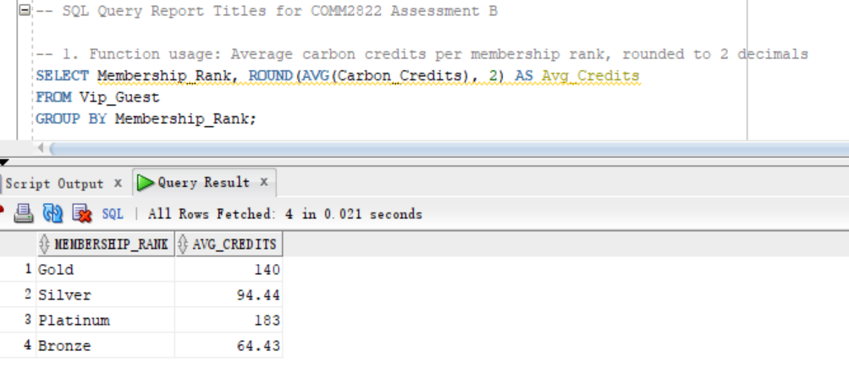Purpose: To compare environmental engagement levels by different membership tiers.
Insight: Platinum members hold the highest average carbon credits (183), and Gold (140), have stronger sustainability engagement among premium tiers.
Business Implication: These findings show that our premium members have strong sustainability engagement. By enhancing the sustainability of the event. The company can connect its environmental commitments with the event itself.

Query 2: Venue Types with Total Capacity Greater Than 100
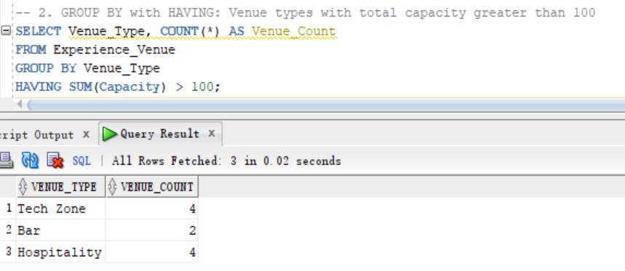
Purpose: The goal is to identify which types of venues have sufficient capacity to host large-scale VIP events.
Insight: By SQL query, Tech Zones and Hospitality venues are more suitable for premium audience experiences. This shows that these venues have an advantage in hosting capability.
Business Implication: Based on the high capacity of Tech Zones and Hospitality venues, they can be identified as prime locations for large exhibition such as corporate viewing parties, media briefings, or brand VIP receptions. Let these events in venues with large capacities provide more customer participation.

Query 3: Guests Whose Carbon Credits Exceed the Average
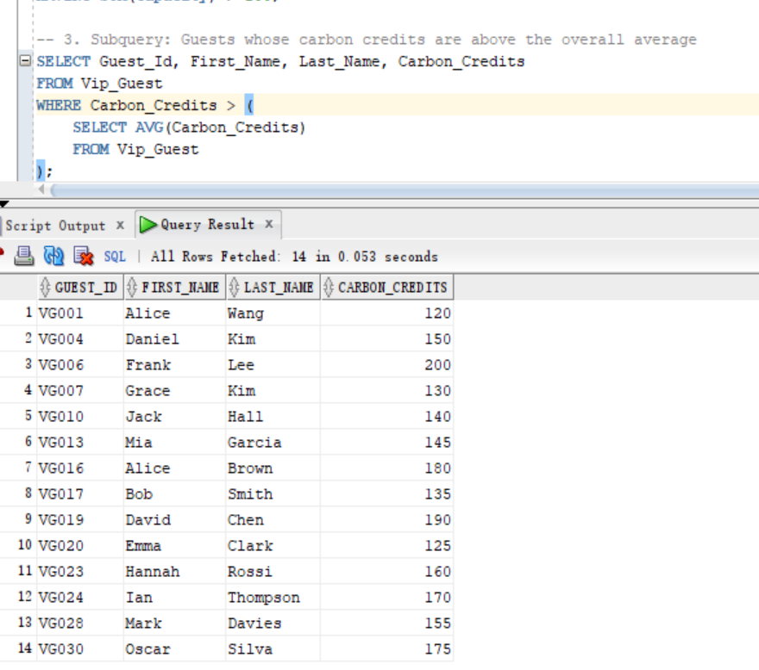Purpose: Based on guests' carbon credit scores, identify the guests who are most environmentally conscious.
Insight: Based on the query, 14 contestants achieved carbon credits that are higher than the average, with the highest reaching 200. This shows that those guests have a strong concern for environmental protection.
Business Implications: We can provide these contestants with organic food and low-carbon beverages, allowing them to enjoy the competition while also establishing our brand as highly connected to the environmental protection image.

Query 4: Global Market Insights and Localization Strategy
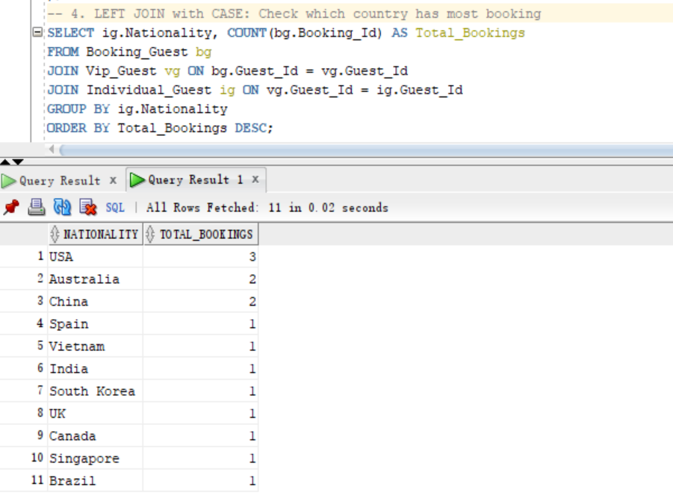Purpose: To identify which nationalities, contribute the most bookings to track global market interest.
Insight: The USA, Australia, and China have most bookings, showing these countries have a high interest in the F1 race.
Business Implication: These markets show significant growth potential and profitability. Therefore, we can focus our event resources and strategies on these countries to maximize our profit.
Query 5: Identify Guest Type for Each Booking
See the Appendix for complete query results
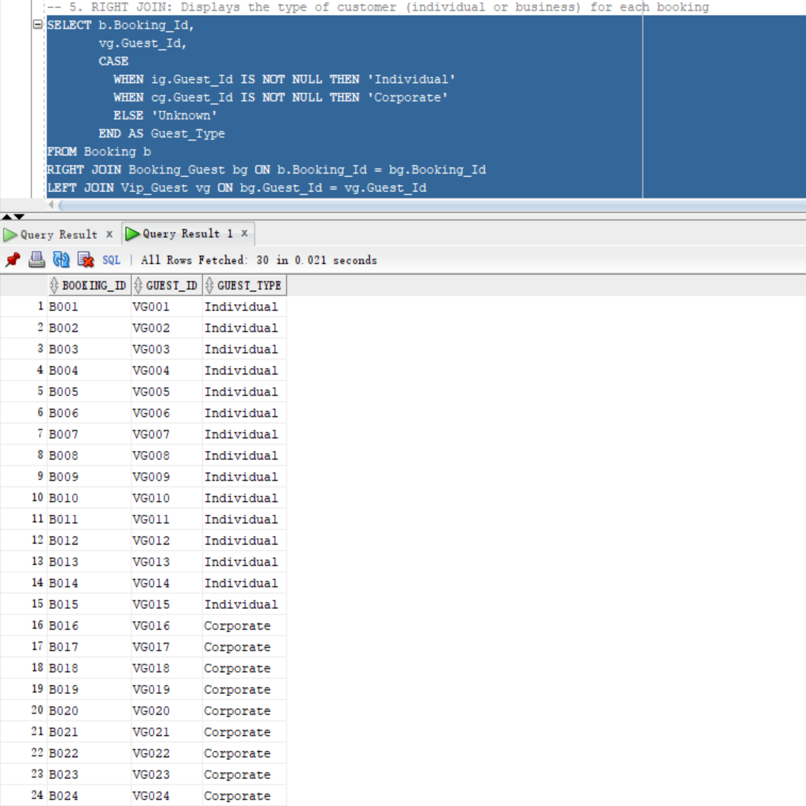Purpose: To classify bookings as being made by individual or corporate guests.
Insight: Bookings are evenly split between individual and corporate guests, which shows that both guests are glad to book the VIP services.
Business Implication: Our strategy is to distinguish between corporate and individual guests. For corporate clients, we will focus on providing sponsorship opportunities and providing brand-exclusive space for their business needs. For individual guests, the emphasis will be on exclusive viewing experiences and personalized hospitality. By identifying the corporate guest's identity, we can look for future collaboration.

Query 6: Available Venues with Bar Service by Location
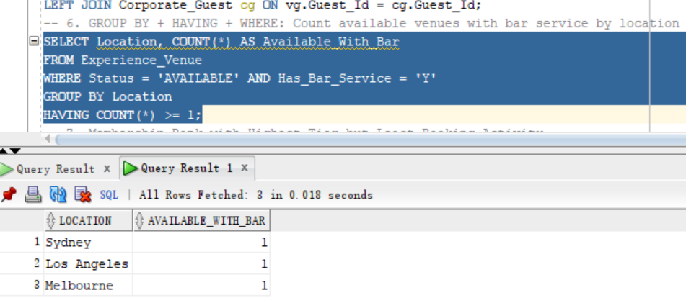Purpose: To identify geographic locations that offer available venues with premium bar service.
Insight: Sydney, Melbourne, and Los Angeles all have venues with bar services for premium event experiences.
Business Implication: These locations can be identified as Electric F1 afterparties or race networking events.

Query 7: Highest Membership Tier with Least Bookings
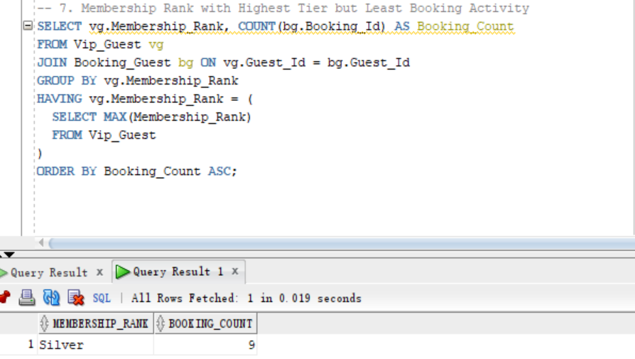Purpose: To assess the effectiveness of our VIP program by analyzing booking activity in our most exclusive membership tier.
Insight: Data indicates that Silver members, our highest-status tier, are the least active bookers. This lack of engagement suggests that the Silver/Gold VIP benefits are hard to attract Silver members to continue booking races to improve to Gold members.
Business Implication: This finding, we need to redesign the Slive/GoldVIP benefit to encourage our silver members to continue to rise. We must find out the root causes. The next step is to redesign our VIP benefits to stimulate the silver vip continue to rise the level.

Appendix
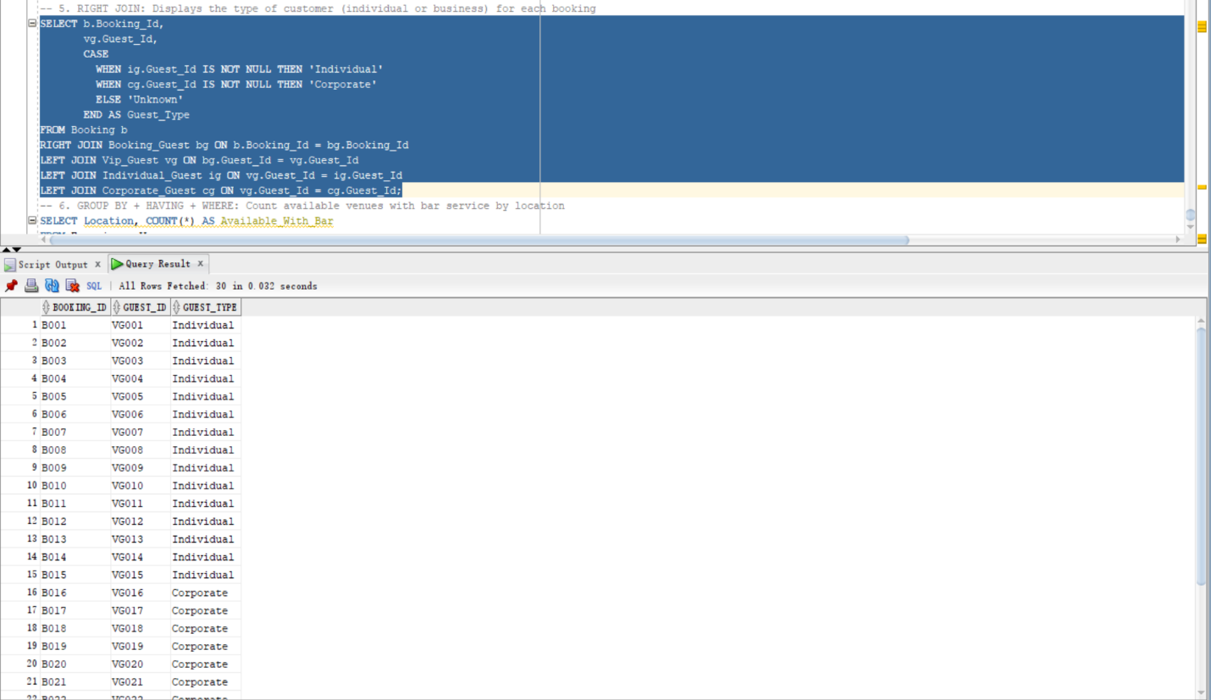
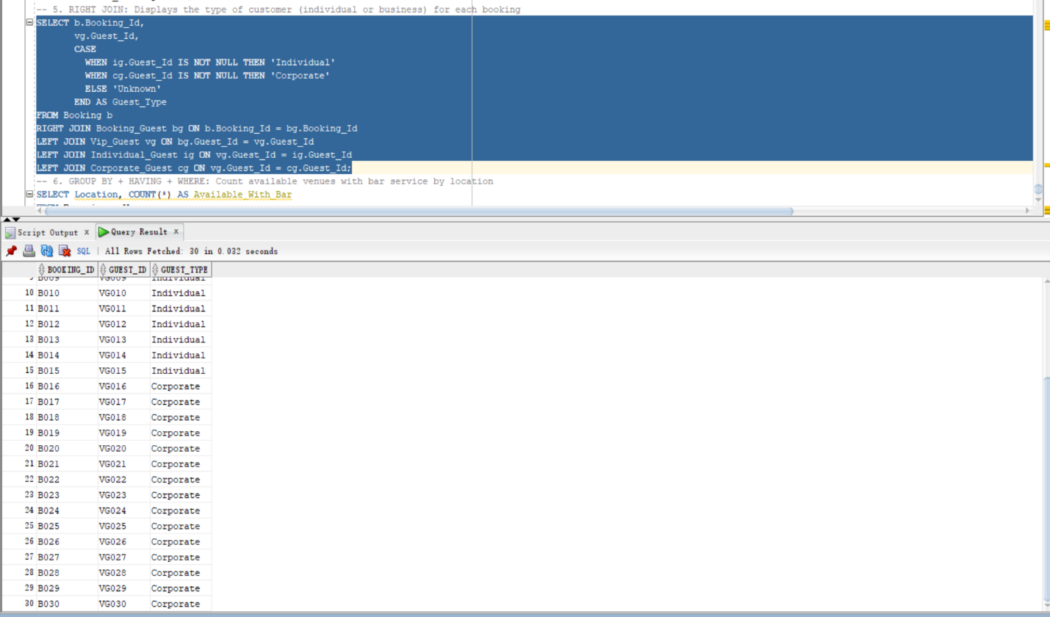

Reference list

- Formula.vegas. (2024). Formula 1 Las Vegas | Race Schedules, Tickets, Hotels, & More | Formula.Vegas. [online] Available at: https://www.formula.vegas/vip-packages.

- Jones, C., Byon, K. and Huang, H. (2019). Service Quality, Perceived Value, and Fan Engagement: Case of Shanghai Formula One Racing. Sport Marketing Quarterly, 28(2). doi:https://doi.org/10.32731/smq.282.062019.01.

- V. Pang, 2024, ‘Introduction to Business Databases Week: 04 Normalisation I’, COMM2822, Moodle, P43, accessed 2 Aug 2025, <INFS1603/ COMM1822>.

- Pang, Dr Vincent. “Introduction to Databases for Business Analytics Week: 08 Data Governance and Ethics.” Moodle, moodle.telt.unsw.edu.au/pluginfile.php/13572995/mod_resource/content/2/COMM2822%20T2%202025%20Week%2008%20Data%20Governance%20and%20Ethics.pdf. Accessed 5 Aug. 2025.

- Pang, Vincent. “Introduction to Databases for Business Analytics Week 03: Table Creation and Basic SQL Function.” Moodel, moodle.telt.unsw.edu.au/pluginfile.php/13572953/mod_resource/content/7/COMM2822%20T2%202025%20Week%20%2003%20Lab-Tutorial%20Bin%2001%20-%20Solution.pdf. Accessed 5 Aug. 2025.

