A SUMMER INTERNSHIP REPORT
ON
TEXAS STATE EMPLOYEE SALARY ANALYSIS AND PREDICTION USING MACHINE LEARNING
2-Month Summer Internship Report
submitted towards the partial fulfillment of the degree
Bachelor of Technology
By
CHINTAMANENI YESWANTH
23CS002808
Submitted to

Department of Computing and Informatics,
School of Engineering & Sciences,
Sir Padampat Singhania University,
Udaipur, 313601, Rajasthan, India
Internship Organization: SkillDzire | Role: Data Analyst Intern
Duration: 22-04-2026 to 22-06-2026 | Location: Hyderabad, India

DECLARATION
I, Chintamaneni Yeswanth, student of B.Tech. (Computer Science and Engineering – Data Science), hereby declare that the 2-Month Summer Internship project report titled “Texas State Employee Salary Analysis and Prediction Using Machine Learning” which is submitted by me to the Department of Computing and Informatics, School of Engineering & Sciences, Sir Padampat Singhania University, Udaipur, Rajasthan, is submitted towards the partial fulfillment of the requirement for the award of the degree of Bachelor of Technology, has not been previously formed the basis for the award of any degree, diploma or other similar title or recognition.
Name and signature of Student: Chintamaneni Yeswanth
Enrollment Number: 23CS002808
Place: Hyderabad, India
Date: 22-06-2026
CERTIFICATE
(Colored copy of the internship certificate is attached as Annexure - I)
This is to certify that the 2-Month Summer Internship project entitled ‘Texas State Employee Salary Analysis and Prediction Using Machine Learning’ being submitted by Chintamaneni Yeswanth (Enrollment Number: 23CS002808), submitted towards the partial fulfillment of the requirement for the award of the degree of Bachelor of Technology, has been carried out under supervision and guidance.
The matter embodied in this report has not been submitted, in part or in full, to any other university or institute for the award of any degree, diploma or certificate.
K. Asha Jyothi
Data Science Mentor, SkillDzire
Email: training1@skilldzire.com

Dr. Amit Kumar Goel
Professor and Dean
Department of Computing and Informatics,
School of Engineering & Sciences,
Sir Padampat Singhania University,
Udaipur, 313601, Rajasthan, India
ACKNOWLEDGEMENT
I would like to express my sincere gratitude to Sir Padampat Singhania University, the Department of Computing and Informatics, and the School of Engineering & Sciences for providing me the opportunity and the academic environment to undertake this 2-Month Summer Internship.
I am deeply thankful to my mentor, Dr. Harish Tiwari, Associate Professor, for his valuable guidance, constant support, and constructive feedback throughout the course of this internship. His insights into data analysis and machine learning greatly helped me in shaping this project.
I would also like to sincerely thank Dr. Amit Kumar Goel, Professor and Dean, for his encouragement and for facilitating the internship programme as part of the academic curriculum.
I extend my gratitude to SkillDzire for providing me with the internship opportunity, and to all the faculty members of the Department of Computing and Informatics for their academic support and guidance throughout this project.
I am also grateful to the open-source community and the developers of Python, Pandas, NumPy, SciPy, Matplotlib, Seaborn, and Scikit-learn, whose tools and libraries formed the technical foundation of this project.
Finally, I would like to thank my family and friends for their continuous support and encouragement during this internship.
Chintamaneni Yeswanth
(23CS002808)
ABSTRACT
Public-sector pay data offers a rich basis for studying how employment attributes relate to earnings. This report presents the work carried out during a 2-Month Summer Internship at SkillDzire, in which Texas state employee salary records were analysed and machine learning regression models were built to predict annual salary. The dataset contains 149,481 employee records. The methodology covered data inspection, quality checks, exploratory data analysis, date-feature engineering, one-hot encoding of ethnicity, gender and employment status, IQR-based outlier removal (leaving 136,596 records), an 80:20 train-test split and MinMax scaling.
The initial notebook model reported an R² of 1.0, which was traced to data leakage: the monthly salary column is exactly one-twelfth of the target, so the model had simply recovered the arithmetic relationship. After removing the leaking columns (MONTHLY, HRLY RATE) and the identifier STATE NUMBER, five regression models were compared: Linear Regression, Ridge Regression, Decision Tree, Random Forest and Gradient Boosting. On the held-out test set, Gradient Boosting performed best, with an R² of 0.414, an MAE of USD 7,998 and an RMSE of USD 10,908; Random Forest was virtually tied.
Exploratory analysis showed that exempt and unclassified regular full-time employees earn the highest average salaries, and that average salaries differ across agencies, ethnic groups and genders; these are descriptive, unadjusted differences and are not evidence of cause. The project demonstrates the full data science workflow and the importance of leakage detection. It is an academic demonstration and not a tool for real pay or employment decisions.
CONTENTS
DECLARATION i
CERTIFICATE ii
ACKNOWLEDGEMENT iii
ABSTRACT iv
LIST OF TABLES vi
LIST OF FIGURES vii
LIST OF ABBREVIATIONS viii
CHAPTER 1 INTRODUCTION 1
CHAPTER 2 LITERATURE REVIEW 3
CHAPTER 3 ORGANIZATION / TOOLS & TECHNOLOGY OVERVIEW 6
CHAPTER 4 METHODOLOGY / SYSTEM DESIGN 8
CHAPTER 5 IMPLEMENTATION 15
CHAPTER 6 RESULTS AND DISCUSSION 18
CHAPTER 7 TESTING AND VALIDATION 23
CHAPTER 8 CONCLUSION AND FUTURE SCOPE OF WORK 25
REFERENCES 27
ANNEXURE - I INTERNSHIP CERTIFICATE 28
ANNEXURE - II MONTHLY ATTENDANCE REPORT 28
ANNEXURE - III SUPERVISOR FEEDBACK FORM 28
ANNEXURE - IV PROJECT SCREENSHOTS 28
ANNEXURE - V IMPORTANT CODE / PROJECT STRUCTURE 31
LIST OF TABLES
Table 4.1 Dataset Feature Description 9
Table 4.2 Final Feature Set Used for Modelling 13
Table 6.1 Effect of Data Leakage on Linear Regression 18
Table 6.2 Regression Model Comparison on the Test Set (MAE, RMSE, R²) 18
Table 6.3 Training versus Test R² (Generalisation Check) 20
Table 7.1 Verification and Validation Checks 23
LIST OF FIGURES
Figure 4.1 Proposed System Architecture / Workflow Diagram 8
Figure 4.2 Distribution of Annual Salary 10
Figure 4.3 Average Annual Salary by Ethnicity 11
Figure 4.4 Average Annual Salary by Gender 11
Figure 4.5 Average Annual Salary by Employment Status 11
Figure 4.6 Annual Salary Box Plot Before Outlier Removal 12
Figure 4.7 Annual Salary Box Plot After Outlier Removal 13
Figure 6.1 Model R² Comparison 19
Figure 6.2 Model MAE Comparison 19
Figure 6.3 Model RMSE Comparison 20
Figure 6.4 Actual vs Predicted Annual Salary (Gradient Boosting) 21
Figure 6.5 Top Feature Importances (Random Forest) 21
LIST OF ABBREVIATIONS
ABBREVIATION | DESCRIPTION
ML | Machine Learning
EDA | Exploratory Data Analysis
MAE | Mean Absolute Error
MSE | Mean Squared Error
RMSE | Root Mean Squared Error
R² | Coefficient of Determination
IQR | Interquartile Range
OHE | One-Hot Encoding
CSV | Comma-Separated Values
USD | United States Dollar
CRF / CRP | Classified Regular Full-Time / Part-Time
CTF / CTP | Classified Temporary Full-Time / Part-Time
URF / URP | Unclassified Regular Full-Time / Part-Time
ERF / ERP | Exempt Regular Full-Time / Part-Time

Chapter - 1

INTRODUCTION

1.1 Background
Salaries paid by public institutions are a major component of government expenditure, and understanding how pay varies with employment status, agency, tenure and working hours is important for budgeting, workforce planning and transparency. With the growing availability of structured payroll records, data analysis and machine learning techniques can be used to uncover patterns in pay and to build models that estimate salary from employee attributes.
This report documents the work carried out during a 2-Month Summer Internship undertaken with SkillDzire, in the domain of Data Analysis and Data Science. The internship focused on applying data analysis and machine learning techniques to a real payroll dataset of Texas state employees. The work involved exploratory data analysis, preprocessing, feature engineering, training and comparing multiple regression algorithms, and identifying and correcting a data leakage problem that affected the first version of the model.

1.2 Problem Statement
Salary levels in a large public workforce depend on several interacting factors, such as the agency, the employment status (for example, classified, unclassified or exempt; full-time or part-time), the number of working hours and the date of joining. Manually studying these relationships across a hundred thousand or more records is impractical. There is a need for a data-driven approach that can summarise how salary differs across groups and provide an indicative estimate of annual salary from the available employee attributes. This project addresses that need by applying supervised regression algorithms to the Texas state employee salary dataset to predict the annual salary (the target variable, ANNUAL).

1.3 Aim of the Project
The aim of this project is to analyse Texas state employee salary data, to build and evaluate machine learning regression models that predict annual salary from employee attributes, and to ensure that the evaluation is trustworthy by detecting and removing any data leakage.

1.4 Objectives
- To perform data inspection, cleaning and exploratory data analysis on the salary dataset.
- To study how annual salary varies with agency, ethnicity, gender and employment status using statistical and visual analysis.
- To engineer date-based features, encode categorical variables, handle outliers and scale the data for modelling.
- To identify and remove features that leak information about the target variable.
- To implement and compare multiple regression algorithms: Linear Regression, Ridge Regression, Decision Tree, Random Forest and Gradient Boosting.
- To evaluate the models using MAE, RMSE and R², and to compare training and test performance to check generalisation.
- To select the best-performing model and summarise the key insights obtained from the data.

1.5 Scope of Work
The scope of this project is limited to a supervised regression task on a single dataset of 149,481 Texas state employee records. The work covers data preprocessing, exploratory analysis, model training, comparison and interpretation. Personal identifiers (names), job class codes and job titles were not used as model inputs. The scope does not include collection of new data, integration with payroll systems or deployment of a web application. Differences in average salary between groups reported in this work are descriptive and unadjusted; they must not be interpreted as evidence of discrimination or of causal effects. The project is intended as an academic demonstration of a data science workflow and not as a tool for making pay or employment decisions.

1.6 Expected Outcome
At the end of the internship, the expected outcome is a cleaned and well-understood dataset, a validated comparison of regression models for annual salary prediction, a clear list of the factors that matter most, and documented lessons about data leakage and honest model evaluation.
Chapter - 2

LITERATURE REVIEW

2.1 Machine Learning for Regression
Regression is a supervised learning approach in which a model learns to predict a continuous numerical value, such as a salary, price or temperature, from input features, using labeled training examples. Regression is widely used in finance, real estate, operations and human-resources analytics. Popular regression algorithms include linear models, regularised linear models, decision trees, ensemble methods such as Random Forest and Gradient Boosting, and instance-based and kernel methods.

2.2 Salary Analysis and Prediction
Salary analysis typically studies how pay depends on factors such as role, seniority, employment type, location and working hours. Predictive models built on such data can support budgeting, benchmarking and workforce planning, and exploratory analysis can help organisations understand pay structures. Such models are decision-support tools: they summarise patterns in historical data but do not explain the reasons behind pay differences, and they can reproduce historical inequities if used carelessly.

2.3 The Salary Dataset
The dataset used in this project contains Texas state government employee payroll records stored in a CSV file with 149,481 rows and 21 columns. Each row describes one employment record with the agency, name, class code and title, ethnicity, gender, employment status, employment date, hourly rate, hours per week, monthly salary and annual salary. Five additional metadata columns (duplicated, multiple_full_time_jobs, combined_multiple_jobs, summed_annual_salary and hide_from_search) are populated for only a few hundred records and flag employees holding more than one job.

2.4 Regression Algorithms Used
2.4.1 Linear Regression
Linear Regression models the target as a weighted sum of the input features and estimates the weights by minimising the sum of squared errors. It is simple, fast and interpretable, and serves as a standard baseline. It can only capture linear relationships between features and the target.
2.4.2 Ridge Regression
Ridge Regression extends Linear Regression with an L2 penalty on the size of the coefficients. This regularisation reduces the variance of the estimates and helps when features are correlated, such as the one-hot encoded columns used in this project.
2.4.3 Decision Tree
A Decision Tree regressor splits the feature space into regions using a sequence of if-then rules and predicts the average target value within each region. Trees can capture non-linear relationships and interactions without feature scaling, but a deep tree can overfit the training data, so the depth is usually limited.
2.4.4 Random Forest
Random Forest is an ensemble of many decision trees, each trained on a random sample of the data and features, whose predictions are averaged. Averaging reduces variance and overfitting compared with a single tree, and the model provides feature-importance scores.
2.4.5 Gradient Boosting
Gradient Boosting builds trees sequentially, where each new tree is fitted to the errors (residuals) of the ensemble built so far. This often yields accurate models for tabular data, although the model has more hyperparameters and is less directly interpretable than a single tree or a linear model.

2.5 Evaluation Metrics for Regression
Mean Absolute Error (MAE) is the average absolute difference between predicted and actual values and is expressed in the units of the target (USD). Mean Squared Error (MSE) is the average of squared differences and penalises large errors more strongly; Root Mean Squared Error (RMSE) is its square root, again in USD. The coefficient of determination (R²) measures the share of the variance of the target explained by the model: a value of 1 means perfect prediction, 0 means no better than predicting the mean, and negative values mean worse than the mean.

2.6 Data Leakage
Data leakage occurs when the model is given information during training that would not be available when making real predictions, or that is a direct arithmetic transformation of the target. Leakage produces unrealistically high scores that do not reflect real performance. Typical examples are including the target in another form (such as monthly pay when predicting annual pay) or fitting preprocessing steps on test data. Detecting leakage requires examining suspiciously perfect results and the relationships between features and the target.

2.7 Research/Project Gap
Many introductory salary-prediction exercises train a single model and report the resulting score without checking whether the inputs trivially determine the target. This project addresses that gap, within a limited academic scope, by comparing five regression algorithms on a consistent preprocessing pipeline, by explicitly diagnosing and documenting a leakage problem, and by reporting realistic performance together with a training-versus-test comparison.

2.8 Summary
This chapter reviewed the concepts of regression, the five algorithms and the evaluation metrics used in the project, and introduced the dataset and the concept of data leakage. The following chapters describe the internship organisation, the methodology, the implementation and the results.
Chapter - 3

ORGANIZATION / TOOLS & TECHNOLOGY OVERVIEW

3.1 Internship Organization – SkillDzire
The internship was undertaken with SkillDzire, an organization that provides structured short-term and summer internship programmes for engineering and computer science students, with a focus on practical, project-based learning in domains such as data science, data engineering and software development.

3.2 Internship Role – Data Analysis
The role undertaken during the internship was that of a Data Analyst Intern, with a focus on the Data Science & Data Engineering track. The work involved analysing a structured payroll dataset, performing exploratory data analysis, preparing data for modelling and applying machine learning regression techniques.

3.3 Internship Duration
The internship was carried out over a period of two months, from 22-04-2026 to 22-06-2026.

3.4 Internship Location
The internship was carried out from Hyderabad, India.

3.5 Mentor Information
The project was carried out under the guidance of Dr. Harish Tiwari, Associate Professor, whose supervision and feedback shaped the direction and quality of the project. Dr. Amit Kumar Goel, Professor and Dean, Department of Computing and Informatics, provided academic oversight for the internship as part of the university curriculum.

3.6 Tools and Technologies
The project was implemented entirely in Python, using data analysis, visualization and machine learning libraries, with Jupyter Notebook for interactive development. A brief overview of each tool is provided below.

3.7 Python
Python was the primary programming language, owing to its readability and extensive ecosystem of data science libraries.

3.8 Pandas
Pandas was used for loading, inspecting, cleaning and transforming the tabular dataset, including date parsing, column selection, missing-value and duplicate checks, and concatenation of encoded features.

3.9 NumPy
NumPy provided efficient numerical operations, used for computing RMSE and for array handling inside other libraries.

3.10 SciPy
SciPy’s statistics module was used to compute z-scores while exploring outliers in the hourly rate and weekly hours columns.

3.11 Matplotlib and Seaborn
Matplotlib was used for static visualizations such as histograms, box plots and bar charts, and Seaborn, built on top of it, for statistically informative plots such as distribution plots, bar plots and scatter plots.

3.12 Scikit-learn
Scikit-learn provided the machine learning functionality: train_test_split, OneHotEncoder, MinMaxScaler, the five regression algorithms and the evaluation metrics (MAE, MSE, R²).

3.13 Jupyter Notebook
The data analysis and model development workflow was carried out in a Jupyter Notebook (TEXAS_ESP.ipynb), enabling an iterative, cell-by-cell approach to exploration, modelling and evaluation.

3.14 Project Structure
The project is organised as follows:
- dataset/salary.csv – the Texas state employee salary dataset.
- notebooks/TEXAS_ESP.ipynb – the Jupyter Notebook containing the analysis and model development workflow.
- salary_analysis_corrected.py – the corrected, reproducible script that generates the results and figures reported here.

3.15 Summary
This chapter described the internship organization, role, duration, location and mentors, and gave an overview of the tools used and the project structure. The next chapter presents the methodology adopted for the project.
Chapter - 4

METHODOLOGY / SYSTEM DESIGN

4.1 Proposed System
The proposed system follows a standard supervised machine learning regression pipeline. The raw employee records are cleaned and explored, transformed into a numerical feature matrix, checked for data leakage and then used to train several regression models. The models are compared on a held-out test set using MAE, RMSE and R², and the best-performing model is selected.

4.2 System Architecture
The overall workflow of the project, from the raw data to the final model selection, is illustrated in Figure 4.1.
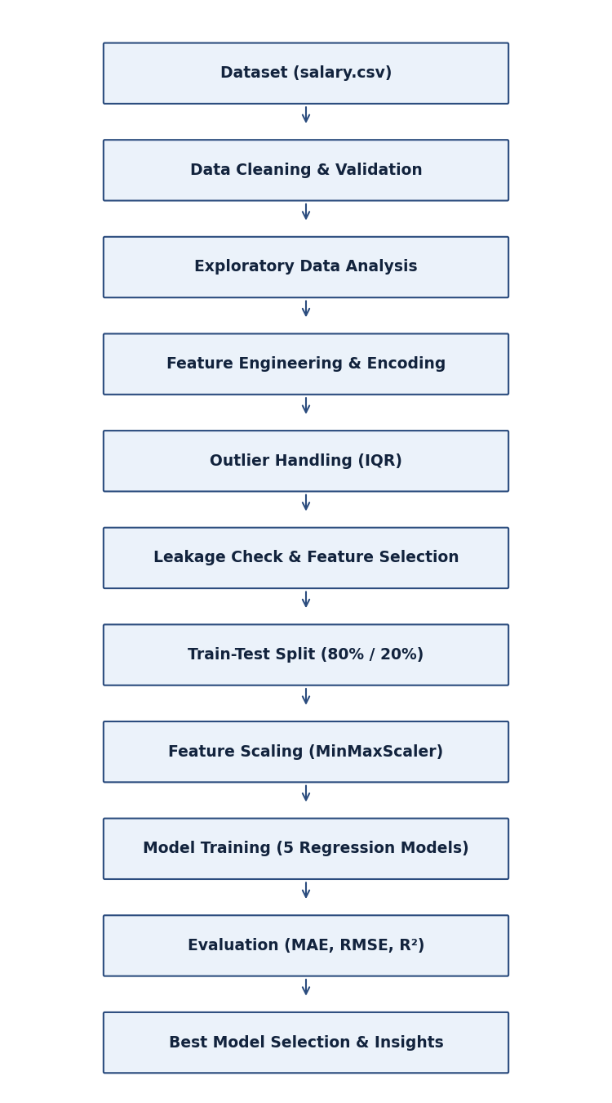
Figure 4.1: Proposed System Architecture / Workflow Diagram

4.3 Dataset Description
The project uses the Texas state employee salary dataset, stored as salary.csv, with 149,481 records and 21 columns. After removing metadata, identifier and leaking columns, the model uses 24 numerical input features derived from six original attributes. Zero duplicate rows were found in the working columns, and the 16 core columns contain no missing values.

4.4 Dataset Features
The columns of the dataset and their treatment in this project are described in Table 4.1.
Table 4.1: Dataset Feature Description
# | Column | Description | Treatment
1 | AGENCY | Numeric code of the state agency | Used as numeric input
2 | AGENCY NAME | Name of the agency | Dropped (duplicates code)
3 | LAST NAME / FIRST NAME / MI | Employee name fields | Dropped (identifiers)
4 | CLASS CODE / CLASS TITLE | Job class code and title | Dropped (high cardinality)
5 | ETHNICITY | Ethnic group (6 categories) | One-hot encoded
6 | GENDER | Male or Female | One-hot encoded
7 | STATUS | Employment status (11 categories) | One-hot encoded
8 | EMPLOY DATE | Date of employment | Split into year, month, day
9 | HRLY RATE | Hourly rate (zero for most records) | Dropped (leaks target)
10 | HRS PER WK | Working hours per week | Used as numeric input
11 | MONTHLY | Monthly salary (USD) | Dropped (leaks target)
12 | ANNUAL | Annual salary (USD) | Target variable
13 | STATE NUMBER | Employee identifier | Dropped (identifier)
14 | Five metadata columns | duplicated, multiple_full_time_jobs, combined_multiple_jobs, summed_annual_salary, hide_from_search | Dropped (mostly empty)

4.5 Target Variable
The target variable is ANNUAL, the annual salary in USD. Before outlier removal it has a mean of USD 50,714.21, a median of USD 44,642.04, a standard deviation of USD 25,117.34, a minimum of USD 600.00 and a maximum of USD 553,500.00. The distribution is strongly right-skewed, as shown in Figure 4.2.
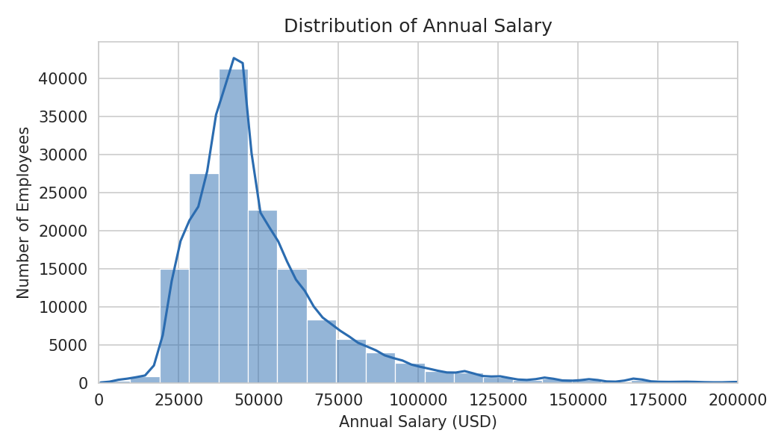
Figure 4.2: Distribution of Annual Salary

4.6 Data Preprocessing
Data preprocessing involved loading the dataset with Pandas, inspecting its structure and data types, trimming extra whitespace in the text columns, and dropping columns that are not suitable as model inputs. Five metadata columns that are almost entirely empty were removed, as were the name fields, the agency name, the job class code and title, and later the employee identifier. The employment date was converted to a datetime type and split into year, month and day features.
Correction of two-digit years
The EMPLOY DATE column stores years with two digits (for example, 02/18/88). When parsed without an explicit format, eight records with hire years between 1968 and 1975 were interpreted as 2068–2075, which is impossible and is visible as isolated points in the notebook’s employment-year plot. In the corrected pipeline the dates are parsed with an explicit format and any year later than 2026 is shifted back by 100 years, giving a valid range of 1968 to 2020.

4.7 Data Quality Analysis
A data quality check using df.isnull().sum() showed zero missing values in the 16 core columns, and df.duplicated().sum() returned zero duplicate rows after the metadata columns were removed. The metadata columns contain missing values for all but a few hundred records (for example, the duplicated column is empty for 149,338 records) because they only flag employees with more than one job.

4.8 Exploratory Data Analysis
Exploratory Data Analysis was carried out to understand the distribution of the numerical variables and how annual salary varies with agency, ethnicity, gender and employment status. The dataset is dominated by classified regular full-time employees (CRF), who make up 95.33% of all records. Average annual salary by ethnicity is shown in Figure 4.3 and by gender in Figure 4.4.
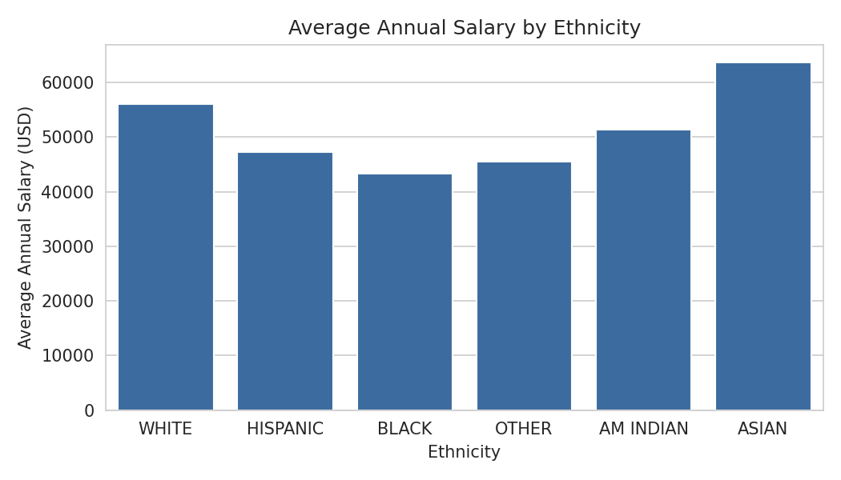
Figure 4.3: Average Annual Salary by Ethnicity
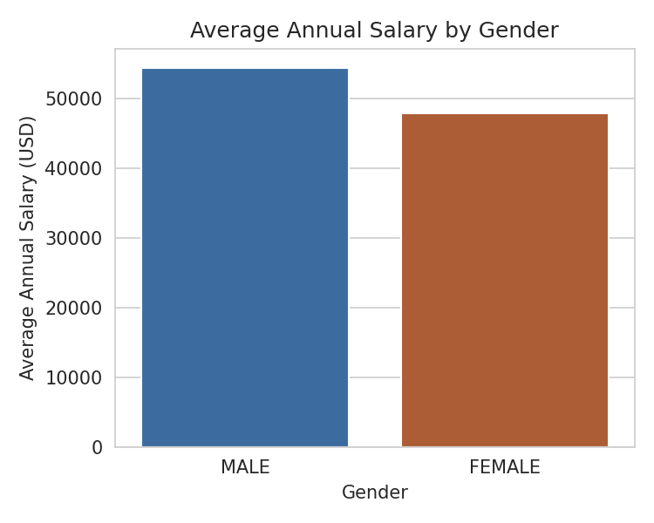
Figure 4.4: Average Annual Salary by Gender
Figure 4.5 shows the average annual salary for each employment status. Exempt regular full-time (ERF) employees have by far the highest average salary, followed by unclassified regular full-time (URF) and unclassified regular part-time (URP) employees, while temporary and part-time classified statuses have the lowest averages.
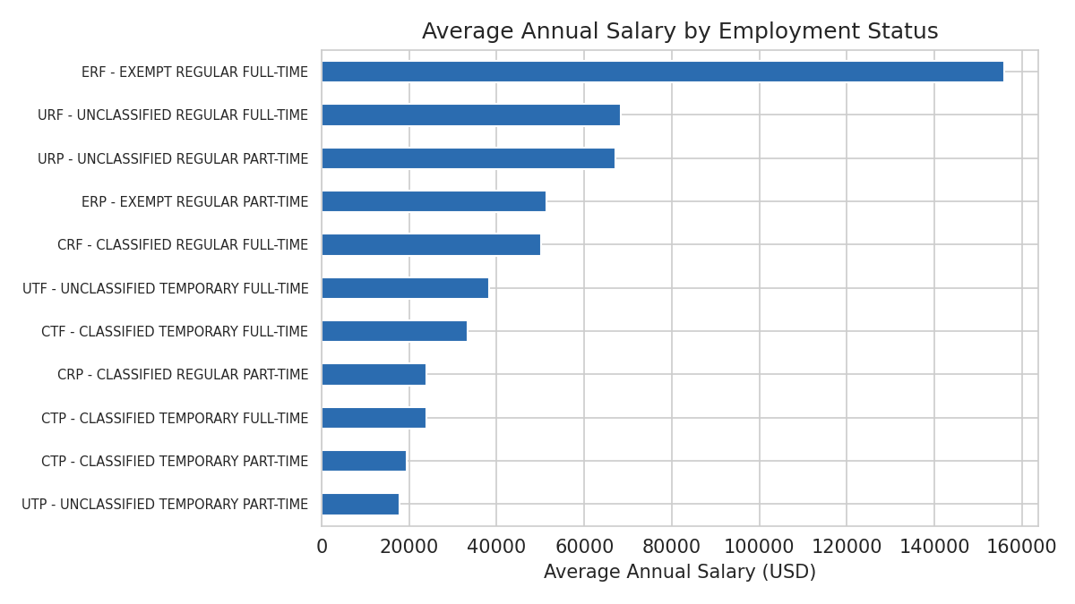
Figure 4.5: Average Annual Salary by Employment Status

4.9 Feature Engineering
The employment date was decomposed into three numerical features (EMPLOY DATE YEAR, EMPLOY DATE MONTH and EMPLOY DATE DAY), allowing the models to use tenure-related information. The year is a proxy for length of service.

4.10 Encoding of Categorical Variables
The categorical columns ETHNICITY (6 categories), GENDER (2 categories) and STATUS (11 categories) were converted to numerical form using scikit-learn’s OneHotEncoder with handle_unknown set to ignore, producing 19 binary columns. The AGENCY column was kept as a numeric code.

4.11 Outlier Handling
Salary distributions contain a small number of very high earners. Outliers in MONTHLY and ANNUAL were removed using the interquartile range rule, retaining values between Q1 − 1.5×IQR and Q3 + 1.5×IQR. This removed 12,885 records (8.62%), leaving 136,596 records, in which annual salary ranges from USD 7,800 to USD 83,594 with a mean of USD 45,100.94. Z-scores for HRLY RATE and HRS PER WK were also explored in the notebook but were not applied to the final dataset. Figures 4.6 and 4.7 show the annual salary box plot before and after outlier removal.
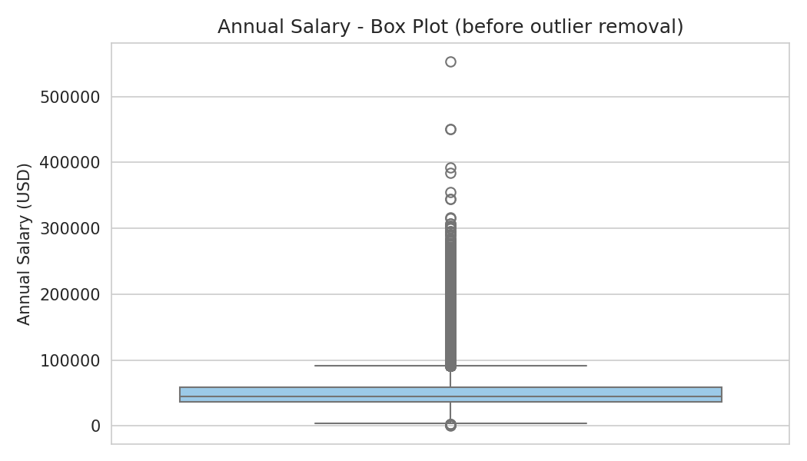
Figure 4.6: Annual Salary Box Plot Before Outlier Removal
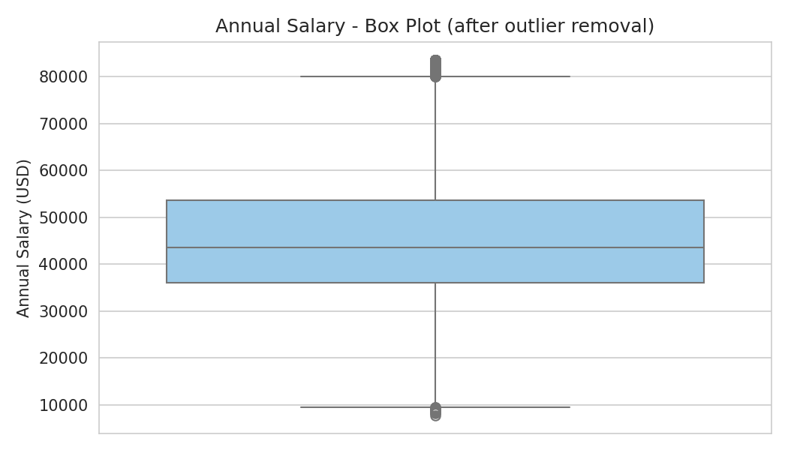
Figure 4.7: Annual Salary Box Plot After Outlier Removal
Removing the upper tail makes the model focus on the typical salary range, but it also means that the model is not designed to predict very high salaries such as those of exempt senior positions.

4.12 Data Leakage Identification and Feature Selection
The first version of the notebook trained Linear Regression on all remaining columns (27 features) and reported an R² of 1.0 with an error of the order of 10⁻¹⁰ USD on both the training and test sets. Such a result is not plausible for real payroll data and indicated leakage. Checking the ratio ANNUAL / MONTHLY showed that it equals exactly 12.0 for every one of the 149,481 records (correlation 1.0000), and in the fitted model the MONTHLY coefficient dominated all others. The hourly rate also determines pay for the few hourly employees, and STATE NUMBER is only an identifier. These three columns were therefore removed from the model inputs, leaving 24 features, listed in Table 4.2.
Table 4.2: Final Feature Set Used for Modelling
Feature group | Count | Columns
Numeric | 2 | AGENCY, HRS PER WK
Date-derived | 3 | EMPLOY DATE YEAR, EMPLOY DATE MONTH, EMPLOY DATE DAY
Ethnicity (one-hot) | 6 | American Indian, Asian, Black, Hispanic, Other, White
Gender (one-hot) | 2 | Female, Male
Employment status (one-hot) | 11 | CRF, CRP, CTF, CTP (full-time), CTP (part-time), ERF, ERP, URF, URP, UTF, UTP
Total | 24

4.13 Train-Test Split
The data were split into training and testing subsets using an 80:20 ratio with scikit-learn’s train_test_split function, with test_size = 0.20 and random_state = 42. This gave 109,276 records for training and 27,320 records for testing.

4.14 Feature Scaling
MinMaxScaler from scikit-learn was used to rescale the features to the range 0 to 1 for the linear models (Linear Regression and Ridge Regression). The scaler was fitted on the training data only and then used to transform the test data, which avoids leakage from the test set. The tree-based models are insensitive to feature scale and were trained on the unscaled features.

4.15 Machine Learning Model Development
Five regression algorithms were implemented on the same training split: Linear Regression, Ridge Regression (alpha = 1.0), Decision Tree (max_depth = 10), Random Forest (100 trees, max_depth = 15) and Gradient Boosting (150 estimators, max_depth = 5). Hyperparameters were set to reasonable fixed values and were not tuned.

4.16 Model Evaluation Metrics
Each model was evaluated on the held-out test set using MAE, RMSE and R². The same metrics were also computed on the training set to detect overfitting.

4.17 Model Selection
Model selection was based on test-set R² and RMSE, with the gap between training and test scores used as a check for overfitting.

4.18 System Limitations
The models use only a limited set of employee attributes. Job class and title, which are likely to explain a large part of pay, were excluded because of their very high number of categories. The performance figures are based on a single train-test split without cross-validation, and the hyperparameters were not tuned. The dataset reflects one workforce at one point in time, so the results may not generalise to other settings.

4.19 Summary
This chapter presented the architecture and methodology, covering data preprocessing, exploratory analysis, feature engineering, outlier handling, leakage identification, splitting, scaling and model development. The following chapter describes the implementation in more detail.
Chapter - 5

IMPLEMENTATION

5.1 Dataset Loading
The dataset was loaded into a Pandas DataFrame at the start of the notebook:
df = pd.read_csv('salary.csv')

5.2 Data Inspection
The structure of the data was inspected using df.head(), df.info(), df.describe() and df.isnull().sum(), confirming 149,481 rows and 21 columns.

5.3 Exploratory Data Analysis Implementation
EDA was implemented using Matplotlib and Seaborn. A representative example is the plot of average annual salary by ethnicity:
sns.barplot(x='ETHNICITY', y='ANNUAL', data=df)
plt.show()

5.4 Data Cleaning
Duplicates were checked and the sparse metadata columns were dropped. The employment date was converted to a datetime and decomposed (with the two-digit-year correction described in Section 4.6):
df = df.drop(columns=['duplicated','multiple_full_time_jobs',
'combined_multiple_jobs','summed_annual_salary',
'hide_from_search'])
df['EMPLOY DATE'] = pd.to_datetime(df['EMPLOY DATE'], format='%m/%d/%y')
future = df['EMPLOY DATE'].dt.year > 2026
df.loc[future,'EMPLOY DATE'] -= pd.DateOffset(years=100)
df['EMPLOY DATE YEAR'] = df['EMPLOY DATE'].dt.year
df['EMPLOY DATE MONTH'] = df['EMPLOY DATE'].dt.month
df['EMPLOY DATE DAY'] = df['EMPLOY DATE'].dt.day

5.5 Dropping Identifier and Descriptive Columns
df = df.drop(columns=['EMPLOY DATE','LAST NAME','FIRST NAME',
'AGENCY NAME','MI','CLASS CODE','CLASS TITLE'])

5.6 Encoding Categorical Data
from sklearn.preprocessing import OneHotEncoder
OHE = OneHotEncoder(handle_unknown='ignore', sparse_output=False)\
.set_output(transform='pandas')
enc = OHE.fit_transform(df[['ETHNICITY','GENDER','STATUS']])
df = pd.concat([df.drop(columns=['ETHNICITY','GENDER','STATUS']), enc], axis=1)

5.7 Outlier Handling
for col in ['MONTHLY','ANNUAL']:
Q1, Q3 = df[col].quantile(0.25), df[col].quantile(0.75)
IQR = Q3 - Q1
df = df[(df[col] >= Q1 - 1.5*IQR) & (df[col] <= Q3 + 1.5*IQR)]

5.8 Feature Preparation and Leakage Removal
The original notebook separated the target by dropping only ANNUAL, so the MONTHLY column remained as an input. The corrected version also removes the leaking and identifier columns:
# original (leaky): X = df.drop('ANNUAL', axis=1)
X = df.drop(columns=['ANNUAL','MONTHLY','HRLY RATE','STATE NUMBER'])
y = df['ANNUAL']

5.9 Train-Test Split and Scaling
from sklearn.model_selection import train_test_split
from sklearn.preprocessing import MinMaxScaler
X_train, X_test, y_train, y_test = train_test_split(
X, y, test_size=0.2, random_state=42)
scaler = MinMaxScaler()
X_train_scaled = scaler.fit_transform(X_train)
X_test_scaled = scaler.transform(X_test)

5.10 Linear and Ridge Regression
from sklearn.linear_model import LinearRegression, Ridge
lin = LinearRegression().fit(X_train_scaled, y_train)
ridge = Ridge(alpha=1.0).fit(X_train_scaled, y_train)

5.11 Decision Tree
from sklearn.tree import DecisionTreeRegressor
tree = DecisionTreeRegressor(max_depth=10, random_state=42)
tree.fit(X_train, y_train)

5.12 Random Forest
from sklearn.ensemble import RandomForestRegressor
rf = RandomForestRegressor(n_estimators=100, max_depth=15,
n_jobs=-1, random_state=42)
rf.fit(X_train, y_train)

5.13 Gradient Boosting
from sklearn.ensemble import GradientBoostingRegressor
gb = GradientBoostingRegressor(n_estimators=150, max_depth=5,
random_state=42)
gb.fit(X_train, y_train)

5.14 Model Evaluation
from sklearn.metrics import mean_absolute_error, mean_squared_error, r2_score
pred = gb.predict(X_test)
mae = mean_absolute_error(y_test, pred)
rmse = np.sqrt(mean_squared_error(y_test, pred))
r2 = r2_score(y_test, pred)

5.15 Model Comparison
The evaluation results of all five models were consolidated and compared side by side. The complete results are presented in Table 6.2 in Chapter 6.

5.16 Summary
This chapter presented the key implementation steps, from loading the dataset through preprocessing, leakage removal, model training and evaluation. The results are discussed in the next chapter.
Chapter - 6

RESULTS AND DISCUSSION

6.1 The Data Leakage Finding
The first experiment reproduced the original notebook: Linear Regression on all 27 features. As shown in Table 6.1, it achieved an R² of 1.0 and an MAE below 10⁻⁹ USD on both the training and the test sets. After removing MONTHLY, HRLY RATE and STATE NUMBER, the same algorithm achieved a test R² of 0.224 and an MAE of USD 9,900. The perfect score of the first experiment therefore reflected the identity ANNUAL = 12 × MONTHLY and not genuine predictive ability, and the corrected scores are the ones that should be used.
Table 6.1: Effect of Data Leakage on Linear Regression
Experiment | Features | Test R² | Test MAE (USD) | Test RMSE (USD)
With MONTHLY, HRLY RATE, STATE NUMBER (original) | 27 | 1.0000 | < 0.000000001 | < 0.000000001
Without leaking columns (corrected) | 24 | 0.2236 | 9,899.52 | 12,554.66

6.2 Model Performance
All five regression models were trained on the same training split (109,276 records) and evaluated on the same held-out test set (27,320 records). The complete comparison is presented in Table 6.2.
Table 6.2: Regression Model Comparison on the Test Set
Model | MAE (USD) | RMSE (USD) | R²
Gradient Boosting | 7,997.85 | 10,907.55 | 0.4139
Random Forest | 7,853.62 | 10,934.97 | 0.4110
Decision Tree | 8,071.19 | 11,113.33 | 0.3916
Linear Regression | 9,899.52 | 12,554.66 | 0.2236
Ridge Regression | 9,900.39 | 12,554.72 | 0.2236

6.3 R² Comparison
Gradient Boosting achieved the highest R² (0.4139), marginally ahead of Random Forest (0.4110) and Decision Tree (0.3916). The linear models were clearly weaker, with an R² of about 0.224, indicating that the relationship between the features and salary is non-linear. Figure 6.1 presents the comparison.
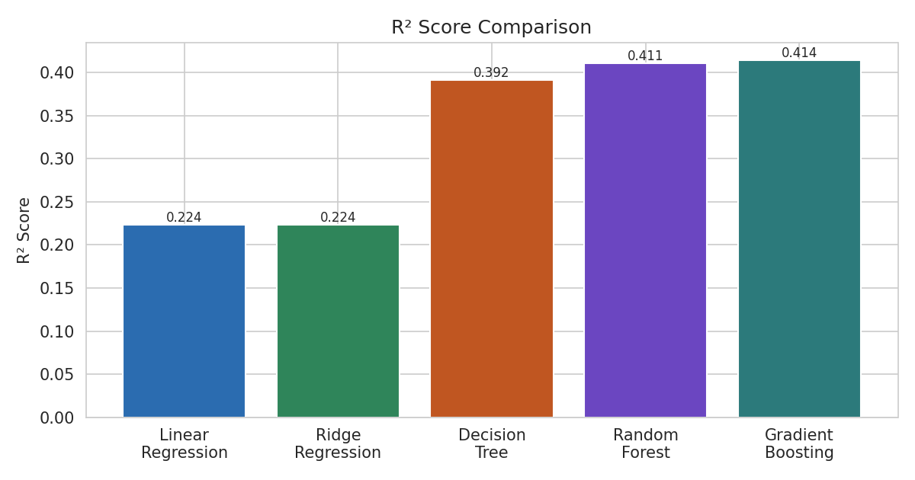
Figure 6.1: Model R² Comparison

6.4 MAE Comparison
Random Forest recorded the lowest MAE (USD 7,853.62), followed by Gradient Boosting (USD 7,997.85) and Decision Tree (USD 8,071.19). The linear models had MAEs of roughly USD 9,900. Figure 6.2 presents the comparison.
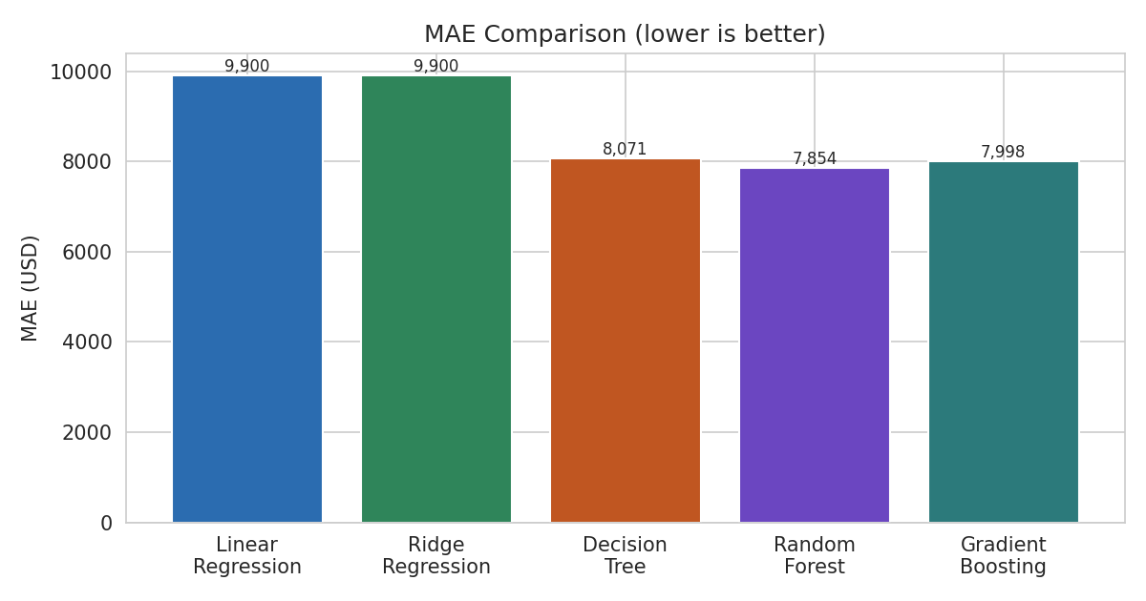
Figure 6.2: Model MAE Comparison

6.5 RMSE Comparison
Gradient Boosting recorded the lowest RMSE (USD 10,907.55), slightly better than Random Forest (USD 10,934.97). Because RMSE penalises large errors more than MAE, this suggests that Gradient Boosting makes fewer very large errors. Figure 6.3 presents the comparison.
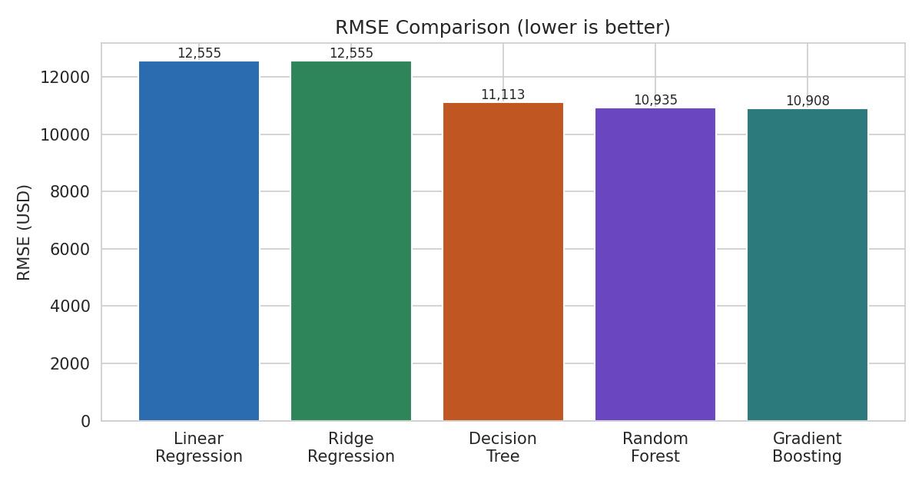
Figure 6.3: Model RMSE Comparison

6.6 Generalisation Check
Table 6.3 compares R² on the training and test sets. Random Forest shows a large gap (0.545 on training versus 0.411 on test), which is a sign of overfitting. Gradient Boosting, with the settings used, shows a very small gap (0.424 versus 0.414), and the linear models are essentially identical on both sets, so these models generalise consistently.
Table 6.3: Training versus Test R² (Generalisation Check)
Model | Train R² | Test R² | Gap
Gradient Boosting | 0.4245 | 0.4139 | 0.0105
Random Forest | 0.5449 | 0.4110 | 0.1339
Decision Tree | 0.4204 | 0.3916 | 0.0287
Linear Regression | 0.2244 | 0.2236 | 0.0008
Ridge Regression | 0.2243 | 0.2236 | 0.0007

6.7 Best Model Selection
Gradient Boosting was selected as the best model. It achieved the highest test R² (0.4139), the lowest RMSE (USD 10,907.55) and a very small train-test gap. It should be noted that its advantage over Random Forest is very small (a difference of about 0.0030 in R²), and Random Forest has a slightly lower MAE, so the two are practically equivalent in accuracy; Gradient Boosting was preferred because it overfits less. The models explain about 41% of the variation in salary: the typical prediction error is about USD 7,998, against a mean salary of USD 45,101 in the modelled data. The scatter of predicted versus actual salary is shown in Figure 6.4.
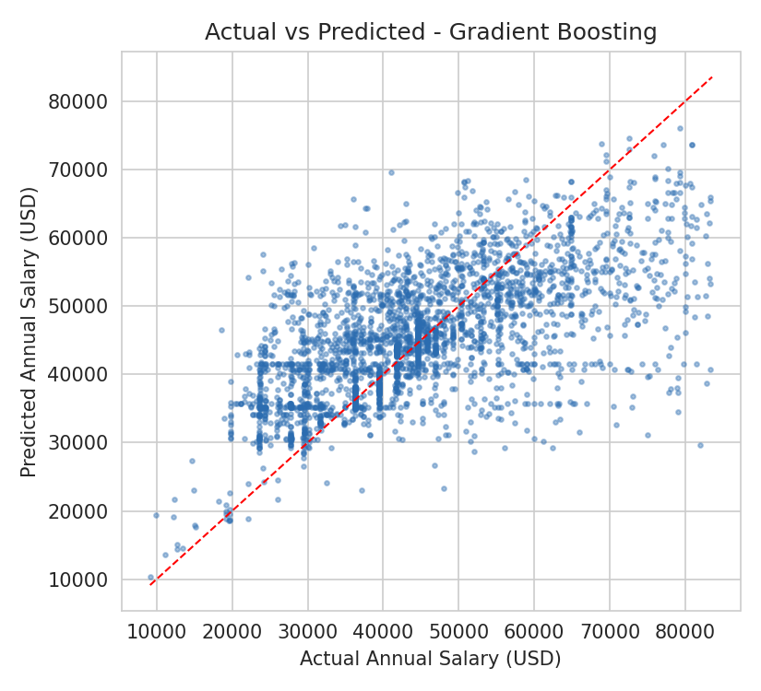
Figure 6.4: Actual vs Predicted Annual Salary (Gradient Boosting)
The vertical stripes in the plot show that many employees share the same few salary values (for example, fixed pay-scale steps), which the available features cannot separate; this is one reason why predictions fall into horizontal bands.

6.8 Feature Importance
The feature importances of the Random Forest model (Figure 6.5) show that the agency (0.320) and the employment year (0.315) are the most influential inputs, followed by the day and month of employment and the weekly hours. The day and month of employment have no real-world reason to affect pay and probably act as additional ways for the trees to separate individual employees; their importance should therefore be interpreted with caution. Gender and ethnicity indicators have comparatively low importance once agency and tenure are accounted for.
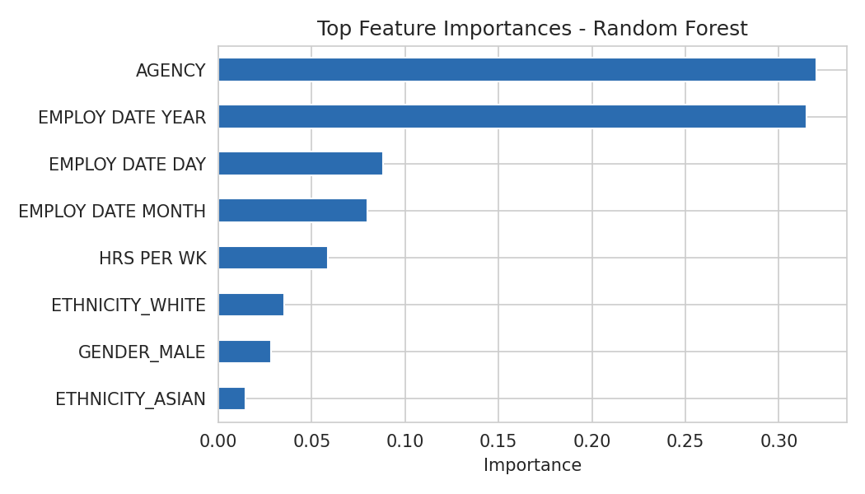
Figure 6.5: Top Feature Importances (Random Forest)

6.9 Insights from the Exploratory Analysis
The exploratory analysis produced the following observations on the full dataset, all of which are unadjusted averages:
- Employment status: exempt regular full-time (ERF) employees have the highest average annual salary (USD 155,908), followed by URF (USD 68,287) and URP (USD 67,191). Classified regular full-time employees, who form the large majority, average USD 50,076.
- Ethnicity: average annual salary is highest for Asian employees (USD 63,711) and White employees (USD 56,058), and lowest for Black employees (USD 43,245).
- Gender: male employees average USD 54,459 compared with USD 47,899 for female employees, a difference of about 13.7%. Female employees are the larger group (85,328 versus 64,153 records).
- Agency: annual salary differs noticeably from one agency to another, and agency is the most important input of the tree-based models.
These group differences are not adjusted for job type, agency, status or tenure, which differ between groups, so they describe the data and do not by themselves show why pay differs or whether any pay practice is unfair. A proper study of pay equity would require adjusting for these factors.

6.10 Discussion of Results
The results show that the tree-based ensemble models predict salary noticeably better than the linear models on this dataset, which is consistent with salary depending on agency and status in a non-linear way. At the same time, the overall level of explained variance (about 41%) shows that the available attributes are not enough to predict an individual salary accurately; the excluded job class and title, which define the position and its pay grade, are likely to carry much of the missing information. The most important result of the project is methodological: an apparently perfect model turned out to be an arithmetic identity, and finding this changed the conclusion from a meaningless R² of 1.0 to a realistic one.

6.11 Limitations of Results
The reported metrics are based on a single train-test split without cross-validation, with fixed untuned hyperparameters, and after removal of high-salary outliers, so they apply to the typical salary range only. The results describe one workforce at one point in time.

6.12 Summary
This chapter presented the leakage finding and the comparison of five regression models. Gradient Boosting was selected as the best model with a test R² of 0.414, an MAE of USD 7,998 and an RMSE of USD 10,908. The next chapter describes the verification and validation checks.
Chapter - 7

TESTING AND VALIDATION

7.1 Testing Strategy
Because this project is an analysis and modelling workflow and not a deployed application, testing focused on verifying the data, the pipeline and the validity of the evaluation. Three levels were covered: data quality checks, pipeline checks (including the leakage check), and checks of model performance and generalisation.

7.2 Notebook Testing
Each cell of the Jupyter Notebook was executed sequentially, and intermediate outputs (dataset shape, missing-value counts, duplicate counts, column lists and evaluation metrics) were inspected at each stage to confirm that the pipeline behaved as expected. The corrected pipeline was additionally re-implemented as a single script to confirm that the results can be reproduced from the raw CSV file.

7.3 Leakage Test
A perfect R² on the first run triggered a leakage investigation. The ratio between the target and each numeric feature was examined, which showed that ANNUAL is exactly 12 times MONTHLY for all records. This test caught the most important defect of the original notebook, and the model was re-evaluated without the leaking columns.

7.4 Model Testing
Each of the five models was tested on the held-out test set, and MAE, RMSE and R² were computed as presented in Chapter 6. The random seed (random_state = 42) was fixed for the train-test split and for all models that use randomness, so that the results are reproducible.

7.5 Validation Checks
Table 7.1 summarises the verification and validation checks performed.
Table 7.1: Verification and Validation Checks
ID | Check | Expected result | Observed result | Status
V01 | Missing values in the core columns | None | 0 missing values | PASS
V02 | Duplicate rows after dropping metadata | None | 0 duplicates | PASS
V03 | Employment date parsing | Valid dates up to 2026 | 8 hire years misread as 2068–2075 by default parsing; corrected | FIXED
V04 | Relationship between features and target | No feature that is a direct multiple of the target | ANNUAL = 12 × MONTHLY for all records; R² = 1.0 observed | FIXED
V05 | Test score after correction | Plausible, below 1 | Gradient Boosting test R² = 0.414 | PASS
V06 | Train versus test gap (selected model) | Small gap | R² 0.424 (train) vs 0.414 (test) | PASS
V07 | Overfitting check for all models | Small gap | Random Forest gap = 0.134; others ≤ 0.029 | NOTED

7.6 Limitations
Formal unit testing frameworks and k-fold cross-validation were not used in this project; testing was carried out through notebook execution, scripted checks and inspection of outputs. Automated tests and testing on additional data were outside the scope of this internship.

7.7 Summary
This chapter described the verification and validation carried out for the project, including the leakage test that corrected the original results and the checks of data quality and generalisation. The final chapter presents the conclusion and future work.
Chapter - 8

CONCLUSION AND FUTURE SCOPE OF WORK

8.1 Conclusion
This internship project analysed 149,481 Texas state employee salary records and built regression models to predict annual salary. The first model reported a perfect R² of 1.0, which was traced to data leakage: the monthly salary is exactly one-twelfth of the target. After removing the leaking columns, five algorithms were compared, and Gradient Boosting performed best, with an R² of 0.414, an MAE of USD 7,998 and an RMSE of USD 10,908 on the test set, with Random Forest almost equal. The exploratory analysis showed that employment status and agency are strongly associated with salary. The project demonstrates that careful validation is as important as model building.

8.2 Skills and Learning Outcomes
The internship provided practical, hands-on experience in:
- Data analysis and cleaning using Pandas, including date handling and the detection of parsing errors.
- Exploratory data analysis and visualization using Matplotlib and Seaborn.
- Feature engineering, one-hot encoding, outlier handling and scaling.
- Applying and comparing multiple regression algorithms using Scikit-learn.
- Evaluating models with MAE, RMSE and R², and comparing training and test scores.
- Recognising and fixing data leakage, and reporting results honestly.
- Understanding the end-to-end data science project workflow.

8.3 Internship Experience
The 2-Month Summer Internship with SkillDzire provided a structured, project-based environment in which to apply classroom knowledge of data science and machine learning to a large, realistic dataset. Guidance from the mentor helped in refining the approach to preprocessing and model evaluation, and the discovery of the leakage problem was a valuable lesson in questioning results that look too good.

8.4 Future Scope of Work
- Including job class code and title with suitable encoding (for example, target or frequency encoding or grouping) to capture the position and pay grade.
- Applying k-fold cross-validation for a more robust estimate of performance.
- Performing systematic hyperparameter tuning for each algorithm.
- Modelling the logarithm of salary to handle skewness, and modelling the high-salary tail separately instead of removing it.
- Removing or replacing the day and month of employment with tenure in years.
- Using explainability techniques such as SHAP to understand individual predictions.
- Carrying out a carefully adjusted pay-equity analysis before drawing any conclusions about group differences.
- Packaging the final model in a simple web application for interactive use.

8.5 Final Summary
In conclusion, this project provided a comprehensive, hands-on introduction to applying machine learning to a real payroll dataset, from exploration to model comparison, and reinforced the importance of careful preprocessing, leakage detection and honest reporting of results. The resulting analysis is an educational demonstration and should not be used for real pay or employment decisions.

REFERENCES
[1] Texas State Employee Salary Dataset (salary.csv), Texas state government employee payroll records used as the project dataset.
[2] Scikit-learn Developers, “scikit-learn: Machine Learning in Python,” scikit-learn documentation. [Online]. Available: https://scikit-learn.org/stable/documentation.html
[3] Pandas Development Team, “pandas documentation,” pandas.pydata.org. [Online]. Available: https://pandas.pydata.org/docs/
[4] NumPy Developers, “NumPy documentation,” numpy.org. [Online]. Available: https://numpy.org/doc/
[5] SciPy Developers, “SciPy documentation,” docs.scipy.org. [Online]. Available: https://docs.scipy.org/doc/scipy/
[6] J. D. Hunter, “Matplotlib: A 2D Graphics Environment,” Computing in Science & Engineering, vol. 9, no. 3, pp. 90–95, 2007.
[7] M. L. Waskom, “seaborn: statistical data visualization,” Journal of Open Source Software, vol. 6, no. 60, p. 3021, 2021.
[8] J. H. Friedman, “Greedy Function Approximation: A Gradient Boosting Machine,” The Annals of Statistics, vol. 29, no. 5, pp. 1189–1232, 2001.
[9] L. Breiman, “Random Forests,” Machine Learning, vol. 45, no. 1, pp. 5–32, 2001.
ANNEXURE
Annexure - I: Internship Certificate
The colored copy of the official SkillDzire internship completion certificate, issued to Chintamaneni Yeswanth for the Data Science & Data Engineering short-term internship programme (duration: 22-04-2026 to 22-06-2026, Certificate ID: 79lnp6aach), is attached below.

Annexure I: SkillDzire Internship Completion Certificate
Annexure - II: Monthly Attendance Report
[Attach approved monthly attendance report here]
Annexure - III: Supervisor Feedback Form
[Attach supervisor feedback form with required signature/stamp here]
Annexure - IV: Project Screenshots
The following pages present representative screenshots of the exploratory data analysis and preprocessing outputs generated in the Jupyter Notebook (TEXAS_ESP.ipynb).
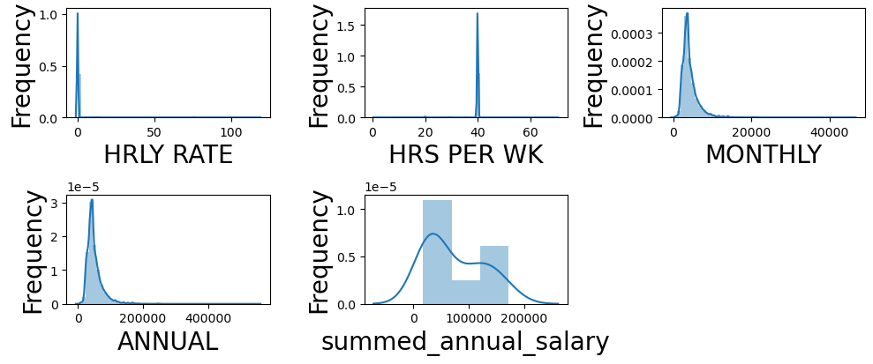
Distribution of Continuous Variables
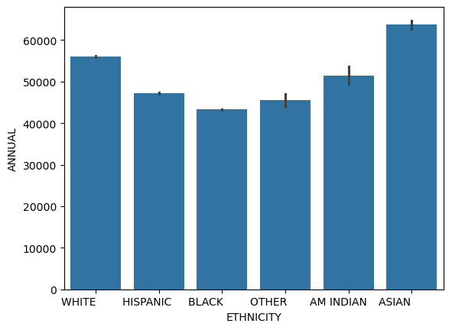
Ethnicity vs Annual Salary
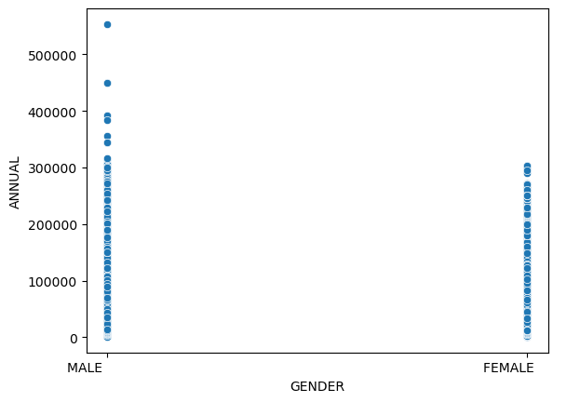
Gender vs Annual Salary
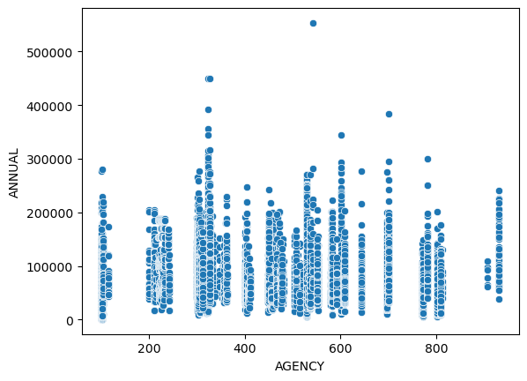
Agency vs Annual Salary
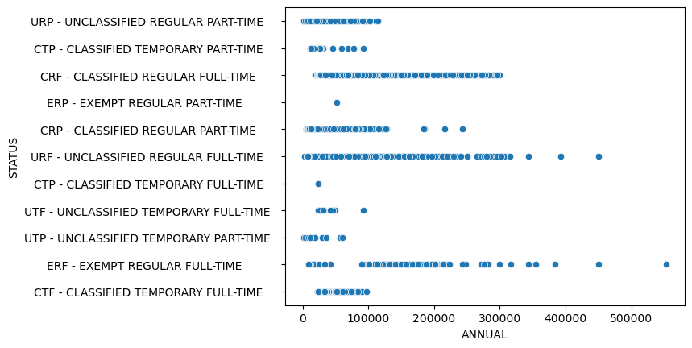
Annual Salary vs Employment Status
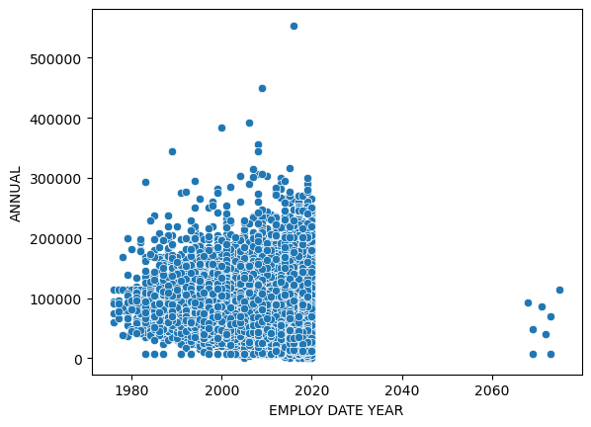
Employment Year vs Annual Salary (shows the two-digit-year parsing issue, points near 2070)
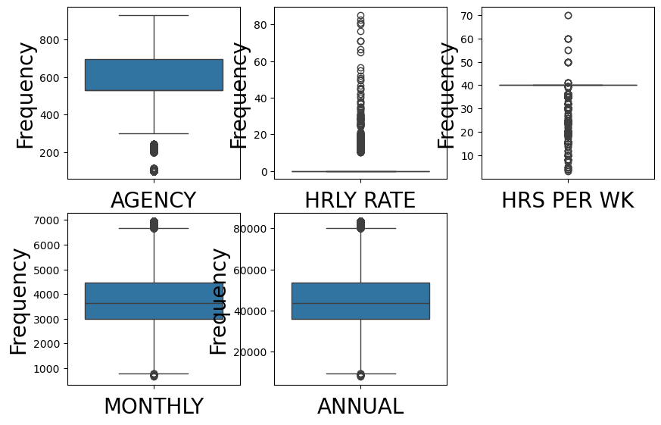
Box Plots after Outlier Handling
Annexure - V: Important Code / Project Structure
The project structure is as follows:
- dataset/salary.csv
- notebooks/TEXAS_ESP.ipynb
- salary_analysis_corrected.py (corrected pipeline and results)
The key correction applied to the original notebook was the removal of the leaking columns before model training:
# original (leaky) - MONTHLY = ANNUAL / 12 remained in the inputs
x = df.drop('ANNUAL', axis=1)

# corrected
X = df.drop(columns=['ANNUAL','MONTHLY','HRLY RATE','STATE NUMBER'])

