PODEM
Introduction:
We want to start up an EDA company that creates an NTU-ATPG (automatic test pattern generation) tool for single stuck-at faults. This NTU-ATPG system has two major functions: test pattern generation and fault simulation. For test pattern generation, it implements the PODEM algorithm [Goel 1981]. For fault simulation, it implements the parallel fault simulation algorithm. In this PA, we first show you how to run ATPG mode. Then, you are asked to fill in the holes in the PODEM code.

Tutorial:
First, please enter the bin directory, and run the golden binary to see results of ATPG mode. Notice that you should run these commands on Linux platforms with GCC version 4.8 or newer. Otherwise, it may not work. Simply type the following commands.
cd bin
./golden_atpg ../sample_circuits/c17.ckt > ../pattern/c17.ptn
Then you will see results generated by PODEM in file “../pattern/c17.ptn”.
Note that operator “>” will save the result to file, so no output will be shown in terminal.
Second, leave the bin directory, enter the src directory, and compile the source code by typing.
cd ..
cd src
make
Make sure that the version of compiler must support C⁺⁺ 11. In case you see any compilation error, please fix it before you proceed. If you succeed, an executable file ‘atpg’ should be correctly generated. Then, in the same directory, run this software in ATPG mode by typing the following command.
./atpg ../sample_circuits/c17.ckt > ../pattern/c17.ptn
The number of total faults, detected faults, and fault coverage should be showed in ./patterns/c17.ptn. Notice that the fault coverage is not correct now because there are some holes in the source code. Your job is to fill in the holes so that your outputs are the same as those generated by the golden binary.
I/O Files:
We explain the results using the following circuit, c17, which is an ISCAS (international symposium of circuit and system) benchmark circuit.
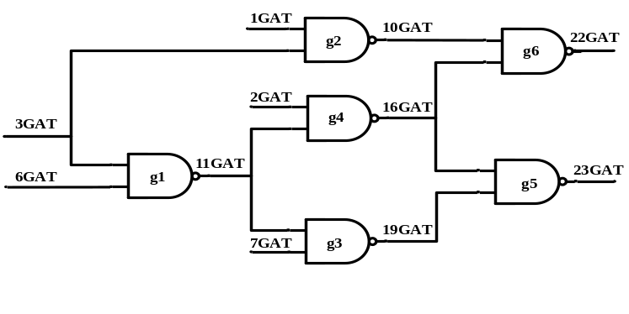
Figure 1. c17 circuit
The following file is our circuit file (c17.ckt). At the beginning, the circuit name is shown after the keyword “name”. Second, circuit primary inputs (PIs) go after the keyword “i”. Third, the circuit primary outputs (POs) go after the keyword “o”. Last, the rest of gates go after the keyword “g” and its gate index. Then there goes a list of input wires followed by a output wire, separated by a semicolon. For example, “g1 nand 6GAT(3) 3GAT(2) ; 11GAT(5)” means NAND gate g1 has two inputs: wire 6GAT and wire 3GAT. The output of NAND gate g1 is wire 11GAT. This circuit has totally 11 wires. Please note that a wire can have multiple fanout branches. For example, wire 11GAT has two branches, one feeds g3 and the other feeds g4.
(The numbers in the parentheses are total gates indices. They are unique numbers for each PI, PO, or logic gate.)
name C17.iscas
i 1GAT(0)
i 2GAT(1)
i 3GAT(2)
i 6GAT(3)
i 7GAT(4)

o 22GAT(10)
o 23GAT(9)

g1 nand 6GAT(3) 3GAT(2) ; 11GAT(5)
g2 nand 3GAT(2) 1GAT(0) ; 10GAT(6)
g3 nand 7GAT(4) 11GAT(5) ; 19GAT(7)
g4 nand 11GAT(5) 2GAT(1) ; 16GAT(8)
g5 nand 19GAT(7) 16GAT(8) ; 23GAT(9)
g6 nand 16GAT(8) 10GAT(6) ; 22GAT(10)
Figure 2. c17 circuit file
The following file is our test pattern (c17.ptn), which is generated by our ATPG tool. The circuit data is shown at the beginning. Then, all test vectors are shown after the keyword “T”. The other ATPG results are shown after test vectors: fault coverage, number of backtracks, etc.

#Circuit Summary:
#---------------
#number of inputs = 5
#number of outputs = 2
#number of gates = 6
#number of wires = 11
#atpg: cputime for reading in circuit ../sample_circuits/c17.sim: 0.0s 0.0s
#atpg: cputime for levelling circuit ../sample_circuits/c17.sim: 0.0s 0.0s
#atpg: cputime for rearranging gate inputs ../sample_circuits/c17.sim: 0.0s 0.0s
#atpg: cputime for creating dummy nodes ../sample_circuits/c17.sim: 0.0s 0.0s
#number of equivalent faults = 22
#atpg: cputime for generating fault list ../sample_circuits/c17.sim: 0.0s 0.0s
T'00110'
T'10111'
T'10001'
T'01000'
T'11011'
T'01100'
T'10000'
T'01111'
#number of aborted faults = 0
#number of redundant faults = 0
#number of calling podem1 = 8
#total number of backtracks = 0
#FAULT COVERAGE RESULTS :
#number of test vectors = 8
#total number of gate faults = 34
#total number of detected faults = 34
#total gate fault coverage = 100.00%
#number of equivalent gate faults = 22
#number of equivalent detected faults = 22
#equivalent gate fault coverage = 100.00%
#atpg: cputime for test pattern generation ../sample_circuits/c17.sim: 0.0s 0.0s
Figure 3. c17 pattern file (generated by ATPG)
Assignments:
Before you start, you should read the readme file that explains important data structure of this PODEM code. Please fill in the holes in the fault simulation code. Enter src directory and find the file podem.cpp, there are three holes in this file. You can simply type the keyword “TODO” to find out the holes. You are asked to complete the following five function,
- find_pi_assignment, this function can find which input we need to imply.
- trace_unknown_path, this function can do the x-path tracing taught in class. Please analyze the complexity of the function, trace_unknown_path() in your report.
- set_uniquely_implied_value, this function can set the uniquely implied value to PI. Please trace the code in backward_imply and recursively imply the value to PI.

After you fill in the holes, your fault coverage should be same as our golden results.

1) Please write a report to explain what you have done in this PA. Also, fill in the following table in your report.
circuit number | number of gates | number of total faults | number of detected faults | number of undetected faults | fault coverage | number of test vector | run time
C432
C499
C880
C1355
C2670
C3540
C6288
C7552
2) (10% bonus) If you use the golden patterns to do N-detect fault simulation, you will find the fault coverage decrease as N increase. Please implement N-detect ATPG that could keep almost the same fault coverage compared to fault simulation when doing N-detect fault simulation. And please explain what you did in your report. You should support the command below,
./atpg –ndet <N> <circuit file> > <pattern file>
N is a number from 1 to 8. For example,
./atpg –ndet 3 ../sample_circuits/c17.ckt > ../patterns/golden_c17.ptn
Your results will be graded by fault coverage and test length of your generated patterns for N = 8. Your fault coverage of N-detect test patterns must be higher than “fault coverage of golden patterns minus 3%”. And test length of N-detect test patterns should not exceed “N times of test length of golden patterns”. Take test patterns for c17 as example, fault coverage should be at least 95% and test length should be lower than 24 when N = 3.
Please note that you will get no bonus point if you just duplicate test pattern for N times.
For more detail and benefit of N-detect test patterns, you could study [Benware 03]

Grading:
80% correctness*
20% report
10% bonus

*correctness will be evaluated by your *.ptn file. If your fault coverage is lower than the golden binary, your score will be discounted.

Submission:
Make a directory <student_id>_pa2
Please copy 2 items /src, report.pdf into directory. Then submit a single *.tgz file to COOL system. Include everything so that your code can be easily compiled using ‘make’. You can use the following command to compress a whole directory:
tar -zcvf <student_id>_pa2.tgz <dir>
Here’s a refence file strcture:
r08943147_pa2/
├─src/ #Including *.cpp, *.h and makefile only
└─report.pdf #Fill the table above and highlight your change of code
Reference:
[Benware 03] B. Benware , C. Schuermyer , S. Ranganathan , R. Madge , P. Krishnamurthy,” Impact of multipledetect test patterns on product quality, “IEEE Int’l Test Conference, 2003. [Goel 1981] P. Goel, “An Implicit Enumeration Algorithm to Generate Tests for Combinational Logic Circuits,” IEEE Trans. on Computers, Vol. 30, No.3, pp215-222, 1981.

---
CAUTION!! We will check for plagiarism. Copying source code results in zero grade for both students!!

---
COPYRIGHT ANNOUNCEMENT
The copyright of this PODEM program belongs to the original authors. This program is only for our education purpose.

