Rayat Shikshan Sanstha’s
Chhatrapati Shivaji College, Satara

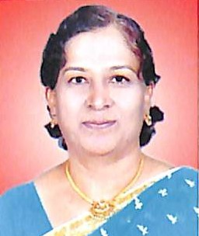 | Dr. Mrs. A. G. Mujawar  Department of English | anisamujawar27@gmail.com | 9860106828
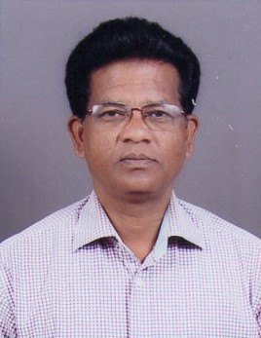 | Dr. S. B. Zodage  Department of Geography | sureshzodage@gmail.com | 9561084067
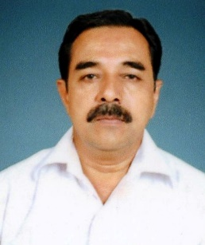 | Dr. A. S. Patil  Department of Geography | patilanandrao123@gmail.com | 9922638684
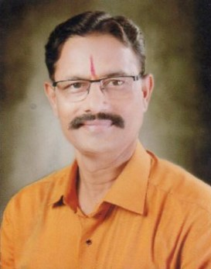 | Dr. R.S. Mane Deshmukh  Department of Geography | ramrajemsd@gmail.com | 8605186951

