The typical structure of a C programming textbook! Here are the major parts you'd usually find:

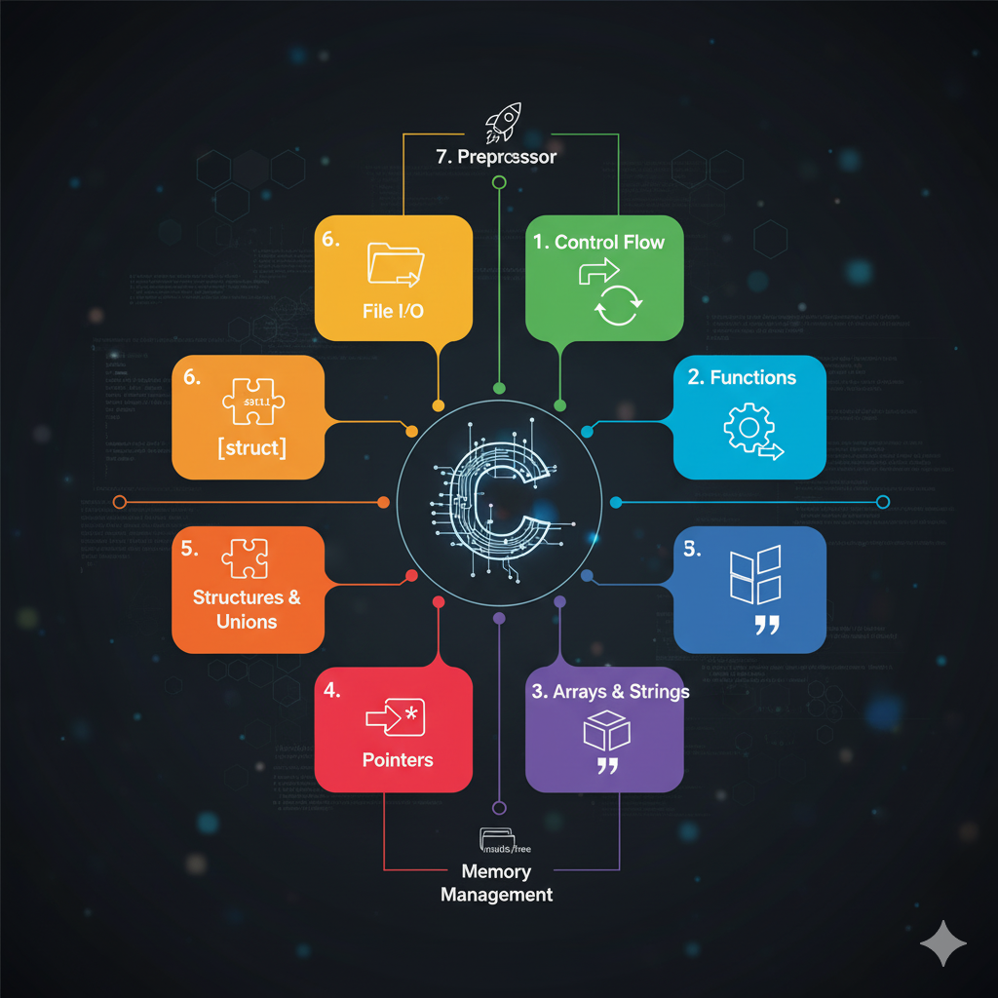

**1. Introduction to C 📚**

This section usually covers the history of C, its features, and how it compares to other programming languages. It also introduces the basic structure of a C program, how to compile and run it, and fundamental concepts like variables, data types, and operators.

**2. Control Flow 🚦**

Here, you'll learn about how to control the execution flow of your program. This includes:

* **Conditional Statements:** if, else if, else, switch for making decisions.
* **Looping Constructs:** for, while, do-while for repetitive tasks.

**3. Functions ⚙️**

Functions are the building blocks of C programs. This part focuses on:

* Defining and calling functions.
* Function parameters and return values.
* Scope of variables (local vs. global).
* Recursion.

**4. Arrays and Strings 📝**

These are crucial for handling collections of data:

* **Arrays:** Storing multiple values of the same type.
* **Strings:** Character arrays used to represent text. This often includes string manipulation functions.

**5. Pointers 📍**

Pointers are a powerful and sometimes challenging concept in C. This section delves into:

* What pointers are and how they work.
* Pointer arithmetic.
* Pointers and arrays.
* Dynamic memory allocation (malloc, calloc, realloc, free).

**6. Structures and Unions 🧩**

These allow you to create custom data types:

* **Structures:** Grouping different data types under a single name.
* **Unions:** Storing different data types in the same memory location.

**7. File I/O 📂**

Learning how to interact with files is essential for many applications:

* Opening, reading from, writing to, and closing files.
* Different file modes (text vs. binary).

**8. Preprocessor Directives 🚀**

These are instructions for the compiler that are processed before actual compilation:

* #include for including header files.
* #define for macros.
* Conditional compilation (#ifdef, #ifndef).

**9. Advanced Topics (Optional, but common) 🌌**

Many textbooks also include:

* **Data Structures:** Linked lists, stacks, queues, trees (often with C implementations).
* **Command-Line Arguments:** How to pass arguments to your program when it runs.
* **Error Handling:** Techniques for dealing with errors gracefully.

Here's an image that might represent the core concepts of C programming: