**AMI Andrew Yang AGREEMENT**

This AGREEMENT entered into on 5 July 2019 between Analytic Measures Inc. (herein “AMI”) with its principal office located at 125 University Ave., Palo Alto, California 94301 and Andrew Yang of 5340 Las Virgenes Road, Calabasas, California 91302 (herein "AYang") with respect to R&D services provided by AYang to AMI.

AMI and AYang agree as follows:

1. The term of this Agreement shall begin on 5 July 2019 and shall continue until 30 September 2019. Neither AMI nor AYang is obligated to extend the term of the Agreement beyond 30 September 2019.

2. AYang’s responsibilities under this Agreement are as follows: participate as requested in AMI work, including but not limited to development and wiki-documentation of methods for inferring reading skills from read-aloud performances and other tasks as requested. AYang will not undertake any project or initiative or execute any major ideas or plans on AMI’s behalf without advance authorization from AMI for all services to be provided and approval of the budget therefore. Whether at home or at AMI’s premises or at any combination of locations, AYang will work for 16-32 hours per week, while not working for more than eight (8) hours per day nor more than thirty-two (32) hours per week.

3. (a) AYang will maintain the confidentiality of all information received in connection with the services performed hereunder regarding the business and activities of AMI and any person or company that AMI works with.

(b) AYang will not use, directly or indirectly, any Confidential Information disclosed to AYang by AMI for AYang’s own use or for any purpose except to carry out the work contemplated by this Agreement. AYang will not disclose any Confidential Information of AMI. AYang agrees that AYang will take all reasonable measures to protect the secrecy of and avoid disclosure or use of the Confidential Information of AMI. Such measures shall include taking at least the same degree of care that AYang utilizes to protect AYang’s own Confidential Information. Confidential Information means any information, technical data, know-how or communication regarding AMI’s internal actions or omissions, whether in oral, written, or other form, and whether designated as confidential or not, and including but not limited to product plans, products, services, operations, customers, markets, software, developments, processes, designs, research, marketing or finances of AMI. Confidential Information does not include information which: (i) is lawfully in AYang’s possession at the time of disclosure; (ii) prior to or after the time of disclosure becomes generally known to the public, not as a result of any improper inaction or action of AYang’s; (iii) is disclosed to AYang by a third party subsequent to disclosure by AMI, and disclosure by such other third party is not in violation of any confidentiality agreement or obligation to AMI; or (iv) is approved by AMI, in writing, for release.

(c) All written materials and computer files submitted to AYang by AMI shall be returned to AMI by AYang within  
five (5) days after demand by AMI.

4. (a) In full consideration for AYang’s work under this agreement, AMI will pay AYang $32 (thirty-two dollars) per hour. AYang will be paid on submission to and approval by AMI of written monthly statements documenting the hours and days worked, and the tasks worked on. AMI shall pay accepted invoices within 14 days of receipt. In no case will AYang receive more than $8,000.00 (eight thousand dollars) under this agreement.   
(b) AMI will reimburse AYang for any reasonable travel expenses that are pre-approved in writing, including economy airfare, car rental, lodging and meals incurred in the course of performing AYang's duties hereunder, at current GSA per-diem rates of the U.S. government.

5. AYang hereby assigns to AMI all copyright interest, patent rights and other proprietary rights in any material prepared by AYang hereunder, including all rights under copyright, such as the exclusive right to reproduce, publish, and sell the same in whole or in part in any form or medium now or hereafter known, in any language, throughout the world, or to refrain from exercising any or all of such rights. Any and all recommendations, information, approaches, suggestions, concepts, ideas, and any and all contributions received from AYang hereunder may be used by AMI without compensation, except for that expressly hereinabove provided.

6. AMI will have the right to terminate this Agreement at any time by written notice without obligation or further payments, and AYang will be entitled (i) to retain all sums previously paid, (ii) to payment of all outstanding unpaid approved statements for work satisfactorily performed, and (iii) to payment for Services through the date that AYang received the notice of termination upon receipt and approval in accordance with this Agreement of a statement covering such Services.

7. Upon termination of the Agreement for any reason, AYang will turn over to AMI all materials relating to the Services (herein the "Materials") regardless of whether the same are complete. The Materials include all manuscripts, work documents, drafts, computer files, correspondence, and related papers and other materials prepared by AYang hereunder or furnished to AYang by AMI and all materials used by AYang in the performance of Services hereunder. Upon termination AMI will retain all of AYang's contributions and shall have the right without liability or further obligation to use the same and any ideas, approaches, suggestions, and other material submitted by AYang as provided herein in any manner free of claim by AYang for any reason.

8. AYang warrants and represents that AYang has the full right, power and authority to enter into this Agreement and to perform its terms and that any material prepared by AYang will be original and will not violate any copyright or personal or proprietary right of any person or entity. AYang’s performance of the Services called for by this Agreement do not and shall not violate any applicable law, rule or regulation or any contracts with third parties. All work performed by AYang shall be performed in a skillful and professional manner commensurate with the requirements of this Agreement.

9. The parties are and shall be independent entities, and nothing herein shall be deemed to cause this Agreement to create an employer-employee relationship, or an agency, partnership or joint venture between the parties. AYang is not entitled to participate in or receive any employee benefits of AMI, such as, but not limited to, insurance, pension, disability, medical, etc. AYang recognizes AMI's right to withhold any monies due AYang, for tax or other purposes, should AMI be required to do so by law.

10. This Agreement will be governed by and interpreted in accordance with the laws of the State of California. AYang agrees that any action at law or in equity arising out of or relating to these terms and conditions shall be filed only in the state or federal courts located in Santa Clara County, California. AYang expressly consents to (i) the personal jurisdiction of these courts and (ii) service of process being effected upon AYang by registered mail sent to the address set forth at the beginning of this Agreement. This Agreement shall be binding upon and inure to the benefit of AYang’s heirs, successors, and assigns and the successors and assigns of AMI. AYang may not assign this Agreement or any of AYang's obligations hereunder. This Agreement merges all prior representations and understandings; and constitutes the entire understanding between the parties concerning the subject matter hereof. No modification of this Agreement shall be effective unless in writing and signed by both parties.

EXECUTED as of the date first set forth above.

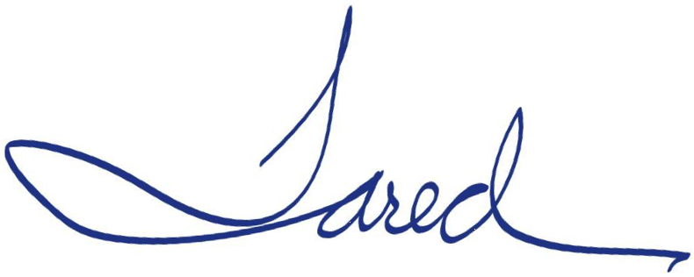 Andrew Yang for Analytic Measures Inc.

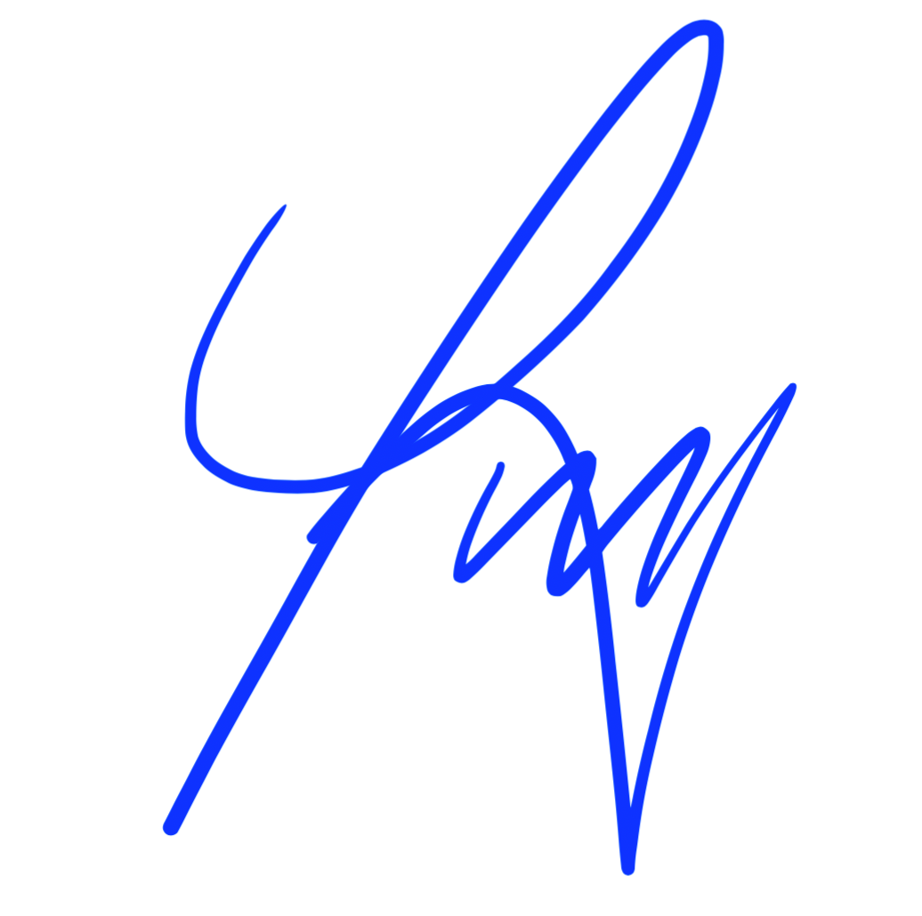

|  |  |  |  |
| --- | --- | --- | --- |
| __________________4 July 2019____ | | ____________________________ 3 July 2019 | |
| Signature | Date | Signature | Date |
| Andrew Yang__________________ | | Jared Bernstein ______________________ | |
| Print Name | | Print Name | |
| United States__________________ | | _President___________________________ | |
| Citizenship/Country of Residence | | Title | |

622-43-9155___________________

Soc. Sec. #