Link nghe: https://www.youtube.com/watch?v=mNaooUv6nhc&list=PLQoFvrOxWqR4cqAYBjrv9petggWGB_ATM&index=1
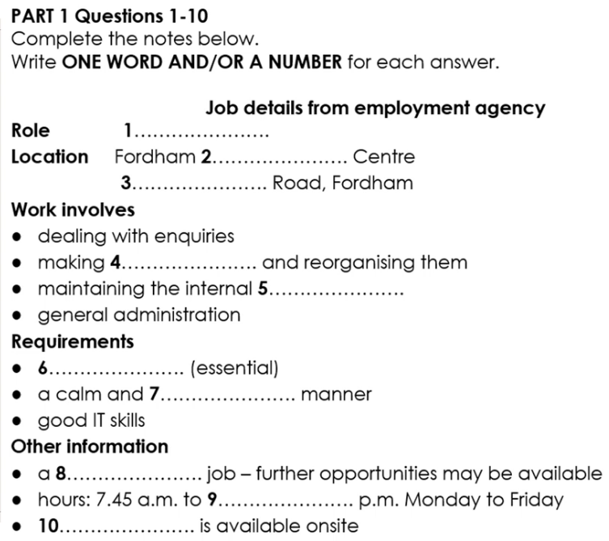

Answers (1–10)
- receptionist
- medical
- Chastons
- appointments
- database
- experience
- confident
- temporary
- 1.15
- parking
Link nghe : https://www.youtube.com/watch?v=6hwBW39h5uI&list=PLQoFvrOxWqR4cqAYBjrv9petggWGB_ATM&index=2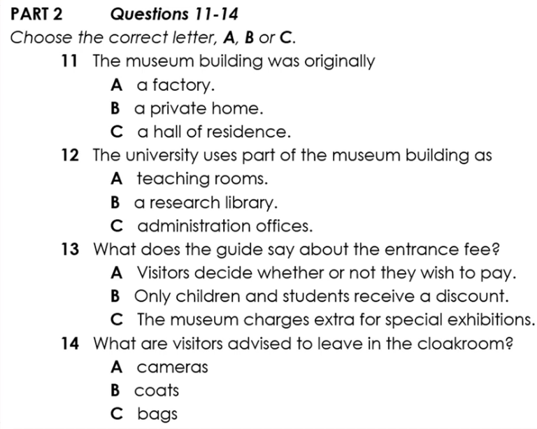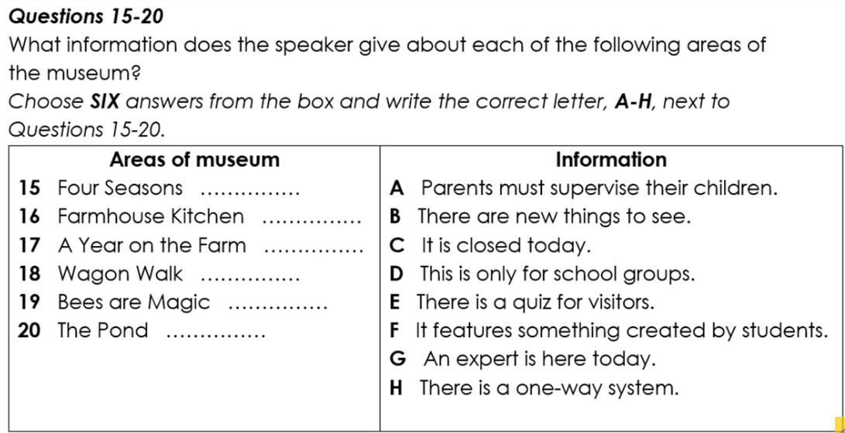

Câu Đáp án
11 B
12 A
13 A
14 C
15 F
16 G
17 E
18 A
19 C
20 A

Link nghe: https://www.youtube.com/watch?v=oGKnYMM1fRE&list=PLQoFvrOxWqR4cqAYBjrv9petggWGB_ATM&index=3
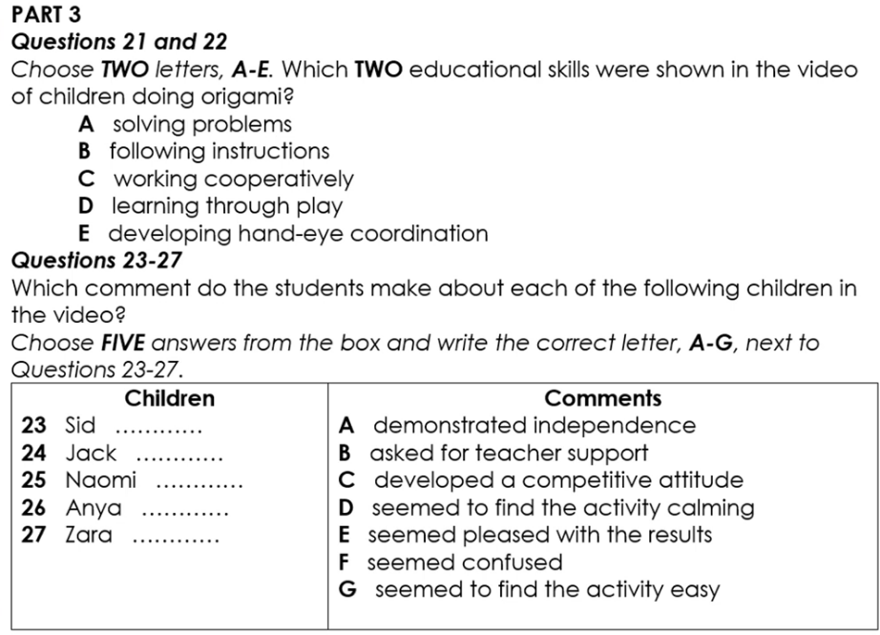
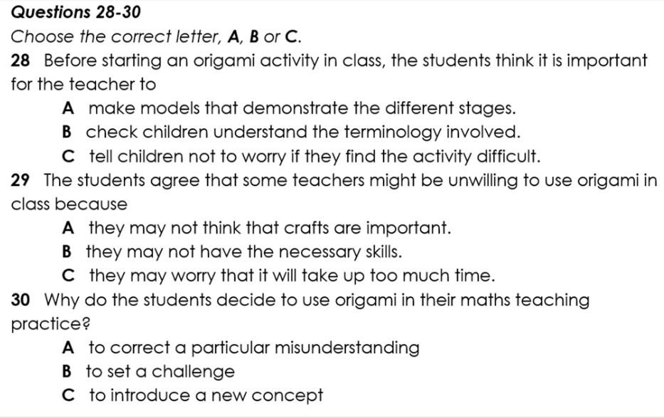
- B
- D
- D
- A
- C
- G
- F
- A
- B
- C

Link nghe: https://www.youtube.com/watch?v=_cskUdSXwYM&list=PLQoFvrOxWqR4cqAYBjrv9petggWGB_ATM&index=4
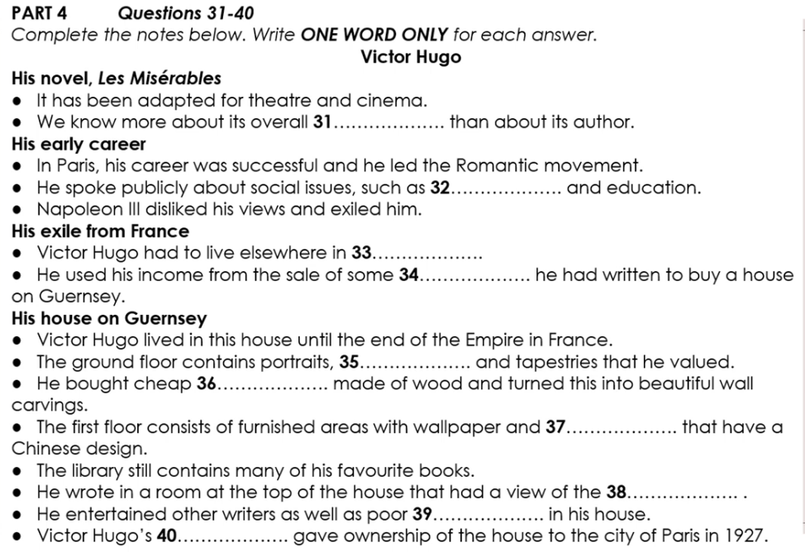
- plot
- poverty
- Europe
- poetry
- drawings
- furniture
- lamps
- harbour
- children
- relatives

