National Taipei University of Technology

Computer Science and Information Engineering

Principles and Applications of Data Science

Spring 2022

Semester Group Project Report

The relationship between temperature, humidity and human stress

Name: 顏翊純、黃彥文

Sid: 110599002、109598113

Date:06/22/2022

**Content(目錄)**

1. Introduction 1

Motivation: 1

Objectives: 1

2. Literature review and related works 1

3. Problem statement 2

4. Proposed models (approaches) 2

5. Experiments 3

K-NN 9

Decision_Tree_with_Ada_Boost_Classifier 10

SVM 12

Stress Level Predict Model 14

Stress Level Predict Model Code: GUI 15

Stress Level Predict Model Code: classifier model 25

Stress Level Predict Model Code: classifier model 26

Stress Level Predict Model Code: K-NN 28

Stress Level Predict Model Code: linear 29

Stress Level Predict Model Code: SVM 33

Stress Level Predict Model Code: run model accuracy 35

6. Conclusion 38

7. Others 38

**Abstract**

With the progress of society and the development of science and technology, people under the great pressure at the same time. We realized that there are much people suffer from Depression or Bipolar Disorder in our daily life, even elementary students. These mental illnesses are not only caused by personal or society reason, but also depend on the nature environment [1]. Just like humid weather will make people feel depress than sunny. We hoped that we can create a model which can predict the stress, by this way, people can do something relaxing at the beginning to make these stress don’t grow larger and larger.

In this project we proposed a tool to predict the stress level by temperature and humidity. We used the data provided from papers[1] written by L. Rachakonda, S. P. Mohanty, E. Kougianos, and P. Sundaravadivel [2][3] to do the analysis. We do the linear analysis and try several algorithms to create the predicting model, e.g. K-NN, SVM, Adaboost. In this prediction, the stress level are classifier to 0, 1, 2, higher number means higher stress. If the prediction get stress level 2, the tool will provide the ten most restful activities to the user.

We also used the Taiwan weather data provided by Taiwan Ministry of Transportation and Communications[2]. We combine the temperature and humidity data each month from year 108 to year 110 to do the stress level prediction. The result also shows on the tool.

1. Introduction

This part is a summary about the whole report and project. Please have the objectives of your project and the motivation in the introduction. In addition, the applications and contributions should be included.

Motivation:

New York Times has written the article, << His College Knew of His Despair. His Parents Didn’t, Until It Was Too Late.>>, using “despair” to talking about the university students may go through in America. And as we realized that there are much people suffer from Depression or Bipolar Disorder in our daily life. We want to found that if there is something we can do before these happens. We start to search for human stress, and two papers written by L. Rachakonda, S. P. Mohanty, E. Kougianos, and P. Sundaravadivel were found. They create an IoT device which can detect the data from human body that can help to detect the stress immediately. We used the data provided by this project to create a model which can predict the human stress by temperature and humidity.

We found that most of them have some common personality, they suffer a big stress at the end, but they are not conscious of when these stresses started. We hoped that we can create a model which can predict the stress, by this way, people can do something relaxing at the beginning to make these stress don’t grow larger and larger.

Objectives:

Create a model which can predict the human stress by temperature and humidity data.

Although the temperature and humidity are the body temperature and humidity in these papers, we’ve known that the weather will also influence the frequency of symptoms, which called “Seasonal affective disorder (SAD)”.

Application and Contributions:

## These mental illnesses somehow caused by the nature environment, by this tool, it may help people to predict the stress, and it can do some restful activities to release these stresses than suffer large stresses at the end and caused the mental illnesses. The point above is not only for the normal person but also the person who was suffered by mental illnesses before and get well now. For people who are suffered by mental illnesses before, it’s easy for them to get mental illnesses again if they don’t have great control. It’s important for them to find out if there is stress in their mind or not and this tool may help.

1. Literature review and related works

Please write your comments and comparisons to the related materials you have reviewed. If there are some related or similar works, please also state and have a discussion and comparison.

(之前找的2篇論文，或其他的)

1. Problem statement

Give a scenario of the problem you are working and state the problem. If possible, you can try to formulate your problem formally.

Weather impacts person’s mood, especially rainy day. Nowadays, with the progress of the society, many people don’t have time to conscious that they are suffered by huge stresses. That’s also one of the reasons that more and more people suffer from the mental illness these days. In addition, conscious the status of oneself can also help to control the temper which can avoid the argue situation and improve the communication.

Scenario1:

Rose is a university student who suffered by depression, it’s not easy for her to detect emotions herself. She hopes that if there is any tool can help her find herself in the stressful way. By this way, she can release some of the stress earlier than accumulated pressure at the end and feel depress without doing anything.

Scenario2:

Burt is a manger in the company, sometimes he felt that he’s easily get anger without any reason. By the stress predict, he can know that today will get a more stressful mood or more relax mood. It can help him to control the temper more easily.

1. Proposed models (approaches)

Please present your proposed models (approaches) for the problem and give the reasons why your models or approaches are designed. Give one or two examples to illustrate how your models run.

Use the classifier algorithm instead of regression algorithm because...

(regression是用連續數據去做，我們的比較像分類)

<https://ikala.cloud/supervised-learning-classification-regression/>

We choose different kinds of algorithm to do the comparison, KNN, SVM and Decision Tree. The data source classify stress to three level, 0, 1, 2, higher number means higher stress, so we choose classifier algorithms instead of regression algorithm.

For each algorithm we will split the data to test and train…(with pic on jupyter)

**K-NN:**

**SVM:**

**Decision Tree:**

1. Experiments

This part is very important. It first includes what the objectives of the experiments are, how you design them, which tools are used, where the data are from, when you have the data, what the measurements are, and what you will compare with. Then, the results are shown with careful analysis and discussion. One should have reasons for all the trends presented in the results.

**Classify by Humidity and Step Count:**

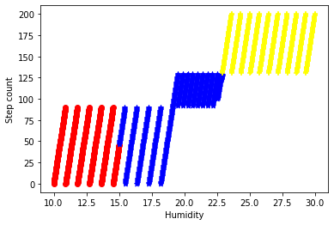

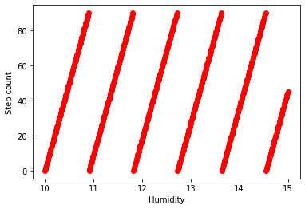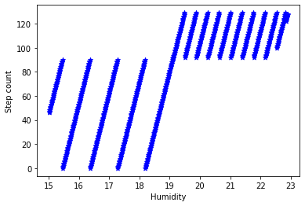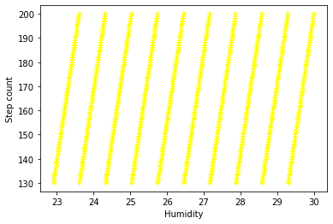

**Classify by Temperature and Step Count:**

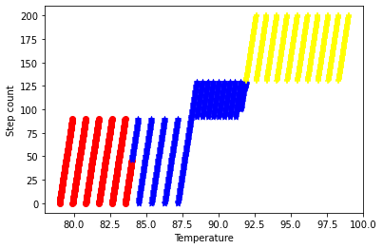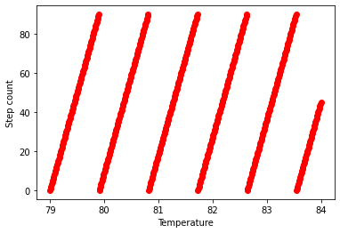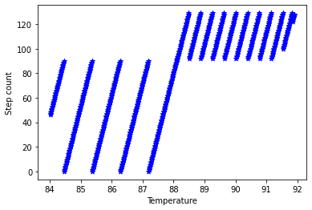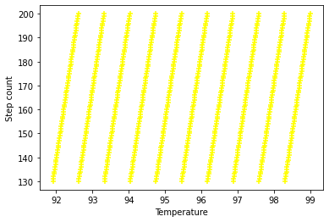

**Classify by Temperature and Humidity:**

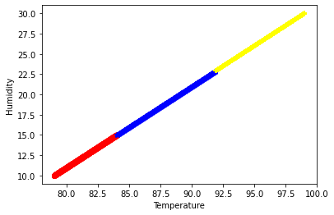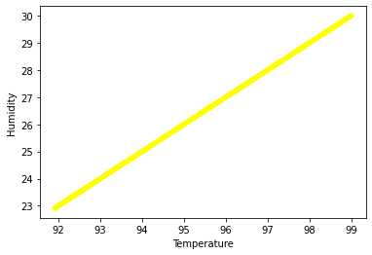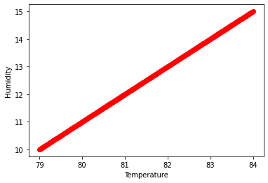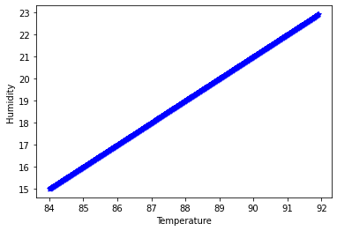

**Correlation coefficient between humidity and stress level is 0.93**

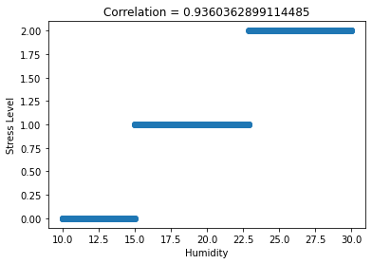

**Correlation coefficient between temperature and stress level is 0.93**

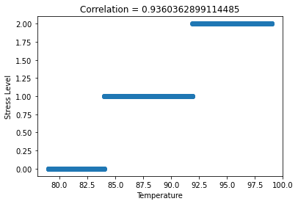

**Correlation coefficient between step count and stress level is 0.83**

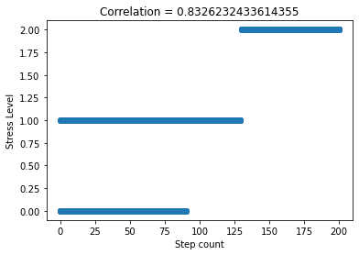

**Correlation coefficient between temperature and step count is 0.87**

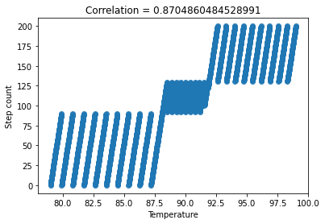

**Correlation coefficient between temperature and humidity is 1.0**

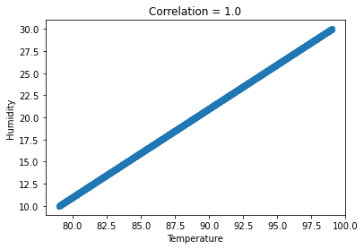

**Correlation coefficient between humidity and step count is 0.87**

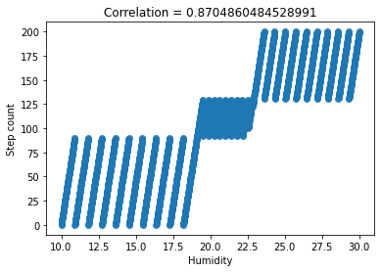

K-NN

hum_temp_data = lysis_data[['Humidity', 'Temperature']]

str_lev_data = lysis_data['Stress Level']

train_data , test_data , train_label , test_label = train_test_split(hum_temp_data, str_lev_data, test_size=0.2)

train_data , ver_data , train_label , ver_label = train_test_split(train_data, train_label, test_size=0.25)

model = KNeighborsClassifier(n_neighbors=3)

# Train the model using the training sets

model.fit(train_data, train_label)

# Predict Output

predicted = model.predict(ver_data) # 0:Overcast, 2:Mild

print("accuracy: ", accuracy_score(ver_label, predicted))

    accuracy:  0.9975

predicted = model.predict(test_data)

print("accuracy: ", accuracy_score(test_label, predicted))

    accuracy:  1.0

Decision_Tree_with_Ada_Boost_Classifier

hum_temp_data = lysis_data[['Humidity', 'Temperature']]

str_lev_data = lysis_data['Stress Level']

train_data , test_data , train_label , test_label = train_test_split(hum_temp_data, str_lev_data, test_size=0.2)

train_data , ver_data , train_label , ver_label = train_test_split(train_data, train_label, test_size=0.25)

model =  AdaBoostClassifier(DecisionTreeClassifier(max_depth=2), n_estimators=50)

model.fit(train_data, train_label)

pred_ver = model.predict(ver_data)

acc_train = accuracy_score(ver_label, pred_ver)

pred_test = model.predict(test_data)

acc_test = accuracy_score(test_label, pred_test)

print("Verification Accuracy: {} \nTest Accuracy: {}".format(acc_train, acc_test))

Verification Accuracy: 1.0

Test Accuracy: 0.9975062344139651

model =  AdaBoostClassifier(DecisionTreeClassifier(max_depth=1), n_estimators=50)

model.fit(train_data, train_label)

pred_ver = model.predict(ver_data)

acc_train = accuracy_score(ver_label, pred_ver)

pred_test = model.predict(test_data)

acc_test = accuracy_score(test_label, pred_test)

print("Verification Accuracy: {} \nTest Accuracy: {}".format(acc_train, acc_test))

Verification Accuracy: 1.0

Test Accuracy: 0.9975062344139651

model = AdaBoostClassifier(n_estimators=50, random_state=0)

model.fit(train_data, train_label)

pred_ver = model.predict(ver_data)

acc_train = accuracy_score(ver_label, pred_ver)

pred_test = model.predict(test_data)

acc_test = accuracy_score(test_label, pred_test)

print("Verification Accuracy: {} \nTest Accuracy: {}".format(acc_train, acc_test))

Verification Accuracy: 1.0

Test Accuracy: 0.9975062344139651

SVM

hum_temp_data = lysis_data[['Humidity', 'Temperature']]

str_lev_data = lysis_data['Stress Level']

train_data , test_data , train_label , test_label = train_test_split(hum_temp_data, str_lev_data, test_size=0.2)

train_data , ver_data , train_label , ver_label = train_test_split(train_data, train_label, test_size=0.25)

C = 2 # SVM regularization parameter

svc = svm.SVC(kernel='linear', C=C).fit(train_data, train_label)

pred_ver = svc.predict(ver_data)

acc_train = accuracy_score(ver_label, pred_ver)

pred_test = svc.predict(test_data)

acc_test = accuracy_score(test_label, pred_test)

print("Verification Accuracy: {} \nTest Accuracy: {}".format(acc_train, acc_test))

Verification Accuracy: 0.9975

Test Accuracy: 0.9925187032418953

C = 2 # SVM regularization parameter

rbf_svc = svm.SVC(kernel='rbf', gamma=0.7, C=C).fit(train_data, train_label)

pred_ver = rbf_svc.predict(ver_data)

acc_train = accuracy_score(ver_label, pred_ver)

pred_test = rbf_svc.predict(test_data)

acc_test = accuracy_score(test_label, pred_test)

print("Verification Accuracy: {} \nTest Accuracy: {}".format(acc_train, acc_test))

Verification Accuracy: 0.9975

Test Accuracy: 0.9950124688279302

C = 2 # SVM regularization parameter

poly_svc = svm.SVC(kernel='poly', degree=3, C=C).fit(train_data, train_label)

pred_ver = poly_svc.predict(ver_data)

acc_train = accuracy_score(ver_label, pred_ver)

pred_test = poly_svc.predict(test_data)

acc_test = accuracy_score(test_label, pred_test)

print("Verification Accuracy: {} \nTest Accuracy: {}".format(acc_train, acc_test))

Verification Accuracy: 1.0

Test Accuracy: 0.9950124688279302

C = 2 # SVM regularization parameter

lin_svc = svm.LinearSVC(C=C, dual=False).fit(train_data, train_label)

pred_ver = lin_svc.predict(ver_data)

acc_train = accuracy_score(ver_label, pred_ver)

pred_test = lin_svc.predict(test_data)

acc_test = accuracy_score(test_label, pred_test)

print("Verification Accuracy: {} \nTest Accuracy: {}".format(acc_train, acc_test))

Verification Accuracy: 0.9975

Test Accuracy: 0.9975062344139651

Through the previous analysis, we found:

* the higher temperature, the higher pressure
* the higher humidity, the higher pressure
* the higher the pressure, the more steps you take.

Stress Level Predict Model

Our goal is to create a model which can predict the human stress by temperature and humidity. The operational window and steps as follow

* input temperature(°F)
* input humidity(RH%)
* choose predict model
* click ‘Predict’ button
* get ‘Predict Stress Level’ (value: 0-2)
* if Predict Stress Level is 2, the window will show ‘The Ten Most Resful Activities’

We analyzed the stress levels from 108 to 110 represented by Taipei, Kaohsiung, Tamsui, Hsinchu, Taichung and Hualien, using data from Central Weather Bureau. Also, we provide source analysis including Linear analysis and Model Accuracy.

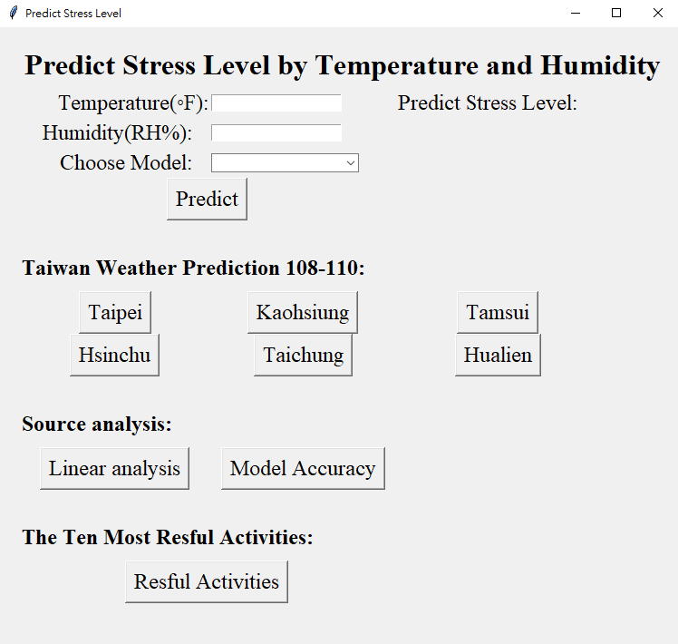

Stress Level Predict Model Code: GUI

def show_model_accuracy():

    classifier_model = ClassifierModel()

    acc_result_window = tk.Tk()

    acc_result_window.title('Model Accuracy')

    result_list = [acc_result.knn(classifier_model),  acc_result.decision_tree(classifier_model), acc_result.adaboost(classifier_model), acc_result.svm(classifier_model), acc_result.svm_rbf(classifier_model), acc_result.svm_poly(classifier_model), acc_result.svm_linear(classifier_model)]

    acc_string = ""

    for acc in result_list:

        acc_string += acc

        acc_string += "\n\n"

    size = len(acc_string)

    acc_string = acc_string[:size-2]

    acc_result_label = tk.Label(acc_result_window, text = acc_string, font=("Times New Roman", 18),  justify=tk.LEFT)

    acc_result_label.grid(sticky = tk.W)

def show_linear_analysis():

    linear_analysis = LinearAnaiysis()

    linear_analysis.linear_with_correlation_all()

    linear_analysis.linear_show_with_stress_level_all()

def taipei_pred():

    mon_data = ["110年1月", "110年2月","110年3月","110年4月","110年5月","110年6月","110年7月","110年8月","110年9月","110年10月","110年11月","110年12月","109年1月", "109年2月","109年3月","109年4月","109年5月","109年6月","109年7月","109年8月","109年9月","109年10月","109年11月","109年12月", "108年1月", "108年2月","108年3月","108年4月","108年5月","108年6月","108年7月","108年8月","108年9月","108年10月","108年11月","108年12月"]

    humi_data = [75,74,83,77,74,74,72,79,72,76,78,77,75,72,75,73,77,68,67,70,73,77,76,88,74,79,75,76,77,77,73,72,79,74,75,77]

    temp_data = [60.8,66.38,68.54,72.32,82.76,84.74,86.54,84.02,85.1,78.26,70.16,64.94,64.22,65.66,69.44,69.62,80.42,86.9,87.62,86.36,82.04,76.1,73.94,64.58,65.3,65.84,67.64,75.56,77,83.3,86.54,86.9,81.14,77.54,71.6,66.38]

    data = {'Humidity': humi_data, 'Temperature': temp_data}

    test_data = pd.DataFrame(data)

    class_model = ClassifierModel()

    predict_val = class_model.knn_prediction(test_data)

    show_data = {'Month': mon_data, 'Humidity': humi_data, 'Temperature': temp_data, 'Predict Stress Level':predict_val}

    show_data_frame = pd.DataFrame(show_data)

    weather_result = tk.Tk()

    weather_result.title('Taipei Weather Predict')

    frame = tk.Frame(weather_result)

    frame.pack(fill='both', expand=True)

    pt = Table(frame, dataframe=show_data_frame, width=605, height=500, cellwidth=150, align='center')

    pt.show()

    # weather_result.mainloop()

def kaohsiung_pred():

    mon_data = ["110年1月", "110年2月","110年3月","110年4月","110年5月","110年6月","110年7月","110年8月","110年9月","110年10月","110年11月","110年12月","109年1月", "109年2月","109年3月","109年4月","109年5月","109年6月","109年7月","109年8月","109年9月","109年10月","109年11月","109年12月", "108年1月", "108年2月","108年3月","108年4月","108年5月","108年6月","108年7月","108年8月","108年9月","108年10月","108年11月","108年12月"]

    humi_data = [69,72,73,75,76,84,81,84,80,77,71,71,70,69,71,69,79,75,76,82,75,74,74,71,71,71,73,74,79,79,81,84,76,72,70,71]

    temp_data = [64.94,69.44,74.48,77.72,84.38,82.76,84.38,83.12,84.38,81.68,76.28,70.16,69.62,71.24,76.46,77,83.48,86.54,86.9,84.38,85.46,82.22,78.44,72.14,71.42,74.84,75.38,80.42,81.5,85.1,84.74,83.84,83.66,81.86,77.18,71.24]

    data = {'Humidity': humi_data, 'Temperature': temp_data}

    test_data = pd.DataFrame(data)

    class_model = ClassifierModel()

    predict_val = class_model.knn_prediction(test_data)

    show_data = {'Month': mon_data, 'Humidity': humi_data, 'Temperature': temp_data, 'Predict Stress Level':predict_val}

    show_data_frame = pd.DataFrame(show_data)

    weather_result = tk.Tk()

    weather_result.title('Kaohsiung Weather Predict')

    frame = tk.Frame(weather_result)

    frame.pack(fill='both', expand=True)

    pt = Table(frame, dataframe=show_data_frame, width=605, height=500, cellwidth=150, align='center')

    pt.show()

def tamsui_pred():

    mon_data = ["110年1月", "110年2月","110年3月","110年4月","110年5月","110年6月","110年7月","110年8月","110年9月","110年10月","110年11月","110年12月","109年1月", "109年2月","109年3月","109年4月","109年5月","109年6月","109年7月","109年8月","109年9月","109年10月","109年11月","109年12月", "108年1月", "108年2月","108年3月","108年4月","108年5月","108年6月","108年7月","108年8月","108年9月","108年10月","108年11月","108年12月"]

    humi_data = [79,80,88,78,82,82,79,84,77,77,80,82,82,85,86,79,84,73,62,72,78,76,76,88,83,87,81,84,82,85,79,77,83,84,80,82]

    temp_data = [59,64.04,65.3,70.7,80.6,83.12,85.1,83.12,83.84,77.36,68.9,63.14,62.24,63.14,67.28,68.18,78.62,84.38,85.82,84.56,79.88,75.2,72.68,63.32,63.68,63.86,66.38,73.58,75.56,81.32,85.28,84.92,79.34,75.74,70.34,64.4]

    data = {'Humidity': humi_data, 'Temperature': temp_data}

    test_data = pd.DataFrame(data)

    class_model = ClassifierModel()

    predict_val = class_model.knn_prediction(test_data)

    show_data = {'Month': mon_data, 'Humidity': humi_data, 'Temperature': temp_data, 'Predict Stress Level':predict_val}

    show_data_frame = pd.DataFrame(show_data)

    weather_result = tk.Tk()

    weather_result.title('Tamsui Weather Predict')

    frame = tk.Frame(weather_result)

    frame.pack(fill='both', expand=True)

    pt = Table(frame, dataframe=show_data_frame, width=605, height=500, cellwidth=150, align='center')

    pt.show()

def hsinchu_pred():

    mon_data = ["110年1月", "110年2月","110年3月","110年4月","110年5月","110年6月","110年7月","110年8月","110年9月","110年10月","110年11月","110年12月","109年1月", "109年2月","109年3月","109年4月","109年5月","109年6月","109年7月","109年8月","109年9月","109年10月","109年11月","109年12月", "108年1月", "108年2月","108年3月","108年4月","108年5月","108年6月","108年7月","108年8月","108年9月","108年10月","108年11月","108年12月"]

    humi_data = [74,76,84,76,78,77,75,79,73,71,76,75,78,74,79,74,78,70,65,72,73,71,73,82,76,80,78,77,77,74,68,74,71,71,70,75]

    temp_data = [59.54,64.22,66.56,71.78,81.5,83.66,85.64,83.48,84.74,78.8,69.98,64.22,62.06,63.68,68,68.9,79.88,85.46,87.44,85.28,81.5,76.82,73.94,64.4,63.86,64.4,66.74,74.48,76.46,82.94,86.36,85.1,80.96,77.36,71.24,64.94]

    data = {'Humidity': humi_data, 'Temperature': temp_data}

    test_data = pd.DataFrame(data)

    class_model = ClassifierModel()

    predict_val = class_model.knn_prediction(test_data)

    show_data = {'Month': mon_data, 'Humidity': humi_data, 'Temperature': temp_data, 'Predict Stress Level':predict_val}

    show_data_frame = pd.DataFrame(show_data)

    weather_result = tk.Tk()

    weather_result.title('Hsinchu Weather Predict')

    frame = tk.Frame(weather_result)

    frame.pack(fill='both', expand=True)

    pt = Table(frame, dataframe=show_data_frame, width=605, height=500, cellwidth=150, align='center')

    pt.show()

def taichung_pred():

    mon_data = ["110年1月", "110年2月","110年3月","110年4月","110年5月","110年6月","110年7月","110年8月","110年9月","110年10月","110年11月","110年12月","109年1月", "109年2月","109年3月","109年4月","109年5月","109年6月","109年7月","109年8月","109年9月","109年10月","109年11月","109年12月", "108年1月", "108年2月","108年3月","108年4月","108年5月","108年6月","108年7月","108年8月","108年9月","108年10月","108年11月","108年12月"]

    humi_data = [71,70,73,70,70,81,77,81,74,71,72,71,76,72,70,70,75,70,74,75,71,69,72,77,75,75,79,79,82,79,79,86,78,71,69,75]

    temp_data = [60.8,66.2,70.7,75.02,83.84,82.04,84.2,82.04,84.2,80.06,72.32,65.84,64.4,66.2,72.14,71.96,81.5,84.38,85.28,83.3,82.58,78.98,75.02,67.1,66.74,68.9,69.98,76.46,77.72,82.76,84.92,83.12,81.86,78.98,73.4,66.74]

    data = {'Humidity': humi_data, 'Temperature': temp_data}

    test_data = pd.DataFrame(data)

    class_model = ClassifierModel()

    predict_val = class_model.knn_prediction(test_data)

    show_data = {'Month': mon_data, 'Humidity': humi_data, 'Temperature': temp_data, 'Predict Stress Level':predict_val}

    show_data_frame = pd.DataFrame(show_data)

    weather_result = tk.Tk()

    weather_result.title('Taichung Weather Predict')

    frame = tk.Frame(weather_result)

    frame.pack(fill='both', expand=True)

    pt = Table(frame, dataframe=show_data_frame, width=605, height=500, cellwidth=150, align='center')

    pt.show()

def hualien_pred():

    mon_data = ["110年1月", "110年2月","110年3月","110年4月","110年5月","110年6月","110年7月","110年8月","110年9月","110年10月","110年11月","110年12月","109年1月", "109年2月","109年3月","109年4月","109年5月","109年6月","109年7月","109年8月","109年9月","109年10月","109年11月","109年12月", "108年1月", "108年2月","108年3月","108年4月","108年5月","108年6月","108年7月","108年8月","108年9月","108年10月","108年11月","108年12月"]

    humi_data = [79,78,84,82,84,84,77,82,80,80,81,75,77,74,80,79,83,75,76,75,76,74,79,81,77,80,75,76,80,81,77,78,75,73,71,75]

    temp_data = [61.88,67.1,70.7,72.86,80.42,82.4,84.56,82.76,82.4,77.36,70.88,67.1,67.1,67.28,70.52,70.7,78.98,84.74,85.1,84.38,81.32,77.54,74.3,68.36,68,69.8,69.62,76.1,75.92,81.86,84.74,84.02,81.32,77.54,73.22,68.36]

    data = {'Humidity': humi_data, 'Temperature': temp_data}

    test_data = pd.DataFrame(data)

    class_model = ClassifierModel()

    predict_val = class_model.knn_prediction(test_data)

    show_data = {'Month': mon_data, 'Humidity': humi_data, 'Temperature': temp_data, 'Predict Stress Level':predict_val}

    show_data_frame = pd.DataFrame(show_data)

    weather_result = tk.Tk()

    weather_result.title('Hualien Weather Predict')

    frame = tk.Frame(weather_result)

    frame.pack(fill='both', expand=True)

    pt = Table(frame, dataframe=show_data_frame, width=605, height=500, cellwidth=150, align='center')

    pt.show()

def show_resful_activities():

    tk.messagebox.showinfo('The Ten Most Restful Activities', '1. Reading\n2. Being in the natural environment\n3. Being on your own\n4. Listening to music\n5. Doing nothing in particular\n6. Walking\n7. Having a bath or shower\n8. Daydreaming\n9. Watching TV\n10. Meditating or practising mindfulness')

def predict_result():

    humi = None

    temp = None

    try:

        humi = float(entry_humi.get())

    except:

        tk.messagebox.showerror(title=None, message="Invlid Humidity Data.")

        return 0

    try:

        temp = float(entry_temp.get())

    except:

        tk.messagebox.showerror(title=None, message="Invlid Temperature Data.")

        return 0

    data = {'Humidity': [humi], 'Temperature': [temp]}

    test_data = pd.DataFrame(data)

    model = combo_mod.get()

    class_model = ClassifierModel()

    predict_val = -1

    try:

        if (model == "K-NN"):

            predict_val = class_model.knn_prediction(test_data)[0]

        elif (model == "Decision Tree"):

            predict_val = class_model.decision_tree_prediction(test_data)[0]

        elif (model == "Adaboost"):

            predict_val = class_model.adaboost_prediction(test_data)[0]

        elif (model == "SVM"):

            predict_val = class_model.svc_prediction(test_data)[0]

        elif (model == "SVM Poly"):

            predict_val = class_model.poly_svc_prediction(test_data)[0]

        elif (model == "SVM RBF"):

            predict_val = class_model.rbf_svc_prediction(test_data)[0]

        elif (model == "SVM Linear"):

            predict_val = class_model.lin_svc_prediction(test_data)[0]

        else:

            tk.messagebox.showerror(title=None, message="Please choose a predict model.")

            return 0

    except:

        tk.messagebox.showerror(title=None, message="Please enter valid data")

        return 0

    res_val.config(text = str(predict_val))

    if predict_val == 2:

        show_resful_activities()

if __name__ == "__main__":

    # 建立主視窗 Frame

    window = tk.Tk()

    window.geometry('750x680')

    # 設定視窗標題

    window.title('Predict Stress Level')

    # 標示文字

    title_label_font_style = tkFont.Font(family="Times New Roman", size=24, weight="bold")

    title = tk.Label(window, text = 'Predict Stress Level by Temperature and Humidity',

                     font = title_label_font_style)

    title.grid(row = 1, column = 0, columnspan = 7, padx = (25, 0), pady = (20, 5))

    # create a label widget

    label_temp = tk.Label(window, text = "Temperature(◦F):", font=("Times New Roman", 18))

    label_humi = tk.Label(window, text = "Humidity(RH%):   ", font=("Times New Roman", 18))

    label_mod = tk.Label(window, text = "Choose Model:   ", font=("Times New Roman", 18))

    # 建立按鈕

    predict_button = tk.Button(window,   # 按鈕所在視窗

                    text = 'Predict',  # 顯示文字

                    command = predict_result, # 按下按鈕所執行的函數

                    font=("Times New Roman", 18))

    # rows and columns as specified

    label_temp.grid(row = 2, column = 1, sticky=tk.E)

    label_humi.grid(row = 3, column = 1, sticky=tk.E)

    label_mod.grid(row = 4, column = 1, sticky=tk.E)

    predict_button.grid(row = 5, column = 1, columnspan = 2)

    # entry widgets, used to take entry from user

    entry_temp = tk.Entry(window, width = 20)

    entry_humi = tk.Entry(window, width = 20)

    combo_mod = ttk.Combobox(window,

                            values=[

                                    "K-NN",

                                    "Decision Tree",

                                    "Adaboost",

                                    "SVM",

                                    "SVM Poly",

                                    "SVM RBF",

                                    "SVM Linear"])

    # arrange entry widgets

    entry_temp.grid(row = 2, column = 2, sticky=tk.W)

    entry_humi.grid(row = 3, column = 2, sticky=tk.W)

    combo_mod.grid(row = 4, column = 2, sticky=tk.W)

    label_res = tk.Label(window, text = "Predict Stress Level:", font=("Times New Roman", 18))

    res_val = tk.Label(window, text = "", font=("Times New Roman", 52))

    label_res.grid(row = 2, column = 3, sticky=tk.W)

    res_val.grid(row = 3, column = 3, rowspan = 3)

    tk.Label(window, text="\n").grid(row = 6, column = 1, columnspan = 3)

    label_taiwan_pred = tk.Label(window, text = "Taiwan Weather Prediction 108-110:",

                                 font=("Times New Roman", 18, "bold"))

    taipei_predict_button = tk.Button(window,

                    text = 'Taipei',

                    command = taipei_pred,

                    font=("Times New Roman", 18))

    kaohsiung_predict_button = tk.Button(window,

                    text = 'Kaohsiung',

                    command = kaohsiung_pred,

                    font=("Times New Roman", 18))

    tamsui_predict_button = tk.Button(window,

                    text = 'Tamsui',

                    command = tamsui_pred,

                    font=("Times New Roman", 18))

    hsinchu_predict_button = tk.Button(window,

                    text = 'Hsinchu',

                    command = hsinchu_pred,

                    font=("Times New Roman", 18))

    taichung_predict_button = tk.Button(window,

                    text = 'Taichung',

                    command = taichung_pred,

                    font=("Times New Roman", 18))

    hualien_predict_button = tk.Button(window,

                    text = 'Hualien',

                    command = hualien_pred,

                    font=("Times New Roman", 18))

    label_taiwan_pred.grid(row = 7, column = 1, columnspan = 3, sticky=tk.W, padx = (0, 0), pady = (0, 10))

    taipei_predict_button.grid(row = 8, column = 1)

    kaohsiung_predict_button.grid(row = 8, column = 2)

    tamsui_predict_button.grid(row = 8, column = 3)

    hsinchu_predict_button.grid(row = 9, column = 1)

    taichung_predict_button.grid(row = 9, column = 2)

    hualien_predict_button.grid(row = 9, column = 3)

    tk.Label(window, text="\n").grid(row = 10, column = 1, columnspan = 3)

    label_source_analysis = tk.Label(window, text = "Source analysis: ",

                                 font=("Times New Roman", 18, "bold"))

    linear_analysis_button = tk.Button(window,

                    text = 'Linear analysis',

                    command = show_linear_analysis,

                    font=("Times New Roman", 18))

    model_accuaracy_button = tk.Button(window,

                    text = 'Model Accuracy',

                    command = show_model_accuracy,

                    font=("Times New Roman", 18))

    label_source_analysis.grid(row = 11, column = 1, sticky=tk.W, padx = (0, 0), pady = (0, 10))

    linear_analysis_button.grid(row = 12, column = 1)

    model_accuaracy_button.grid(row = 12, column = 2)

    tk.Label(window, text="\n").grid(row = 13, column = 1, columnspan = 3)

    label_reful_activities = tk.Label(window, text = "The Ten Most Resful Activities: ",

                                 font=("Times New Roman", 18, "bold"))

    show_resful_activities_button = tk.Button(window,

                    text = 'Resful Activities',

                    command = show_resful_activities,

                    font=("Times New Roman", 18))

    label_reful_activities.grid(row = 14, column = 1, columnspan = 3, sticky=tk.W, padx = (0, 0), pady = (0, 10))

    show_resful_activities_button.grid(row = 15, column = 1, columnspan = 2)

    window.mainloop()

Stress Level Predict Model Code: classifier model

class ClassifierModel:

    def __init__(self):

        lysis_data=pd.read_csv("../Stress-Lysis.csv")

        hum_temp_data = lysis_data[['Humidity', 'Temperature']]

        str_lev_data = lysis_data['Stress Level']

        train_data , self.test_data , train_label , self.test_label = train_test_split(hum_temp_data, str_lev_data, test_size=0.2)

        self.train_data , self.ver_data , self.train_label , self.ver_label = train_test_split(train_data, train_label, test_size=0.25)

        self.knn_model = KNeighborsClassifier(n_neighbors=3).fit(self.train_data, self.train_label)

        self.svc_model = svm.SVC(kernel='linear', C=2).fit(self.train_data, self.train_label)

        self.rbf_svc_model = svm.SVC(kernel='rbf', gamma=0.7, C=2).fit(self.train_data, self.train_label)

        self.poly_svc_model = svm.SVC(kernel='poly', degree=3, C=2).fit(self.train_data, self.train_label)

        self.lin_svc_model = svm.LinearSVC(C=2, dual=False).fit(self.train_data, self.train_label)

        self.decision_tree_model = AdaBoostClassifier(DecisionTreeClassifier(max_depth=2), n_estimators=50).fit(self.train_data, self.train_label)

        self.adaboost_model = AdaBoostClassifier(n_estimators=50, random_state=0).fit(self.train_data, self.train_label)

    def svc_prediction(self, predict_data):

        return self.svc_model.predict(predict_data)

    def rbf_svc_prediction(self, predict_data):

        return self.rbf_svc_model.predict(predict_data)

    def poly_svc_prediction(self, predict_data):

        return self.poly_svc_model.predict(predict_data)

    def lin_svc_prediction(self, predict_data):

        return self.lin_svc_model.predict(predict_data)

    def knn_prediction(self, predict_data):

        return self.knn_model.predict(predict_data)

    def decision_tree_prediction(self, predict_data):

        return self.decision_tree_model.predict(predict_data)

    def adaboost_prediction(self, predict_data):

        return self.adaboost_model.predict(predict_data)

Stress Level Predict Model Code: classifier model

class DecisionTreeModel:

    def __init__(self):

        lysis_data=pd.read_csv("../Stress-Lysis.csv")

        hum_temp_data = lysis_data[['Humidity', 'Temperature']]

        str_lev_data = lysis_data['Stress Level']

        train_data , self.test_data , train_label , self.test_label = train_test_split(hum_temp_data, str_lev_data, test_size=0.2)

        self.train_data , self.ver_data , self.train_label , self.ver_label = train_test_split(train_data, train_label, test_size=0.25)

        self.decision_tree_model = AdaBoostClassifier(DecisionTreeClassifier(max_depth=2), n_estimators=50).fit(self.train_data, self.train_label)

        self.adaboost_model = AdaBoostClassifier(n_estimators=50, random_state=0).fit(self.train_data, self.train_label)

    def decision_tree_prediction(self, predict_data):

        return self.decision_tree_model.predict(predict_data)

    def adaboost_prediction(self, predict_data):

        return self.adaboost_model.predict(predict_data)

if __name__ == '__main__':

    DecisionTreeModel = DecisionTreeModel()

    predicted = DecisionTreeModel.decision_tree_prediction(DecisionTreeModel.ver_data) # 0:Overcast, 2:Mild

    acc_train = accuracy_score(DecisionTreeModel.ver_label, predicted)

    predicted = DecisionTreeModel.decision_tree_prediction(DecisionTreeModel.test_data)

    acc_test = accuracy_score(DecisionTreeModel.test_label, predicted)

    print("Decision Tree Verification Accuracy: {} \nDecision Tree Test Accuracy: {}".format(acc_train, acc_test))

    predicted = DecisionTreeModel.adaboost_prediction(DecisionTreeModel.ver_data) # 0:Overcast, 2:Mild

    acc_train = accuracy_score(DecisionTreeModel.ver_label, predicted)

    predicted = DecisionTreeModel.adaboost_prediction(DecisionTreeModel.test_data)

    acc_test = accuracy_score(DecisionTreeModel.test_label, predicted)

    print("Adaboost Verification Accuracy: {} \nAdaboost Test Accuracy: {}".format(acc_train, acc_test))

Stress Level Predict Model Code: K-NN

class KNNModel:

    def __init__(self):

        lysis_data=pd.read_csv("../Stress-Lysis.csv")

        hum_temp_data = lysis_data[['Humidity', 'Temperature']]

        str_lev_data = lysis_data['Stress Level']

        train_data , self.test_data , train_label , self.test_label = train_test_split(hum_temp_data, str_lev_data, test_size=0.2)

        self.train_data , self.ver_data , self.train_label , self.ver_label = train_test_split(train_data, train_label, test_size=0.25)

        self.knn_model = KNeighborsClassifier(n_neighbors=3).fit(self.train_data, self.train_label)

    def knn_prediction(self, predict_data):

        return self.knn_model.predict(predict_data)

if __name__ == '__main__':

    KNNModel = KNNModel()

    predicted = KNNModel.knn_prediction(KNNModel.ver_data) # 0:Overcast, 2:Mild

    acc_train = accuracy_score(KNNModel.ver_label, predicted)

    predicted = KNNModel.knn_prediction(KNNModel.test_data)

    acc_test = accuracy_score(KNNModel.test_label, predicted)

    print("KNN Verification Accuracy: {} \nKNN Test Accuracy: {}".format(acc_train, acc_test))

Stress Level Predict Model Code: linear

class LinearAnaiysis:

    def __init__(self):

        lysis_data=pd.read_csv("../Stress-Lysis.csv")

        self.temp_data = lysis_data['Temperature']

        self.humi_data = lysis_data['Humidity']

        self.step_data = lysis_data['Step count']

        self.str_lev_data = lysis_data['Stress Level']

        self.stress_level_classifier_data = [lysis_data[self.str_lev_data == 0], lysis_data[self.str_lev_data == 1], lysis_data[self.str_lev_data == 2]]

        self.linear_name_x = ['Humidity', 'Temperature', 'Step count', 'Humidity', 'Temperature', 'Temperature']

        self.linear_name_y = ['Stress Level', 'Stress Level', 'Stress Level', 'Step count', 'Step count', 'Humidity']

    def get_data_by_name(self, name):

        if (name == 'Humidity'):

            return self.humi_data

        elif(name == 'Temperature'):

            return self.temp_data

        elif(name == 'Step count'):

            return self.step_data

        elif (name == 'Stress Level'):

            return self.str_lev_data

        else:

            return None

    def linear_with_correlation(self, x_name, y_name):

        x_data = self.get_data_by_name(x_name)

        y_data = self.get_data_by_name(y_name)

        correlation = x_data.corr(y_data)

        print("correlation coefficient between", x_name, "and", y_name, "is", correlation)

        plt.scatter(x_data, y_data, alpha=0.8)

        plt.xlabel(x_name)

        plt.ylabel(y_name)

        plt.title("Correlation = {}".format(correlation))

        plt.show()

    def linear_with_correlation_all(self):

        plot_row = 0

        plot_column = 0

        fig, axs = plt.subplots(2, 3)

        for i in range(6):

            linear_data_x = self.get_data_by_name(self.linear_name_x[i])

            linear_data_y = self.get_data_by_name(self.linear_name_y[i])

            correlation = linear_data_x.corr(linear_data_y)

            # print("correlation coefficient between", self.linear_name_x[i], "and", self.linear_name_y[i], "is", correlation)

            axs[plot_column, plot_row].scatter(linear_data_x, linear_data_y, alpha=0.8)

            axs[plot_column, plot_row].set(xlabel=self.linear_name_x[i], ylabel=self.linear_name_y[i])

            axs[plot_column, plot_row].set_title("Correlation = {}".format(correlation))

            if (plot_row == 2):

                plot_column += 1

                plot_row = 0

            else:

                plot_row += 1

        fig.tight_layout()

        fig.set_figheight(6)

        fig.set_figwidth(12)

        plt.gcf().canvas.set_window_title('Linear analysis with any of two labels')

        plt.show()

    def set_column_num(self, label):

        if (label == 'Humidity'):

            return 0

        elif(label == 'Temperature'):

            return 1

        elif(label == 'Step count'):

            return 2

        else:

            return None

    def linear_show_with_stress_level_all_in_one(self, x_name, y_name):

        x_num = self.set_column_num(x_name)

        y_num = self.set_column_num(y_name)

        stress_0 = self.stress_level_classifier_data[0]

        stress_1 = self.stress_level_classifier_data[1]

        stress_2 = self.stress_level_classifier_data[2]

        plt.scatter(stress_0.iloc[:, x_num], stress_0.iloc[:, y_num], c="red", marker='o', label='Stress Level 0')

        plt.scatter(stress_1.iloc[:, x_num], stress_1.iloc[:, y_num], c="blue", marker='*', label='Stress Level 1')

        plt.scatter(stress_2.iloc[:, x_num], stress_2.iloc[:, y_num], c="yellow", marker='+', label='Stress Level 2')

        plt.xlabel(x_name)

        plt.ylabel(y_name)

        plt.show()

    def linear_show_with_stress_level_split_to_three(self, x_name, y_name):

        x_num = self.set_column_num(x_name)

        y_num = self.set_column_num(y_name)

        color = ["red", "blue", "yellow"]

        marker = ['o', '*', '+']

        num = 0

        for stress_level in self.stress_level_classifier_data:

            label_name = "Stress Level" + str(num)

            plt.scatter(stress_level.iloc[:, x_num], stress_level.iloc[:, y_num], c=color[num], marker=marker[num], label=label_name)

            plt.xlabel(x_name)

            plt.ylabel(y_name)

            plt.show()

            num += 1

    def linear_show_with_stress_level_all(self):

        linear_name_x = ['Humidity', 'Temperature', 'Temperature']

        linear_name_y = ['Step count', 'Step count', 'Humidity']

        color = ["red", "blue", "yellow"]

        marker = ['o', '*', '+']

        stress_0 = self.stress_level_classifier_data[0]

        stress_1 = self.stress_level_classifier_data[1]

        stress_2 = self.stress_level_classifier_data[2]

        plot_row = 0

        plot_column = 0

        fig, axs = plt.subplots(3, 4)

        for i in range(3):

            x_num = self.set_column_num(linear_name_x[i])

            y_num = self.set_column_num(linear_name_y[i])

            axs[plot_column, plot_row].scatter(stress_0.iloc[:, x_num], stress_0.iloc[:, y_num], c="red", marker='o', label='Stress Level 0')

            axs[plot_column, plot_row].scatter(stress_1.iloc[:, x_num], stress_1.iloc[:, y_num], c="blue", marker='*', label='Stress Level 1')

            axs[plot_column, plot_row].scatter(stress_2.iloc[:, x_num], stress_2.iloc[:, y_num], c="yellow", marker='+', label='Stress Level 2')

            axs[plot_column, plot_row].set(xlabel=linear_name_x[i], ylabel=linear_name_y[i])

            axs[plot_column, plot_row].set_title("Stress Level 0 ~ 2")

            plot_row += 1

            num = 0

            for stress_level in self.stress_level_classifier_data:

                label_name = "Stress Level" + str(num)

                axs[plot_column, plot_row].scatter(stress_level.iloc[:, x_num], stress_level.iloc[:, y_num], c=color[num], marker=marker[num], label=label_name)

                axs[plot_column, plot_row].set(xlabel=linear_name_x[i], ylabel=linear_name_y[i])

                axs[plot_column, plot_row].set_title("Stress Level {}".format(num))

                num += 1

                plot_row += 1

            if (plot_row == 4):

                plot_column += 1

                plot_row = 0

            else:

                plot_row += 1

        fig.tight_layout()

        fig.set_figheight(8)

        fig.set_figwidth(15)

        plt.gcf().canvas.set_window_title('Linear analysis with stress level')

        plt.show()

if __name__ == '__main__':

    linear_analysis = LinearAnaiysis()

    linear_analysis.linear_with_correlation_all()

    linear_analysis.linear_show_with_stress_level_all()

Stress Level Predict Model Code: SVM

class SVMModel:

    def __init__(self):

        lysis_data=pd.read_csv("../Stress-Lysis.csv")

        hum_temp_data = lysis_data[['Humidity', 'Temperature']]

        str_lev_data = lysis_data['Stress Level']

        train_data , self.test_data , train_label , self.test_label = train_test_split(hum_temp_data, str_lev_data, test_size=0.2)

        self.train_data , self.ver_data , self.train_label , self.ver_label = train_test_split(train_data, train_label, test_size=0.25)

        self.svc_model = svm.SVC(kernel='linear', C=2).fit(self.train_data, self.train_label)

        self.rbf_svc_model = svm.SVC(kernel='rbf', gamma=0.7, C=2).fit(self.train_data, self.train_label)

        self.poly_svc_model = svm.SVC(kernel='poly', degree=3, C=2).fit(self.train_data, self.train_label)

        self.lin_svc_model = svm.LinearSVC(C=2, dual=False).fit(self.train_data, self.train_label)

    def svc_prdiction(self, predict_data):

        return self.svc_model.predict(predict_data)

    def rbf_svc_prdiction(self, predict_data):

        return self.rbf_svc_model.predict(predict_data)

    def poly_svc_prdiction(self, predict_data):

        return self.poly_svc_model.predict(predict_data)

    def lin_svc_prdiction(self, predict_data):

        return self.lin_svc_model.predict(predict_data)

if __name__ == '__main__':

    SVMModel = SVMModel()

    pred_ver = SVMModel.svc_prdiction(SVMModel.ver_data)

    acc_train = accuracy_score(SVMModel.ver_label, pred_ver)

    pred_test = SVMModel.svc_prdiction(SVMModel.test_data)

    acc_test = accuracy_score(SVMModel.test_label, pred_test)

    print("SVM Verification Accuracy: {} \nSVM Test Accuracy: {}".format(acc_train, acc_test))

    pred_ver = SVMModel.rbf_svc_prdiction(SVMModel.ver_data)

    acc_train = accuracy_score(SVMModel.ver_label, pred_ver)

    pred_test = SVMModel.rbf_svc_prdiction(SVMModel.test_data)

    acc_test = accuracy_score(SVMModel.test_label, pred_test)

    print("SVM RBF Verification Accuracy: {} \nSVM RBF Test Accuracy: {}".format(acc_train, acc_test))

    pred_ver = SVMModel.poly_svc_prdiction(SVMModel.ver_data)

    acc_train = accuracy_score(SVMModel.ver_label, pred_ver)

    pred_test = SVMModel.poly_svc_prdiction(SVMModel.test_data)

    acc_test = accuracy_score(SVMModel.test_label, pred_test)

    print("SVM Poly Verification Accuracy: {} \nSVM Poly Test Accuracy: {}".format(acc_train, acc_test))

    pred_ver = SVMModel.lin_svc_prdiction(SVMModel.ver_data)

    acc_train = accuracy_score(SVMModel.ver_label, pred_ver)

    pred_test = SVMModel.lin_svc_prdiction(SVMModel.test_data)

    acc_test = accuracy_score(SVMModel.test_label, pred_test)

    print("SVM Linear Verification Accuracy: {} \nSVM Linear Test Accuracy: {}".format(acc_train, acc_test))

Stress Level Predict Model Code: run model accuracy

def svm(classifier_model):

    pred_ver = classifier_model.svc_prediction(classifier_model.ver_data)

    acc_train = accuracy_score(classifier_model.ver_label, pred_ver)

    pred_test = classifier_model.svc_prediction(classifier_model.test_data)

    acc_test = accuracy_score(classifier_model.test_label, pred_test)

    result = "SVM Verification Accuracy: {} \nSVM Test Accuracy: {}".format(acc_train, acc_test)

    # print(result)

    return result

def svm_rbf(classifier_model):

    pred_ver = classifier_model.rbf_svc_prediction(classifier_model.ver_data)

    acc_train = accuracy_score(classifier_model.ver_label, pred_ver)

    pred_test = classifier_model.rbf_svc_prediction(classifier_model.test_data)

    acc_test = accuracy_score(classifier_model.test_label, pred_test)

    result = "SVM RBF Verification Accuracy: {} \nSVM RBF Test Accuracy: {}".format(acc_train, acc_test)

    # print(result)

    return result

def svm_poly(classifier_model):

    pred_ver = classifier_model.poly_svc_prediction(classifier_model.ver_data)

    acc_train = accuracy_score(classifier_model.ver_label, pred_ver)

    pred_test = classifier_model.poly_svc_prediction(classifier_model.test_data)

    acc_test = accuracy_score(classifier_model.test_label, pred_test)

    result = "SVM Poly Verification Accuracy: {} \nSVM Poly Test Accuracy: {}".format(acc_train, acc_test)

    # print(result)

    return result

def svm_linear(classifier_model):

    pred_ver = classifier_model.lin_svc_prediction(classifier_model.ver_data)

    acc_train = accuracy_score(classifier_model.ver_label, pred_ver)

    pred_test = classifier_model.lin_svc_prediction(classifier_model.test_data)

    acc_test = accuracy_score(classifier_model.test_label, pred_test)

    result = "SVM Linear Verification Accuracy: {} \nSVM Linear Test Accuracy: {}".format(acc_train, acc_test)

    # print(result)

    return result

def knn(classifier_model):

    predicted = classifier_model.knn_prediction(classifier_model.ver_data) # 0:Overcast, 2:Mild

    acc_train = accuracy_score(classifier_model.ver_label, predicted)

    predicted = classifier_model.knn_prediction(classifier_model.test_data)

    acc_test = accuracy_score(classifier_model.test_label, predicted)

    result = "KNN Verification Accuracy: {} \nKNN Test Accuracy: {}".format(acc_train, acc_test)

    # print(result)

    return result

def decision_tree(classifier_model):

    predicted = classifier_model.decision_tree_prediction(classifier_model.ver_data) # 0:Overcast, 2:Mild

    acc_train = accuracy_score(classifier_model.ver_label, predicted)

    predicted = classifier_model.decision_tree_prediction(classifier_model.test_data)

    acc_test = accuracy_score(classifier_model.test_label, predicted)

    result = "Decision Tree Verification Accuracy: {} \nDecision Tree Test Accuracy: {}".format(acc_train, acc_test)

    # print(result)

    return result

def adaboost(classifier_model):

    predicted = classifier_model.adaboost_prediction(classifier_model.ver_data) # 0:Overcast, 2:Mild

    acc_train = accuracy_score(classifier_model.ver_label, predicted)

    predicted = classifier_model.adaboost_prediction(classifier_model.test_data)

    acc_test = accuracy_score(classifier_model.test_label, predicted)

    result = "Adaboost Verification Accuracy: {} \nAdaboost Test Accuracy: {}".format(acc_train, acc_test)

    # print(result)

    return result

if __name__ == '__main__':

    classifier_model = ClassifierModel()

    svm(classifier_model)

    svm_rbf(classifier_model)

    svm_poly(classifier_model)

    svm_linear(classifier_model)

    knn(classifier_model)

    decision_tree(classifier_model)

    adaboost(classifier_model)

**Tools:**

1. Jupyter notebook

2. Python Library

**Data Sources:**

1. Conclusion

Please include what the project has done and whether the objectives are achieved. What do you get in the project and what can be donein the future?

(收獲+未來展望)

Our project used several kinds of algorithms to create the predict model and user can compare the accuracy. By using the predicting model, user can insert the temperature and humidity to predict the stress level. We also use Taiwan’s temperature and humidity from year 108 to year 110 per month to do the prediction. It also shows the linear analysis on the tool. We found that high humidity and high temperature will get higher stress level. When user gets stress level 2(highest level), the tool will show ten of most restful activities to suggest user. After finished this project, we learned several algorithms which can train the model to classify the data. We hope that this can help people conscious of their mental status.

In the future, this predicting model can combine other data to do the analysis, e.g., when get higher predicted stress level, more people go travel at the same time. This can be analyzed by getting traffic data or how much tickets were sold at tourist spots. It can also be used to combine the IoT device to have warning message to user.

1. Others

Please state the workload and role of each member in your team for the project. Besides, show the timeline for the project and check whether all the proposed works have been done.

(分工+timeline)

**Reference**

**[1] Shukla, J. (2013). Extreme weather events and mental health: Tackling the psychosocial challenge. International Scholarly Research Notices, 2013.**

**[2] Rachakonda, L., Sundaravadivel, P., Mohanty, S. P., Kougianos, E., & Ganapathiraju, M. (2018, December). A smart sensor in the iomt for stress level detection. In 2018 IEEE International Symposium on Smart Electronic Systems (iSES)(Formerly iNiS) (pp. 141-145). IEEE.**

**[3] Rachakonda, L., Mohanty, S. P., Kougianos, E., & Sundaravadivel, P. (2019). Stress-Lysis: A DNN-integrated edge device for stress level detection in the IoMT. IEEE Transactions on Consumer Electronics, 65(4), 474-483.**

1. https://www.kaggle.com/datasets/laavanya/stress-level-detection
2. https://stat.motc.gov.tw/mocdb/stmain.jsp?sys=100&funid=a8101