**The Fifth Space Foundation helps and promotes the development and upgrading of the culture and entertainment industry**

Shanghai International Film Festival was grandly opened on 21 June, 2018. The theme of this International Film Festival is: the next five years of Chinese film.

In the festival, Yinjie Jin, President of the US Fifth Space Foundation in Chinese Zone, was invited to participate in the Shanghai International Film Festival, describing D5TChain (Fifth Chain), and reached a deep strategic cooperation with IPTChain and Inspire the East(Shanghai).

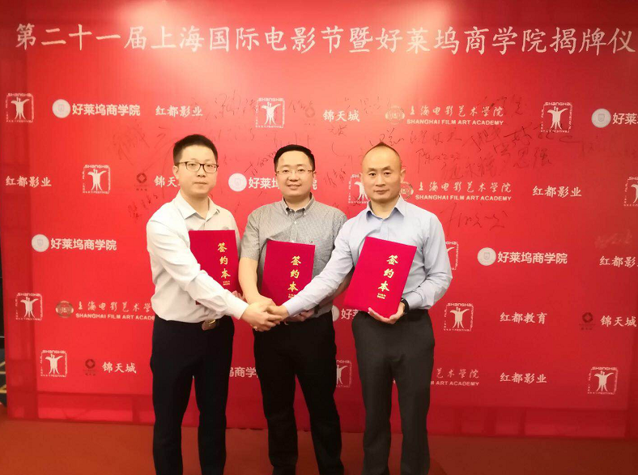

D5TChain (Fifth Chain) is a global film entertainment digital asset trading platform created by the Fifth Foundation of Blockchain technology. It is committed to realizing the industry of the digital asset be securitization, transparency and fairness. according to technology and applications of blockchain try to apply it in the market to the maximum.

As we all know, the core of the entertainment industry is IP. It is diversified. It includes many forms of expression, including but not limited to culture, electronic sports, live broadcast, cartoon, games, music, drama, theme pavilion, ancillary product and so on.

In the era of entertainment, the benefit from IP is a lot, but most of the benefits are occupied by the oligarchs, and all IP practitioners do not get more protection and benefits.

With the development of blockchain technology in recent years, the entertainment industry has ushered in another opportunity.

The Fifth Space Foundation began to use the blockchain technology revolution to build a community and make the past ideas of the entertainment industry be realistic, thus upgrading the entire entertainment industry system!

Jin Yinjie, President of the US Fifth Space Foundation in Chinese Zone, was invited to participate discussion forum of "China-US Film Industry in the Shadow of Chinese and American films industry" and had a wonderful speech.

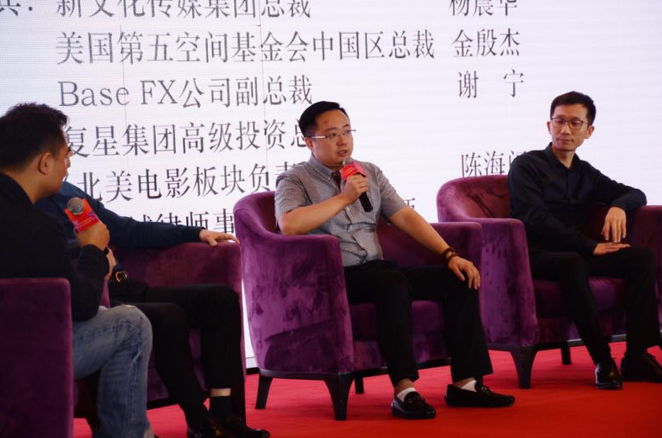

In the past, the entertainment industry was based on a centralized platform. The platform provided an intervening mechanism and charging channel, at the same time, it charged the service charge and the payment of royalty. However, the creators of the massive content with fast cash needed, when transferring to decentralization from centralization, it will become more valuable.

According to information, the core team of D5T (Fifth Chain) consists of: Chris Edwards, Lars Herrmann, Curt Faudon. Among them, Chris Edwards is the CEO of The Third Flood, published Television work including "Avatar", "StarCraft 2: Star of the Heart", "Wonder Woman", "Gravity", "Paddington 2", "Kingsman", currently participates 75% of Hollywood productions in The Third Flood (third floor). Of course, The Third Flood (third floor) also participated in the production of many Chinese films, such as Yimou Zhang 's "Great Wall" and Jingming Guo's "Grand".

Lars Herrmann is a famous cinematographer and director who has advertised for famous brands such as Pepsi, Burger King, Coca-Cola, GM, Corona, Mattel, Heineken, and also often cooperate with famous director Steve Miner. Jeffrey Kimbauer.

Curt Faudon is a famous Austrian director who won first prize and jury award at the film festivals in Cannes, Berlin, Monte Carlo, Chicago, New York and Sydney.

Furthermore, Foundation consultant team of The Fifth Space is also very strong, including professor Mike Peise from University of School of Cinematic Arts,

famous British director and photographer Jane de Bonte,

“The Lord Of The Rings” and” Spider-Man” visual-effects supervisor Jim Rygiel, Chinese writers in the world literary, Geling Yan, Dr. Feng Guo, and founder of Bile, Linyi Zeng.

The Hollywood Business School with a strong core team and foundation advisory components will be a powerful sword for 5T (Fifth Chain). It is not difficult to imagine that the entertainment sector has officially beginning, let us wait and see.

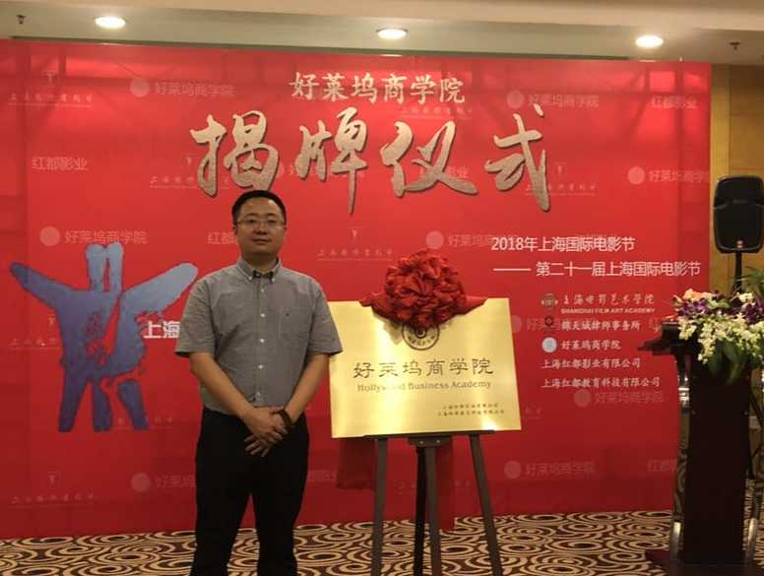

The blockchain + the dividend period of the era is beginning, and its value will gradually be reflected in the landing of blockchains and applications.

I am cross-business finance, give you the latest and most cutting-edge information, long press the QR code and click on the contact to learn more.