1. Seasonal Auto-Regressive Integrated Moving Average (SARIMA) models.
2. The SIRIMA model is used for modeling seasonal time series where the mean and variance of a given season is not fixed across the years. Before we go any further, let us talk about what is a time serie? Times series are values that are recorded at a fixed interval which can be seconds, minutes, hourly, daily, weekly, monthly, and so (Analytics Vidhya)[1].

SARIMA model is used for predicting the sales of a products, it can be also used for estimating the electricity of households, to predict the number of disease incidence, or traffic prediction.

SARIMA model is very successful in analyzing and forecasting times series data with seasonal components (Antonanzas, Javier, et al) [2]

1. Kostas Hatalis states in datasciencecentral.com website that the SARIMA models are “denoted as SARIMA (p, d, q) (P, D, Q) [S]”, “where S is the number of periods for each season, d is the degree of differencing (the number of times the data have had past values subtracted), and P, D, and Q refers to the autoregressive, differencing and moving average terms for the seasonal”[3].

(p, d, q) and (P, D, Q) are nonseasonal and seasonal respectively.

1. SARIMA models apply to times series and numerical data

**4a.** Numerical, and time series

**4b.** There is no minimum number of observations requires because the more we have data, the better the forecasting (Rob J. Hyndman and Andrey V. Kostenko)[4]

**4c**. SARIMA does not work well if the series are not stationary.

Most time

**5a.** SARIMA model works well when the series are stationary. Otherwise, it will get biased coefficients.

SARIMA model has two different seasonally: Additive and Multiplicative

The SARIMA model is based on the Box and Jenkins procedure and has three steps:

Identification, estimation and diagnostic checking (Fredrik Nikolaisen Sävås)[5].

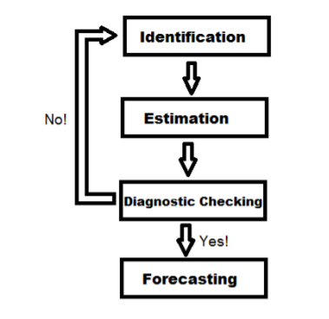

Figure 1: The Box and Jenkins Procedure

Identification refers to the finding of integration orders d and D, the autoregressive orders p and P, and the moving average orders q and Q. It can also be done by finding sample autocorrelation (SAC) and sample partial autocorrelation (SAPC)

Estimation helps to find the best model based on the identification.

Diagnostic Checking

Forecasting

**5b**.

When working with time series, in most cases, we assume that the series are stationary which mean that the mean and the variance do not vary over time.

There is another case also where there is a trend and seasonal over time which we call non-stationarity. Meaning that there is a variation of mean at specific times frames.

**6.**

**6a.**

import pandas as pd

import numpy as np

from scipy.stats import norm

import statsmodels.api as sm

import matplotlib.pylab as plt

%matplotlib inline

from matplotlib.pylab import rcParams

from statsmodels.tsa.statespace.sarimax import SARIMAX

**6b.**

Find the trend and seasonality

Find auto correlation function (ACF) and partial auto correlation function (PACF)

Find coefficient of SARIMAX models based on ACF and PACF

Split the data into training and testing

Create the model

model=SARIMAX(training,order=(4,1,4),seasonal_order=(1,0,0,12),

enforce_stationarity=False,enforce_invertibility=False)

Fit the model

model_fit =model.fit(disp=False)

forecast and plot result.

R =len(testing)

forecast=model_fit.forecast(R times

forecast=np.exp(forecast)

**7.**

**7a.** Plot the forecast result

Find the likelihood

RMSE (Root Mean Square Error)

**7b**. Call the summary method on model_fit.summary()

References

1. <https://www.analyticsvidhya.com/blog/2018/08/auto-arima-time-series-modeling-python-r/>
2. Antonanzas, Javier, et al. "Review of photovoltaic power forecasting." *Solar Energy* 136 (2016): 78-111.
3. <https://www.datasciencecentral.com/profiles/blogs/tutorial-forecasting-with-seasonal-arima>
4. <http://www.bishophill.com/admin/sidebar_images/1741759940_test.pdf>
5. <https://www.diva-portal.org/smash/get/diva2:631413/FULLTEXT01.pdf>