@Class-02-2026-08-27-Thursday

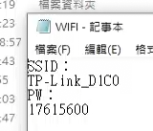
SSID
TP-Link_D1C0
PW
17615600

https://k10206.tistory.com/m/1083

上課講義
https://drive.google.com/drive/folders/1wth9PMujGX4s0x4QwWgb8-obzv2D3TiA

https://drive.google.com/drive/mobile/folders/1ZjaP_u2fQAy0a2aj4NfnfnVdSSu2Mn1p

工業4.0概論(I-4.0; Industrial-4.0)

上課講義
https://drive.google.com/drive/folders/1wth9PMujGX4s0x4QwWgb8-obzv2D3TiA

https://drive.google.com/drive/mobile/folders/1ZjaP_u2fQAy0a2aj4NfnfnVdSSu2Mn1p

미쓰비시 GX Works3 (V1.128J) 다운로드
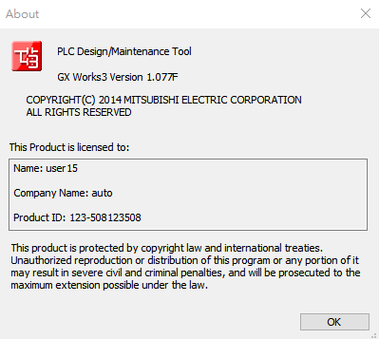

@2026-09-03
- PLF（下降緣脈衝
  - Matched filter
  - https://www.junyiacademy.org/new-video/-4kfaILZU2c?parent-topic-id=nycu-ocw-004

@2026-09-08
- 01-DVP-PLC101samples_tc

- 1-61.6 互鎖控制回路
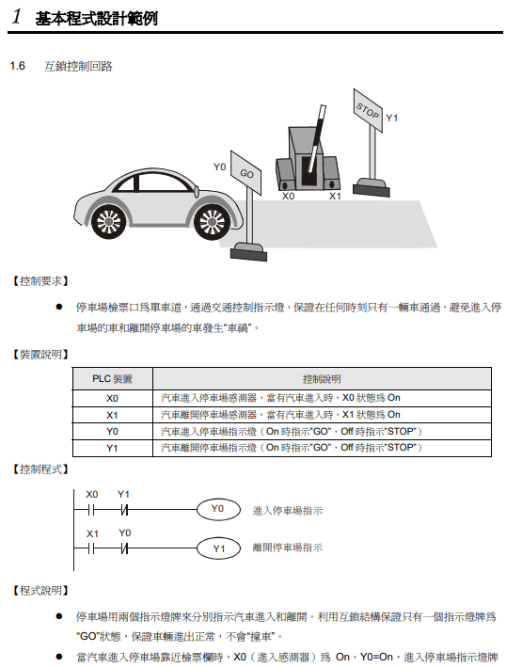

- 1.7 上電時參數的自動初始化
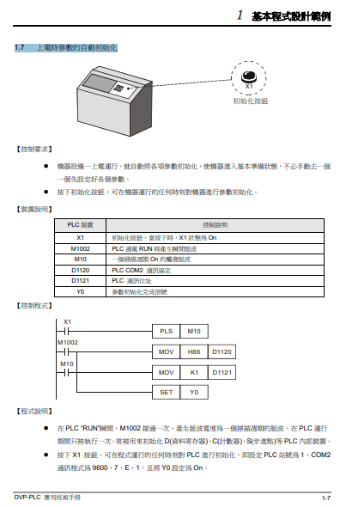

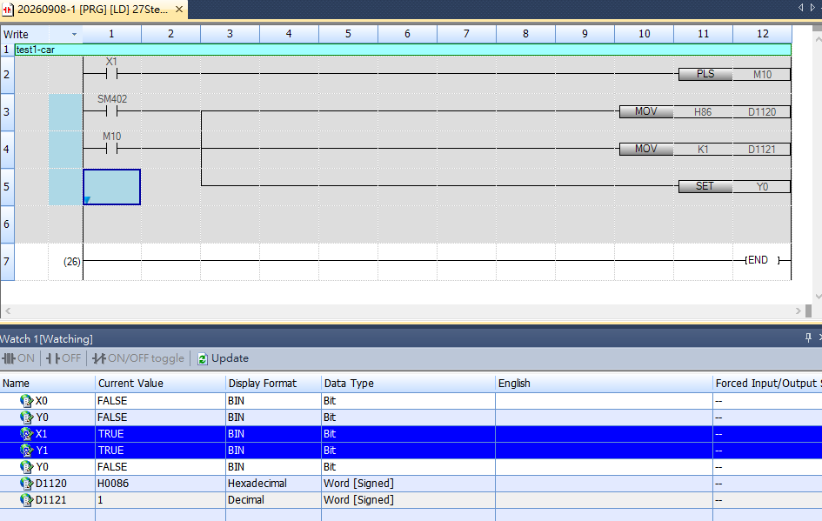

- 1.8 傳統自保持回路與 SET/RST 應用
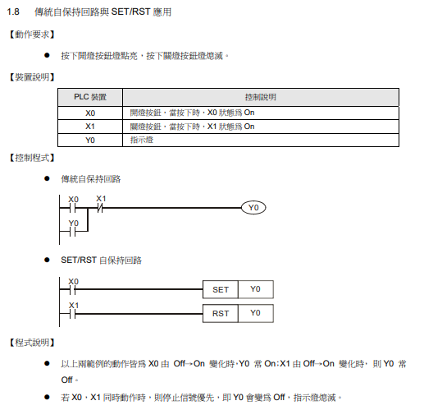
- 1.9 自保持與解除回路 (SET/RST)
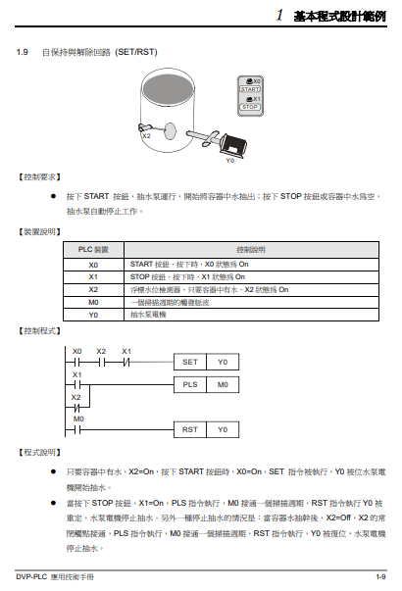
- 1.10 交替輸出回路 (輸出具停電保持)
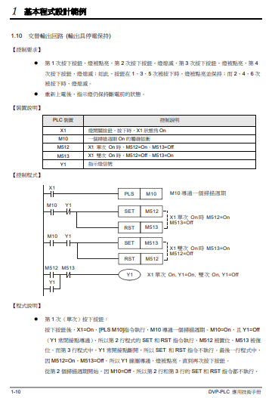

- 1.11 條件控制回路
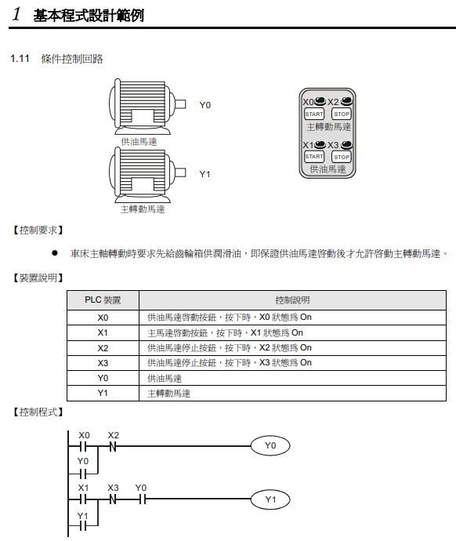
- 1.12 先入信號優先回路
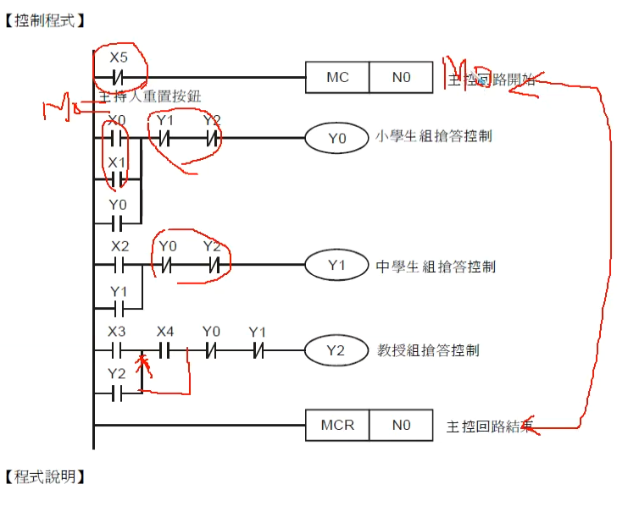
- 1.13 後入信號優先回路
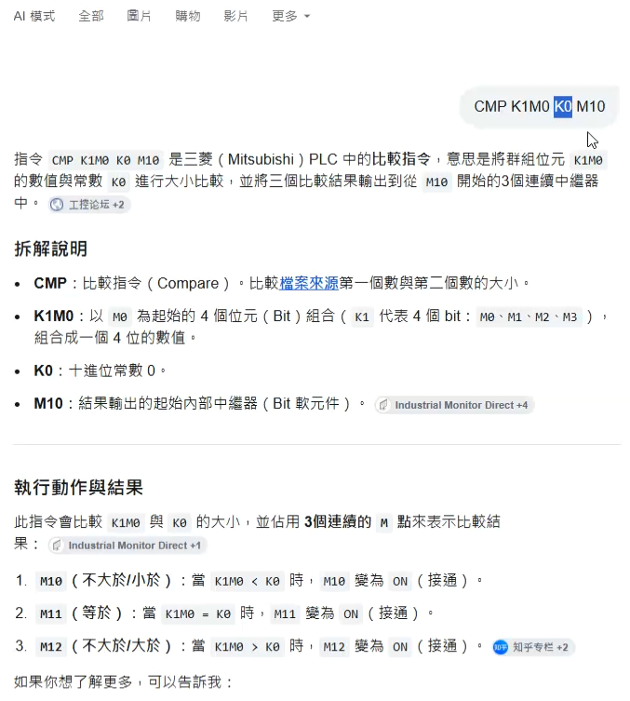
- 1.14 地下停車場出入口進出管制
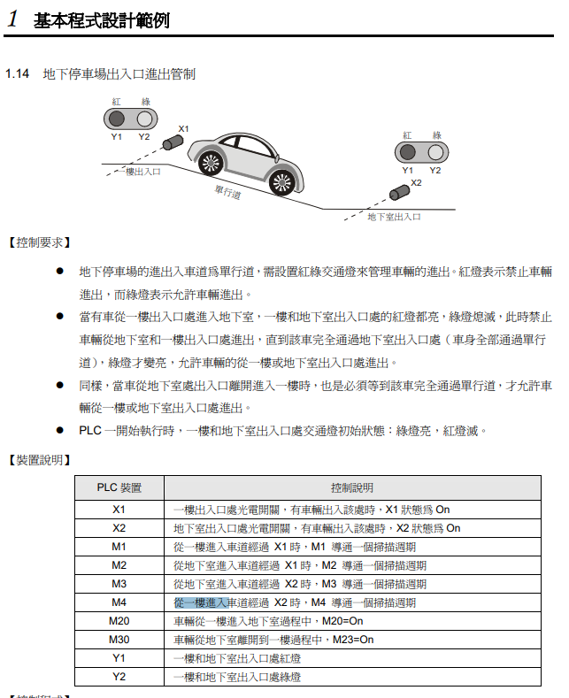

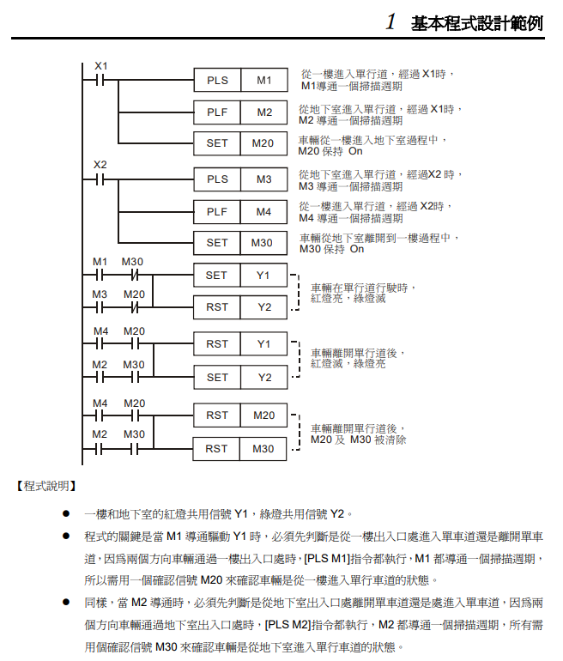

- 1.16 程式的選擇執行
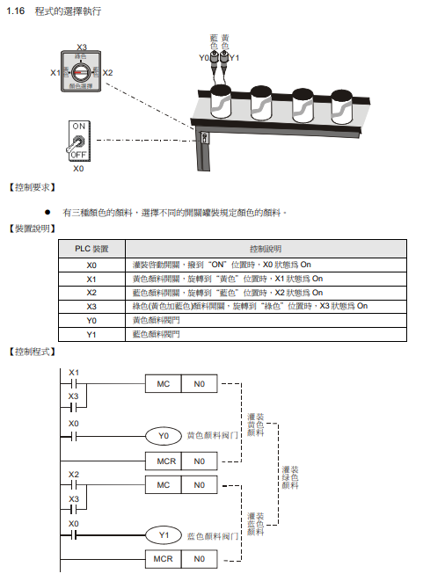
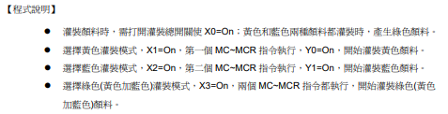

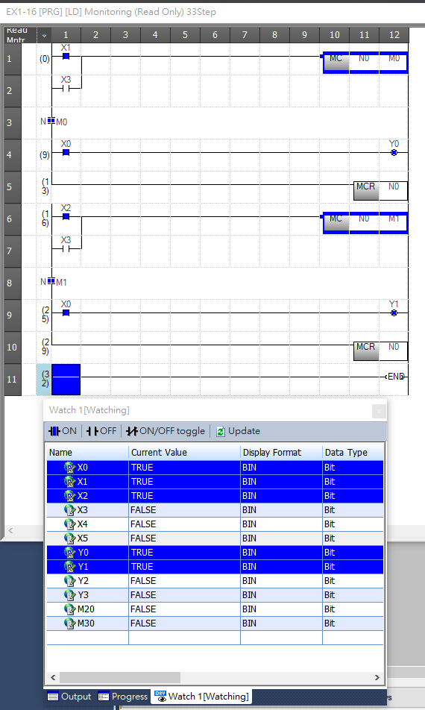

- 1.17 MC/MCR 手自動控制
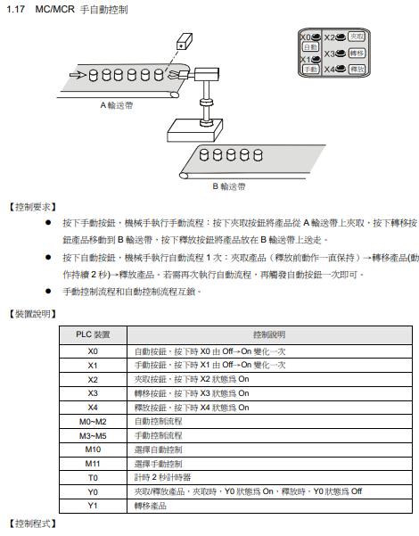
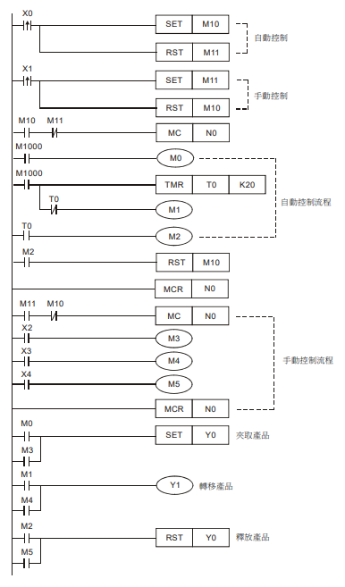
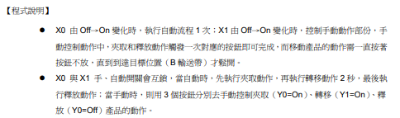

上面沒做，跳2.1

- .1 產品的批量包裝
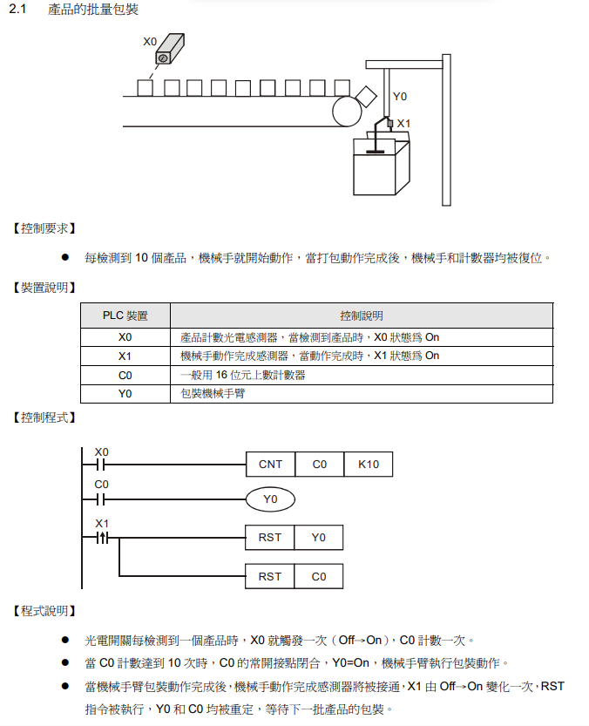

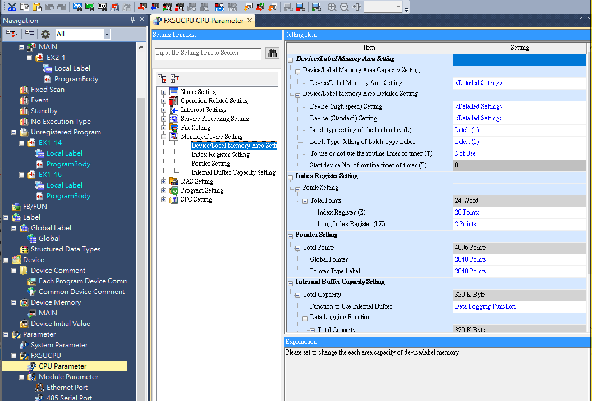
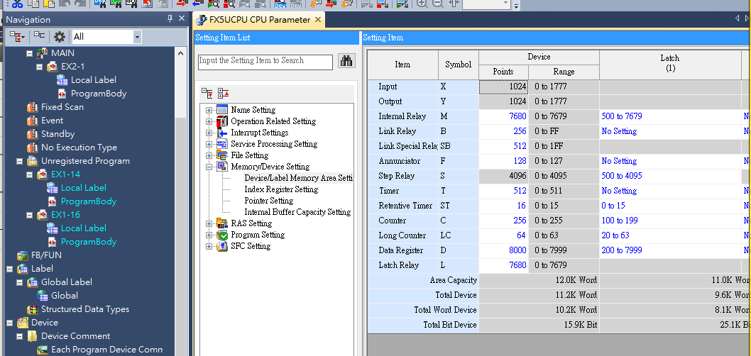

- 2.3 產品出入庫數量監控 (32 位元上下數計數器)
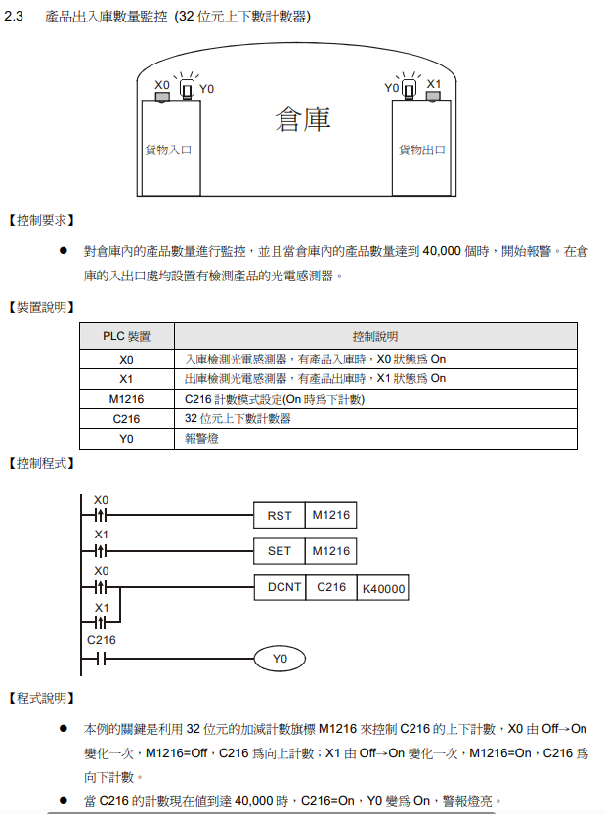
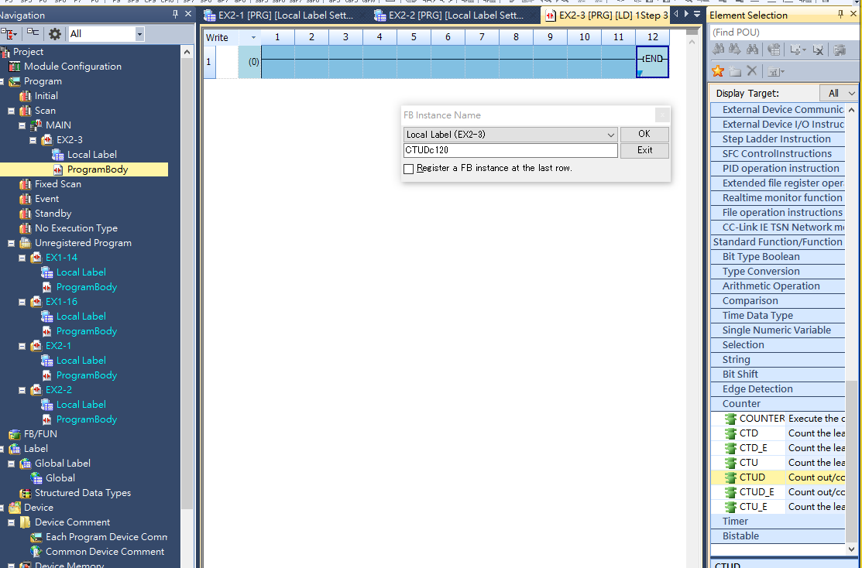

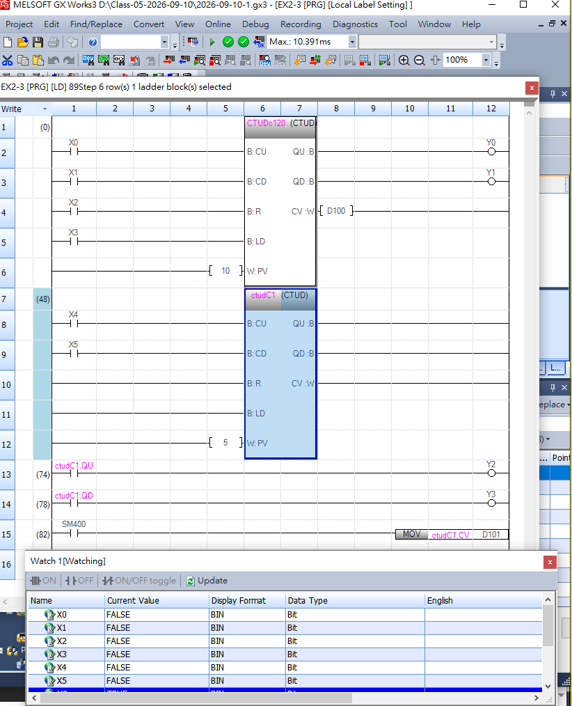

- aaa2.4 3 個計數器構成的 24 小時時鐘
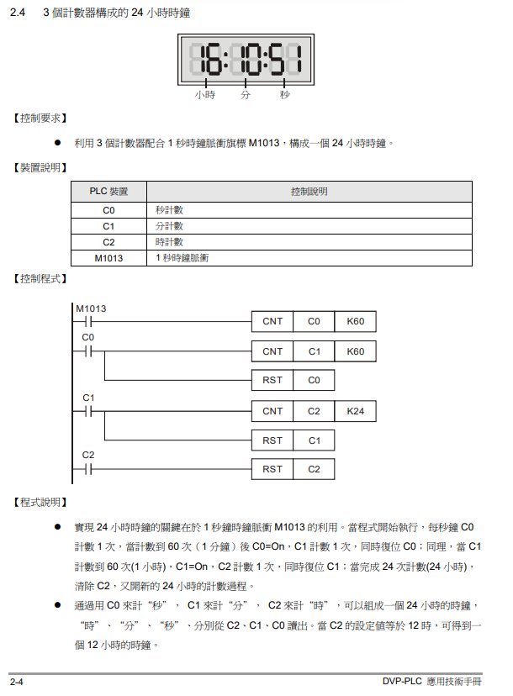

https://k10206.tistory.com/m/1083

미쓰비시 GX Works3 (V1.128J) 다운로드
- 3.1 延時 Off 程式
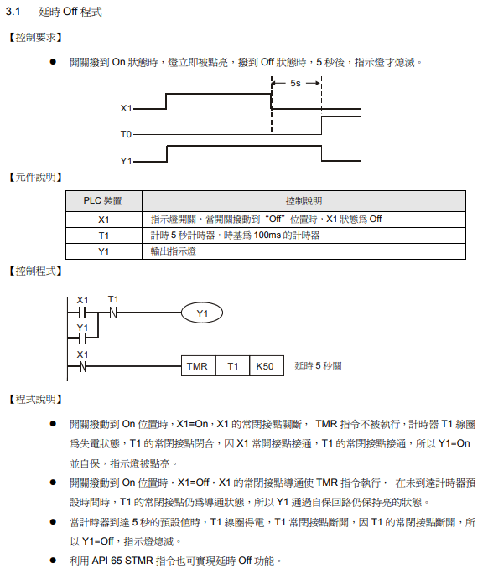
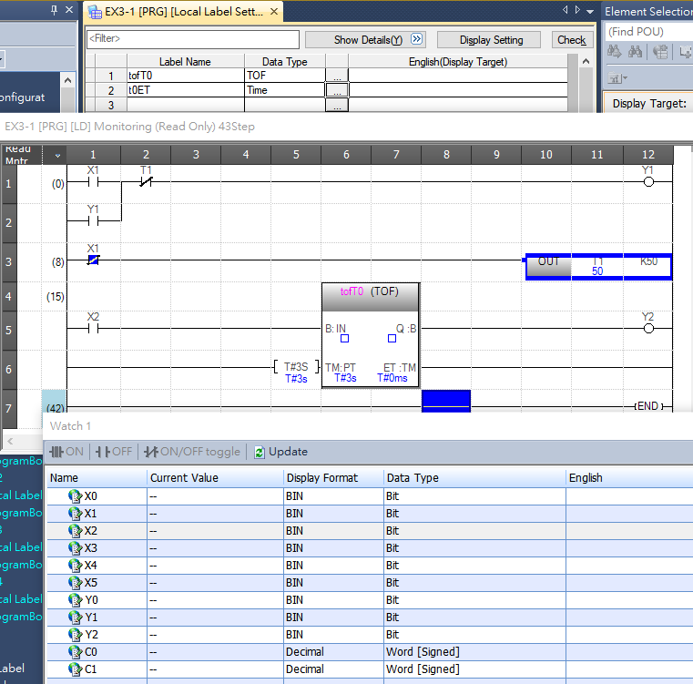
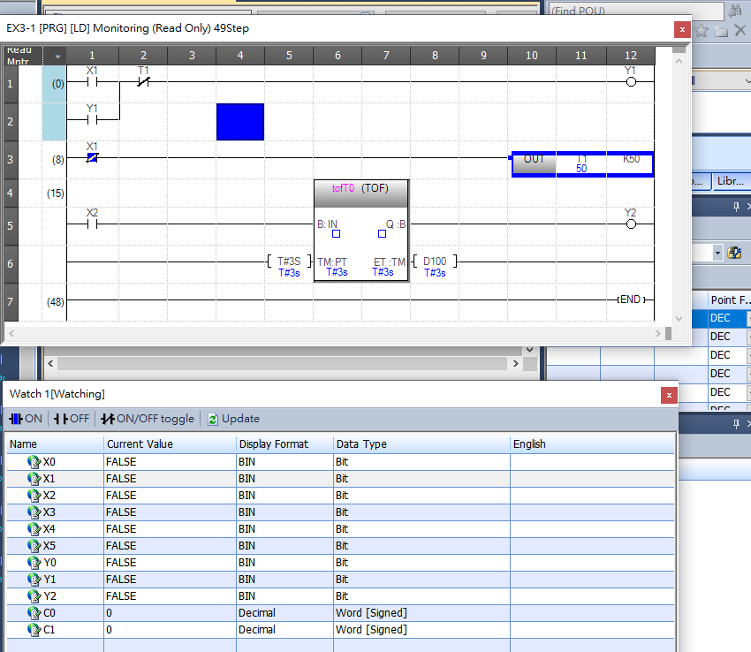
@2026-09-15-TUESDAY@
- 反應速率
  - RELAY 繼電器 反應速率 是 ms(milisecond) 10⁻³
  - TR 電晶體 是 us(microsecond) 10⁻⁶
- PLC IP ADDRESS
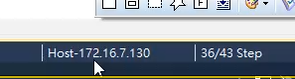

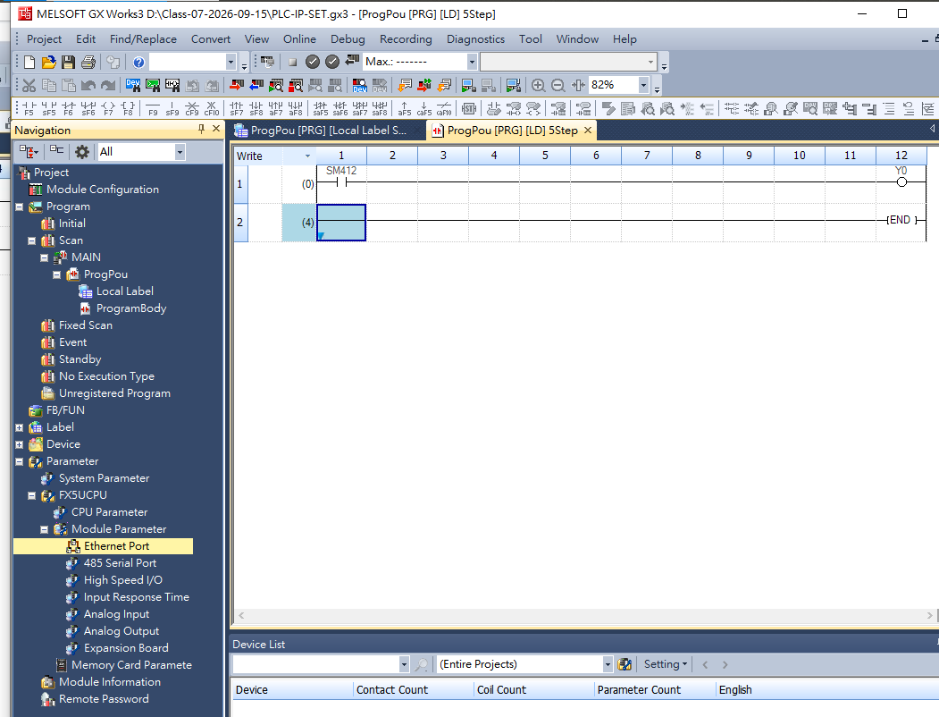

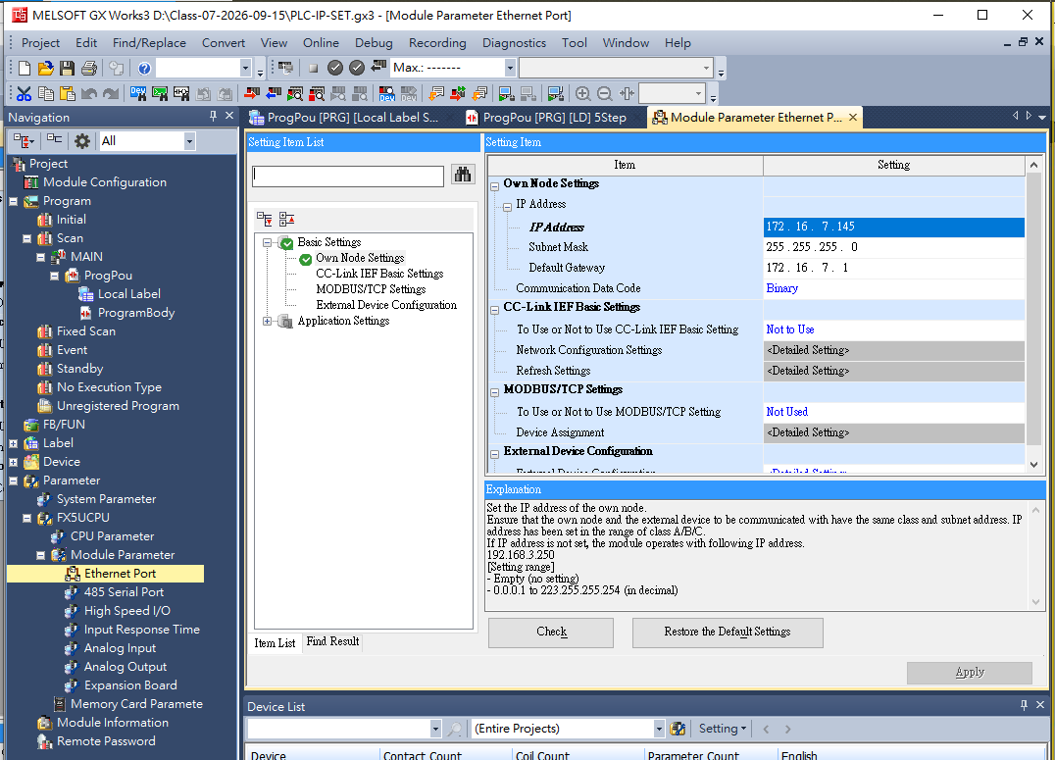
130+15=145

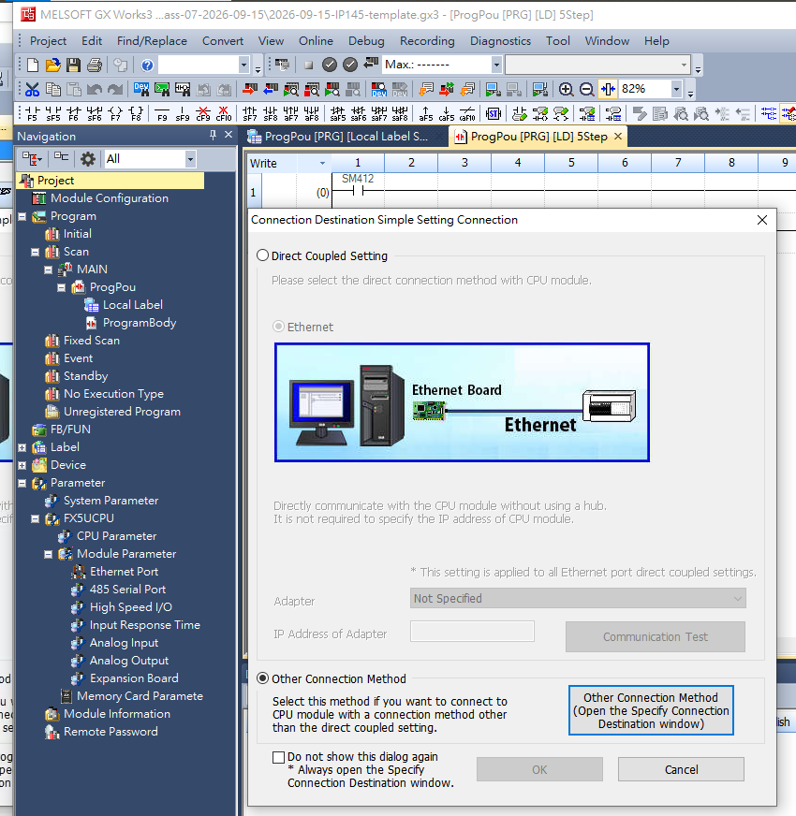

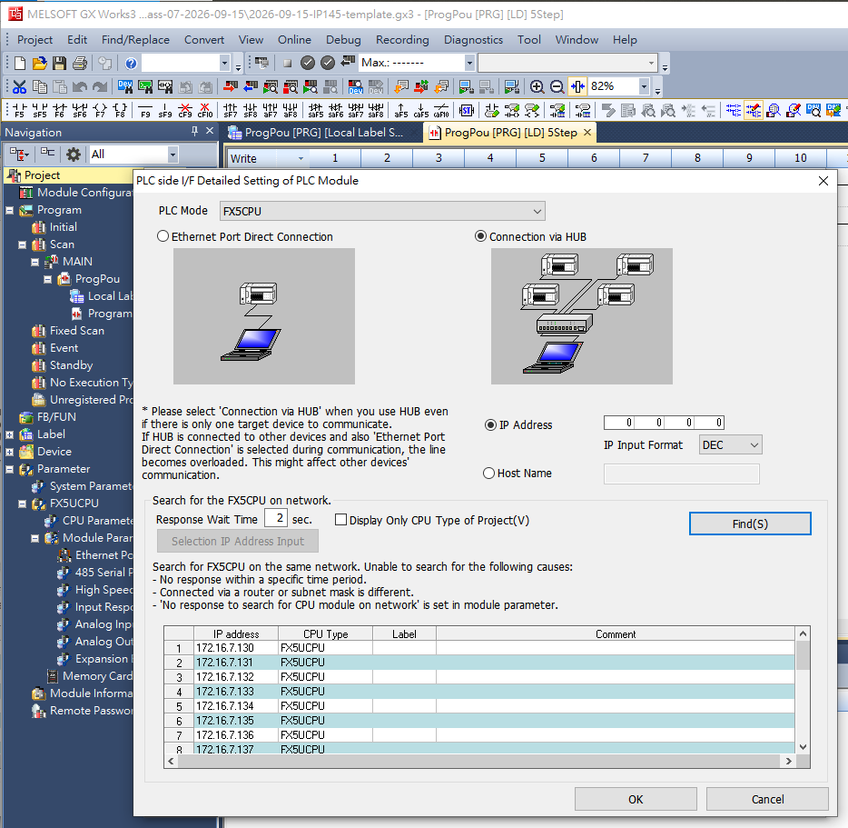

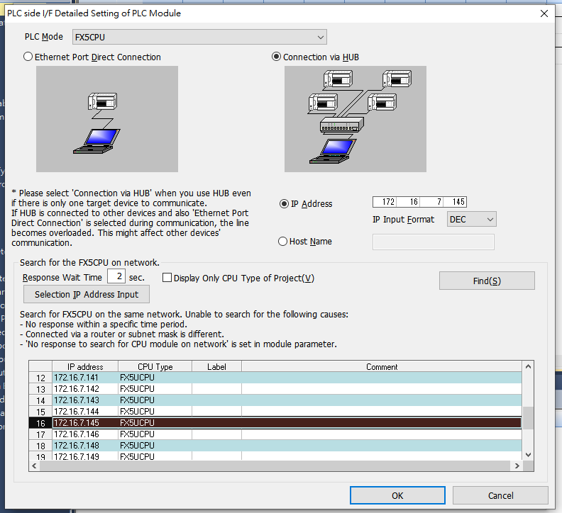

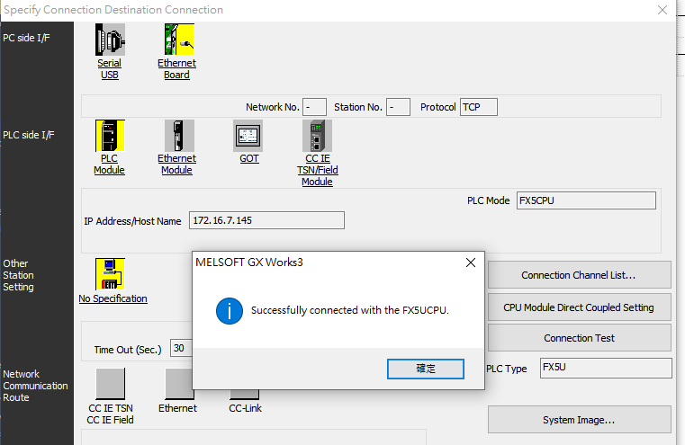

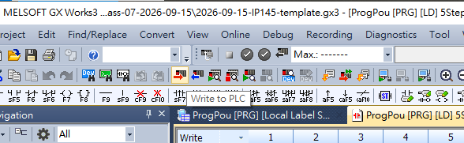

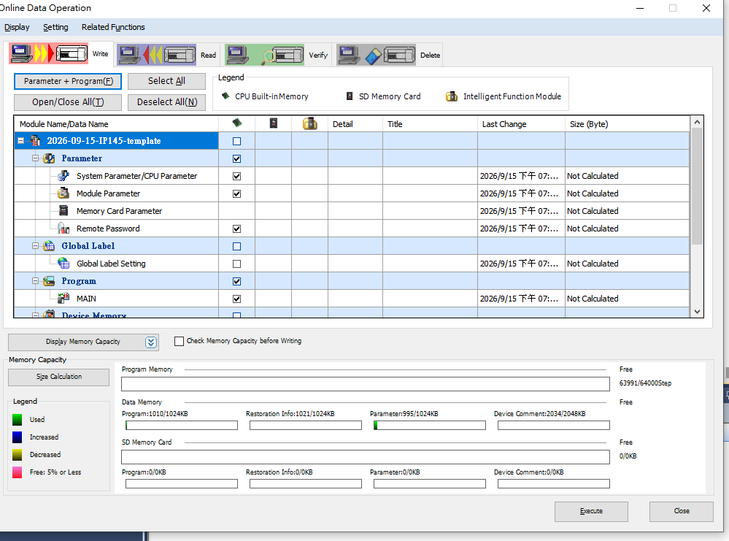

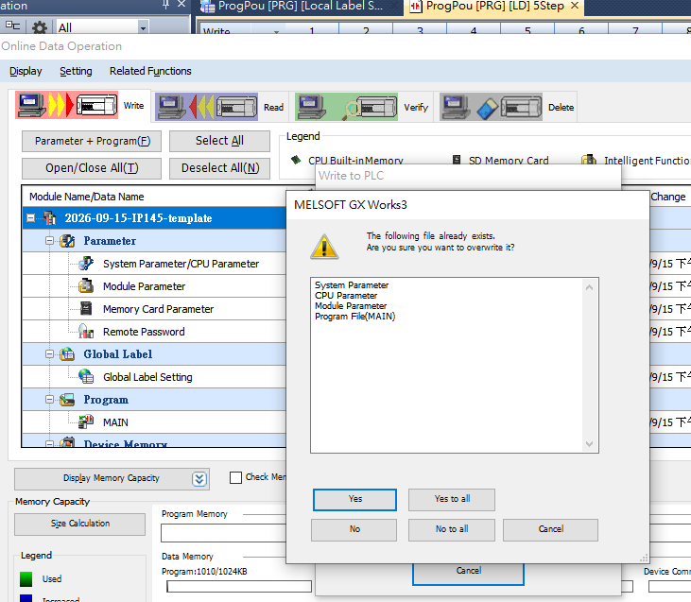

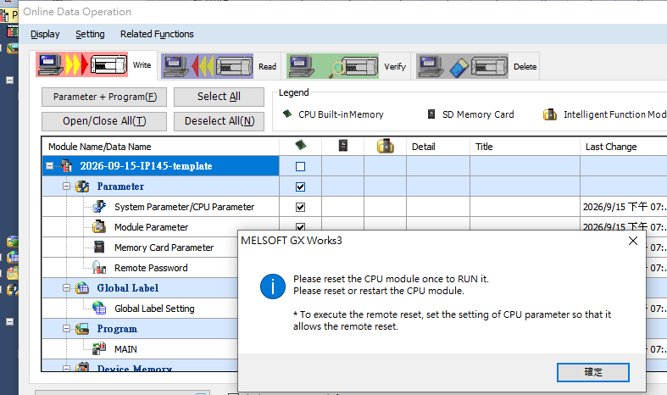

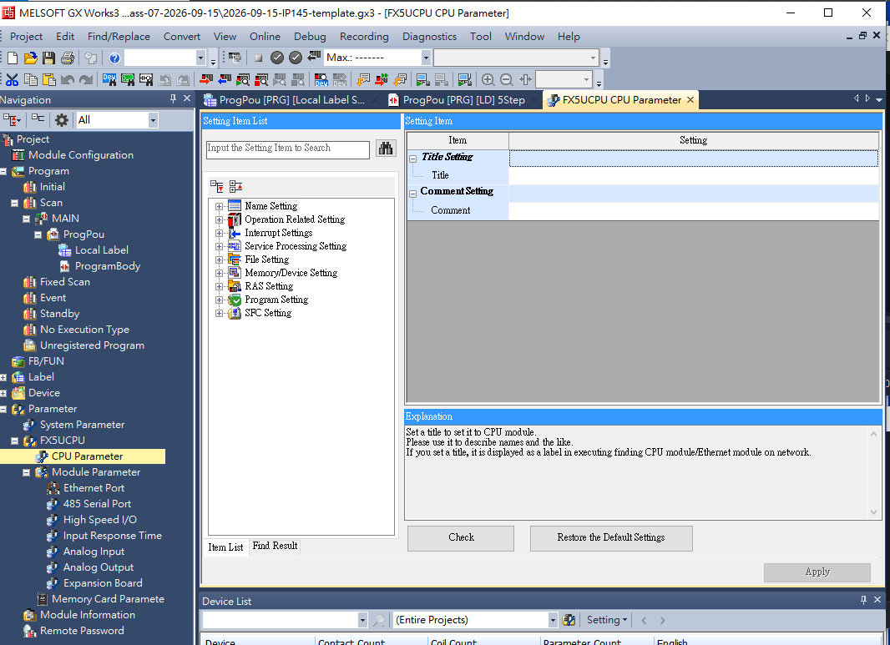

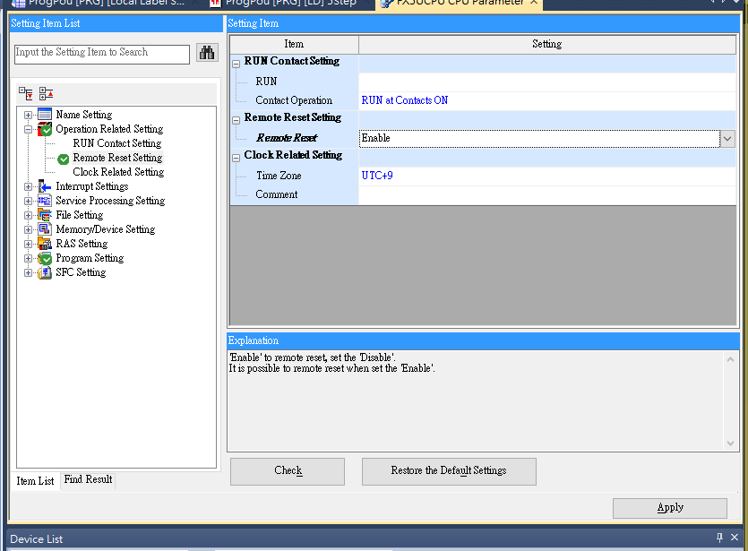

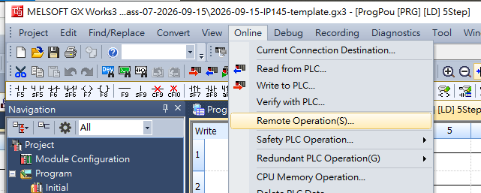

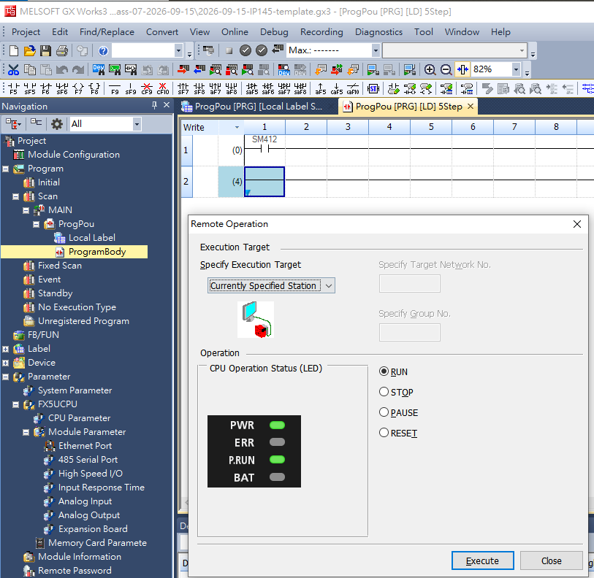

@2026-09-17

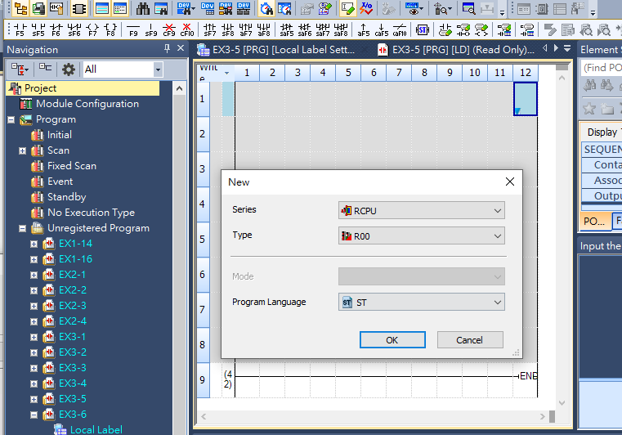

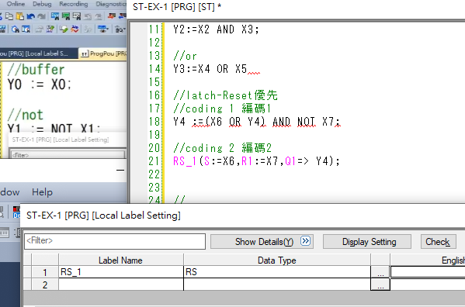

@2026-09-29

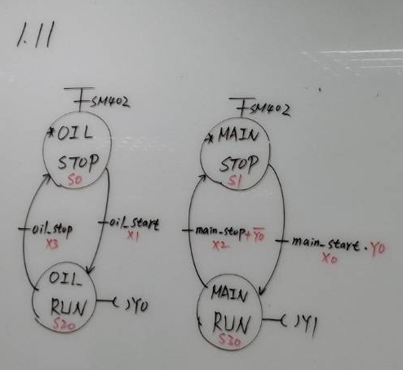

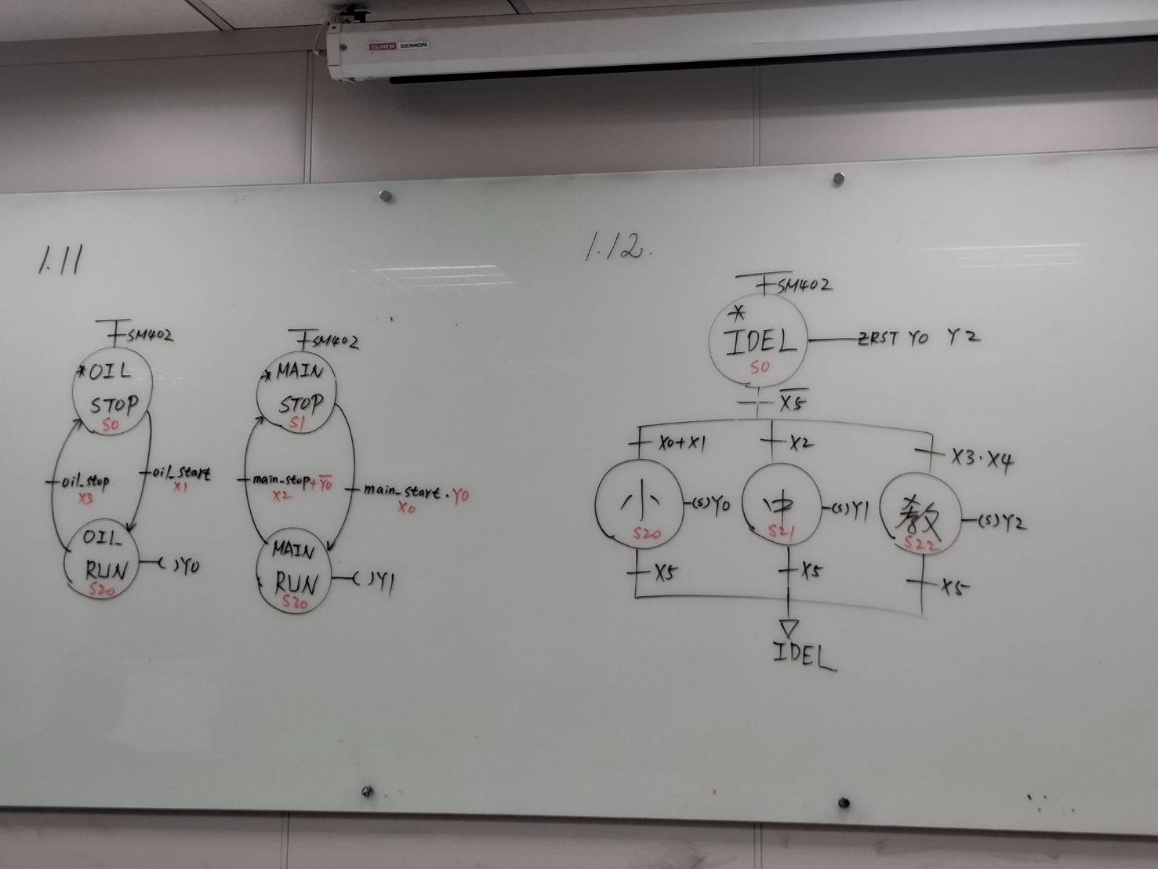

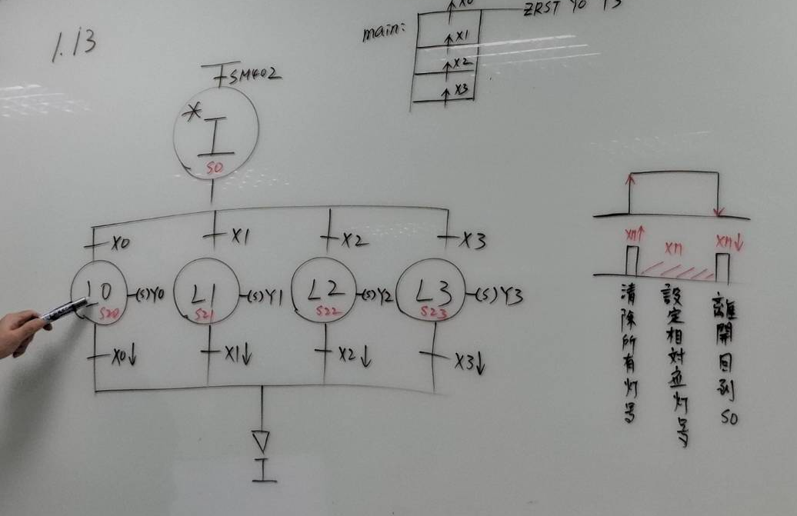
@2026-10-01-

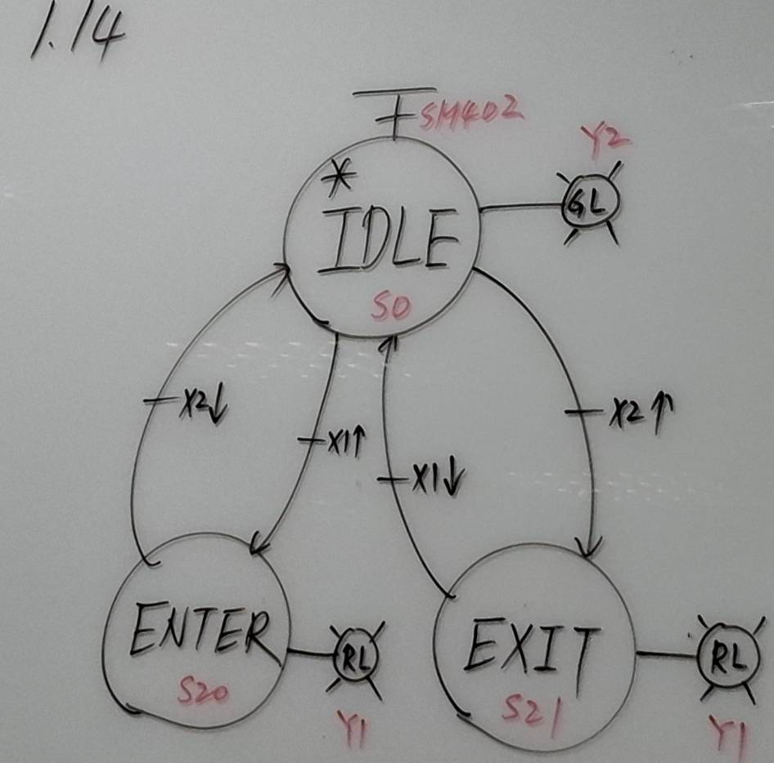

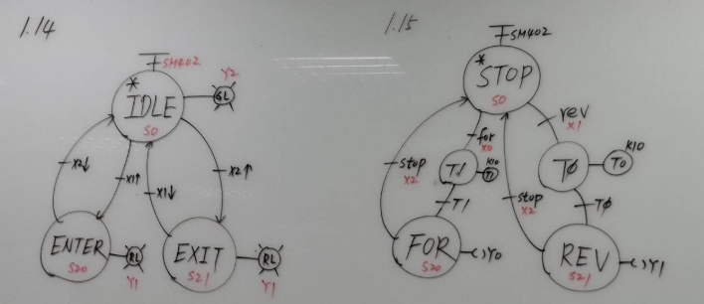

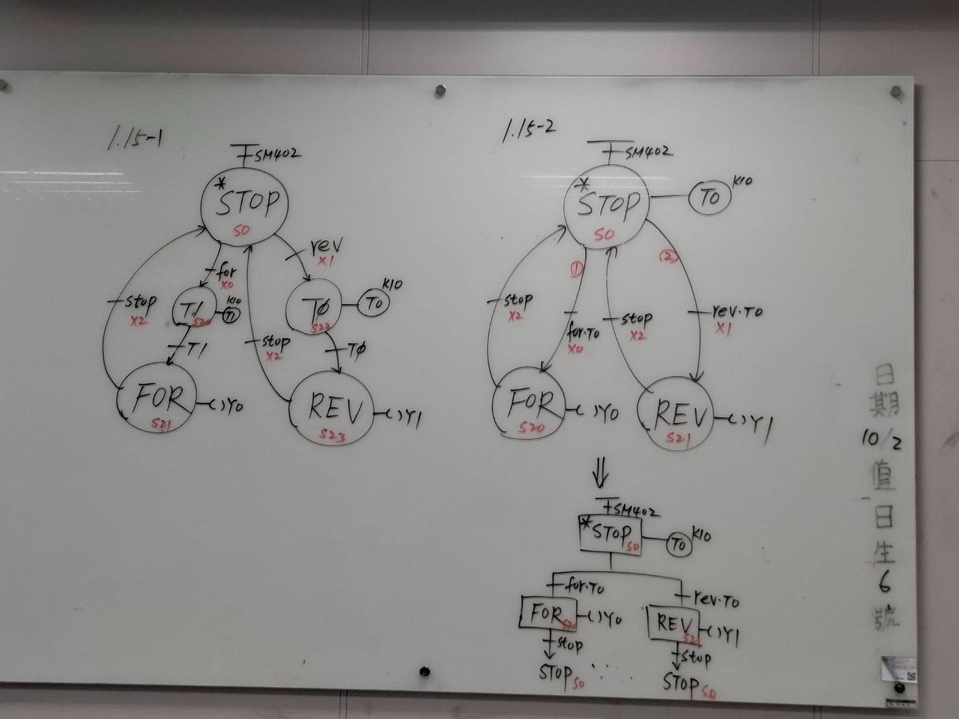

@2026-10-06-

MX Configurator
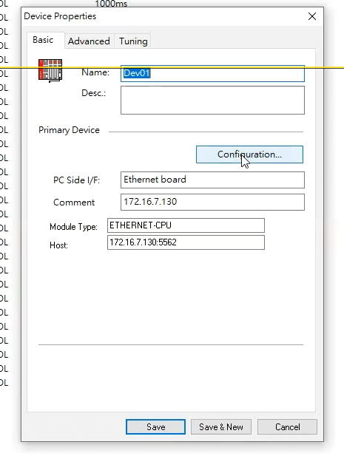
172.16.7.145
130+15

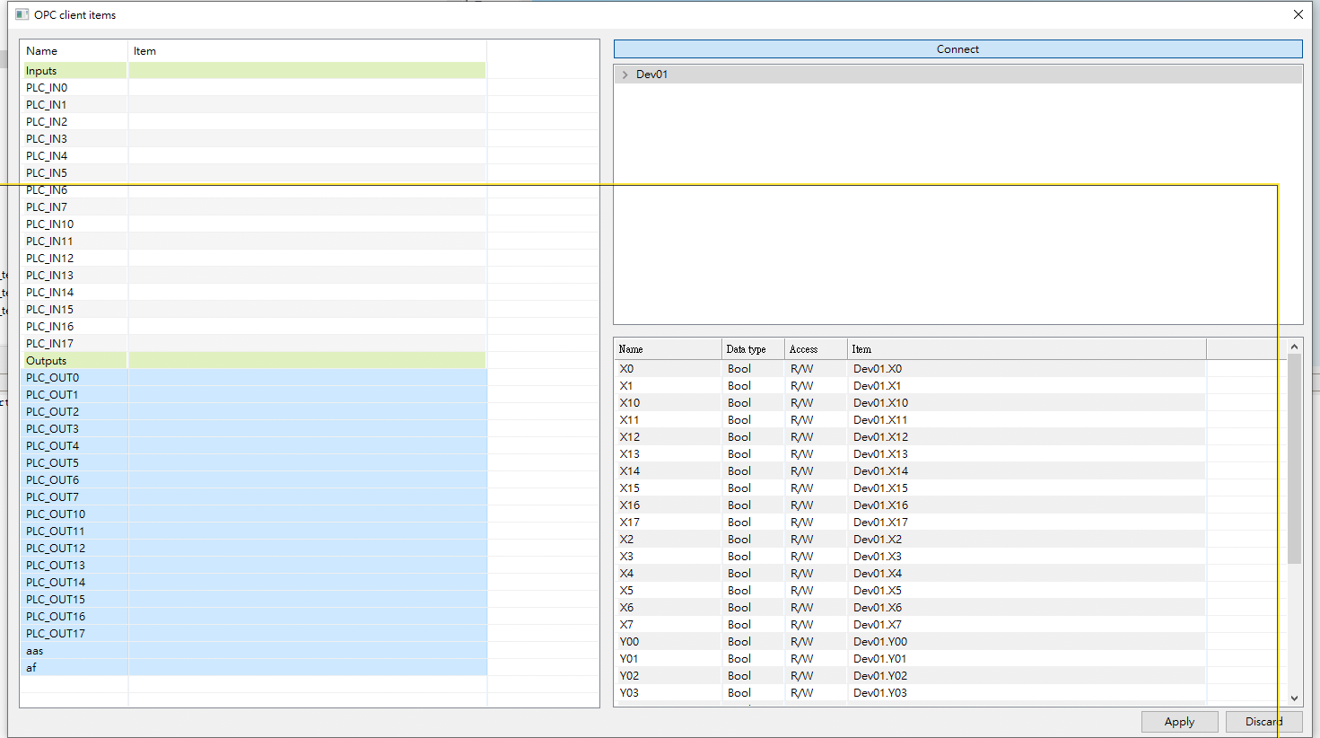

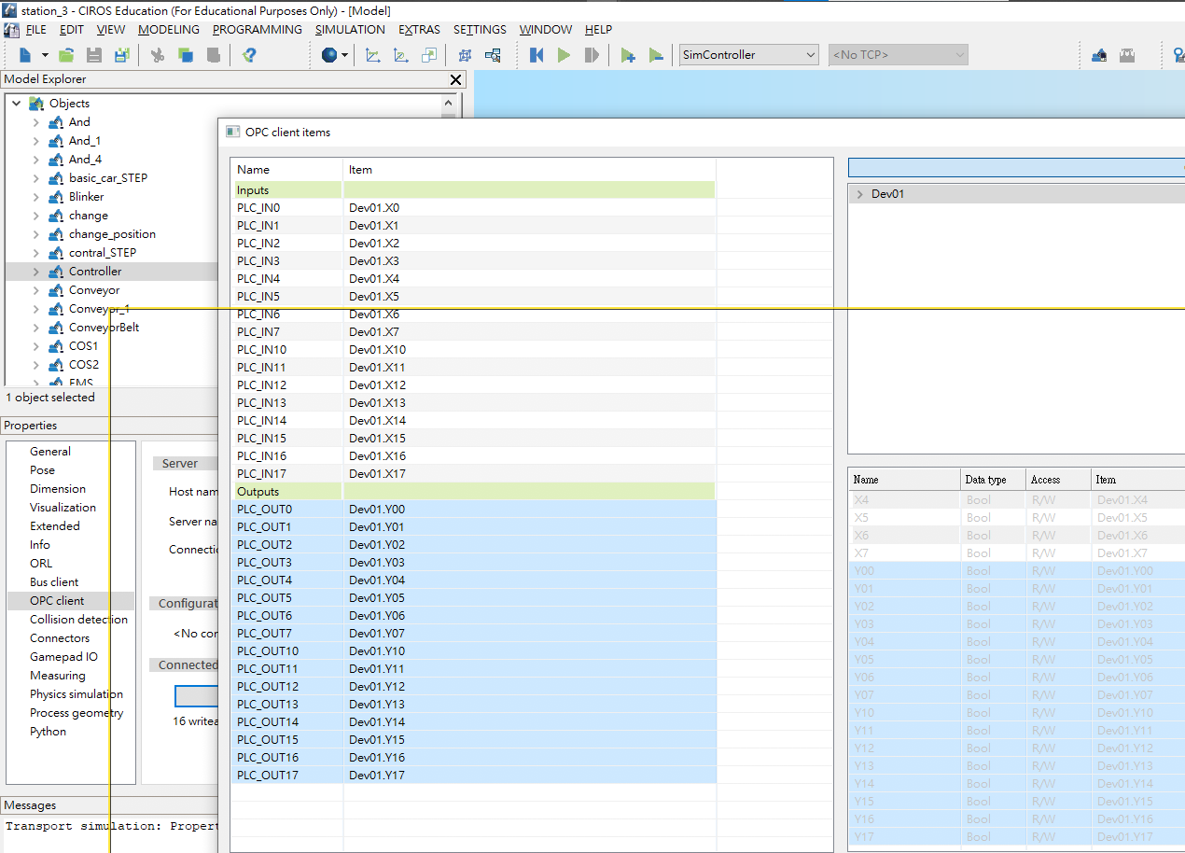

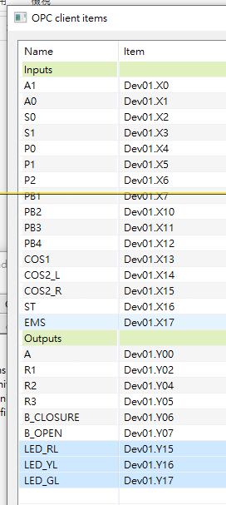
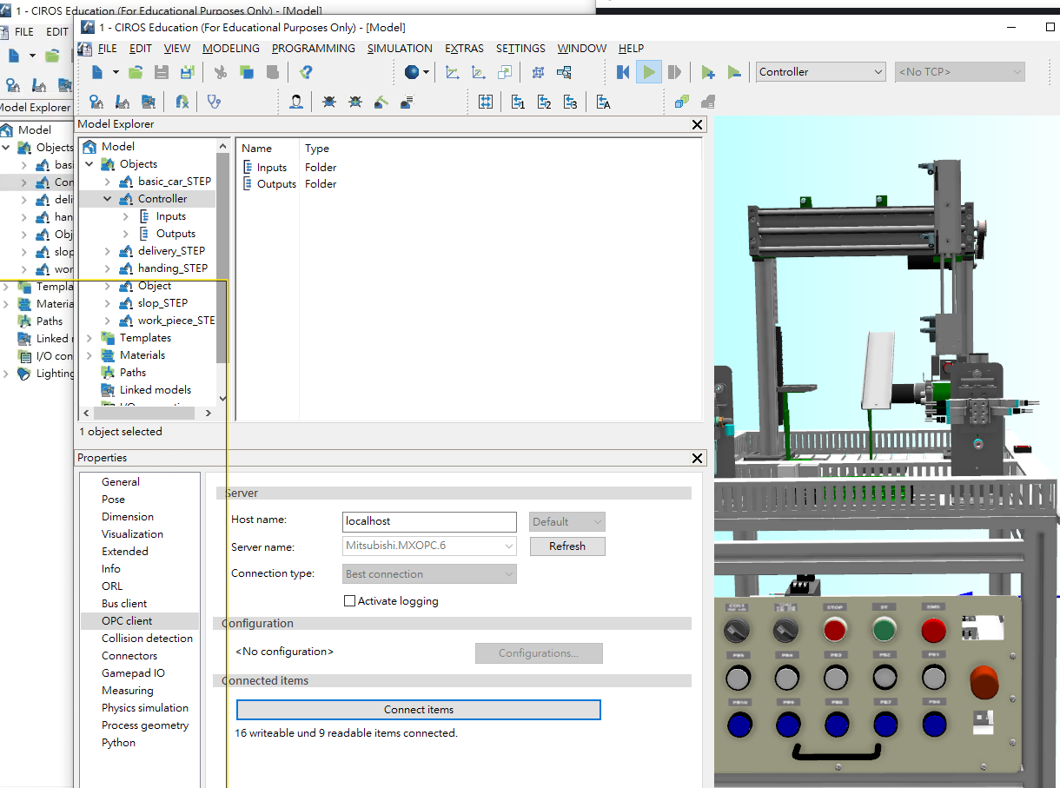
#202610-08

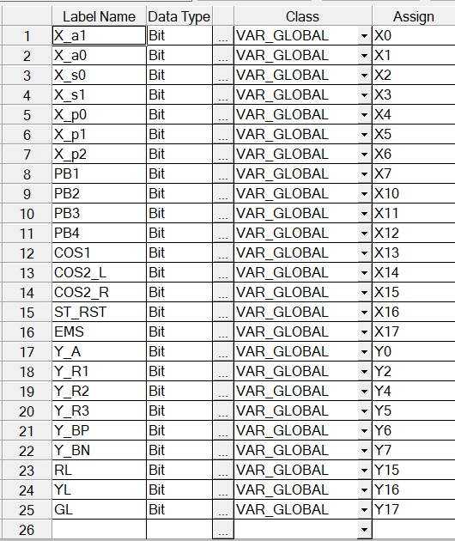

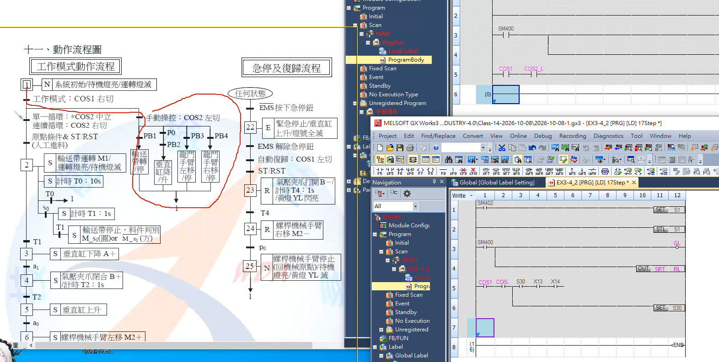

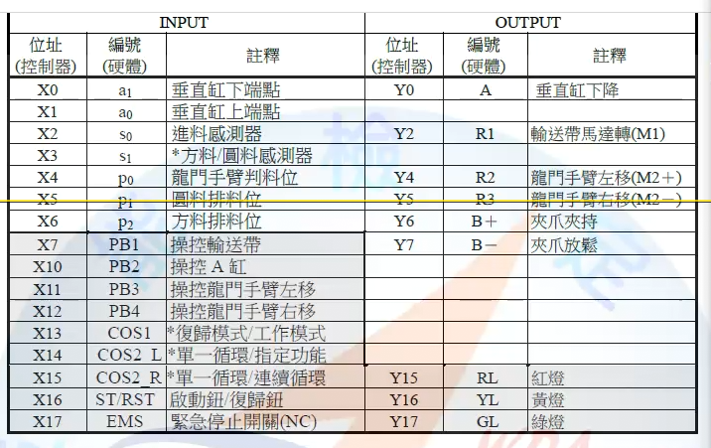

#2026-10-15-1

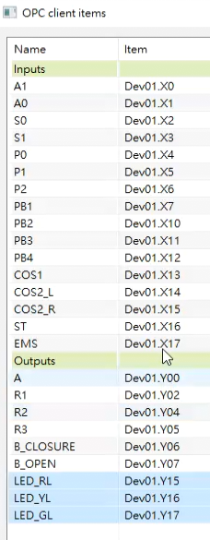

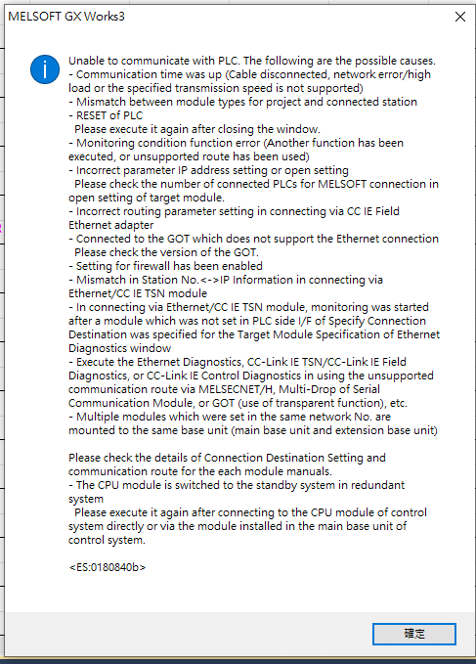
2026-10-20-1

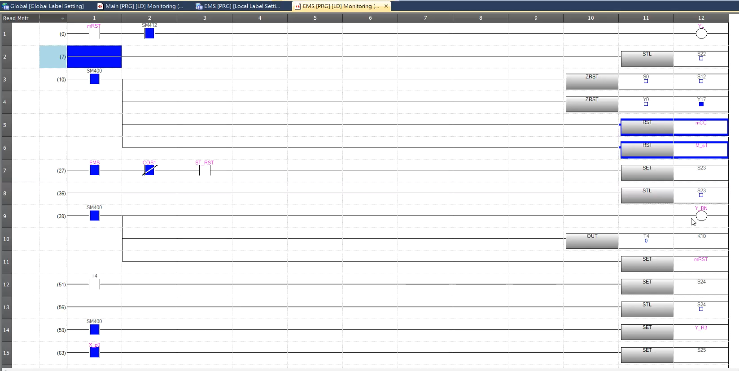
- node-red-contrib-ui-led

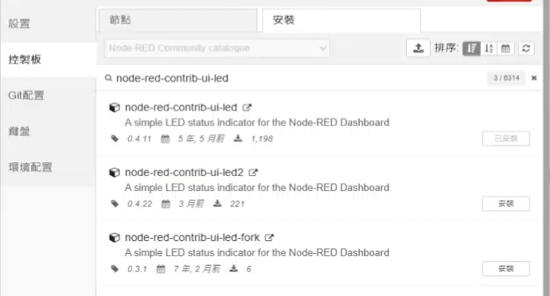

@2026-10-29-CL21
- 8bit 16 bit
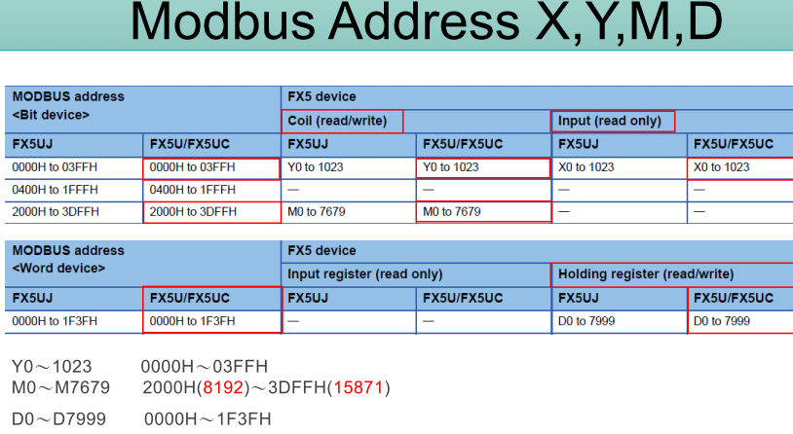

msg.payload =
{
value: msg.payload,
'fc': 5, //FC 5: Force Single Coil
'unitid': 1,
'address': 8292, // (8192 + offset) M100= 8192+100=8292
'quantity': 1
}
return msg;

msg.payload ={
value: msg.payload,
'fc': 5,
'unitid': 1,
'address': 0,
'quantity': 1
}
return msg;

msg.payload =
{
value: msg.payload,
'fc': 1,
'unitid': 1,
'address': 8292,
'quantity': 1
}
return msg;

- 2222

