@Class-02-2026-08-27-Thursday

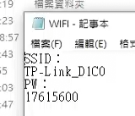
SSID
TP-Link_D1C0
PW
17615600

- Class03 資料
https://drive.google.com/drive/folders/1ZjaP_u2fQAy0a2aj4NfnfnVdSSu2Mn1p

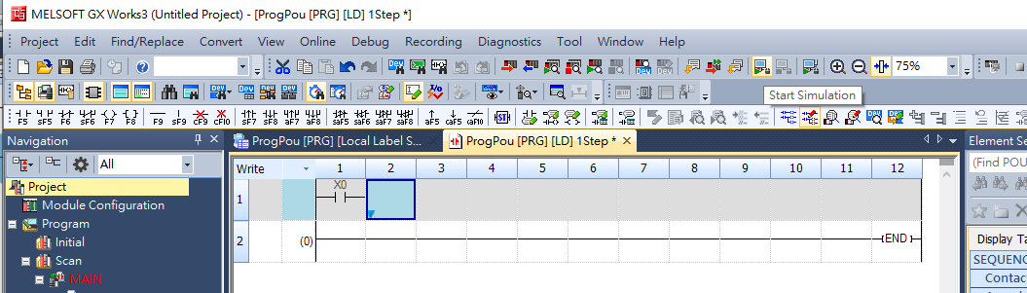

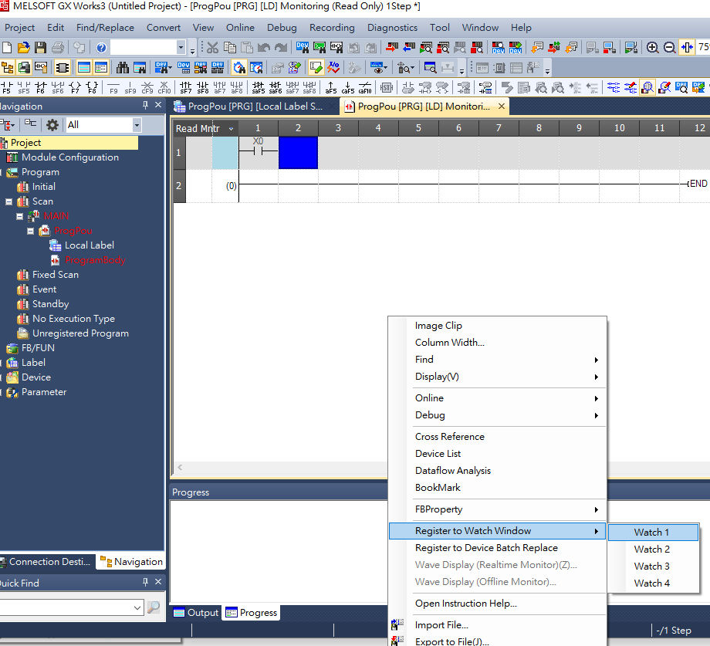
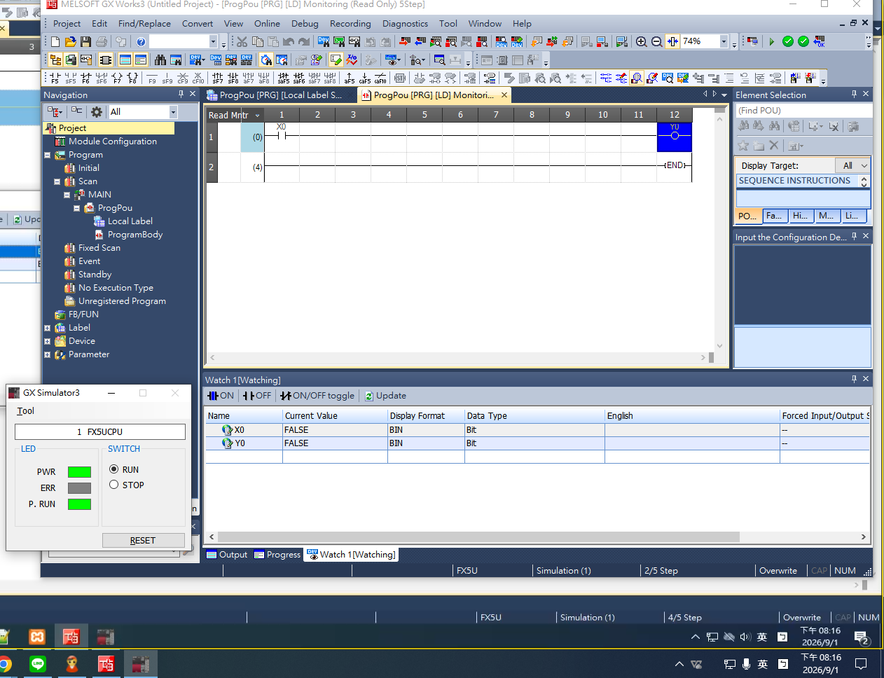
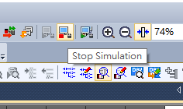
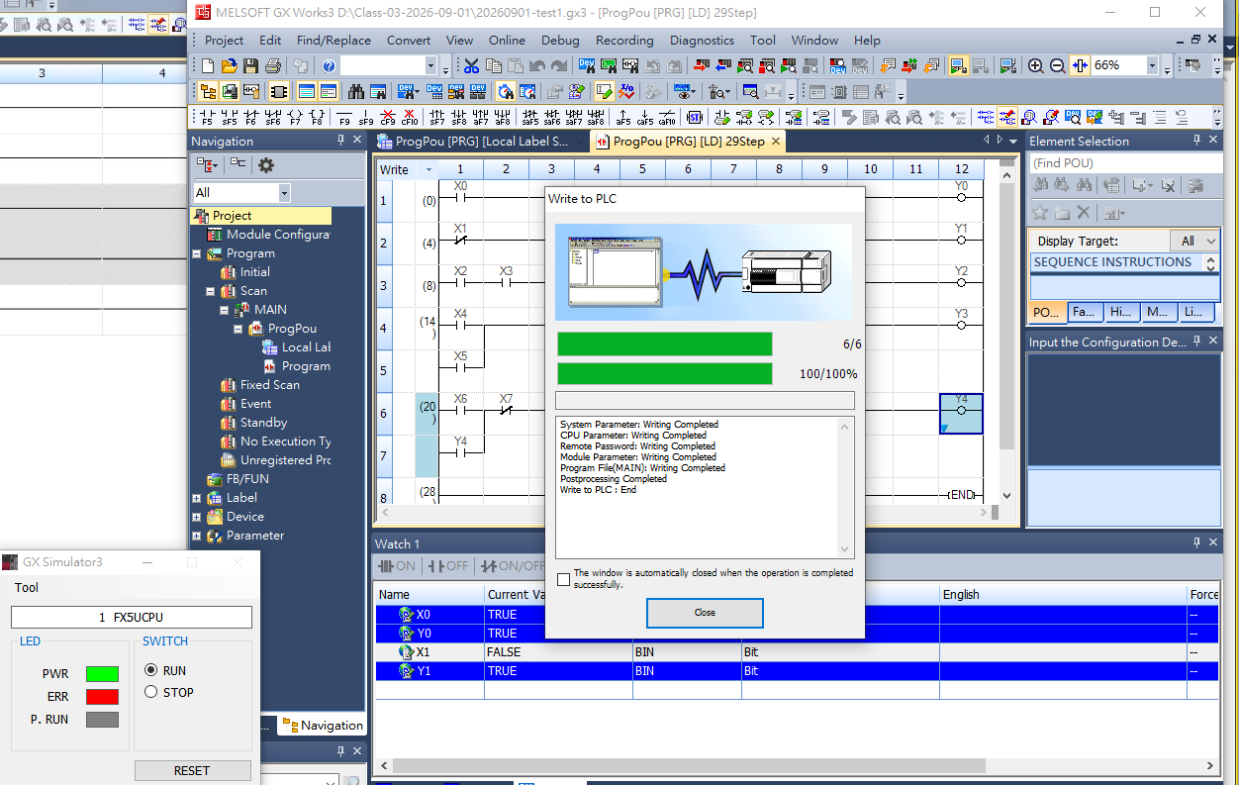
- 重要操作順序
  - 切換write
  - Transfer(=compile)
  - Simulatiom (這時候會下載的虛擬PLC)
  - Watch1 window 操控

- Final
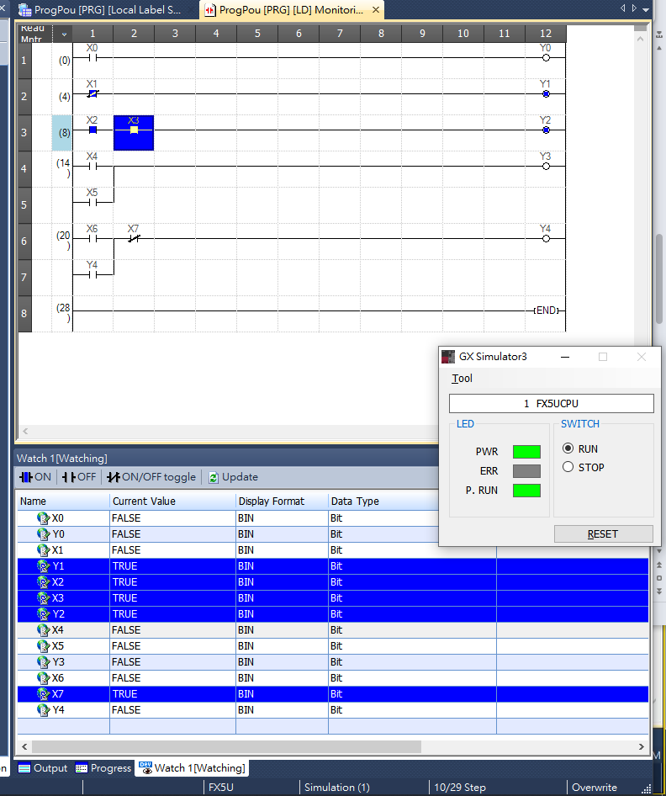
- Hot key
  - Compile=trandfer >>F4
  - Add row >> Shift+insert
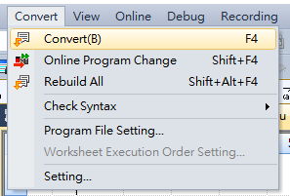
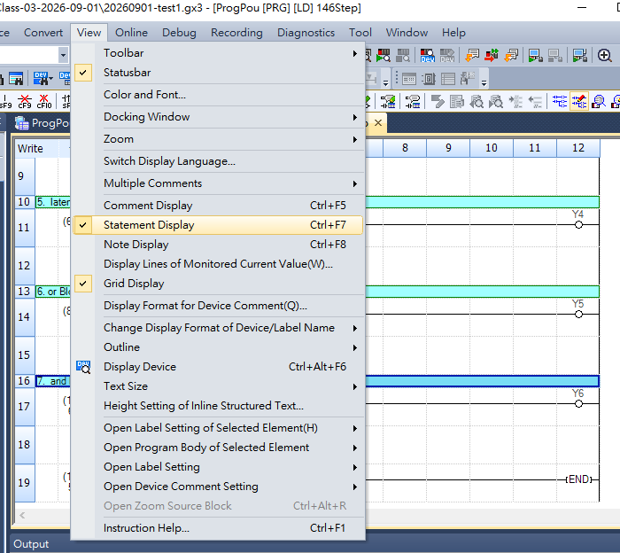

- 2222

