@Class-02-2026-08-27-Thursday

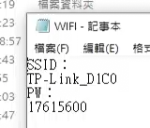
SSID
TP-Link_D1C0
PW
17615600

@2026-09-03
- PLF（下降緣脈衝
  - Matched filter
  - https://www.junyiacademy.org/new-video/-4kfaILZU2c?parent-topic-id=nycu-ocw-004

- 2222

