@Class-02-2026-08-27-Thursday

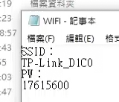
SSID
TP-Link_D1C0
PW
17615600

- 2222

