@Class-02-2026-08-27-Thursday

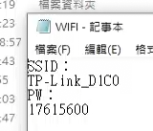
SSID
TP-Link_D1C0
PW
17615600

https://k10206.tistory.com/m/1083

上課講義
https://drive.google.com/drive/folders/1wth9PMujGX4s0x4QwWgb8-obzv2D3TiA

https://drive.google.com/drive/mobile/folders/1ZjaP_u2fQAy0a2aj4NfnfnVdSSu2Mn1p

工業4.0概論(I-4.0; Industrial-4.0)

上課講義
https://drive.google.com/drive/folders/1wth9PMujGX4s0x4QwWgb8-obzv2D3TiA

https://drive.google.com/drive/mobile/folders/1ZjaP_u2fQAy0a2aj4NfnfnVdSSu2Mn1p

미쓰비시 GX Works3 (V1.128J) 다운로드
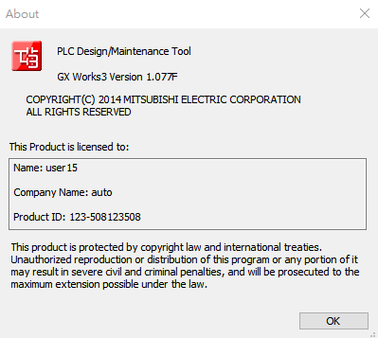

@2026-09-03
- PLF（下降緣脈衝
  - Matched filter
  - https://www.junyiacademy.org/new-video/-4kfaILZU2c?parent-topic-id=nycu-ocw-004

@2026-09-08
- 01-DVP-PLC101samples_tc

- 1-61.6 互鎖控制回路
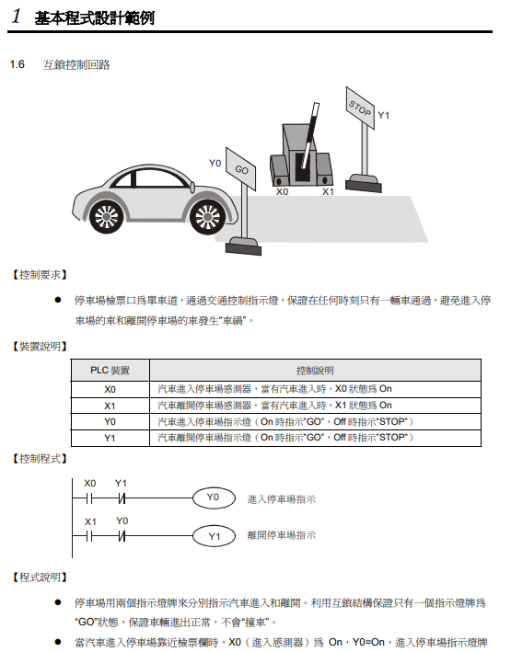

- 1.7 上電時參數的自動初始化
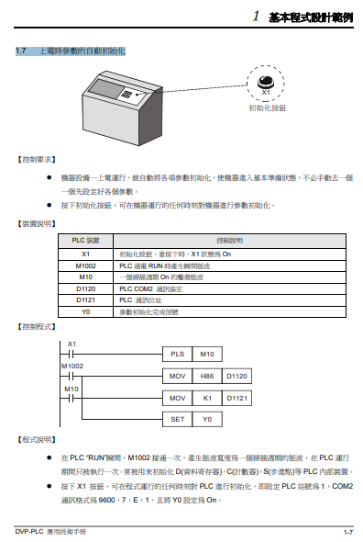

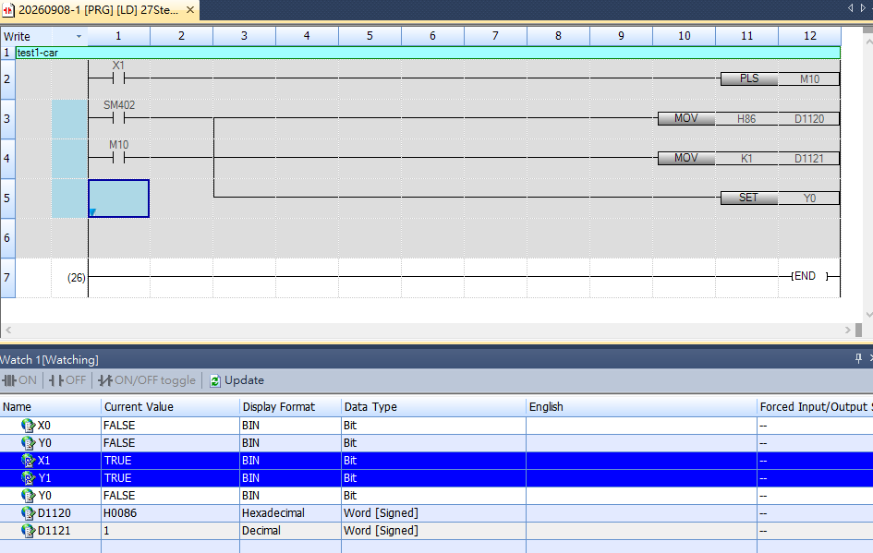

- 1.8 傳統自保持回路與 SET/RST 應用
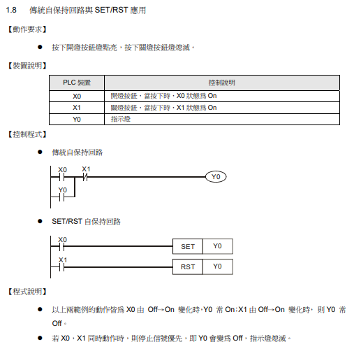
- 1.9 自保持與解除回路 (SET/RST)
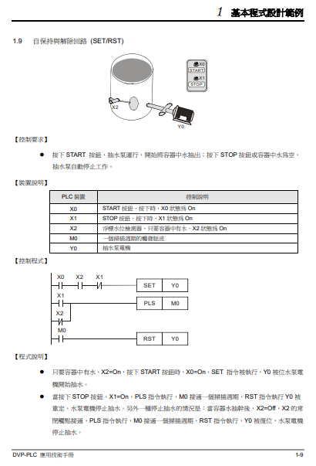
- 1.10 交替輸出回路 (輸出具停電保持)
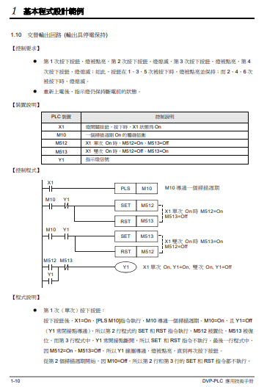

- 1.11 條件控制回路
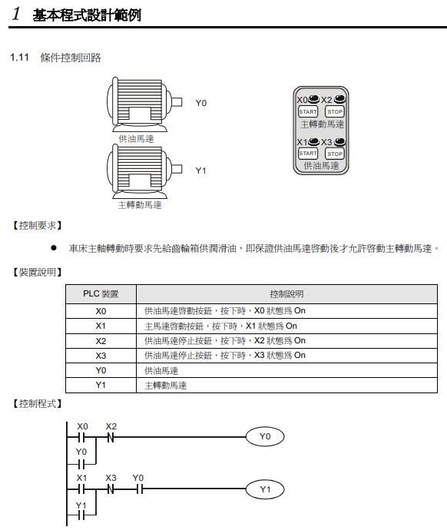
- 1.12 先入信號優先回路
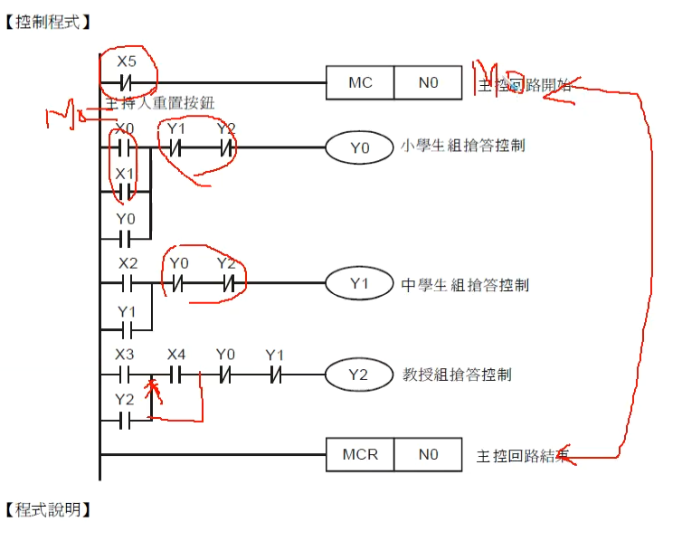
- 1.13 後入信號優先回路
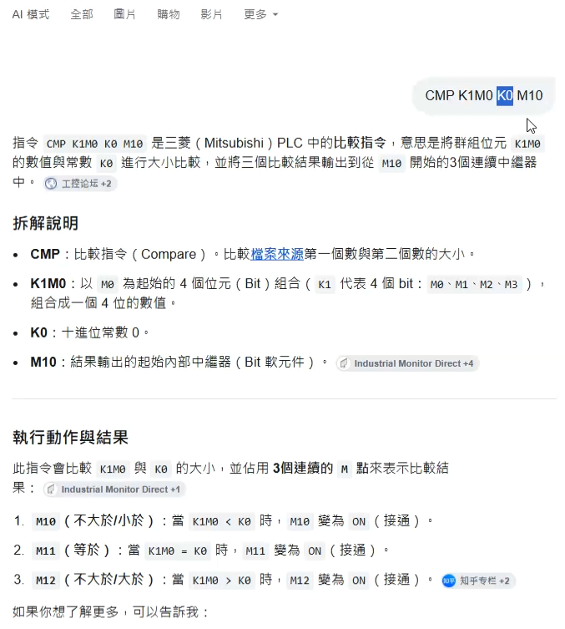
- 1.14 地下停車場出入口進出管制
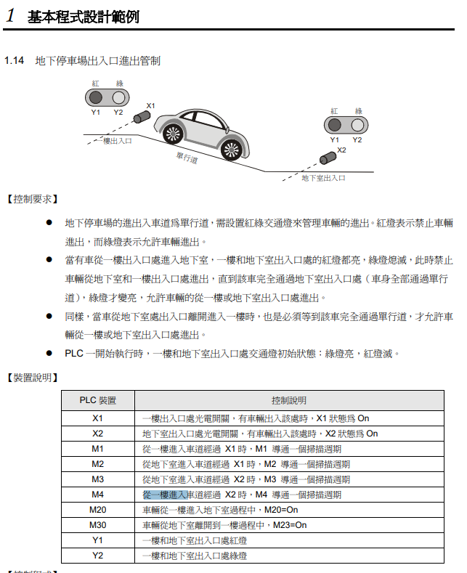

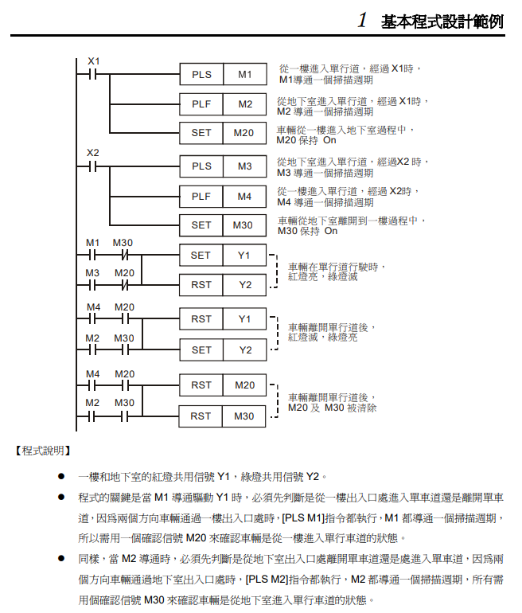

- 1.16 程式的選擇執行
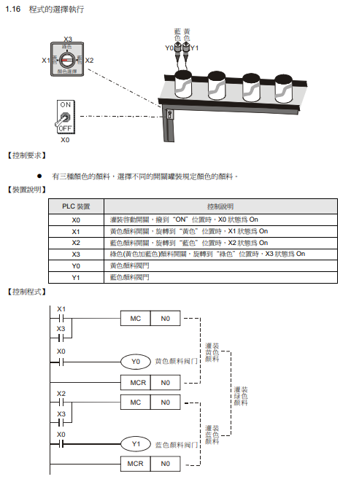
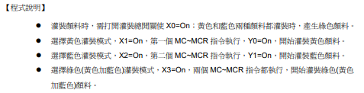

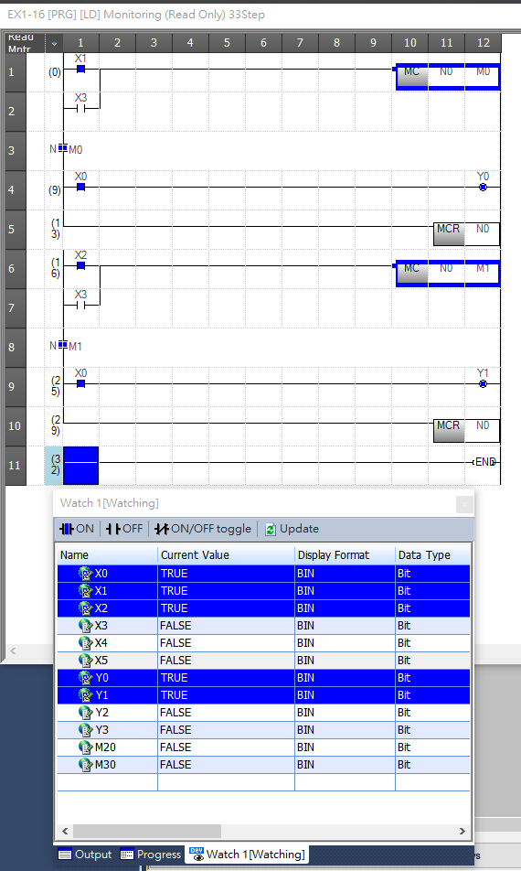

- 1.17 MC/MCR 手自動控制
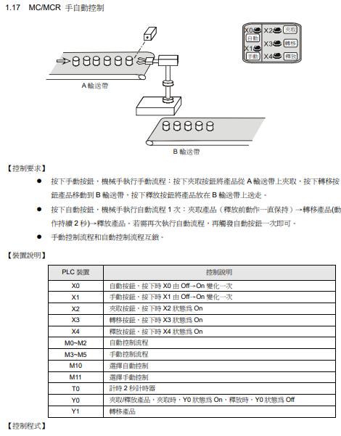
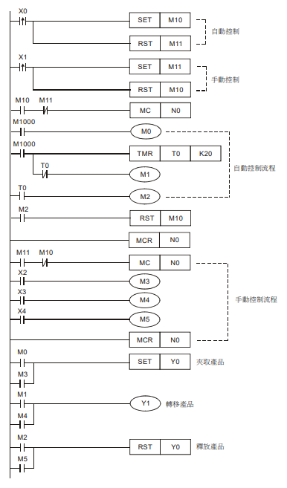
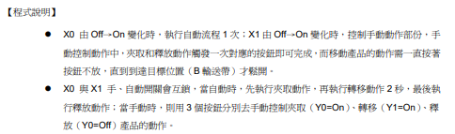

上面沒做，跳2.1

- .1 產品的批量包裝
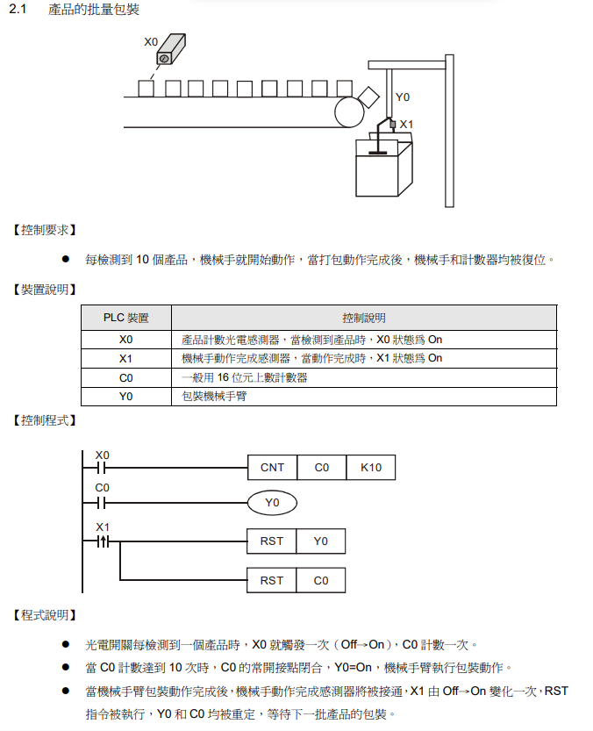

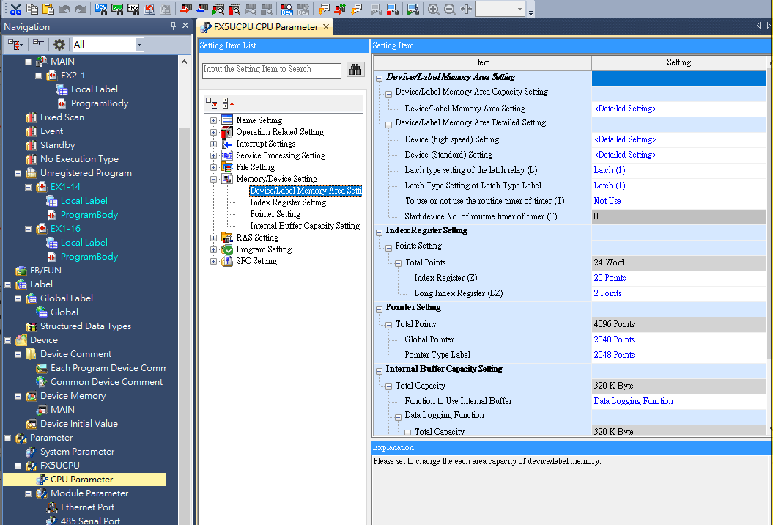
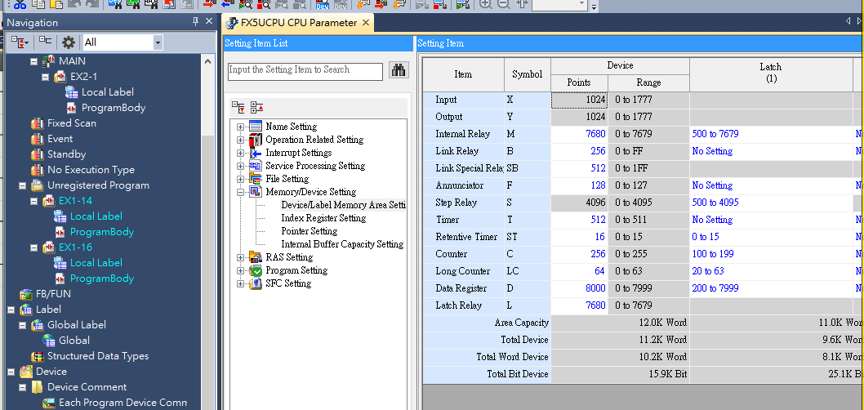

- 2.3 產品出入庫數量監控 (32 位元上下數計數器)
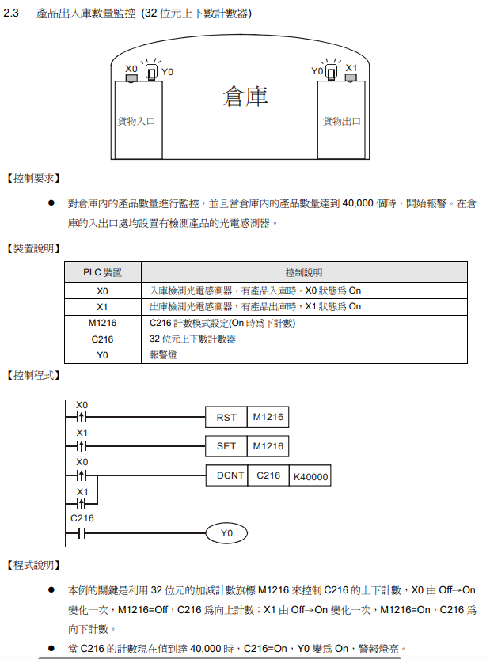
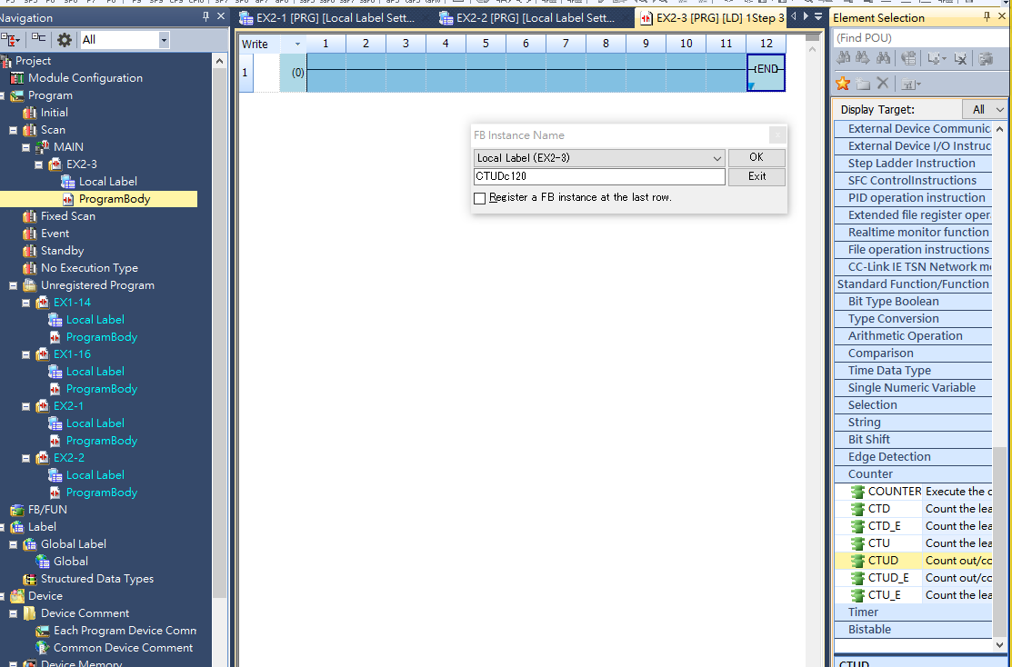

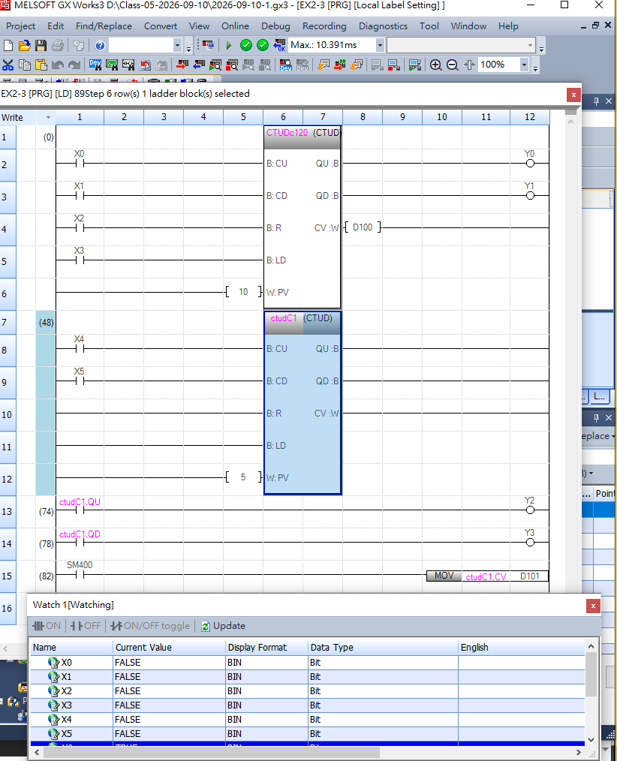

- aaa2.4 3 個計數器構成的 24 小時時鐘
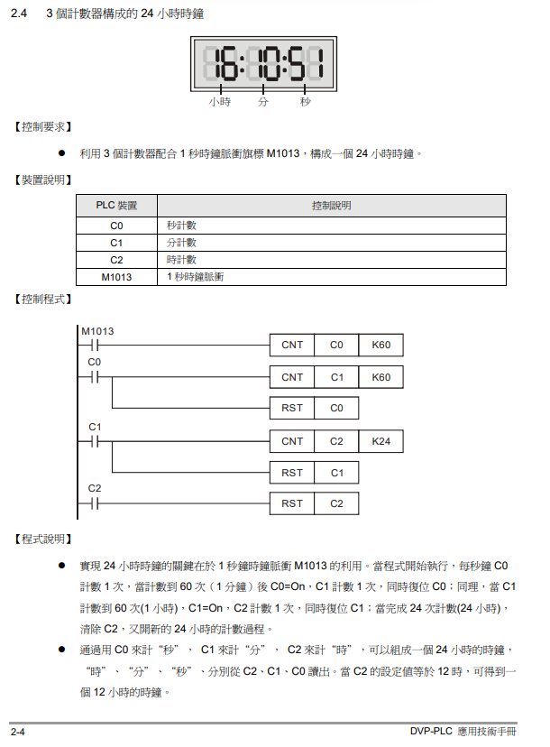

https://k10206.tistory.com/m/1083

미쓰비시 GX Works3 (V1.128J) 다운로드
- 3.1 延時 Off 程式
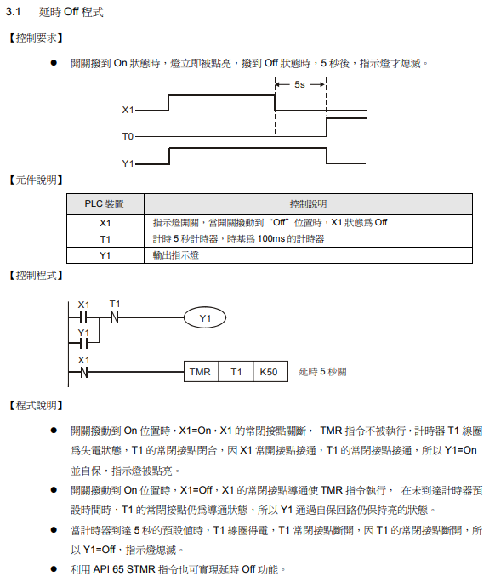
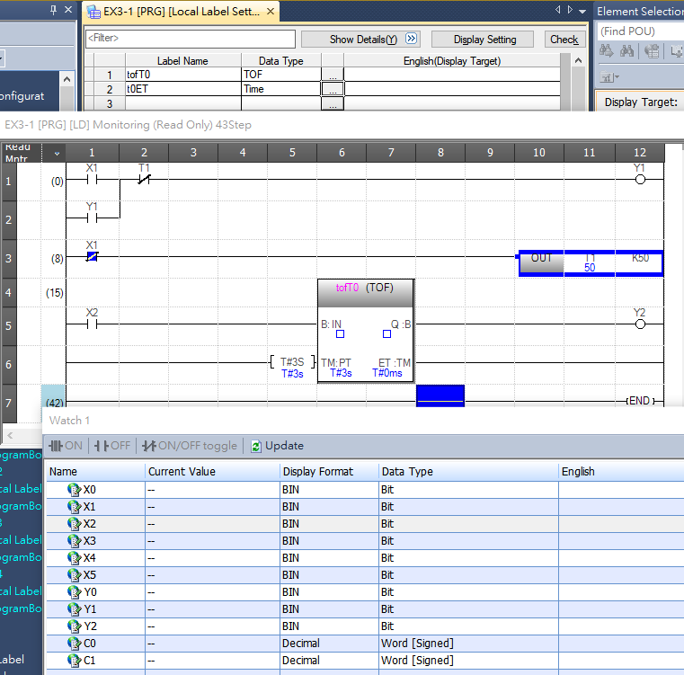
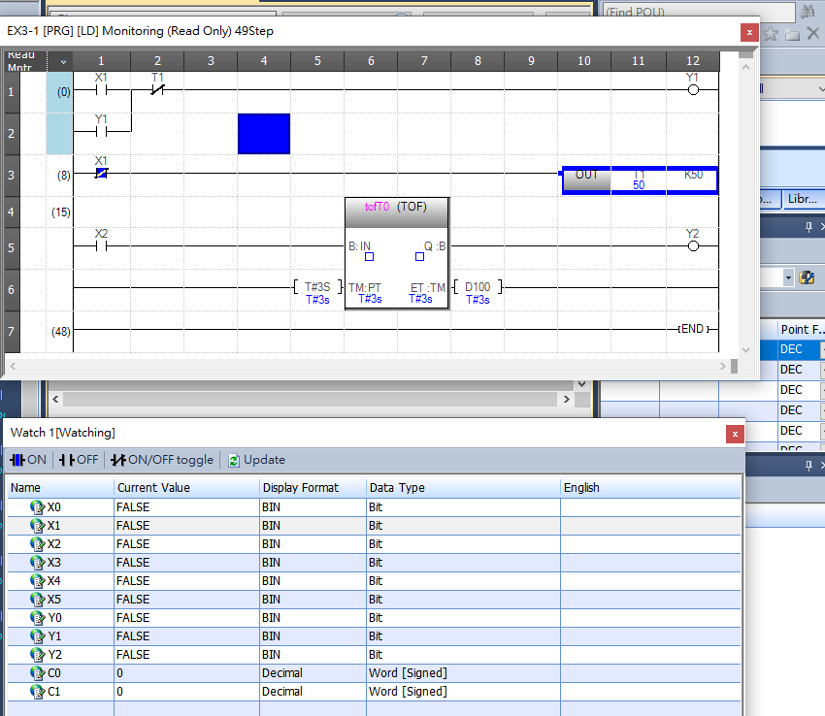
@2026-09-15-TUESDAY@
- 反應速率
  - RELAY 繼電器 反應速率 是 ms(milisecond) 10⁻³
  - TR 電晶體 是 us(microsecond) 10⁻⁶
- PLC IP ADDRESS
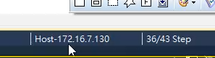

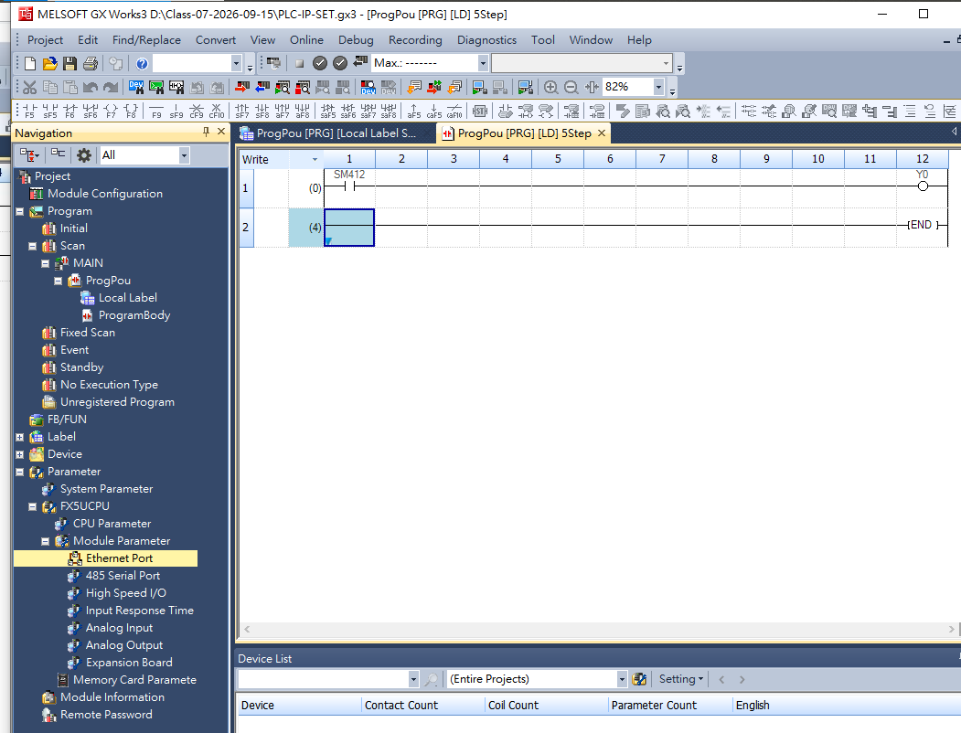

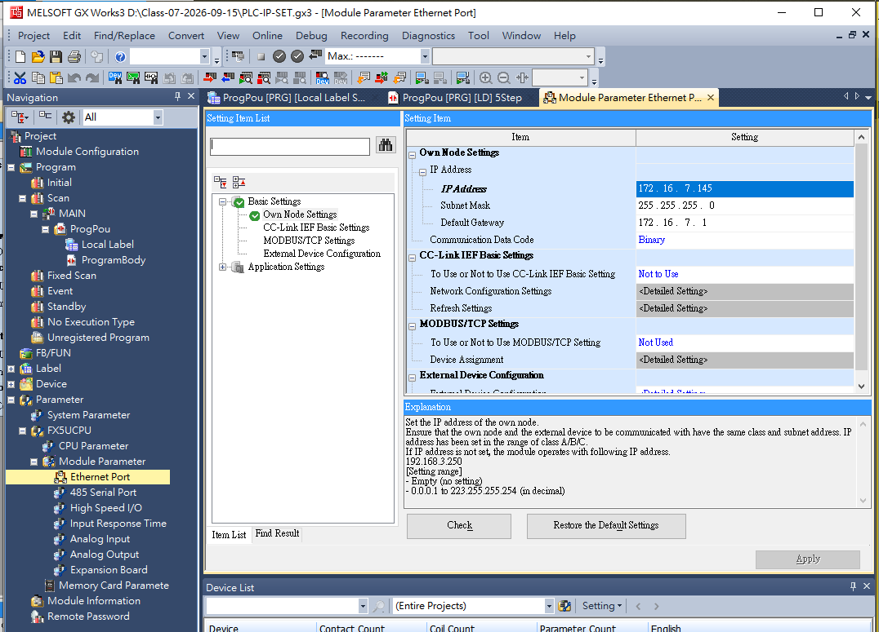
130+15=145

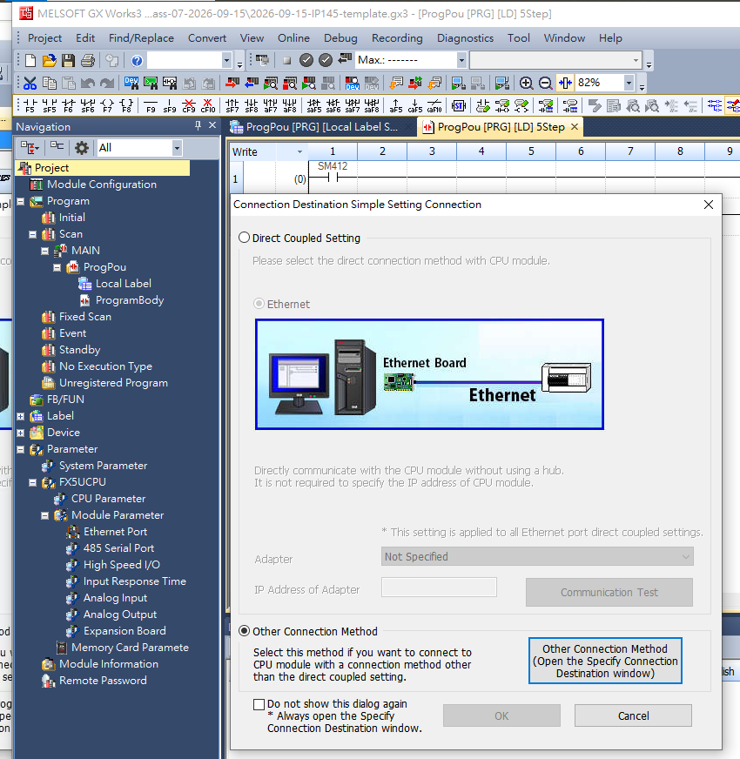

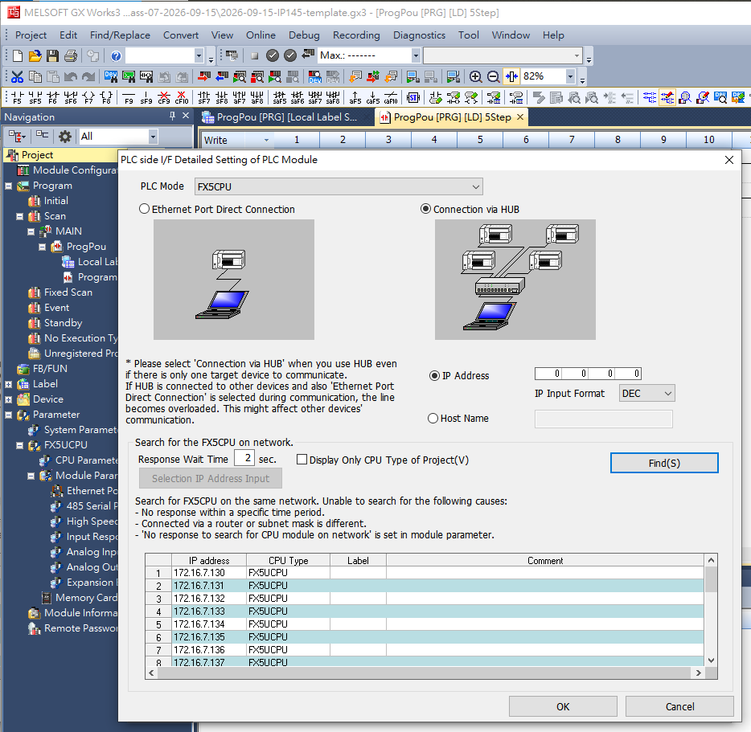

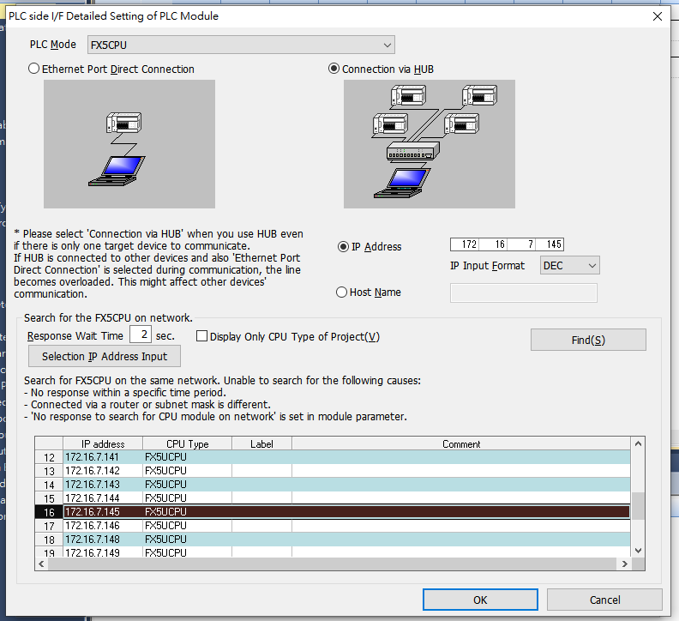

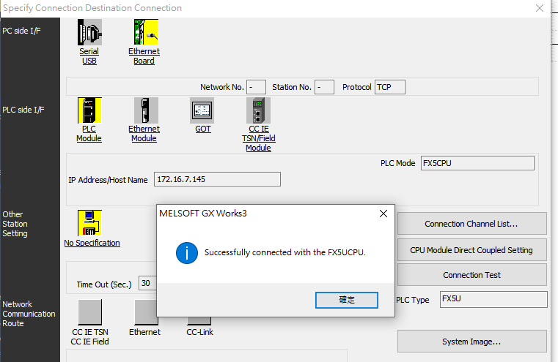

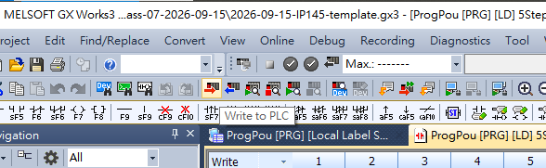

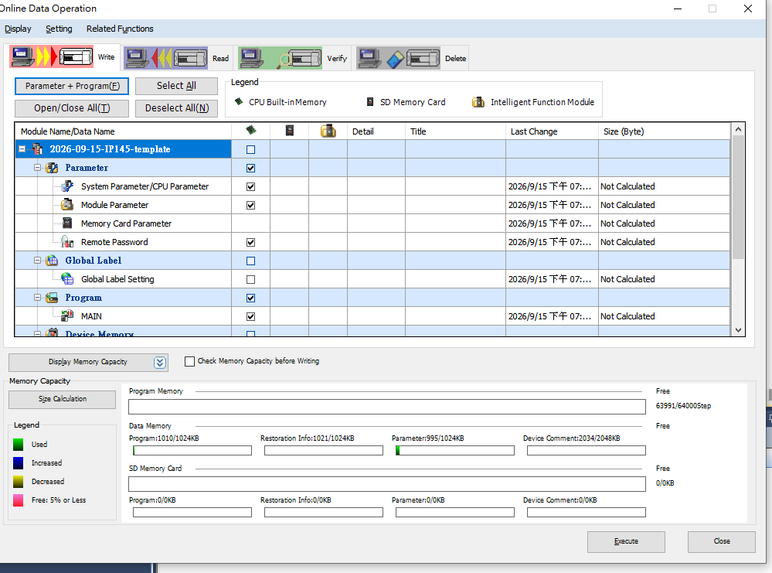

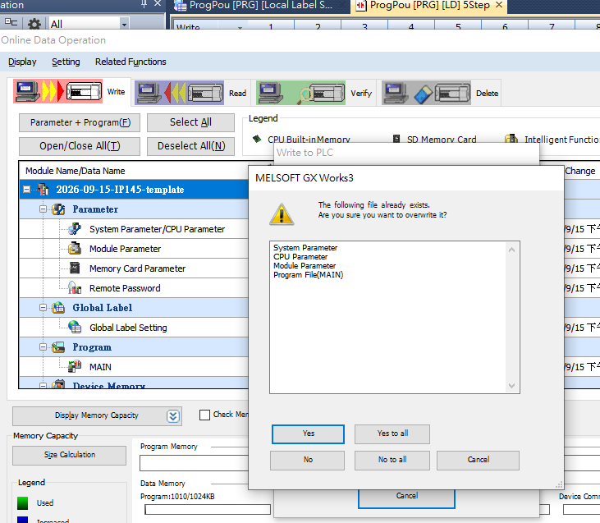

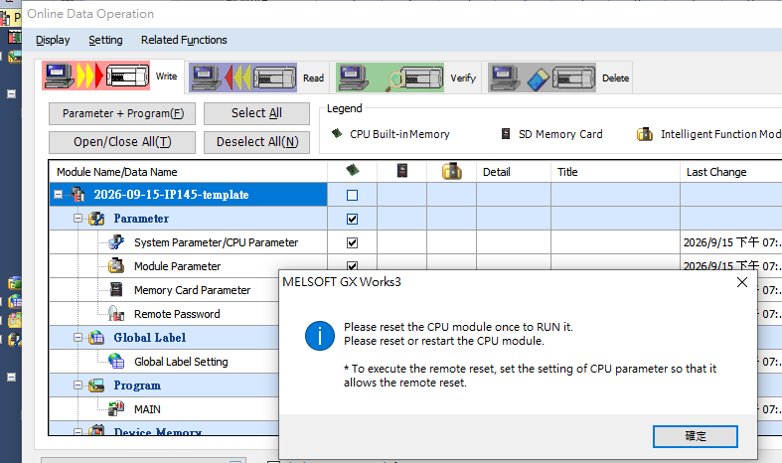

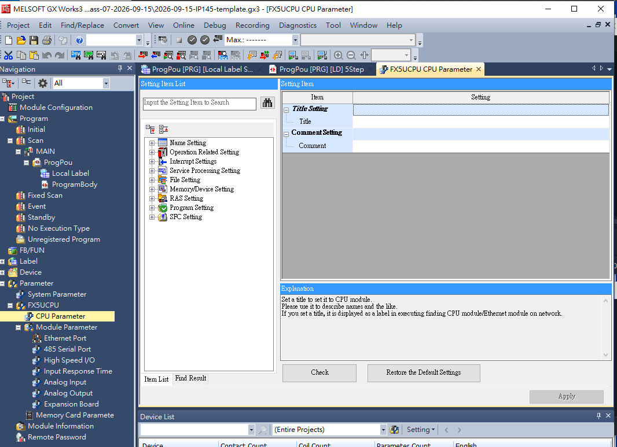

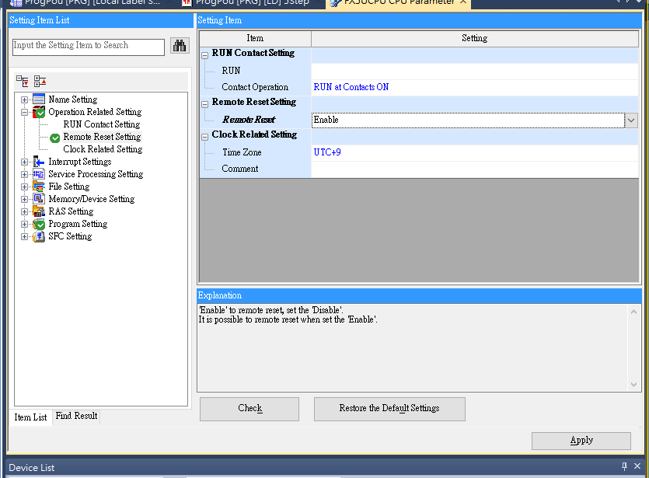

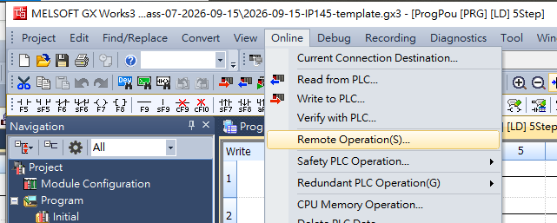

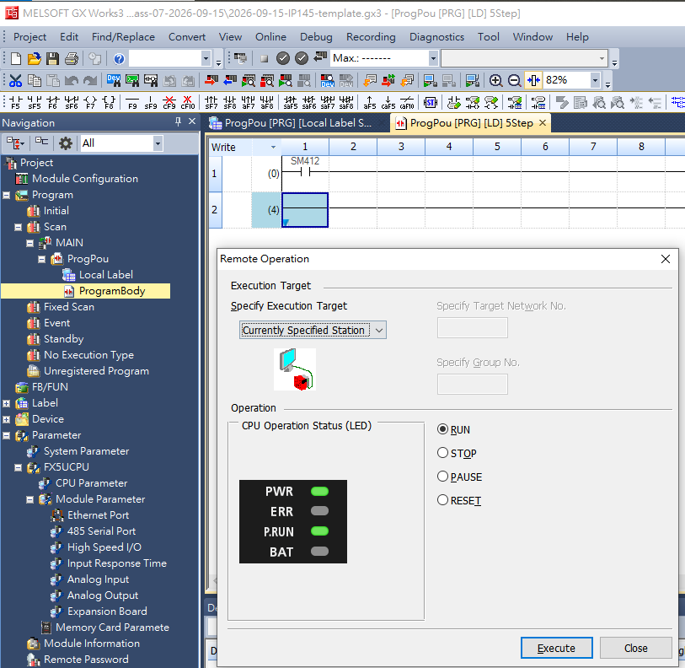

@2026-09-17

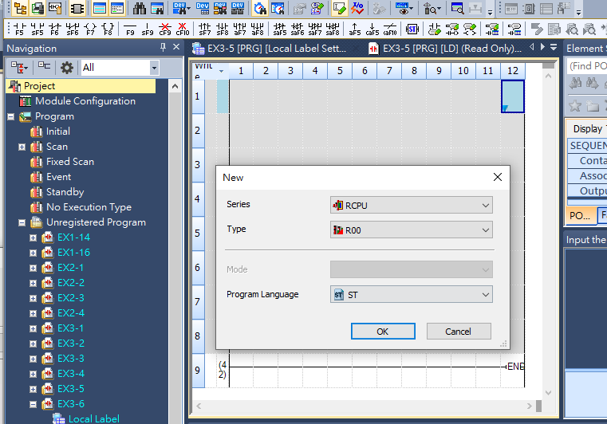

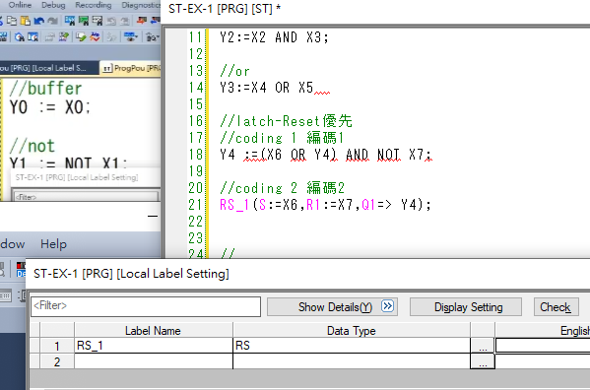

@2026-09-29

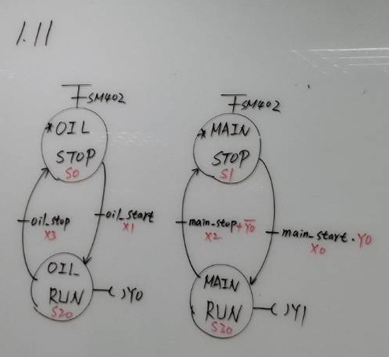

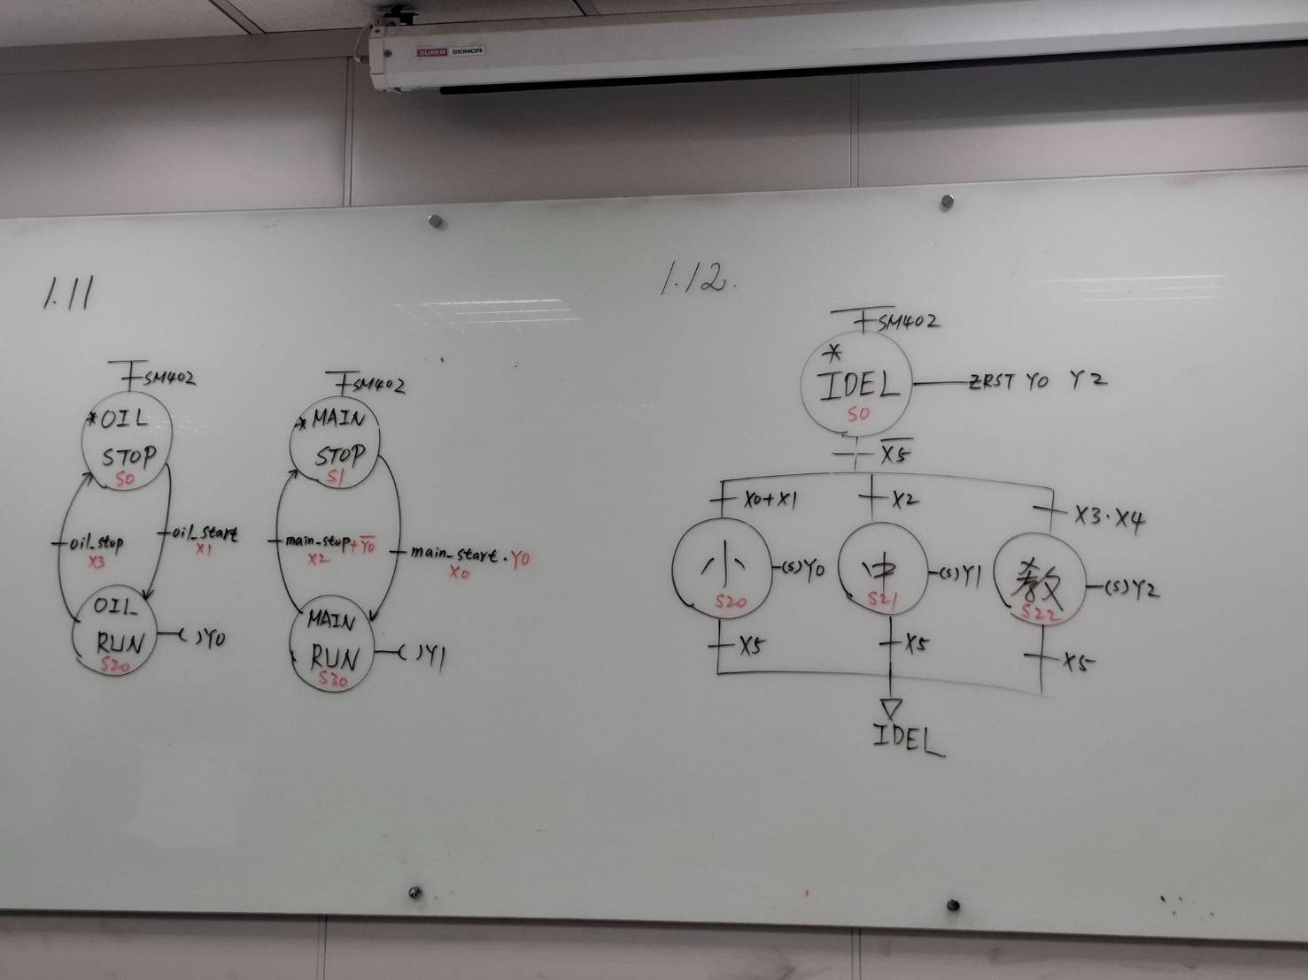

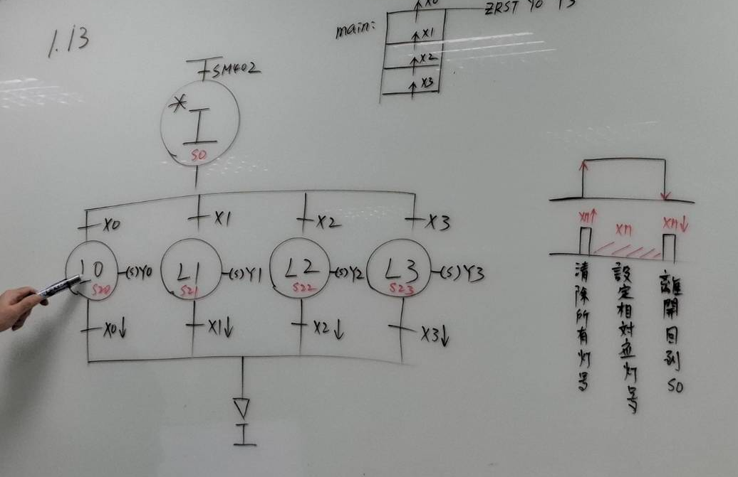
@2026-10-01-

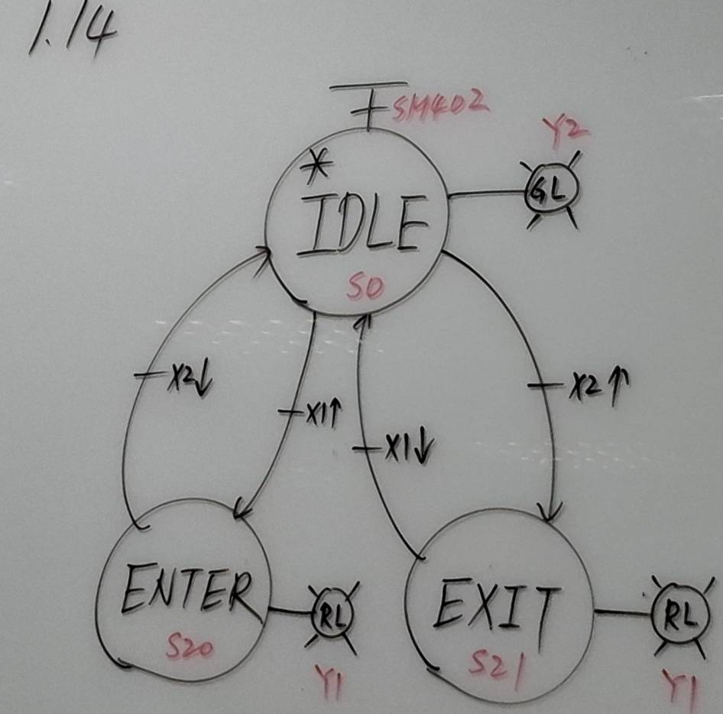

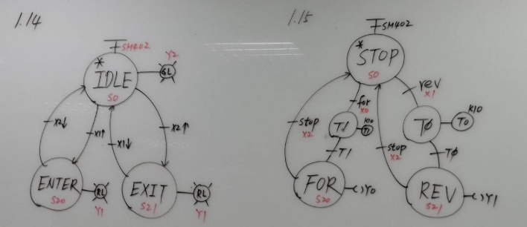

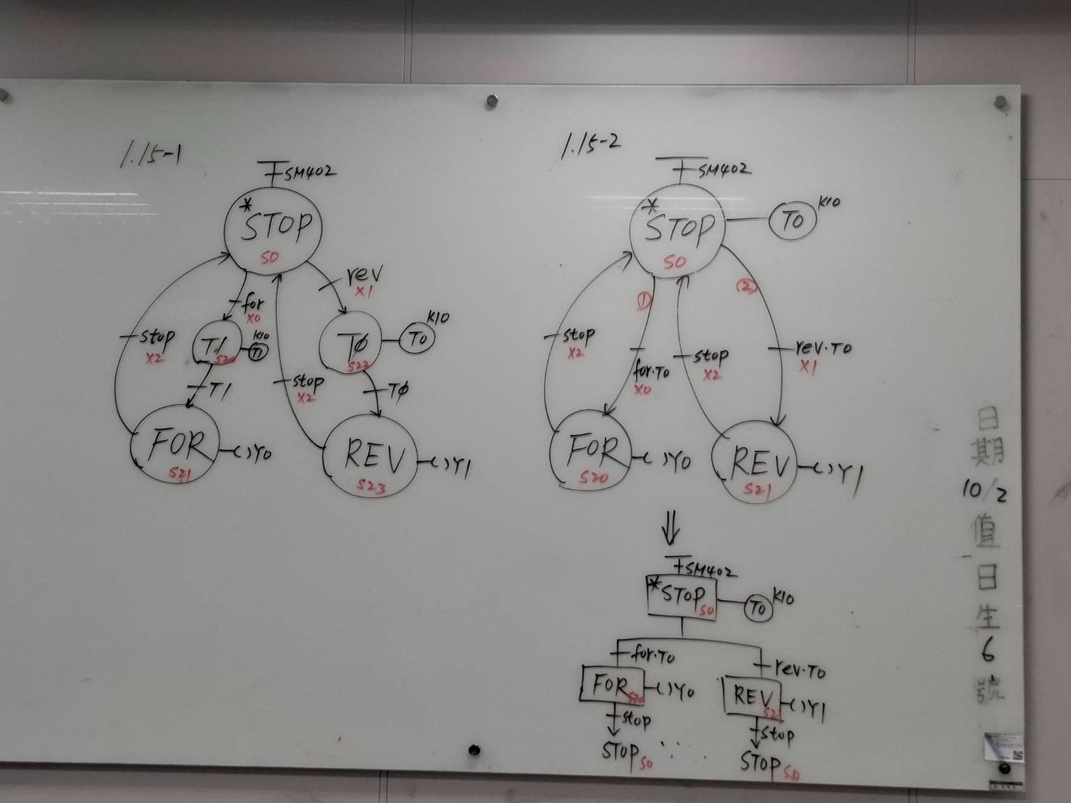

@2026-10-06-

MX Configurator
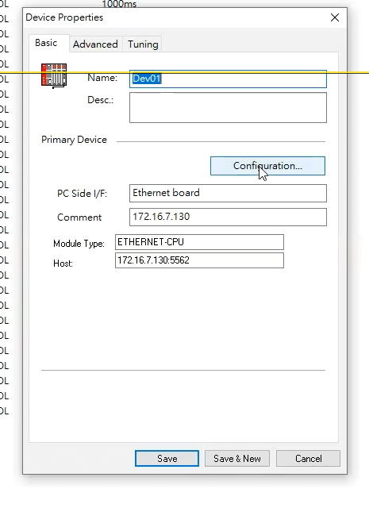
172.16.7.145
130+15

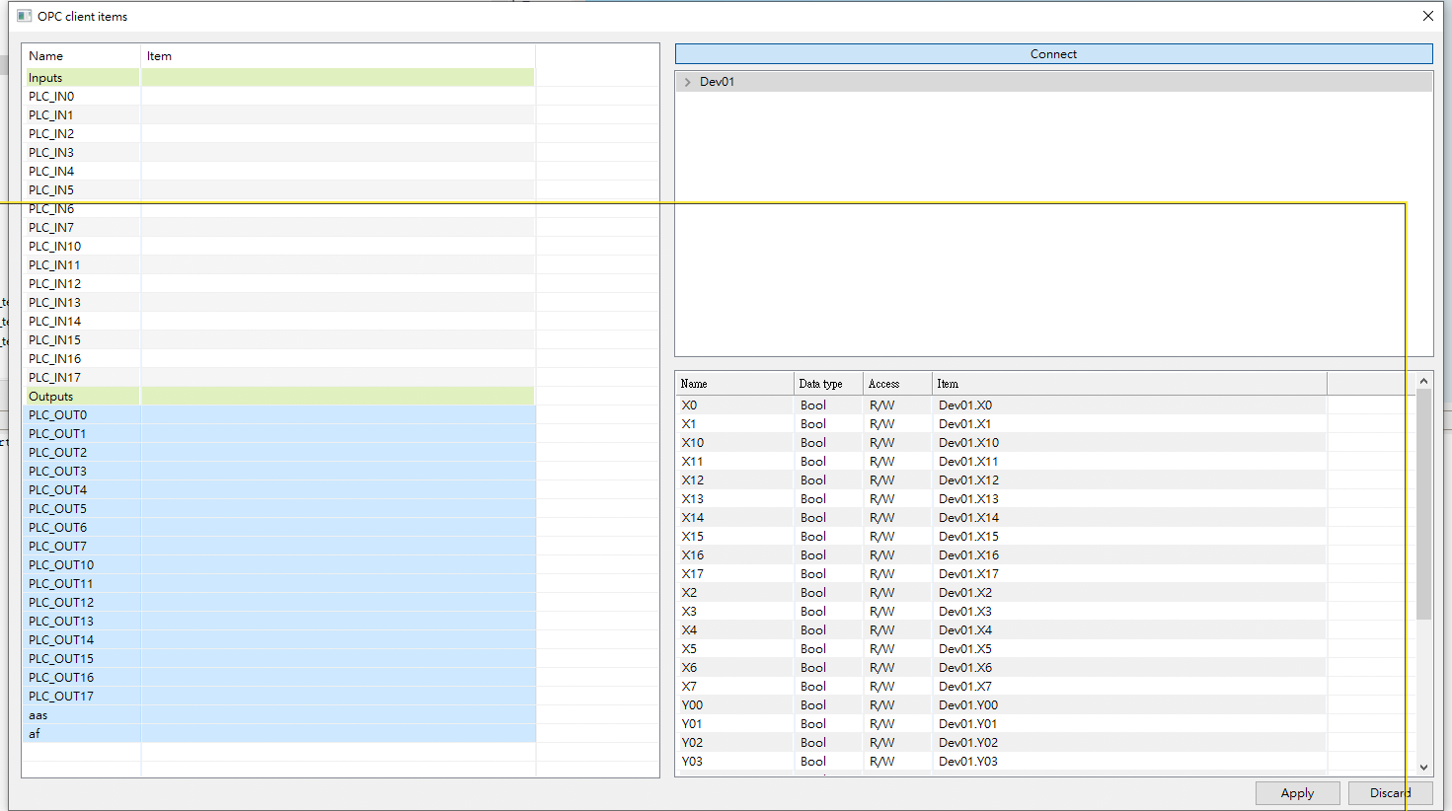

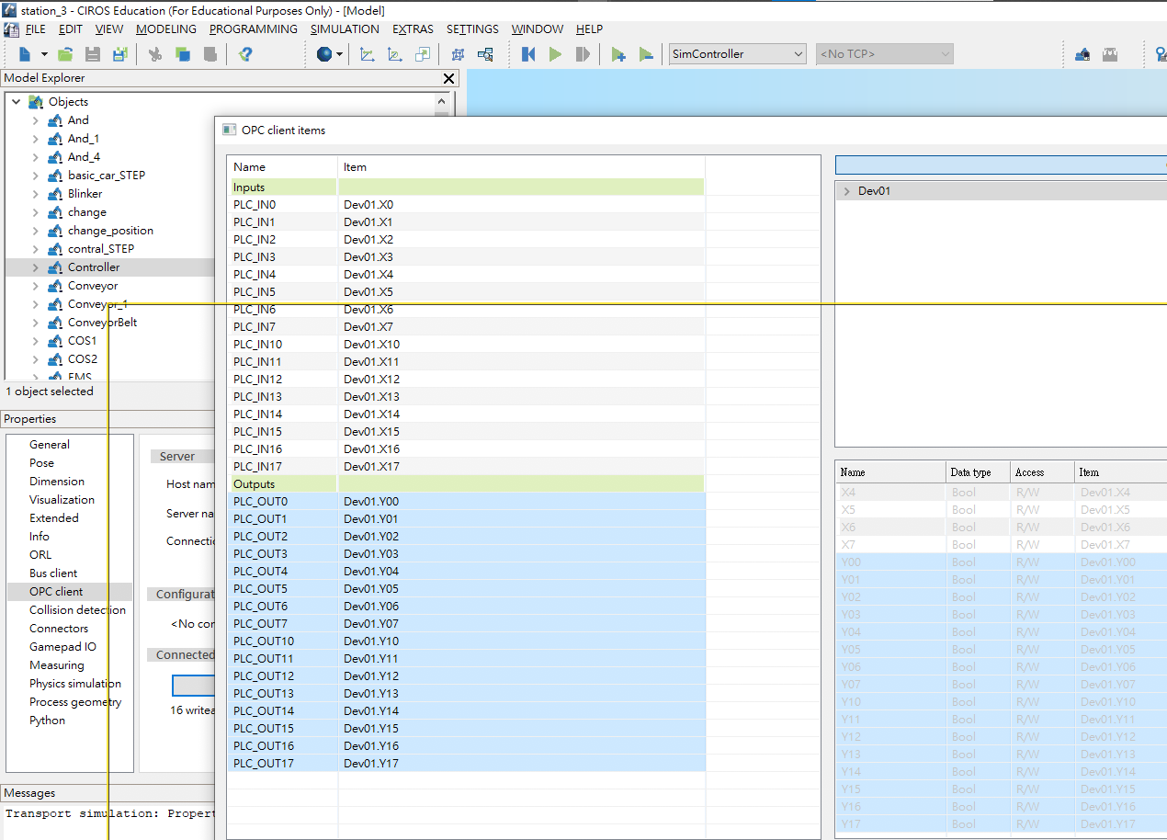

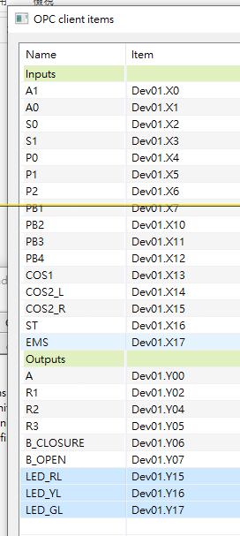
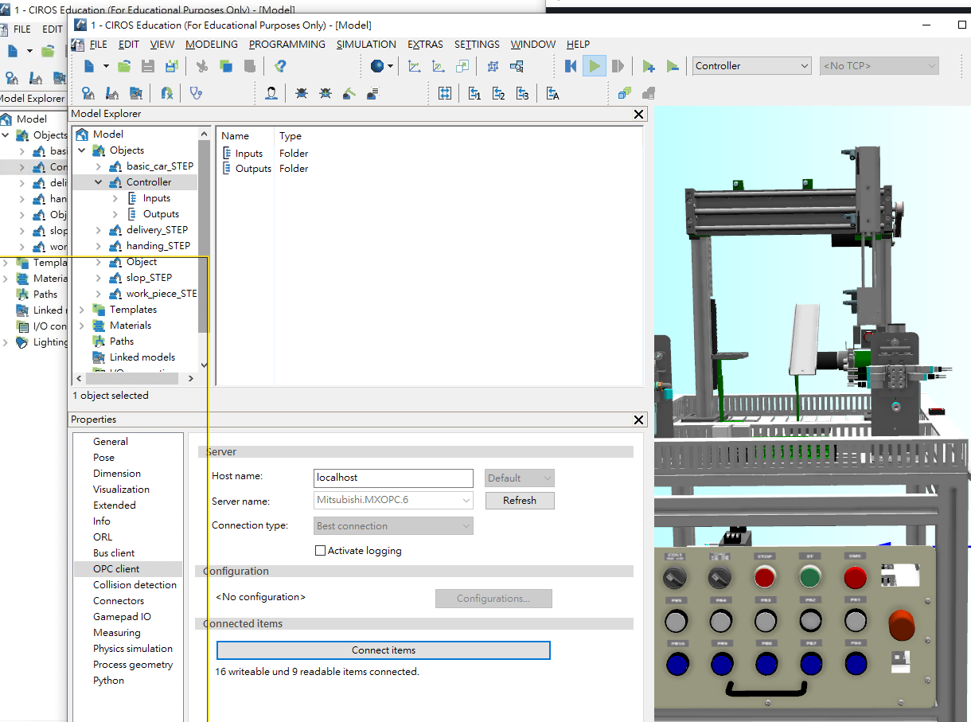
#202610-08

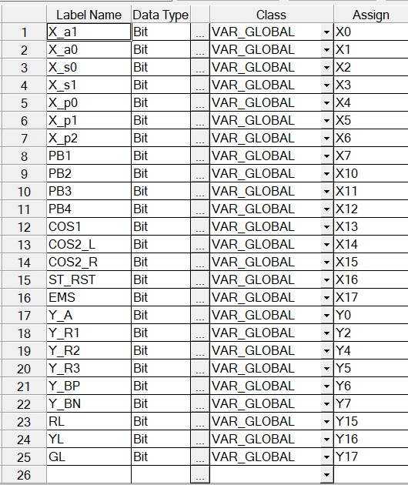

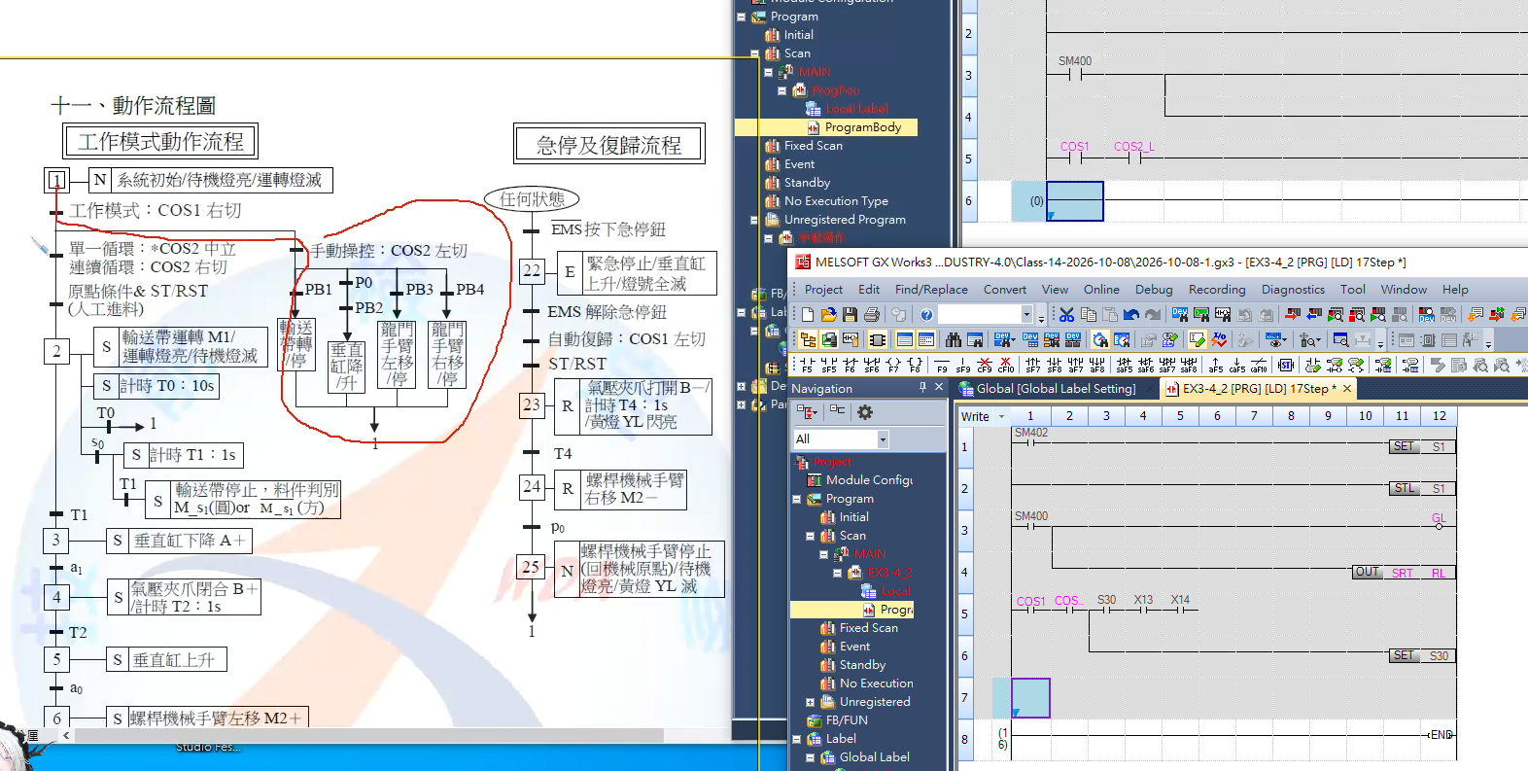

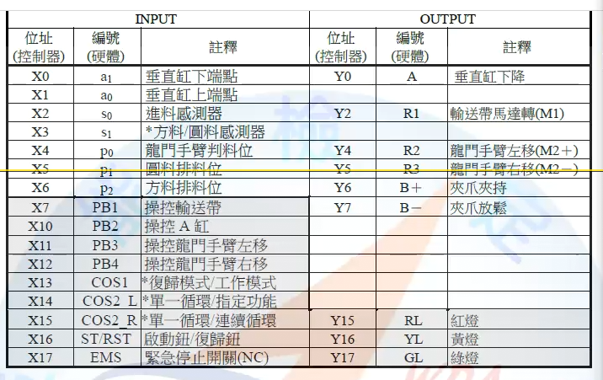

#2026-10-15-1

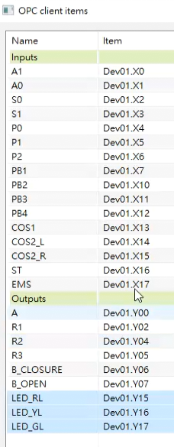

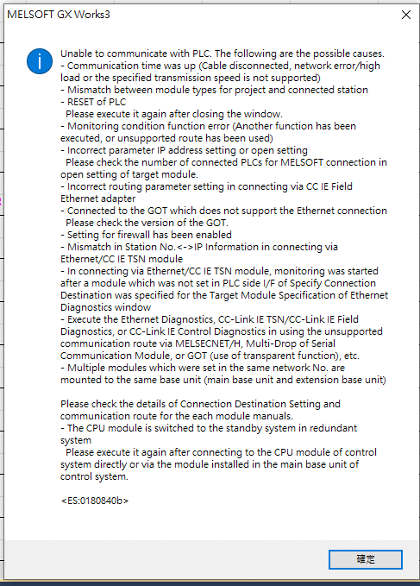
2026-10-20-1

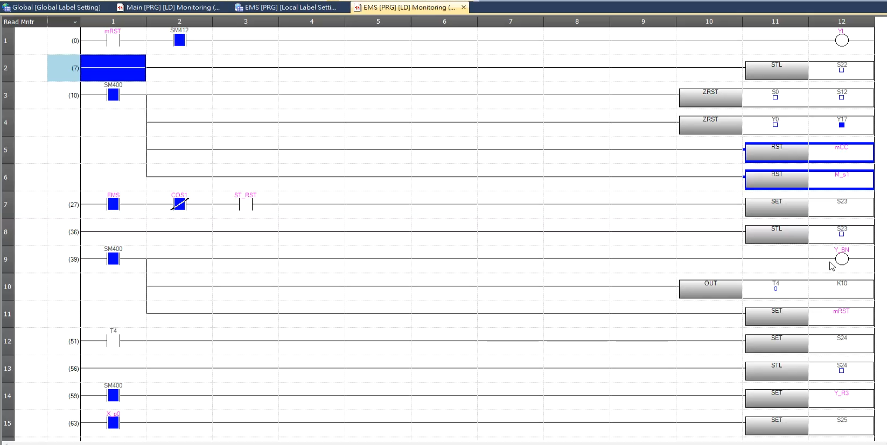
- node-red-contrib-ui-led

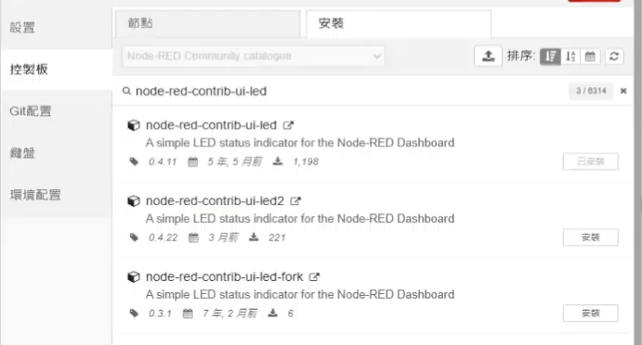

@2026-11-05-TUESDAY

  - http://127.0.0.1:1880/#flow/
  - http://127.0.0.1:1880/ui/
- Node
  - node-red-node-random
  - node-red-contrib-ui-led
@2026-11-10-TUESDAY

  - http://127.0.0.1:1880/#flow/
  - http://127.0.0.1:1880/ui/
- Node
  - node-red-node-random
  - node-red-contrib-ui-led

<div>Teachable Machine Image Model</div>
<button type="button" onclick="init()">Start</button>
<div id="webcam-container"></div>
<div id="label-container"></div>
<script src="https://cdn.jsdelivr.net/npm/@tensorflow/tfjs@latest/dist/tf.min.js"></script>
<script src="https://cdn.jsdelivr.net/npm/@teachablemachine/image@latest/dist/teachablemachine-image.min.js"></script>
<script type="text/javascript">
// More API functions here:
// https://github.com/googlecreativelab/teachablemachine-community/tree/master/libraries/image

// the link to your model provided by Teachable Machine export panel
const URL = "https://teachablemachine.withgoogle.com/models/G4A8FVg5i/";

let model, webcam, labelContainer, maxPredictions;

// Load the image model and setup the webcam
async function init() {
const modelURL = URL + "model.json";
const metadataURL = URL + "metadata.json";

// load the model and metadata
// Refer to tmImage.loadFromFiles() in the API to support files from a file picker
// or files from your local hard drive
// Note: the pose library adds "tmImage" object to your window (window.tmImage)
model = await tmImage.load(modelURL, metadataURL);
maxPredictions = model.getTotalClasses();

// Convenience function to setup a webcam
const flip = true; // whether to flip the webcam
webcam = new tmImage.Webcam(200, 200, flip); // width, height, flip
await webcam.setup(); // request access to the webcam
await webcam.play();
window.requestAnimationFrame(loop);

// append elements to the DOM
document.getElementById("webcam-container").appendChild(webcam.canvas);
labelContainer = document.getElementById("label-container");
for (let i = 0; i < maxPredictions; i++) { // and class labels
labelContainer.appendChild(document.createElement("div"));
}
}

async function loop() {
webcam.update(); // update the webcam frame
await predict();
window.requestAnimationFrame(loop);
}

// run the webcam image through the image model
async function predict() {
// predict can take in an image, video or canvas html element
const prediction = await model.predict(webcam.canvas);
for (let i = 0; i < maxPredictions; i++) {
const classPrediction =
prediction[i].className + ": " + prediction[i].probability.toFixed(2);
labelContainer.childNodes[i].innerHTML = classPrediction;
}
}
</script>

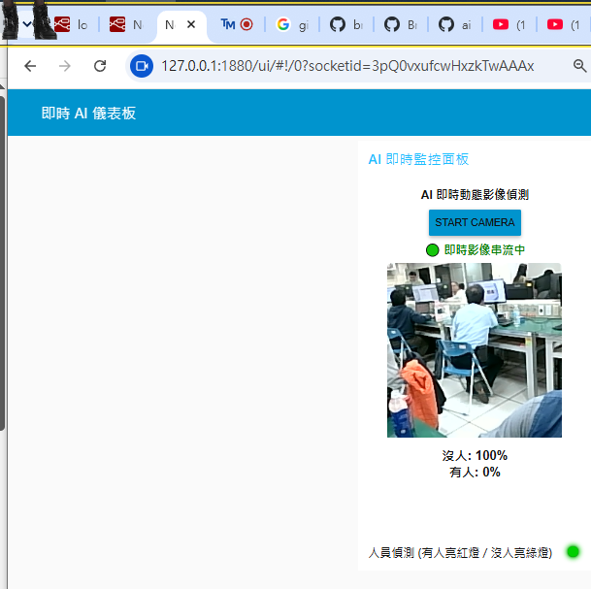
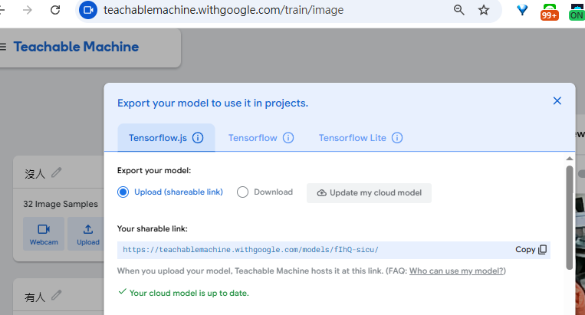

- 2222

