Steps to setup the project:
1. This project is done using Django. To run the project, first we must install python, virtual environment and django.
First of all, make sure that the system has Python 3 installed.
Next we will need to install virtual Environment using the command(for linux):

sudo pip3.6 install virtualenv

Then activate the virtual env:

source venv/bin/activate

Install Django: pip install django
Then apply all the migrations using command:

python3.6 manage.py makemigrations
python3.6 manage.py migrate
python3.6 manage.py runserver

2. On giving the command “runserver”, it will show the address where the project is running. For example:
Starting development server at http://127.0.0.1:8000/

Copy and paste the address and append “/list” to it.
Hence the complete address will be:
http://127.0.0.1:8000/list

If all the previous steps have been followed properly and python, virtualenv and django has been installed properly, then one should see the home page as:

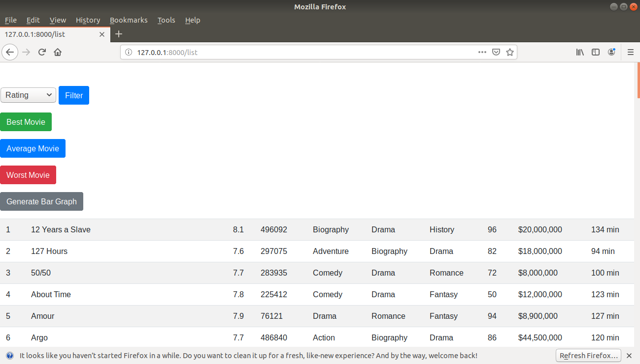
For more information on how to setup the project and install the prerequisites, one can refer to the site:
https://simpleisbetterthancomplex.com/series/2017/09/04/a-complete-beginners-guide-to-django-part-1.html#introduction

