Separating biological change from observation in an invasive plant time series
Working manuscript, 10 October 2026. This draft reports completed analyses and distinguishes them from planned validation. It is not ready for submission: segmentation accuracy, demographic events, the historical endpoint transformation and any evolutionary mechanism remain unvalidated. Authorship and affiliations should be supplied by the research team.

Abstract
Repeated imagery can reveal the spread of clonal invaders, but segmented patches need not represent biological individuals. Here we reconstruct an aerial record of Spartina alterniflora and test how response definitions, observation units and acquisition conditions affect ecological interpretation. The apparent temporal growth pattern depends on an unresolved endpoint transformation and the exclusion of shrinking or rapidly expanding patches. Prediction from initial geometry transfers poorly across years, and a temporal RGB-to-mask audit reproduces balanced archived labels while strongly overpredicting their full-raster prevalence. A same-season satellite extension through 2025 shows that acquisition-date choice can reverse the direction of spectral change even on fixed spatial support. External genetic records demonstrate that field-defined patches can contain multiple inferred lineages, while common-garden trait associations depend on recorded block composition. These results identify distinct tests required to connect canopy change, demographic processes and inherited traits. Combining explicit observation models with independent event labels, genetic identity and replication across environments offers a route to testing ecological and evolutionary explanations without treating image objects as biological individuals.

Main text
Biological invasions alter ecosystems through changes in abundance, spatial spread and interactions with resident organisms. In coastal wetlands, Spartina alterniflora can transform habitat structure and ecosystem processes ¹. Repeated aerial surveys offer a way to observe these changes at the scale of individual vegetation patches. Advances in image segmentation make it feasible to extract many such observations, and spectral and phenological information has already been used to study this invasion ². Recent Spartina segmentation work also shows that genuinely site-held-out performance is lower and more variable than random cross-validation, making spatial and temporal transfer a primary validation target ²⁵. The scientific challenge is to establish what the extracted objects measure.
A vegetation patch is an observation unit whose identity can change as plants grow, overlap or become obscured. Patch disappearance may represent death, incorporation into continuous vegetation, incomplete image coverage or a failure of detection. Likewise, a new segmented object does not necessarily identify a newly recruited genetic individual. If these processes affect inclusion in a growth dataset, the properties of retained observations may change even when the underlying population process does not. Distinguishing observation from biology is therefore necessary before interpreting temporal change.
Evolutionary explanations require an additional evidential step. Work involving Xiamen University’s College of the Environment and Ecology has demonstrated that trait clines can differ between field and common-garden conditions, between reproductive and vegetative traits, and among gardens ^{3,4,5,6}. These studies make trait identity and environmental replication central to the interpretation of an invasion. Common-garden work on S. alterniflora has documented persistent differences between growth forms under shared conditions ⁷. Studies of other invasive plants have combined common gardens, genetic information or environmental gradients to test adaptation ^{8,9}. Such evidence motivates evolutionary hypotheses but cannot be replaced by a correlation between year and remotely observed growth. We therefore examine the recoverable evidence chain before assigning mechanisms to the historical image series.

Reconstructing the image-to-table evidence chain
We independently rehashed all 1,001 files in the recovered archive, comprising 38,654,767,408 bytes, and found no checksum discrepancies. Fifteen paired RGB images and binary masks had identical array dimensions of 26,606 by 24,443 pixels. RGB rasters carried a shared EPSG:4326 transform, whereas masks lacked a geographic reference. Equal dimensions and header transforms establish a common array convention but do not establish the accuracy of registration.
Two annotation deliveries contained matching polygon sets after standardizing ring start, orientation and redundant closing vertices: 714 images and 9,234 objects. Polygon rasterization and 79 delivered PNG masks had a median intersection over union of 0.9965. This comparison measures consistency between annotation encodings, not the accuracy of the segmentation model. The original training photographs, segmentation checkpoint and fixed training/validation/test split have not been recovered, and the original model performance remains unverified.
A fixed region of interest, inferred from the first survey and then held constant, linked 5,745 of 5,746 archived patch-date positions to recovered mask bounding boxes. Archived x and y represented bounding-box row and column within this crop, rather than full-image centroids. An exclusive-maximum rectangular foreground count reproduced 5,744 historical areas. This rule omits the final bounding-box row and column and can include foreground belonging to nearby objects. We consequently retain historical areas as archived measurements rather than validated component areas.

The response and sample definition change the apparent temporal pattern
The annual matrix contained 2,459 candidate trajectory rows, of which 1,769 appeared in only one survey. Connecting successive observed years within rows produced 957 transitions. All had consecutive annual labels, although the selected survey dates varied within years. These transitions are conditional on the archived tracking procedure and do not constitute a census of demographic events.
All 854 records in the modelling workbook matched annual transitions on starting year, initial area, area increment and next-survey bounding-box position, preserving the frequency of repeated keys. Four records had multiple matching candidates, so the mapping did not establish a unique biological identity for every record. The retained set was exactly reproduced by the rule 0 < (A₁ − A₀)/A₀ < 10. This excluded 50 nonpositive changes and 53 relative increments of at least ten. The model thus described a selected set of growing, successfully tracked objects.
The stored growth_rate was inconsistent with (A₁ − A₀)/A₀ for all 138 records starting in 2016 and all 50 starting in 2018. The other five years agreed within numerical tolerance. No recovered transformation explained these differences. Accordingly, recomputation is a sensitivity analysis, rather than a claim to recover the intended original endpoint.
For the same 854 records, the Spearman correlation between year and annual mean endpoint was −0.714 for stored values and −0.107 for area-derived relative increments, with exact two-sided rank-permutation P values of 0.088 and 0.840, respectively (seven annual means). Including all 957 archived transitions gave a correlation of −0.607 for area-derived relative increments (exact P = 0.167). The latter mean is sensitive to extreme changes from small initial areas. These comparisons show that a mechanistic account of a temporal trend requires a resolved endpoint and an explicit sampling population; none of the comparisons independently establishes such a mechanism.

Objects, trajectories and observation gaps
Eight-connected component extraction produced 8,280 components across the 15 cropped masks, including small components. Component areas summed exactly to independently calculated mask foreground counts in each survey. Eighty component-date objects were shared by 167 archived observations, giving 87 excess rows relative to unique objects. Shared endpoints may reflect branching tracks or duplicate assignments. Their cause remains to be determined, and these observations cannot be treated as independent individuals.
An unregistered adjacent-survey overlap screen examined 5,459 source observations. Of these, 1,386 continued to an archived successor that passed the overlap criterion, and 1,123 continued to a successor that did not. Another 177 lacked a next-row observation but overlapped another mask object; 2,772 lacked both a next-row observation and a qualifying overlap. One source bounding box was unresolved. These categories are diagnostic candidates, not rates of survival, recruitment, splitting or merging.
Eighty observations without a next-row record had at least 95% exact black or white RGB values at their preceding foreground locations in the next image. Inspection of diagnostic crops confirmed that complete black coverage gaps occur. This result demonstrates an observation problem without establishing that all flagged locations are missing data. Death cannot be assigned from absence in an unvalidated mask alone. The distinction parallels the separation of occurrence and detection in ecological observation models ¹⁰, although the current surveys do not by themselves satisfy the replicate-observation assumptions required for a fitted detection model.
Automatic feature matching did not resolve the alignment problem. Six of 14 adjacent image pairs supplied sufficient matches for a partial-affine diagnostic fit. Spatially held-out feature residuals remained substantial, and no pair passed the descriptive diagnostic gate. Features may include changing vegetation or erroneous matches; these residuals are not independent ground-control errors. No fitted transform was applied to the imagery or used to classify biological events.

Field patches and genetic individuals are distinct units
To evaluate the biological meaning of a patch independently of image segmentation, we audited a published native-range genetic dataset ¹¹. Its spatial table contained 935 uniquely labelled sampled stems in ten field-defined patches and 223 inferred multilocus lineages. Individual patches contained 5–45 lineages; one lineage occurred in two patches, giving 224 patch–lineage combinations (Extended Data Fig. 8). These counts reproduce summaries from the supplied lineage assignments. We did not independently infer genotypes or re-estimate the lineage threshold.
This comparison establishes a concrete mismatch among sampled stems, field-defined patches and inferred genetic lineages in the external study. It does not establish how many lineages occur in our aerial objects, because the datasets lack a shared image-to-genotype correspondence. Consequently, an image model can estimate canopy structure while remaining unable to identify genets. Evolutionary interpretation requires that additional link.

Prediction with starting information and explicit holdouts
We established a fixed benchmark using log initial area and initial bounding-box coordinates, excluding next-survey locations and legacy principal components. Three exactly repeated transitions were removed, leaving 954 observations in 661 dependency groups. Groups joined annual trajectory rows sharing a dated bounding-box position. We evaluated a training-mean baseline, ridge regression and extremely randomized trees using within-fold preprocessing, forward-year prediction and buffered spatial holdouts ¹².
For the primary endpoint, log(A₁/A₀), pooled forward-year R² values were −0.591 for the training mean, −0.941 for ridge regression and −1.116 for trees (455 predictions across 2016–2020). Performance differed by year; for example, positive R² in some earlier folds did not extend to 2019 and 2020. Both fitted models had lower pooled mean absolute error than the mean baseline, while their squared errors were larger. The benchmark therefore reveals sensitivity to large prediction errors and temporal transfer, rather than supporting a uniform statement about all loss functions.
Within-site buffered spatial R² values for log area ratio were −0.017, 0.051 and 0.086, respectively, over 954 predictions. For relative area increment, trees achieved a spatial R² of 0.278 but a forward-year R² of −0.601. Initial area also enters both response definitions, so apparent size dependence need not identify a biological mechanism. These benchmarks do not evaluate climate effects or establish independent-site transfer. They identify the performance of starting-geometry baselines on archived, still unvalidated labels.

External landscape observations expose a second measurement scale
We obtained the public CCAV-10m V4 coastal vegetation product ¹³, including eight annual maps for 2016–2023, a sample workbook and the class-code key. All three downloaded files matched the provider's checksums. The sample workbook was byte-identical to an existing project copy, resolving its provenance. Of 13,059 public rows, 13 were exact duplicates on coordinates, year and standardized class. Within the full aerial-image footprint, 106 rows represented 99 unique coordinates, all labelled as mangroves. No local S. alterniflora labels were present. Training/validation membership was unavailable, so neither these records nor the source paper's reported national accuracy supplied an independent local accuracy estimate.
After nearest-neighbour reprojection to a fixed 10 m grid, the satellite product classified 97.62 ha of the historical ROI as S. alterniflora in 2016, 24.82 ha in 2019, 71.64 ha in 2022 and 35.22 ha in 2023 (Fig. 4). Four grid phases changed those estimates to ranges of 97.62–98.47, 24.68–25.79, 71.39–71.89 and 35.22–35.75 ha, respectively. These ranges describe discretization sensitivity, not classification uncertainty. Mangrove and unmapped areas also changed. From 2016 to 2017, 49.48 ha changed from the S. alterniflora class to the mangrove class, whereas 8.60 ha changed in the opposite direction. These are map-class transitions; species replacement remains an untested explanation alongside classification and observation effects.
Projecting recovered mask foreground pixel centres into the corresponding annual satellite grids yielded S. alterniflora-class agreement of 20.1–65.0% across 12 aerial surveys from 2016 to 2021 (Extended Data Fig. 4). Foreground totals matched independently extracted component totals in every survey. The agreement is conditional on historical mask positivity and is not an accuracy estimate. Small patches may occupy mixed 10 m pixels, annual composites differ from individual flight dates, and absolute georeferencing remains unverified. The satellite results therefore identify where landscape composition and isolated-object measurements must be reconciled, without validating either product as biological truth.

A public UAV archive reconnects isolated objects with landscape occupation
A separate data publication from the same estuary ^{23,24} supplied ten 20 cm orthomosaics and ten S. alterniflora distribution rasters for August 2013–June 2022. All 20 files, totalling 1,844,072,803 bytes, matched provider MD5 digests. Every distribution-map bounding rectangle lay within our full aerial footprint. The December 2021 and June 2022 products, labelled RTK in the source filenames, add acquisition months absent from the recovered 15-date sequence (Extended Data Fig. 10). The source describes flights mainly at daytime low tide; exact tidal stage and independent registration accuracy remain unavailable.
The earlier images cannot be counted as independent external replication. After projecting the public and recovered August 2014 and August 2015 images onto a shared diagnostic grid, their greyscale correlations were 0.9991 and 0.9989. Feature matching supplied 1,769 of 1,773 and 3,104 of 3,104 affine-consistent matches, respectively. This near-identity is consistent with shared source imagery or closely related processed versions; the original flight-level provenance is unresolved. The public distribution maps nonetheless supply an additional measurement representation that includes extensive connected vegetation.
On a fixed 248.935 ha intersection of all ten RGB observation footprints and classification rectangles, the mapped-positive area was 21.35 ha in August 2013, 100.21 ha in November 2018, 111.81 ha in December 2021 and 122.82 ha in June 2022. On the nearly coincident native classified grids within shared RGB coverage, the two latest maps retained 111.70 ha of positive labels, removed 0.30 ha and added 11.33 ha. These are map-label inventories and transitions, not verified invasion rates or demographic events: source zero is explicitly tagged NoData, flight seasons vary, and label-generation errors have not been independently quantified. The results make landscape occupation a measurable companion endpoint to isolated-patch growth, while preventing the selected historical trajectories from being mistaken for a complete census of invaded area.

Temporal transfer exposes a calibration failure in RGB-to-mask prediction
We next tested whether the archived RGB–mask relationship transported across surveys. An Extra-Trees classifier trained on RGB, chromaticity and excess-green features from 14 surveys was evaluated on the completely held-out fifteenth survey, with up to 3,000 archived-positive and 3,000 archived-zero pixels per survey. On these balanced samples, mean ROC-AUC was 0.855 and mean IoU was 0.673 (Extended Data Fig. 11). The result indicates that the stored labels contain reproducible spectral structure, but it is not a segmentation-accuracy estimate because the target labels are the archived masks.
The same fixed threshold was then applied to a uniform sample of the full held-out raster. Archived positive labels occupied only 0.32% of sampled pixels on average, whereas the predictions occupied 28.83%, an absolute prevalence bias of 28.51 percentage points. Thus balanced discrimination did not yield a calibrated landscape area estimate. This failure is consistent with sparse labels, survey-specific radiometry and unmodelled observation conditions, and prevents treating a colour-only AI surrogate as an invasion census without independent labels and probability calibration.

A local spectral extension reveals sensitivity to observation timing
We extended observations of the same aerial-image footprint through September 2025 using Sentinel-2 Collection 1 Level-2A ²¹. A complete local catalogue query returned 74 September candidates for 2019–2025; 16 distinct acquisition dates met the fixed local cloud-screening and selection rules. September 2022 was absent from the queried collection, and only one 2020 date met the threshold. The primary comparison retained the same 652.10 ha across all six available years, equivalent to 84.1% of the full footprint (Extended Data Fig. 9). These are spectral observations, not new species labels.
Within the historical ROI's 275.83 ha of common support, median NDVI was 0.434 in 2021, 0.159 in 2023, 0.203 in 2024 and 0.340 in 2025. Locations assigned to the S. alterniflora class in the fixed 2019 CCAV map showed corresponding medians of 0.237, 0.063, 0.069 and 0.177. However, a comparison of the 2019 and 2025 composites was sensitive to acquisition timing: on 26.12 ha valid in all six endpoint acquisitions and all annual composites, the median paired-pixel NDVI difference ranged from −0.059 to +0.325 across the nine possible date pairs. Thus, even the sign of this endpoint contrast depended on the observations compared. The pairs share dates and pixels and are not independent replicates. Cloud-buffer and multiple-observation sensitivities are provided with the source tables.
The share of valid pixels with positive MNDWI in the fixed S. alterniflora map stratum varied from 30.4% to 68.6% across available years. This index is a water-exposure diagnostic, not an inundation measurement. Together, these results identify acquisition conditions and changing surface water as alternatives that must be evaluated before interpreting spectral change as a biological gain or loss. We have not normalized tidal stage or established intervention timing.
A separate ten-site Chinese field study ²² supplies a possible route to later local ground observations: its Site10 coordinate, rounded to 0.01°, falls within our image footprint, and its Fujian sampling campaign occurred in September 2025. The published summaries describe two 50 × 50 m tidal-position windows, but neither precise boundaries nor raw imagery or individual trait records were available in the public attachment. The overlapping coordinate therefore motivates provenance tracing; it does not establish a shared plot or independent geographic validation.

Clonal traits: garden contrasts and source effects require different checks
A separate public dataset ¹⁴ supplied 400 records from eight Chinese source populations in three common gardens, with 344 observed ramet counts and 338 emergence-time records. We treated source populations as the units for latitude comparisons and formed 24 source-by-garden means. Zhanjiang minus Dongying differences were +5.05 peak ramets and −31.58 days on the recorded emergence-time scale. Exploratory 95% percentile intervals from a crossed source and within-garden block bootstrap were +2.67 to +7.47 and −48.70 to −15.44, respectively (5,000 draws). Additive block adjustment retained corresponding contrasts of +4.99 ramets and −29.77 days. These are garden-associated contrasts, not isolated temperature effects; the dataset does not establish the timing origin, genotype identities or missingness causes.
Source-latitude interpretations were less stable. Unadjusted emergence correlations in Taizhou and Zhanjiang were 0.786 and 0.810, with exact two-sided permutation P values of 0.0279 and 0.0218. A shared-source maximum-statistic adjustment over six trait-by-garden tests gave P = 0.137 and 0.110. More consequentially, the Zhanjiang linear slope changed from +1.992 to −0.043 days per degree after additive block adjustment (Extended Data Fig. 6). Low-latitude LZ emergence records occurred only in blocks 1–10, whereas nine of ten observed high-latitude DY records occurred in blocks 11–20. Timing distributions differed between these recorded block ranges. Block adjustment requires additional assumptions and is not established ground truth; this sensitivity identifies missing design information that must be resolved before a source cline can support adaptation.
Withholding all three garden cells of each source population, a fixed garden-specific latitude model reduced squared error for unadjusted emergence means by 48.2% relative to the garden-mean baseline; extremely randomized trees reduced it by 22.8%. Neither improved ramet-count prediction over that baseline (Extended Data Fig. 7). The targets remained means conditional on observation availability. Consequently, positive predictive skill did not resolve the block-composition sensitivity or establish heritable differences. This external experiment is comparative evidence about inference, not a reconstruction of evolutionary change at the aerial survey site.

Discussion
The recovered record is valuable because it allows the observation process to be inspected. It also changes the interpretation of the historical analysis. The strongest current results concern provenance, conditioning and prediction. They do not establish a decline in total invaded area, inherited changes in growth, adaptive ecotypes or a causal effect of climate. A large calibration score cannot resolve an undefined response or an observation process that selectively removes shrinking, merging or unobservable patches.
External experimental research sharpens the competing explanations. A greenhouse study of ten Chinese and sixteen US source populations reported greater above- and belowground biomass in invasive-source plants and range-dependent relationships among latitude, flowering and biomass ¹⁵. A three-garden study of nine Chinese seed origins reported environment-dependent germination and seedling responses ¹⁶. The latter conclusion was assessed from the published abstract and archived dataset methods; we have not completed a full-text review or raw-data reanalysis of that experiment. Together, these studies motivate separate hypotheses about source-associated traits and environmental responses, rather than a universal direction of change in adult patch expansion. Maternal effects, ancestry, life stage and garden conditions remain relevant. Neutral-marker differentiation among Chinese and US populations ¹⁷ further motivates ancestry controls but does not establish adaptive change at this site. The two public common-garden dataset records were archived; file-access failures prevented reanalysis, and their reported results remain attributed to the original authors.
The Xiamen research programme also identifies competing ecological mechanisms that our analysis must separate. Liu and Pennings linked size, density and flowering across long-term salt-marsh observations ¹⁸; an apparent change in patch growth could therefore arise from crowding or allocation without requiring evolutionary change. Native–introduced comparisons found different vegetative and reproductive clines ^{5,19}, whereas Qiao and colleagues combined reciprocal transplants with quantitative and population genetics to investigate admixture and adaptation ²⁰. These are different evidential designs. A prediction score from aerial geometry does not supply their experimental contrasts, and a common-garden source effect does not by itself demonstrate home-site advantage. The raw geographic and three-year greenhouse tables accompanying reference ⁵ have now been retrieved from the originating GCE-LTER archive; a separate analysis remains local while source-specific distribution terms are reconciled. Related publications may share source material and must not be counted as independent experimental replications without a cohort audit.
A falsifiable ecological question is whether the transition from isolated establishment to landscape occupation is governed by crowding and coalescence, neighbouring vegetation, environmental responses or heritable source differences. The satellite maps now supply candidate locations for assessing vegetation boundaries and map disagreement. Distinguishing these mechanisms requires independent species labels and event histories; assigning local adaptation additionally requires inherited trait differences and fitness comparisons across environments. Neither a present-day common garden alone nor a space-for-time comparison would demonstrate evolution during this historical image series.
The overlapping public UAV archive now supplies the missing landscape-scale counterpart for this comparison, including a later 2022 acquisition. Its early image correspondence also shows why public availability should not be equated with independent replication. A useful next test is whether isolated objects become incorporated into continuous mapped vegetation while landscape occupation persists or expands, with registration, label continuity and phenological differences independently checked.
The temporal-transfer audit adds a direct AI falsification test to this framework. This emphasis follows recent Spartina benchmarking in which site-held-out scores fell below random-fold estimates ²⁵. A model that reproduces balanced historical labels but overpredicts their full-raster prevalence would inflate apparent occupation if used without an observation model. Independent expert labels, negative sampling and calibration across acquisition conditions are therefore prerequisites for converting the archived masks into demographic or landscape-rate estimates.
The next ecological analysis should define an explicit population at risk. A suitable representation would distinguish visible patch objects from candidate biological trajectories, permit multiple objects to merge, and record intervals in which an object cannot be observed. Growth estimates should be conditional on verified continuity, with separate treatment of disappearance and merger. Continuous vegetation should be mapped alongside isolated patches so that incorporation into a larger canopy is not mistaken for a loss of invaded area. Environmental effects should then be compared with density, neighbourhood structure and observation conditions as competing explanations.
Independent labels are required to make that representation testable. We have frozen a pilot sample of two image tiles in each of 16 geographic strata, yielding 32 locations repeated across 15 surveys. Tile selection did not consult the historical masks. Development, validation and test roles are assigned to entire spatial strata across all dates, with a buffer around held-out strata. The 480 native RGB crops and an annotation interface are available locally; completed expert labels do not yet exist. This pilot is intended to estimate annotation effort, disagreement and detection error before choosing a confirmatory sample size. It must not be presented as a completed independent validation of the historical segmenter, whose original training locations are unknown.
An evolutionary extension would require evidence that distinguishes inherited variation from plasticity and observation. Common gardens or reciprocal transplants across independent source populations, supported by clone identity or genetic data, could test whether verified field phenotypes predict persistent growth and tolerance differences. Sample size should follow variance and effect-size estimates from a pilot, with source populations—not image tiles—as the relevant independent replication. Contemporary samples cannot, without additional evidence, reconstruct genetic change between historical annual image cohorts. This limitation should remain explicit even if predictive performance improves.
The broader opportunity is to measure how invasion alters its own observable units as isolated patches expand and join continuous stands. Demonstrating that process across sites would connect AI measurement to demographic and ecological theory. The present work supplies a reproducible basis for that test and identifies the evidence still needed; it does not claim that the general mechanism has already been demonstrated.

Methods

Archive, coordinate and area audits
Source files were read without modification. SHA-256 values and byte counts were compared with the recovery manifest. Raster metadata, binary-value histograms and downsampled overlays were examined separately. The region of interest comprised rows 4,000–21,999 and columns 10,000–24,999 in the full arrays. This crop rule was inferred from the 2014 survey and tested without refitting on subsequent dates. Bounding-box joins, external-contour counts and rectangular slice counts were retained as separate audit variables. The connected-component audit used eight-neighbour connectivity. UAV component areas and distances remain in pixels because registration and measurement accuracy are unresolved; satellite map areas are separately reported as projected classified area. The first two survey filenames specify months, not known days.

Endpoint provenance and selection
Positive annual area entries were connected within matrix rows. Relative increment was defined as (A₁ − A₀)/A₀; log area ratio was ln(A₁/A₀). Neither was labelled an annualized rate. Workbook-to-matrix matching preserved the multiplicity of repeated keys, and ambiguous matches were reported. Stored and recomputed endpoints were compared at tolerance 10⁻⁸. Annual trend statistics used seven annual means. Exact two-sided P values enumerate all 5,040 permutations of annual ranks and assume exchangeability under the null; they do not model serial dependence. These comparisons are descriptive, not tests of heritability or environmental causation.

Transition and alignment diagnostics
Adjacent masks were linked by raw-array intersections conditional on component area ≥100 pixels and intersection ≥10 pixels. Intersection divided by smaller-component area was screened at 0.10, 0.25 and 0.50. Exact black or white next-survey RGB values at previous component pixels provided a fill diagnostic. A separate feature-alignment screen used 16 fixed 2,048-pixel windows, downsampled by two, SIFT descriptors, mutual nearest matching and a 0.65 ratio criterion. Partial-affine RANSAC used one spatial checkerboard fold; the other fold supplied diagnostic residuals. These analyses did not correct rasters or supply independently validated event labels.

Predictive benchmark
Identical transitions were deduplicated on year, both areas and both bounding-box positions. A union-find graph linked annual rows that shared a dated position, and the resulting groups were excluded from training whenever represented in a test fold. Forward folds predicted each starting year from 2016 through 2020 using earlier starting years only. Spatial folds withheld four quadrants defined at ROI column 7,500 and row 9,000, with a 512-pixel exclusion around held-out initial positions. All folds and predictions were saved.
The fixed model set comprised the training mean; median imputation, standard scaling and ridge regression with alpha = 10; and median imputation followed by 160 extremely randomized trees with minimum leaf size 10. The random seed was 20261007. No hyperparameter tuning or post hoc best-model claim was made. Median imputation and scaling were fitted on each training fold. We reported pooled and fold-level R², root mean squared error and mean absolute error. The only features were log initial area and the two initial coordinates. Climate, next-observation geometry, historical model outputs and precomputed principal components were excluded.

Frozen annotation pilot
The ROI was divided into 1,080 tiles of maximum side length 512 pixels, retaining partial edge tiles. Tile centres assigned membership in 16 geographic strata. Two tiles were sampled without replacement per stratum using seed 20261008; inclusion probability was 2/Nₕ for stratum h. All dates were exported at the selected locations without filtering by old-mask positivity or visibility. Sixteen locations were designated development, eight validation and eight test. A 1,024-pixel buffer around held-out strata leaves six sampled development tiles wholly eligible for training; the others must not be used for training within that buffer. The pilot does not yet provide annotated outcomes or a precision estimate. Future design-based totals must account for unequal tile inclusion probabilities, partial tiles and repeated observations of the same locations.

External satellite context and sample provenance
CCAV-10m V4 files were downloaded from Science Data Bank (10.57760/sciencedb.31077) on 7 October 2026 under CC-BY-4.0. We verified provider MD5 digests and generated SHA-256 manifests. Sample class names were stripped of surrounding whitespace. Exact duplicates were defined by longitude, latitude, year and class. WGS84 was assumed for sample coordinates because the workbook did not explicitly state a CRS. Sample membership in the product's original training and validation sets was unavailable.
National rasters were read through local windows and reprojected by nearest neighbour to EPSG:32650 at 10 m resolution. Pixel centres determined inclusion in the full-image footprint (117.404195622047–117.432930102047° E; 23.9134768474132–23.9374309174132° N) and in the historical ROI derived from the aerial header transform. Projected pixel area was 0.01 ha. Four grid origins, separated by 0 or 5 m in each direction, assessed discretization sensitivity. All class totals partitioned each footprint; adjacent-year transitions partitioned the same fixed grid. Code 255 was retained as unmapped/NoData and was not interpreted as habitat absence. No classification-error adjustment or area confidence interval was estimated.
For each recovered mask from 2016–2021, foreground pixel centres within the historical ROI were converted using the common aerial header transform and assigned the corresponding annual satellite class. Counts were checked against the independently generated component table. This conditional comparison did not sample negative masks, identify genetic individuals or estimate segmentation accuracy. National classified rasters, local clips, class keys, source digests, annual tables and analysis scripts are retained separately from the recovered originals.

External clonal-trait reanalysis
We downloaded the versioned Figshare dataset 10.6084/m9.figshare.33329481.v1 ¹⁴, verified its provider MD5 and archived SHA-256 and licence metadata. The source-by-garden-by-block key was unique. Dongying listed ten block identifiers per source and Taizhou and Zhanjiang listed twenty. Eight environmental columns were constant within each of the eight sources. Missing trait values were retained as missing. No experimental calendar, genotype or family identifiers, linked article, or explanation of block assignment and missingness was supplied. We therefore retained the reported emergence-day scale without assigning calendar dates, and did not identify source effects as genetic effects.
Primary summaries equally weighted observed source-by-garden means. All 40,320 permutations of the eight source-latitude labels were applied jointly across gardens and traits. Two-sided Spearman statistics and the maximum absolute statistic across six comparisons were reported under source exchangeability. We obtained pointwise exploratory percentile intervals using 5,000 source bootstrap draws and, separately, crossed draws of sources and recorded blocks within each garden (seed 20261007). A shared block resample was applied to all selected sources in that garden. These analyses condition on the recorded block structure, whose experimental meaning remains to be verified.
Sensitivity analyses fitted each trait to additive source and block categories within each garden and averaged predictions over all recorded blocks. This assumes additive effects and extrapolates into some missing combinations. Restricting to blocks 1–10 yielded only seven sources observed in all gardens because Taizhou FX was wholly missing. Separate ramet-count scenarios assigned missing observations zero or the observed maximum of 33; these scenarios were not described as mortality estimates or biological bounds. Exact tests were also repeated for block-adjusted source means as a sensitivity analysis.
Prediction used 24 unadjusted observed means, with all three cells of each source withheld together (eight folds; 21 training cells per fold). Fixed models were the training garden mean, separate within-garden linear latitude regressions, and 200 extremely randomized trees with minimum leaf size two and seed 20261007. Trees used garden indicators and latitude only; no model tuning was performed. We reported RMSE, MAE, pooled R² and squared-error skill relative to the training garden-mean baseline. Full-data block-adjusted estimates were not used as predictive targets or features. This benchmark tests transfer to a withheld source within the same three gardens, not transfer to a new garden, genotype or field site.

Public UAV distribution archive and image correspondence
We downloaded pinned ScienceDB V4 files for reference ²³ through the source page's public file listing and download URLs, checking provider MD5, byte counts and local SHA-256 for every original. Source pixels are 0.2 m in WGS84/UTM zone 50N. Distribution rasters contain foreground 1 and zero tagged NoData. Native mapped-positive area was counted as the number of foreground pixels times 0.04 m²; zero was not assigned a biological absence interpretation. Metadata and the dataset abstract were reviewed; the complete methods of the associated data paper ²⁴ were not obtained.
For a fixed-support comparison, all three RGB-band observation masks and each classification rectangle were projected by nearest neighbour to a common 1 m UTM grid. We intersected these footprints over all ten dates. Source class arrays were explicitly averaged with zero retained in the denominator, yielding the fraction of native pixels carrying a positive label, rather than allowing the NoData tag to produce all-positive averages. The maximum absolute difference between native positive area and its full 1 m representation was 0.000758 ha. The fixed common support and its intersection with the historical ROI were held constant across dates. These accounting checks do not estimate classification uncertainty.
The December 2021 and June 2022 classified arrays have identical dimensions and resolution, with a header-origin difference of 0.0001093 m. After confirming this difference was below 0.001 m, we paired native array cells within RGB coverage present on both dates and enumerated all four 0/1 transitions. The near-identical headers do not establish physical coregistration. Removed and added positives refer only to map labels. No rate was annualized across the December–June interval.
For source correspondence, August 2014 and August 2015 public RGB images and same-month recovered images were projected by bilinear interpolation onto a 1,200 × 1,220 diagnostic grid over the public image bounds. Greyscale correlations used shared valid nonblack pixels. SIFT matching used up to 5,000 features, a nearest-neighbour ratio below 0.65 and a partial-affine RANSAC tolerance of three diagnostic-grid pixels. These full-image matching counts are provenance diagnostics, not held-out registration validation; no fitted transform was used to correct ecological trajectories.

RGB-to-mask temporal transfer audit
We paired 15 recovered RGB orthomosaics and masks from 2014–2021. For each
leave-one-survey-out fold, an Extra-Trees classifier (300 trees, minimum leaf
size 8, square-root feature sampling, balanced class weights, seed 20261010)
used RGB, excess-green, pairwise colour differences and chromaticity features;
coordinates were excluded. Up to 3,000 positive and 3,000 zero-labelled pixels
were sampled per survey for the balanced test. A separate uniform sample of
4,000 full-raster pixels per held-out survey quantified prevalence bias at the
fixed probability threshold 0.5. Metrics and predictions are retained in
`data/derived/rgb_mask_transfer_20261010/`. Because all targets are archived
masks, these are transfer and calibration diagnostics rather than independent
accuracy estimates.

Same-season Sentinel-2 extension
An internal analysis specification was recorded after catalogue inspection and before calculating the spectral time series; it was not an externally registered protocol. We queried all Sentinel-2 Collection 1 Level-2A items intersecting the full aerial footprint in September of each year from 2019 to 2025 through Earth Search. The number of returned items equalled the catalogue match count for each query. Legacy sentinel-2-l2a products were excluded because their offset metadata have documented inconsistencies. For all 16 selected Collection 1 dates, original product XML matched provider SHA-256 digests and confirmed each selected reflectance band's scale (0.0001) and offset (−0.1). These checks establish metadata consistency, not independent radiometric calibration.
Local SCL classes 4, 5 and 6 defined provisional clear pixels. We retained dates with at least 80% clear coverage of the full footprint, resolved multiple granules on the same date by greatest local clear fraction and then item identifier, and selected up to three highest-ranked dates per year before inspecting spectral outcomes. This selects clear September observations, not a representative annual sample. Source DN windows for blue, green, red, near-infrared and shortwave-infrared bands were extracted without radiometric modification. HTTP byte-range lengths, content ranges and source ETags were checked, and each retained window was hashed. Full-band source checksums were not verified because only intersecting tiles were downloaded. All 10 m bands were required to share the exact projected grid; 20 m SCL and SWIR were assigned to it by nearest neighbour.
NDVI was (NIR − red)/(NIR + red), and MNDWI was (green − SWIR)/(green + SWIR). Nodata, negative contributing reflectances and nonpositive denominators were excluded and counted. The primary mask removed a 20 m neighbourhood around rejected SCL pixels; a zero-buffer sensitivity was also computed. Water-class pixels were retained to avoid conditioning on the absence of inundation. Annual summaries were pixelwise medians among accepted September dates. Comparisons used the identical pixels with at least one valid NDVI observation in every available year; a second analysis required two observations per year among the five years with at least two selected dates, excluding 2020. September 2022 remained a gap without interpolation or product substitution.
Spatial strata were the full footprint, historical ROI, fixed 2019 CCAV S. alterniflora and mangrove classes, and the intersection with Site10's coordinate-rounding cell. The last is not a sampled-plot boundary. MNDWI summaries used available MNDWI values within the fixed NDVI support and report their denominator separately. Acquisition-date ranges describe the spatial median of each date with at least 80% coverage of the fixed stratum; they are not confidence intervals and need not contain the spatial median of a pixelwise temporal composite. Endpoint sensitivity compared every selected 2019 date with every selected 2025 date on pixels valid in all six acquisitions and in the primary common support. Spatial pixels and reused dates were not treated as independent biological replicates. The difference between spatial medians and the median of paired-pixel differences were tabulated separately because they estimate different quantities.

External genetic observation units
We downloaded the supplemental archive associated with reference ¹¹ from Figshare (10.3389/fgene.2026.1810782.s002; CC-BY-4.0), verified its provider MD5 and recorded SHA-256. We used the supplied table of population, individual, patch, local coordinates and inferred clone identity. Unique sample identifiers and patch–coordinate pairs were checked before counting stems, lineages and patch–lineage combinations. Genotypic richness was calculated as (G − 1)/(N − 1), where G is the number of inferred lineages and N the number of sampled stems within a patch. Maps show the patches with the smallest and largest observed lineage counts; all ten patches remain in the summary. The original threshold-based lineage assignments were retained, without a new genetic clustering analysis. These descriptive comparisons neither validate aerial objects nor estimate selection.

Data availability
Code, archived tables, derived audit outputs, fixed fold membership and the pilot sampling manifest are in https://github.com/ydchen0806/spartina-ai-eco-evolution. The companion dataset is https://huggingface.co/datasets/cyd0806/spartina-ai-eco-evolution-data; release synchronization and file digests are recorded in the project audit reports. The 38.65 GB recovered raw archive and the 480-crop annotation pilot remain on the project server and are not bundled into the code repository. Original segmentation training images, checkpoint and split, the complete endpoint-generation implementation and the old scenario exporter remain unrecovered. No expert pilot annotations are currently claimed. External CCAV V4 data are attributed to Yuying Li et al. (10.57760/sciencedb.31077; CC-BY-4.0); local derived rasters retain that attribution and licence. The 198.22 MB national-source download is retained on the project server, with scripts and checksums in the repository. Common-garden metadata are archived for 10.5061/dryad.2rbnzs7q7 and 10.5061/dryad.j3tx95xsc (CC0); their raw files have not been obtained. The separate Figshare clonal-trait CSV (10.6084/m9.figshare.33329481.v1, Xincong Chen, CC-BY-4.0) has been downloaded, verified and reanalysed; original data, derived tables, bootstrap draws and complete held-out predictions are provided in distinct source and analysis directories.
The external genet–ramet archive and our descriptive outputs retain the original authors’ CC-BY-4.0 attribution. GCE-LTER BOT-GCED-1912 raw tables and new numerical reanalyses remain on the project server: the dataset EML states CC-BY-4.0, whereas the download portal displays older terms restricting redistribution. These tables are not included in the public release.
The local Sentinel-2 Collection 1 extension includes 154 native-grid windows: 74 SCL screening windows and five spectral bands for each of 16 selected dates. An 8.78 MB companion HF archive contains these subsets, product XML, complete catalogue responses and provenance. Contains modified Copernicus Sentinel data (2019–2025), under the Copernicus Sentinel Data Legal Notice. The public repository includes annual composites, valid-count rasters, spatial-support summaries, date-pair sensitivity and source manifests. The ten-site study's published supplement and article text ²² are archived under CC-BY-4.0; raw Site10 UAV and individual trait records have not been acquired.
The complete 20-file Zhangjiang UAV V4 archive ²³ is mirrored under external_sources/zhangjiang_uav_20261007 in the companion HF dataset, with provider MD5 and verified remote LFS SHA-256. Original and adapted imagery, maps, tables and figures retain Huang et al.'s CC-BY-NC-SA-4.0 licence, independently of the code licence. The source publication and earlier same-month image correspondence are documented; this archive is not the still-unobtained raw Site10 material from reference ²².

Code availability
Analysis and figure-building scripts are available at https://github.com/ydchen0806/spartina-ai-eco-evolution. Scripts specify response definitions, exclusion rules, random seeds and group holdouts; source tables and complete predictions accompany the unrestricted analyses. The GCE-LTER reanalysis scripts require local original files and write their outputs to a user-specified directory. Optional browser and publication dependencies are listed separately.

References
1. Li, B. et al. Spartina alterniflora invasions in the Yangtze River estuary, China: An overview of current status and ecosystem effects. Ecological Engineering 35, 511–520 (2009). https://doi.org/10.1016/j.ecoleng.2008.05.013
2. Tian, J. et al. Development of spectral-phenological features for deep learning to understand Spartina alterniflora invasion. Remote Sensing of Environment 242, 111745 (2020). https://doi.org/10.1016/j.rse.2020.111745
3. Liu, W., Maung-Douglass, K., Strong, D. R., Pennings, S. C. & Zhang, Y. Geographical variation in vegetative growth and sexual reproduction of the invasive Spartina alterniflora in China. Journal of Ecology 104, 173–181 (2016). https://doi.org/10.1111/1365-2745.12487
4. Liu, W., Strong, D. R., Pennings, S. C. & Zhang, Y. Provenance-by-environment interaction of reproductive traits in the invasion of Spartina alterniflora in China. Ecology 98, 1591–1599 (2017). https://doi.org/10.1002/ecy.1815
5. Liu, W., Zhang, Y., Chen, X., Maung-Douglass, K., Strong, D. R. & Pennings, S. C. Contrasting plant adaptation strategies to latitude in the native and invasive range of Spartina alterniflora. New Phytologist 226, 623–634 (2020). https://doi.org/10.1111/nph.16371
6. Chen, X., Liu, W., Pennings, S. C. & Zhang, Y. Plasticity and selection drive hump-shaped latitudinal patterns of flowering phenology in an invasive intertidal plant. Ecology 102, e03311 (2021). https://doi.org/10.1002/ecy.3311
7. Gallagher, J. L., Somers, G. F., Grant, D. M. & Seliskar, D. M. Persistent Differences in Two Forms of Spartina Alterniflora: A Common Garden Experiment. Ecology 69, 1005–1008 (1988). https://doi.org/10.2307/1941255
8. Maron, J. L., Vilà, M., Bommarco, R., Elmendorf, S. & Beardsley, P. Rapid Evolution of an Invasive Plant. Ecological Monographs 74, 261–280 (2004). https://doi.org/10.1890/03-4027
9. Colautti, R. I. & Barrett, S. C. H. Rapid Adaptation to Climate Facilitates Range Expansion of an Invasive Plant. Science 342, 364–366 (2013). https://doi.org/10.1126/science.1242121
10. MacKenzie, D. I. et al. Estimating Site Occupancy Rates When Detection Probabilities Are Less Than One. Ecology 83, 2248–2255 (2002). https://doi.org/10.1890/0012-9658(2002)083[2248:ESORWD]2.0.CO;2
11. Tomasula, J., Caslin, S., Wimp, G. M. & Hamilton, M. B. Mating portfolio and neutral mechanisms are primary causes of genet-ramet frequencies and spatial distributions in smooth cordgrass (Spartina alterniflora) along salt marsh tidal gradients. Frontiers in Genetics 17, 1810782 (2026). https://doi.org/10.3389/fgene.2026.1810782
12. Roberts, D. R. et al. Cross-validation strategies for data with temporal, spatial, hierarchical, or phylogenetic structure. Ecography 40, 913–929 (2017). https://doi.org/10.1111/ecog.02881
13. Li, Y. et al. CCAV-10m: an annual spatiotemporal dataset for eastern coastal China's wetland vegetation by integrating Sentinel-1/2 observations via deep learning. Earth System Science Data 18, 2907–2927 (2026). https://doi.org/10.5194/essd-18-2907-2026
14. Chen, X. Clonal traits data of the invasive Spartina alterniflora in China. Figshare, version 1 (2026). https://doi.org/10.6084/m9.figshare.33329481.v1
15. Liu, W., Chen, X., Wang, J. & Zhang, Y. Does the effect of flowering time on biomass allocation across latitudes differ between invasive and native salt marsh grass Spartina alterniflora? Ecology and Evolution 12, e8681 (2022). https://doi.org/10.1002/ece3.8681
16. Liu, W., Li, L., Ye, C., Chen, X. & Zhang, Y. Temperature affects the relative importance of phenotypic plasticity and natural selection contributing to the niche breadth of invasive plants. Oikos 2025, e11347 (2025). https://doi.org/10.1002/oik.11347
17. Xia, L., Geng, Q. & An, S. Rapid Genetic Divergence of an Invasive Species, Spartina alterniflora, in China. Frontiers in Genetics 11, 284 (2020). https://doi.org/10.3389/fgene.2020.00284
18. Liu, W. & Pennings, S. C. Self-thinning and size-dependent flowering of the grass Spartina alterniflora across space and time. Functional Ecology 33, 1830–1841 (2019). https://doi.org/10.1111/1365-2435.13384
19. Liu, W. et al. Climate and geographic adaptation drive latitudinal clines in biomass of a widespread saltmarsh plant in its native and introduced ranges. Limnology and Oceanography 65, 1399–1409 (2020). https://doi.org/10.1002/lno.11395
20. Qiao, H., Liu, W., Zhang, Y., Zhang, Y.-Y. & Li, Q. Q. Genetic admixture accelerates invasion via provisioning rapid adaptive evolution. Molecular Ecology 28, 4012–4027 (2019). https://doi.org/10.1111/mec.15192
21. Copernicus Sentinel-2 Collection 1 Level-2A [data set]. Earth Search collection metadata and source product XML. https://doi.org/10.5270/S2_-742ikth
22. Liu, Y. et al. Environmental stress and plant-plant interactions jointly shape intertidal cordgrass traits across broad spatial scales. Frontiers in Plant Science (2026). https://doi.org/10.3389/fpls.2026.1913369
23. Huang, M., Zhang, Y., Zhou, Z. & Zhu, X. A dataset of the UAV remote sensing spatial distribution of Spartina alterniflora in the Zhangjiang Estuary of Fujian Province from 2013 to 2022. Science Data Bank, version 4 (2023). https://doi.org/10.57760/sciencedb.o00119.00069
24. Huang, M., Zhang, Y., Zhou, Z. & Zhu, X. A dataset of the UAV remote sensing spatial distribution of Spartina alterniflora in the Zhangjiang Estuary of Fujian Province from 2013 to 2022. China Scientific Data 8 (2023). https://doi.org/10.11922/11-6035.csd.2023.0011.zh
25. Le Guillou, A., Brehier, M., Ammann, J., Dauvergne, X. & Stéphan, P. Training strategy over architecture: A systematic ablation study for Spartina detection from aerial imagery with small geospatial datasets. PLOS ONE 21, e0358464 (2026). https://doi.org/10.1371/journal.pone.0358464
Reference metadata and available Crossref abstracts were retrieved and checked on 7 October 2026. Full texts of references ^{13,15,17,22} were additionally consulted; collection metadata and selected source product XML were checked for reference ²¹. References ^{3,4,5,6,18,19,20} were checked against Crossref abstracts and Xiamen affiliations; original archive methods were additionally read for reference ⁵. Reference ¹¹ was checked against publisher metadata and the supplied raw tables, scripts and metadata. This does not constitute a full-text review of every reference; publisher versions and full bibliographic formatting still require final editorial checking. For references ^{23,24}, the source dataset metadata, all original TIFFs, Crossref metadata and the indexed data-paper abstract were examined; full data-paper Methods were not obtained.

Figure 1
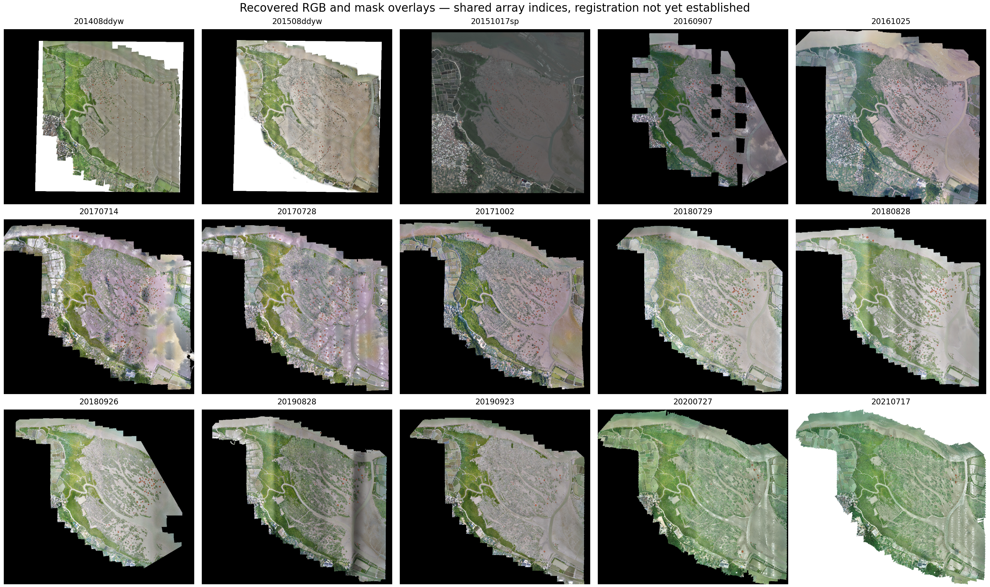
Recovered observations and provenance. Fifteen RGB/mask overlays shown at shared array indices. Colours indicate archived mask foreground. Equal array positions are an inspection convention, not proof of registration. Dense continuous vegetation is not exhaustively represented by these masks.

Figure 2
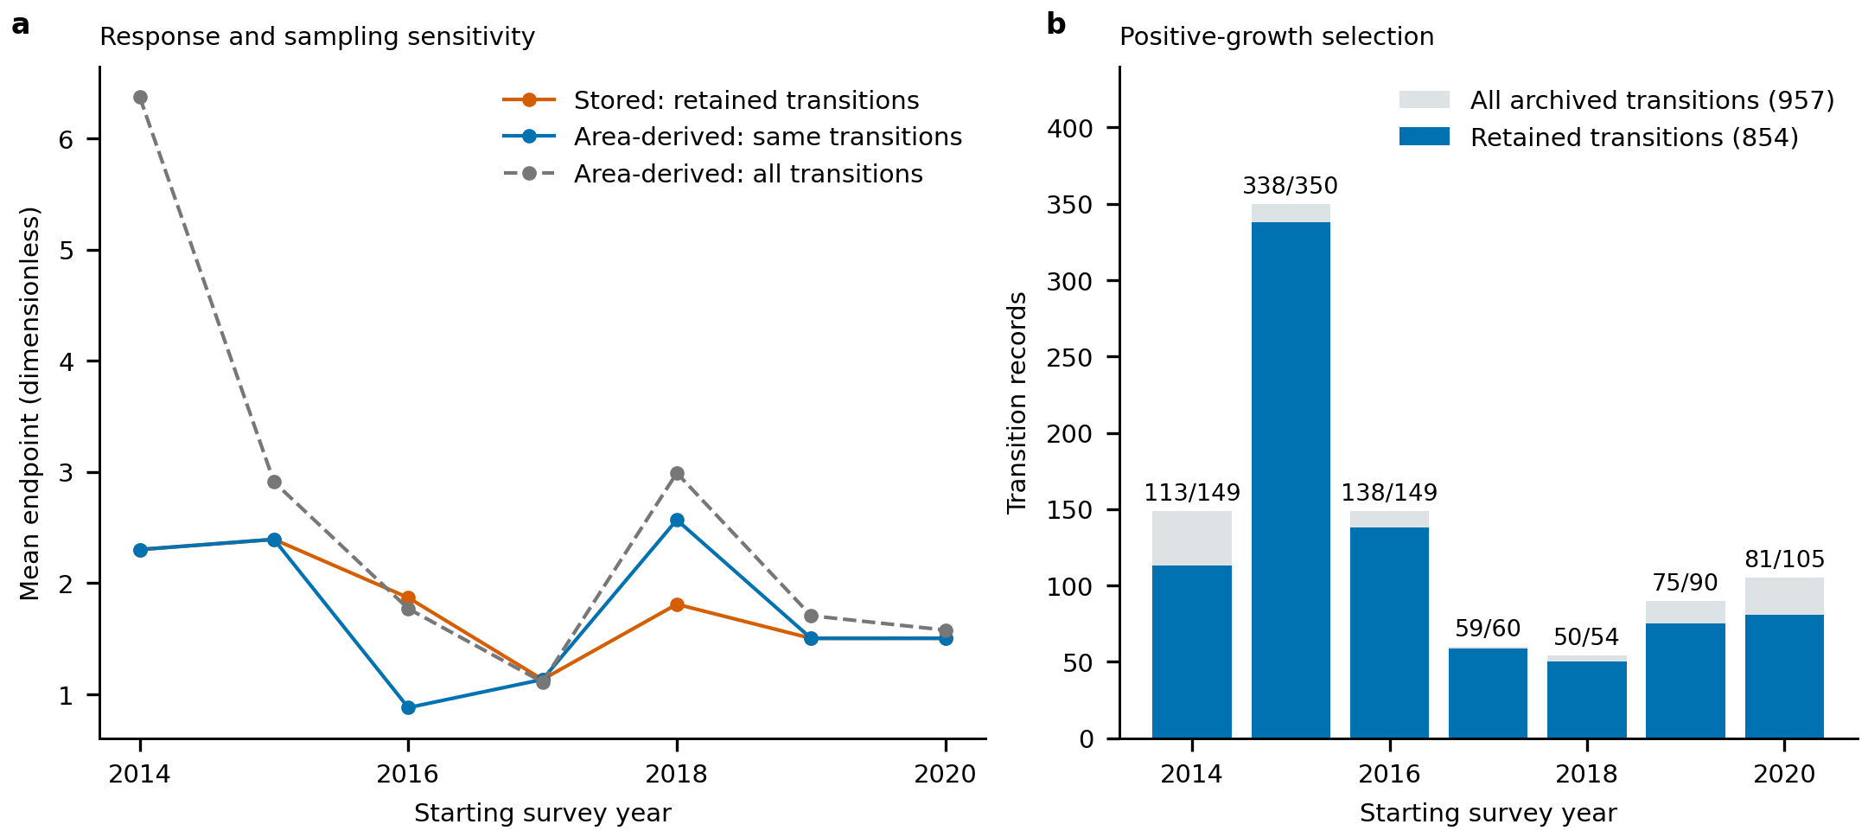
Endpoint and sample-definition sensitivity. Annual means compare stored endpoints, area-derived increments for the same model records and increments for all archived transitions. Record-level differences occur in 2016 and 2018. Labels in panel b give retained/all records. Stored values are not assumed to have the same intended definition as recomputed increments.

Figure 3
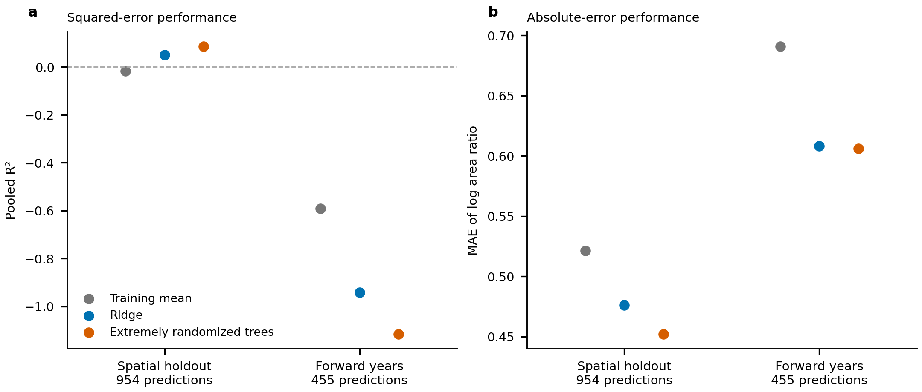
Prediction from starting geometry under spatial and temporal holdouts. Panel a shows pooled R² for the primary log area-ratio endpoint; panel b shows mean absolute error for the same predictions. Spatial holdouts contain 954 predictions and forward-year holdouts contain 455. Negative R² denotes performance below the pooled held-out mean reference; the fold-specific training-mean model is reported separately. Divergence between squared and absolute error makes the loss function consequential. Archived labels and identities remain unvalidated.

Figure 4
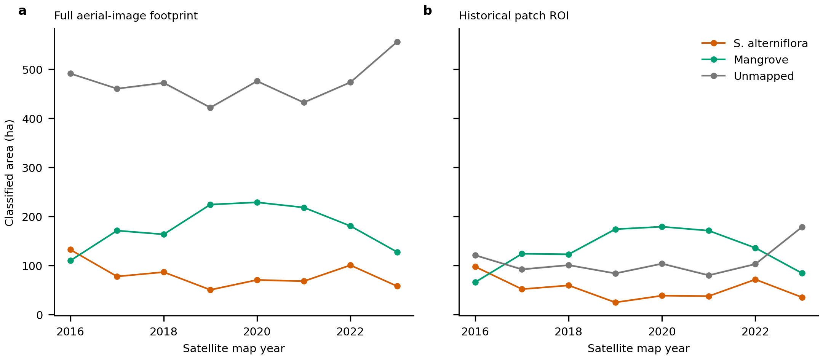
Satellite classified area across fixed footprints. Annual S. alterniflora, mangrove and unmapped class areas in the full-image footprint and historical patch ROI. Lines use the baseline 10 m UTM grid; shading spans four grid phases. The shaded range is not a classification-error confidence interval. Unmapped areas vary over time and remain separately tabulated. Derived from CCAV-10m V4, Yuying Li et al., CC-BY-4.0.

Extended Data Figure 1
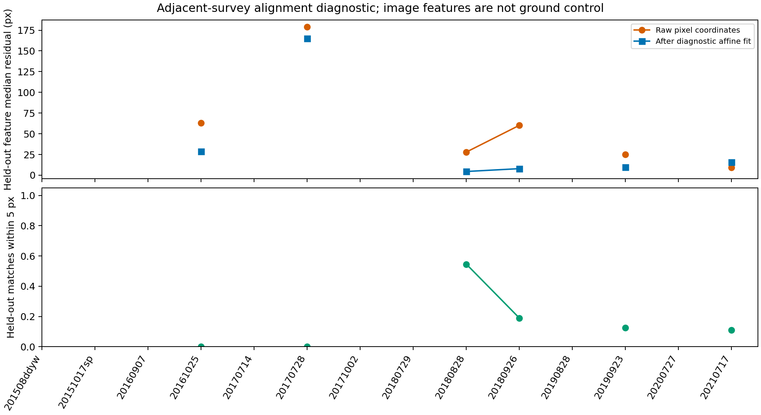
Image alignment diagnostic. Residuals of matched image features in spatially held-out tiles before and after a diagnostic transform. Missing points denote insufficient matching support. Feature residuals do not replace independent ground-control measurements.

Extended Data Figure 2
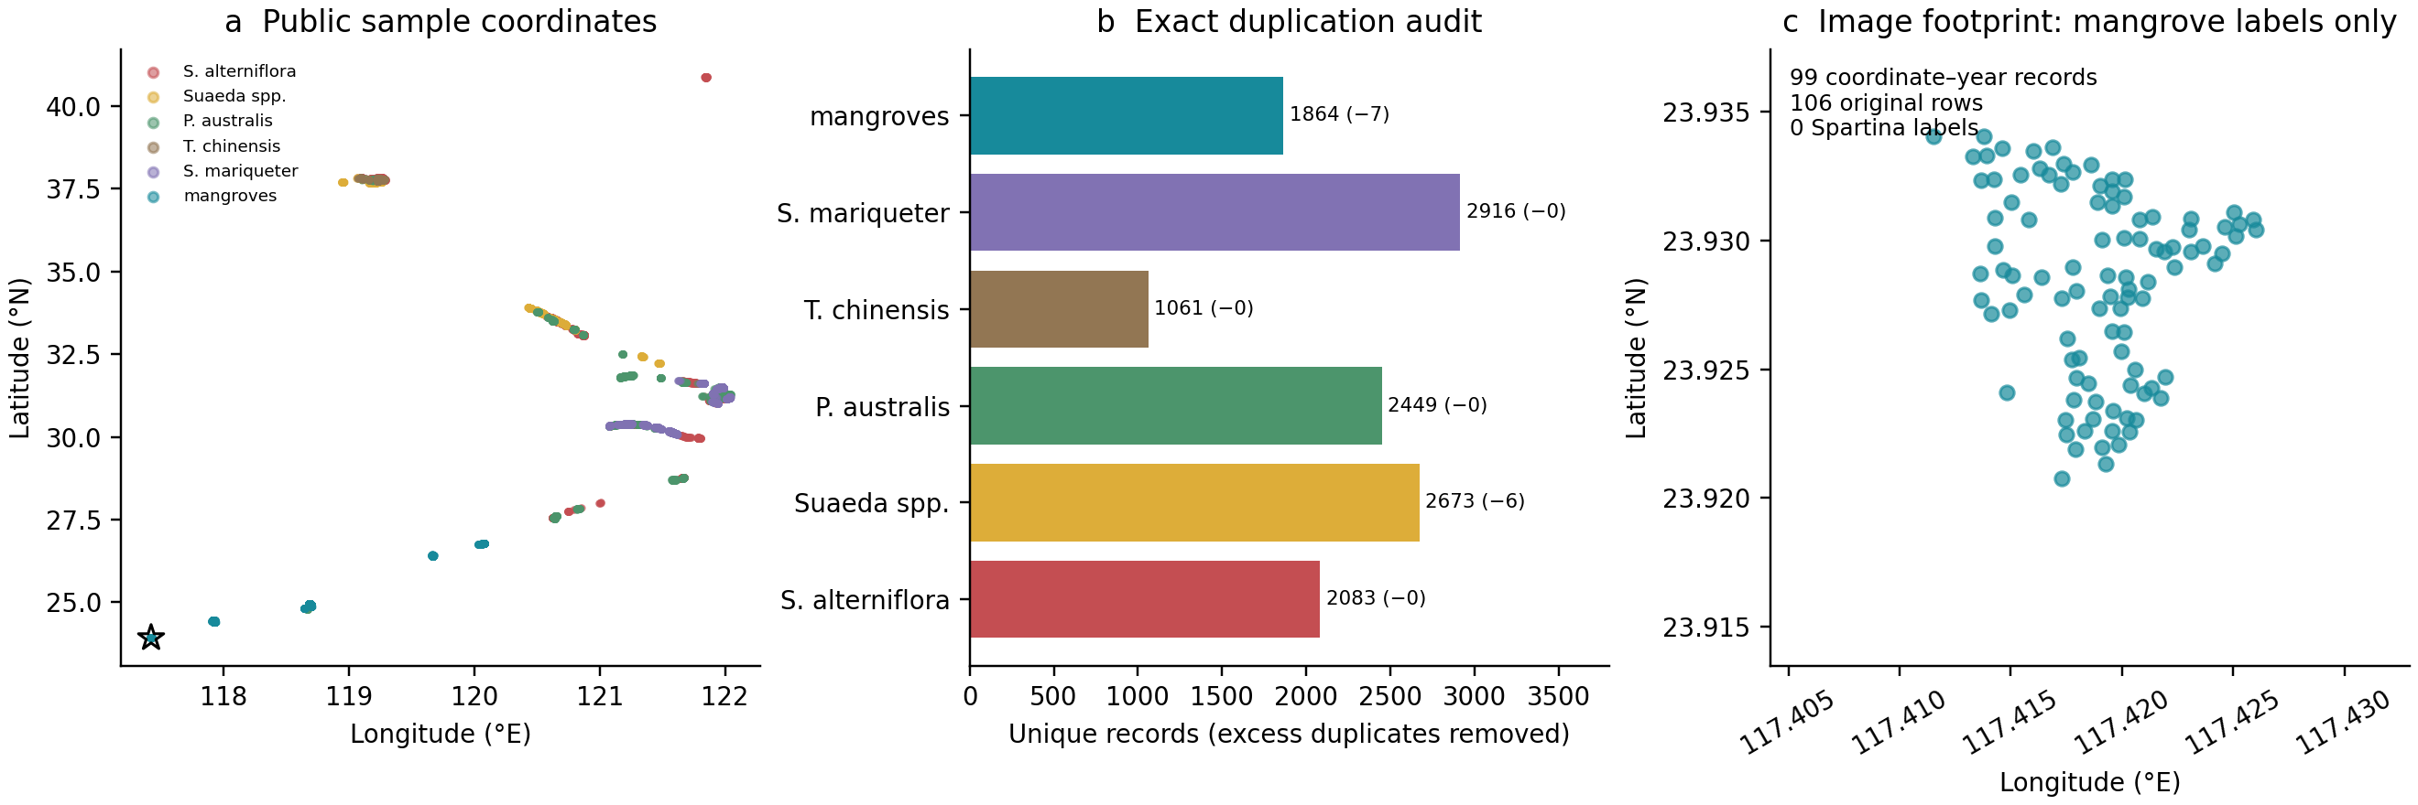
Public satellite sample audit. Geographic distribution, exact-duplicate audit and locations within the image footprint. The 106 local rows reduce to 99 coordinates, all labelled as mangroves. No independent model accuracy is estimated. Data: CCAV-10m V4, Yuying Li et al., CC-BY-4.0.

Extended Data Figure 3
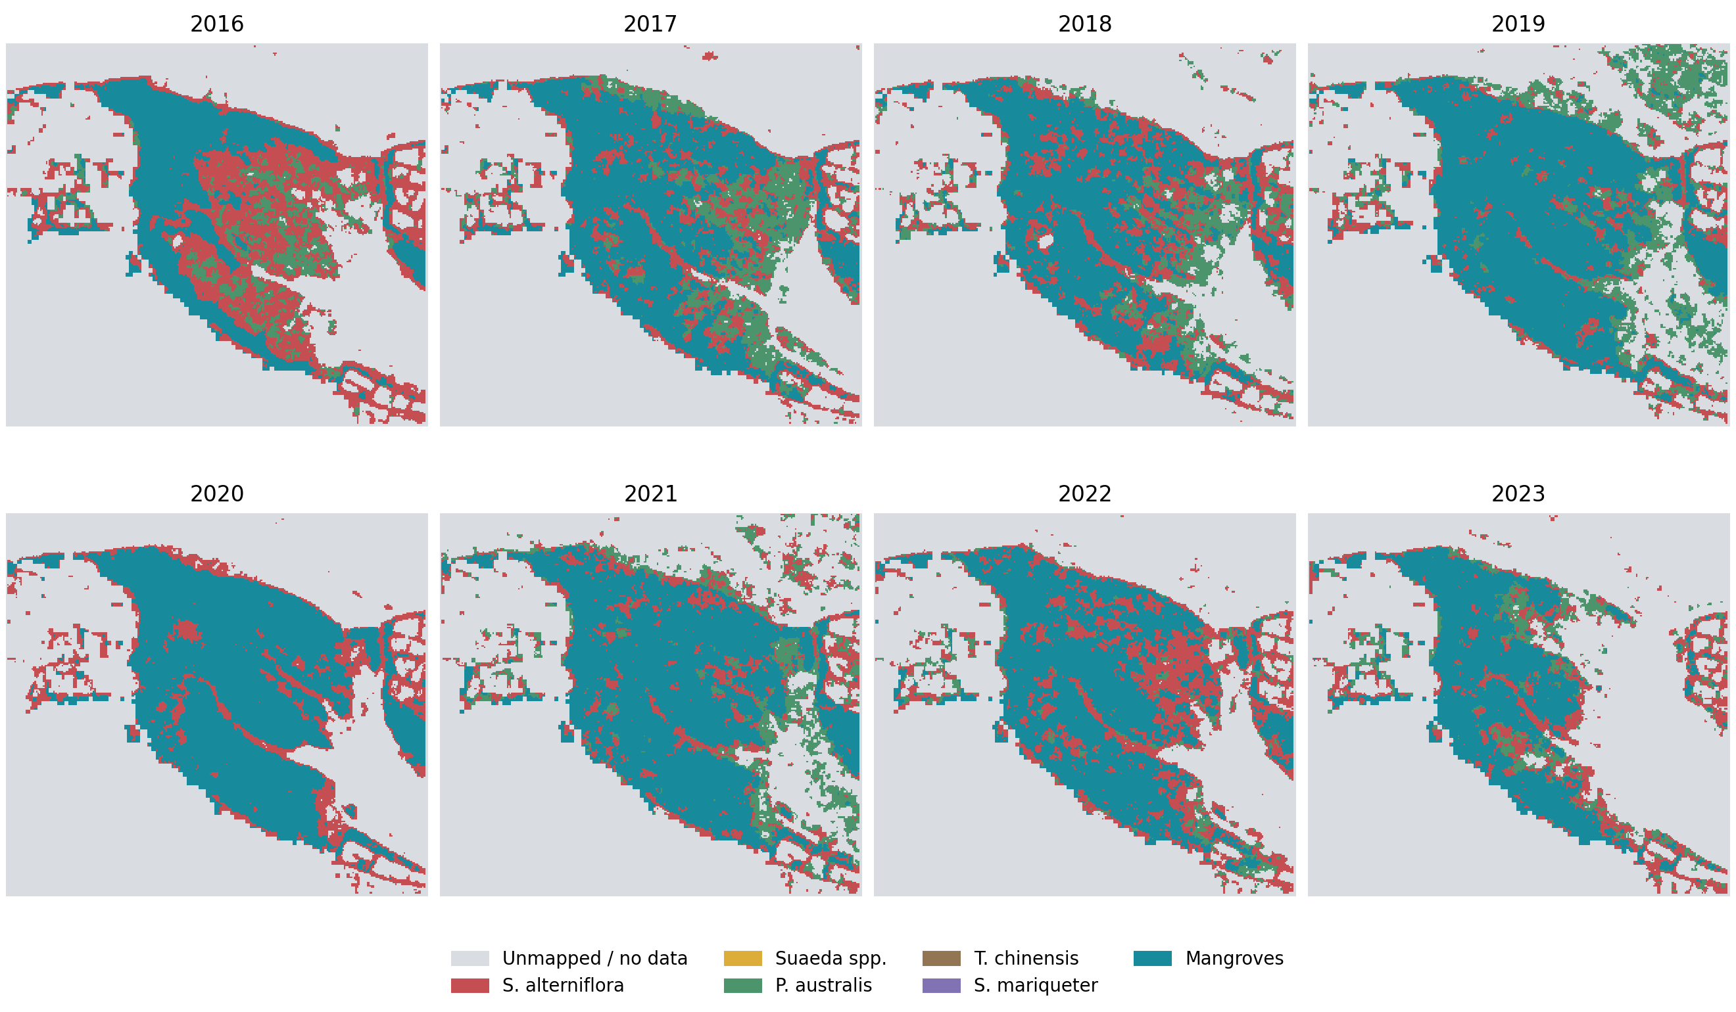
Annual satellite classes in the image footprint. Maps share a 10 m projected grid. Grey indicates unmapped/NoData; changes between classes do not independently establish species replacement. Derived from CCAV-10m V4, Yuying Li et al., CC-BY-4.0.

Extended Data Figure 4
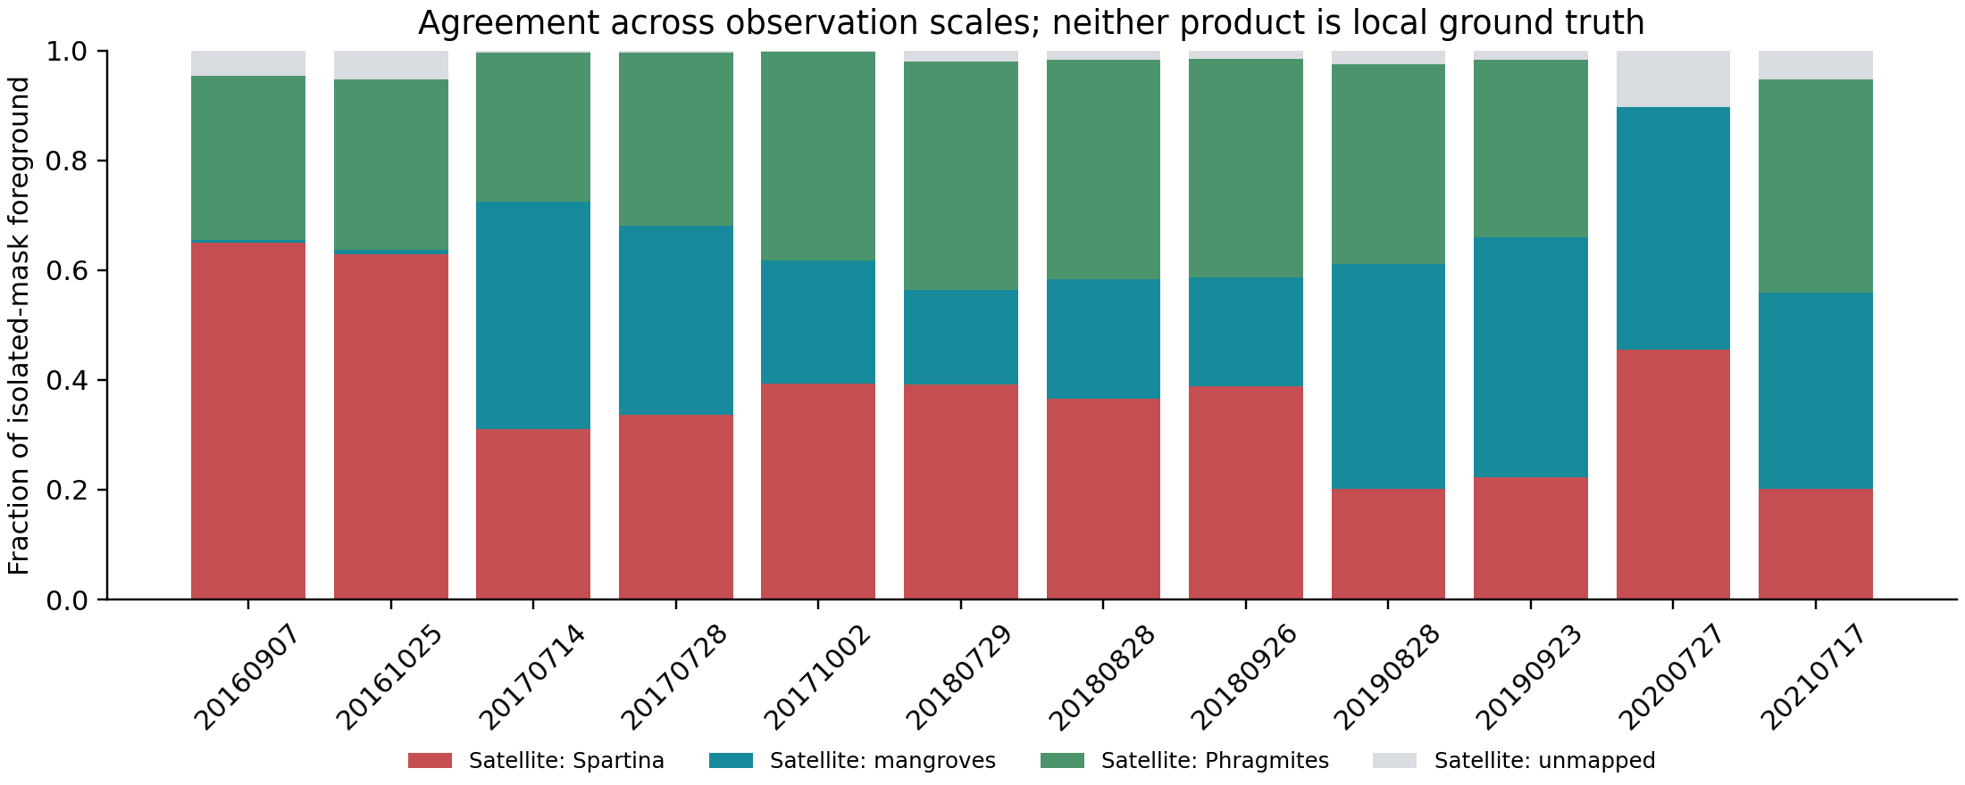
Agreement of isolated masks with annual satellite classes. Fractions refer to recovered ROI foreground pixel centres, assigned the same-year satellite class. Both products remain unvalidated locally; the comparison is conditional on mask positivity, includes acquisition-time and scale differences, and is not an accuracy assessment. Satellite source: CCAV-10m V4, Yuying Li et al., CC-BY-4.0.

Extended Data Figure 5
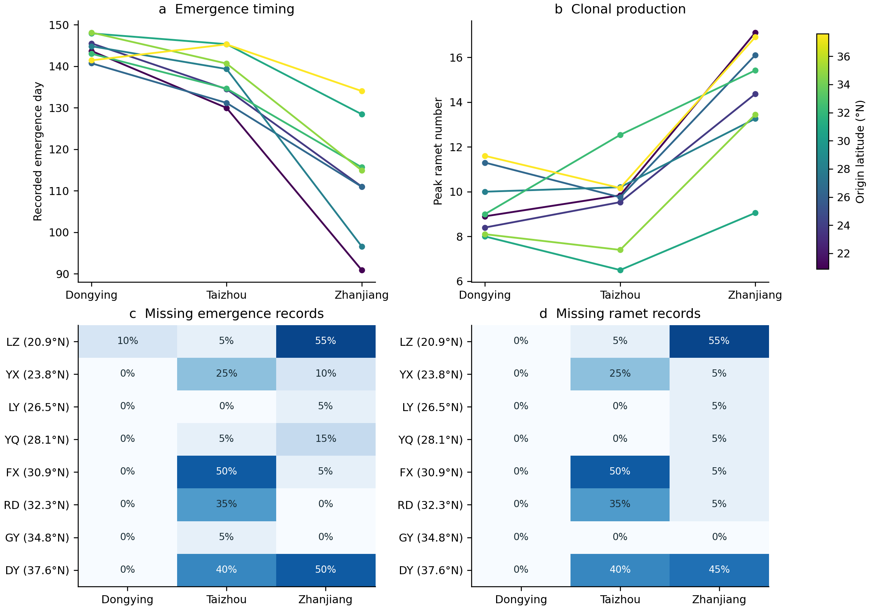
Clonal trait means and missingness across gardens. Lines connect source-level observed means, coloured by source latitude. Heatmaps show missing fractions among listed records. Sources are not identified genotypes; the time origin of the emergence variable is undocumented. Data: Xincong Chen, Figshare version 1, CC-BY-4.0.

Extended Data Figure 6
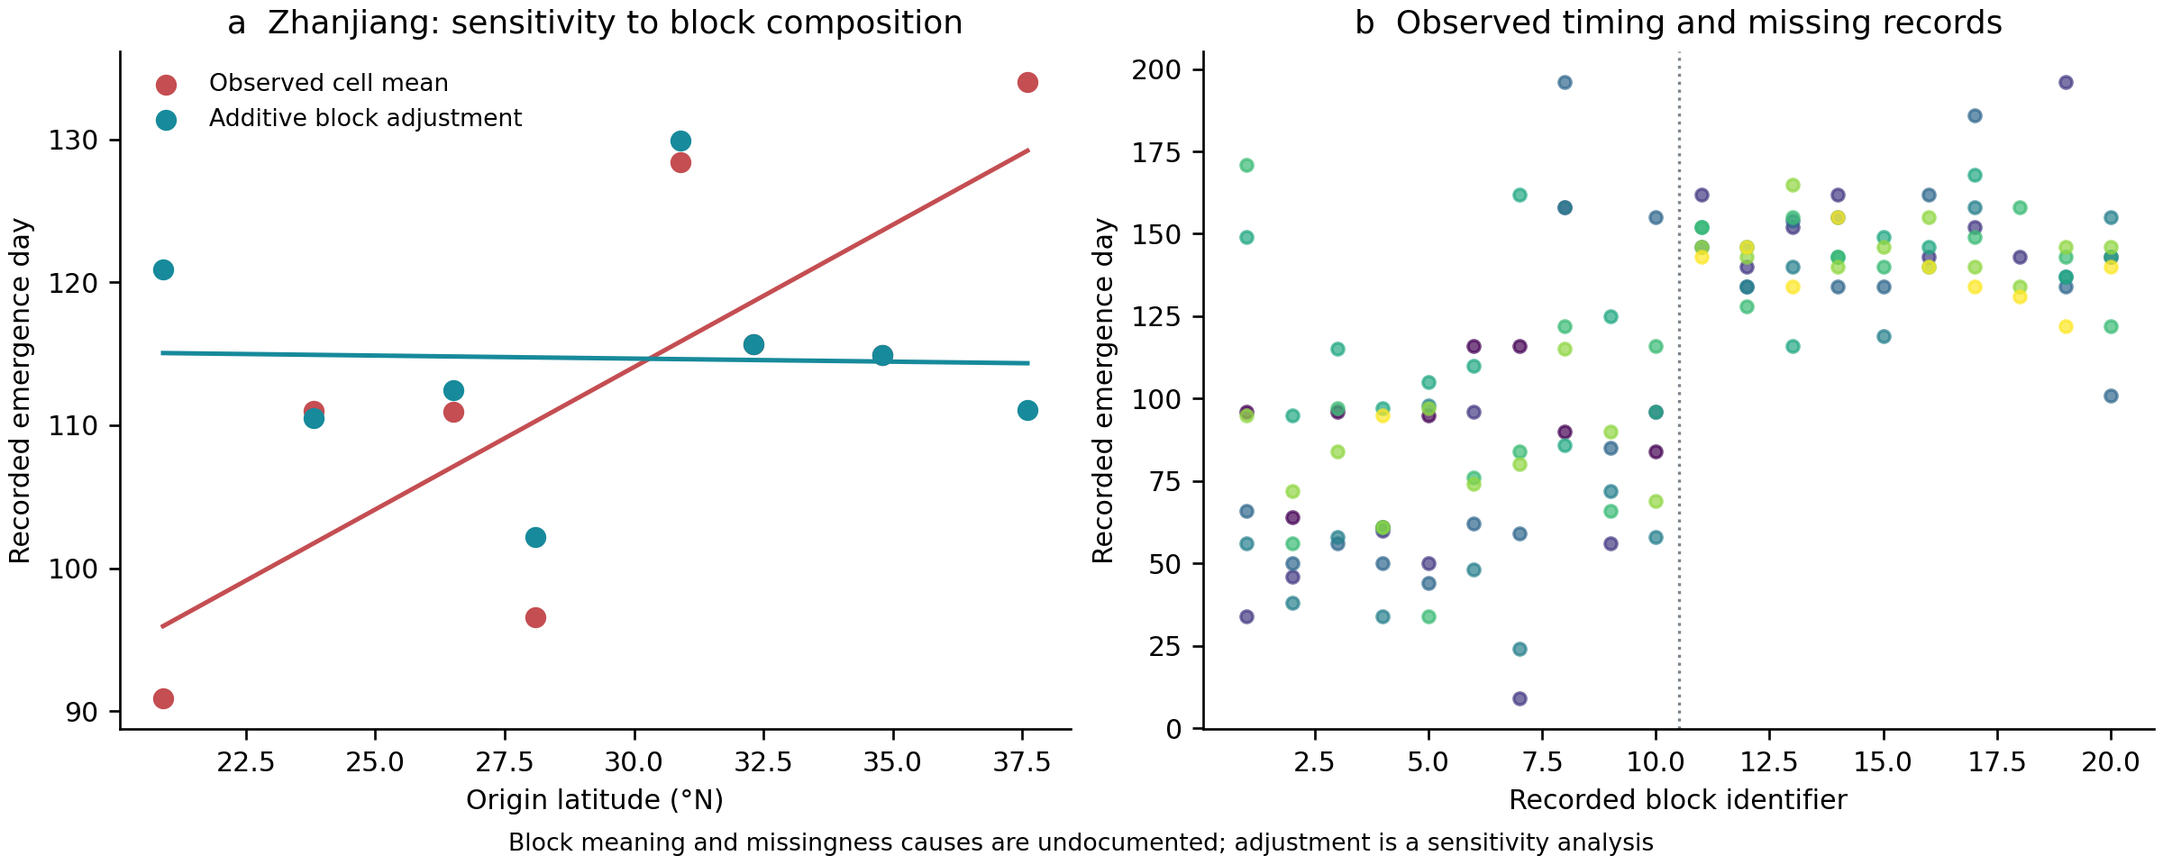
Source-cline sensitivity to recorded blocks. Zhanjiang observed and additive-block-adjusted source means yield different emergence–latitude slopes. Raw timing records are plotted by block identifier; colour indicates source latitude as in Extended Data Fig. 5. The dashed divider separates identifiers 1–10 and 11–20, without assigning them an undocumented batch or year meaning. Adjustment is a sensitivity analysis, not a validated correction. Data: Xincong Chen, Figshare version 1, CC-BY-4.0.

Extended Data Figure 7
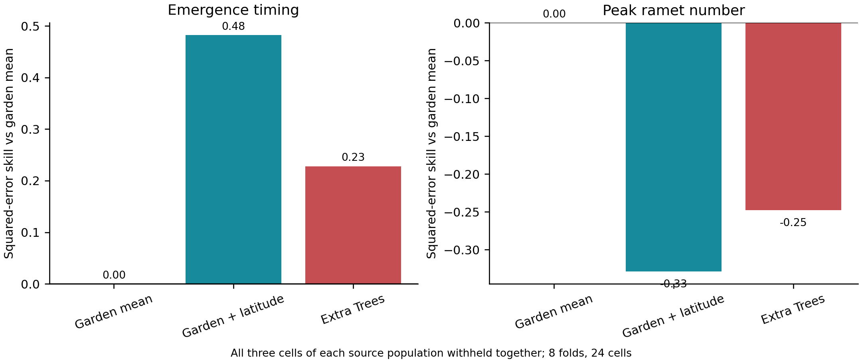
Prediction with entire sources withheld. Squared-error skill relative to the fold-specific garden-mean predictor, for unadjusted observed emergence and ramet-count means. All three cells of each source were withheld together. Positive emergence skill remains subject to the block/missingness sensitivity and does not identify genetic effects. Data: Xincong Chen, Figshare version 1, CC-BY-4.0.

Extended Data Figure 8
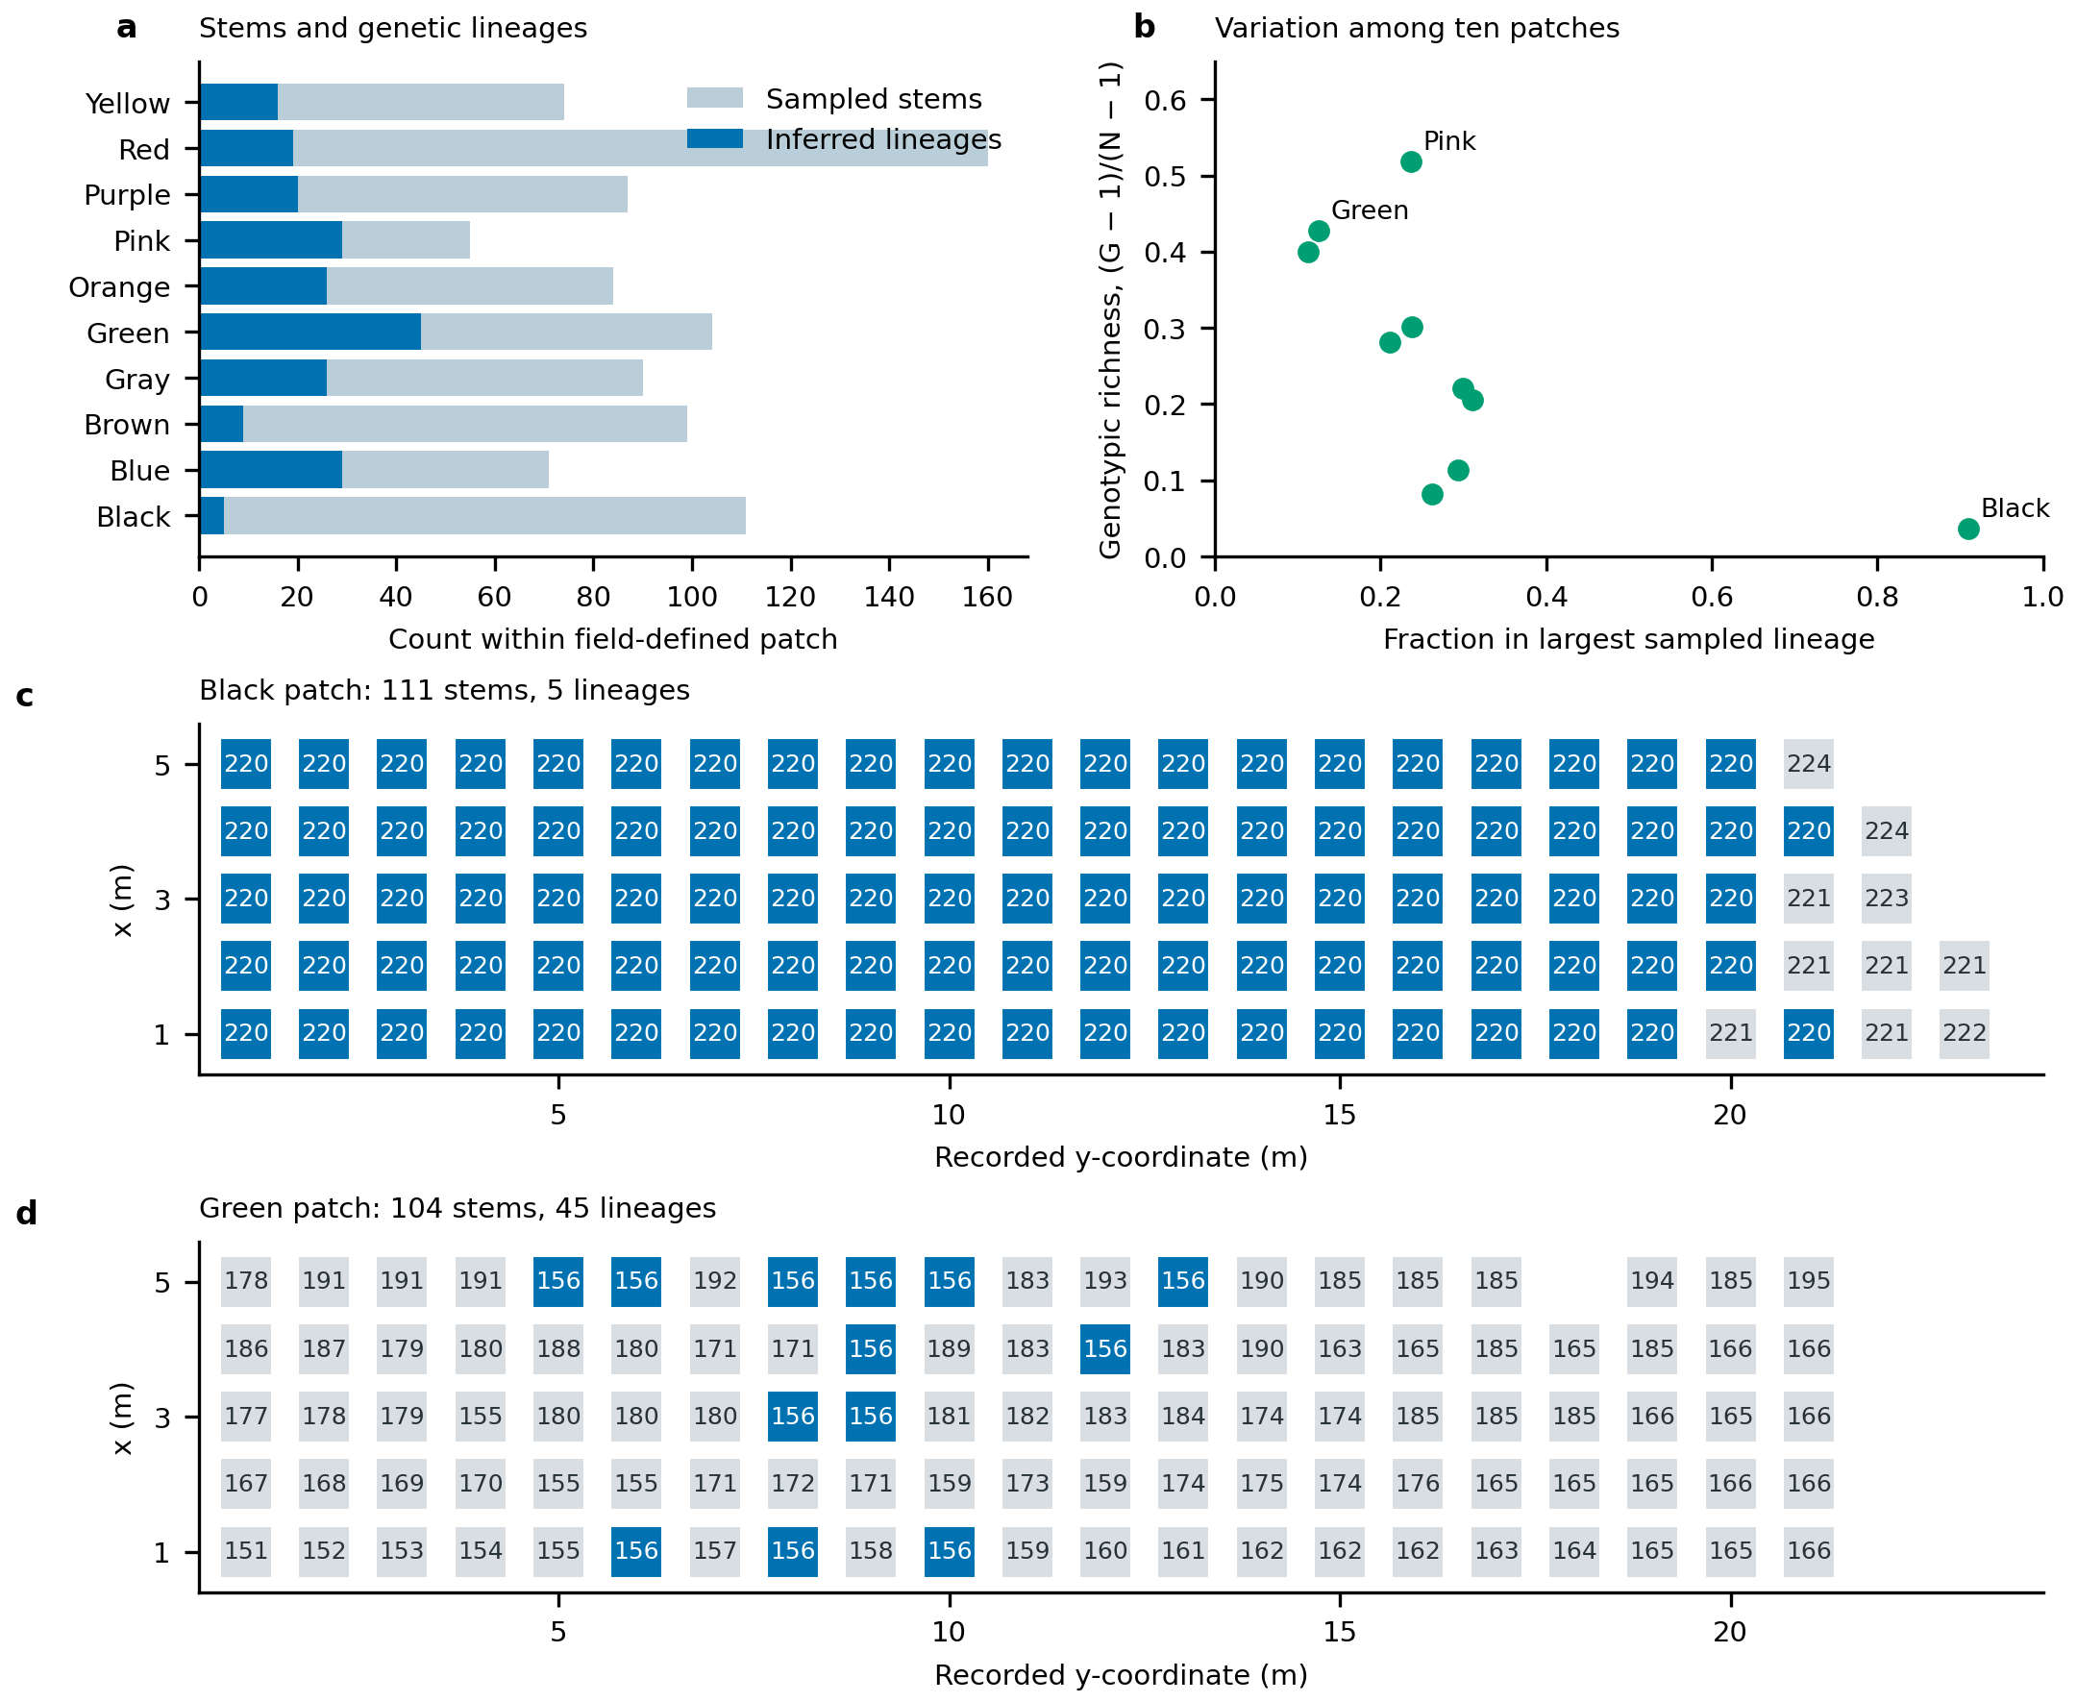
Field patches contain multiple inferred genetic lineages. a, Sampled stems and lineage counts for all ten patches. b, Genotypic richness against dominance of the largest sampled lineage; each point is one patch. c,d, Spatial records from the patches with the lowest and highest lineage counts. Numbers identify the source authors’ inferred lineages; blue marks the most frequently sampled lineage within each displayed patch. The selection of these two illustrations is descriptive, with all patches retained in panels a and b. Sampling coordinates are local metres. Supplied lineage assignments are retained without re-estimating the genetic threshold. These native-range data do not calibrate genetic identity in the local aerial imagery. Data: Tomasula, Caslin, Wimp and Hamilton (2026), CC-BY-4.0.

Extended Data Figure 9
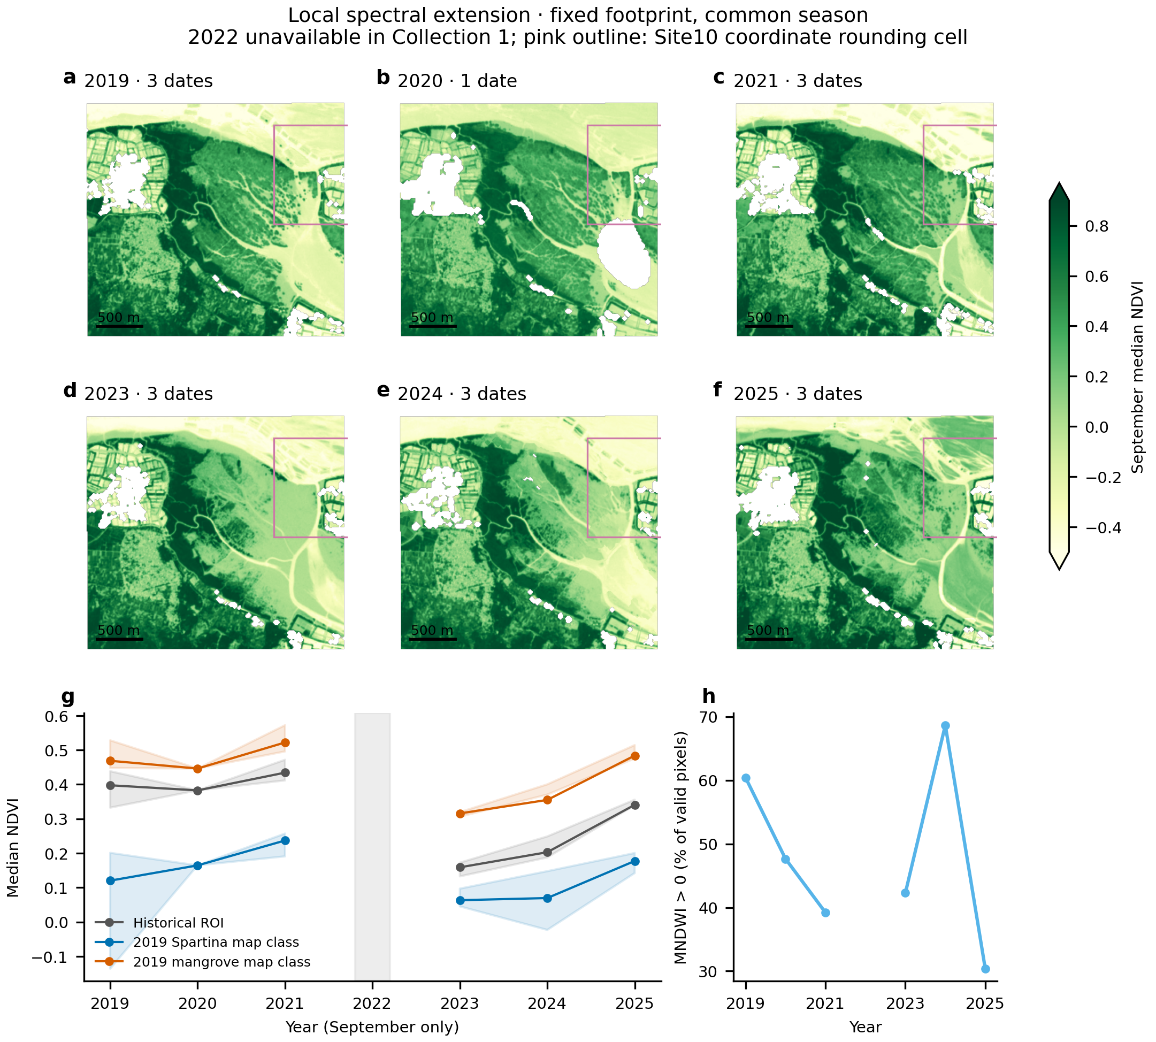
Same-season spectral observations extend the local footprint to 2025. a–f, Pixelwise September median NDVI in six available years, with one selected date in 2020 and three in each other year. Maps show each year's accepted coverage; statistical comparisons use identical pixels valid in every available year. White indicates missing accepted observations; colour extremes beyond the displayed range are indicated on the colour bar. Pink outlines mark the 0.01° coordinate-rounding cell around published Site10, clipped at the image boundary, not the study's 50 × 50 m sample windows. g, Spatial median NDVI on fixed common support in the historical ROI and two fixed 2019 CCAV map strata. Shading spans qualifying individual-date spatial medians and is not a confidence interval; aggregation order means that it need not contain the composite statistic. h, Fraction of pixels with positive MNDWI among those with valid MNDWI within the fixed S. alterniflora map stratum. This is a water-exposure diagnostic, not measured inundation. September 2022 was absent from the queried Collection 1 catalogue and remains a gap. No species-cover, demographic or evolutionary inference is assigned to the spectral indices. Scale bars, 500 m. Contains modified Copernicus Sentinel data (2019–2025); CCAV strata derived from Yuying Li et al., CC-BY-4.0.

Extended Data Figure 10
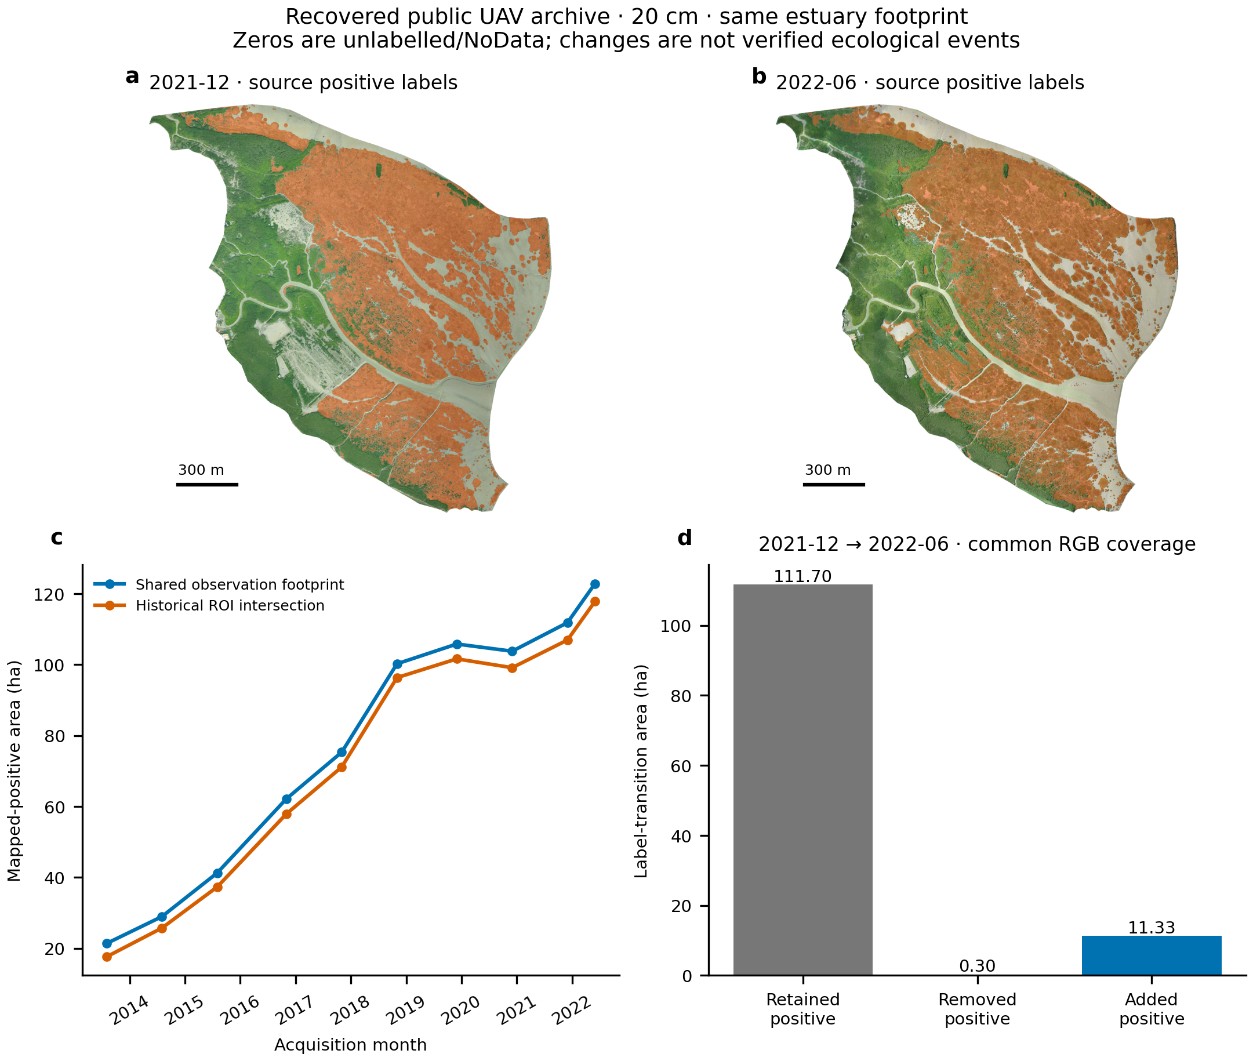
Public 20 cm UAV products expand the local observation record. a,b, December 2021 and June 2022 source orthomosaics with mapped-positive labels overlaid in orange; zero-labelled pixels are not treated as verified absences. c, Mapped-positive area on the fixed 248.935 ha all-date observation intersection and its 211.60 ha intersection with the historical ROI. One-metre fractions retain native zero values in their denominator; observations differ in season. d, Original 20 cm classified-array transitions within 250.163 ha observed in both endpoint RGB products: 111.697 ha retain positive labels, 0.305 ha lose positive labels and 11.326 ha gain them. Classified header origins differ by 0.0001093 m; physical registration and ecological event identity remain unvalidated. Source-image correspondence in August 2014 and August 2015 is consistent with shared historical imagery, so these products do not supply independent-site validation. Scale bars, 300 m. Adapted from Huang, Zhang, Zhou and Zhu, ScienceDB V4, CC-BY-NC-SA-4.0.

Extended Data Figure 11
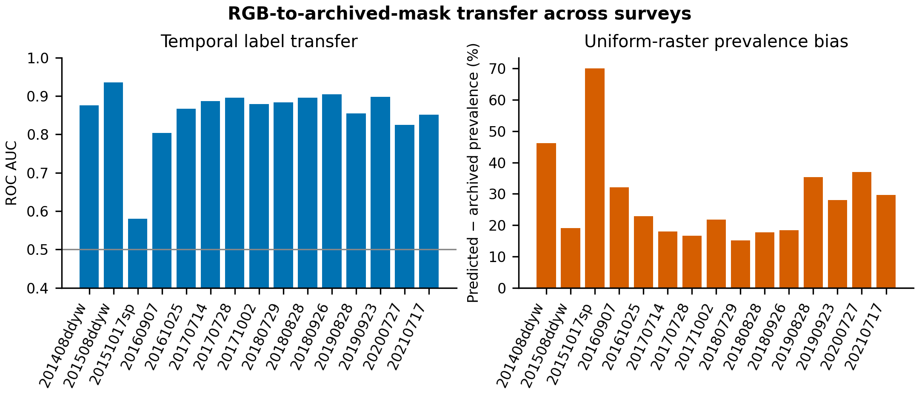
Temporal transfer and prevalence calibration of an RGB-to-archived-mask classifier. Left, ROC-AUC on balanced positive/zero samples when each survey is held out. Right, predicted minus archived positive prevalence on uniform full-raster samples at a fixed probability threshold. Balanced discrimination is label reproduction, not independent accuracy; prevalence bias shows why an uncalibrated colour surrogate cannot estimate invasion area.

