Separating biological change from observation in an invasive plant time series
Working manuscript, 7 October 2026. This draft reports completed analyses and distinguishes them from planned validation. It is not ready for submission: segmentation accuracy, demographic events, the historical endpoint transformation and any evolutionary mechanism remain unvalidated. Authorship and affiliations should be supplied by the research team.

Abstract
Clonal plant invasions spread through shoot production, recruitment and the coalescence of vegetation. Repeated imagery can reveal changes in cover, but the resulting patches need not correspond to biological individuals. Here we reconstruct an aerial record of Spartina alterniflora invasion and test how response definitions, observation units and experimental design affect interpretation. The apparent temporal growth pattern depends on both an unresolved endpoint transformation and the exclusion of shrinking or rapidly expanding patches. Shared objects and image gaps further complicate demographic inference, while prediction from initial patch geometry transfers poorly across years. Annual satellite maps reveal discrepancies between isolated-patch measurements and landscape composition. An external genetic dataset confirms that field-defined patches can contain many inferred lineages. Reanalysis of common-garden clonal traits identifies garden-associated contrasts but also an emergence–latitude relationship that depends strongly on recorded block composition. Together, these results show why canopy objects, demographic trajectories and inherited traits require distinct validation. They provide a reproducible framework for testing whether apparent changes in invasion reflect biological processes or changes in what can be observed. Establishing the mechanism requires independent event labels, verified genetic identity and replication across environments.

Main text
Biological invasions alter ecosystems through changes in abundance, spatial spread and interactions with resident organisms. In coastal wetlands, Spartina alterniflora can transform habitat structure and ecosystem processes ¹. Repeated aerial surveys offer a way to observe these changes at the scale of individual vegetation patches. Advances in image segmentation make it feasible to extract many such observations, and spectral and phenological information has already been used to study this invasion ². The scientific challenge is to establish what the extracted objects measure.
A vegetation patch is an observation unit whose identity can change as plants grow, overlap or become obscured. Patch disappearance may represent death, incorporation into continuous vegetation, incomplete image coverage or a failure of detection. Likewise, a new segmented object does not necessarily identify a newly recruited genetic individual. If these processes affect inclusion in a growth dataset, the properties of retained observations may change even when the underlying population process does not. Distinguishing observation from biology is therefore necessary before interpreting temporal change.
Evolutionary explanations require an additional evidential step. Work involving Xiamen University’s College of the Environment and Ecology has demonstrated that trait clines can differ between field and common-garden conditions, between reproductive and vegetative traits, and among gardens ^{3,4,5,6}. These studies make trait identity and environmental replication central to the interpretation of an invasion. Common-garden work on S. alterniflora has documented persistent differences between growth forms under shared conditions ⁷. Studies of other invasive plants have combined common gardens, genetic information or environmental gradients to test adaptation ^{8,9}. Such evidence motivates evolutionary hypotheses but cannot be replaced by a correlation between year and remotely observed growth. We therefore examine the recoverable evidence chain before assigning mechanisms to the historical image series.

Reconstructing the image-to-table evidence chain
We independently rehashed all 1,001 files in the recovered archive, comprising 38,654,767,408 bytes, and found no checksum discrepancies. Fifteen paired RGB images and binary masks had identical array dimensions of 26,606 by 24,443 pixels. RGB rasters carried a shared EPSG:4326 transform, whereas masks lacked a geographic reference. Equal dimensions and header transforms establish a common array convention but do not establish the accuracy of registration.
Two annotation deliveries contained matching polygon sets after standardizing ring start, orientation and redundant closing vertices: 714 images and 9,234 objects. Polygon rasterization and 79 delivered PNG masks had a median intersection over union of 0.9965. This comparison measures consistency between annotation encodings, not the accuracy of the segmentation model. The original training photographs, segmentation checkpoint and fixed training/validation/test split have not been recovered, and the original model performance remains unverified.
A fixed region of interest, inferred from the first survey and then held constant, linked 5,745 of 5,746 archived patch-date positions to recovered mask bounding boxes. Archived x and y represented bounding-box row and column within this crop, rather than full-image centroids. An exclusive-maximum rectangular foreground count reproduced 5,744 historical areas. This rule omits the final bounding-box row and column and can include foreground belonging to nearby objects. We consequently retain historical areas as archived measurements rather than validated component areas.

The response and sample definition change the apparent temporal pattern
The annual matrix contained 2,459 candidate trajectory rows, of which 1,769 appeared in only one survey. Connecting successive observed years within rows produced 957 transitions. All had consecutive annual labels, although the selected survey dates varied within years. These transitions are conditional on the archived tracking procedure and do not constitute a census of demographic events.
All 854 records in the modelling workbook matched annual transitions on starting year, initial area, area increment and next-survey bounding-box position, preserving the frequency of repeated keys. Four records had multiple matching candidates, so the mapping did not establish a unique biological identity for every record. The retained set was exactly reproduced by the rule 0 < (A₁ − A₀)/A₀ < 10. This excluded 50 nonpositive changes and 53 relative increments of at least ten. The model thus described a selected set of growing, successfully tracked objects.
The stored growth_rate was inconsistent with (A₁ − A₀)/A₀ for all 138 records starting in 2016 and all 50 starting in 2018. The other five years agreed within numerical tolerance. No recovered transformation explained these differences. Accordingly, recomputation is a sensitivity analysis, rather than a claim to recover the intended original endpoint.
For the same 854 records, the Spearman correlation between year and annual mean endpoint was −0.714 for stored values and −0.107 for area-derived relative increments, with exact two-sided rank-permutation P values of 0.088 and 0.840, respectively (seven annual means). Including all 957 archived transitions gave a correlation of −0.607 for area-derived relative increments (exact P = 0.167). The latter mean is sensitive to extreme changes from small initial areas. These comparisons show that a mechanistic account of a temporal trend requires a resolved endpoint and an explicit sampling population; none of the comparisons independently establishes such a mechanism.

Objects, trajectories and observation gaps
Eight-connected component extraction produced 8,280 components across the 15 cropped masks, including small components. Component areas summed exactly to independently calculated mask foreground counts in each survey. Eighty component-date objects were shared by 167 archived observations, giving 87 excess rows relative to unique objects. Shared endpoints may reflect branching tracks or duplicate assignments. Their cause remains to be determined, and these observations cannot be treated as independent individuals.
An unregistered adjacent-survey overlap screen examined 5,459 source observations. Of these, 1,386 continued to an archived successor that passed the overlap criterion, and 1,123 continued to a successor that did not. Another 177 lacked a next-row observation but overlapped another mask object; 2,772 lacked both a next-row observation and a qualifying overlap. One source bounding box was unresolved. These categories are diagnostic candidates, not rates of survival, recruitment, splitting or merging.
Eighty observations without a next-row record had at least 95% exact black or white RGB values at their preceding foreground locations in the next image. Inspection of diagnostic crops confirmed that complete black coverage gaps occur. This result demonstrates an observation problem without establishing that all flagged locations are missing data. Death cannot be assigned from absence in an unvalidated mask alone. The distinction parallels the separation of occurrence and detection in ecological observation models ¹⁰, although the current surveys do not by themselves satisfy the replicate-observation assumptions required for a fitted detection model.
Automatic feature matching did not resolve the alignment problem. Six of 14 adjacent image pairs supplied sufficient matches for a partial-affine diagnostic fit. Spatially held-out feature residuals remained substantial, and no pair passed the descriptive diagnostic gate. Features may include changing vegetation or erroneous matches; these residuals are not independent ground-control errors. No fitted transform was applied to the imagery or used to classify biological events.

Field patches and genetic individuals are distinct units
To evaluate the biological meaning of a patch independently of image segmentation, we audited a published native-range genetic dataset ¹¹. Its spatial table contained 935 uniquely labelled sampled stems in ten field-defined patches and 223 inferred multilocus lineages. Individual patches contained 5–45 lineages; one lineage occurred in two patches, giving 224 patch–lineage combinations (Extended Data Fig. 8). These counts reproduce summaries from the supplied lineage assignments. We did not independently infer genotypes or re-estimate the lineage threshold.
This comparison establishes a concrete mismatch among sampled stems, field-defined patches and inferred genetic lineages in the external study. It does not establish how many lineages occur in our aerial objects, because the datasets lack a shared image-to-genotype correspondence. Consequently, an image model can estimate canopy structure while remaining unable to identify genets. Evolutionary interpretation requires that additional link.

Prediction with starting information and explicit holdouts
We established a fixed benchmark using log initial area and initial bounding-box coordinates, excluding next-survey locations and legacy principal components. Three exactly repeated transitions were removed, leaving 954 observations in 661 dependency groups. Groups joined annual trajectory rows sharing a dated bounding-box position. We evaluated a training-mean baseline, ridge regression and extremely randomized trees using within-fold preprocessing, forward-year prediction and buffered spatial holdouts ¹².
For the primary endpoint, log(A₁/A₀), pooled forward-year R² values were −0.591 for the training mean, −0.941 for ridge regression and −1.116 for trees (455 predictions across 2016–2020). Performance differed by year; for example, positive R² in some earlier folds did not extend to 2019 and 2020. Both fitted models had lower pooled mean absolute error than the mean baseline, while their squared errors were larger. The benchmark therefore reveals sensitivity to large prediction errors and temporal transfer, rather than supporting a uniform statement about all loss functions.
Within-site buffered spatial R² values for log area ratio were −0.017, 0.051 and 0.086, respectively, over 954 predictions. For relative area increment, trees achieved a spatial R² of 0.278 but a forward-year R² of −0.601. Initial area also enters both response definitions, so apparent size dependence need not identify a biological mechanism. These benchmarks do not evaluate climate effects or establish independent-site transfer. They identify the performance of starting-geometry baselines on archived, still unvalidated labels.

External landscape observations expose a second measurement scale
We obtained the public CCAV-10m V4 coastal vegetation product ¹³, including eight annual maps for 2016–2023, a sample workbook and the class-code key. All three downloaded files matched the provider's checksums. The sample workbook was byte-identical to an existing project copy, resolving its provenance. Of 13,059 public rows, 13 were exact duplicates on coordinates, year and standardized class. Within the full aerial-image footprint, 106 rows represented 99 unique coordinates, all labelled as mangroves. No local S. alterniflora labels were present. Training/validation membership was unavailable, so neither these records nor the source paper's reported national accuracy supplied an independent local accuracy estimate.
After nearest-neighbour reprojection to a fixed 10 m grid, the satellite product classified 97.62 ha of the historical ROI as S. alterniflora in 2016, 24.82 ha in 2019, 71.64 ha in 2022 and 35.22 ha in 2023 (Fig. 4). Four grid phases changed those estimates to ranges of 97.62–98.47, 24.68–25.79, 71.39–71.89 and 35.22–35.75 ha, respectively. These ranges describe discretization sensitivity, not classification uncertainty. Mangrove and unmapped areas also changed. From 2016 to 2017, 49.48 ha changed from the S. alterniflora class to the mangrove class, whereas 8.60 ha changed in the opposite direction. These are map-class transitions; species replacement remains an untested explanation alongside classification and observation effects.
Projecting recovered mask foreground pixel centres into the corresponding annual satellite grids yielded S. alterniflora-class agreement of 20.1–65.0% across 12 aerial surveys from 2016 to 2021 (Extended Data Fig. 4). Foreground totals matched independently extracted component totals in every survey. The agreement is conditional on historical mask positivity and is not an accuracy estimate. Small patches may occupy mixed 10 m pixels, annual composites differ from individual flight dates, and absolute georeferencing remains unverified. The satellite results therefore identify where landscape composition and isolated-object measurements must be reconciled, without validating either product as biological truth.

Clonal traits: garden contrasts and source effects require different checks
A separate public dataset ¹⁴ supplied 400 records from eight Chinese source populations in three common gardens, with 344 observed ramet counts and 338 emergence-time records. We treated source populations as the units for latitude comparisons and formed 24 source-by-garden means. Zhanjiang minus Dongying differences were +5.05 peak ramets and −31.58 days on the recorded emergence-time scale. Exploratory 95% percentile intervals from a crossed source and within-garden block bootstrap were +2.67 to +7.47 and −48.70 to −15.44, respectively (5,000 draws). Additive block adjustment retained corresponding contrasts of +4.99 ramets and −29.77 days. These are garden-associated contrasts, not isolated temperature effects; the dataset does not establish the timing origin, genotype identities or missingness causes.
Source-latitude interpretations were less stable. Unadjusted emergence correlations in Taizhou and Zhanjiang were 0.786 and 0.810, with exact two-sided permutation P values of 0.0279 and 0.0218. A shared-source maximum-statistic adjustment over six trait-by-garden tests gave P = 0.137 and 0.110. More consequentially, the Zhanjiang linear slope changed from +1.992 to −0.043 days per degree after additive block adjustment (Extended Data Fig. 6). Low-latitude LZ emergence records occurred only in blocks 1–10, whereas nine of ten observed high-latitude DY records occurred in blocks 11–20. Timing distributions differed between these recorded block ranges. Block adjustment requires additional assumptions and is not established ground truth; this sensitivity identifies missing design information that must be resolved before a source cline can support adaptation.
Withholding all three garden cells of each source population, a fixed garden-specific latitude model reduced squared error for unadjusted emergence means by 48.2% relative to the garden-mean baseline; extremely randomized trees reduced it by 22.8%. Neither improved ramet-count prediction over that baseline (Extended Data Fig. 7). The targets remained means conditional on observation availability. Consequently, positive predictive skill did not resolve the block-composition sensitivity or establish heritable differences. This external experiment is comparative evidence about inference, not a reconstruction of evolutionary change at the aerial survey site.

Discussion
The recovered record is valuable because it allows the observation process to be inspected. It also changes the interpretation of the historical analysis. The strongest current results concern provenance, conditioning and prediction. They do not establish a decline in total invaded area, inherited changes in growth, adaptive ecotypes or a causal effect of climate. A large calibration score cannot resolve an undefined response or an observation process that selectively removes shrinking, merging or unobservable patches.
External experimental research sharpens the competing explanations. A greenhouse study of ten Chinese and sixteen US source populations reported greater above- and belowground biomass in invasive-source plants and range-dependent relationships among latitude, flowering and biomass ¹⁵. A three-garden study of nine Chinese seed origins reported environment-dependent germination and seedling responses ¹⁶. The latter conclusion was assessed from the published abstract and archived dataset methods; we have not completed a full-text review or raw-data reanalysis of that experiment. Together, these studies motivate separate hypotheses about source-associated traits and environmental responses, rather than a universal direction of change in adult patch expansion. Maternal effects, ancestry, life stage and garden conditions remain relevant. Neutral-marker differentiation among Chinese and US populations ¹⁷ further motivates ancestry controls but does not establish adaptive change at this site. The two public common-garden dataset records were archived; file-access failures prevented reanalysis, and their reported results remain attributed to the original authors.
The Xiamen research programme also identifies competing ecological mechanisms that our analysis must separate. Liu and Pennings linked size, density and flowering across long-term salt-marsh observations ¹⁸; an apparent change in patch growth could therefore arise from crowding or allocation without requiring evolutionary change. Native–introduced comparisons found different vegetative and reproductive clines ^{5,19}, whereas Qiao and colleagues combined reciprocal transplants with quantitative and population genetics to investigate admixture and adaptation ²⁰. These are different evidential designs. A prediction score from aerial geometry does not supply their experimental contrasts, and a common-garden source effect does not by itself demonstrate home-site advantage. The raw geographic and three-year greenhouse tables accompanying reference ⁵ have now been retrieved from the originating GCE-LTER archive; a separate analysis remains local while source-specific distribution terms are reconciled. Related publications may share source material and must not be counted as independent experimental replications without a cohort audit.
A falsifiable ecological question is whether the transition from isolated establishment to landscape occupation is governed by crowding and coalescence, neighbouring vegetation, environmental responses or heritable source differences. The satellite maps now supply candidate locations for assessing vegetation boundaries and map disagreement. Distinguishing these mechanisms requires independent species labels and event histories; assigning local adaptation additionally requires inherited trait differences and fitness comparisons across environments. Neither a present-day common garden alone nor a space-for-time comparison would demonstrate evolution during this historical image series.
The next ecological analysis should define an explicit population at risk. A suitable representation would distinguish visible patch objects from candidate biological trajectories, permit multiple objects to merge, and record intervals in which an object cannot be observed. Growth estimates should be conditional on verified continuity, with separate treatment of disappearance and merger. Continuous vegetation should be mapped alongside isolated patches so that incorporation into a larger canopy is not mistaken for a loss of invaded area. Environmental effects should then be compared with density, neighbourhood structure and observation conditions as competing explanations.
Independent labels are required to make that representation testable. We have frozen a pilot sample of two image tiles in each of 16 geographic strata, yielding 32 locations repeated across 15 surveys. Tile selection did not consult the historical masks. Development, validation and test roles are assigned to entire spatial strata across all dates, with a buffer around held-out strata. The 480 native RGB crops and an annotation interface are available locally; completed expert labels do not yet exist. This pilot is intended to estimate annotation effort, disagreement and detection error before choosing a confirmatory sample size. It must not be presented as a completed independent validation of the historical segmenter, whose original training locations are unknown.
An evolutionary extension would require evidence that distinguishes inherited variation from plasticity and observation. Common gardens or reciprocal transplants across independent source populations, supported by clone identity or genetic data, could test whether verified field phenotypes predict persistent growth and tolerance differences. Sample size should follow variance and effect-size estimates from a pilot, with source populations—not image tiles—as the relevant independent replication. Contemporary samples cannot, without additional evidence, reconstruct genetic change between historical annual image cohorts. This limitation should remain explicit even if predictive performance improves.
The broader opportunity is to measure how invasion alters its own observable units as isolated patches expand and join continuous stands. Demonstrating that process across sites would connect AI measurement to demographic and ecological theory. The present work supplies a reproducible basis for that test and identifies the evidence still needed; it does not claim that the general mechanism has already been demonstrated.

Methods

Archive, coordinate and area audits
Source files were read without modification. SHA-256 values and byte counts were compared with the recovery manifest. Raster metadata, binary-value histograms and downsampled overlays were examined separately. The region of interest comprised rows 4,000–21,999 and columns 10,000–24,999 in the full arrays. This crop rule was inferred from the 2014 survey and tested without refitting on subsequent dates. Bounding-box joins, external-contour counts and rectangular slice counts were retained as separate audit variables. The connected-component audit used eight-neighbour connectivity. UAV component areas and distances remain in pixels because registration and measurement accuracy are unresolved; satellite map areas are separately reported as projected classified area. The first two survey filenames specify months, not known days.

Endpoint provenance and selection
Positive annual area entries were connected within matrix rows. Relative increment was defined as (A₁ − A₀)/A₀; log area ratio was ln(A₁/A₀). Neither was labelled an annualized rate. Workbook-to-matrix matching preserved the multiplicity of repeated keys, and ambiguous matches were reported. Stored and recomputed endpoints were compared at tolerance 10⁻⁸. Annual trend statistics used seven annual means. Exact two-sided P values enumerate all 5,040 permutations of annual ranks and assume exchangeability under the null; they do not model serial dependence. These comparisons are descriptive, not tests of heritability or environmental causation.

Transition and alignment diagnostics
Adjacent masks were linked by raw-array intersections conditional on component area ≥100 pixels and intersection ≥10 pixels. Intersection divided by smaller-component area was screened at 0.10, 0.25 and 0.50. Exact black or white next-survey RGB values at previous component pixels provided a fill diagnostic. A separate feature-alignment screen used 16 fixed 2,048-pixel windows, downsampled by two, SIFT descriptors, mutual nearest matching and a 0.65 ratio criterion. Partial-affine RANSAC used one spatial checkerboard fold; the other fold supplied diagnostic residuals. These analyses did not correct rasters or supply independently validated event labels.

Predictive benchmark
Identical transitions were deduplicated on year, both areas and both bounding-box positions. A union-find graph linked annual rows that shared a dated position, and the resulting groups were excluded from training whenever represented in a test fold. Forward folds predicted each starting year from 2016 through 2020 using earlier starting years only. Spatial folds withheld four quadrants defined at ROI column 7,500 and row 9,000, with a 512-pixel exclusion around held-out initial positions. All folds and predictions were saved.
The fixed model set comprised the training mean; median imputation, standard scaling and ridge regression with alpha = 10; and median imputation followed by 160 extremely randomized trees with minimum leaf size 10. The random seed was 20261007. No hyperparameter tuning or post hoc best-model claim was made. Median imputation and scaling were fitted on each training fold. We reported pooled and fold-level R², root mean squared error and mean absolute error. The only features were log initial area and the two initial coordinates. Climate, next-observation geometry, historical model outputs and precomputed principal components were excluded.

Frozen annotation pilot
The ROI was divided into 1,080 tiles of maximum side length 512 pixels, retaining partial edge tiles. Tile centres assigned membership in 16 geographic strata. Two tiles were sampled without replacement per stratum using seed 20261008; inclusion probability was 2/Nₕ for stratum h. All dates were exported at the selected locations without filtering by old-mask positivity or visibility. Sixteen locations were designated development, eight validation and eight test. A 1,024-pixel buffer around held-out strata leaves six sampled development tiles wholly eligible for training; the others must not be used for training within that buffer. The pilot does not yet provide annotated outcomes or a precision estimate. Future design-based totals must account for unequal tile inclusion probabilities, partial tiles and repeated observations of the same locations.

External satellite context and sample provenance
CCAV-10m V4 files were downloaded from Science Data Bank (10.57760/sciencedb.31077) on 7 October 2026 under CC-BY-4.0. We verified provider MD5 digests and generated SHA-256 manifests. Sample class names were stripped of surrounding whitespace. Exact duplicates were defined by longitude, latitude, year and class. WGS84 was assumed for sample coordinates because the workbook did not explicitly state a CRS. Sample membership in the product's original training and validation sets was unavailable.
National rasters were read through local windows and reprojected by nearest neighbour to EPSG:32650 at 10 m resolution. Pixel centres determined inclusion in the full-image footprint (117.404195622047–117.432930102047° E; 23.9134768474132–23.9374309174132° N) and in the historical ROI derived from the aerial header transform. Projected pixel area was 0.01 ha. Four grid origins, separated by 0 or 5 m in each direction, assessed discretization sensitivity. All class totals partitioned each footprint; adjacent-year transitions partitioned the same fixed grid. Code 255 was retained as unmapped/NoData and was not interpreted as habitat absence. No classification-error adjustment or area confidence interval was estimated.
For each recovered mask from 2016–2021, foreground pixel centres within the historical ROI were converted using the common aerial header transform and assigned the corresponding annual satellite class. Counts were checked against the independently generated component table. This conditional comparison did not sample negative masks, identify genetic individuals or estimate segmentation accuracy. National classified rasters, local clips, class keys, source digests, annual tables and analysis scripts are retained separately from the recovered originals.

External clonal-trait reanalysis
We downloaded the versioned Figshare dataset 10.6084/m9.figshare.33329481.v1 ¹⁴, verified its provider MD5 and archived SHA-256 and licence metadata. The source-by-garden-by-block key was unique. Dongying listed ten block identifiers per source and Taizhou and Zhanjiang listed twenty. Eight environmental columns were constant within each of the eight sources. Missing trait values were retained as missing. No experimental calendar, genotype or family identifiers, linked article, or explanation of block assignment and missingness was supplied. We therefore retained the reported emergence-day scale without assigning calendar dates, and did not identify source effects as genetic effects.
Primary summaries equally weighted observed source-by-garden means. All 40,320 permutations of the eight source-latitude labels were applied jointly across gardens and traits. Two-sided Spearman statistics and the maximum absolute statistic across six comparisons were reported under source exchangeability. We obtained pointwise exploratory percentile intervals using 5,000 source bootstrap draws and, separately, crossed draws of sources and recorded blocks within each garden (seed 20261007). A shared block resample was applied to all selected sources in that garden. These analyses condition on the recorded block structure, whose experimental meaning remains to be verified.
Sensitivity analyses fitted each trait to additive source and block categories within each garden and averaged predictions over all recorded blocks. This assumes additive effects and extrapolates into some missing combinations. Restricting to blocks 1–10 yielded only seven sources observed in all gardens because Taizhou FX was wholly missing. Separate ramet-count scenarios assigned missing observations zero or the observed maximum of 33; these scenarios were not described as mortality estimates or biological bounds. Exact tests were also repeated for block-adjusted source means as a sensitivity analysis.
Prediction used 24 unadjusted observed means, with all three cells of each source withheld together (eight folds; 21 training cells per fold). Fixed models were the training garden mean, separate within-garden linear latitude regressions, and 200 extremely randomized trees with minimum leaf size two and seed 20261007. Trees used garden indicators and latitude only; no model tuning was performed. We reported RMSE, MAE, pooled R² and squared-error skill relative to the training garden-mean baseline. Full-data block-adjusted estimates were not used as predictive targets or features. This benchmark tests transfer to a withheld source within the same three gardens, not transfer to a new garden, genotype or field site.

External genetic observation units
We downloaded the supplemental archive associated with reference ¹¹ from Figshare (10.3389/fgene.2026.1810782.s002; CC-BY-4.0), verified its provider MD5 and recorded SHA-256. We used the supplied table of population, individual, patch, local coordinates and inferred clone identity. Unique sample identifiers and patch–coordinate pairs were checked before counting stems, lineages and patch–lineage combinations. Genotypic richness was calculated as (G − 1)/(N − 1), where G is the number of inferred lineages and N the number of sampled stems within a patch. Maps show the patches with the smallest and largest observed lineage counts; all ten patches remain in the summary. The original threshold-based lineage assignments were retained, without a new genetic clustering analysis. These descriptive comparisons neither validate aerial objects nor estimate selection.

Data availability
Code, archived tables, derived audit outputs, fixed fold membership and the pilot sampling manifest are in https://github.com/ydchen0806/spartina-ai-eco-evolution. The companion dataset is https://huggingface.co/datasets/cyd0806/spartina-ai-eco-evolution-data; a GitHub update does not imply that the same changes have been synchronized there. The 38.65 GB recovered raw archive and the 480-crop annotation pilot remain on the project server and are not bundled into the code repository. Original segmentation training images, checkpoint and split, the complete endpoint-generation implementation and the old scenario exporter remain unrecovered. No expert pilot annotations are currently claimed. External CCAV V4 data are attributed to Yuying Li et al. (10.57760/sciencedb.31077; CC-BY-4.0); local derived rasters retain that attribution and licence. The 198.22 MB national-source download is retained on the project server, with scripts and checksums in the repository. Common-garden metadata are archived for 10.5061/dryad.2rbnzs7q7 and 10.5061/dryad.j3tx95xsc (CC0); their raw files have not been obtained. The separate Figshare clonal-trait CSV (10.6084/m9.figshare.33329481.v1, Xincong Chen, CC-BY-4.0) has been downloaded, verified and reanalysed; original data, derived tables, bootstrap draws and complete held-out predictions are provided in distinct source and analysis directories.
The external genet–ramet archive and our descriptive outputs retain the original authors’ CC-BY-4.0 attribution. GCE-LTER BOT-GCED-1912 raw tables and new numerical reanalyses remain on the project server: the dataset EML states CC-BY-4.0, whereas the download portal displays older terms restricting redistribution. These tables are not included in the public release.

Code availability
Analysis and figure-building scripts are available at https://github.com/ydchen0806/spartina-ai-eco-evolution. Scripts specify response definitions, exclusion rules, random seeds and group holdouts; source tables and complete predictions accompany the unrestricted analyses. The GCE-LTER reanalysis scripts require local original files and write their outputs to a user-specified directory. Optional browser and publication dependencies are listed separately.

References
1. Li, B. et al. Spartina alterniflora invasions in the Yangtze River estuary, China: An overview of current status and ecosystem effects. Ecological Engineering 35, 511–520 (2009). https://doi.org/10.1016/j.ecoleng.2008.05.013
2. Tian, J. et al. Development of spectral-phenological features for deep learning to understand Spartina alterniflora invasion. Remote Sensing of Environment 242, 111745 (2020). https://doi.org/10.1016/j.rse.2020.111745
3. Liu, W., Maung-Douglass, K., Strong, D. R., Pennings, S. C. & Zhang, Y. Geographical variation in vegetative growth and sexual reproduction of the invasive Spartina alterniflora in China. Journal of Ecology 104, 173–181 (2016). https://doi.org/10.1111/1365-2745.12487
4. Liu, W., Strong, D. R., Pennings, S. C. & Zhang, Y. Provenance-by-environment interaction of reproductive traits in the invasion of Spartina alterniflora in China. Ecology 98, 1591–1599 (2017). https://doi.org/10.1002/ecy.1815
5. Liu, W., Zhang, Y., Chen, X., Maung-Douglass, K., Strong, D. R. & Pennings, S. C. Contrasting plant adaptation strategies to latitude in the native and invasive range of Spartina alterniflora. New Phytologist 226, 623–634 (2020). https://doi.org/10.1111/nph.16371
6. Chen, X., Liu, W., Pennings, S. C. & Zhang, Y. Plasticity and selection drive hump-shaped latitudinal patterns of flowering phenology in an invasive intertidal plant. Ecology 102, e03311 (2021). https://doi.org/10.1002/ecy.3311
7. Gallagher, J. L., Somers, G. F., Grant, D. M. & Seliskar, D. M. Persistent Differences in Two Forms of Spartina Alterniflora: A Common Garden Experiment. Ecology 69, 1005–1008 (1988). https://doi.org/10.2307/1941255
8. Maron, J. L., Vilà, M., Bommarco, R., Elmendorf, S. & Beardsley, P. Rapid Evolution of an Invasive Plant. Ecological Monographs 74, 261–280 (2004). https://doi.org/10.1890/03-4027
9. Colautti, R. I. & Barrett, S. C. H. Rapid Adaptation to Climate Facilitates Range Expansion of an Invasive Plant. Science 342, 364–366 (2013). https://doi.org/10.1126/science.1242121
10. MacKenzie, D. I. et al. Estimating Site Occupancy Rates When Detection Probabilities Are Less Than One. Ecology 83, 2248–2255 (2002). https://doi.org/10.1890/0012-9658(2002)083[2248:ESORWD]2.0.CO;2
11. Tomasula, J., Caslin, S., Wimp, G. M. & Hamilton, M. B. Mating portfolio and neutral mechanisms are primary causes of genet-ramet frequencies and spatial distributions in smooth cordgrass (Spartina alterniflora) along salt marsh tidal gradients. Frontiers in Genetics 17, 1810782 (2026). https://doi.org/10.3389/fgene.2026.1810782
12. Roberts, D. R. et al. Cross-validation strategies for data with temporal, spatial, hierarchical, or phylogenetic structure. Ecography 40, 913–929 (2017). https://doi.org/10.1111/ecog.02881
13. Li, Y. et al. CCAV-10m: an annual spatiotemporal dataset for eastern coastal China's wetland vegetation by integrating Sentinel-1/2 observations via deep learning. Earth System Science Data 18, 2907–2927 (2026). https://doi.org/10.5194/essd-18-2907-2026
14. Chen, X. Clonal traits data of the invasive Spartina alterniflora in China. Figshare, version 1 (2026). https://doi.org/10.6084/m9.figshare.33329481.v1
15. Liu, W., Chen, X., Wang, J. & Zhang, Y. Does the effect of flowering time on biomass allocation across latitudes differ between invasive and native salt marsh grass Spartina alterniflora? Ecology and Evolution 12, e8681 (2022). https://doi.org/10.1002/ece3.8681
16. Liu, W., Li, L., Ye, C., Chen, X. & Zhang, Y. Temperature affects the relative importance of phenotypic plasticity and natural selection contributing to the niche breadth of invasive plants. Oikos 2025, e11347 (2025). https://doi.org/10.1002/oik.11347
17. Xia, L., Geng, Q. & An, S. Rapid Genetic Divergence of an Invasive Species, Spartina alterniflora, in China. Frontiers in Genetics 11, 284 (2020). https://doi.org/10.3389/fgene.2020.00284
18. Liu, W. & Pennings, S. C. Self-thinning and size-dependent flowering of the grass Spartina alterniflora across space and time. Functional Ecology 33, 1830–1841 (2019). https://doi.org/10.1111/1365-2435.13384
19. Liu, W. et al. Climate and geographic adaptation drive latitudinal clines in biomass of a widespread saltmarsh plant in its native and introduced ranges. Limnology and Oceanography 65, 1399–1409 (2020). https://doi.org/10.1002/lno.11395
20. Qiao, H., Liu, W., Zhang, Y., Zhang, Y.-Y. & Li, Q. Q. Genetic admixture accelerates invasion via provisioning rapid adaptive evolution. Molecular Ecology 28, 4012–4027 (2019). https://doi.org/10.1111/mec.15192
Reference metadata and available Crossref abstracts were retrieved and checked on 7 October 2026. Full texts of references ^{13,15,17} were additionally consulted. References ^{3,4,5,6,18,19,20} were checked against Crossref abstracts and Xiamen affiliations; original archive methods were additionally read for reference ⁵. Reference ¹¹ was checked against publisher metadata and the supplied raw tables, scripts and metadata. This does not constitute a full-text review of every reference; publisher versions and full bibliographic formatting still require final editorial checking.

Figure 1
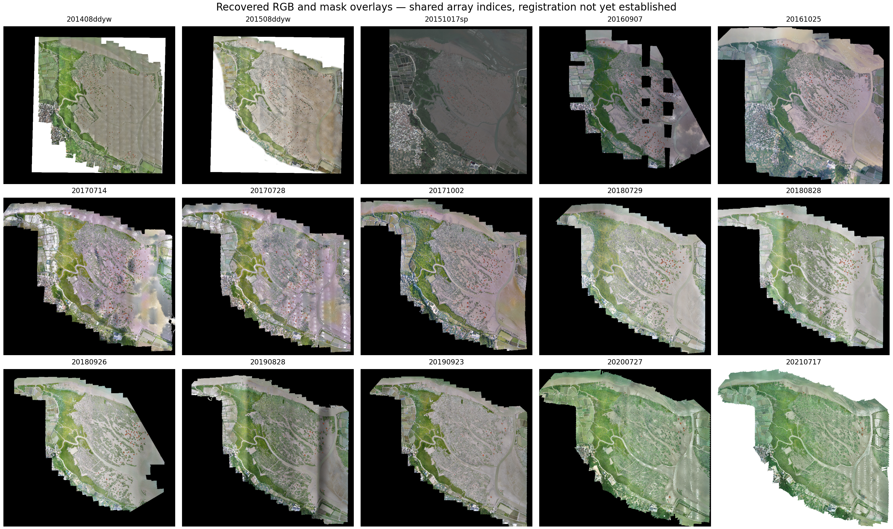
Recovered observations and provenance. Fifteen RGB/mask overlays shown at shared array indices. Colours indicate archived mask foreground. Equal array positions are an inspection convention, not proof of registration. Dense continuous vegetation is not exhaustively represented by these masks.

Figure 2
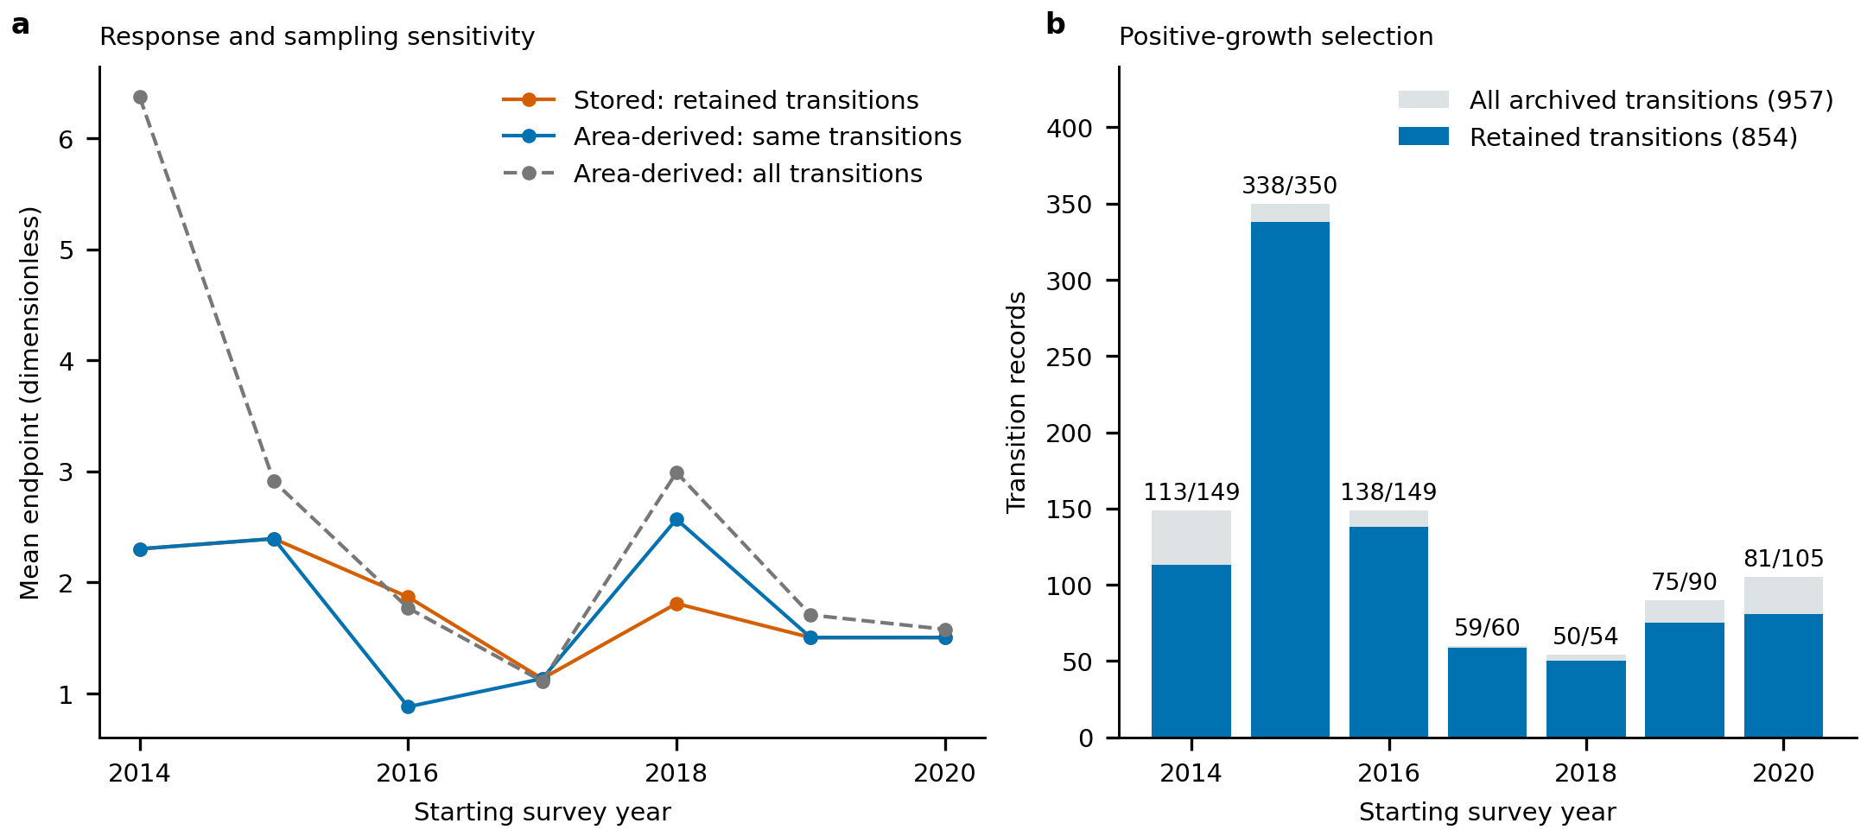
Endpoint and sample-definition sensitivity. Annual means compare stored endpoints, area-derived increments for the same model records and increments for all archived transitions. Record-level differences occur in 2016 and 2018. Labels in panel b give retained/all records. Stored values are not assumed to have the same intended definition as recomputed increments.

Figure 3
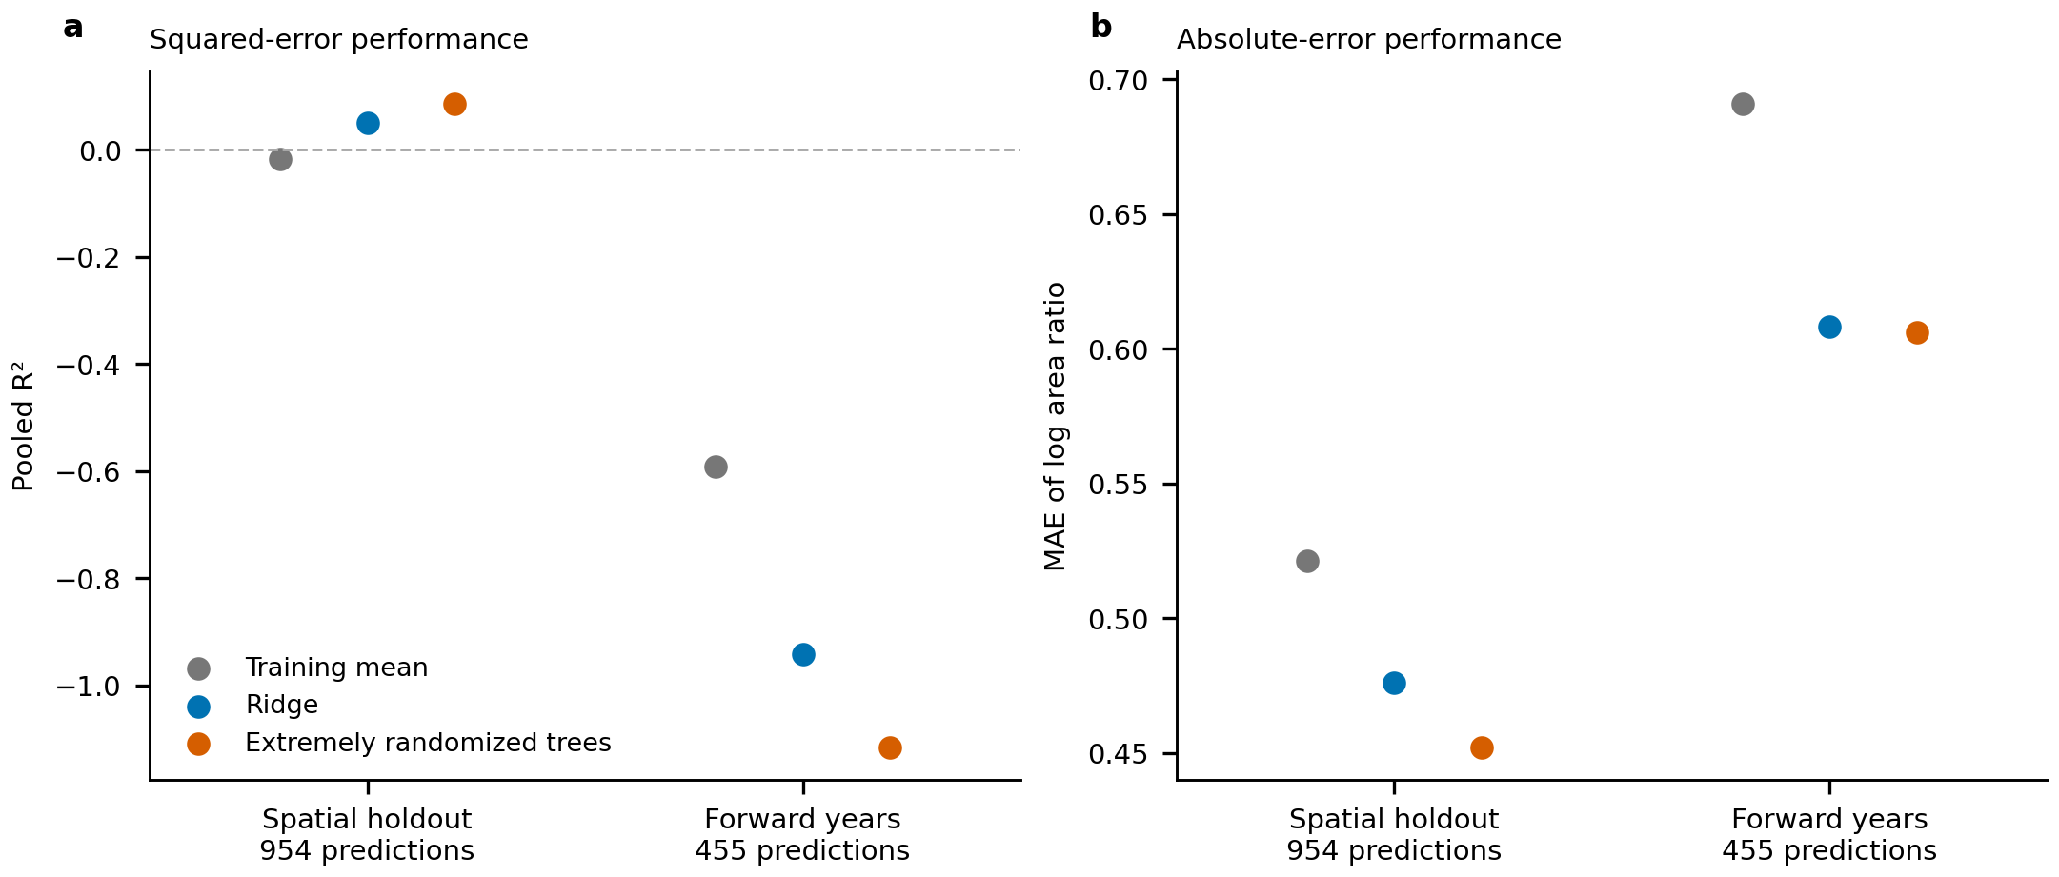
Prediction from starting geometry under spatial and temporal holdouts. Panel a shows pooled R² for the primary log area-ratio endpoint; panel b shows mean absolute error for the same predictions. Spatial holdouts contain 954 predictions and forward-year holdouts contain 455. Negative R² denotes performance below the pooled held-out mean reference; the fold-specific training-mean model is reported separately. Divergence between squared and absolute error makes the loss function consequential. Archived labels and identities remain unvalidated.

Figure 4
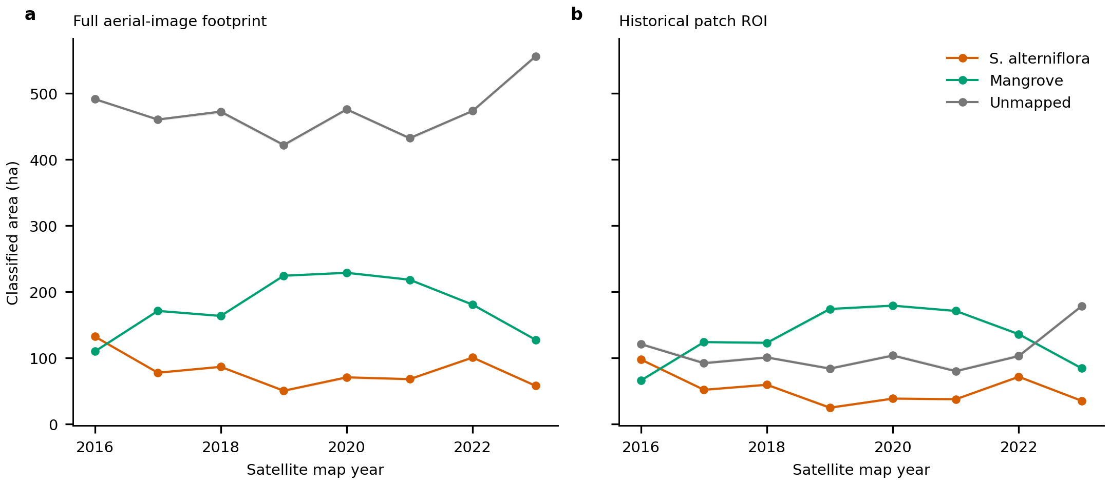
Satellite classified area across fixed footprints. Annual S. alterniflora, mangrove and unmapped class areas in the full-image footprint and historical patch ROI. Lines use the baseline 10 m UTM grid; shading spans four grid phases. The shaded range is not a classification-error confidence interval. Unmapped areas vary over time and remain separately tabulated. Derived from CCAV-10m V4, Yuying Li et al., CC-BY-4.0.

Extended Data Figure 1
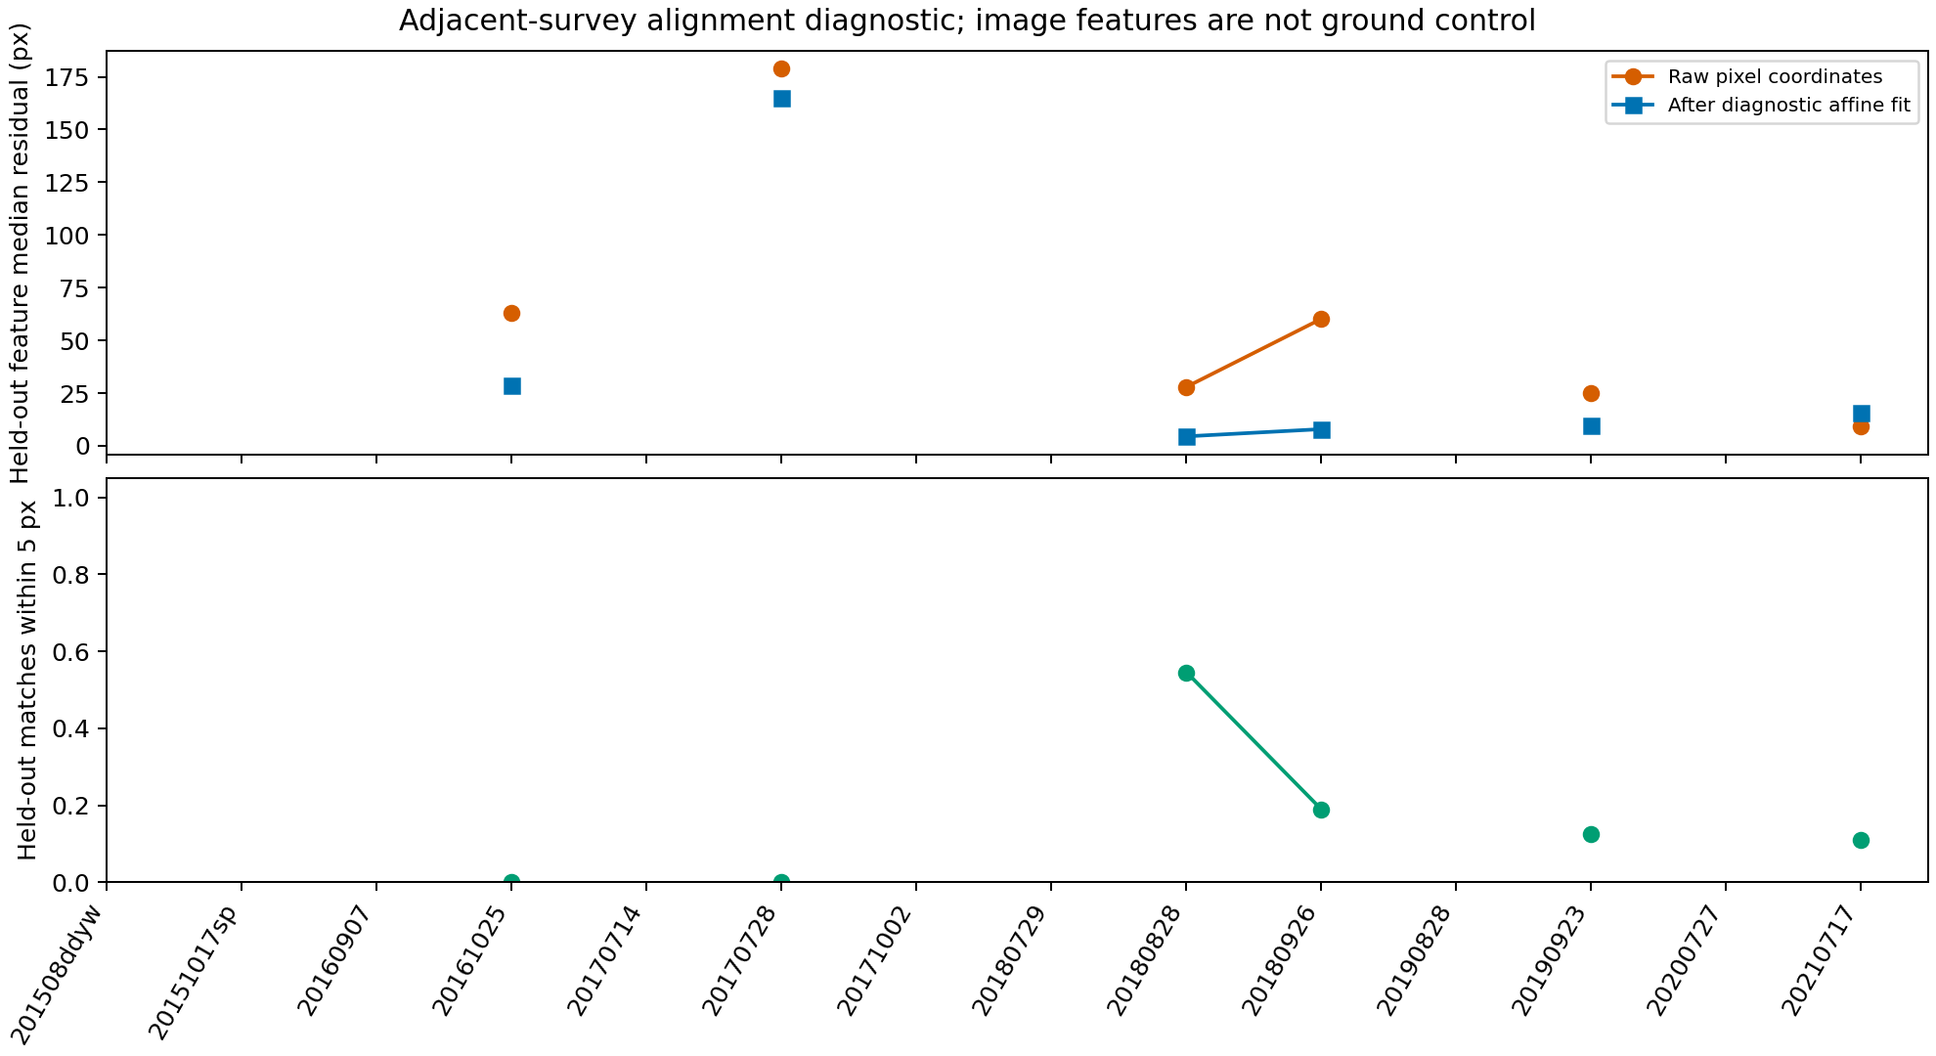
Image alignment diagnostic. Residuals of matched image features in spatially held-out tiles before and after a diagnostic transform. Missing points denote insufficient matching support. Feature residuals do not replace independent ground-control measurements.

Extended Data Figure 2
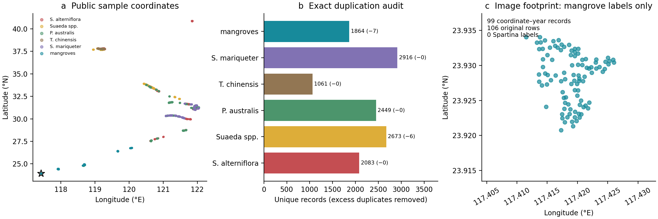
Public satellite sample audit. Geographic distribution, exact-duplicate audit and locations within the image footprint. The 106 local rows reduce to 99 coordinates, all labelled as mangroves. No independent model accuracy is estimated. Data: CCAV-10m V4, Yuying Li et al., CC-BY-4.0.

Extended Data Figure 3
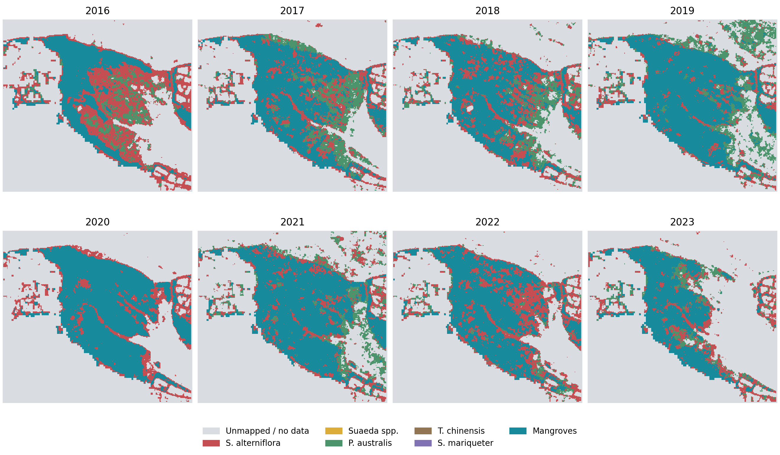
Annual satellite classes in the image footprint. Maps share a 10 m projected grid. Grey indicates unmapped/NoData; changes between classes do not independently establish species replacement. Derived from CCAV-10m V4, Yuying Li et al., CC-BY-4.0.

Extended Data Figure 4
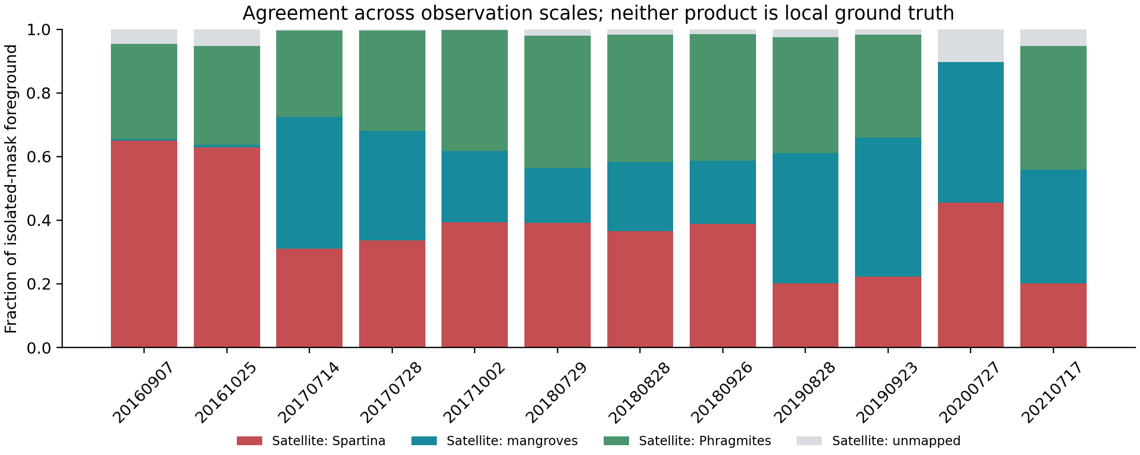
Agreement of isolated masks with annual satellite classes. Fractions refer to recovered ROI foreground pixel centres, assigned the same-year satellite class. Both products remain unvalidated locally; the comparison is conditional on mask positivity, includes acquisition-time and scale differences, and is not an accuracy assessment. Satellite source: CCAV-10m V4, Yuying Li et al., CC-BY-4.0.

Extended Data Figure 5
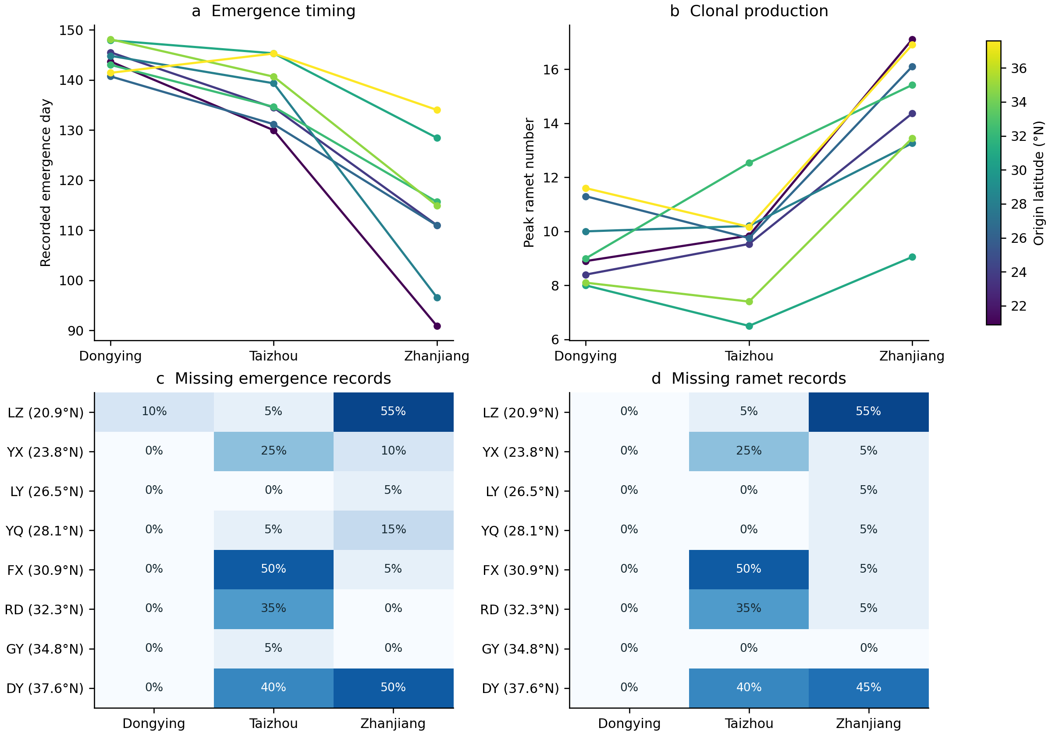
Clonal trait means and missingness across gardens. Lines connect source-level observed means, coloured by source latitude. Heatmaps show missing fractions among listed records. Sources are not identified genotypes; the time origin of the emergence variable is undocumented. Data: Xincong Chen, Figshare version 1, CC-BY-4.0.

Extended Data Figure 6
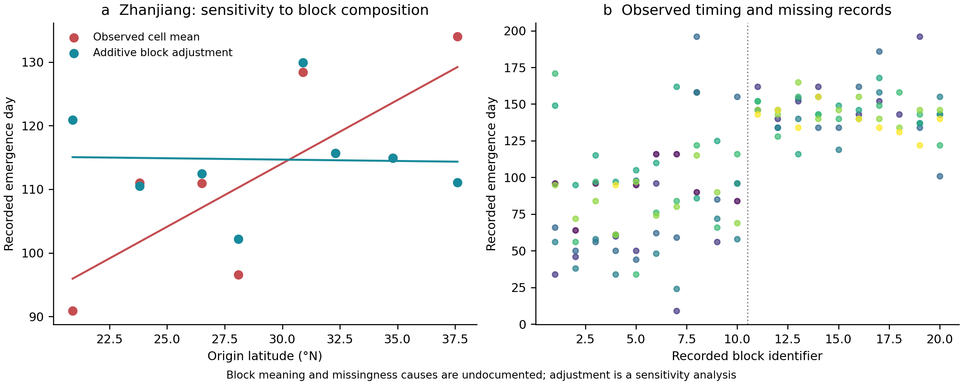
Source-cline sensitivity to recorded blocks. Zhanjiang observed and additive-block-adjusted source means yield different emergence–latitude slopes. Raw timing records are plotted by block identifier; colour indicates source latitude as in Extended Data Fig. 5. The dashed divider separates identifiers 1–10 and 11–20, without assigning them an undocumented batch or year meaning. Adjustment is a sensitivity analysis, not a validated correction. Data: Xincong Chen, Figshare version 1, CC-BY-4.0.

Extended Data Figure 7
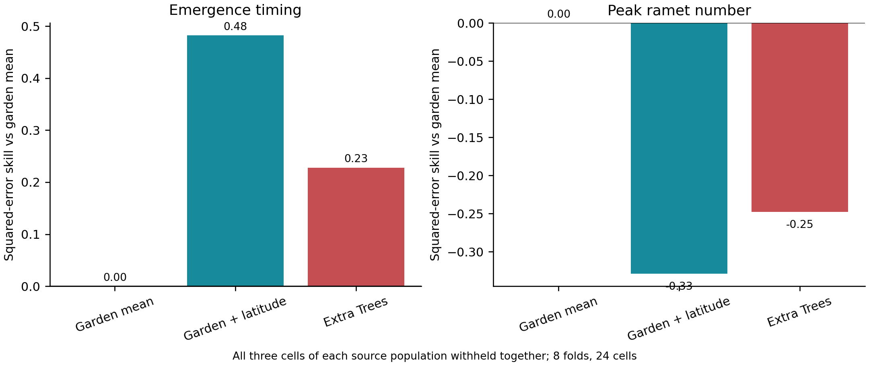
Prediction with entire sources withheld. Squared-error skill relative to the fold-specific garden-mean predictor, for unadjusted observed emergence and ramet-count means. All three cells of each source were withheld together. Positive emergence skill remains subject to the block/missingness sensitivity and does not identify genetic effects. Data: Xincong Chen, Figshare version 1, CC-BY-4.0.

Extended Data Figure 8
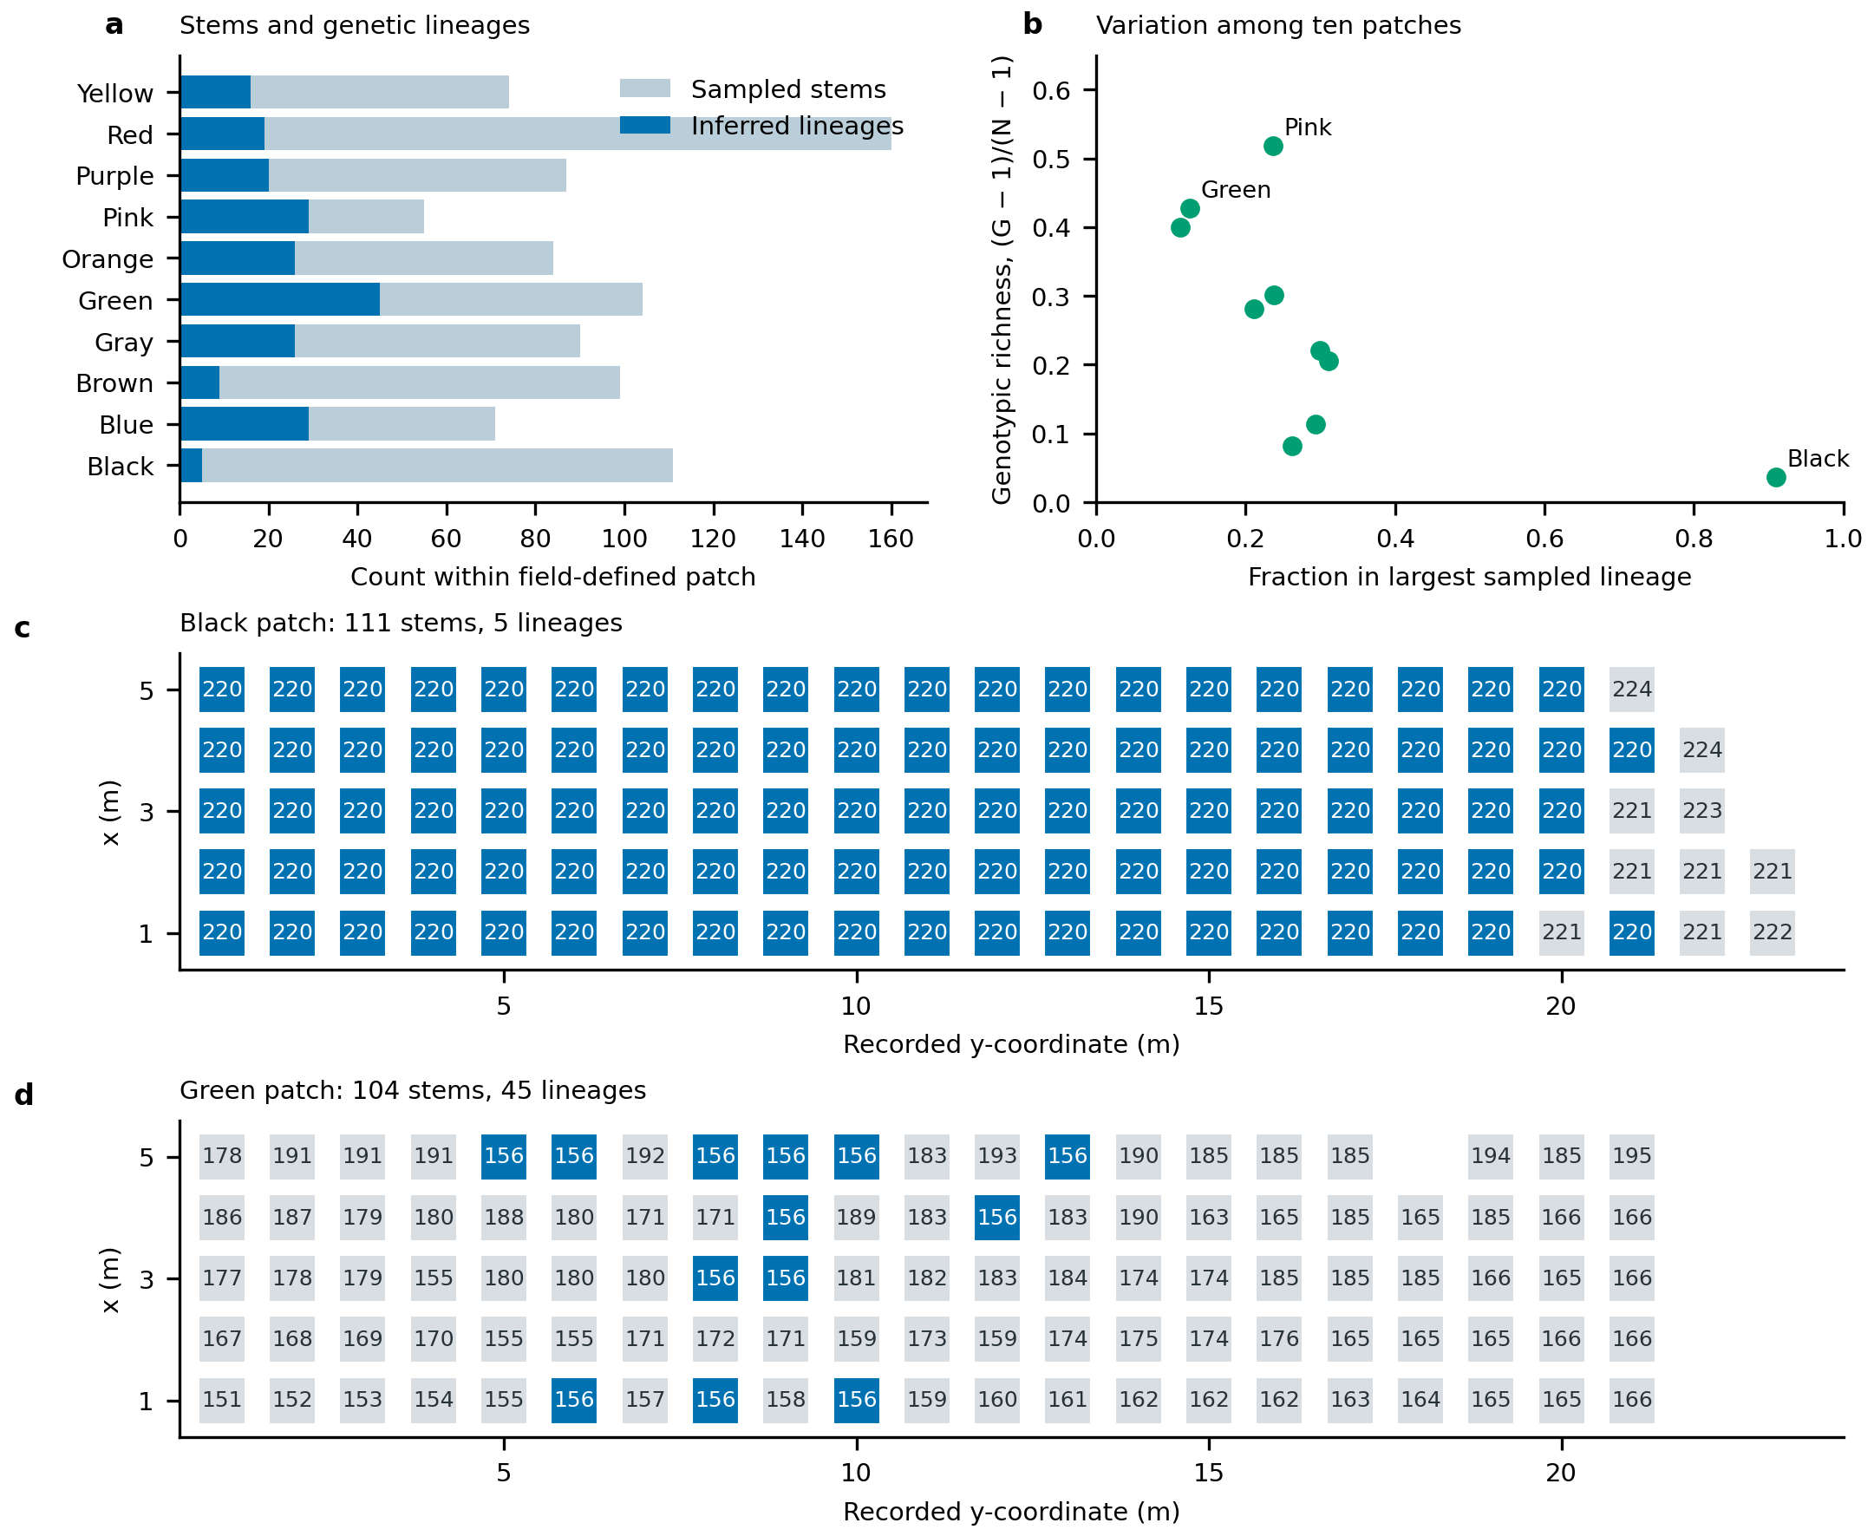
Field patches contain multiple inferred genetic lineages. a, Sampled stems and lineage counts for all ten patches. b, Genotypic richness against dominance of the largest sampled lineage; each point is one patch. c,d, Spatial records from the patches with the lowest and highest lineage counts. Numbers identify the source authors’ inferred lineages; blue marks the most frequently sampled lineage within each displayed patch. The selection of these two illustrations is descriptive, with all patches retained in panels a and b. Sampling coordinates are local metres. Supplied lineage assignments are retained without re-estimating the genetic threshold. These native-range data do not calibrate genetic identity in the local aerial imagery. Data: Tomasula, Caslin, Wimp and Hamilton (2026), CC-BY-4.0.

