BS6200 Project Report

Machine Learning-based EEG siganl classification

Yaoding Chen
ychen096@e.ntu.edu.sg
Nanyang Technological University, Singapore
Table of Content

1 Introduction 3
2 Problem Statement 3
3 Dataset Description 4
4 Data Preprocessing 7
4.1 Raw Data 7
4.1.1 Feature Scaling 7
4.1.2 Principal Component Analysis (PCA) 8
4.2 Feature Engineering and Selection 8
4.2.1 Fast Furrier transformation (FFT) 8
4.2.2 Least Absolute Shrinkage and Selection Operator (Lasso) 10
5 Model Choices 10
5.1 Logistic Regression (LR) 11
5.2 K Nearest Neighbour (KNN) 11
5.3 Support Vector Classifier (SVC) 11
5.4 Naïve Bayes Classifier (NBC) 12
5.5 Random Forest Classifier (RFC) 12
5.6 Gradient Boosting Classifier (GBDT) 13
5.7 Multilayer Perceptron (MLP) 14
5.8 Majority Voting Classifier (MVC) 14
6 Model Training and Evaluation 14
6.1 Classification with Raw Data 14
6.1.1 Training and Testing procedures 14
6.1.2 Model Performance 15
6.1.3 Majority Voting Classifier 15
6.2 Classification with Engineered Features 16
6.3 Classification with Hybrid Deep Learning Models 17
7 Conclusions and future works 19
8 Code Availability 20
9 References 20

Introduction
Epilepsy is a neurological disease characterised by recurrent, unprovoked seizures. It is one of the most common neurological disease, affecting 70 million worldwide (Paul, 2018). About 30% of people with epilepsy are medically intractable, which is associated with adverse outcomes, such as serious comorbidities, injury and death (Kuhlmann et al., 2018). Clinically, seizure can be recorded in electroencephalogram (EEG), which is an electrophysiological monitoring method that measures brain electrical activity. Since the disease onset is considered to be potentially dangerous and largely unpredictable, close monitoring of EEG signals for early detection of seizure is important to avoiding severe adverse outcomes caused by the disease. Thus, developing an automated approach for seizure detection based on machine learning has drawn great interest in the field of both biomedical sciences and data science.
Technically, EEG signals measures voltage fluctuations due to intra-neuron ionic current, which can be caused by seizure and a variety of non-seizure states, such as eye open and eye close with different patterns. Distinguishing the signals from each other can improve our understanding of brain function with the different patterns identified to be involved in the signals, which will increases our knowledge of neuropathological processes, eventually contributing to better seizure detection, prediction and treatment. Thus, lately various machine learning approaches have been proposed to decode the signals. In this paper, we will construct and assess a series of supervised learning approaches, along with different feature engineering approaches, to classify EEG signals into 5 different classes.

Problem Statement
The project aims to apply and develop suitable machine learning approaches to perform multi-class classification of EEG signals with a simplified, machine learning-ready version of EEG dataset from the University of Bonn (Andrzejak et al., 2001), which is acquired through UCI Machine Learning Repository (Asuncion & Newman, 2007), to order to compare and contrast how different data preprocessing approach may affect choices and accuracy of different machine learning models. Thus, we propose hypotheses as follows:
- Different machine learning approaches, including ensemble learners and deep learning classifiers, can classify EEG signals into 5 classes with good accuracy.
- Dimension reduction methods such as principal component analysis (PCA) can retain the accuracy of machine learning models despite reduced size of input data.
- Feature engineering methods based on wave analysis can increase the accuracy of machine learning classifiers.
Our ultimate aim is develop optimised models for the multi-class classification of EEG signals and compare and analyse their results with insights into model choices.

Dataset Description
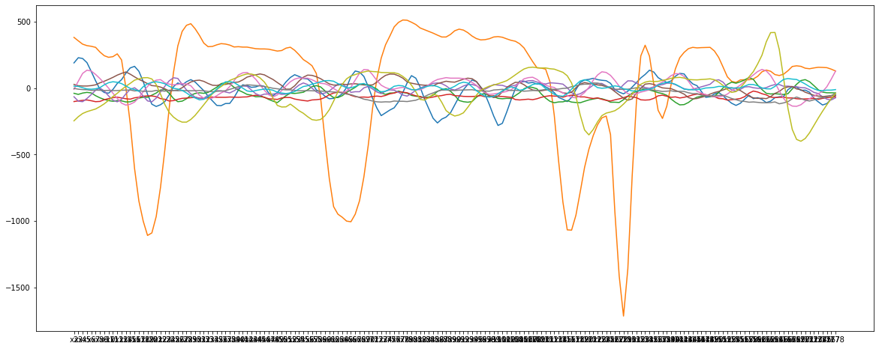
Figure 1. Example EEG signals
As illustrated in Figure 1, EEG signals are time-series data involving fluctuations and waves. According to the description on UCI Machine Learning Repository, the whole dataset consists of 11500 pieces of EEG signals data from 500 individuals. Each piece of data measures a time period of 23.6 seconds with 178 data points. The dataset classify all EEG data into five distinct types by biological significance:
- during seizure activity
- in brain tumour sites
- in healthy brain
- during eye close
- during eye open
Among the data classes, only Class 1 is considered to have seizure activity, while the rest are non-seizure but related to other defined biological states. As illustrated in Figure 2, recordings of seizure activity have much more volatile curves than other classes of recordings. Thus, a good number of works have been aimed to perform binary classification of the signals, which can achieve high accuracy (Resque et al., 2019).
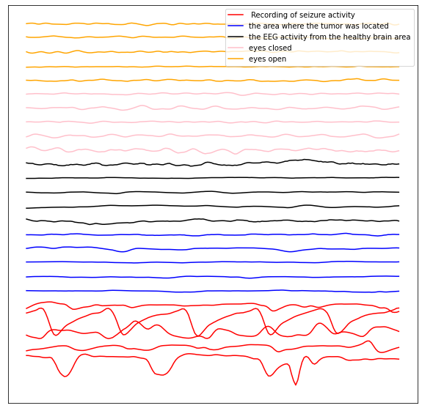
Figure 2. Classification of EEG signals
To further visualise the differences between data classes, we leverage multidimensional scaling (MDS) to visualise the high dimensional data of EEG (Cox & Cox, 2008), as shown in Figure 3. In Figure 3a, it is all non-seizure cases cluster in the centre, whereas the rest sparsely located off the central cluster are mostly seizure cases. In Figure 3b, we further aims to visualise high-dimensional non-seizure data with MDS, where different classes of data tend to mix with each other.
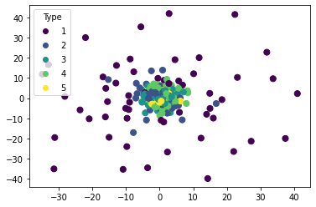
3a) visualisation of all classes of EEG data (Class 1-5)
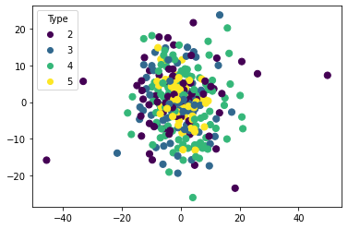
3b) visualisation of non-seizure classes (Class 2-5)
Figure 3. Visualisation of different types of EEG signal clustering using MDS
Thus, the cluster suggests relatively higher difficulty of 5-class classification when compared with binary classification, where most models used can reach accuracy as high as more than 90%. Also, for binary classification, the chance of getting accurate results are 50%, which suggests a much higher baseline than 20%-baseline in the 5-class classification question. Thus, any model with > 20% accuracy outperforms random guess. In this model, we will validate whether most machine learning techniques can outperform this and further compare the models.

Data Preprocessing

Raw Data

Feature Scaling
Our first step is feature scaling to limit the range of the data, which gives us certain benefits. First, feature scaling can avoid feature variance from affecting the performance of models such as support vector classifier (SVC) and K-nearest neighbours (KNN) classifier that are prone to unequal variance. Second, it is known that data normalisation is known to improve performance in SVC (Liu, 2011) and other models. Third, for models not sensitive to data distribution, deploying the same data scaling method also makes it possible to compare between machine learning models using the same set of features. Lastly, it is also important to our next step, principal component analysis (PCA), as it tries to get the data with largest variance.
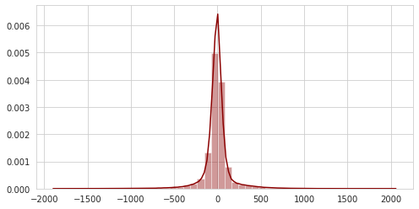
Figure 4. Distribution plot of EEG data
Thus, to choose a proper data scaling technique, we plot the data distribution in Figure 4, which the EEG data is already normally distributed. Thus, we standardise the data with StandardScaler from the scikit-learn package to create a standard normal distribution of the data and to scale the data within [0,1] for models with raw data data. Since our engineered features have quite different ranges, to normalise them, we use normalize function from the sckit-learn package to ensure each data have the same range and normally distributed.

Principal Component Analysis (PCA)
As is mentioned above, PCA is a technique used for dimension reduction by identifying components with largest variance. For our data with 178 dimensions in the input, with PCA can be beneficial in several aspects. First, it can remove correlated features in the dataset, which simplifies the input dimensions. Second, with less features, the speed of algorithm execution is faster. Third, it is likely that PCA can reduces overfitting when often occurs when there are too many variables, which may contribute to better model performance. Here we plot the scree plot of our PCA result as illustrated in Figure 5. To get 95% of the explained variance ratio, we select 39 principal components (PCs) with largest variance.
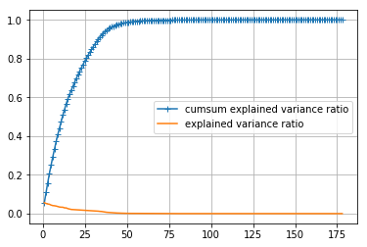
Figure 5. PCA scree plot

Feature Engineering and Selection

Fast Furrier transformation (FFT)
Although it is possible for machine learning models to learn the features in the dataset with relatively good accuracy, we also try to dissect the EEG signals based on existing knowledge of EEG analysis, which may help us to build more interpretable models. EEG signals are typically separated by 4 pre-defined frequency bands, namely alpha, beta, gamma, theta and delta waves, which are considered to be correlated with different spectra of neurological diseases (Newson & Thiagarajan, 2019). FFT is an algorithm to efficiently calculate discrete Fourier transform (DFT), which converts equally-spaced samples of a function into a same-length sequence of a complex-valued function of frequency, namely the discrete-time Fourier transform (DTFT). Therefore, FFT allows interpretation of the data in a frequency domain rather than a time domain, which is typically used in biomedical signal processing (Krishnan & Athavale, 2018). In this way, we can analyse the data of different frequency bands.
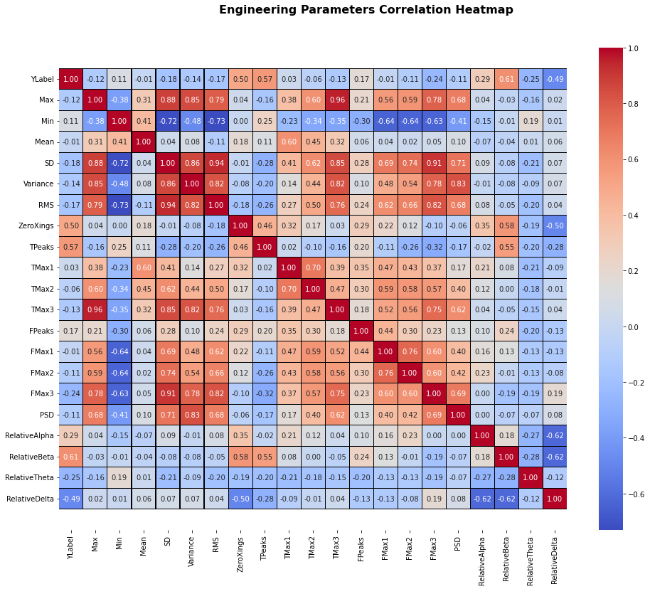Figure 6. Heatmap of engineered features
In our project, we engineer a series of variables based on FFT, which can be illustrated in the heatmap below (Figure 6). The feature is constructed based in a previous work and analyse a variety of wave features of the signals. These features are describes as follows:
- Max, Min, Mean, SD, Variance, RMS, ZeroXings refer to the max, min, mean, standard deviation, variance, root mean square, zero crossings of 178 data points in each piece of the data respectively.
- TPeaks refers to the number of peaks in the time domain, while TMax1, TMax2, TMax3 refer to the respective values of three largest peaks.
- FPeaks refers to the number of peaks in the frequency domain, while FMax1, FMax2, FMax3 refer to the respective amplitudes of three largest peaks.
- PSD is the power spectral density of the 178 data points in each piece of the data respectively.
- RelativeAlpha, RelativeBeta, RelativeTheta, RelativeDelta refer to the relative distribution of the alpha, beta, theta and delta wavebands.

Least Absolute Shrinkage and Selection Operator (Lasso)
With the features constructed, we further apply Lasso regression analysis to select the features of importance to classification. We use grid search to tune alpha in Lasso. As a result, 10 variables, i.e., Max, Min, ZeroXings, TPeaks, TMax1, TMax2, FMax1, RelativeAlpha, RelativeBeta and RelativeTheta are selected as the analysis result shows the value of importance larger than 0.

Model Choices
To make 5-class classification, we use 4 classical machine learning models, 2 ensemble learning models, and 1 deep learning model with scikit-learn in Python (Pedregosa et al., 2011). We aim to test them in three different set of features to build raw data-based, PCA-based and engineered feature-based models.
In a number of classifiers, multiclass classification is often transformed into one-vs-one or one-vs-rest classification, which we will provide more details about later in this section. For tuning the hyperparameter, we use grid search with cross validation. Here we aim to describe the models and how they deal with multiclass classification and how we tune the models as follows.

Logistic Regression (LR)
Logistic regression is designed for modelling the probability of certain binary classification. Here, to deal with multiclass classification, the one-vs-rest scheme is adopted. Thus, five independent logistic regression models are trained to perform the classification. For each model, we aims to fit the probability $p$ and an n-array of $(x_{1},x_{1},x_{1},…, x_{n})$ into the following equation:
$$log\frac{p}{1-p}=β_{0}+β_{1}x_{1}+β_{2}x_{2}+…+β_{n}x_{n}$$
To tune the model, we use grid search to find the best $β_{0}$ for the model. In raw data-based model, the best value of $β_{0}$ is found to be 0.07896522868499725. In PCA-based model, it is 0.18047217668271703.

K Nearest Neighbour (KNN)
K nearest neighbour algorithm classifies data according to majority voting or averaging of distance between the data point and different clusters. In scikit-learn, majority voting is by default and multiclass classification is natively supported. The number of nearest neighbours are tuned with grid search, which consistently turns out to be 2 in both raw data- and PCA-based models.

Support Vector Classifier (SVC)
SVC calculates hyperplane that separate the data points with largest margin in a high-dimension space, where the flexibility of kernel functions help make good classification for linear and non-linear data. Though SVC is designed for binary classification, to address multiclass classification, the sckit-learn implementation of SVC uses a one-vs-one scheme, which generates N* (N-1)/2 binary classifier models given a N-class classification question.
We tune our SVC model for optimising the degree of the polynomial kernel function to better fit the data and the regularisation parameter C to avoid overfitting. In all models we train, the optimal degree number is 3, whereas C equates 100, 10000 and 100 in raw data-based, PCA-based, and FFT-based models respectively.

Naïve Bayes Classifier (NBC)
NBC is based on the Bayes theorem, which allows us to calculate a posteriori probability based on a priori probability, hence predicting the chance of variables of interest based on the data found on the hypothesis and the total data, which then classify the data according to larger a posteriori probability. Thus,
$$posterior= \frac{prior × likelihood}{evidence}$$
Thus, the equation can expressed mathematically:
$$p \left(C_{k} | X\right) ∝ p\left(C_{k}, X\right)=p\left(C_{k}\right)∙\prod{p(x_{n})}$$
In natural language processing, NBC, which natively support multiclass classification, is often used for predict word tags, which treat different words as independent events to calculate and compare the chance of different tags. However, assumption of independence of the variables may not hold in our case due to multilinearity and noise, yet we still try the model in our dataset, considering its popularity as a base estimator for comparisons. We do not perform grid search for parameters of the model. Instead, the input dataset is divided by 7:3 for train/test datasets for the classifier.

Random Forest Classifier (RFC)
RFC is an ensemble learning method which fit fits a number of decision tree classifiers on a variety sub-samples of the dataset which then uses averaging to improve classification accuracy. Decision tree learning is a non-parametric supervised learning which learns features with a set of simple decision rules, which is called leaves. However, the approach often causes overfitting, which makes pruning of leaves highly important.
Here in RFC, each tree is the ensemble built from a bootstrap sample from the training set. The best split of nodes are found either from all input features or a random subset of size. By calculating average prediction results of individual decision trees, RFC is able to reduce some error caused by overfitted trees. In scikit-learn, RFC calculates average probabilistic prediction rather than use a majority-voting scheme.
To tune the model, we apply grid search to the maximum depth of the tree (max_depth) and the number of features to consider when looking for the best split (max_features) to control the size of each tree. Thus, optimally, the parameters equate 9 and 33 in the raw data-based model respectively, and 9 and 2 in the PCA-based model.

Gradient Boosting Classifier (GBDT)
Gradient boosting classifier, or gradient boosting decision trees (GBDT) uses many weak learning models together, typically decision tree classifiers. Thus, the model can be illustrated as an additive model with a weighted sum of a set of base learners $f(x, θ_{m})$ shown below:
$$F\left(x;\left\{a_{m}, θ_{m}\right\}\right)= \sum_{m=1}^{M}{a_{m}f(x, θ_{m})}$$
With addition of new learners to the classifier, old trees are not adjusted, yet a gradient descent procedure is used to find the optimal $a_{m}$ that minimises the average value of the loss function $θ_{m}$ when adding the new tree. Although arbitrary differentiable loss functions can be used, deviance is by default in scikit-learn. Multiclass classification is natively supported as the labels do not usually affect calculation of the loss function.
To tune the model, we apply grid search to the maximum depth of the individual regression estimators (max_depth) and the number of features to consider when looking for the best split (max_feature). Thus, optimally, in raw data and PCA based models, max_feature is the square of the number of the features and max_depth is 9, while in the engineered feature based model, max_feature is the logarithm of the number of the features to base 2 and max_depth is 7.

Multilayer Perceptron (MLP)
MLP is a class of feedforward artificial neural network, which can extract features itself with hidden layers, which are helpful to learn high dimensional, multi-class data. In each layer, there is a set of extracted features, called nodes, which are extracted from the prior layer. All the nodes in the same will be used to calculate the nodes in the next layer with different weights. The weights are adjusted with backpropagation to minimise the loss function, which in scikit-learn is the log-loss function by default in a gradient descent manner. To tune the model, we apply grid search to the number of hidden layers, which is optimally 512 in raw data and PCA based models and 256 in the engineered feature based model.

Majority Voting Classifier (MVC)
We also try to combine our best models with MVC, which is an ensemble learning scheme where the majority of the predicted class labels from different base learners is the output class label of the ensemble learner. This is thought to balance out the individual weaknesses of individual models, thus increasing classification accuracy.

Model Training and Evaluation

Classification with Raw Data

Training and Testing procedures
Here we use a variety of models which include LR, SVC, NBC, MLP, RFC, GBDT for processing the data without feature engineering. We first take a grid search approach with cross validation to tune hyperparameters of our models. With the tuned parameters, we further divide the data into 70% training and 30% testing and then re-run the model for training and testing, which produces the model accuracy in the raw dataset and PCA-based dataset.

Model Performance
As mentioned in the Data Preprocessing section, PCA increases training results to different extent, as discussed previously. A summary of training results is presented in Table 1.
Models | Accuracy  (raw data) | Accuracy  (PC) | Change
LR | 0.25645 | 0.25732 | 0%
SVC | 0.68792 | 0.69922 | 1%
KNN | 0.49406 | 0.51898 | 2%
NBC | 0.44538 | 0.62967 | 18%
MLP | 0.69284 | 0.71544 | 2%
RFC | 0.51463 | 0.62417 | 11%
GBDT | 0.68937 | 0.72675 | 4%
Table 1. Accuracy change of models before and after PCA
Although all models are better classifiers than guessing, logistic regression always have the worst performance, which may suggest nonlinear nature of the categorical data which may be unsuitable for working with logistic regression. KNN can correctly classify around half of the result. However, the distance-based method may be subject to the mixed-up data points between clusters, thus contributing to a lower performance. Interestingly, NBC and RFC get similar accuracy at around 62%. Here removal of correlated variables may partly explain the increased accuracy in naïve Bayes classifier after PCA. It is notable that SVC, MLP, and GBDT can make classification as accuracy as around 70%.

Majority Voting Classifier
Thus, to leverage the 3 highly accurate models (SVM, MLP and GBDT), we further apply them to a majority voting classifier, which produces an accuracy of 73%, outperforming the three models together with the PCA-processed dataset, as illustrated in Figure 7.
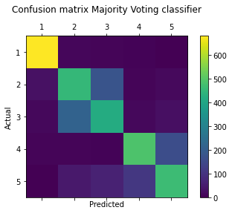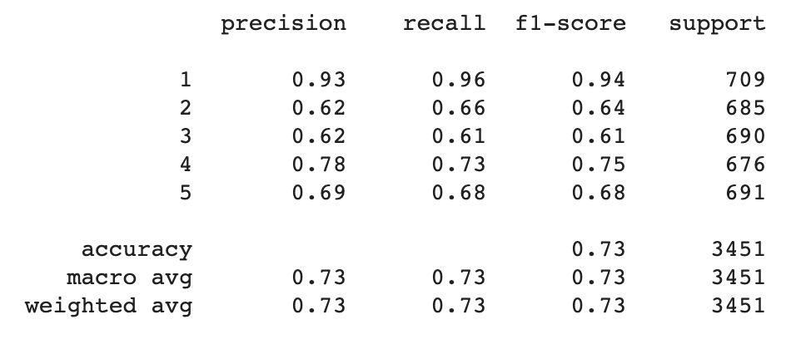
Figure 7. Classification report of majority voting classifier (raw data + PCA)
As expected, Class 1 has very high precision, recall and F1 score, while the rest have much lower classification accuracy, which pulls down the overall performance of the classifier. Similar issues should happen in all the above-mentioned models.

Classification with Engineered Features
To test whether models based on engineered features can outperform those based on PCA or raw data, we train three models with grid search for hyperparameter tuning. The three models are SVC, MLP and GBDT. We use the same approach to train and test the models yet based on a engineered feature dataset scaled with normalisation. Table 2 and 3 show the summary of the model performance:
Models | Accuracy  (Raw + PCA) | Accuracy  (FFT) | Accuracy  (FFT + Lasso) | Change  (FFT vs. FFT +Lasso)
SVC | 0.69922 | 0.72012 | 0.71429 | -1%
MLP | 0.71544 | 0.68870 | 0.68609 | 0%
GBDT | 0.72675 | 0.73118 | 0.71416 | -2%
Table 3. Comparison of accuracy between FFT-based and PCA-based models
It is clear that despite significantly reduced input data, the models have similar performance or outperforms those using PCA-processed or raw data data, which suggests that the constructed features are able to capture most of the features that are important to classification. However, it is interesting that feature selection using Lasso reduces the accuracy of classification. As we have mentioned correlated parameters previously and as is shown in Figure 6, there is a good number of correlated variables, whereas Lasso tends to drop one of the features, leading to loss of information. This is quite different from PCA, which calculates a new variable based on correlated variables, thus preserving more information.

Classification with Hybrid Deep Learning Models
As previously mentioned, simple neural network such as MLP can produce good classification results, which suggests the potential capability of deep learning in the field. Thus, we construct several one-dimensional convolutional neural network (CNN)-long short-term memory (LSTM) with different architectures to make the classification. With various filters in the convolutional layers, pooling layers, normalization layers, and fully connected layers, CNN can extract abundant features from the dataset. However, CNN is incapable to extract time-series information due to its incapability to retain memory of previous time series patterns. LSTM is a recurrent neural network, where loops retain the time-series information in the network. Thus, hybrid CNN-LSTM models may combine the ability of LSTM to retain long term time-dependency and the good modelling ability of CNN.
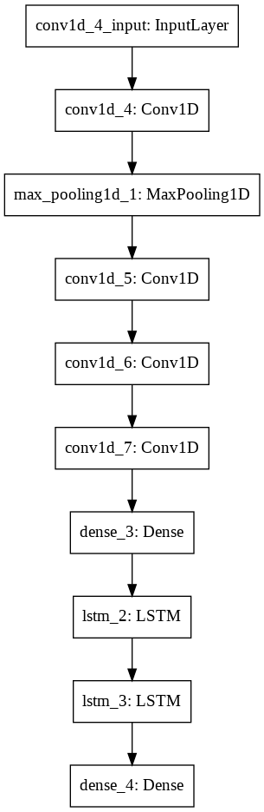 | 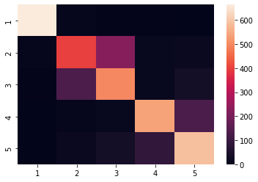
 | 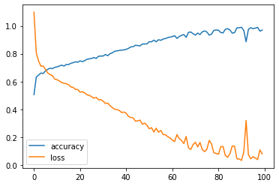

Figure 8. Architecture (left), confusion matrix (upper right) and training (lower right) of 1D-CNN LSTM model
One of its kind have been proposed for seizure detection and multiclass classification of EEG signals (Xu et al., 2020). Thus, we train a series of similar models to this one, but reduce the node number for faster training. We split training and test dataset by 7:3. All our deep learning models outperform the previous mentioned machine learning techniques (see Jupyter Notebook for detail). The best classification accuracy is 78% and the worst 76%. Here we will describe the architecture of the model in detail. An illustration of the model, including its training performance, and classification accuracy in test dataset, is shown in Figure 8. More information about other models are available in the attached Jupyter Notebook.
The model consists of four 1D-CNN layers, one 1-D max-pooling layer, two fully connected layer, and two LSTM layers. The model starts with a 1D-CNN with an input shape of (178, 1), allowing direct input of raw data from our dataset. After the first 1D-CNN, the model uses a 1D max-pooling layer to reduce the number of training parameters, thus speeding up training. This layer is followed by three 1D-CNN layers. Each of the CNN layers have 64 convolutional kernels. The features extracted from CNN is then fed into an fully connected layers for activation of sigmoid function activation, which is then input into two LSTM layers with the 64 and 32 dimension output respectively. The sequence information is retained in the first LSTM layer but dropped in the second. The final output of LSTM is then used for activation of the SoftMax function for multiclass classification, since the function can assigns decimal probabilities to each class in a multi-class problem.

Conclusions and future works
In this project, we apply a number of popular machine learning methods for a 5-class EEG signal classification question based on a machine learning-ready seizure detection dataset. All our models can classify the data with better accuracy than random guess, yet we are still missing some popular classifiers, such as XGBoosting (Parui et al., 2019) and extreme learning machine (Zhao et al., 2018), which are worth trying in the future.
Specifically, we find that PCA can slightly improve model performance when training with raw data or PCs, while Lasso-based feature selection reduces model performance, which may be resulted from different treatment of correlated variables, yet direct comparison is yet to made with the two techniques. Thus, whether additional dimension reduction techniques such as linear discriminant analysis can also improve model performance is also worth studies in the future (Subasi & Gursoy, 2010).
Furthermore, we show that hybrid deep learning models, specifically 1D-CNN LSTM models, outperform our tuned models. However, it is also noted that our model performance is not as good as in the original paper we mention (Xu et al., 2020), which is probably due to reduced node and layer numbers. Considering low interpretability of deep learning, it may be possible to leverage deep learning to perform better feature selection or other feature engineering techniques in the future (Chatterjee et al., 2019), which may help us to improve the classification accuracy of interpretable models.
Besides, we observe a high risk of misclassify brain tumour and non-brain tumour EEG. Considering high risk of brain tumour, additional efforts should be made to penalise misclassification of high-risk states into low-risk states (Chitti et al., 2021), such as seizure, in order to build a safer models to the medical practioners and patients, which is another major future direction.
Finally, a lasting question in the field is whether seizure is predictable. Although some proposed methods such GenericPred (Golestani & Gras, 2014) to predict seizure in a short time period, we have not got enough time to deploy the model to our dataset, which is a good future direction for our next step.

Code Availability
The code for reproducing the results are available in Jupyter Notebook format at https://github.com/ydchen17/SeizureDetection. The dataset is supplied within the notebooks. Further changes, if applicable, may be made to the GitHub repository.

References
Andrzejak, R. G., Lehnertz, K., Mormann, F., Rieke, C., David, P., & Elger, C. E. (2001). Indications of nonlinear deterministic and finite-dimensional structures in time series of brain electrical activity: Dependence on recording region and brain state. Physical Review E, 64(6), 61907. https://doi.org/10.1103/PhysRevE.64.061907
Asuncion, A., & Newman, D. (2007). UCI machine learning repository. Irvine, CA, USA.
Chatterjee, R., Maitra, T., Hafizul Islam, S. K., Hassan, M. M., Alamri, A., & Fortino, G. (2019). A novel machine learning based feature selection for motor imagery EEG signal classification in Internet of medical things environment. Future Generation Computer Systems, 98, 419–434. https://doi.org/https://doi.org/10.1016/j.future.2019.01.048
Chitti, S., Kumar, J. T., & Kumar, V. S. (2021). EEG Signal Feature Selection Algorithm and Support Vector Machine Model in Patient’s Fatigue Recognition. Arabian Journal for Science and Engineering. https://doi.org/10.1007/s13369-021-06206-1
Cox, M. A. A., & Cox, T. F. (2008). Multidimensional scaling. In Handbook of data visualization (pp. 315–347). Springer.
Golestani, A., & Gras, R. (2014). Can we predict the unpredictable? Scientific Reports, 4(1), 6834. https://doi.org/10.1038/srep06834
Krishnan, S., & Athavale, Y. (2018). Trends in biomedical signal feature extraction. Biomedical Signal Processing and Control, 43, 41–63. https://doi.org/https://doi.org/10.1016/j.bspc.2018.02.008
Kuhlmann, L., Lehnertz, K., Richardson, M. P., Schelter, B., & Zaveri, H. P. (2018). Seizure prediction — ready for a new era. Nature Reviews Neurology, 14(10), 618–630. https://doi.org/10.1038/s41582-018-0055-2
Liu, Z. (2011). A method of SVM with normalization in intrusion detection. Procedia Environmental Sciences, 11, 256–262.
Newson, J. J., & Thiagarajan, T. C. (2019). EEG Frequency Bands in Psychiatric Disorders: A Review of Resting State Studies . In Frontiers in Human Neuroscience (Vol. 12, p. 521).
Parui, S., Bajiya, A. K. R., Samanta, D., & Chakravorty, N. (2019). Emotion Recognition from EEG Signal using XGBoost Algorithm. 2019 IEEE 16th India Council International Conference (INDICON), 1–4. https://doi.org/10.1109/INDICON47234.2019.9028978
Paul, Y. (2018). Various epileptic seizure detection techniques using biomedical signals: a review. Brain Informatics, 5(2), 6. https://doi.org/10.1186/s40708-018-0084-z
Pedregosa, F., Varoquaux, G., Gramfort, A., Michel, V., Thirion, B., Grisel, O., Blondel, M., Prettenhofer, P., Weiss, R., & Dubourg, V. (2011). Scikit-learn: Machine learning in Python. The Journal of Machine Learning Research, 12, 2825–2830.
Resque, P., Barros, A., Rosário, D., & Cerqueira, E. (2019). An Investigation of Different Machine Learning Approaches for Epileptic Seizure Detection. 2019 15th International Wireless Communications & Mobile Computing Conference (IWCMC), 301–306. https://doi.org/10.1109/IWCMC.2019.8766652
Subasi, A., & Gursoy, M. I. (2010). EEG signal classification using PCA, ICA, LDA and support vector machines. Expert Systems with Applications, 37(12), 8659–8666.
Xu, G., Ren, T., Chen, Y., & Che, W. (2020). A One-Dimensional CNN-LSTM Model for Epileptic Seizure Recognition Using EEG Signal Analysis. Frontiers in Neuroscience, 14, 578126. https://doi.org/10.3389/fnins.2020.578126
Zhao, H., Guo, X., Wang, M., Li, T., Pang, C., & Georgakopoulos, D. (2018). Analyze EEG signals with extreme learning machine based on PMIS feature selection. International Journal of Machine Learning and Cybernetics, 9(2), 243–249. https://doi.org/10.1007/s13042-015-0378-x

