Homeostasis Final Report Spring 2025

May 2, 2025

Mehdi Aksadi, Yaritzel Carlos, Miriam Duran, Luis Mata, Khaliq Mohammed, Elias Muzemil, Katana Jade Taylor, Raphael Webster

Table of Contents

Perspective, Goals, and Structure 2

OKR goals 3

Synthetic Biology and iGEM perspective 3

Team structure 4

Progress and Team Deliverables 5

Deliverable 1: Kill/Growth Curve 5

Deliverable 2: Optimizing Transfection DNA: Lipofectamine 2000 Ratio 6

Deliverable 3: Confirm pSRE cholesterol sensitivity 7

Contributions 9

Perspective on semester progress 9

Next Steps 11

# Perspective, Goals, and Structure

## OKR goals

Overall objectives:

1. Develop a synthetic biology system that regulates cholesterol
2. Develop a Gold level iGEM project capable of winning a Gold medal
3. Win the village prize for therapeutics, and the grand prize

Objective we focused on this semester: Confirm that promoter functions at different levels in different cholesterol concentrations via dual luciferase assay. This shows that the promoter is most responsive in high conditions, leading to the highest genetic expression in high conditions.

Key results:

* Determine the concentration of βCD and cholesterol to simulate high and low cholesterol levels in human cells without inhibiting the growth of cells
* Optimize the transfection procedure and specifically the amount of DNA and Lipofectamine 2000 needed for the highest rate of transfection
* Run Dual Luciferase assays (DLA) to confirm the level of promoter function by observing genes under the control of the promoter and a standard promoter with statistical significance

## Synthetic Biology and iGEM perspective

Synthetic Biology

* Engineered organisms are used to provide alternative methods to address certain issues within the field of synthetic biology. Genetic engineering could provide targeted interventions for metabolic dysregulation that is tailored to individual genetic profiles. The project, at hand, focuses on a genetically engineered synthetic cholesterol regulation circuit consisting of the pSRE promoter/biosensor component that detects cholesterol levels and a regulator to inhibit cholesterol production. By providing a mechanism for modulating dysregulation of cholesterol levels, this circuit can offer benefits for mitigating the risk of metabolic complications.
* During this Spring 2025 semester, the team engages in extensive wet lab experiments to verify the effectiveness and sensitivity of the pSRE promoter. These efforts included conducting multiple transfections under cholesterol conditions determined via a kill curve. Each transfection was followed by dual luciferase assays to quantify the promoter activity in response to the varying cholesterol conditions. The data collected from these trials is critical to optimizing the circuit’s performance and advancing the system toward a more robust therapeutic model.

Village of focus in IGEM

* Of the villages and prizes in iGEM, our project and team activities are most closely relevant to therapeutics, as it aims to address metabolic dysregulation through a genetically manufactured cholesterol regulation circuit. By integrating the pSRE promoter as a cholesterol-sensitive biosensor with a part that downregulates cholesterol synthesis, our system represents a synthetic biology-based therapeutic strategy for conditions such as cardiovascular disease and metabolic concerns. The circuit is designed to respond dynamically to cellular cholesterol levels, which provides the potential for personalized and precise interventions. Throughout the Spring 2025 semester, we validated the biosensor’s responsiveness through transfection and DLA trials, a great step forward in validating the feedback-based therapeutic system. Our works also align closely with the goals of the Best Biosensor and Best Measurement, given our emphasis on quantitative validation and sensor functionality within the disease-relevant context. This created more cell waste at higher concentrations, so the threshold was set to 100 µM just prior to cell waste accumulated in the flasks.

## Team structure

To work efficiently, and tackle all parts of our semester OKR goals, our team was broken down into sub-teams which were the cell maintenance, transfection, and DLA teams.

* CELL MAINTENANCE:
  + Team : Miriam Duram, Elias Muzemil, and Raphael Webster
    - Helped with key result #1, which states that we must determine the concentration of βCD and cholesterol to simulate high and low cholesterol levels in human cells
    - Responsible for starting the HepG2 wild-type cell line and continuously passaging and monitoring the cell flasks throughout the semester to ensure cell availability for all experiments
    - Set up the cell growth curves and compiled the results into a final kill curve which would reveal the βCD and cholesterol concentrations to habituate cells in
* TRANSFECTION TEAM:
  + Team: Mehdi Aksadi, Yaritzel Carlos, Katana Jade Taylor
    - Helped with key result #2, which states that we must optimize the transfection procedure, with a particular focus on determining the amount of DNA and Lipofectamine 2000 required for the procedure
    - Ensured that ample DNA was prepped and available for each condition of the transfection protocol, and they ran many practice and optimization trials
    - Responsible for running the transfection of the cells at the determined βCD and cholesterol concentrations
* DLA TEAM:
  + Team: Luis Mata and Khaliq Mohammad
    - Helped with key result #3 which states that we must run the Dual Luciferase assays (DLA) to confirm the function of the promoter.
    - Calculated how many Assays were required per condition to ensure statistical significance, which led to creating an efficient timeline of experiments
    - Responsible for performing a luminescence sensitivity analysis of the FLx800 and GloMax 20/20, which would reveal which device would be better for the DLA moving forward

# Progress and Team Deliverables

To achieve our OKR goals (this semester) our team set three time-sensitive deliverables; they are described below:

## Deliverable 1: Kill/Growth Curve

To define extrema, Hep G2 cells were habituated in β-Cyclo-Dextrin (βCD) and cholesterol to observe what makes a high and low cholesterol environment. This was decided by the moment before inflection where the cells would decay instead of grow. The threshold was set just before the cells experienced a decrease in doubling time below the standard deviation of the control. Conveniently for cholesterol habituation, the cells experienced a massive difference just after 50µM making the determination obvious. For βCD, the substance was non-toxic, so no concentration killed the cells off, but it did ensue changes that rapidly increased doubling time. This caused more cell waste at higher concentrations, so the threshold was set to 100 µM just before cell waste accumulated in the flasks. [Cell Growth Unlimited](https://iit0.sharepoint.com/:x:/r/teams/SyntheticBiologyEffort-iGEM-IPRO/_layouts/15/Doc.aspx?sourcedoc=%7B86B3DA3E-7E17-4BEB-B26B-AA2CC7860D1A%7D&file=Cell%20Growth%20Unlimited.xlsx&action=default&mobileredirect=true&DefaultItemOpen=1&ct=1741198943728&wdOrigin=OFFICECOM-WEB.START.REC&cid=8f1390a7-b3c8-479a-91c1-ccdfd51e4766&wdPreviousSessionSrc=HarmonyWeb&wdPreviousSession=4a15104e-10ce-4772-9aa3-7ca9eabcb944)

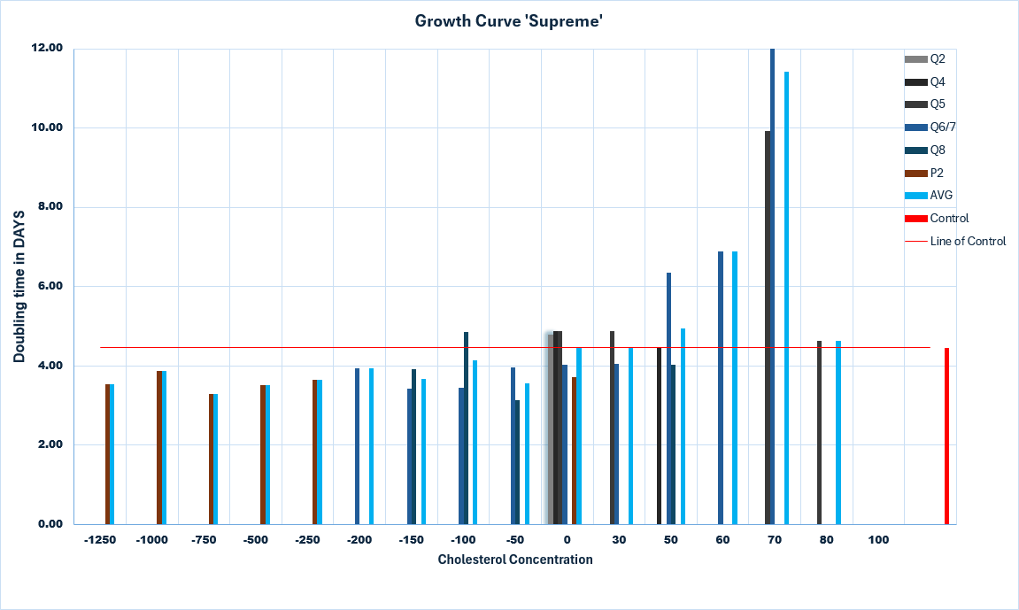

Figure 1 Kill Curve highlighting minima (-100 βCD) and maxima (50 Chol) concentrations of cholesterol for culturing HepG2 wild-type cells determined based on similar doubling time as compared to the control. Kill curve is a compilation of data from approximately 7 growth curves in the varying cholesterol and βCD concentrations listed on the x-axis. Concentrations measured in µM.

## Deliverable 2: Optimizing Transfection DNA: Lipofectamine 2000 Ratio

To identify the most effective concentrations of DNA and Lipofectamine 2000 to be used when transfecting cells with DNA in order to achieve the highest possible transfection efficiency, a range of different concentration ratios were tested. DNA used throughout the semester was V2, a plasmid vector designed for this project that includes luminescent proteins, and Green Fluorescent Protein (GFP). This optimization is critical for ensuring the most reliable and meaningful data throughout the experiments. GPF was used for the optimization trials because it allows for easy visualization of success under fluorescent microscopy. Ultimately, our goal is to apply the optimized conditions to transfect cells with our synthetic biology plasmid at rates resulting in high transfection efficiency.

[Protocol used for transfection](https://iit0.sharepoint.com/:w:/r/teams/SyntheticBiologyEffort-iGEM-IPRO/Shared%20Documents/S25/homeostasis/Transfection/Transfection%20Protocol%20for%20dual%20luciferase.docx?d=w5413eb1fea014806975aaf92051fd324&csf=1&web=1&e=LIlKvf): The amounts mentioned are for one well of a 96 well plate. This protocol uses 0.6ug DNA to 1.6ul Lipofectamine 2000.

[Confluency tool:](https://ct.catapult.org.uk/resources/confluency-tool) Confluency measured using online Catapult confluency tool.

[Merged_Optimization_Transfection_18april:](https://iit0.sharepoint.com/:x:/r/teams/SyntheticBiologyEffort-iGEM-IPRO/Shared%20Documents/S25/homeostasis/Transfection/Merged_Optimization_Transfection_18april.xlsx?d=w798501abfd364a04ab7190cd9d0ea89a&csf=1&web=1&e=rY42vP) Excel sheet for optimization with analysis

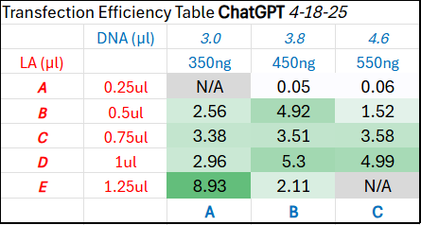

Figure 2, Transfection Efficiency Table from Transfection Optimization Experiment. Found in Merged_Optimization_Transfection_18april

In figure 2, The rows in red indicate the amount of Lipofectamine 2000 in µl. The columns in blue indicate the amount of GFP DNA in ng and µl based on the concentration of DNA that we used. For replication with a different concentration, the ng of DNA will remain the same and the µl will have to be adjusted.

In this table, the most optimal ratio is 1.25ul LA to 350ng DNA. We chose to not go with this value and instead use the practice value determined optimal by the F21 team, which was 1.6ul LA to 600ng DNA, as referenced in *“protocol used for transfection,”* linked above. We chose this because we received consistent high values for transfection efficiency when doing the control assay transfection with GFP DNA. Further experimentation is required to determine the optimal LA:DNA ratio that results in the highest transfection efficiency. Tested values should initially increase logarithmically to get a better idea of the range to zoom in on and then can be narrowed down.

## Deliverable 3: Confirm pSRE cholesterol sensitivity

A past team designed a synthetic promotor not found in nature. It was made through the modification of the promoter sterol regulatory element. The goal was to create a promotor that would transcribe at different rates based on the quantity of cholesterol in the environment. The general idea being that it would work as a sensor in the plasmid. Past teams had tried to validate this through running a dual luciferase assay (DLA) but failed at statistically showing that the promoter is sensitive to cholesterol levels. Therefore, the objective of this semester was to validate the synthetic promotor. The team first investigated what cholesterol concentrations to compare and contrast and then cells were transfected. Once we had cells found in different environments the DLA experiment was performed. The DLA works through quantifying the luminescence of proteins. Those two proteins being Renilla and Firefly. Whenever our plasmid gets transcribed, we will see Renilla being produced. However, the amount of Firefly we should see produced is dependent on the amount of cholesterol in the environment. Therefore, when we compare these ratios, we can see if the promoter is either producing more, or less Firefly when in different cholesterol environments. We ran 18 assays per cholesterol condition. In the end we were able to show that the activity of the promoter does vary as expected when put in medium cholesterol (low condition in graph) conditions and high cholesterol conditions.

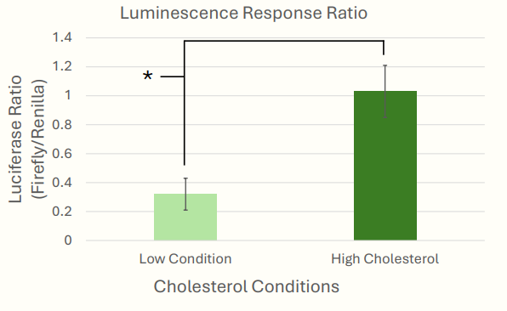

Figure 3 The graph illustrates the comparative ratio of Renilla to Firefly activity when in these two conditions. The low condition is associated with 64.7 µM concentration. High cholesterol is 50 µM more than that. Running a t-test showed that there was statistical significance between the results of both conditions.

However, we fell short of showing that the BCD concentration was significant. BCD consumes cholesterol, allowing us to test how the promoter would activate in these very low concentrations of cholesterol. However, it’s believed that poor transfection led to this. When running a t-test on this condition the assay team got very close to showing that it was statistically significant. Doing more trials should show that it is statistically significant.

[Protocol for dual luciferase assay](https://iit0.sharepoint.com/:w:/r/teams/SyntheticBiologyEffort-iGEM-IPRO/Shared%20Documents/S25/homeostasis/Dual%20luciferase%20assay/DLA_Procedure.docx?d=w853973d92e6b421ea2f64217fa4e4fcd&csf=1&web=1&e=wrdTKP): The protocol highlights the quantity of reagents needed and how to use the machines to take luminescence readings.

[Full data on assay:](https://iit0.sharepoint.com/:x:/r/teams/SyntheticBiologyEffort-iGEM-IPRO/Shared%20Documents/S25/homeostasis/Dual%20luciferase%20assay/FinalDLA%20Data%20-%205_1_25.xlsx?d=wa55d16dfc3bc4d92ba1fd597b2d53fbf&csf=1&web=1&e=WQxfZc) Shows the data from every single assay we did and the measurements of the BCD data also that we didn’t present.

## Contributions

*Produce a table or linked spreadsheet which* *describe team member’s contributions to each deliverable. Assign relative credit as a percentage which should add up to 100%.*

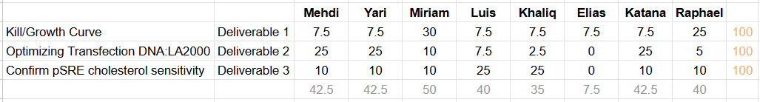

This [excels sheet](https://iit0.sharepoint.com/:x:/r/teams/SyntheticBiologyEffort-iGEM-IPRO/Shared%20Documents/S25/homeostasis/Managing/ExcelGanttChartHomeostasis_B.xlsx?d=w51b07e28d6454c8b85c0308ced9b2d43&csf=1&web=1&e=XhlDen) list out the completion of goals related to each deliverable per team member on a weekly basis.

## Perspective on semester progress

To aid our objective of a cholesterol regulating synthetic biology solution, the goal of the semester was to confirm the sensitivity of the synthetic promoter. To accomplish this, we had to determine a high and low cholesterol cell environment, optimize a ratio of lipofectamine to DNA and run a Dual Luciferase Assay confirming reproducible results.

**High and Low Cholesterol Environments**

A kill curve would determine the threshold of cell death, and to form a kill curve we required a series of growth curves. The cells’ growth would have to be tracked across multiple growth conditions to begin examining highs and lows. So first, what is high and low was determined through control growth groups growth. Then, determining a high was a set number we hypothesized would kill the cell and evenly split values in-between (this was repeated with more subdividing values until a relative to control growth was determined). Next, the same procedure for determining a low, but with βCD was compiled. Finally, a map of the averages of growth created our kill curve.

**Transfection Optimization**

Determining the best ratio of DNA to Lipofectamine affects the accuracy and efficiency of the Dual Luciferase Assay (For example a zero may be determined in DLA, but it can be possible that a transfection failed). A new range was set, to check for any better results, based on a report from Fall 2021 (F21). A re-trial of the F21 result (600 ng DNA: 1.6µL Lipofectamine 2000) was also performed to confirm reproducibility. The results lead us to continue with the F21 ratios, because its values were consistently high, but our results did point out that a logarithmic growth in the ratio’s exists and more experimentation on zoomed in values could yield better results.

**Dual Luciferase Assay**

Achieving proof, the promoter works required high and low conditions for the cells, the same cells being transfected with the promoter, then a Dual Luciferase Assay (DLA) performed on the cells to check for luminescence. Tabling the values then comparing them with our expected results confirmed that the promoter did work, and that the data was statistically significant.

**Challenges**

The challenges that our team encountered during this project were placing orders for mandatory supplies (such as the dual luciferase assay kit), quantifying materials taking longer than expected (due to time coordination difficulties), the contamination of cells, transfection optimization values versus practice values, and communicating to the IPRO class what the experiments done were for and how they connected to the overall semester deliverables.

# Next Steps

Our team has laid the essential groundwork for future groups to optimize transfection and dual-luciferase assays (DLA) under cholesterol concentrations that reflect disease-state conditions.

Another round of DLA in µM BCD condition may be necessary. This can be done by taking 3 DLAs on each of 6 wells transfected with 1.6 µL lipofectamine and 600 ng of V2 DNA. Each well is seeded with 20,000 cells. A simple T-test comparing the results can show how confident we are in the results.

It will also be necessary to validate the siRNA sequence’s ability to reduce cholesterol production and to confirm cholesterol inhibition through functional assays. The data gathered this semester should be used in conjunction with previous semester’s data on siRNAs to determine which would be useful to include in the vector. In parallel, the inverter sequence must be tested to ensure it reverses the current response of the V2 plasmid to the desired output behavior. Physical properties such as binding affinity and degradation rate should be taken on the pristinamycin induced protein. The finalized plasmid, including this inverter, should then be tested under the defined cholesterol conditions to confirm circuit performance.

To ensure these tasks are completed effectively, future teams should begin the semester with a clearly defined project timeline and shared understanding of the OKRs and KRs. Establishing strong communication practices and early cross-training will be essential, as team members' schedules may become more complex mid-semester. By ensuring that everyone is familiar with each other’s roles and tasks, the team will be better equipped to collaborate and troubleshoot, ultimately driving the project toward successful completion.