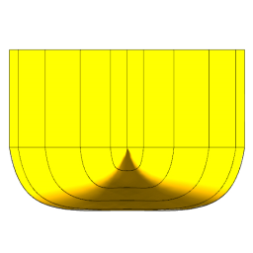

The YDEOS Project
Yacht Design and Engineering Open Source
v. 2020

Project info

September 29th, 2020
Copyright © 2020-2021 The YDEOS project
Authors: Guillaume Florent (2020)

This work is licensed under a
Creative Commons Attribution-NonCommercial-NoDerivs 3.0Unported License.
Contents

1. Introduction 4
1.1. Vision 4
1.2. Scope 4
1.3. Governance 4
2. Architecture 5
2.1. Technology 5
2.2. Decisions 5
2.2.1. Functional Core, Imperative Shell 5
2.2.2. Pipes and filters 5
2.2.3. Side effects 5
2.2.4. Dependencies 5
2.2.5. Parallelism 5
2.2.6. Feedback 6
2.2.7. Graphical User Interfaces 6
2.3. Integration & Delivery 6
2.3.1. Tests 6
2.3.2. Version control 6
2.3.3. CI / CD 6
A. Project checklist 7
A.1. Structure 7
A.2. Code 7
A.3. Testing 7
A.4. CI 7

Conventions:
Some code or symbol in a sentence
library name
code

Column header #1 | Column header #2 | Column header #3 | Column header #4
Table content

http://www.anylink.com

1. Introduction

1.1. Vision
The YDEOS project is a collection of software libraries and executables that help with yacht and ship design and engineering.

1.2. Scope
The following topics are intended to be covered:
- units conversions
- forces modeling
- hydrodynamics and resistance estimates using textbook and publication formulae and regressions
- aerodynamic sails and windage models
- upright and heeled/trimmed hydrostatics
- 2D foil sections generation
- sailing yacht velocity prediction
- sailing yacht polars handling and utilities
- offsets from CAD
- 2D structured meshing
- ship and yacht related CFD cases generators
- automated sail shape analysis

1.3. Governance
The governance model for 2020 / 2021 is a BDFL model (https://en.wikipedia.org/wiki/Benevolent_dictator_for_life)

2. Architecture

2.1. Technology
The initial developments of the YDEOS project will use Python 3 and its scientific stack (Numpy, Scipy, etc …). The scientific ecosystem + ease of development combination of Python is unrivaled; yet, some parts of the project may later have to be re-written using other technologies for performance reasons.
The targeted Python 3 versions are >= 3.7.

2.2. Decisions

2.2.1. Functional Core, Imperative Shell
Functional Core, Imperative Shell: development will follow this philosophy with domains modeled as functionally as possible.
The SRP (Single Responsability Principle) should be respected by functions. If you have to use ‘then’ or ‘and’ to describe what a function does, it may need refactoring.
Shells may be developed in imperative style, with an optional Service Layer if orchestration logic starts to creep into domain logic or into the shell developments.
Potential shells are:
- CLI (Command Line Interface)
- GUI (Graphical User Interface)
- Web entry points
- CAD Workbench

2.2.2. Pipes and filters
Keep in mind that, to make the YDEOS project globally more useful, the output of executables should be designed as the input of others. Create common formats between projects whenever it makes sense.

2.2.3. Side effects
Side effects coding should be separated into ‘what’ and ‘how’ parts.

2.2.4. Dependencies
Each project should be as self-contained as possible. Whenever possible, there should be no dependency on any other internal project.
Depending on the Python scientific stack is OK. Depending on PythonOCC for geometry stuff is OK.

2.2.5. Parallelism
Any function taking typically more than 10 seconds to complete should have the option to be parallelized.

2.2.6. Feedback
Any function taking more than 2 seconds to complete should report its progress. In a CLI shell, a library like tqdm should be used to give the user a sense of progress. A progress bar should be used in a GUI.

2.2.7. Graphical User Interfaces
TkInter, wxPython are recommended. PyQt is okay.

2.3. Integration & Delivery

2.3.1. Tests
Use pytest and hypothesis. hypoyhesis is a Python implementation of Haskell’s QuickCheck and helps with testing edge cases properly.

2.3.2. Version control
Use the Git Feature Branch Workflow
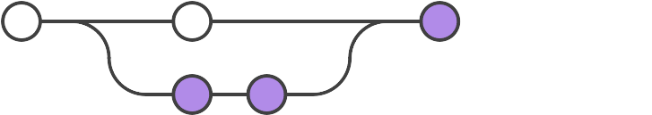
The master branch should never contain broken code.

2.3.3. CI / CD
Implement CI/CD principles to create:
- an install script for Linux and Windows for the whole YDEOS project software
- a Docker image that contains the whole YDEOS project software
CI should be handled at each internal project level and at the YDEOS project level (end-to-end scenarii). The CI tool will be Travis CI.
CD will be handled at the YDEOS project level.

A. Project checklist

A.1. Structure
/<project>
.gitignore
requirements.txt
LICENSE
README.rst
setup.py
/bin
/docs
/tests
/<same name as project>
__init__.py (with text art and version, author, license info)

A.2. Code
Type hints on all functions
PEP8 with a 120 characters line length limit
Numpy style docstrings

A.3. Testing
Unit tests using pytest

A.4. CI
Travis CI
Code quality

