**2021025081 DESQUITADO, Yuichi**

**APM1111 Statistical Theory – Formative Assessment 9**

**SPEED DATING AND THE MANIFESTATION OF A REAL ONE**

**DEPENDING ON ATTRACTIVENESS AND CHARISMA**

**RATIONALE**

A study has been conducted where participants are involved in speed dating and rating how much they would like to go on a real date with their partners by the end of the night, wherein attractiveness (attractive, average, ugly) and personality (high charisma, some charisma, no charisma) are taken into consideration. Gender was also determined as potential moderator.

For this study, a mixed-design ANOVA will be used to investigate whether said conditions and measurements will have an adequate reason to reject the null hypothesis in favor of the alternate, which are:

$H_{0}:$ All group means are equal

($μ_{1}=μ_{2}=…$)

$H_{A}:$ Not all group means are equal

($μ_{1}≠μ_{2}≠…$)

**DATASET**

|  |  |  |  |  |  |  |  |  |  |  |  |  |  |  |  |  |  |  |
| --- | --- | --- | --- | --- | --- | --- | --- | --- | --- | --- | --- | --- | --- | --- | --- | --- | --- | --- |
| **MALE** | | | | | | | | | **FEMALE** | | | | | | | | | |
| **ATH** | **AvH** | **UH** | **ATS** | **AVS** | **US** | **ATN** | **AVN** | **UN** | **ATH** | **AvH** | **UH** | | **ATS** | **AVS** | **US** | **ATN** | **AVN** | **UN** |
| 86 | 84 | 67 | 88 | 69 | 50 | 97 | 48 | 47 | 89 | 91 | 93 | | 88 | 65 | 54 | 55 | 48 | 52 |
| 91 | 83 | 53 | 83 | 74 | 48 | 86 | 50 | 46 | 84 | 90 | 85 | | 95 | 70 | 60 | 50 | 44 | 45 |
| 89 | 88 | 48 | 99 | 70 | 48 | 90 | 45 | 48 | 99 | 100 | 89 | | 80 | 79 | 53 | 51 | 48 | 44 |
| 89 | 69 | 58 | 86 | 77 | 40 | 87 | 47 | 53 | 86 | 89 | 83 | | 86 | 74 | 58 | 52 | 48 | 47 |
| 80 | 81 | 57 | 88 | 71 | 50 | 82 | 50 | 45 | 89 | 87 | 80 | | 83 | 74 | 43 | 58 | 50 | 48 |
| 80 | 84 | 51 | 96 | 63 | 42 | 92 | 48 | 43 | 80 | 81 | 79 | | 86 | 59 | 47 | 51 | 47 | 40 |
| 89 | 85 | 61 | 87 | 79 | 44 | 86 | 50 | 45 | 82 | 92 | 85 | | 81 | 66 | 47 | 50 | 45 | 47 |
| 100 | 94 | 56 | 86 | 71 | 54 | 84 | 54 | 47 | 97 | 69 | 87 | | 95 | 72 | 51 | 45 | 48 | 46 |
| 90 | 74 | 54 | 92 | 71 | 58 | 78 | 38 | 45 | 95 | 92 | 90 | | 98 | 64 | 53 | 54 | 53 | 45 |
| 89 | 86 | 63 | 80 | 73 | 49 | 91 | 48 | 39 | 95 | 93 | 96 | | 79 | 66 | 46 | 52 | 39 | 47 |
| **ATH = Attractive, High Charisma**  **ATS = Attractive, Some Charisma**  **ATN = Attractive, No Charisma** | | | | | | **AVH = Average, High Charisma**  **AVS = Average, Some Charisma**  **AVN = Average, No Charisma** | | | | | | **UH = Ugly, High Charisma**  **US = Ugly, Some Charisma**  **UN = Ugly, No Charisma** | | | | | | |

*Table 1. Ratings of participants on how much they*

*want to go on a real date in the later evening*

The study interviewed 180 participants, 90 per gender, 30 per attractiveness (attractive, average, ugly), and 10 per personality (high charisma, some charisma, no charisma).

**DATA PRE-ANALYSIS**

For this test, we will be using ANOVA, specifically Repeated Measures ANOVA in JASP, since there are more than two independent variables that we need to check significance of, while also attempting to check if there is three-way interaction between gender, attractiveness, and personality.

If there is a three-way interaction between the aforementioned factors, we will also attempt to look at their two-way interaction, such as gender-attractiveness, attractiveness-personality, and personality-gender.

For this study, we will be assuming alpha $α=0.05$ [ $95\%$*Confidence Level (CL)*].

To further progress in this study, we have to go through assumptions check to see if the dataset is fit for Repeated Measures ANOVA.

**ASSUMPTION 1: You have one dependent variable that is measured at the continuous level.**

**Remark** – The variable “*Ratings*” is a dependent variable measured at a continuous level.

**ASSUMPTION 2: You have two or more independent variables that consist of categorical, independent groups.**

**Remark** – The variables are grouped by “*Attractiveness*” (*Attractive, Average, Ugly*) and “*Personality*” (*High Charisma, Some Charisma, No Charisma*).

**ASSUMPTION 3:** **You should have independence of observations.**

**Remark** – These ratings are given independently, sourced from different people and no participants have repeated participation.

**ASSUMPTION 4: There should be no significant outliers in the three or more groups of your independent variable in terms of the dependent variable.**

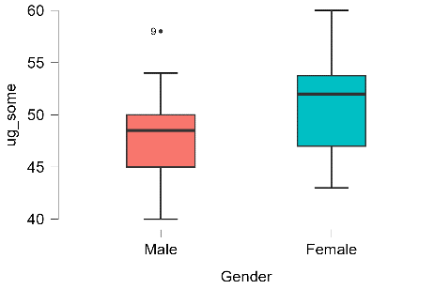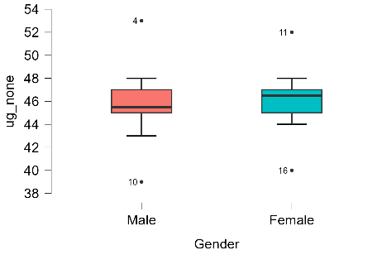

*Figure 1. Boxplots of all groups*

**Remarks –** There areoutliers in all groups.

**ASSUMPTION 5: Your dependent variable should be approximately normally distributed for each group of the independent variable.**

*Table 2. Descriptive Statistics containing Shapiro-Wilk Test for Normality*

**Remarks –** All groups are normal as the Shapiro-Wilk Test of each possible group returned a p-value > 0.05.

**ASSUMPTION 6: You have homogeneity of variances (i.e., the variance of the dependent variable is equal in each group of your independent variable).**

*Table 3. Levene’s Test for Homogeneity of Variance of the dataset*

**Remarks –** All ofthe possible groups in the dataset are homogenous with each other as their p-value > 0.05.

**ASSUMPTION 7: You should have homogeneity of variance or sphericity among all possible pairs (i.e. the variances of all groups are equal among each other).**

*Table 4. Mauchy’s Test for Sphericity of the dataset*

**Remark –** The variances among all possible groups are homogenous as checked by the Mauchy’s Test, wherein the returned p-value > 0.05.

**COMPUTATION**

*Table 5. Descriptives of the dataset*

*Table 6. Within Subject Effects of the dataset*

*Table 7. The Between Subject Effects of Gender*

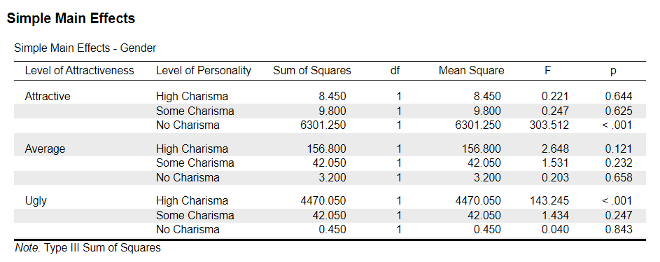

*Table 8. Simple Main Effects of the dataset*

**REPORTING**

The researcher investigated the dataset generated by the study about speed dating and their willingness to go on a real date later the event has ended according to the attractiveness and personality of their dates. The study was comprised of 180 respondents, male and female groups both have 90 participants (N = 180).

On Assumption 1-3, the dataset was able to provide appropriate conditions supporting its fit for three-way ANOVA (BWW). However, Assumption 4 was violated as there are outliers existing in every group. For Assumption 5-7, all are met with satisfaction. Shapiro-Wilk Test, Levene’s Test, and Mauchy’s Test all returned a p-value > 0.05.

With this result, there researcher had gone through the three-way ANOVA, selecting Gender as “*Between Subject Factor*”, while Attractiveness and Personality for “*Repeated Measure Factors*”.

It was found that there is a three-way interaction between Attractiveness, Personality, and Gender, wherein *F(4, 36) = < 0.001*. Moreover, the two-way of Gender-Attractiveness, Attractiveness-Personality, and Personality-Gender are *F(2, 36) = < 0.001, F(4, 36) = < 0.001, F(2, 36) = < 0.001* respectively.

Post-Hoc Tests also revealed that Male Participants that are categorized as Ugly and No Charisma has extremely high significant difference from other groups, wherein p-value < 0.001.



