Hira Yasin Dhamyal

Homework 3:

**Confidence Bounds**

$$P\left(\left|\frac{k}{N}-A\right|≥ 0.05\right)≤0.05$$

$$P\left(\left|\frac{k}{N}-A\right|≥ 0.05\right)≤\frac{1}{{\left(0.05\right)}^{2}*4*N}≤0.05$$

$$N≥2000$$

2 from the notes: $$\frac{ϵ\sqrt{N}}{σ}≤{z_(}_{σ}/2)$$

$$N≥ \frac{{z^{2}}_{\frac{σ}{2}} σ^{2}}{ϵ^{2}}$$

$$N≥ \frac{{z^{2}}_{\frac{σ}{2}} {σ_max }^{2}}{ϵ^{2}}$$

$$N≥ \frac{{z^{2}}_{0.025} {0.5}^{2}}{{0.05}^{2}} =25.8$$

3

$$\frac{∂^{2}}{N∈^{2}}≤ δ$$

$$\frac{0.25}{1000*0.05}≤0.5\% confidence$$

**Information Theory**

The code in the file “InformationTheory.py” calculates all the answers.

H(X,Y) = 4.343270973379060621627129829

H(X) = 1.979535827148047032079397084

H(Y) = 2.552858518262912003215413064

H(X|Y) = 1.790412455116148694928287623

H(Y|X) = 2.363735146231013568275859594

I(X,Y) = 0.189123372031898337151109461

CH(P(Y|X=1),P(Y|X=2)) = 1.565425697467379827998183846

CH(P(Y|X=2),P(Y|X=1)) = 0.9788469356635435141078972133

KL(P(Y|X=1),P(Y|X=2)) = 0.313223840855216545675233961

KL(P(Y|X=2),P(Y|X=1)) = 0.0187469650419886804421361509

**Feature Selection**

(i)

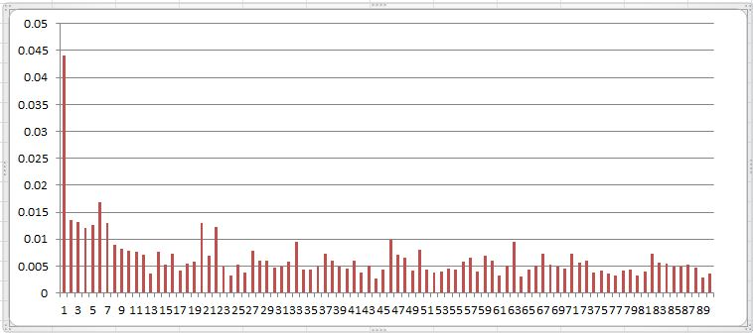

(ii)

This is ascending list of the mutual information, the 1st item is the mutual information and the 2nd item of the tuple is the index.

(0.009785206758803788, 45),

(0.012057067352972517, 3),

(0.012212199251362854, 21),

(0.012696627171112418, 4),

(0.012971430264049566, 19),

(0.013005528438005065, 6),

(0.01316579169802612, 2),

(0.013624632339241494, 1),

(0.016875909646492104, 5),

(0.044168725042736945, 0)

**Naïve Bayes Classification**

The code in the file “NaiveBayes.py” calculates all the answers.

1. accuracy for Maximum Likelihood estimate over all features is 8.934492572 %
2. accuracy for Maximum a Posteriori estimation over all features is 8.9971541213 %
3. accuracy for Maximum a Posteriori estimation over top 10 features is 8.92404898044 %

**Hypothesis Testing:**

1.

Null Hypothesis : $μ\left(A-B\right)=0 where A and B are means for the 2 tests$

Alternate hypothesis : : $μ\left(A-B\right) ≠0$

We are going to perform a 2 way t-test

$\overline{d}±t_{0.025,19}\left(\frac{sd}{\sqrt{n}}\right)$

In python file “Hypothesis testing, I calculated the $\overline{d}$ and the sD for the data

$$-2±t_{0,025,19}\left(\frac{3.656}{\sqrt{20}}\right)$$

$$-2±2.093\left(\frac{3.656}{\sqrt{20}}\right)$$

$$-2±2.093\left(0.818\right)$$

$$-2 +- 1.711$$

$$(-3.711 , -0.289)$$

0 doesn’t lie in between the 2 ranges, so we can reject the null hypothesis with 95% confidence

2. $t=\left[{(x}_{1}-x_{2}\right)-D] / SE$

$=\frac{ \overline{d}-D}{SE} =\frac{-2-0}{0.818}= -2.44$

p-value =

=

3. null :

Alternate: $e_{m}<e_{d}$

Chi-Square value M for the data = $\frac{{(\left|n_{01}-n_{10}\right|-1)}^{2}}{n_{01}+n_{10}}$

Code written in the file “Hypothesis Testing.py” calculates the equation for me

M = 0.16

Chi_square values at (1,0.95) = 3.84

0.16<3.84

We cant reject the null hypothesis

4. p-value = P(chi-square value > 0.16) = 0.6891