Web Design Project

Simple quiz Website to learn HTML, Java Script

Doyun

Andrej

Alexon

Enis

Mohanad

Table of Contents

* Our Thema of the Project
* Purpose of this Website
* Organization of the Website

**Our Thema of the Project**

A simple quiz website

**Purpose of this Website**

Easy HTML, Java Script leraning with some Quizzes

**Organization of the Website**

* start.html
* index.html
* result.html
* review.html
* jsq.html
* quiz.js (Java Script for index.html)
* quiz.css (CSS for start.html)
* index22.css (CSS for index.html)
* result22.css (CSS for result.html)
* review22.css (CSS for review.html)

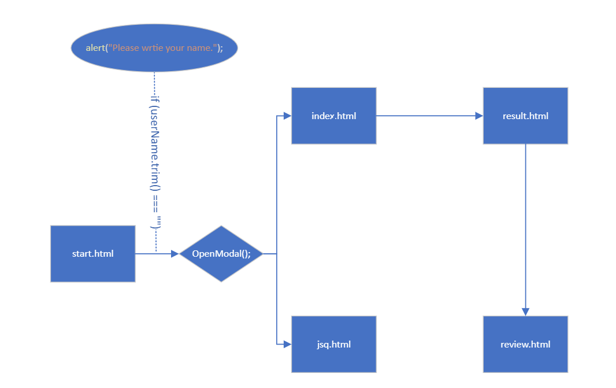

ㅇㅇㅇㅇ