Web Design Project Plan
Doyun, Andrej, Enis, Alexon, Mohanad

1st Week
Plan our entire project
- Simple quiz website
2nd Week
Write the basic code for the project
- Create index.html; Doyun, Andrej
- Create result.html; Enis, Alexon
- Create quiz.js; Doyun, Andrej, Enis, Alexon
3rd Week
Add some new files, update some codes, create a git repository
- Create start.html; Mohanad, Andrej
- Update index.html; Doyun, Andrej
- Update result.html; Enis, Alexon
- Update quiz.js; Doyun
- GitHub Repository
4th Week
Add a new feature, update some codes
- Add a new feature: Timer; Doyun, Andrej, Alexon
- Update quiz.js; Enis
5th Week
Add a new feature, update some codes, create new file
- Finish Timer feature; Alexon
- Add a new feature: Review page; Doyun
- Create review.html; Doyun
- Update quiz.js; Enis, Mohanad
- Update result.html; Enis, Mohanad

6th Week
Bug fix of JavaScript
- Timer feature bug fix; Andrej, Mohanad
- Add Quiz contents for quiz.html; Doyun, Andrej, Enis, Alexon, Mohanad
- Add contents for review.html; Doyun, Andrej, Enis, Alexon, Mohanad
- Create css files (start.css, index.css, review.css ,result.css); Andrej, Enis, Alexon, Mohanad

Start.html
Element:
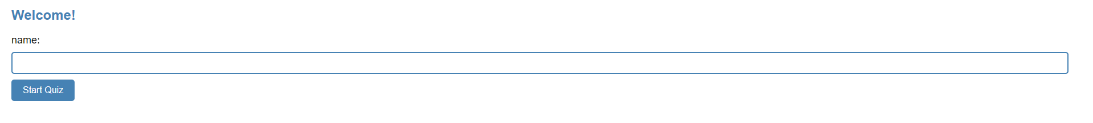
Greeting
Space for the user's name
Start Quiz button.

Script:
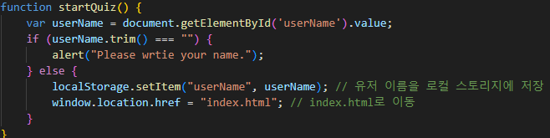
Save the user's name to local storage
Message output if no username is entered
Go to index.html on button click

Index.html
Element:
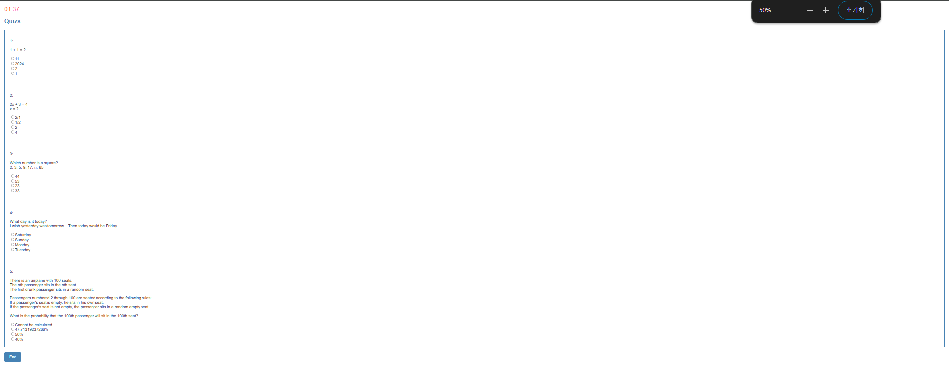
Timer
Quizzes
Answer options for quizzes
End button

Script:
Save the user’s score to local storage
Save the time to local storage
Go to result.html on button click
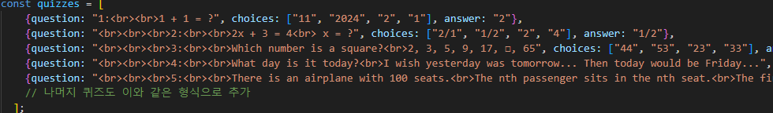
Create quizzes contents and explanations
Save explanations to local storage

result.html
Element:
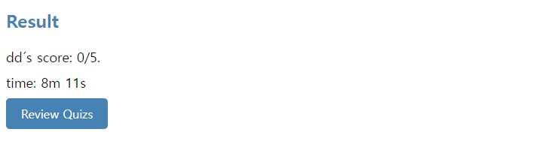
User’s score
Time
ReviewQuiz Button

Script:
Get and show username, score, time from local stroge on html

review.html
Element:
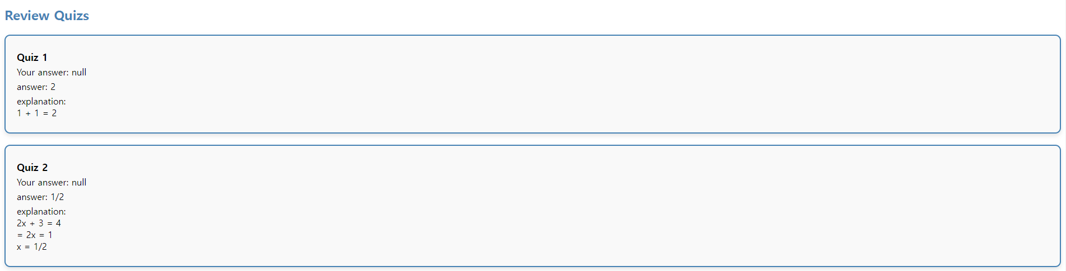
User’s answer, correct answer and explanations for quizzes

Script:
Get and show data about quizzes and explanations from local storage

