2017-2018

INTERNATIONAL FINANCIAL SUPPORT FORM admissions.enrollment.rochester/apply/status

International applicants are required to demonstrate they have the financial means (either through private funds or sponsorship) to attend the University of Rochester. Applicants who are unable to meet the full cost of attendance without need-based aid from the University should NOT complete this form. These students must submit the CSS Profile: (https://student.collegeboard.org/css-financial-aid-profile).

Applicants who are able to meet the full cost of attendance must submit this completed form along with their application for admission. Your application will remain incomplete without a completed International Financial Support Form on file. Applications who can pledge the full, four year cost will, on average, increase their chances of admission.

This form and supporting documents should be uploaded as PDFs through your MyROC account (enrollment.rochester.edu/myroc). If you are unable to submit these documents via MyROC, you may email them to international@ur.rochester.edu.
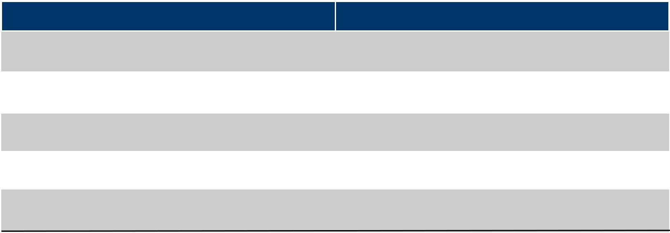

 | Estimated Costs (2017-18 Academic Year) | Amounts (U.S. Dollars)
 | Tuition and Fees
 | Tuition and Fees | $53,500
 | Health Insurance | $2,300
 | Room and Board | $15,700
 | Books and Supplies | $1,310
 | Personal Expenses | $1,080
 | Total | $73,890*


*Tuition, Fees, and room and board expenses will increase in future years.

Please complete form on Page 2 ➔

International Financial Support Form Page 1

2017-2018

INTERNATIONAL FINANCIAL SUPPORT FORM admissions.enrollment.rochester/apply/status

Legal Name*: ______________________________________________________________________________________
Last (Family) First (Given) Middle *For non-U.S. citizens: write your name exactly as it appears on your passport.

Date of Birth: _________________________ Email Address: ______________________________________________

Source of Funds:
Please include the sources of support for all years of undergraduate study. The total must be equal to or greater than the total shown on Page 1.

Enter all amounts in U.S. Dollars.
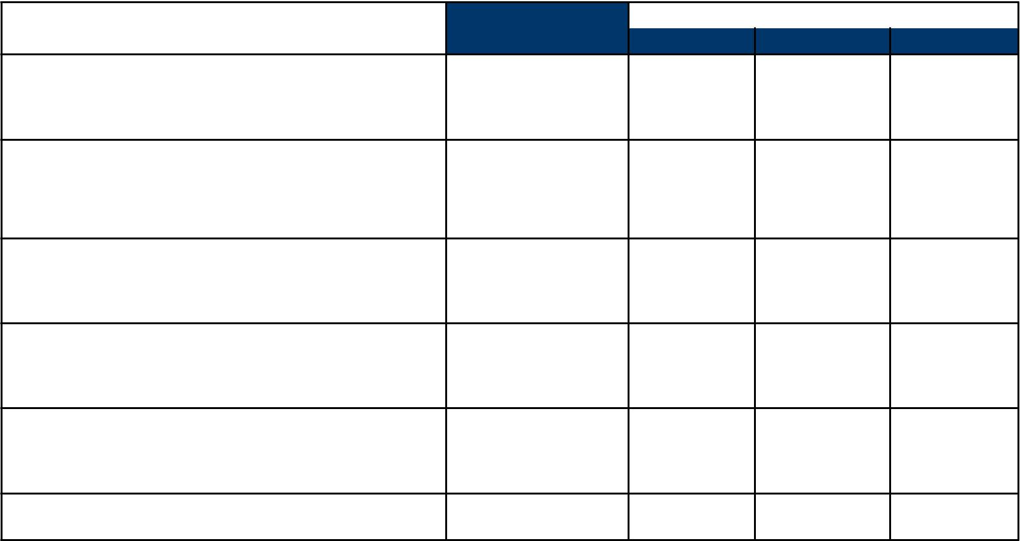

Assured Support, |  |  |  | Projected Support
First Year |  |  | Second Year | Third Year | Fourth Year

Your savings

Name of bank:

___________________________________________________

Your parents or other family savings

Name: _____________________________________________

Name: _____________________________________________

Your government*

Type of award:

___________________________________________________

Private sponsor*

Type of award:

___________________________________________________

Other*

Specify:

___________________________________________________

TOTAL

*Please provide a copy of your support letter

I certify that I have read the information provided on this form and that it is true and complete. I understand that any misrepresentation may be cause for refusing or revoking admission.

Student Signature: __________________________________________________________________________________________________________

Student Name: _____________________________________________________________________ Date: ___________________________

Parent Signature: __________________________________________________________________________________________________________

Parent Name: ______________________________________________________________________ Date: ___________________________

International Financial Support Form Page 2

