ELEC 3300 Project Summary Sheet
This is a ONE Page Summary Sheet, Content more than 1 page will be deleted.
All the fonts used in this Sheet should be in Times New Roman at 12 points

Group Number | Group 50
Project Title | Auto Drawing Machine
Name of Student 1 | DU Yinwei
Name of Student 2 | CHEN Yi

Please attach ONE photo of your project here
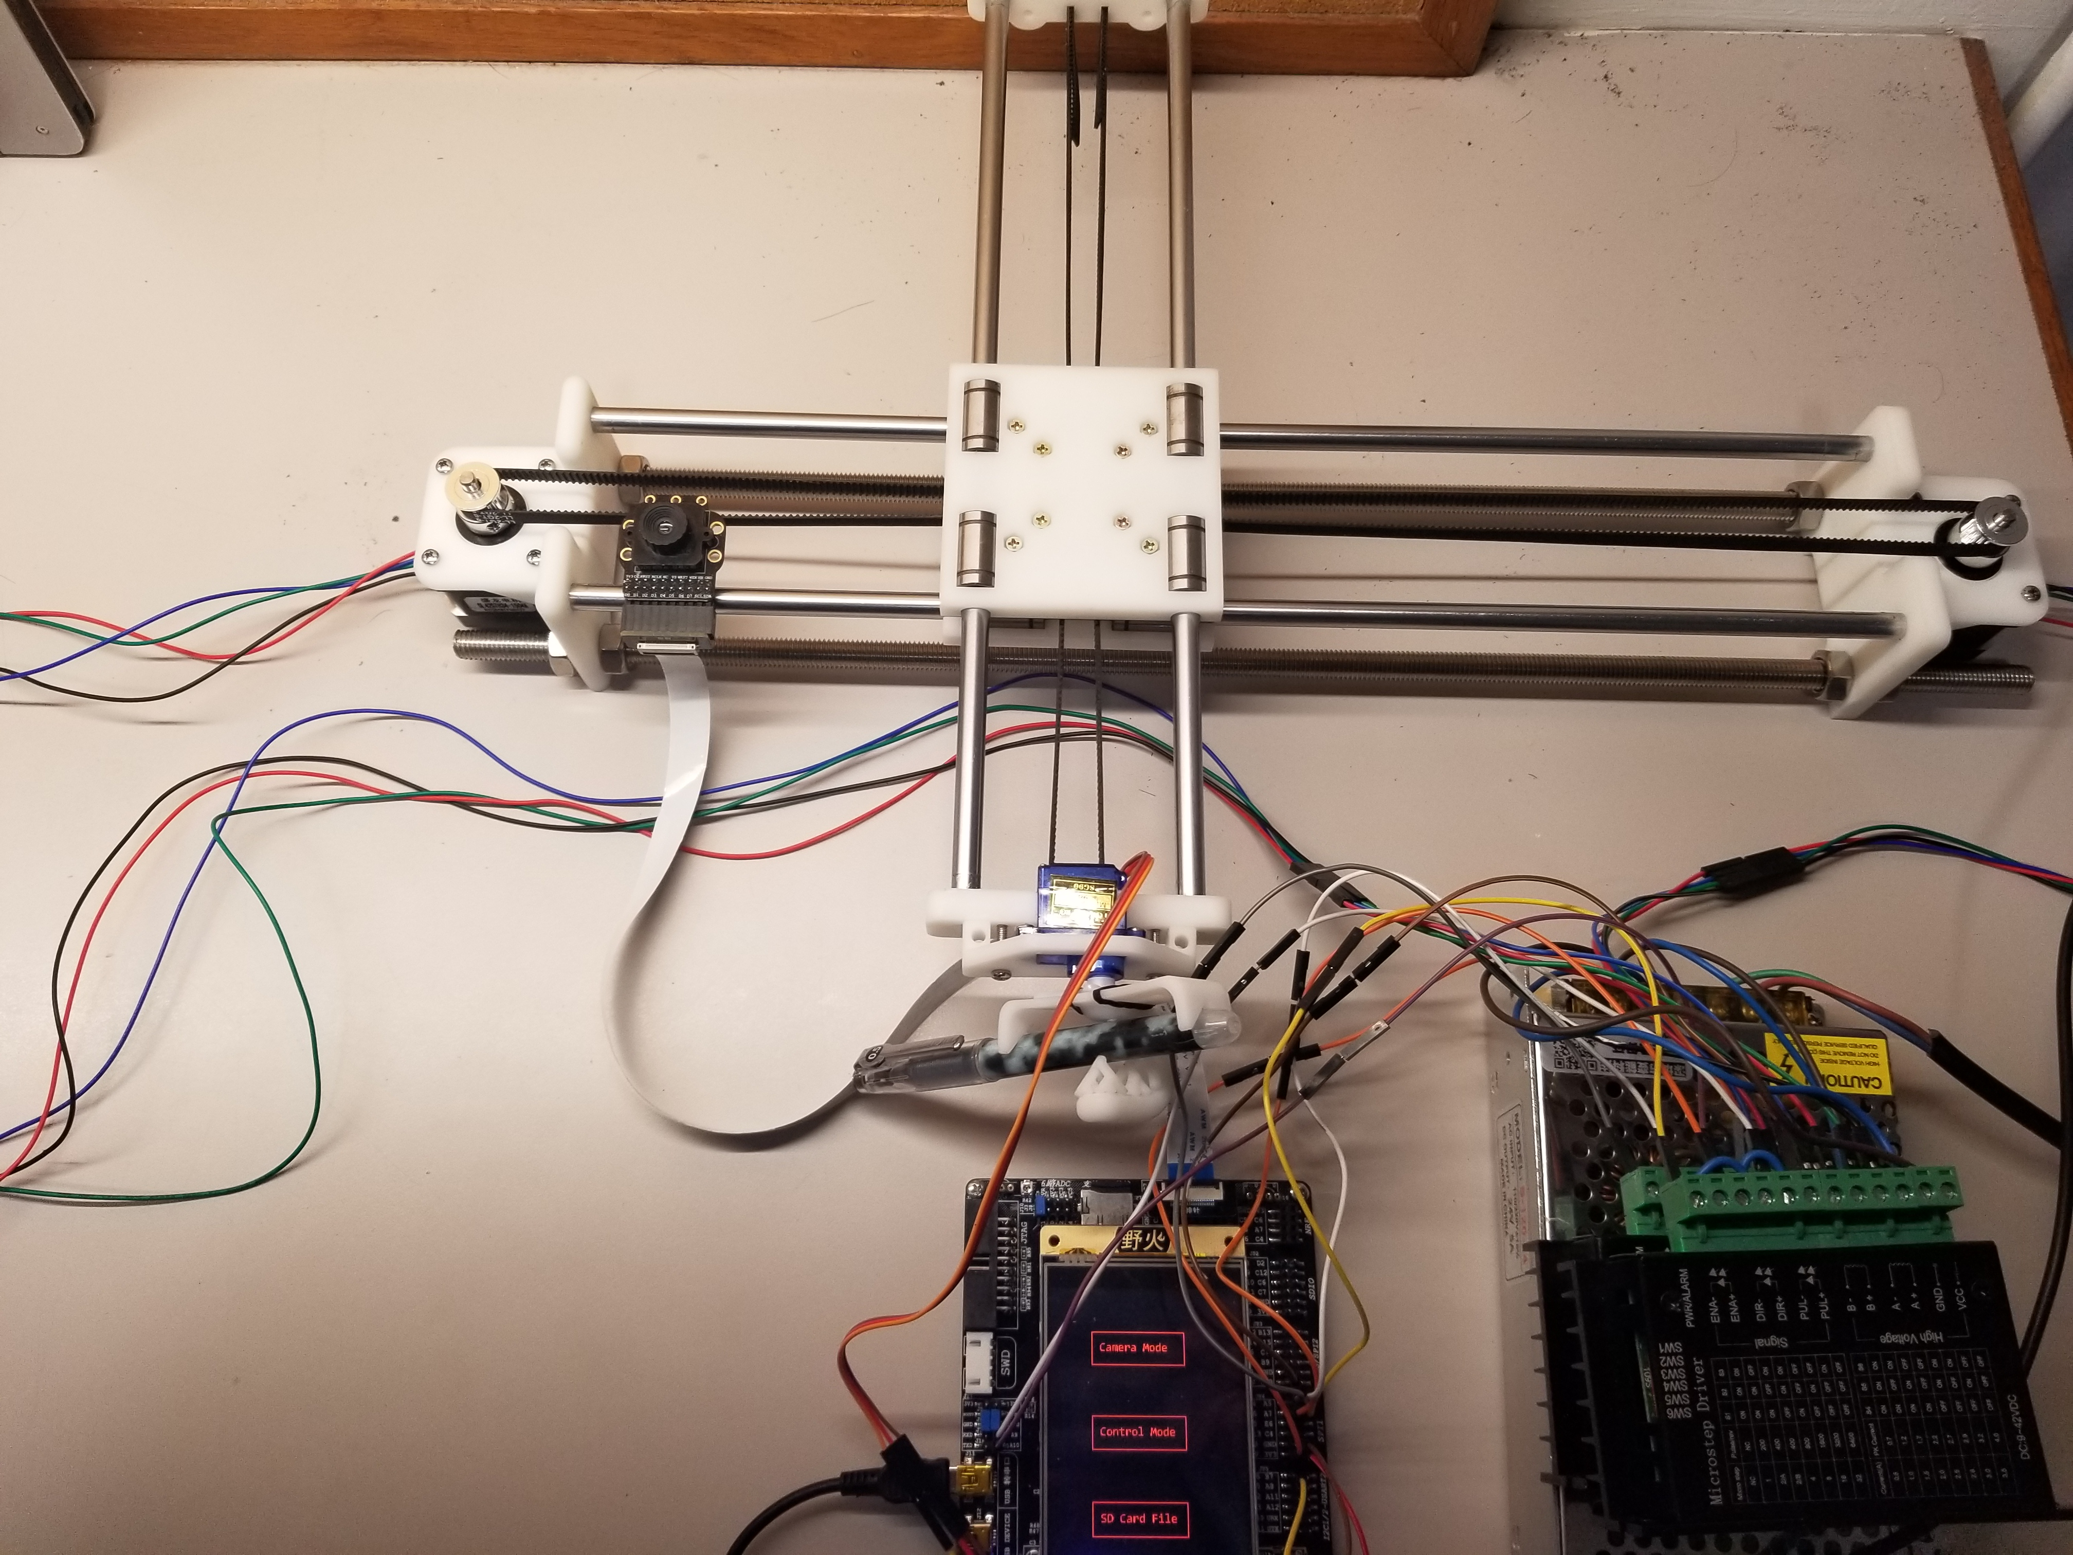
Please list the functions of your project in point form

- Use two Nema17 stepper motor to control the x and y movement of the pen
- Use one SG90 server motor to control the writing angle of the pen
- Use the LCD screen to display information and enable user to give instructions by touching the screen
- Use an OV7725 camera for user to take picture of an object.
- Implement a FAT file system in SD card, which can store the path information for the stepper motor as well as store the picture taken in the previous point.
- Use HC05 Bluetooth module for controlling the system via mobile phone.
- On laptop, we use MATLAB to transform an RGB picture first to halftone black and white picture. Then do a nearest neighbor search to find the approximate path for the pen.
- Overall, our drawing machine works in 3 modes:
  - Manual mode:
The user can control the pen’s position and angle directly by touching on the screen.
  - SD Card Mode:
The machine will read a pre-stored txt file in the SD card and draw a picture based on that file
  - Camera Mode:
The user can take a picture using a camera and then send the file to the laptop for further processing. After that, a text file will be sent back to STM32 and the machine will draw a picture based on that.

