Arrays (Easy)
1. Find largest element in an array without sorting
2.Second Largest element in an array without sorting array
https://www.geeksforgeeks.org/problems/second-largest3735/1
Approach 1: using two loops O(N)
- first for finding the first largest
- second for finding the second largest
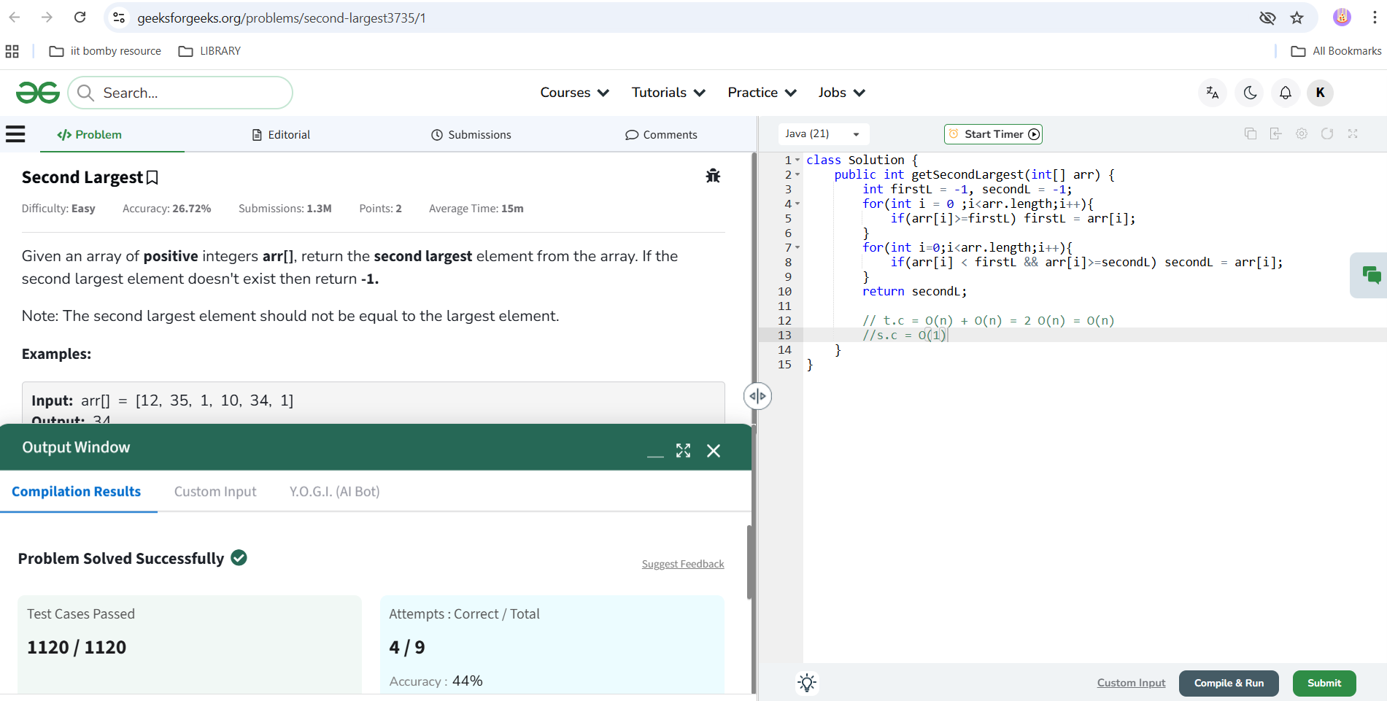

Approach 2: using single loop O(N)
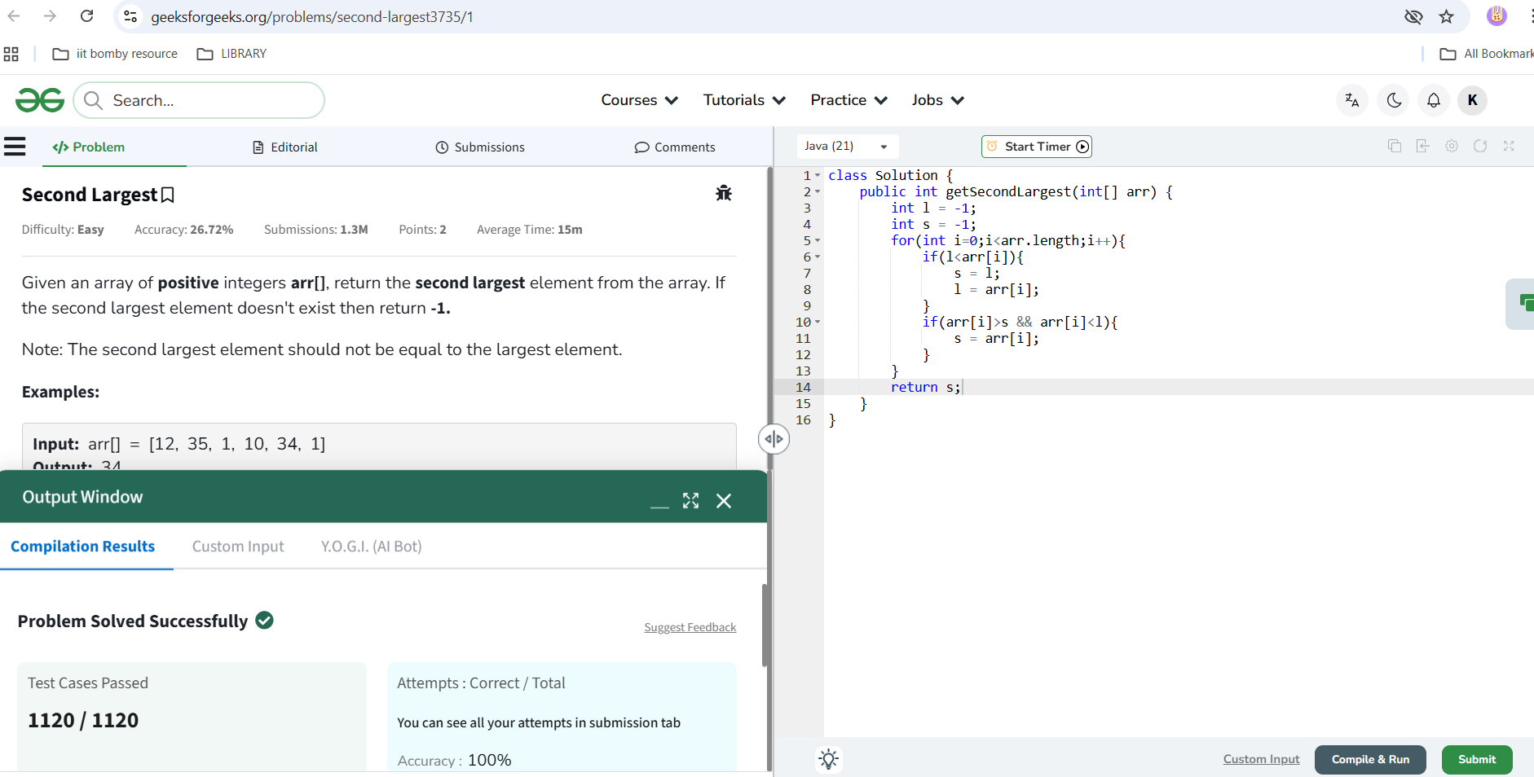
3. check if an array is sorted or not
https://www.geeksforgeeks.org/problems/check-if-an-array-is-sorted0701/1
approach 1: we will check each ith element with all the future elements, if it’s larger than any of them, it’s not sorted
Time complexity: O(N^2), Space complexity: O(1)
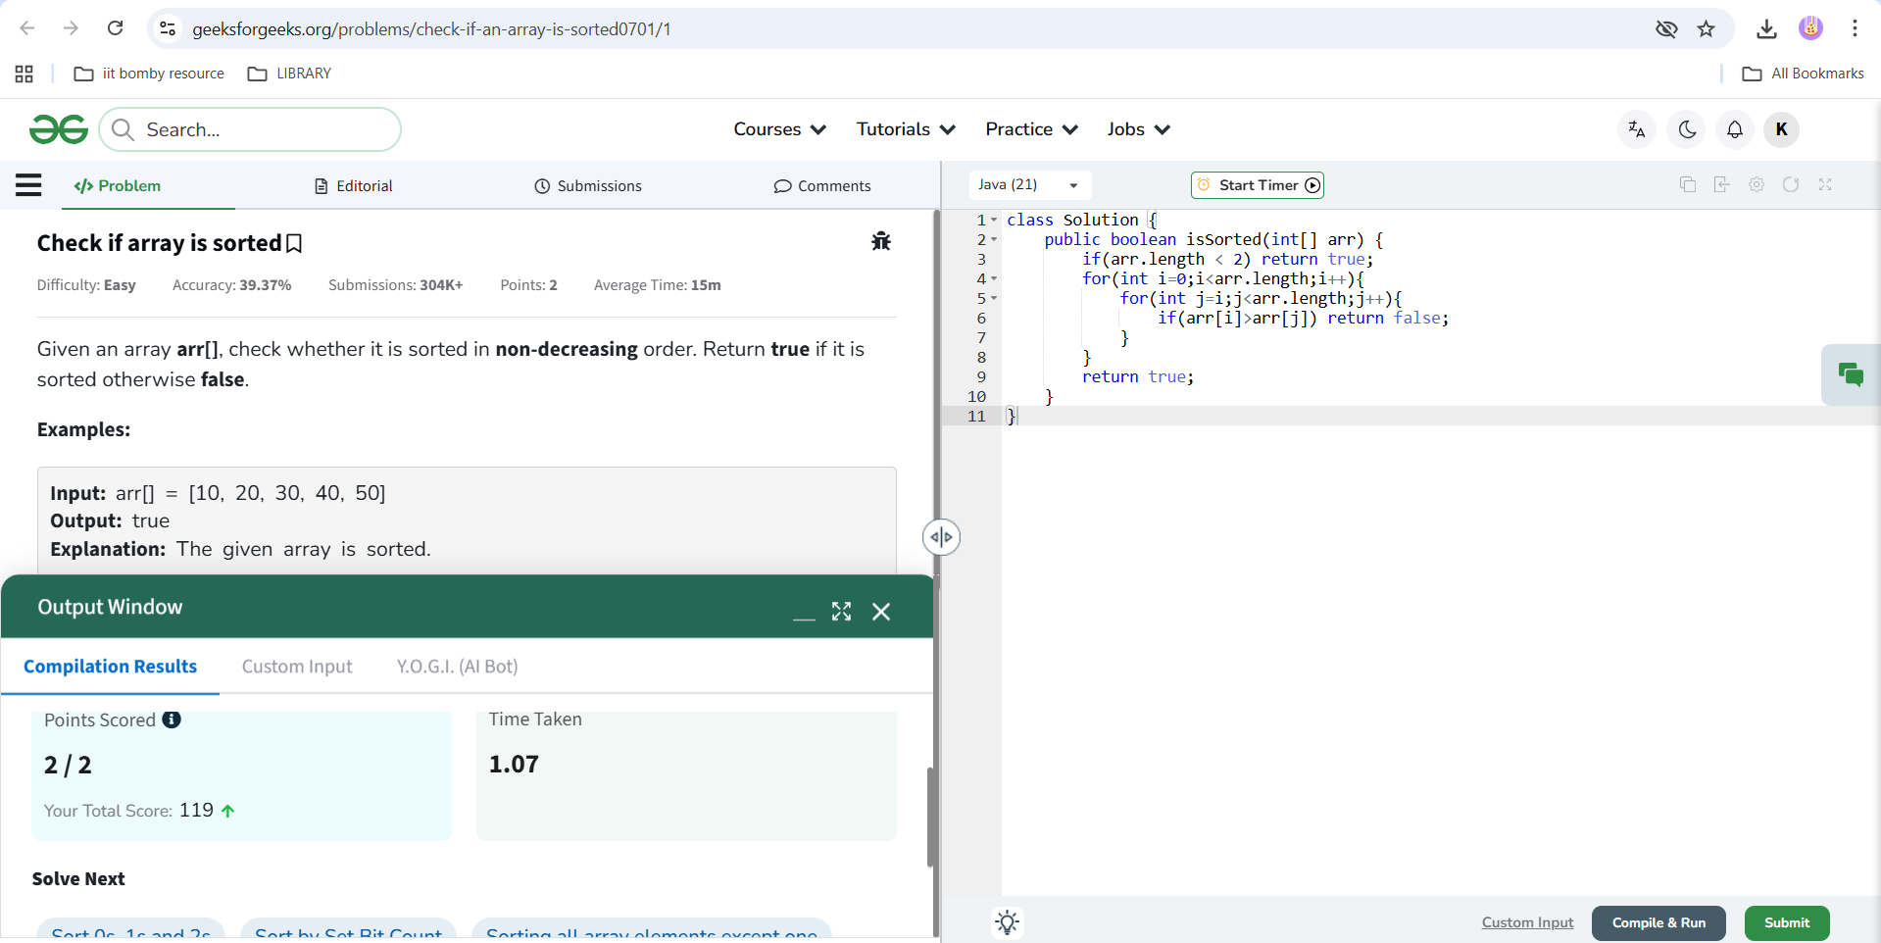

Approach 2: we will check each element with it’s previous element, if it’s smaller than the previous one, it’s not sorted.
Time complexity: O(N), Space complexity: O(1)
Similar questions to solve:
3.1 Sorting all array elements except one - https://www.geeksforgeeks.org/problems/sorting-all-array-elements-except-one4653/1
3.2 Sort by Set Bit Count - https://www.geeksforgeeks.org/problems/sort-by-set-bit-count1153/1
3.3 Sort 0s, 1s and 2s - https://www.geeksforgeeks.org/problems/sort-an-array-of-0s-1s-and-2s4231/1

4. check if array is sorted and rotated

