**PROJECT REPORT**

**On**

# **EasyMart – Shopping Website and Inventory Management**

Submitted in partial fulfilment of the requirement for the

Course **FSE** (22CS037) of

**COMPUTER SCIENCE AND ENGINEERING**

**B.E. Batch-2022**

**in**

**Jan - 2025**



|  |  |
| --- | --- |
|  |  |
| **Under the Guidance of** | **Submitted By** |
| **Ms. Sana Bharti** |  |
|  | **Jasjeet Kaur** |
|  | **2210990442** |
|  | **Kanchan Yadav**  **2210990471** |

**DEPARTMENT OF COMPUTER SCIENCE AND ENGINEERING**

**CHITKARA UNIVERSITY**

**PUNJAB**

**CERTIFICATE**

This is to be certified that the project entitled “**EasyMart:** **Shopping Website and Inventory Management**” has been submitted for the Bachelor of Computer Science Engineering at Chitkara University, Punjab during the academic semester Jan 2025 - May 2025 is a Bonafide piece of project work carried out by “Jasjeet Kaur 2210990442, Kanchan Yadav 2210990471” towards the partial fulfilment for the award of the course Full Stack Engineering (22CS037) under the guidance of Ms. Sana Bharti and supervision.

**Sign. of Project Guide:**

Ms. Sana Bharti

**Full Stack Engineering (22CS037)**

**CANDIDATE’S DECLARATION**

We, **Jasjeet Kaur 2210990442 & Kanchan Yadav 2210990471 of the Group-10**, B.E.-2022 of the Chitkara University, Punjab hereby declare that the Full Stack Engineering (22CS037) entitled **“EasyMart:** **Shopping Website and Inventory Management”** is an original work and data provided in the study is authentic to the best of our knowledge. This report has not been submitted to any other Institute for the award of any other course.

|  |  |  |
| --- | --- | --- |
| **Sign. of Student 1** | **Sign. of Student 2** |  |
| Jasjeet Kaur | Kanchan Yadav |  |
| 2210990442 | 2210990471 |  |

Place: Chitkara University

Date: 20th May 2025

**Full Stack Engineering (22CS037)**

**ACKNOWLEGEMENT**

It is our pleasure to be indebted to various people, who directly or indirectly contributed in the development of this work and who influenced my thinking, behaviour and acts during the course of study.

We express our sincere gratitude to all for providing me an opportunity to undergo Full Stack Engineering (22CS037) as the part of the curriculum.

We are thankful to **Ms. Sana Bharti & Mr. Gautam Mukherjee** for her support, cooperation, and motivation provided to us during the training for constant inspiration, presence and blessings.

Lastly, we would like to thank the almighty and our parents for their moral support and friends with whom we shared our day-to day experience and received lots of suggestions that improve our quality of work.

|  |  |  |  |  |  |  |  |  |  |  |  |  |  |  |  |
| --- | --- | --- | --- | --- | --- | --- | --- | --- | --- | --- | --- | --- | --- | --- | --- |
| |  |  |  | | --- | --- | --- | | **Sign. of Student 1** | **Sign. of Student 2** |  | | **Jasjeet Kaur** | **Kanchan Yadav** |  | | **2210990442** | **2210990470** |  | |  |  |  |  |  |  |
|  |  |  |  |  |  |  |
|  |  |  |  |  |  |  |

**Full Stack Engineering (22CS037)**

**The report consists of following chapters:**

1. **Abstract/keywords………………………………………………………………………………………6**
2. **Introduction ……………………………………………………………………………………………..7**
   * **Background**
   * **Problem Statement**
3. **Software and Hardware Requirement Specification………………………………………………….9** 
   * **Methods**
   * **Software requirements**
   * **Hardware Requirements**
4. **Database Analysing ……………………………...…………………………………………………….10**
5. **GUI Constructing (Project Snapshots) ……………………………………………………………………11**
6. **Code-Implementation and Database Connections…………………………………………………...17**
7. **Limitations……………………………………………………………………………………………...18**
8. **Conclusion………………………………………………………………………………………………19**
9. **Future Scope…………………………………………………………………………………………….20**
10. **Contributions of all Teammates………………………………………………………………………..21**

**Full Stack Engineering (22CS037)**

### **Abstract/Keywords**

**EasyMart** is a **modern e-commerce platform** designed to streamline the online shopping experience by connecting **vendors and customers** through a single, intuitive application. In today’s fast-paced digital economy, convenience, efficiency, and accessibility are paramount. **EasyMart** addresses this demand by offering a **user-friendly interface** and powerful backend that make product browsing, purchasing, and inventory management seamless for both customers and sellers.

This robust platform is built using a powerful tech stack comprising **React.js** for the frontend and **Node.js with Express.js** for the backend. **MySQL** is used as the **relational database** to store and manage structured data efficiently. For **authentication**, **JWT (JSON Web Tokens)** is implemented to ensure secure and stateless user sessions. The application leverages **NodeMailer** to send automated email notifications, while **GitHub** is utilized for **version control** and team collaboration. Development and testing are carried out using **Visual Studio Code**, ensuring smooth integration and code quality throughout the lifecycle.

At the heart of **EasyMart** lies the goal of creating a **secure, scalable, and feature-rich shopping environment**. Vendors can **easily list products, manage inventory**, and track **order analytics**, while customers enjoy a smooth shopping journey with features such as **advanced search**, **product filtering**, and **real-time order tracking**. These functionalities simplify decision-making and enhance user engagement across the platform.

**EasyMart** includes essential features to ensure both **convenience and personalization**. A **secure registration/login system** with **email verification** (via **NodeMailer**) safeguards user information. Customers can manage **Wishlist**, add items to their **cart**, and view their **order history**. Vendors have access to dedicated **dashboards** for tracking orders, analysing revenue trends, and managing their store effectively.

With a focus on simplicity and usability, **EasyMart** delivers a **responsive design** that works seamlessly across devices. The **search and filter tools** allow users to quickly locate products by **category, price range**, and other specifications, enhancing the shopping experience. Each product page provides detailed information such as **price, stock availability**, and additional metadata, ensuring users have all the necessary details to make informed decisions.

**Full Stack Engineering (22CS037)**

**2. Introduction**

#### **2.1 Background**

As digital commerce continues to expand rapidly, individuals, businesses, and organizations are increasingly relying on online platforms for day-to-day transactions. The retail and e-commerce sectors have experienced exponential growth due to the convenience and accessibility they offer. However, this growth has also introduced challenges related to efficient inventory management, seamless user experience, and the need for secure, scalable, and responsive platforms.

Modern consumers expect intuitive interfaces, quick transactions, and reliable order management. At the same time, vendors seek platforms that allow them to manage their products, monitor performance, and interact with customers effectively. Despite the availability of numerous online marketplaces, many lack integrated tools that serve the needs of both customers and sellers efficiently, creating a gap in user satisfaction and vendor utility.

EasyMart is developed as a response to these challenges, offering a platform that simplifies online shopping while supporting robust vendor management. The application is designed to streamline the interaction between buyers and sellers, enabling smooth navigation, secure transactions, and reliable data handling. From product discovery to purchase and post-order engagement, the platform enhances every step of the user journey.

Built with technologies like Node.js, Express.js, MySQL, and React.js, EasyMart provides a strong backend infrastructure along with an interactive, user-friendly frontend. This combination ensures high performance, scalability, and maintainability. Key features such as vendor-specific dashboards, product listing modules, user authentication, and real-time order tracking work together to deliver a comprehensive e-commerce solution.

The vision behind EasyMart is to build a versatile shopping and inventory platform that supports both end-users and vendors. It emphasizes ease of use, functionality, and reliability. By integrating essential features into a single application, EasyMart aims to redefine the way small businesses and consumers interact in the digital retail environment.

#### **2.2 Problem Statement**

The rapid growth of e-commerce has undoubtedly transformed the retail industry, offering unparalleled convenience and accessibility. However, this convenience has also introduced several operational and user experience challenges. Many existing platforms are either too complex, lack critical features for vendors, or fail to provide a seamless shopping experience for users. These gaps can hinder customer satisfaction and reduce vendor efficiency in managing their digital stores.

Traditional e-commerce platforms often fall short in addressing key issues such as user-friendly interfaces, product management tools for vendors, secure transaction mechanisms, and efficient order tracking systems. For example:

**Full Stack Engineering (22CS037)**

* Vendors may face difficulty in listing and managing products due to a lack of intuitive interfaces.
* Customers often struggle with navigation and product discovery due to poor search and filter functionalities.
* Many platforms do not offer real-time updates or dashboards for tracking sales, orders, or inventory.

Moreover, the lack of integration between vendor operations and customer engagement features leads to fragmented experiences for both parties. These limitations highlight the need for a well-rounded, full-stack solution that addresses both vendor-side and customer-side requirements efficiently.

**EasyMart** is built to overcome these common e-commerce shortcomings by offering a comprehensive and cohesive solution. It bridges the gap between usability and functionality by including features such as:

* **Role-Based Dashboards**: Separate interfaces tailored for vendors and customers to manage relevant information and operations.
* **Product Management System**: Tools for vendors to easily list, update, and monitor products.
* **Order Management Module**: For customers to track orders and for vendors to handle order confirmations, shipping, and cancellations.
* **Search and Filter Options**: Advanced search tools for customers to quickly find products by category, price, and other parameters.
* **Email Notifications**: Automated alerts on sign-up, order updates, and more to enhance user engagement.

This approach ensures that all users, whether vendors or shoppers, can enjoy a smooth and efficient online shopping experience. By addressing these fundamental challenges, **EasyMart** aims to elevate the quality of digital retail services and support businesses in managing their operations with ease and accuracy.

The platform’s mission is to provide a modern, feature-rich e-commerce solution that simplifies buying and selling online. With its streamlined tools and responsive interface, EasyMart is positioned to empower both small and medium-sized businesses and provide customers with the quality experience they expect in today’s digital economy.

**Full Stack Engineering (22CS037)**

**3. Software and Hardware Requirement Specification**

**3.1 Methods**

To build the **EasyMart** platform efficiently, the following technologies and practices were used:

**Backend**:

* **Node.js** and **Express.js** enabled fast, asynchronous server-side operations and API handling.
* **Nodemailer** was used for sending email notifications.
* **RESTful APIs** facilitated smooth communication between frontend and backend.

**Database**:

* **MySQL** managed structured data like users, orders, and products.

**Authentication**:

* **JWT** ensured secure login sessions.
* **Email Verification** was added during registration for account authenticity.

**Frontend**:

* **React.js** built a dynamic, responsive UI using reusable components.

**Tools**:

* **GitHub** handled version control and team collaboration.
* **VS Code** was used as the main development environment.

**3.2 Software Requirements**

* **Node.js (v14+)** – Backend runtime environment
* **MySQL** – Structured data storage
* **Express.js** – Backend framework
* **React.js** – Frontend UI library
* **JWT** – User authentication
* **Axios** – API communication
* **Git** – Version control
* **VS Code** – Code editor

**3.3 Hardware Requirements**

* **Processor**: Intel Core i5 or better
* **RAM**: Minimum 8 GB
* **Storage**: At least 100 GB free space
* **Internet**: Stable connection for development and deployment

**Full Stack Engineering (22CS037)**

**4. Database Analysing**

**4.1 Database Analysis**

The database design for **EasyMart** focuses on the efficient organization and retrieval of the following core entities:

* **Users**: Stores login credentials, personal information, and role types (customer or vendor).
* **Products**: Contains details like product name, description, price, category, stock availability, and vendor association.
* **Orders**: Tracks order history, including order status, items purchased, timestamps, and customer details.
* **Cart**: Temporarily stores products added by customers prior to checkout.
* **Wishlist**: Maintains a list of favourite products saved by customers for future purchase.
* **Order Items**: A supporting table to store individual products within an order (used to manage one-to-many relationships).

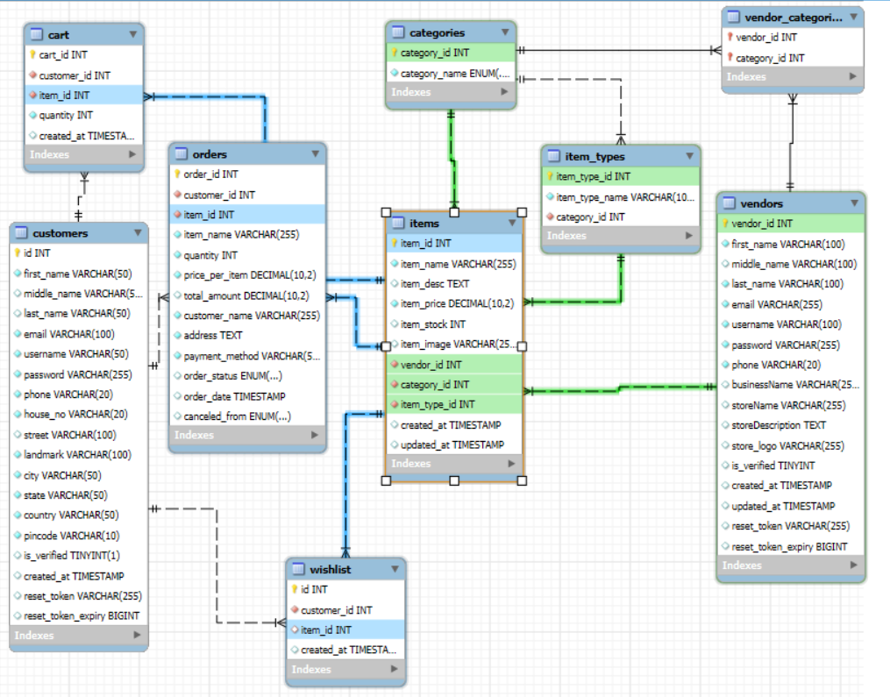

**Full Stack Engineering (22CS037)**

**Backend Engineering (22CS026)**

**5. GUI Constructing (Project Snapshots)**

**EasyMart Starting Page:**

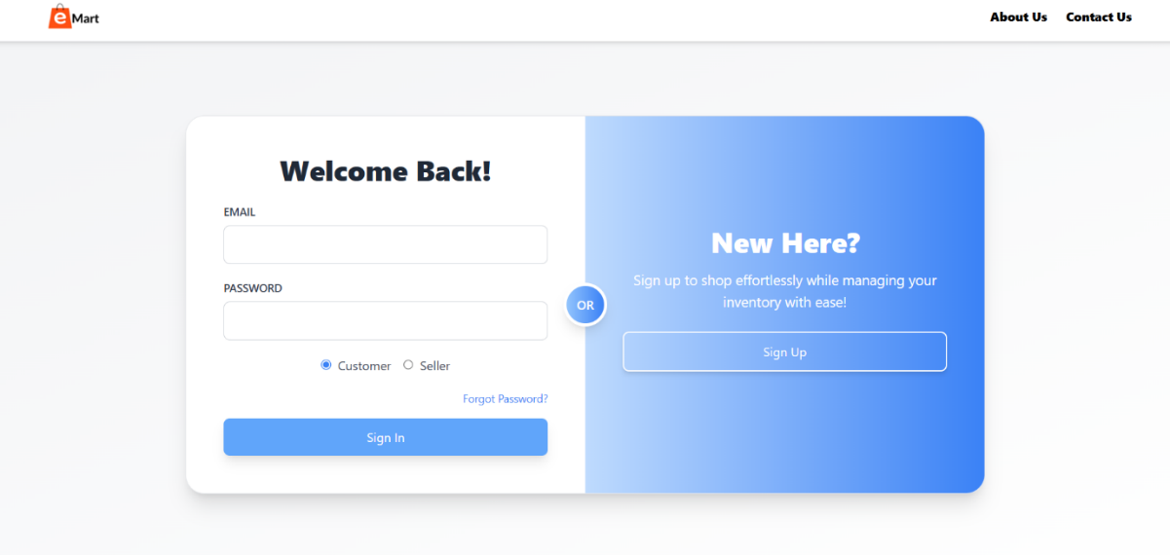

**Customer Home Page:**

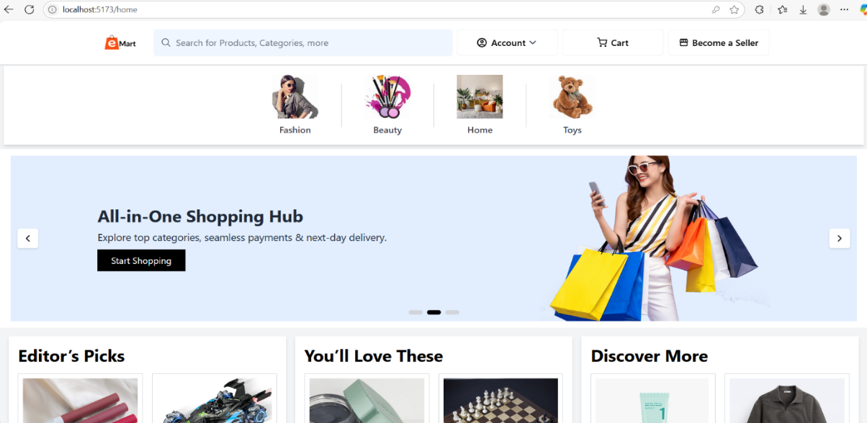

**Vendor Home Page:**

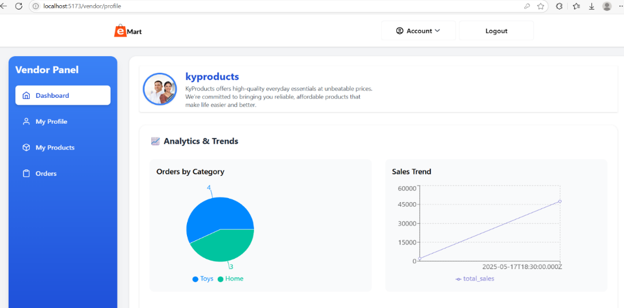

**Full Stack Engineering (22CS037)**

**Category Products, Seach, Filter functionality:**

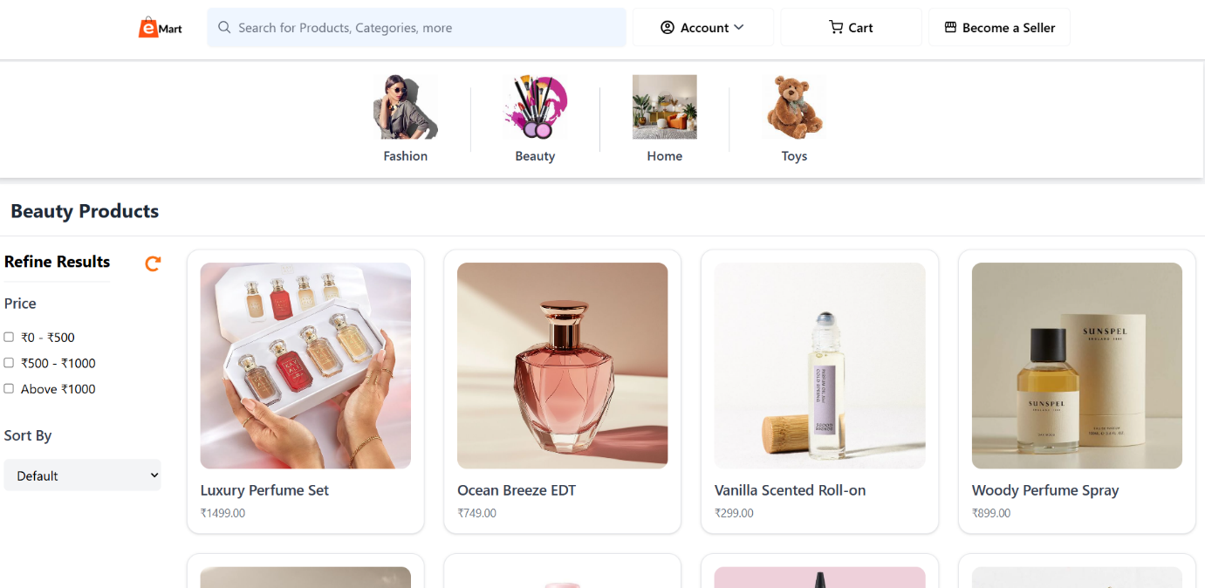

**Product Profilie:**



**Full Stack Engineering (22CS037)**

**Customer account management:**

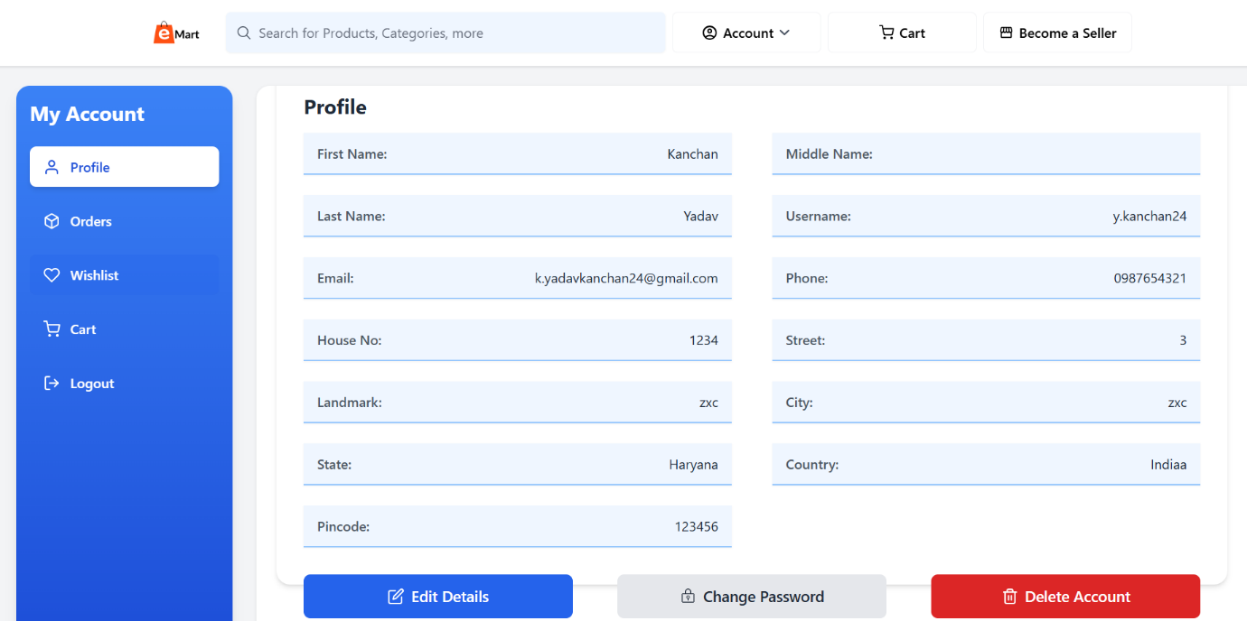

**Vendor account management**: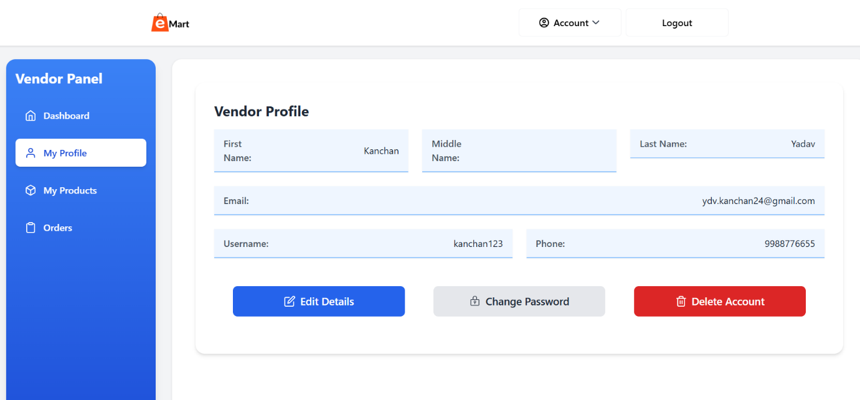

**Full Stack Engineering (22CS037)**

**Wishlist, Cart, Orders functionality:**

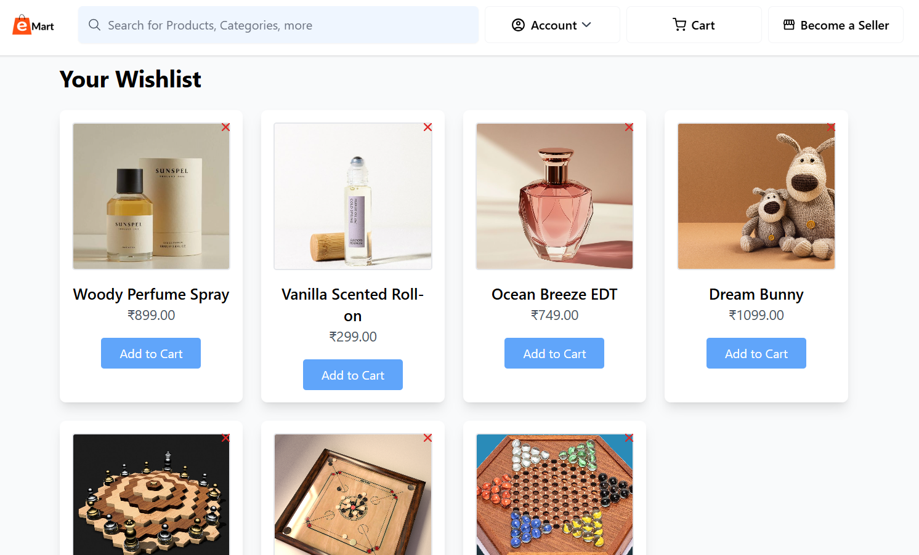

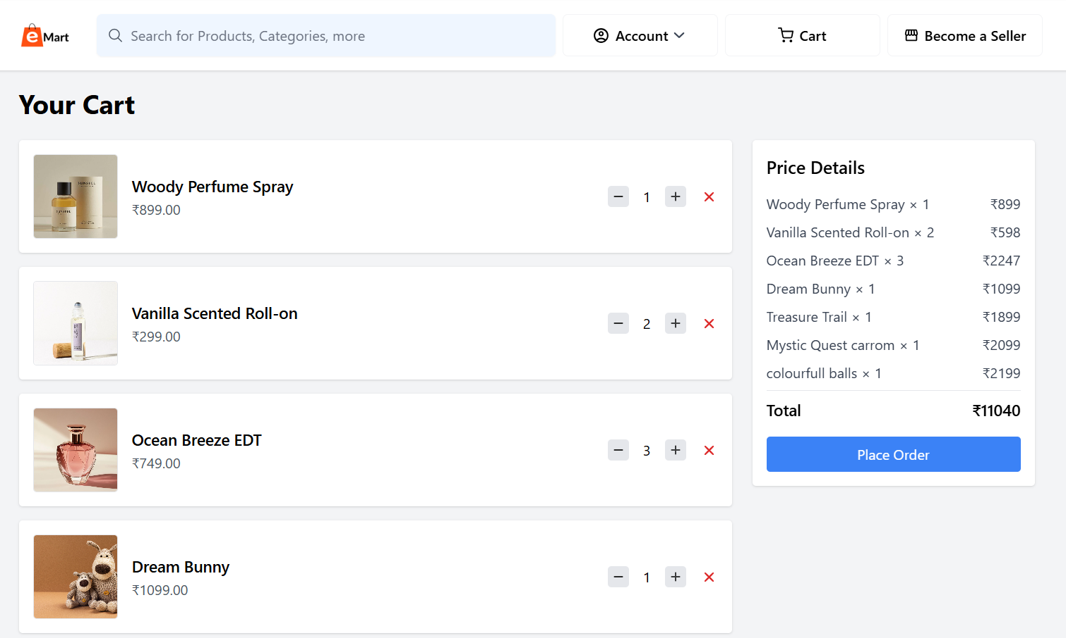

**Full Stack Engineering (22CS037)**

**Order details are customers end:**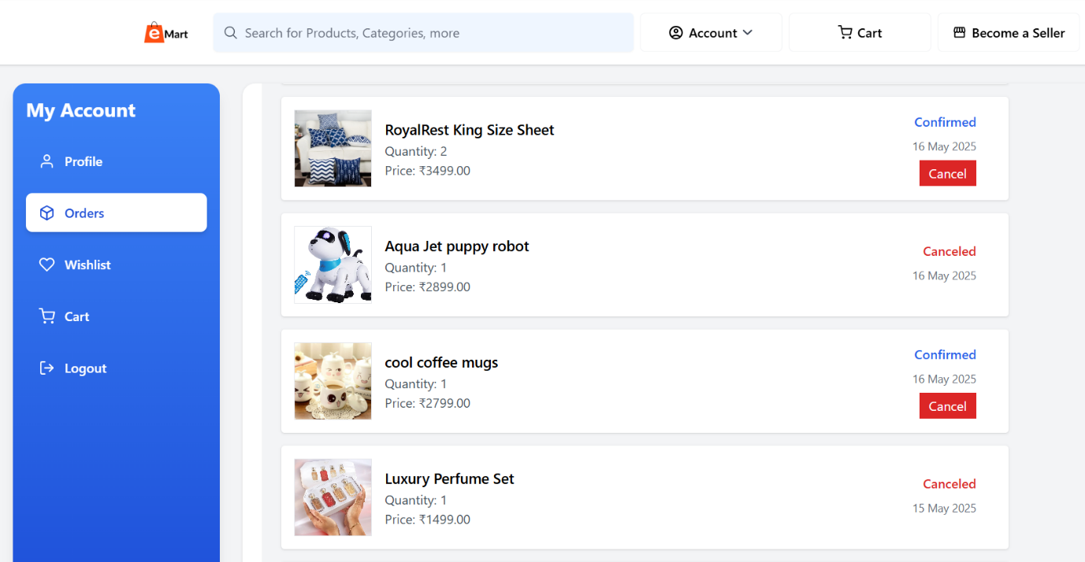

**Products at vendor dashboard:** 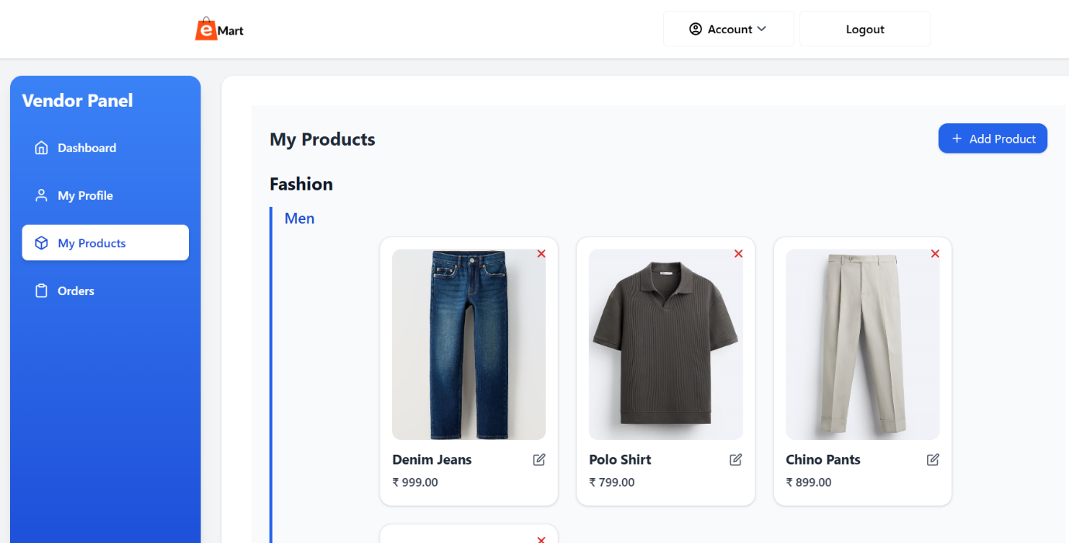

**Full Stack Engineering (22CS037)**

**Order management at vendors end:**

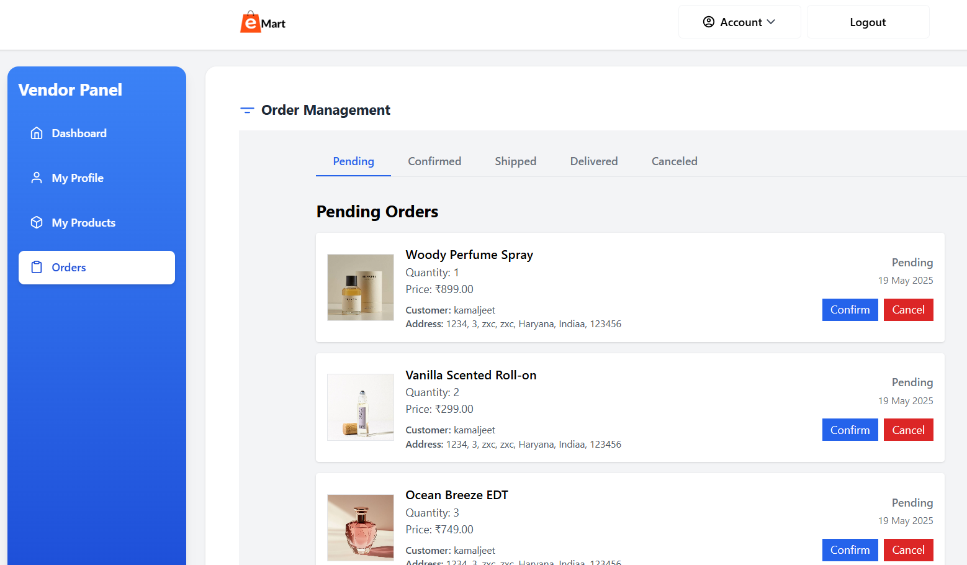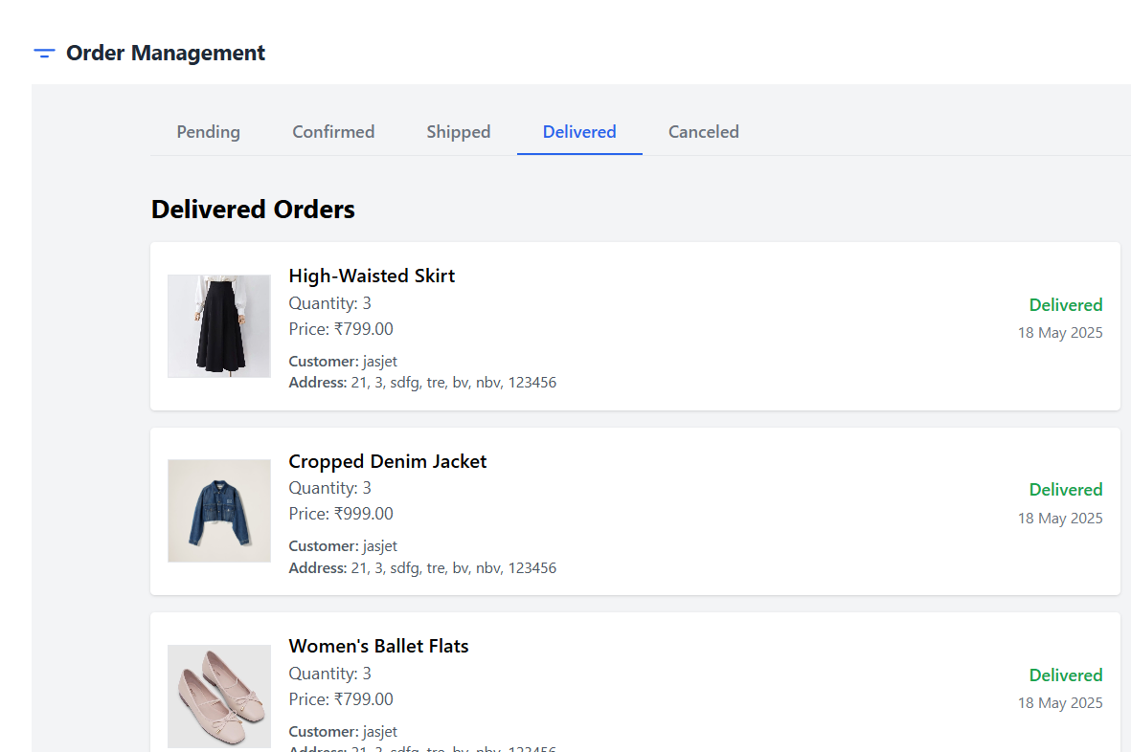

**Full Stack Engineering (22CS037)**

**6. Code-Implementation and Database Connections**

**Frontend & Backend File hierarchy:  
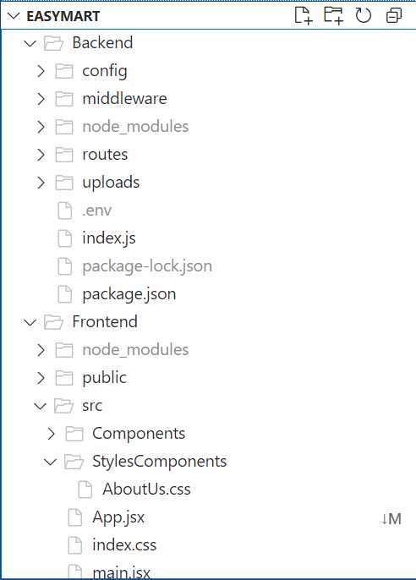**

**Full Stack Engineering (22CS037)**

**Backend Engineering (22CS026)**

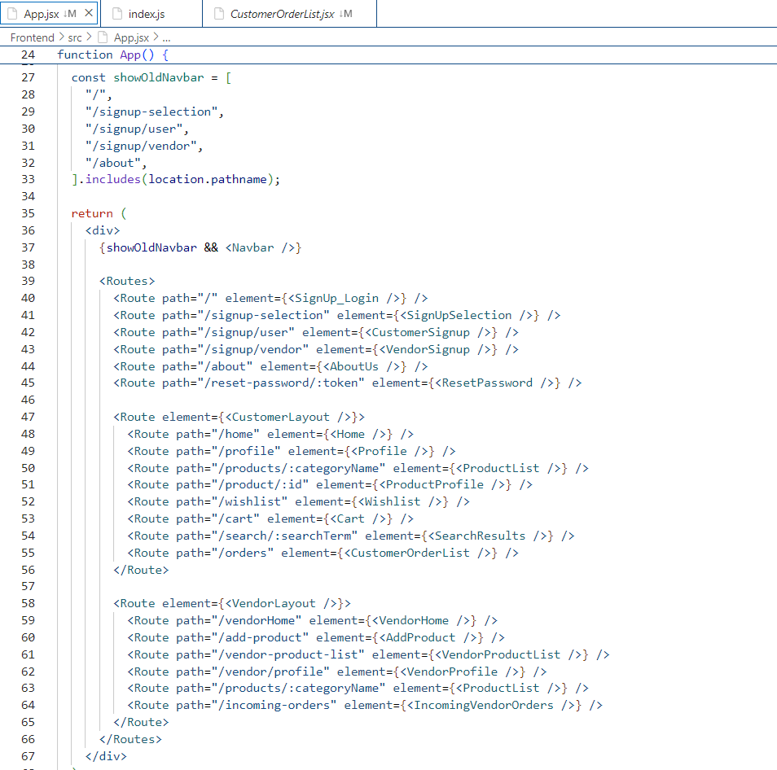

**7. Limitations**

Despite the innovative features and robust functionality of **EasyMart**, there are several limitations the platform currently faces. These limitations may affect its ability to fully meet all user expectations and provide an optimal experience in every use case. Key limitations include the following:

1. **Vendor Onboarding and Product Verification**

A significant aspect of EasyMart is its ability to allow vendors to easily list and manage products. However, onboarding a large number of vendors and ensuring the accuracy of their product listings can be challenging. In the early stages, verifying vendor credentials, standardizing product information, and maintaining quality control across listings require manual oversight. As the platform grows, automated verification and stricter vendor guidelines will be needed to maintain trust and consistency.

1. **Scalability Challenges in Handling Large Order Volumes**

As the user base and transaction volume increase, the platform may face performance bottlenecks, particularly in areas such as order processing, real-time analytics, and database queries. While EasyMart is built using scalable technologies, infrastructure upgrades and optimizations (like load balancing and query optimization) will be required to ensure consistent performance under high traffic.

**Full Stack Engineering (22CS037)**

**8. Conclusion**

**EasyMart** is a feature-rich, full-stack e-commerce platform designed to simplify online shopping while offering powerful tools for vendors to manage their stores and inventory. With the growing reliance on digital platforms for commerce, users expect seamless, fast, and secure experiences — and EasyMart rises to meet those expectations by combining intuitive design with robust functionality.

At its core, EasyMart is committed to enhancing both the **customer** and **vendor** experience. Customers benefit from a responsive and user-friendly interface, advanced search and filtering capabilities, secure authentication, and real-time order tracking. Vendors are empowered with a dedicated dashboard to manage product listings, view sales analytics, and handle order fulfillment with ease.

The platform is built using modern technologies such as **MySQL**, **Express.js**, **React.js**, and **Node.js**, ensuring a scalable and secure backend, an interactive frontend, and smooth API communication. This technology stack allows EasyMart to adapt as user demands grow, making it a reliable solution for both small businesses and medium-sized enterprises.

Beyond technical implementation, EasyMart aims to address real-world challenges in the online shopping landscape—such as vendor onboarding, order management, and system performance—while maintaining a clean and engaging user experience. With automated email notifications, role-based dashboards, and modular design, the platform achieves a balance between functionality and simplicity.

As EasyMart evolves, future enhancements like payment gateway integration, logistics automation, and analytics-driven features will further strengthen its value. The vision is to provide an all-in-one solution for digital commerce that is **scalable**, **efficient**, and **customer-centric**.

Through continued innovation, collaboration, and feedback-driven improvement, EasyMart is well-positioned to become a trusted platform in the digital retail space—empowering vendors and delighting customers across the board.

**Full Stack Engineering (22CS037)**

**9. Future Scope**

The future of **EasyMart** holds significant potential for growth, feature enhancement, and innovation in the e-commerce and inventory management space. As digital commerce continues to evolve, EasyMart is well-positioned to become a comprehensive solution for both buyers and vendors by expanding its functionality and improving platform performance.

**1. Expanding the Product and Vendor Base**

* EasyMart aims to onboard a broader range of vendors from various domains to diversify its product offerings.
* Increasing product categories will enhance customer choice and improve the overall shopping experience.
* Vendor onboarding features will be further streamlined with automated verification systems and self-service tools.

**2. Global Reach and Local Market Integration**

* Future development includes expanding the platform’s availability to regional and international markets.
* Partnering with local sellers in different regions will enable localized product offerings and better delivery options.

**3. Payment Gateway and Logistics Integration**

* Integration with secure and widely used payment gateways will enable seamless transactions and build customer trust.
* Incorporating logistics APIs for real-time shipping updates, order tracking, and delivery coordination will optimize end-to-end user experience.

**4. Integration with Third-Party Platforms**

* EasyMart plans to integrate with third-party inventory management tools, CRM systems, and marketing platforms.
* This will help vendors manage operations more efficiently and personalize customer engagement through advanced analytics.

**5. Advanced Analytics and Reporting Tools**

* The platform will introduce detailed sales reports, customer behavior tracking, and business insights for vendors.
* These features will support data-driven decision-making and help vendors scale their operations effectively.

**6. Enhanced User Personalization**

* Upcoming features include personalized product recommendations, smart search enhancements, and customer-specific offers based on past behavior and preferences.
* These updates will boost engagement and improve retention.

**7. Community and Support Expansion**

* A built-in support system including live chat, vendor helplines, and FAQ modules is planned to enhance customer and vendor experience.
* Community forums and discussion boards may also be introduced to encourage vendor collaboration and knowledge sharing.

**8. Scalability and Technology Enhancements**

* EasyMart will continue to evolve its tech stack by optimizing backend infrastructure for high performance and scaling

**Full Stack Engineering (22CS037)**

**10. Contributions of all Teammates**

**10.1 Jasjeet Kaur (2210990442)**

1. **Vendor Login and Signup**: Developed secure authentication for vendors using JWT, enabling vendors to create and access their accounts safely.
2. **Email Verification**: Integrated email verification using NodeMailer to validate vendor accounts during registration.
3. **Add Product Functionality**: Implemented the ability for vendors to add new product listings including details like name, price, category, stock, and images.
4. **My Products Page (Vendor Side)**: Developed a dedicated interface for vendors to view, manage, and organize all their listed products.
5. **Edit Product Details (Vendor Side)**: Enabled functionality for vendors to update or modify product information as needed.
6. **Vendor Dashboard**: Created a vendor-specific dashboard to monitor orders, sales activity, and product status.
7. **Order Management (Vendor Side)**: Built features for vendors to confirm, ship, deliver, or cancel customer orders.
8. **Top Picks Section (Customer Home Page)**: Designed and implemented a visually appealing section to display trending or recommended products to customers.
9. **Search Functionality**: Developed a robust search feature to allow users to quickly find desired products based on keywords.
10. **Wishlist Functionality**: Implemented the ability for customers to save favorite products to their wishlist for future purchases.
11. **Place Order (Customer Side)**: Built the order placement flow allowing customers to checkout successfully with real-time updates.
12. **UI Design and Implementation**: Contributed to designing a responsive and user-friendly interface across both customer and vendor modules.
13. **Product Image Upload (Vendor Side)**: Implemented functionality for vendors to upload product images during the product listing process.
14. **Form Validations**: Added front-end and back-end validations for all input fields to ensure data integrity and prevent invalid submissions.
15. **Navigation and Routing Setup**: Configured protected routes and navigation flows for vendor-specific pages using React Router.

**Full Stack Engineering (22CS037)**

**10.2 Kanchan Yadav (22210990471)**

1. **Customer Login and Signup**: Developed secure login and registration features for customers using JWT.
2. **Session Management**: Ensured secure token-based sessions for both vendor and customer logins.
3. **Forgot Password Functionality**: Created a reset password system to assist users in recovering account access via email verification.
4. **Vendor Analytics and Trends**: Implemented visual analytics with charts and graphs on the vendor dashboard to track product performance and trends.
5. **Revenue Calculation (Vendor Side)**: Built real-time revenue tracking modules based on recent orders and total sales.
6. **Order Management (Vendor Side)**: Collaborated in managing order status updates and vendor-side tracking features.
7. **User Profile Management (Vendor and Customer)**: Developed profile pages displaying personal and account details for both user types.
8. **Edit User Details**: Enabled secure editing of profile data for vendors and customers.
9. **Change Password**: Added functionality to allow users to update their passwords through the profile section.
10. **Delete Account**: Implemented secure account deletion logic for both customer and vendor roles.
11. **Logout Functionality**: Developed logout features that invalidate JWT sessions for both vendors and customers.
12. **UI Design and Implementation**: Participated in UI layout creation and responsive design across multiple views.
13. **Product Filtering (Customer Side)**: Built filters by category, price, and availability to simplify product discovery.
14. **Cart Functionality**: Enabled adding, removing, and managing items in the cart prior to checkout.
15. **Order Details and History (Customer Side)**: Developed a feature to view detailed order summaries and past purchases.
16. **Order Cancellation (Customer Side)**: Provided functionality for customers to cancel eligible orders within a specific time window.

**Full Stack Engineering (22CS037)**