Steve’s Shed’s Website Report

Yelyzaveta Dolha

Collaborators: Annika Jungfleisch , Leah Guilfoyle, Jahred Juele
Table of Contents

User Research 4
Survey Results ti
Internet Research & Conversa6ons with Shed Owners Results 8
User & System Requirements 10
Assumptions 10
Issues and Risks 11
Lessons learned from 01 12
Personas 13
User Scenarios 1ti
Customer Journey Maps 18
Storyboard 20
User Flows 21
02 21
Site Flow 24
01 24
02 27
Wireframes 28
01 28
02 34
Paper Wireframes 34
Medium Fidelity Figma Wireframes 38
Interactive Prototype 44
User Testing ti6
Card Sorting ti6
Tree Testing 60
Usability Reports 69
Paper Wireframes User Testing 69
Figma Medium-Fidelity Wireframes User Testing 72
Figma High-Fidelity Interactive Prototype User Testing 76
Design Master Template 80
Colour Pallet 80
Accessibility 81
Typography 82
White Space and UI Conven6ons 83
Corner Ratios 83
Accessibility 84
Assumptions tested 87
Issues and Risks - Reﬂection 87
Competitor Benchmarking 89
Appendix 96

User Research
As the client is a startup without an existing customer base to interview, I implemented a two-phased research strategy to identify and validate user needs.

Phase One: Primary Research (Quantitative & Qualitative Survey)

The ﬁrst phase involved a targeted survey of 10 questions focused on user demographics, content expectations, and previous purchasing experiences with garden structures. I collected 1ti responses from participants aged 22 to 64.
Participant Rationale: I selected this cohort for three strategic reasons:
- Due to the absence of a current client list and the need to comply with data protection regulations, I used a controlled group of known contacts.
- I prioritised homeowners (speciﬁcally parents and their peers) who have either previously purchased a shed or are currently in the market. Their lived experience provided invaluable insights into the industry's "real-world" pain points.
- By surveying a broad age range, I gathered data on how diﬀerent generations navigate high-ticket e-commerce platforms. This helped us determine that I should balance a "visual-ﬁrst" modern design with the high levels of accessibility and ease of use required by older homeowners. Additionally, the group participated as "future homeowners" to provide insights into the trust-building elements required for a new premium brand before users commit to a signiﬁcant investment.
The survey questions and answers are included below.

Phase Two: Secondary Research (Literature Review & Forum Analysis)

The second phase involved a deep dive into industry-speciﬁc literature and active consumer communities to bridge the gap between academic UX principles and current Irish market trends. the key literature includes:
- (Warlina et al., 2019): Designing Websites for Online Business in the Agricultural Sector
  - This provided the academic framework for establishing trust in the outdoor service sector. It informed my decision to prioritise clear navigation and localised content to build immediate brand authority.
- (Miller, 2017): ti Things Every Shed Company Needs to Succeed Online
  - This identiﬁed 3D rendering and high-quality visuals as "must-have" features. As my client has no physical builds completed yet, 3D visualization shield from a "feature" to a core requirement for conversion.
- (HC, 2021): Consumer Gardening Spend Reports

  - These reports validated the project's ﬁnancial viability. Record-high gardening spends in Ireland justiﬁes the "Premium/Dearest" positioning, proving the market is ready to invest in high-quality, durable structures.
I analysed active discussions on platforms such as AskAboutMoney and Boards.ie. These communities were chosen because users there are typically in the "Consideration" phase of the buyer’s journey. my analysis revealed:
- Users frequently expressed frustration with "cowboy builders" and "half-done jobs" (e.g., leaving sites in a messy state). This led directly to my "One Price, One Person" value proposition, emphasising full site cleanup and foundation work.
- A recurring theme was confusion regarding insulation needs and shed types. This highlighted a requirement for the website to act as a consultant, oﬀering educational guidance at every step of the user ﬂow.
I have included a summary of the research below.

Survey Results
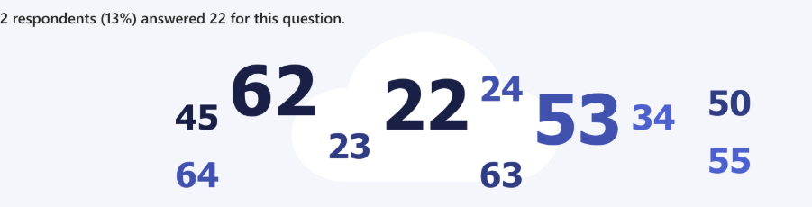
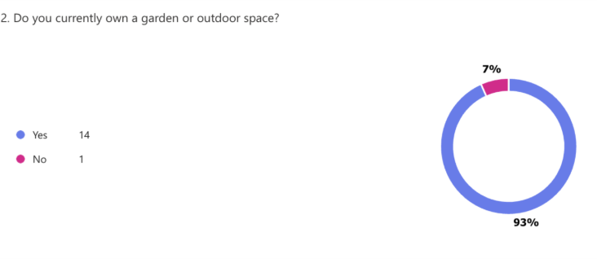
How old are you?

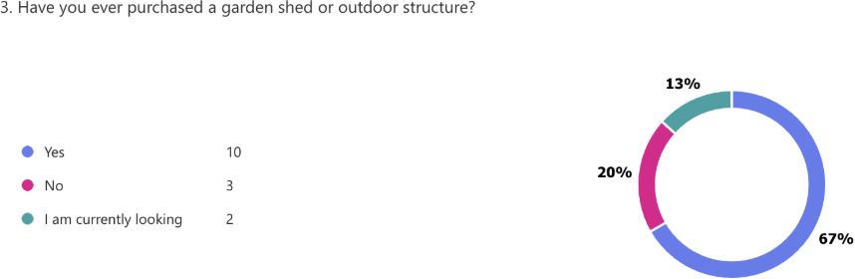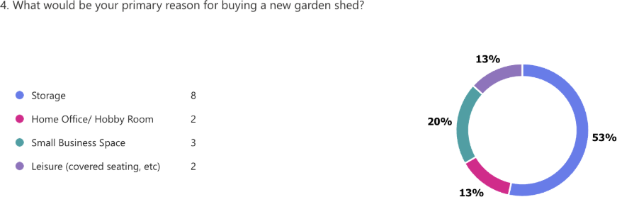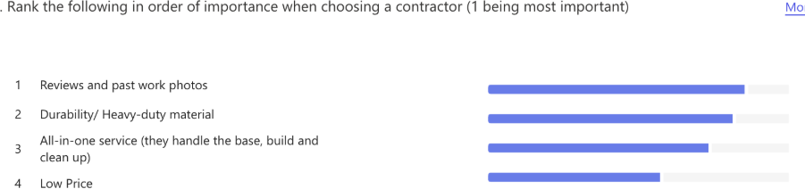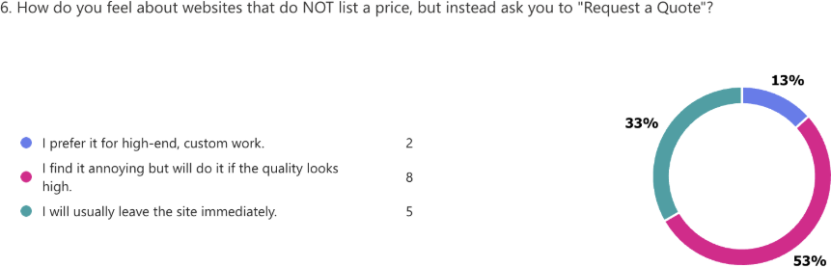

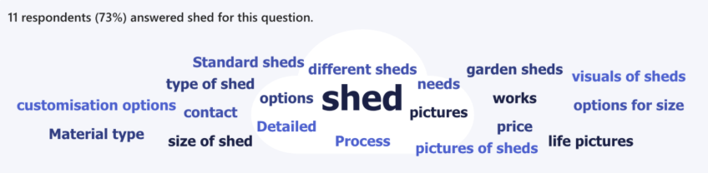
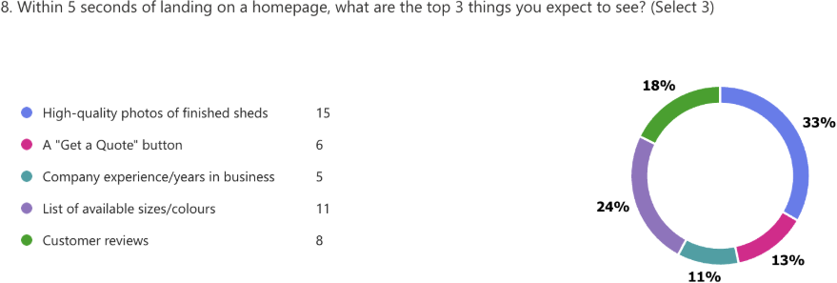
What do you think is the content for a garden shed website?
What is a feature of a garden shed website?
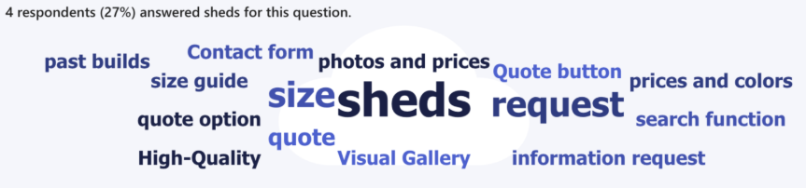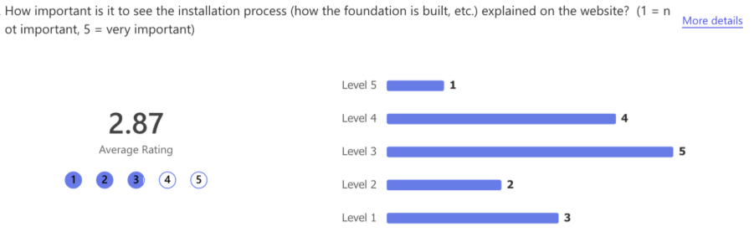

Internet Research & Conversations with Shed Owners Results
User Requirements

- There is a clear demand for "visual-first" design. This includes high-quality photos of different styles, 3D renders, and a potential "360-degree" interior view to showcase quality.
- Users expressed interest in a digital "design tool" or configurator to help customise their sheds and view them immediately online before requesting quotes.
Market Trends & Opportunities

- Consumers are increasingly viewing sheds as extensions of the home (studios or garden rooms) rather than just storage, supporting a "Modern & Premium" brand positioning.
- The Irish market has seen explosive growth in garden structures (up 7ti% since 2018), with a significant "premium" segment willing to spend over €ti,000 on garden assets.
- Sheds are the second most common garden accessory in Ireland, confirming high market demand.
- Given the high value of the investment, the website should emphasise an "all-in" service to justify the premium costs.
User Concerns (Forum Insights)

- Potential customers prioritise information regarding material quality, insulation, and long-term durability.
- While quality is essential, price remains the primary factor mentioned in consumer recommendations and discussions.

Summary of Findings

The data from the survey, online discussions, and competitor research shows that users in this market make decisions primarily based on visual quality, trust and long-term value. The survey results highlight a strong demand for high-quality photos, clear size options and visible previous work, indicating that users want to see the product before engaging with detailed information. This tells us that design decisions must prioritise a visual-ﬁrst approach with large imagery, minimal text and clear structure. I should avoid clumpered layouts or heavy technical paragraphs that could overwhelm users.
The research also reveals concerns about unreliable builders and incomplete work, meaning trust is a major factor in decision-making. Because this is a high-cost purchase, users need reassurance before making contact. This inﬂuences the decision to emphasize the “One Price,

One Person” full-service installation model and include clear credibility signals such as experience, salesmanship and process transparency. I should not design the site like a budget retailer or remove important trust-building sections such as “How I Work” or “About”.
Although price makers, the data suggests users are investing in durability and quality rather than just choosing the cheapest option. These supports using a “Request a Quote” system instead of direct online purchasing, reinforcing the premium and consultative positioning of the brand. I should avoid discount-style messaging or presenting the sheds as standard e-commerce products.

User & System Requirements
The primary users include homeowners, farmers and all types of businesses. They must be able to:
UR01: Users must be able to easily browse through the website and see the standard shed sizes.
UR02: Users must be able to view available colours and all the basic specifications. UR03: Users must clearly understand that installation is included.
UR04: Users must be able to request a quote quickly and easily.
UR05: Users must feel confident in the business's quality and credibility. UR06: Users must be able to contact Steve via email.
UR07: Users must be able to view previous work and reviews.
UR08: DIY customers must be able to browse any additional related products.

These system requirements describe what the website must technically do: SR01: The system must include a responsive design (both mobile and desktop).
SR02: The system must include a “Request a Quote” form that showcases a customer’s interest and provides a way to contact Steve (by email) for other concerns.
SR03: The system must allow clear navigation between all pages, e.g. Home, Sheds, DIY & Extras, About, and Request a Quote.
SR04: The system must allow image galleries to display previous high-quality shed images. SR05: The system must allow easy access to future content updates.
SR06: The system can be hosted under the domain stevesheds.ie.
SR07: The system must load quickly and display properly across major browsers.
SR08: The system must provide clear error feedback on the Request a Quote form to prevent user frustration.

Assumptions
Things I assume to be true:

- Steve will provide written content for the website.
- Steve will provide or approve final imagery before launch.
- I assume users prefer an initial email-based 'Request a Quote' over a phone call to allow for price contemplation.
- Pricing will not be displayed publicly.
- Only three standard shed sizes will be showcased initially.
- An online payment system can be developed, but not initially integrated
- The business operates within Ireland only.

Issues and Risks
Risk: No Existing Photos or Reviews
There are currently no real photos of the installed shed. Lack of visual credibility at launch. Mitigation: Could use 3D renders, staged mock-ups, early installation photography, stock photos, and placeholders.

Risk: Premium Pricing Without Displaying Prices
Customers will likely hesitate if no pricing guidance is provided.
Mitigation: Emphasise the value, process transparency, and strong trust signals.

Risk: Scope Creep
Steve may request some additional features during development, as it’s a new business. Mitigation: Clearly define agreed features before development.

Risk: Limited Social Media Presence No existing social proof.
Mitigation: Focus on testimonials from his other business and credibility messaging.

Risk: DIY Section Expanding
DIY products may grow beyond the initial plan. Mitigation: Design a scalable product category layout.

Risk: 3D render tools may have high load times on mobile devices, impacting the 'Aesthetic and Minimalist' heuristic.
Mitigation: Optimise assets and use lazy loading to improve performance.

Lessons learned from 01
Our research, including a survey, competitor benchmarking, heuristic evaluations and internet research, revealed four critical pillars that must be considered when designing the Steve’s Sheds website.

The "Total Solution" vs. The "Half-Job" Gap

Our forum research on Boards.ie and AskAboutMoney highlighted a recurring frustration. Customers are often left to deal with half the job, foundation digging and site clean-up. I have moved away from a simple product catalogue. The website must explicitly market the “One Price, One Person” value proposition. The Wireframes include a dedicated “How I Work” section that validates the customer’s need for a stress-free, end-to-end service.

Trust as a Primary Conversion Metric

During the Heuristic Evaluation, I discovered that key competitors (e.g., Shanette) triggered browser security warnings. my user scenarios (e.g., "Mary, age 62") showed that older, premium-focused demographics will immediately abandon a site if they feel their data is at risk. To justify being "the dearest" on the market, the website architecture must prioritise professionalism over volume. I learned that SSL certification, high-resolution 3D renders, to compensate for a lack of physical portfolio, and a minimalist aesthetic are non-negotiable for building immediate brand authority.

Information Overload vs. The Scrolling Behaviour

Our surveys and "future homeowner" analysis revealed that users prefer scrolling through high-quality visual content rather than reading dense technical jargon. Current market leaders like Steeltech were found to have cluttered interfaces that caused cognitive overload. The wireframes adopt a "Mobile-First, Minimalist Advantage" approach. I intentionally reduced the amount of text on the homepage and replaced "Add to Cart" with a "Request a Quote" redirect. This accommodates the high-touch, consultative nature of a premium purchase while preventing "price-scaring" before the value of the service is understood.

The "Consultant" Role in UX

Forum analysis found that users are often confused about technical requirements such as insulation or planning permission. The next iteration of wireframes will include educational touchpoints. Instead of a static FAQ, the user journey is designed to guide the user through these decisions (e.g., "Do I need insulation?"), positioning Steve not just as a builder, but as an expert consultant.

Personas
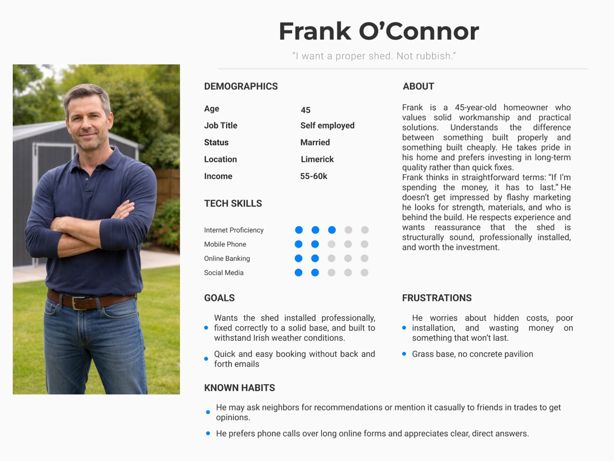
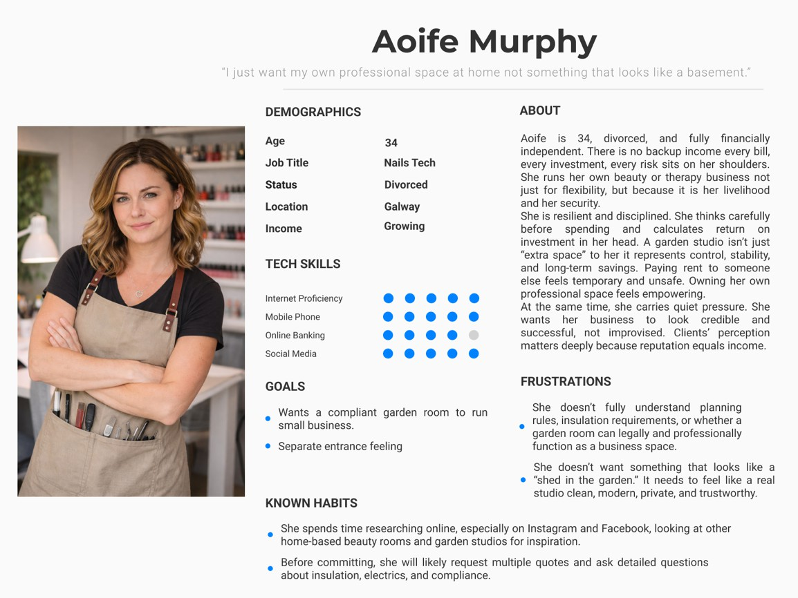

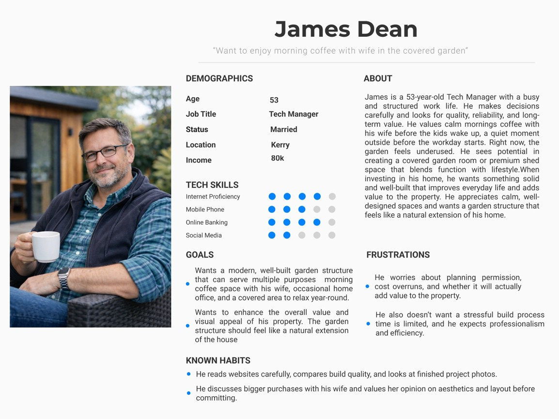

User Scenarios
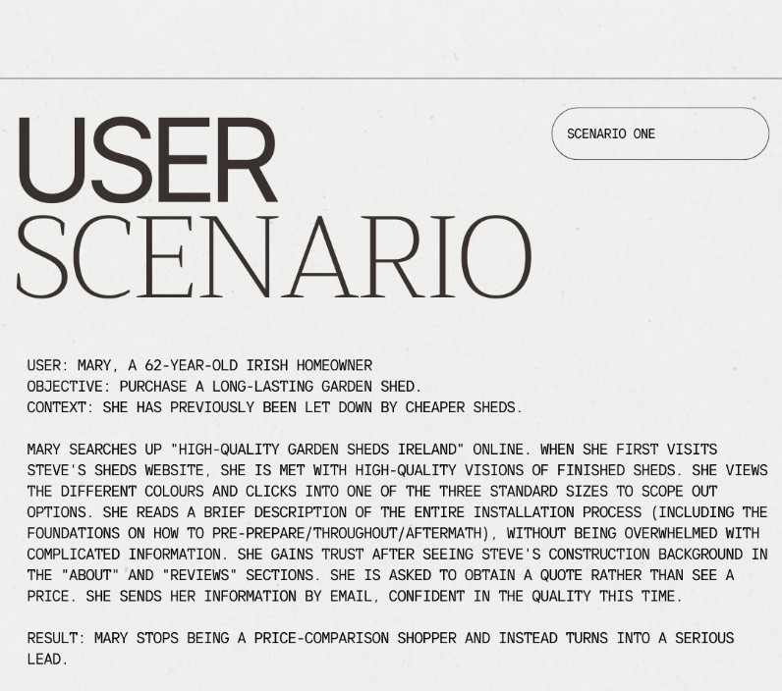

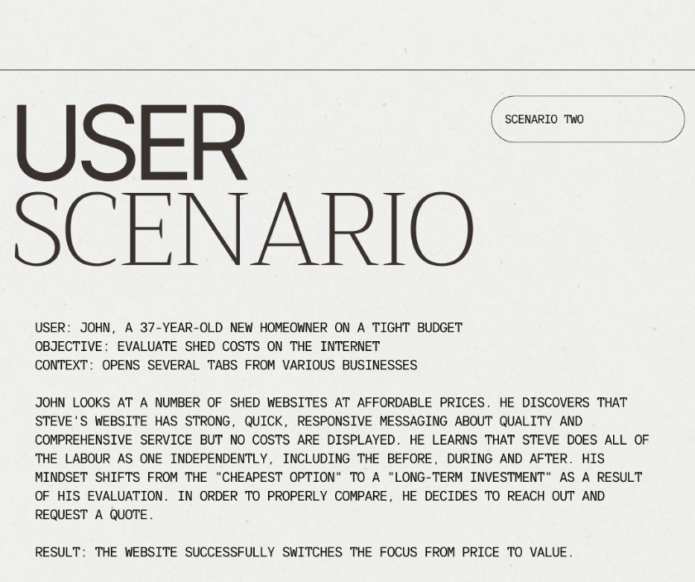
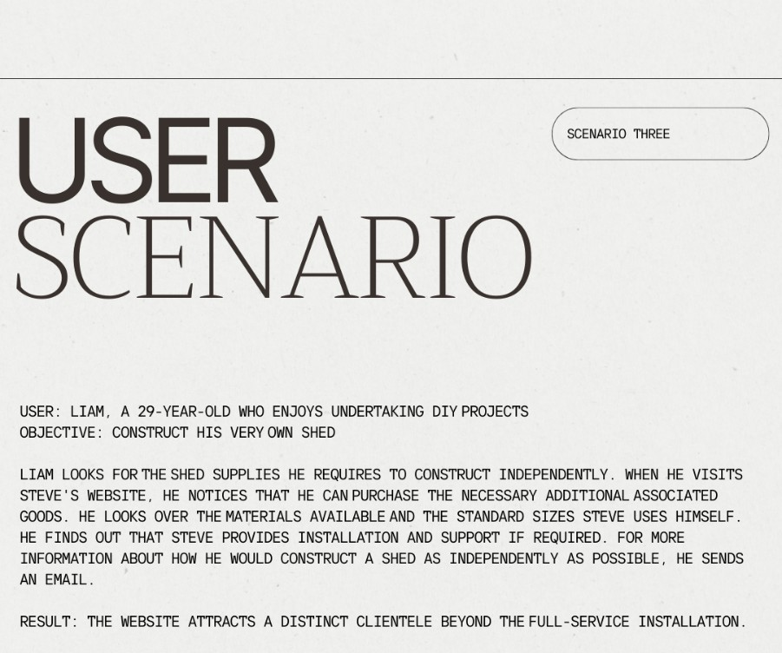

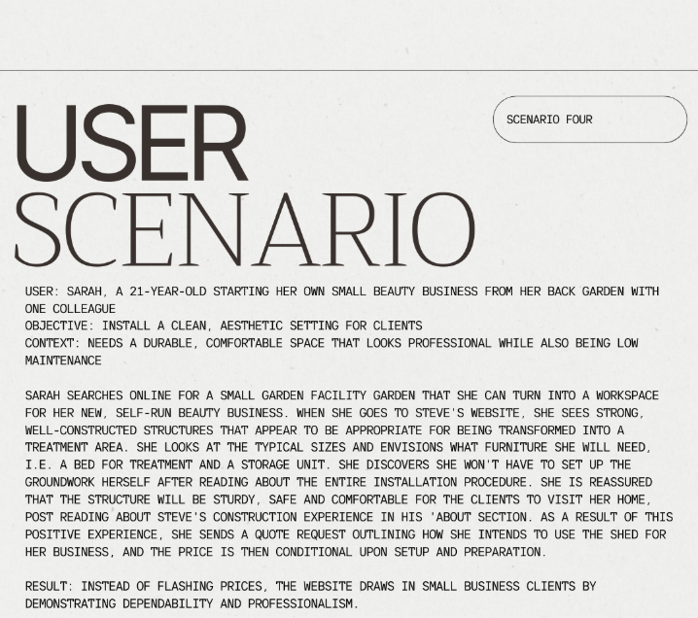
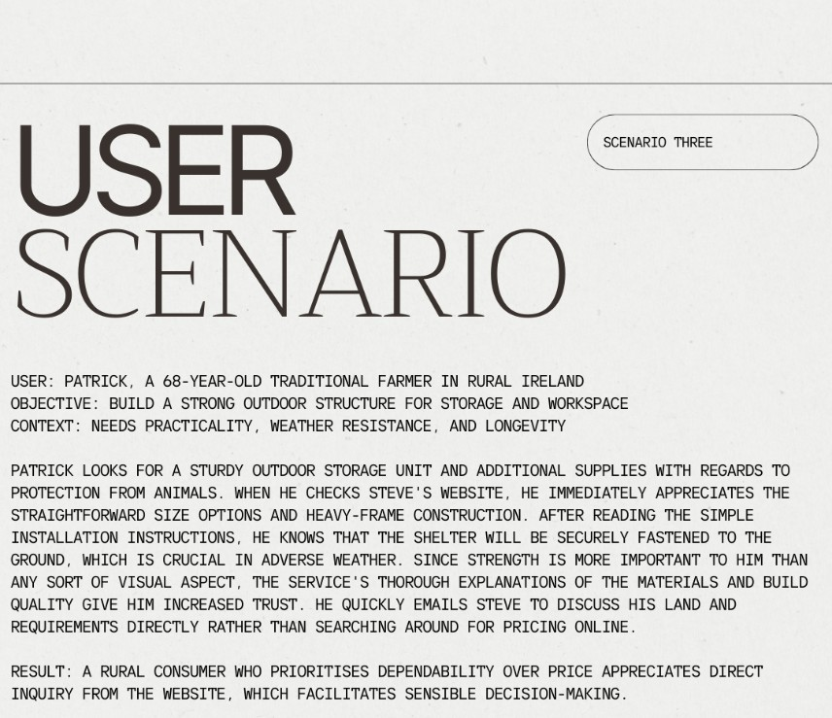
FIVE

Customer Journey Maps

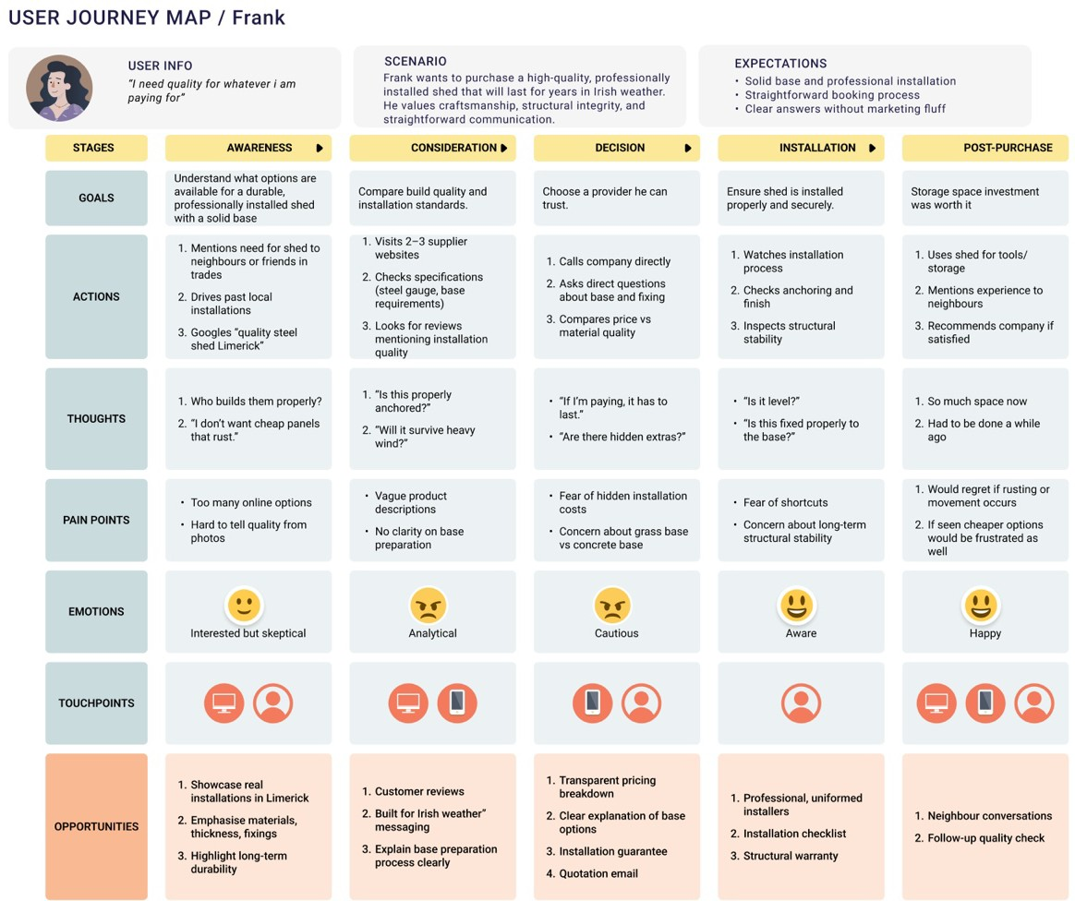

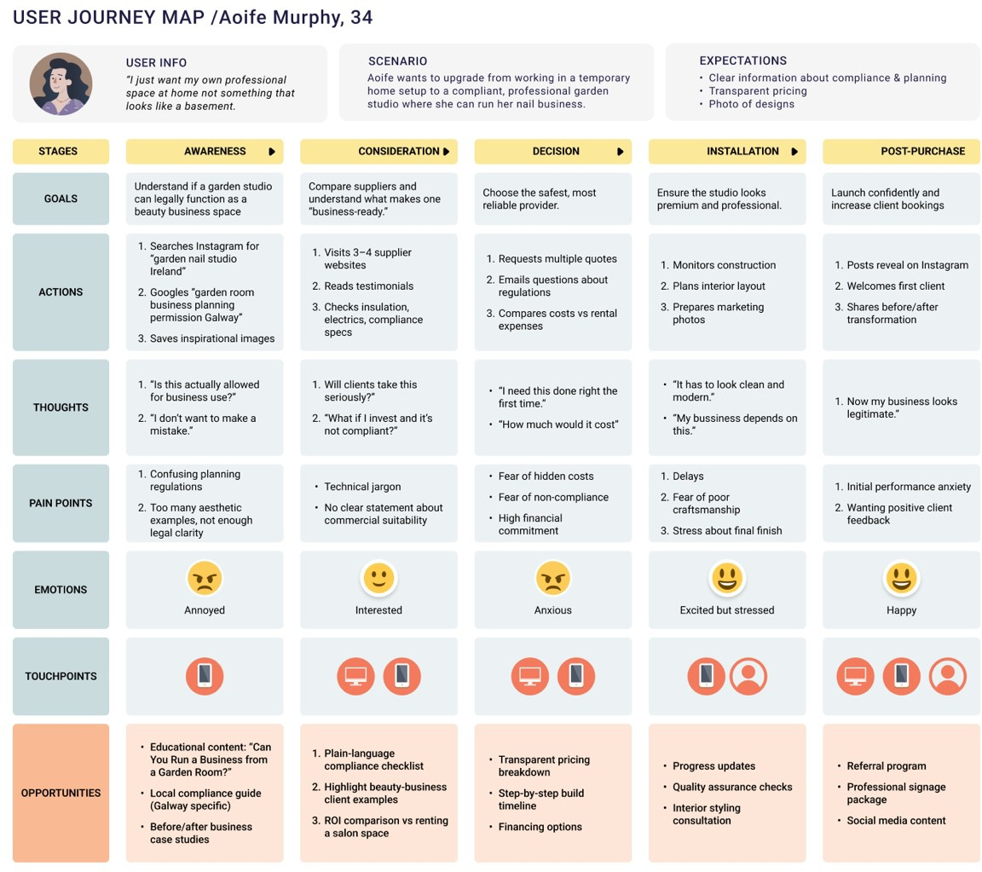
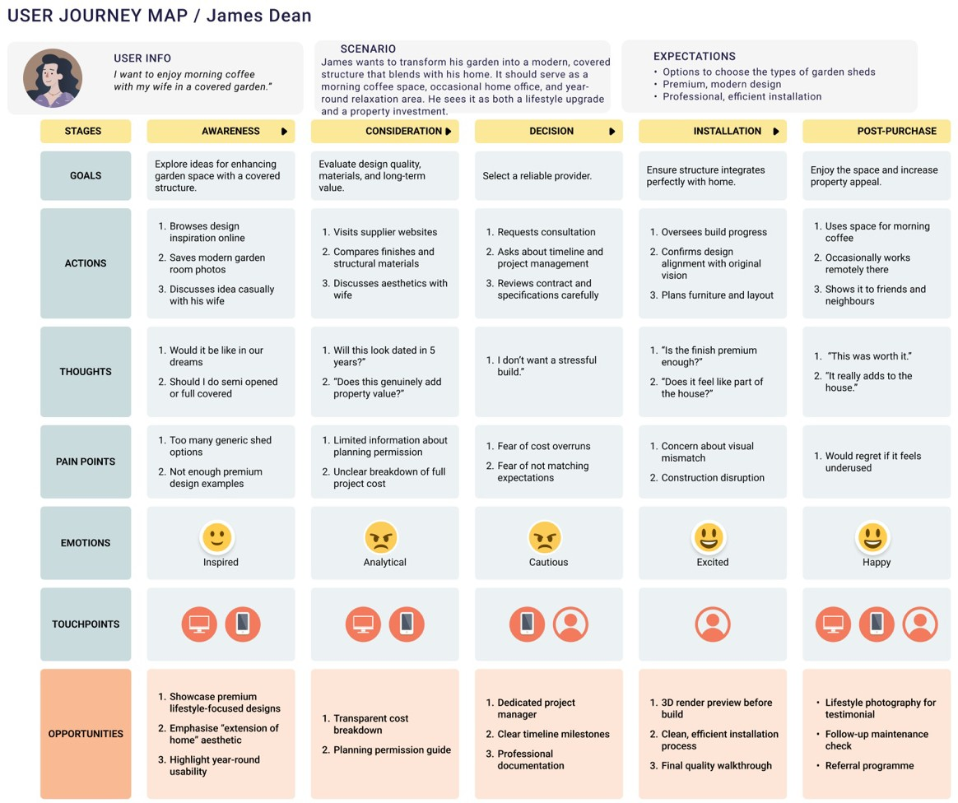

Storyboard
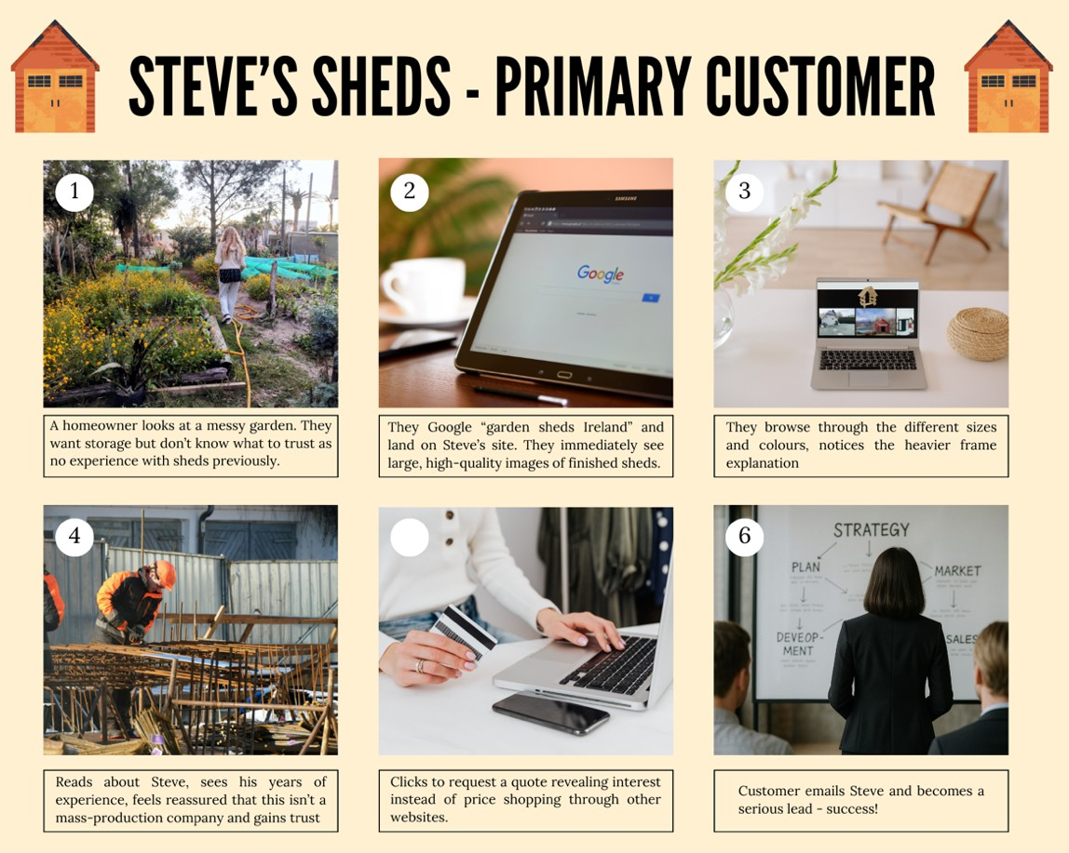
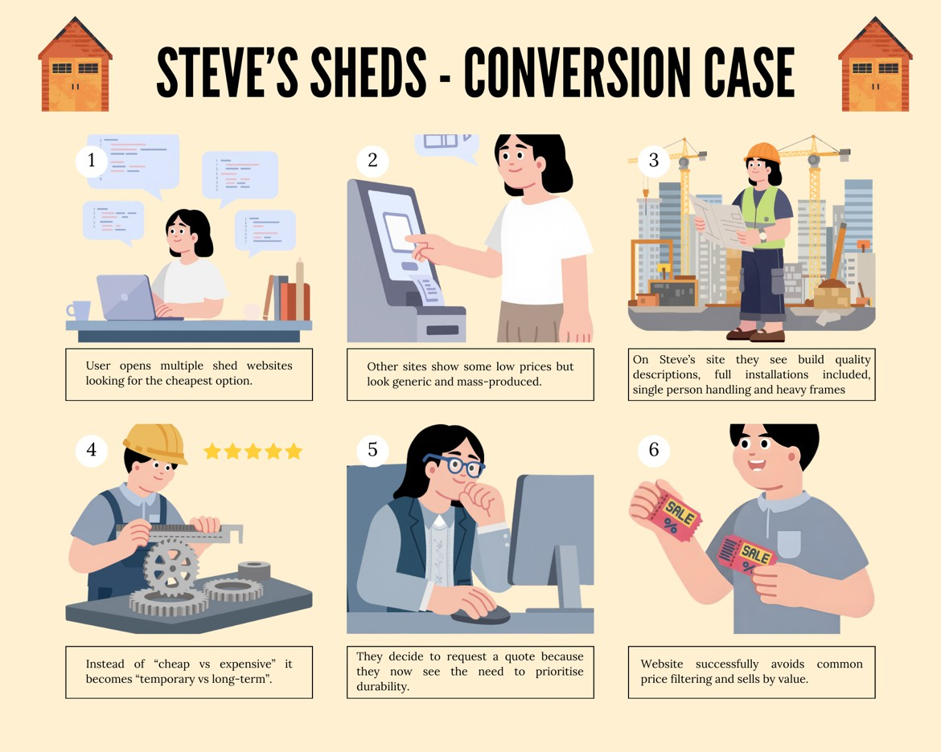

User Flows

02
Known-Item Seeking (Eﬃciency Focus)
Goal: Find a specific standard product and initiate contact.

- Entry: User arrives on the Homepage via direct search.
- Navigation: User identifies the "Sheds" link in the header immediately (avoiding the "clutter" found in competitors like Steeltech).
- Selection: User sees the Standard Sizes section immediately and selects "Small Shed."
- Conversion: User scans the Icon-based Specs (size/material) on the product page.
- Action: Clicks "Request a Quote" to start the professional dialogue, bypassing the search for a non-existent price tag.
Exploratory Seeking (Inspiration & Trust Focus)
Goal: Browsing to see if this premium brand fits their vague "garden room" idea.

- Entry: User lands on the Homepage.
- Engagement: User follows the "Scroll & Catch" strategy, stopping at the high-quality pictures.
- Discovery: User clicks on the Benefits to understand what makes Steve "the dearest" (discovering the foundations/cleanup service).
- Cross-Sell: User navigates to "DIY & Extras" to see maintenance products, validating Steve's expertise.
- Action: Having built trust through the "About Steve" section, the user navigates back to the header to click the floating "Request a Quote" button.
Exhaustive Research (Comparison & Technical Focus)
Goal: Comparing Steve’s "Total Solution" against half-job competitors and finding as much information as possible before the purchase.
- Entry: User arrives on the Homepage.
- Deep Dive: User immediately looks for the "Benefits" or "Credibility" section to find technical details on groundworks.
- Technical Validation: User checks the "Mould Prevention" specs to compare build quality against cheaper alternatives.
- Verification: User reads the Heritage/About section to verify Steve's 1ti+ years of construction background.
- Action: Convinced that the "One Price" model saves them from hiring a separate groundworks contractor, they complete the Inquiry Form.

Re-ﬁnding (Direct Action Focus)
Goal: A returning user who has already decided and needs to contact Steve.

- Entry: User returns to stevessheds.ie.
- Direct Path: User ignores the gallery and goes straight to the Header Navigation.
- Target: User clicks the "Contact" or "Request a Quote" link.
- Final Action: Submits the form with specific details previously considered.

Urgent Problem Solving (Mould Expert)
Goal: A current shed owner with an active mould problem seeks an urgent solution and discovers Steve as the expert.
- Entry: User arrives via organic search ("mould in shed Ireland") test conﬁrms "Shed Cleaning Supplies" is ﬁndable at 100% success, but only 71% directness, meaning some hesitation in the path.
- Guide discovery: User browses to ﬁnd mould remover, the 29% who weren't directly likely passed through a competing section ﬁrst; the Guide label needs to intercept them earlier.
- Expert validation: User reads Steve's mould prevention content, the 100% success on "Years of Experience" conﬁrms that once users reach About/credentials, they ﬁnd it immediately and without doubt.
- Product cross-sell: User locates "Shed Cleaning Supplies" to purchase a treatment 100% success validates this node is well-labelled; the indirect paths suggest users arrive via DIY & Extras rather than a direct Guide link.
- Action: Reassured by Steve's credentials and having found a product, the user clicks "Request a Quote".
Legal Research (Planning Permission)
Goal: A pre-purchase user needs to conﬁrm they are legally permimed to build before contacting Steve.
- Entry: User arrives via search ("do I need planning permission for a shed in Ireland"). No direct test task covered this, conﬁrming it is an untested gap in the current IA.
- Guide navigation: User looks for legal or help content. The path diagram shows users routed through "Help" and "FAQs" when looking for non-product information, suggesting that planning content would be found there, but indirectly.
- Rule research: User reads exemption thresholds and size criteria. The 43% directness on Steel Frame Speciﬁcations shows that technical/detailed content is harder to navigate directly; planning rules would likely face the same friction.

- Decision point: User determines whether their build is exempt or requires a council application. This fork has no current home in the IA and represents the clearest content gap identiﬁed by the test.
- Trust-building: Exempt users move straight to a quote; unsure users need Steve positioned as an advisor. The 100% result on "Years of Experience" conﬁrms that once users reach Steve's credentials, trust is immediate.
- Action: Exempt users click "Request a Quote Form" (86% success); unsure users book a consultation. The 14% who went to "Contact Form" instead of the quote form suggests both paths need clearer label distinctions.
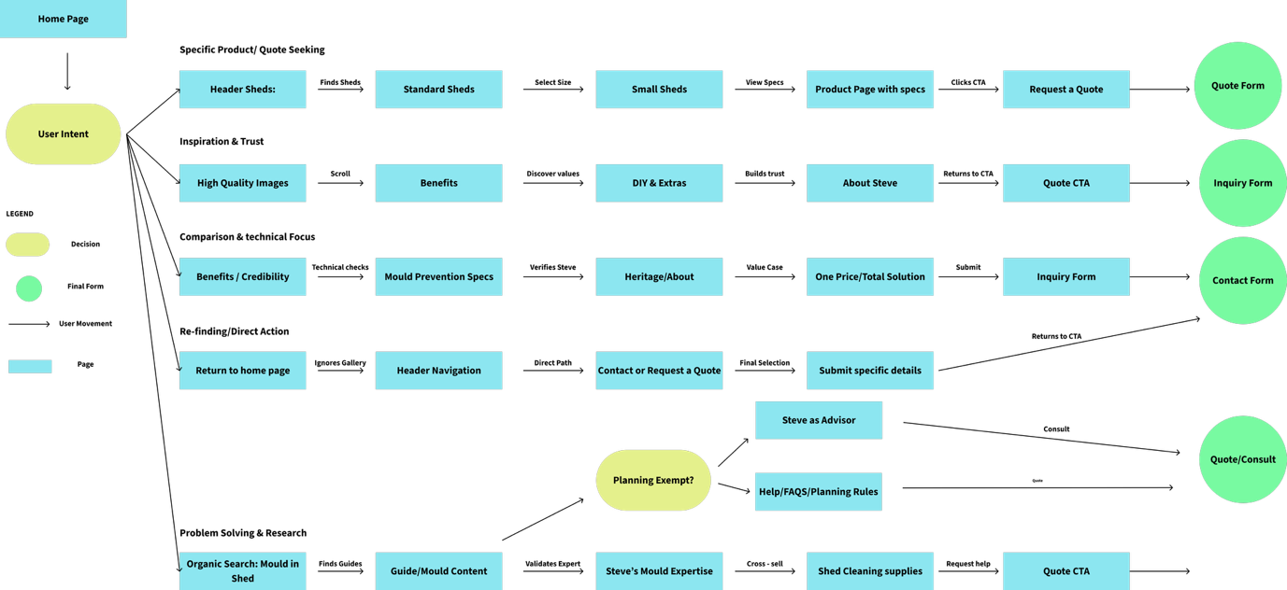
Figure 1 - Visualisa.on of User Flows

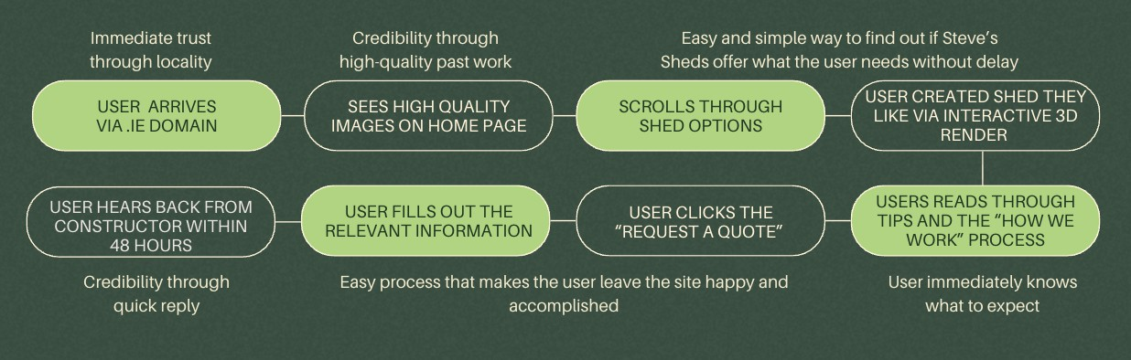

Figure 2 - Additional User Flow

Site Flow

01
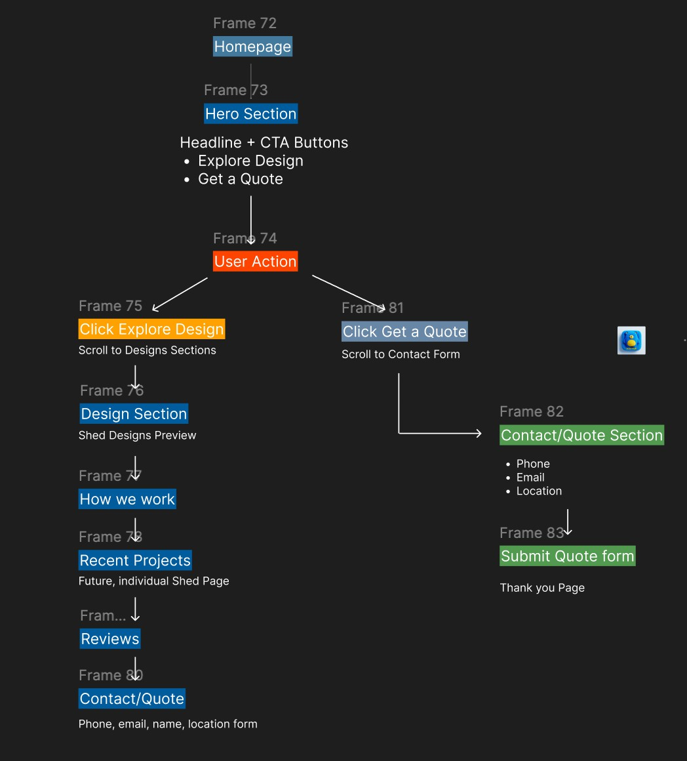

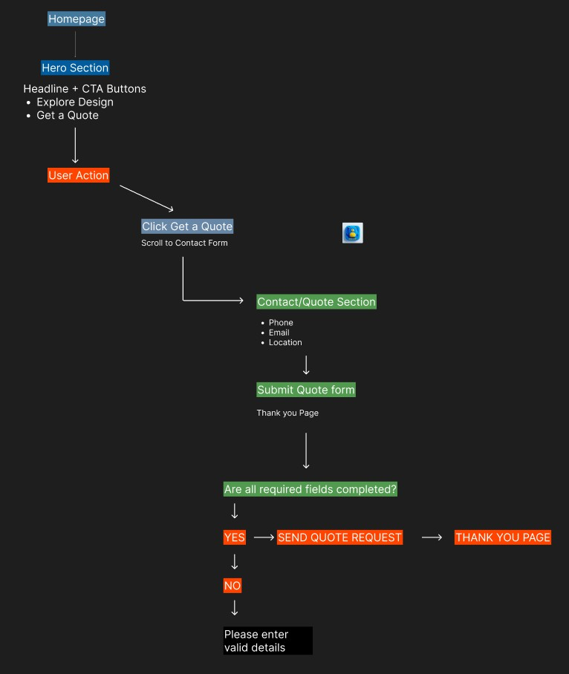
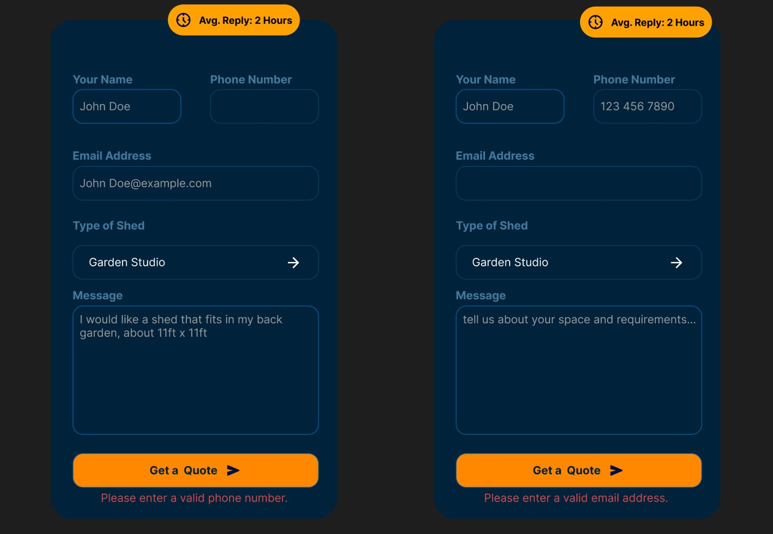

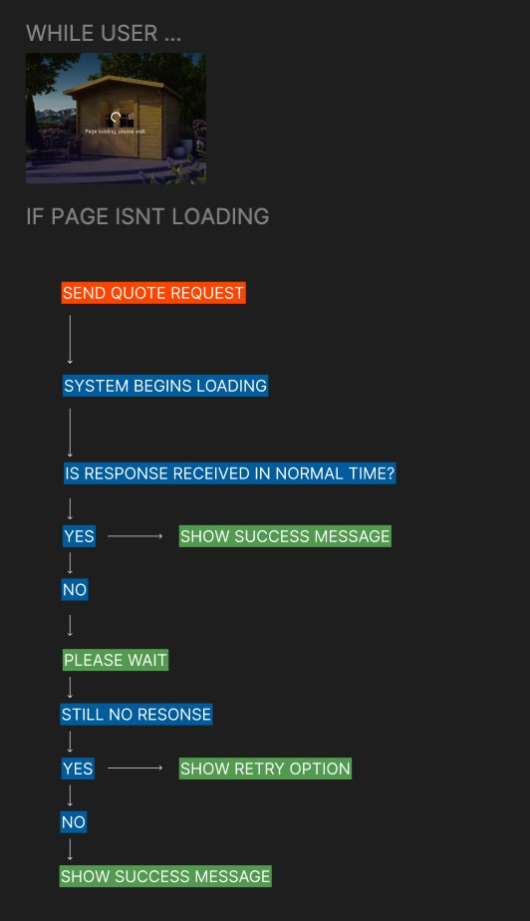

02
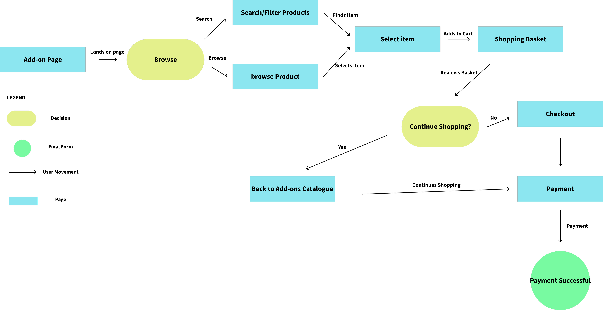

Figure 3 - Site Flow: Add-Ons Purchase Journey
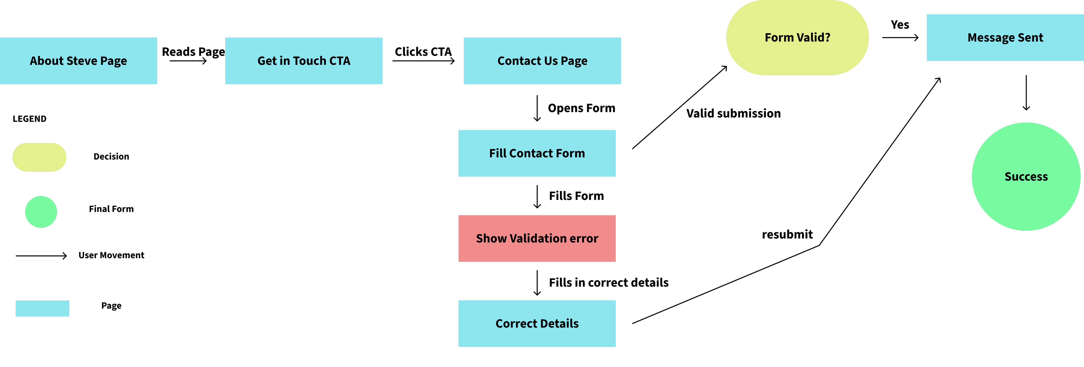
Figure 4 - Site Flow: Contact & Enquiry Journey
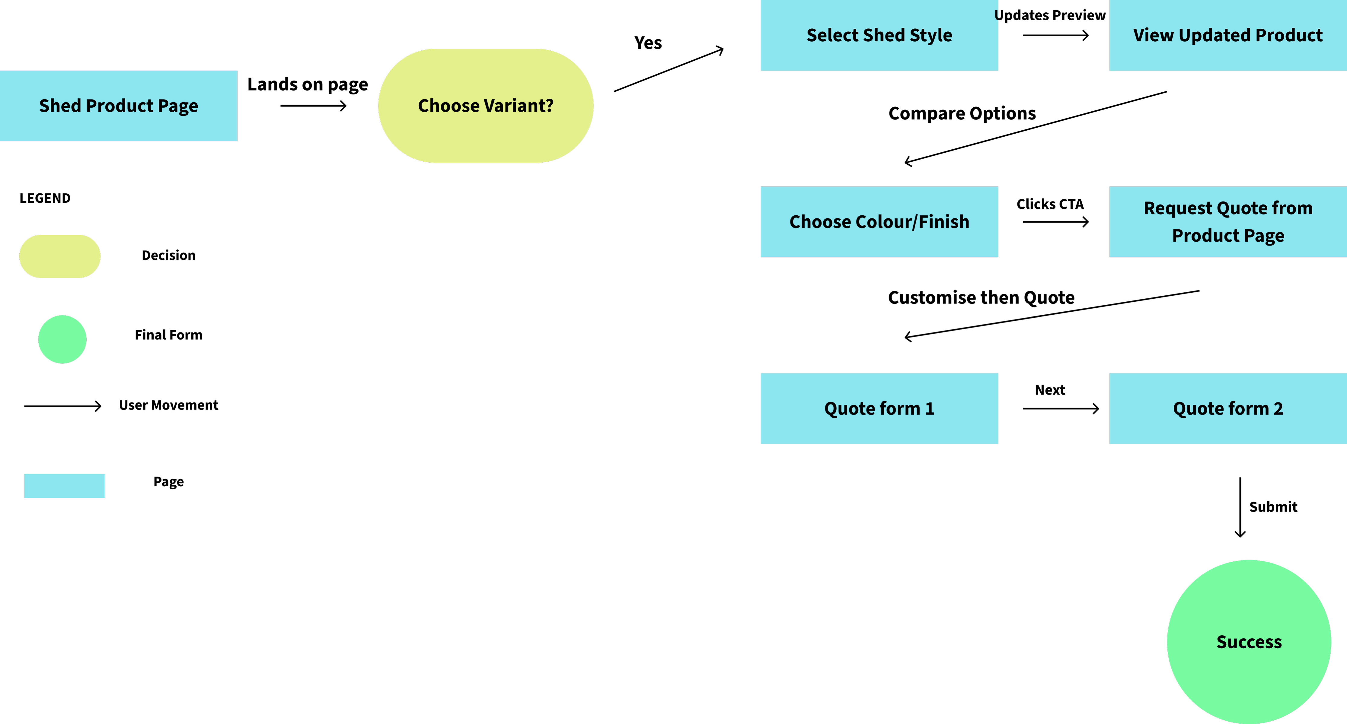

Figure 5: Site Flow: Shed Conﬁgure & Quote Request

Wireframes

01

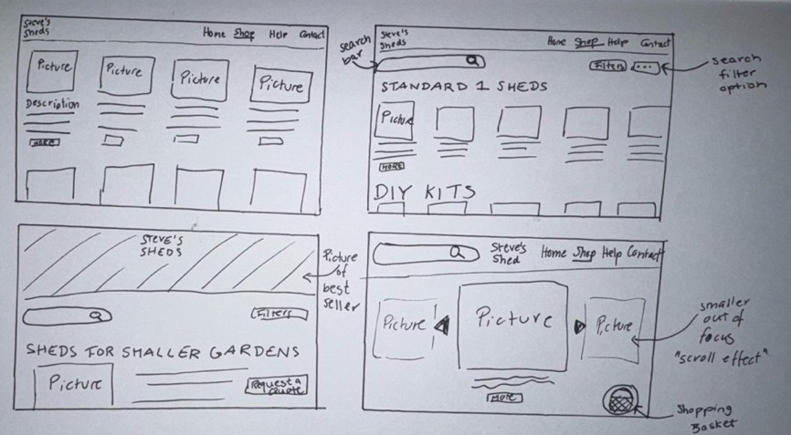
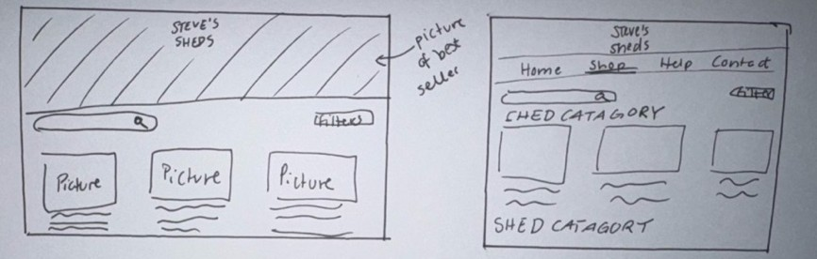
Sketches of six versions of Steve’s Sheds Shop Page:

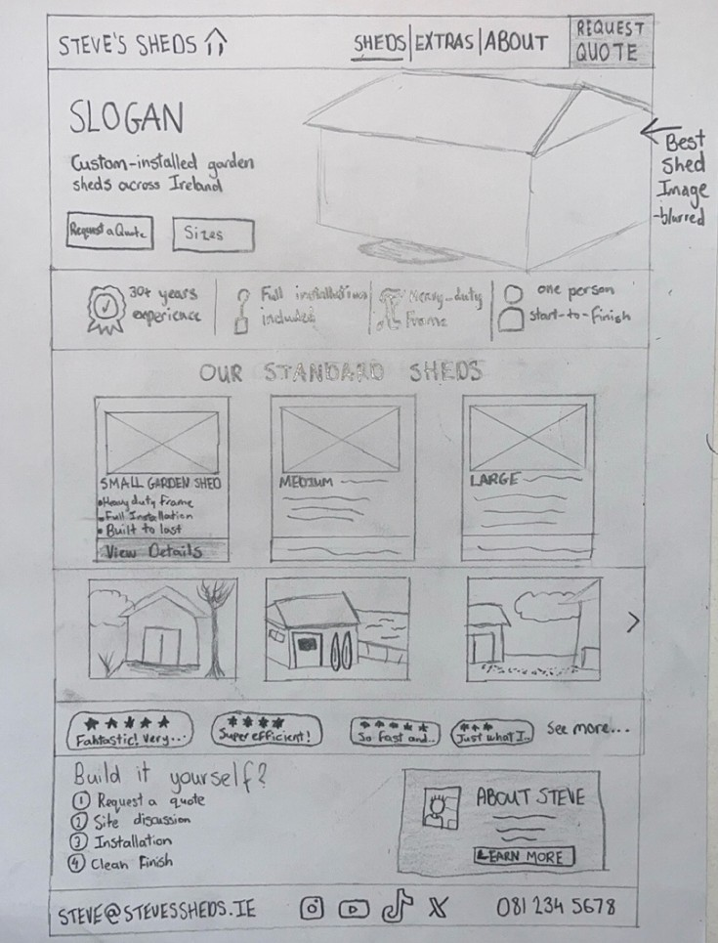
Sketch of the best features/designs of the previous six versions into one page:

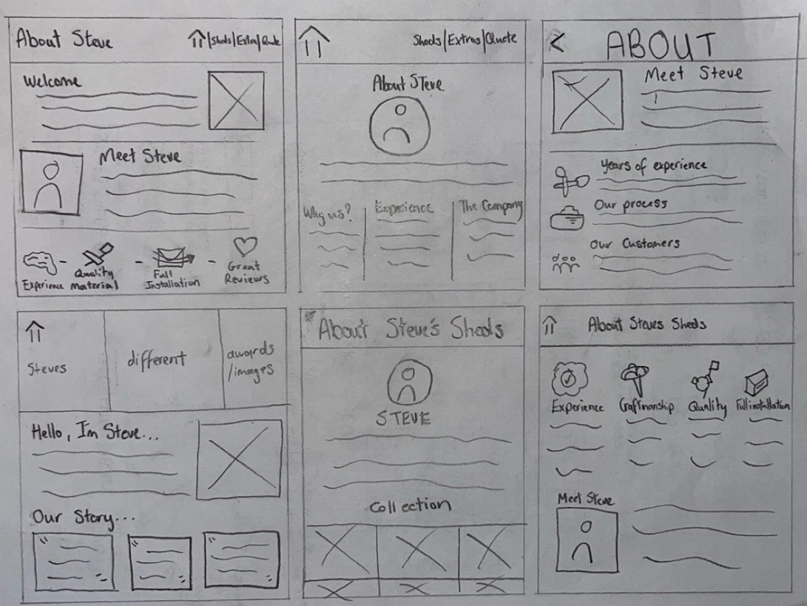
Wireframe sketches of six versions of Steve’s Sheds About Page:

Wireframe sketch of the best features/designs of the previous six versions into one About page:
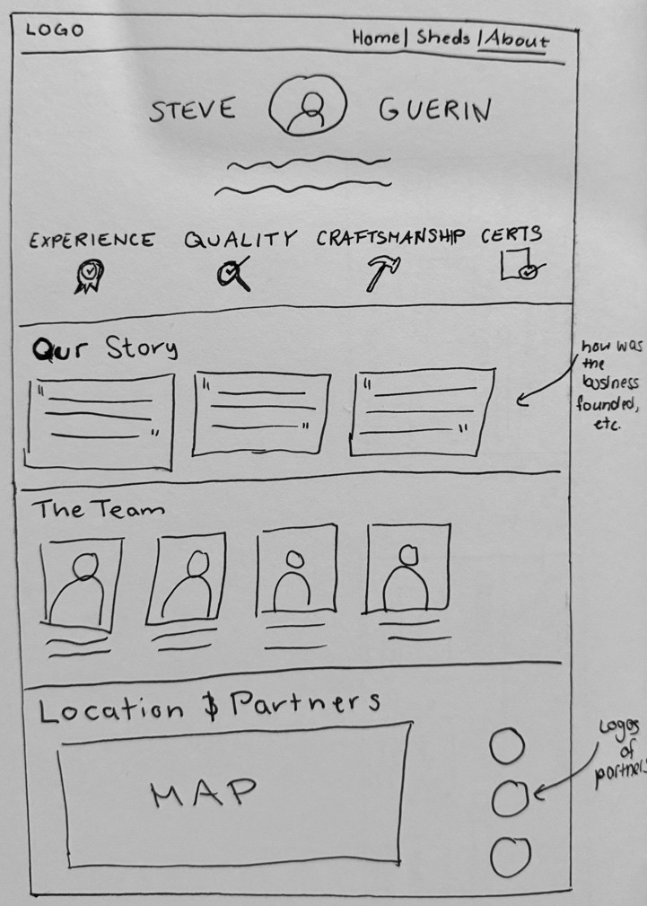

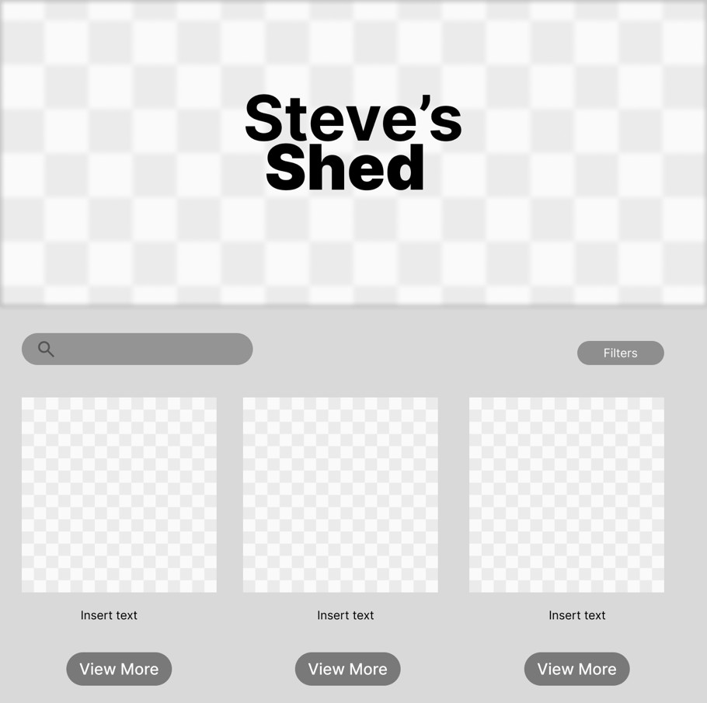
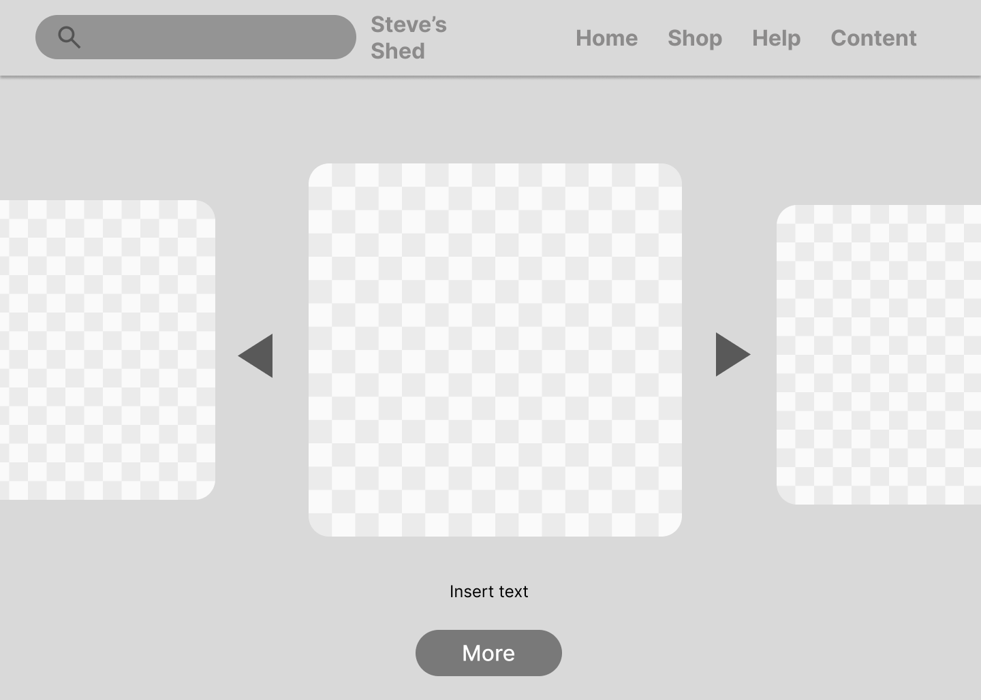

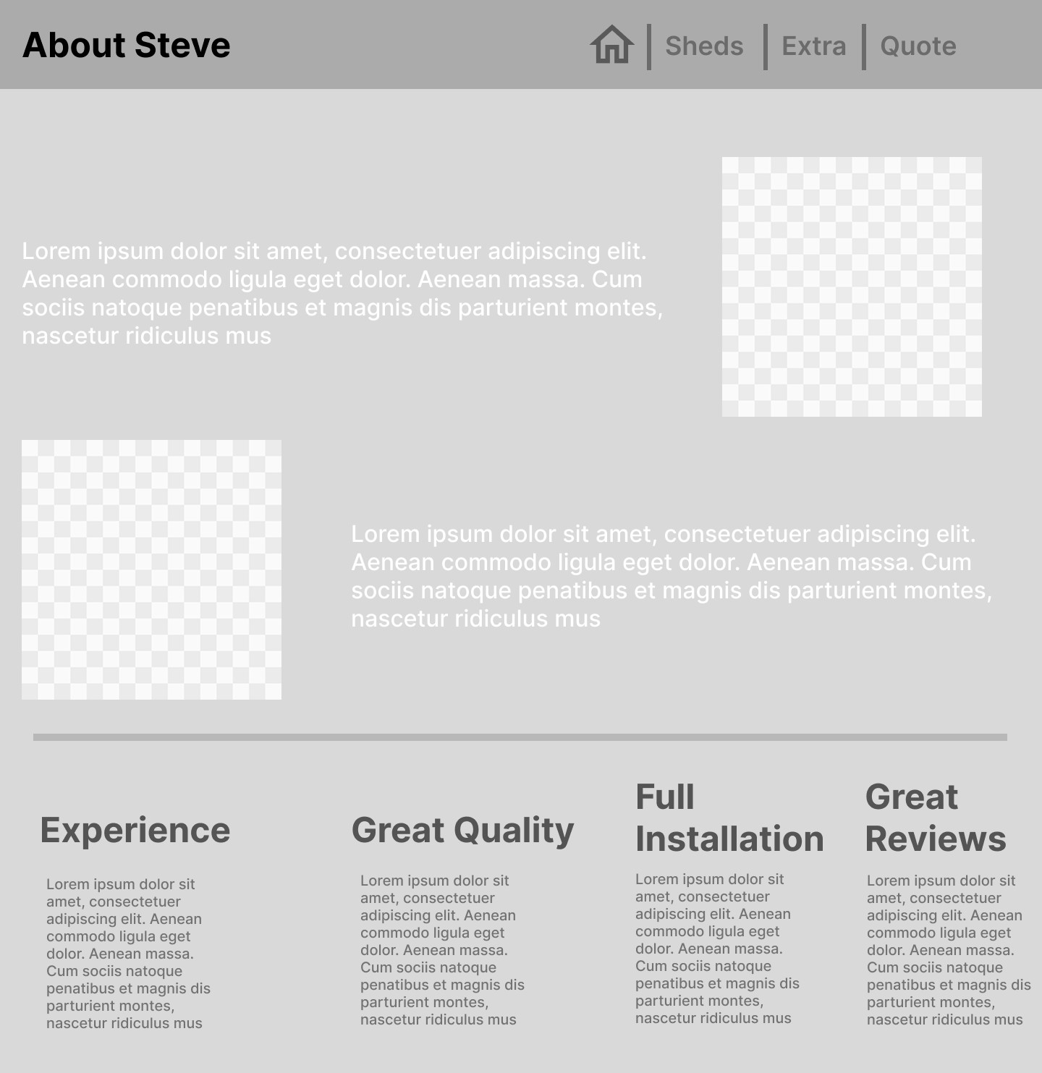
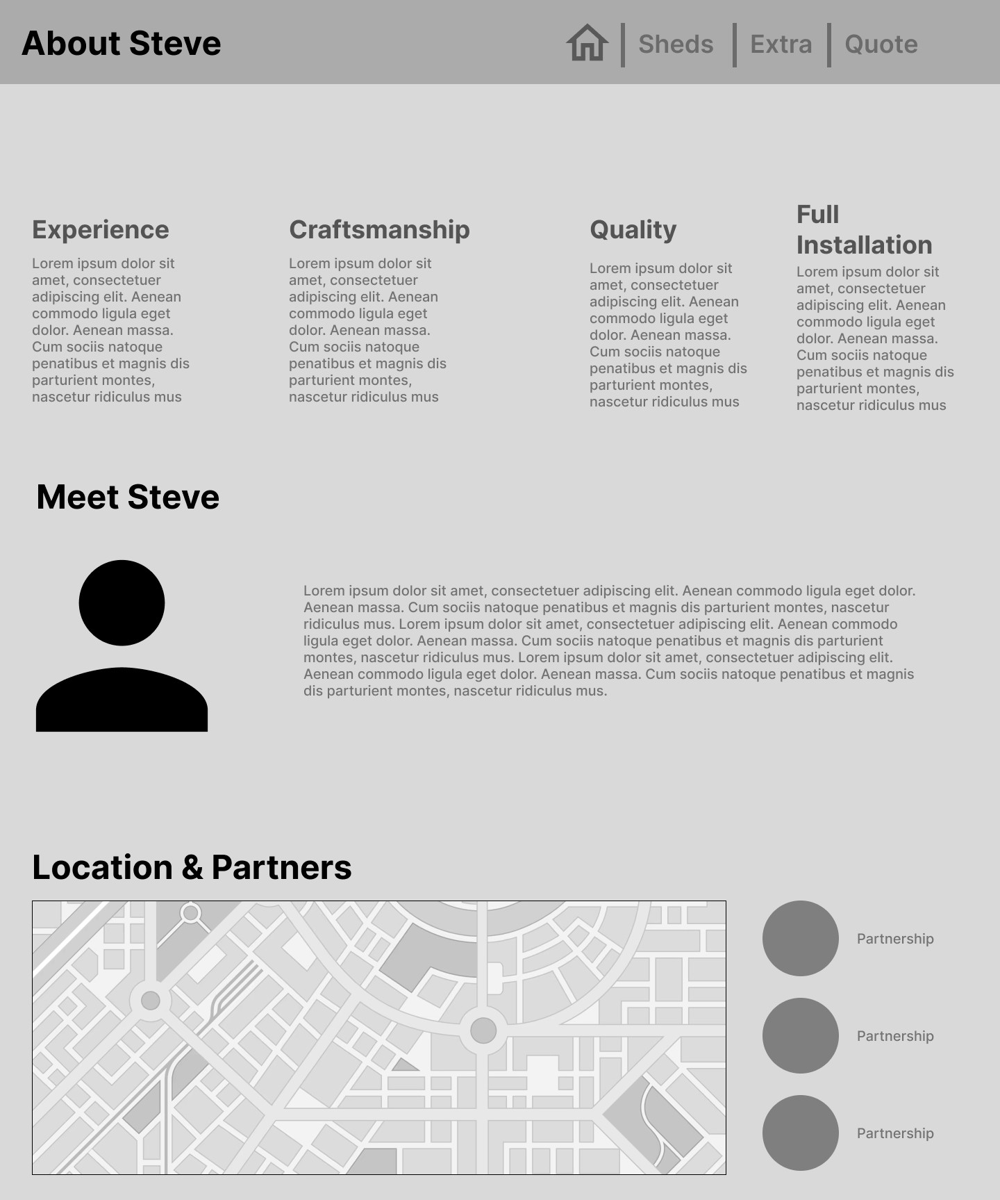

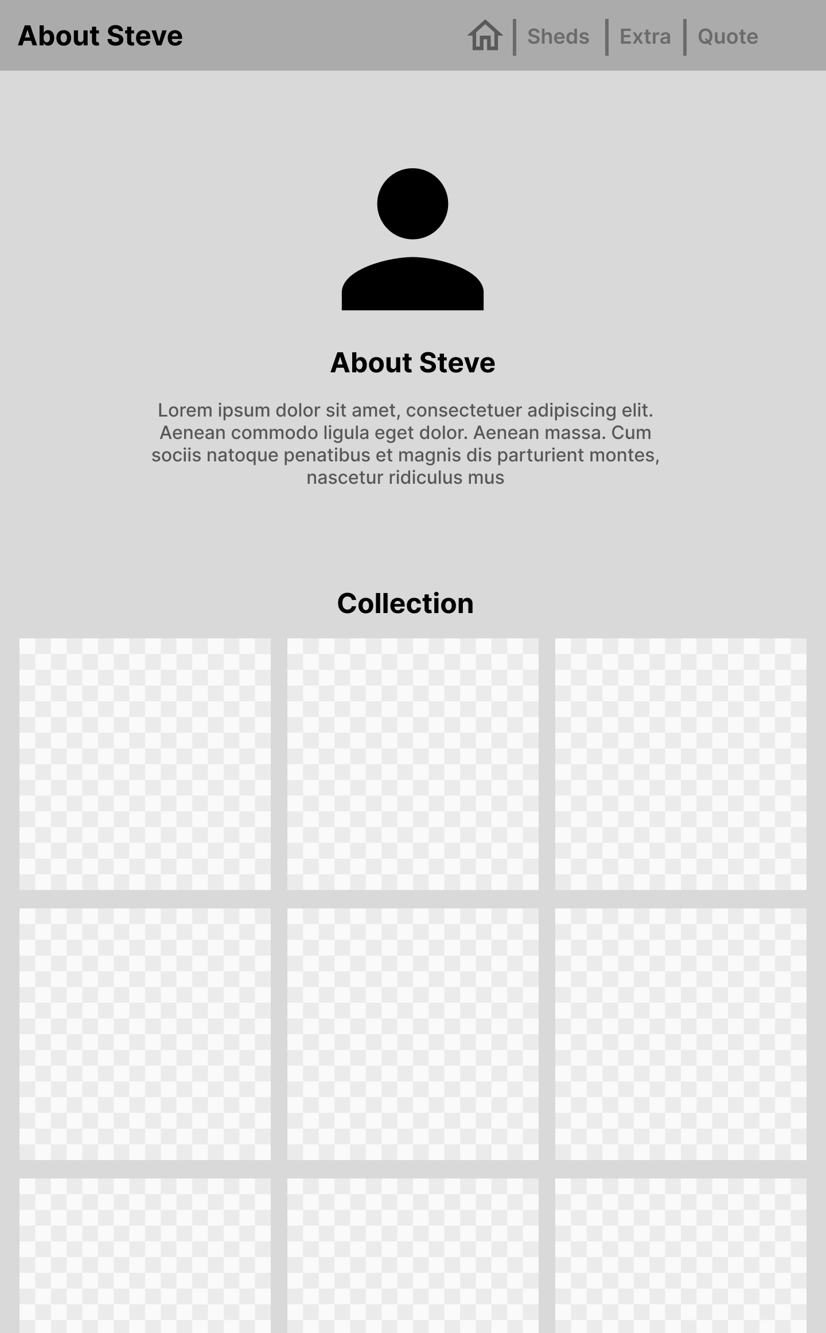

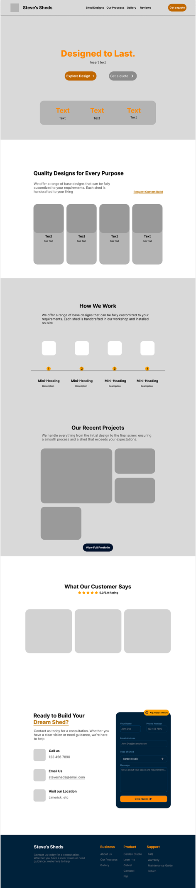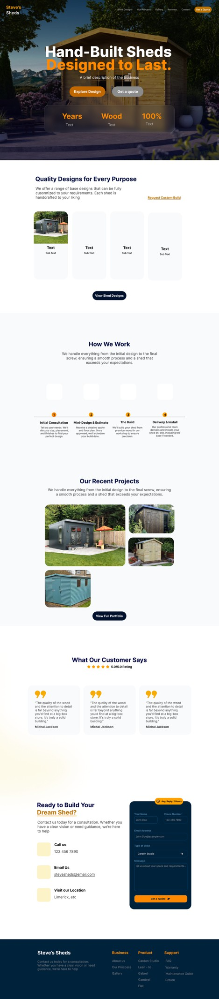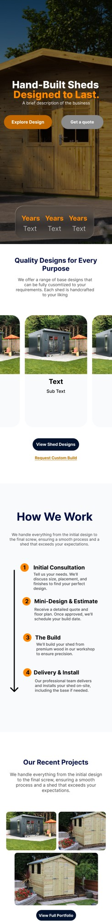

02

Paper Wireframes
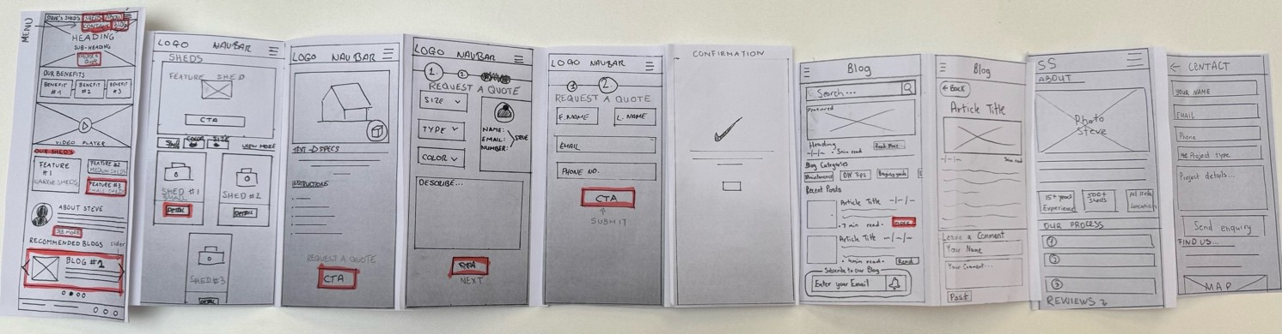
Figure 6: Final Paper Wireframes for Mobile

I began the design process by creating multiple paper sketches for each key screen, such as the Home, About, Blog, and Shed pages. I experimented with a range of layouts and structures rather than selling on one early on. This gave us the opportunity to test several variations for each screen to determine which designs seemed the most intuitive and user-friendly. I then moved forward by creating a single, polished low-ﬁdelity wireframe for each screen. I combined the best features from each of the initial ideas. I were able to transition from free-form concepts to more organised layouts while maintaining some ﬂexibility.
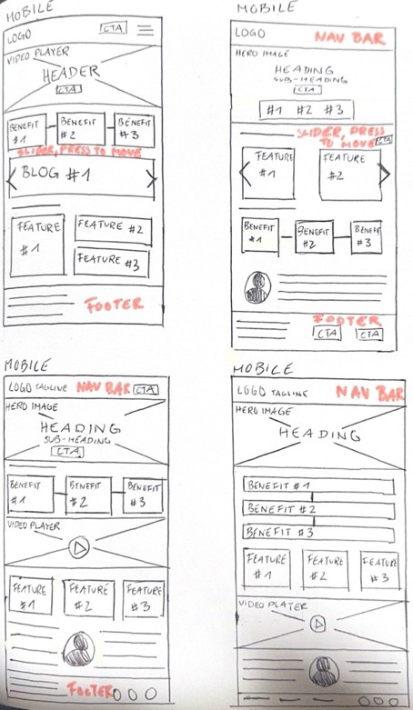
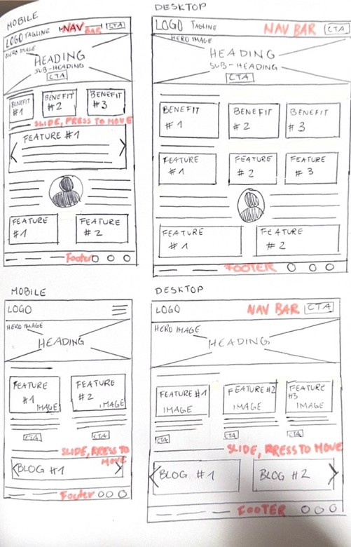
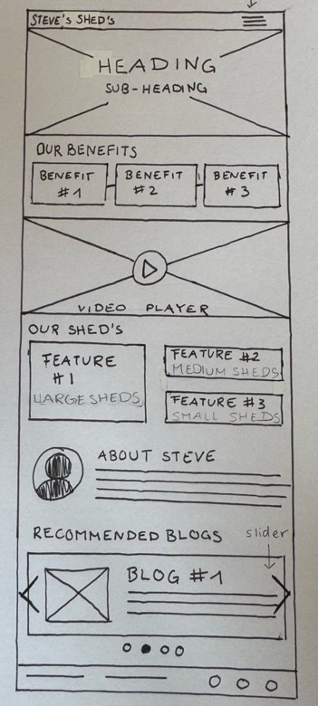
Figure 7 - Sketches for the Home Page Figure 8 - Sketches for the Home Page Figure 9 - Final Home Page Sketch

I deliberately went with common design patterns to optimise usability throughout this process. For example, I displayed the sheds and add-ons using card-based layouts, which minimises cognitive load and makes it as easy as possible for users to evaluate their choices quickly. This is done by grouping relevant information (such as pictures, titles, and actions)

into distinct units (GoodUI – "Make it Easy to Compare Options"). As a way to make browsing straighforward, I also added a standard ﬁlter sidebar to the sheds page. This allows users to narrow down their options based on attributes such as size, colour, and material, encouraging better decision-making and aligning with the GoodUI principle of simplifying choices for users ("Use Filters to Reduce Choice Overload"). Additionally, I made sure that the most important sections like Sheds, Guides, and Contact were always visible and predictable by using a simple top navigation bar to ensure consistency across all pages. This way, users can become familiar with the site and reduce the eﬀort required to navigate through it (GoodUI – "Make Navigation Obvious").
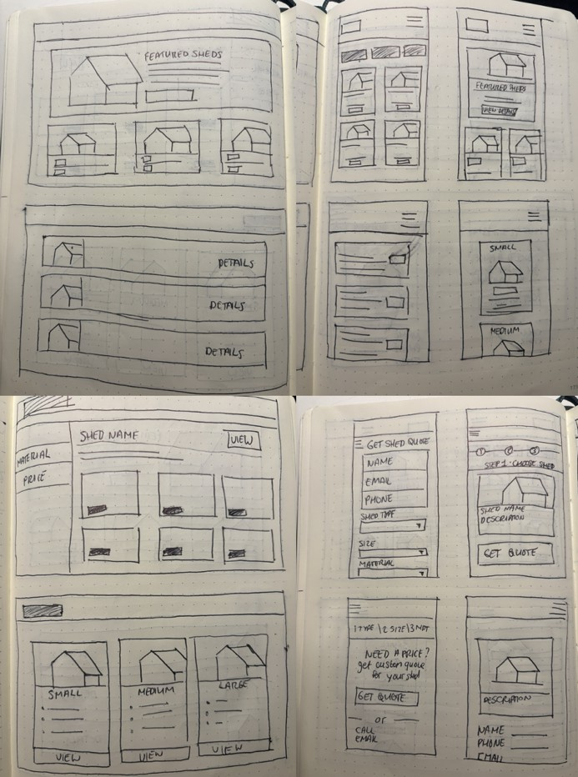
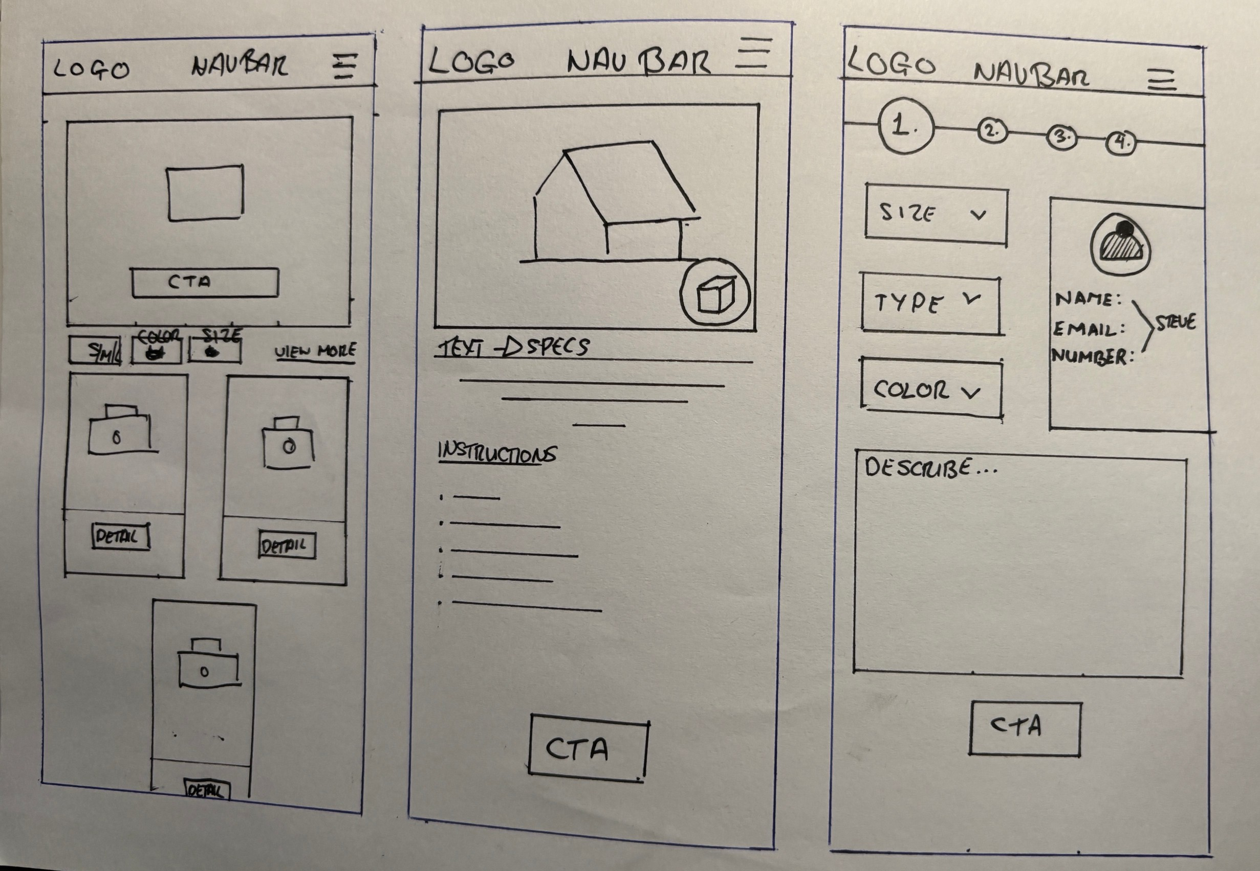
Figure 10 - Shed Page Sketches Figure 11 - Final Shed Page Sketch

I maintained focus mainly on structure, hierarchy, and user ﬂow, without going too sidetracked by visual styling, using low-ﬁdelity wireframes. This made it simpler to test concepts, improve navigation, and ensure that important tasks could be completed quickly without wasting time. This phase served as an essential interlink between the preliminary ideas and the more intricate high-ﬁdelity designs. without wasting time.

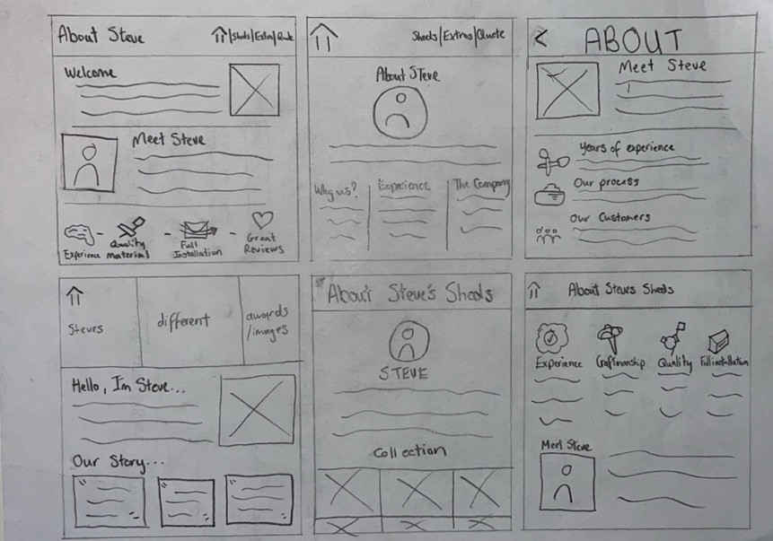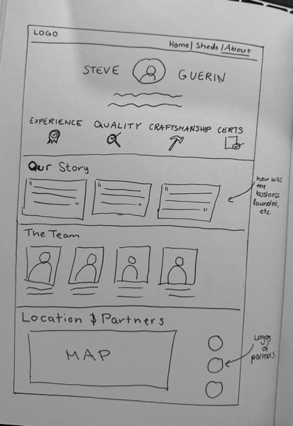
Figure 12 - Sketches of About Page Figure 13 - Final About Page Sketch
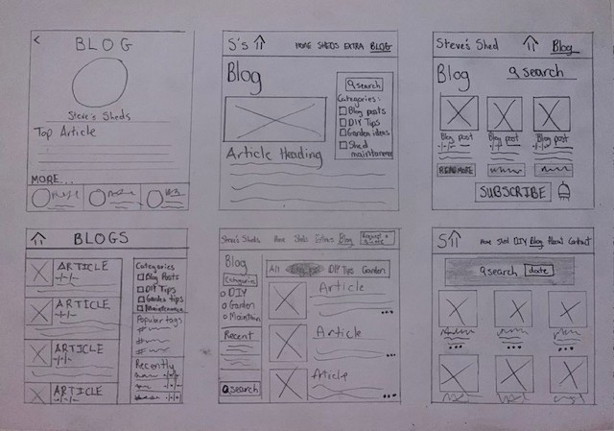
Figure 14 – Sketches of Blog Page
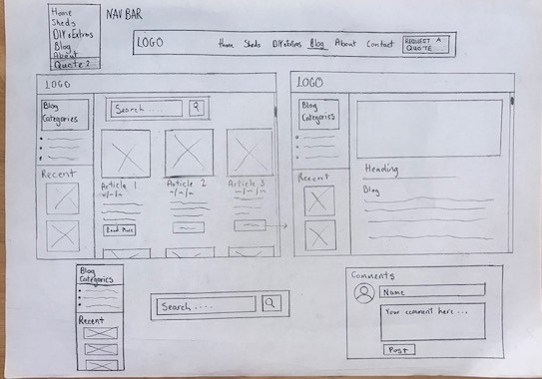
Figure 15 - Sketches of Blog Page

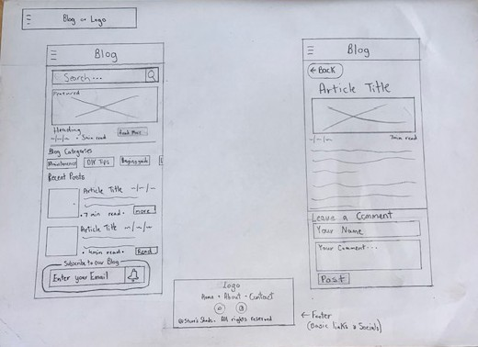
Figure 16 - Final Blog Sketch
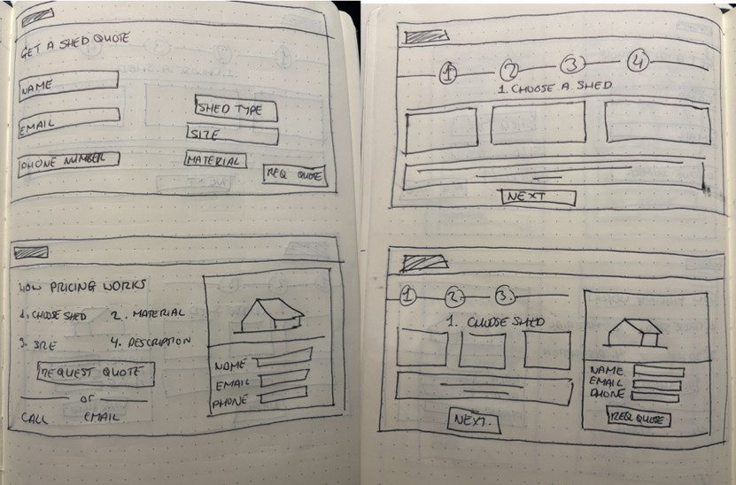
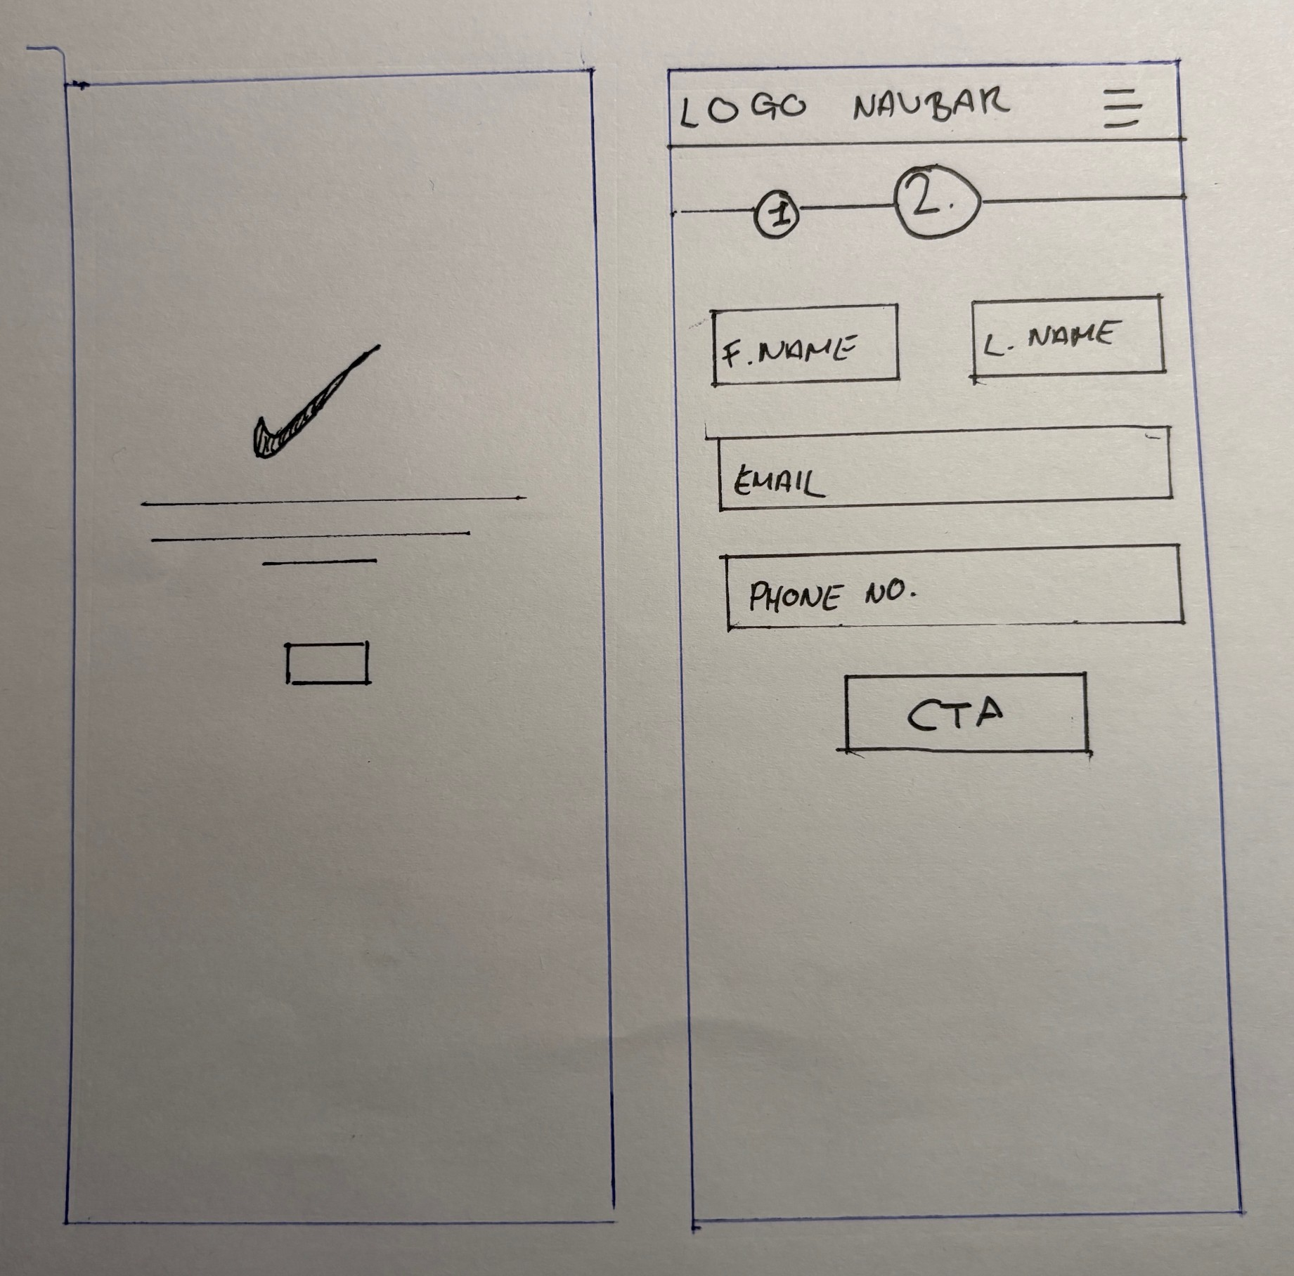
Figure 17 - Request A Quote Page Sketches Figure 18 - Final Request A Quote Page Sketch

Medium Fidelity Figma Wireframes
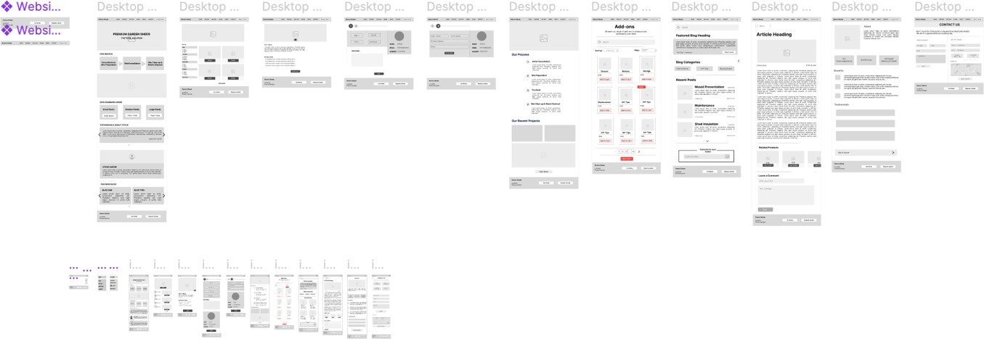
Figure 19 - Medium Fidelity Figma
Link to the Figma: hmps://www.ﬁgma.com/design/psR4TD8ar0jxXtS2yDWBvW/Steve-s-Shed-s?node-id=64ti-126&t=7qgFGvtiGx77VA6W4-1

Blog Section Renamed "Guides" and Integrated Product Overview
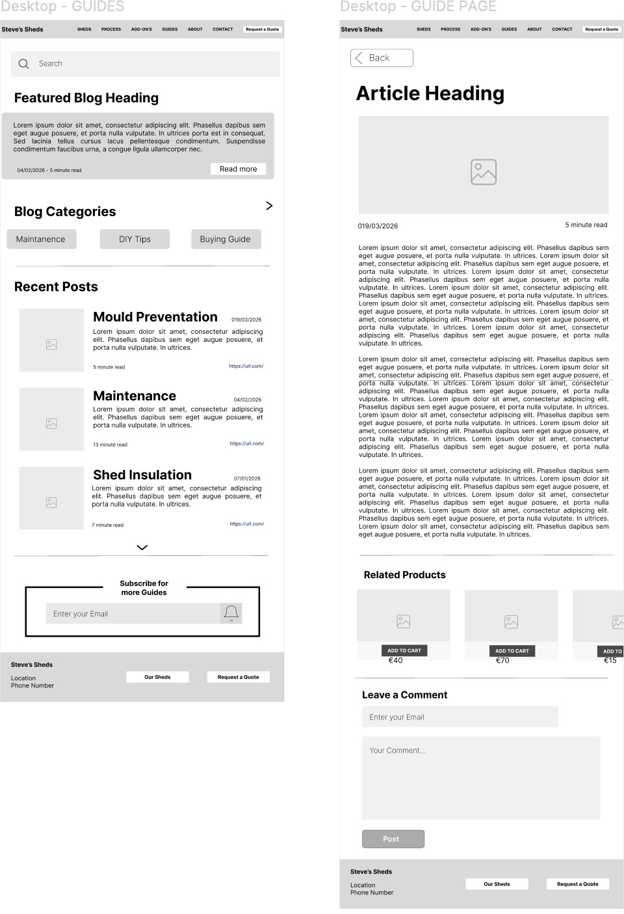
The paper wireframes labelled the educational content section "Blog." During paper wireframe User Test 1, the participant did not understand the purpose of the section during unmoderated exploration and found it valuable only after it was verbally explained. A label that requires explanation to function is not working. Tree testing Task 3 confirmed this further. Only one of seven participants found the insulation guide directly. The remaining six navigated to the About page or product pages instead, as they associated expert advice with those sections rather than a "Blog."
In the medium-fidelity Figma, the section was renamed "Guides" and linked to relevant product pages to provide a second path for users seeking advice mid-task. Medium-fidelity User Test 1 confirmed that the rename improved task completion.

Some initial hesitation remained, with the participant briefly
Figure 20 - Guide Pages

connecting mould prevention to shed build quality before self-correcting to the Guides section.

Dedicated Gallery Page Separated from Product Catalogue Paper wireframe User Test 3 produced one of the most important findings of the testing cycle. The participant actively searched for a "Previous Work" section separate from the commercial catalogue. When they could not find one, they returned to the catalogue and tried to extract real installation evidence from product renders. The user explicitly stated the distinction they were looking for: proof of completed projects, not product photography. This is a well-established behaviour in high-consideration purchases. Users want evidence of past performance before they commit to a conversion path.
Card sorting supported this separation structurally. Participants treated commercial imagery and portfolio imagery as conceptually distinct even without being prompted to do so, suggesting that the distinction carries real intuitive weight for this user group.
The medium-fidelity Figma introduced a standalone gallery section for completed installations, kept architecturally separate from the shed catalogue. Medium-fidelity User Test 2 validated this directly. The participant distinguished between the catalogue and the portfolio immediately and without prompting. An additional insight from this test was that users found 3D renders insufficient for judging real-world scale and finish and expressed a strong preference for actual installation photography. This identified a content requirement for the live site.

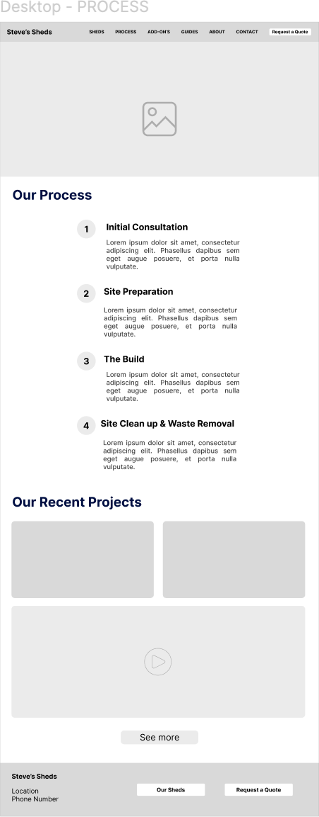
Figure 21 - Process Page

"Request a Quote" CTA Elevated to Primary Navigation
Tree testing Task ti recorded four direct successes out of seven participants, with two routing through the Contact page and one initially selecting the Shed page before reversing course. The Contact-page substitution pattern indicates that users were not clearly distinguishing between a quote function and a general contact function. In a live environment, this conflation carries a real risk of conversion drop-off.
Paper wireframe User Test 2 offered a useful counterpoint: the participant completed the quote path efficiently and described the "Request a Quote" button as the logical next step for a premium service. The mechanism was not the problem, its position was. The CTA needed to be immediately visible rather than requiring users to navigate to a secondary page.

The medium-fidelity Figma promoted the CTA to a persistent position in the main navigation, making it available at every stage of the user journey. Medium-fidelity User Test 3 confirmed that header-level placement enabled direct, unhesitating access to the contact functionality.

Phone Number Added to Contact Page & Global Footer Introduced
Paper wireframe User Test 3 explicitly flagged the absence of a phone number. The participant stated they wanted a visible number alongside the contact form for urgent or high-value inquiries. In professional services UX, a phone number serves as a trust signal, regardless of whether users intend to call. Its presence communicates availability and legitimacy in a way a form alone does not.
Tree testing Task 8 provided structural support for the footer decision. Two of seven participants navigated to the About page first when looking for contact information, suggesting the Contact page alone was not reliably intercepting users. A global footer carrying contact details addresses this by meeting users at the secondary location where they instinctively look.
The medium-fidelity Figma added the phone number to the Contact page and introduced a persistent footer across all pages. Medium-fidelity User Test 3 confirmed the phone number was immediately findable via the Contact page. Medium-fidelity User Test 4 independently reinforced the footer decision. The participant stated unprompted that the footer would have been their second place to look, directly validating the dual-placement approach.

Figure 22 – Header/ Nav Bar
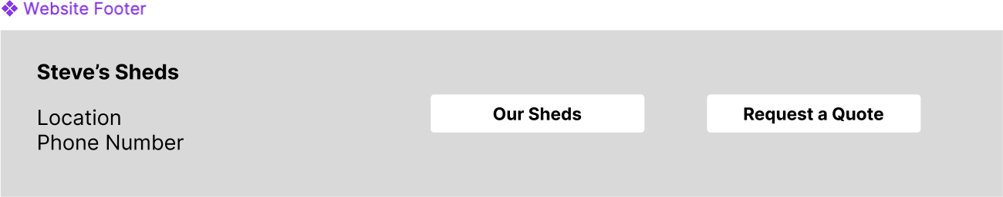

Figure 23 - Footer

Value Proposition and Benefits Section Surfaced on Homepage
Tree testing Task 9 recorded the largest gap between direct and indirect success in the entire test. Only two of the seven participants found the benefits section directly. Five went to the About page first. This indicates the content was not being surfaced at the point where users expected to encounter it, within the primary landing experience, but was instead housed in a secondary section they had to actively seek out.
Card sorting provided early evidence of this problem. "Benefits" and "Testimonials" produced the lowest participant consensus of all 34 cards, with no clear dominant grouping. When cards

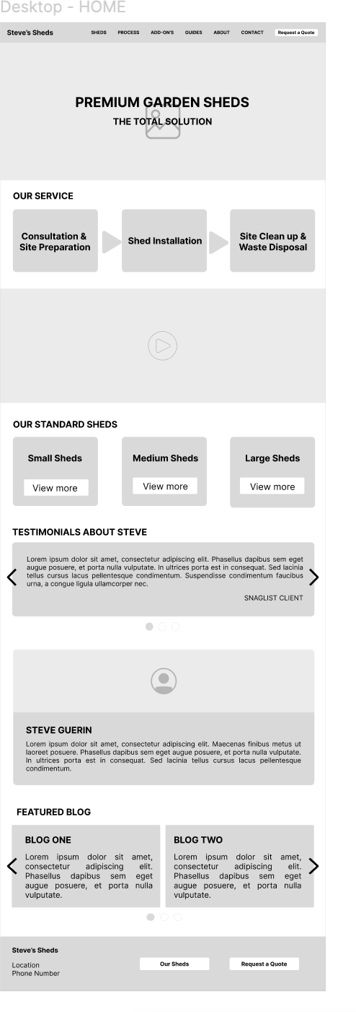
produce this level of disagreement in open sorting, it signals that the content has no self-evident categorical home and must be placed deliberately rather than relying on users to find it through navigation.
Paper wireframe User Test 1 reinforced the case. That participant confirmed that "About Steve" and reviews were the first things they sought out, identifying heritage and social proof as the primary drivers of trust for high-ticket decisions. Placing the value proposition within the homepage scroll, rather than behind a navigation click, ensures it reaches users during the initial exploratory phase, before any commitment to a specific product or action has formed.

Figure 24 - Home Page

Technical Specifications Relabelled and Elevated in Hierarchy
Tree testing Task 6 produced the lowest direct-success rate of all nine tasks: fewer than half of participants found the Steel Frame Specifications directly, with most stalling at the "Customisations" subpage. A sub-ti0% direct success rate on a core informational task is a systemic failure, not an individual error. "Customisations" implies user-driven configuration activity rather than static technical reference content, creating a mismatch that sent participants elsewhere when they were looking for specifications.

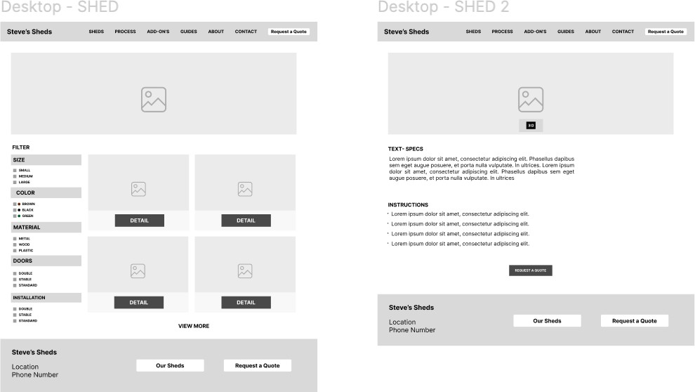
The tree testing summary identified this as a primary focus for the next design iteration. Paper wireframe User Test 1 provided additional behavioural evidence that the participant spent significant
time on the specification section of the shed detail page, specifically seeking insulation data, confirming
that technical specifications are high-priority content for the

Figure 25 - Shed Pages

target user and must be immediately legible.
The medium-fidelity Figma addressed this in two ways: the section was relabelled with descriptive, content-accurate language, and it was moved higher in the site hierarchy to reduce the navigational depth required. Specification links were also embedded directly within product pages to provide a contextual access path for users who look for technical details within the product selection flow. Medium-fidelity User Test 2 confirmed that the catalogue and filter system worked well overall, though it surfaced a further refinement. Shed names were only visible after clicking through to a detail view, which added an unnecessary step. This was flagged for resolution in the high-fidelity iteration.
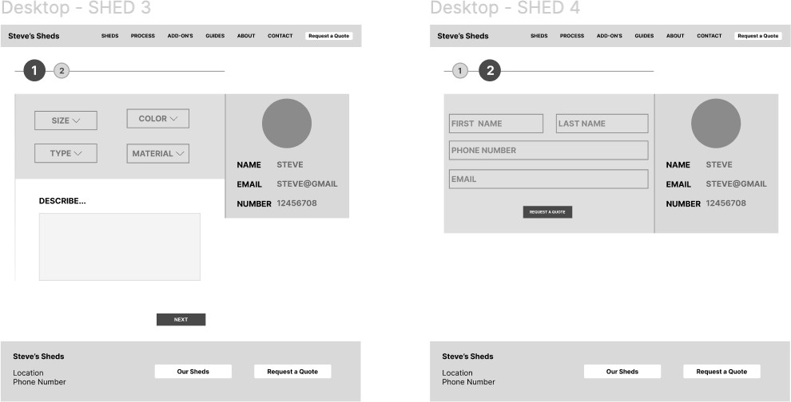

Figure 26 - Request a Quote Pages

Shed Names Made Visible at Catalogue Card Level
This finding came from medium-fidelity testing rather than the paper wireframe cycle, but it was a direct result of introducing the filter system in Figma. During medium-fidelity User Test 2, the participant filtered sheds successfully but noted that names were only visible after clicking into a detail page, requiring an additional interaction for what they treated as primary identifying information. A catalogue card should carry enough information for a user to make a triage decision without committing to a deeper navigational step. This was flagged as a targeted refinement for the high-fidelity prototype.

Opening Hours Placeholder Added to Contact Page
Medium-fidelity User Test 4 identified a content gap that had not been visible at the paper wireframe stage. The participant noted that the Contact page listed operating days (Mon–Fri) but no opening times, and immediately observed that this would prevent a potential customer from knowing whether it was appropriate to call. For a service business, the absence of opening times is not a neutral omission. It introduces uncertainty, which can suppress direct phone contact and reduce the business's perceived accessibility. A

placeholder was added in the medium-fidelity Figma, pending client confirmation, to ensure the structural provision was in place for the high-fidelity.
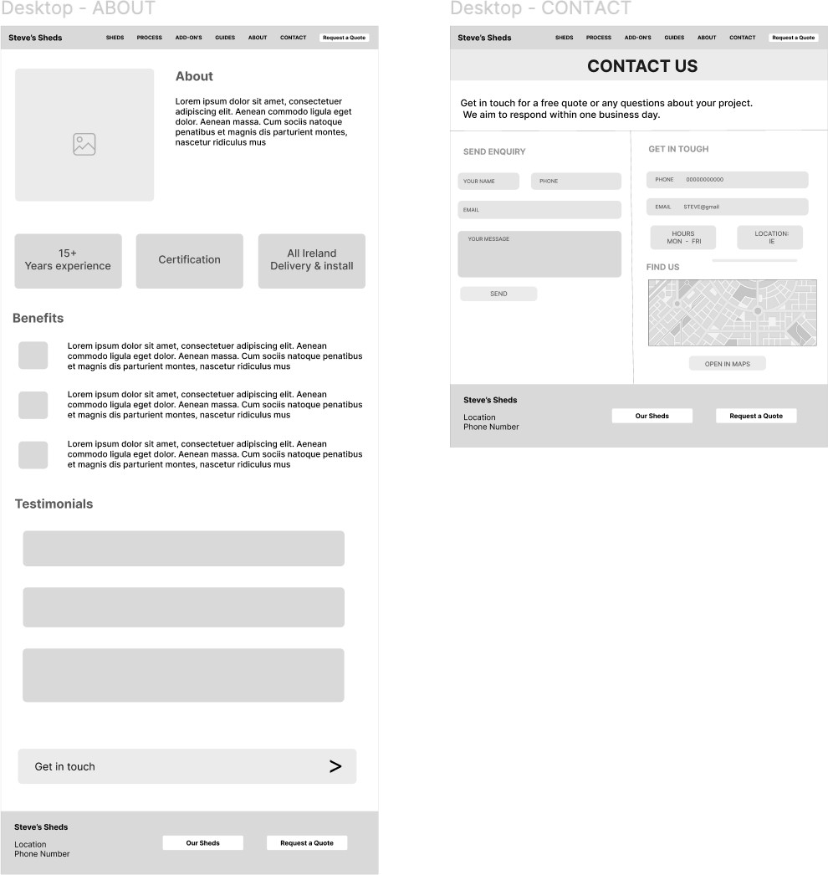
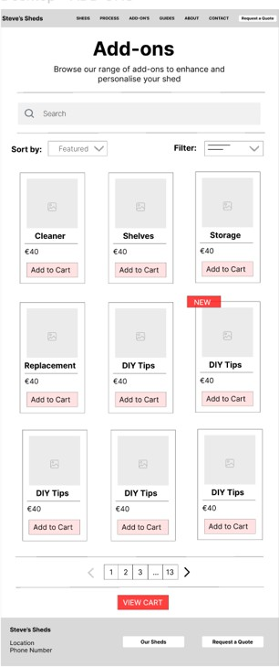
Figure 27 – About, Contact and Add-On Pages

Interactive Prototype
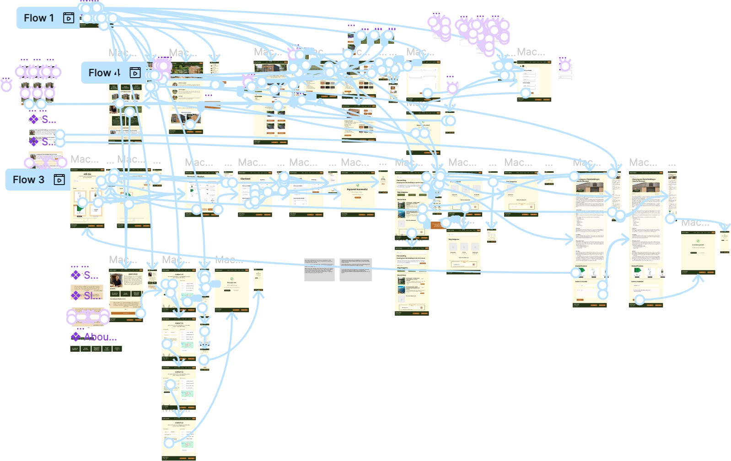
Figure 28 - Interactive Prototype (Figma Prototype View)
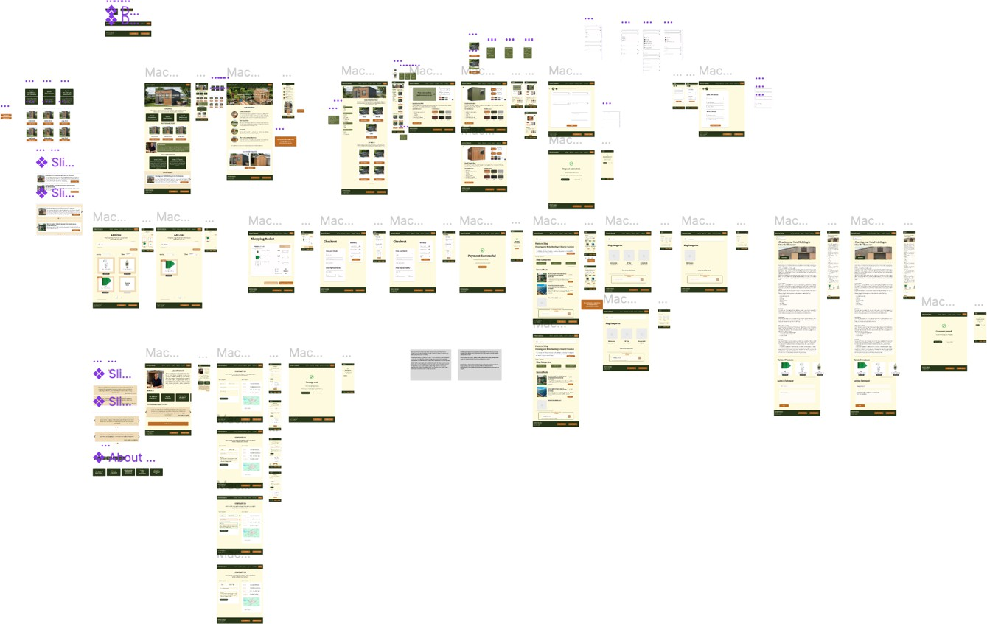
Figure 29 - Interactive Prototype (Figma Design View)
Link to the Figma

Overview of Transitions
During the usability testing of the medium-ﬁdelity wireframes, the results indicated a clear and logical Information Architecture (IA) and a successful visual hierarchy. However, speciﬁc friction points were identiﬁed, particularly regarding the discoverability of the business's contact details and operational hours.
Testing revealed that the use of low-ﬁdelity placeholders increased the users' cognitive load, making it diﬃcult to locate essential information. Consequently, the interactive prototype was populated with high-ﬁdelity, real-world content to enhance perceived credibility and provide a more authentic user experience.
During ﬁnal testing, a minor technical issue was identiﬁed with the 'Back' button's hit target. Following Fims’s Law, I expanded the touch target area (the interactive frame) to ensure better accuracy and ease of use, particularly for mobile users.

Global Design Modiﬁcations
Two signiﬁcant iterations were applied globally:
- The interface was updated to align with the Master Design Template, incorporating a nature-inspired palette and premium typography to reﬂect Steve’s salesmanship.
- The 'Add-Ons' tab was removed from the primary navigation at the client’s request. This reduces visual clumper and ensures the user remains focused on the core "Total Solution" value proposition.

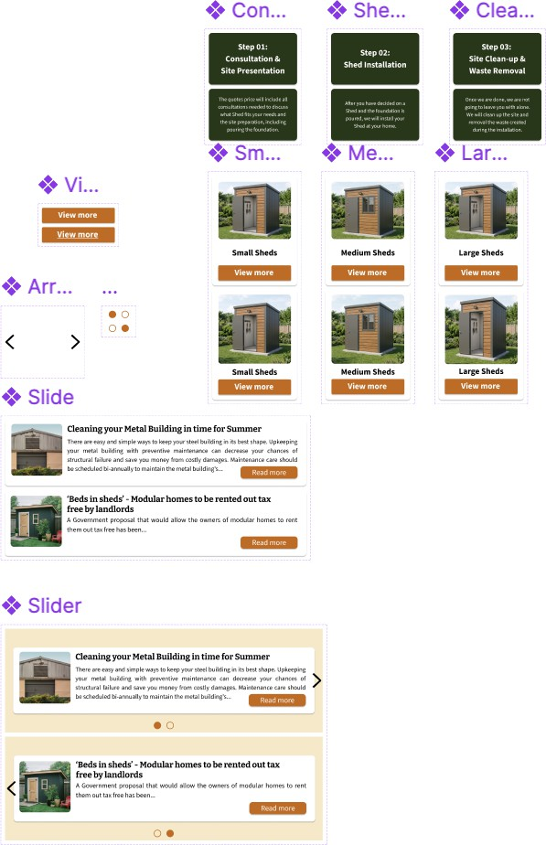
A critical phase of the transition to the high-ﬁdelity interactive prototype was the development of a robust, component-based design system. Following Design principles, created a library of reusable UI components, including global headers, footers, interactive sliders, and product cards. This approach ensures visual consistency across the entire application and enables eﬃcient, scalable design updates.

Figure 30 - Figma Components

Navigation & Global UI Elements
The global Header and Footer were developed as master components to maintain a uniﬁed user experience across all sub-pages.
The menu was reﬁned to improve discoverability. By streamlining the links and ensuring high contrast, reduced the user's cognitive load, enabling intuitive navigation.

In response to initial user testing, the footer was expanded to act as a secondary navigation hub. It now stores persistent contact information, ensuring these key data points are accessible from every page without requiring a return to the 'Contact' page.
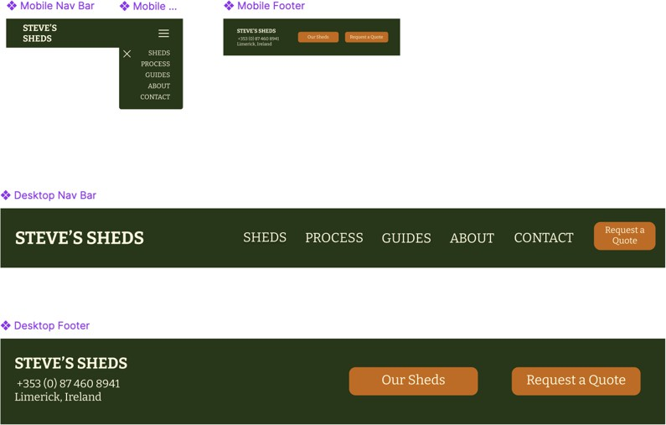
Figure 31 - Headers and Footers

Responsive Design & Scalability
While this report primarily showcases the Desktop viewport to maintain conciseness, a comprehensive Mobile version was developed in tandem.
UI elements such as product tiles and navigation menus were adapted into a vertical stack to suit handheld ergonomics.
Sliders and carousels were built with touch-target sizes that comply with WCAG 2.1 accessibility standards, ensuring that users with limited motor dexterity can navigate the interactive elements as easily as those using a mouse on a desktop.

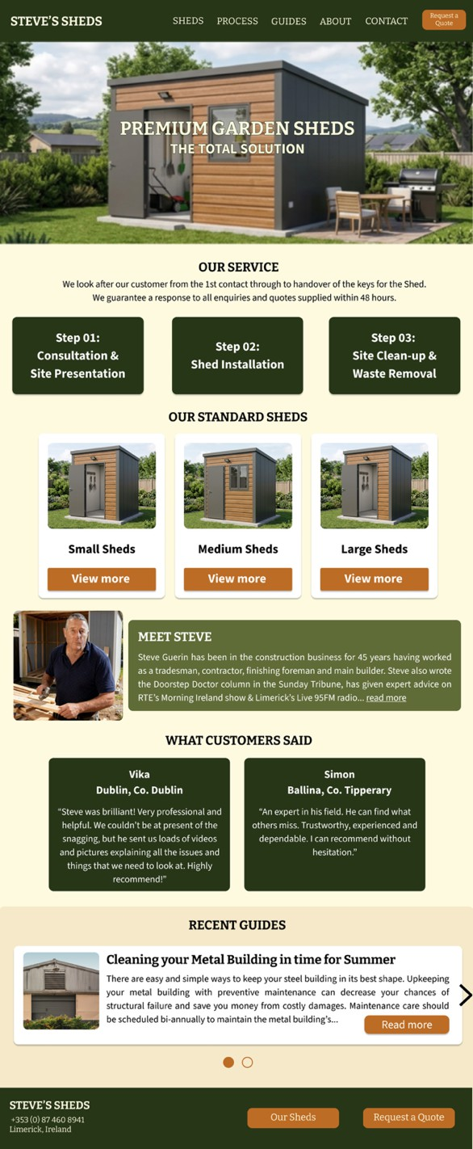
Figure 32 - Home Page

The Home Page
The transition to high-ﬁdelity involved a strategic decision to remove the video hero background. This was driven by two factors. Firstly, a placeholder video would undermine the premium brand identity, and secondly, autoplay videos can trigger seizures or cause distress for users with vestibular disorders. Removing the video aligns with WCAG accessibility guidelines regarding motion and ﬂashing content.
The content in this prototype is a strategic blend of client-provided assets and professionally sourced copy, designed to enhance the brand's perceived trustworthiness. The "Meet Steve" section was adapted directly from the client-provided text.
I utilised concise, action-oriented language to ensure the technical process remains digestible for a non-expert audience, thereby reducing cognitive friction during the exploration phase.
To provide a realistic user experience, the testimonials and "Recent Guides" were curated from reputable online sources to act as high-ﬁdelity placeholders. All external content sources are documented and linked in the Appendix.

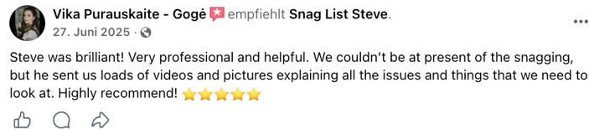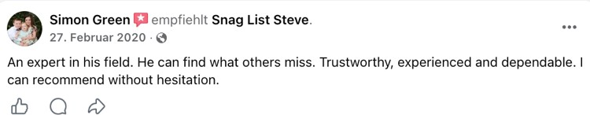
Figure 34 - Original Testimonial 1 Figure 33 - Original Testimonial 2

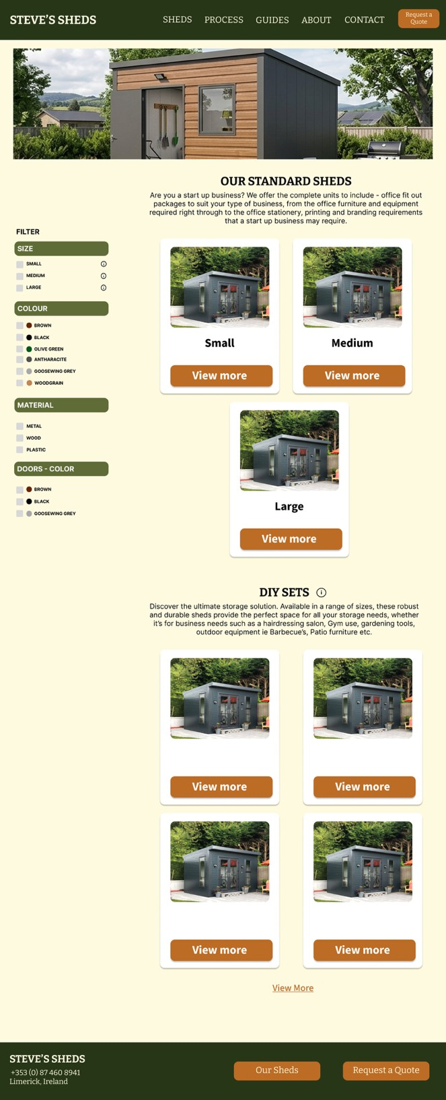
The Shed Pages

The main Shed overview underwent a signiﬁcant restructuring to adopt an F-Pattern layout. As evidenced by the Nielsen Norman Group (Pernice, 2017), users tend to scan digital content in an 'F' shape. Therefore, placing key information along this path ensures higher information retention.
A dedicated section for DIY Sets was integrated into the product architecture following the last iteration. This addition ensures the prototype accurately reﬂects the business’s diverse revenue streams beyond standard installations.

I also expanded the Shed Selection logic. Given the limited availability of client assets, prioritised Quality over Quantity, prototyping the "Small Sheds" selection to a high-ﬁdelity standard using AI-enhanced imagery to maintain a realistic aesthetic.

Figure 35 - Shed Page

Figure 36 - Shed Selection Page (Small Sheds)
The 3D render component was also reﬁned, though it remains a partially interactive high-ﬁdelity mock-up. It serves as a Proof of Concept for a future interactive conﬁgurator.
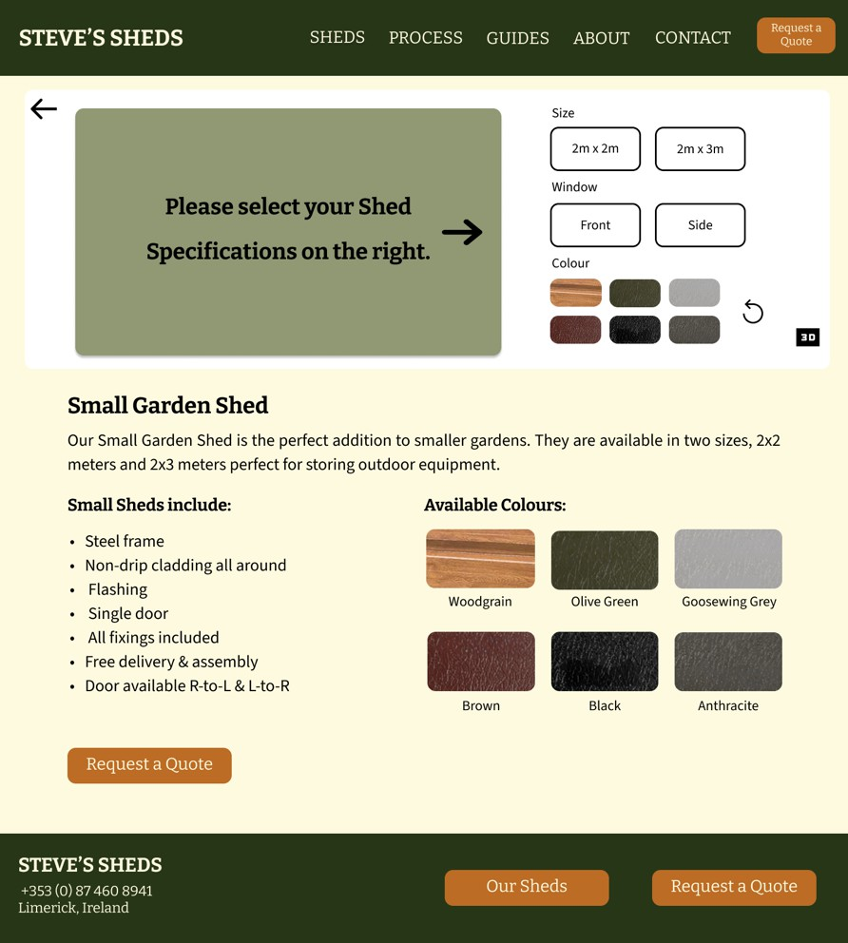
The 'Instruction' section was removed in this version as it no longer aligned with the updated operational workﬂows provided by the stakeholder. In its place, I introduced a Technical Speciﬁcations section and a Colour palette. By prioritising technical specs (dimensions, material grades, and cladding types), address the user's need for 'Visual Proof' and factual certainty, which was a recurring theme in user testing.
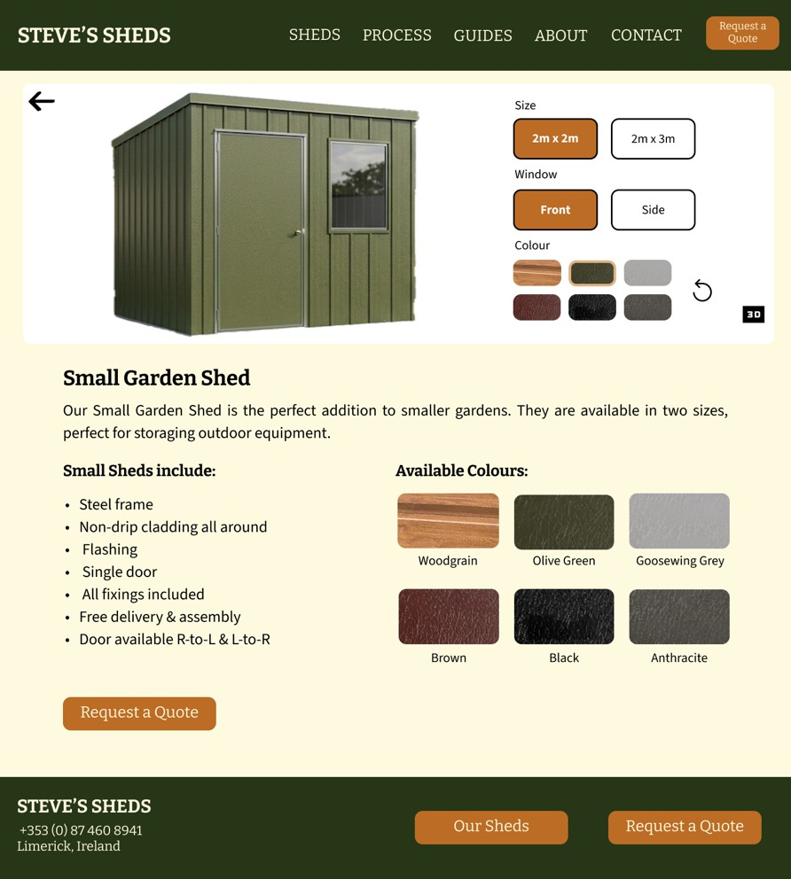
The descriptive text on this page is a synthesis of client-provided data and team-written text. This collaboration ensures that, while the technical details remain faithful to Steve’s builds, the language is accessible, helping bridge the gap between professional construction terminology and consumer understanding.

Figure 37 - Shed Selection Page (Small Sheds) 3D Render Activated

The Request a Quote Pages

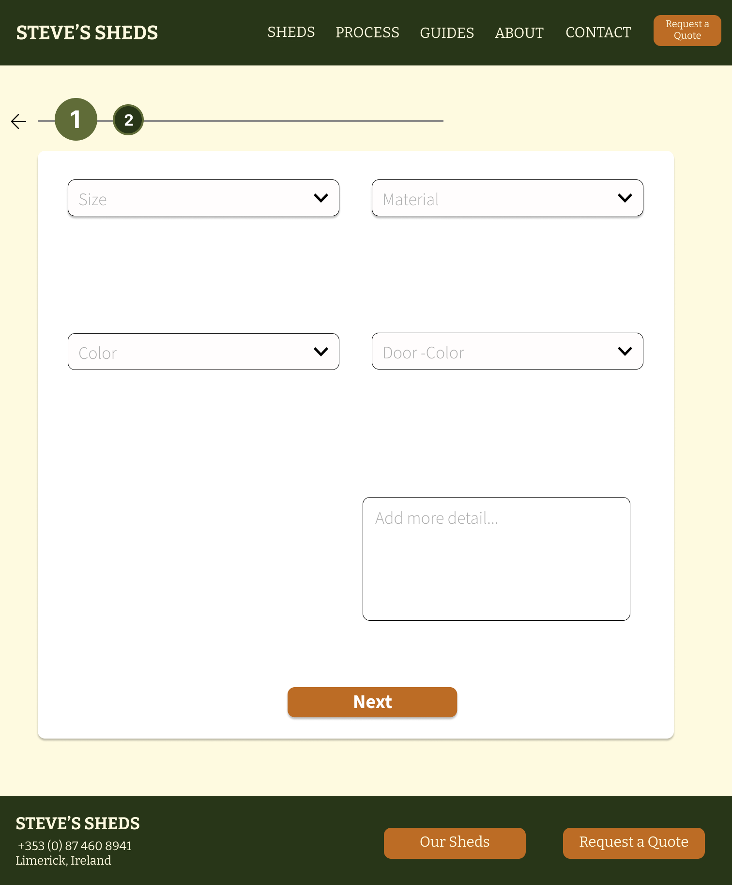
Figure 38 - Request a Quote Page
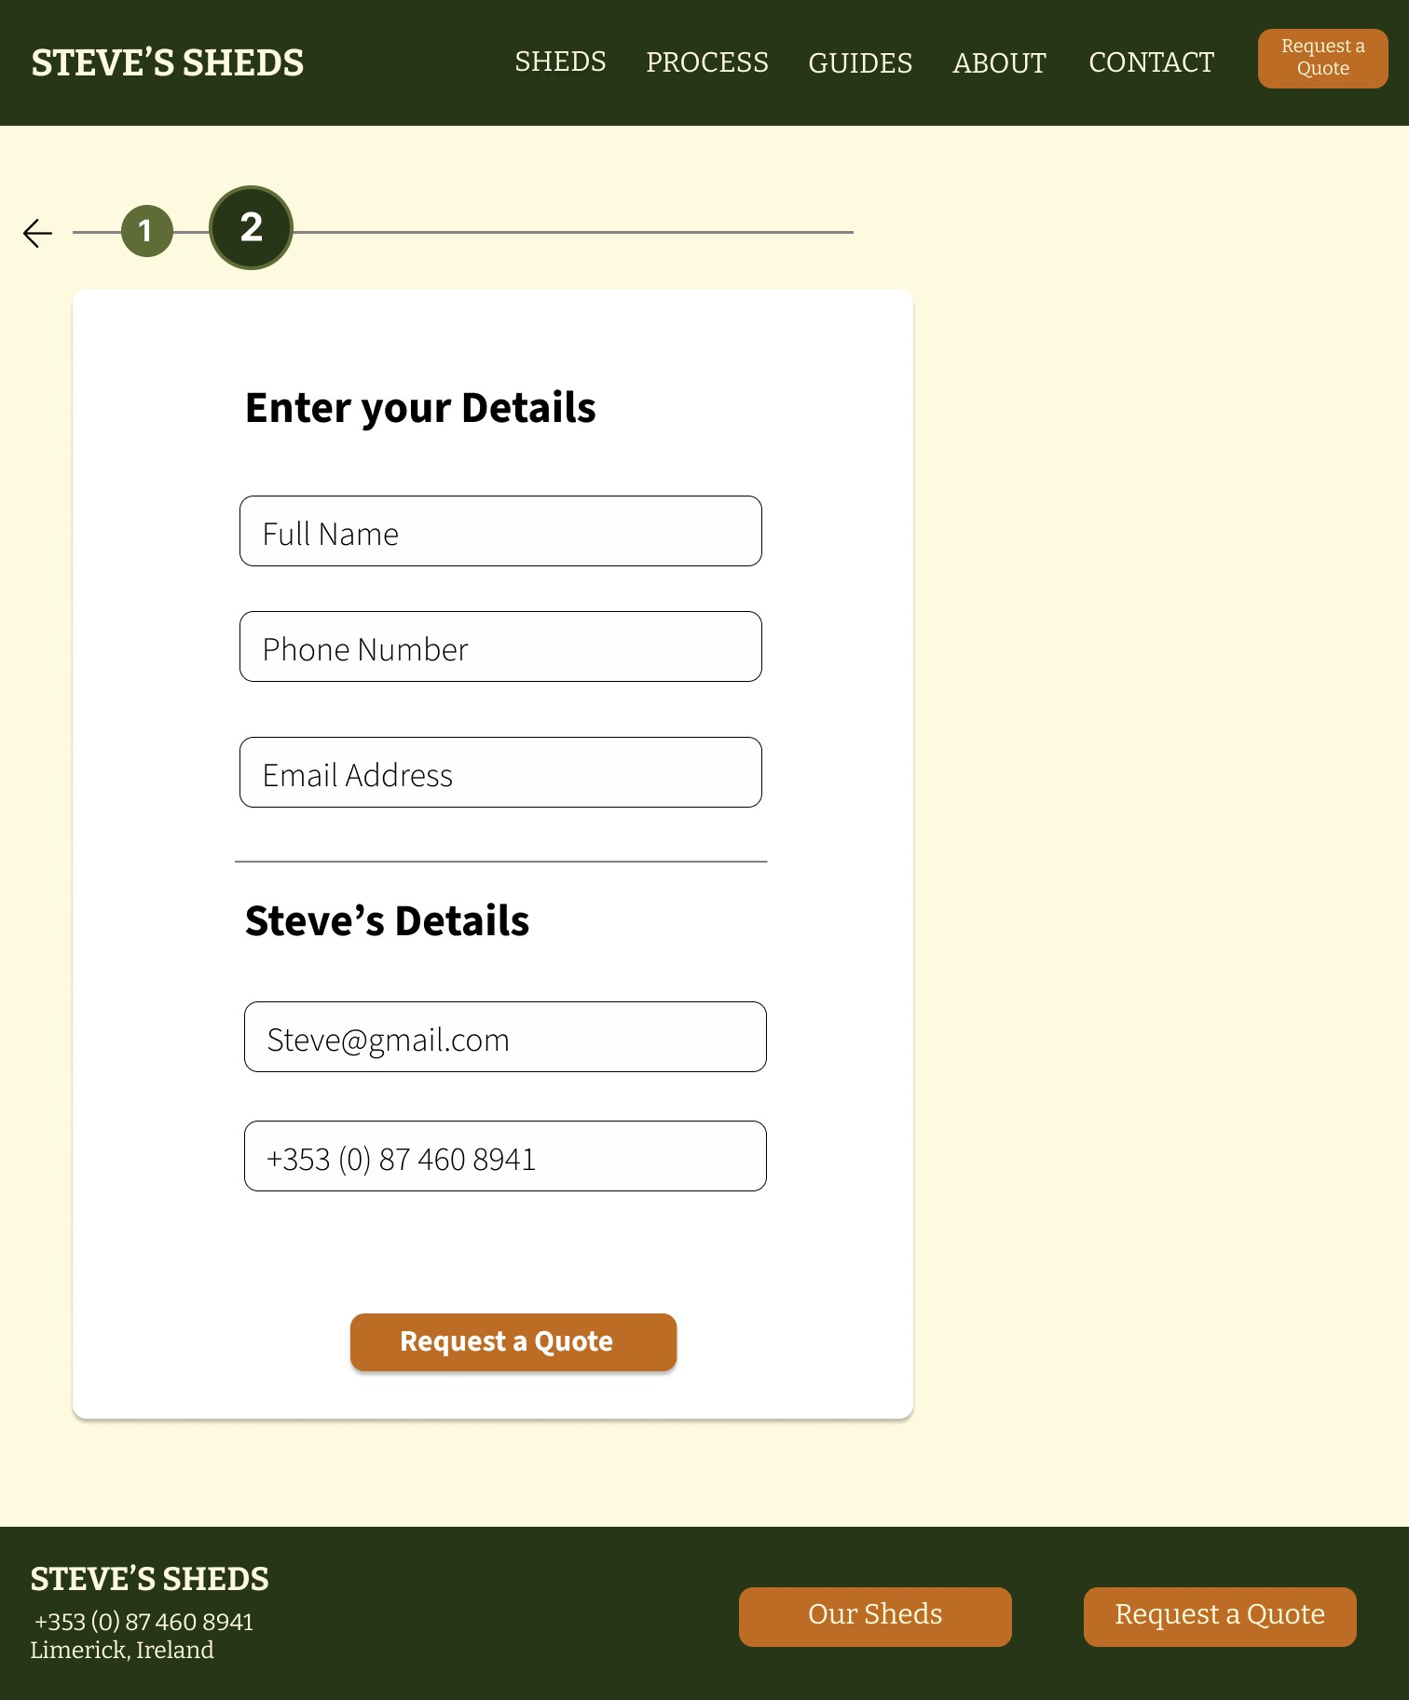
Figure 39 - Request a Quote Page

The 'Request a Quote' page was transitioned from a two-column layout to a single-column vertical ﬂow. This is a critical accessibility improvement.
A vertical ﬂow ensures a predictable Linear Focus Order for Screen Readers. Furthermore, single-column forms generally achieve higher completion rates because they provide a clearer path to the Call to Action (CTA).
Lastly, I implemented a dedicated Success State page. By using redundant coding (combining icons, text, and colour), To ensure the conﬁrmation is accessible to users with colour vision deﬁciencies.

The Process Page
The Process Page layout remained consistent to preserve the mental model established in earlier iterations, but was enhanced with AI-generated imagery to justify the premium price point.
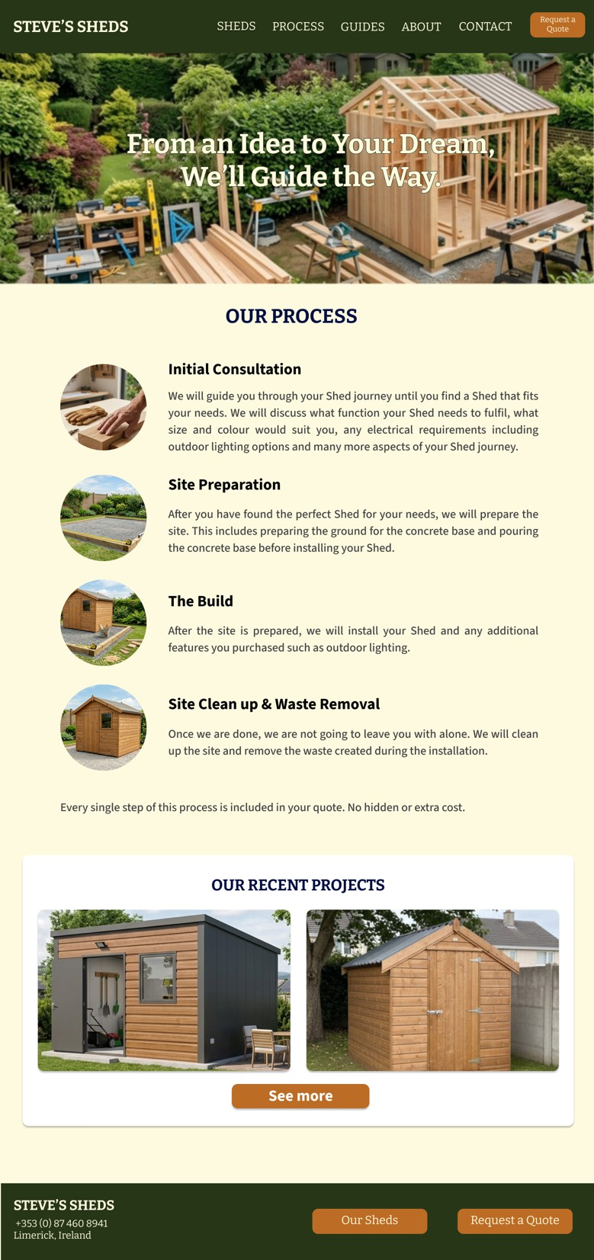
Figure 40 - Process Page

The Guides Pages
The Guides (Blog) section was developed to be scalable. To manage user expectations where content was missing, I implemented Functional Overlays that inform the user that the content is forthcoming. This prevents "Dead Ends" in navigation and maintains professional transparency.
The 'Guides' overview and selection pages maintained their original structural layout but were populated with Open-Source content and Creative Commons imagery. This was a strategic decision to demonstrate the site's content-rendering capabilities while awaiting the client's ﬁnal assets. Elevated the 'Featured Blog' to full interactivity in the prototype. This allows the client to experience the user ﬂow from discovery to deep-reading, providing a realistic representation of how his unique expertise will be presented to the audience.
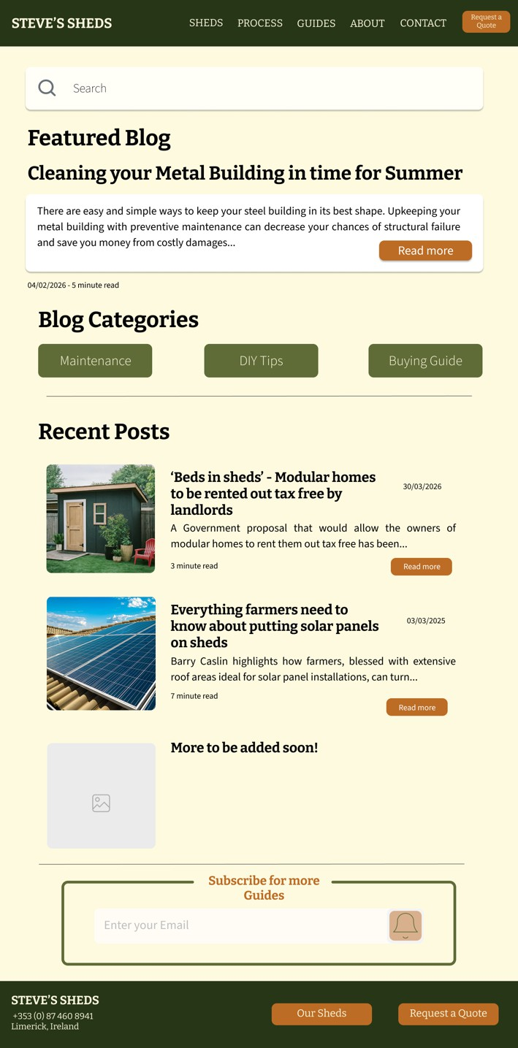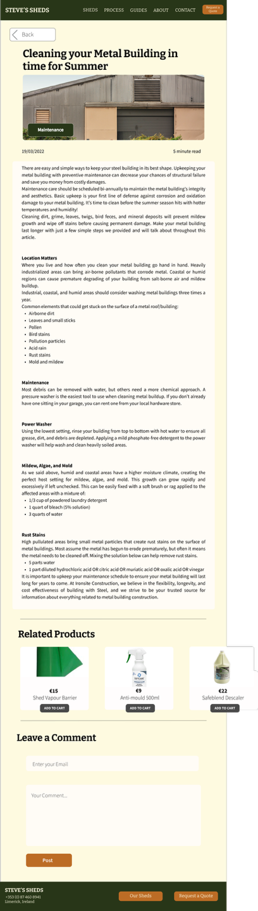
Figure 41 - Guides page Figure 42 - Guide Selection Page

About Page

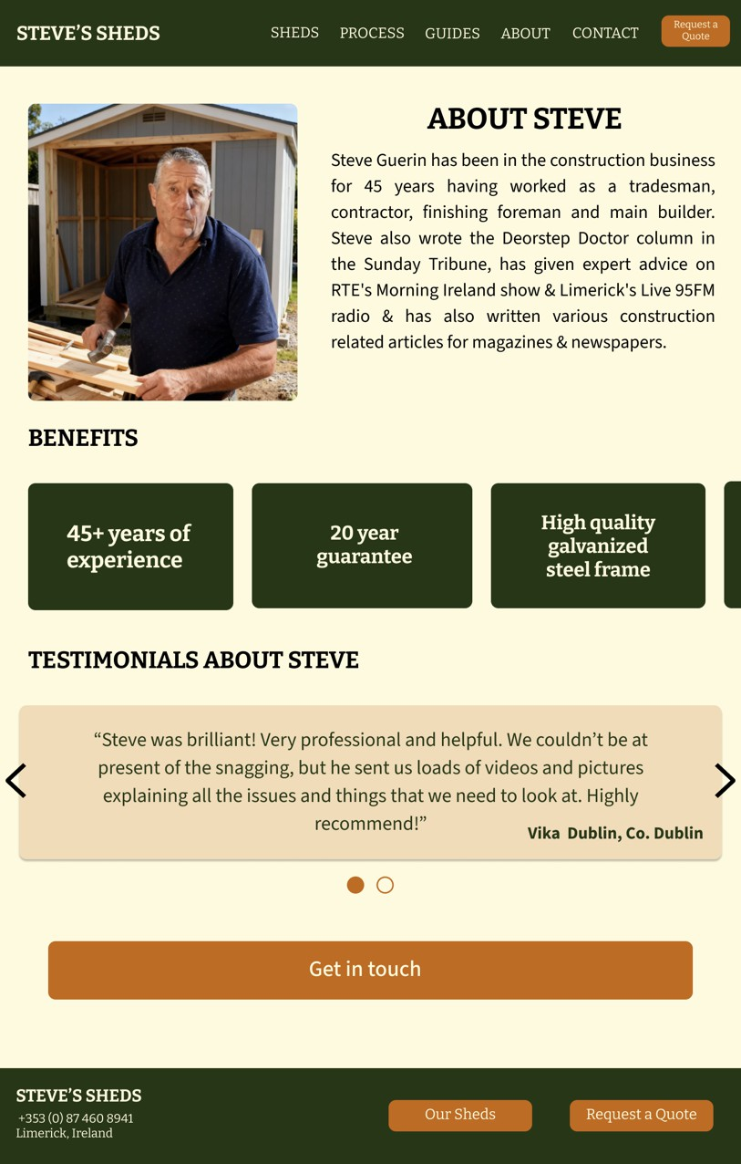
Figure 41 - About Page


Figure 42 - The original About image

The About Page layout remained consistent to preserve the mental model established in earlier iterations, except for the beneﬁts section and the testimonials.
I iterated on the 'Beneﬁts' section by moving from a static list to a Horizontal Card Slider (Carousel). This decision was based on two factors.
Primarily, it keeps the page length manageable and reduces scroll fatigue. Secondly, it encourages active discovery.
To address the lack of client photography, I used expansion tools to create a professional portrait of Steve, ensuring the business's face is present to establish Social Proof.
The original image was taken from the client’s Snag List business Facebook account.

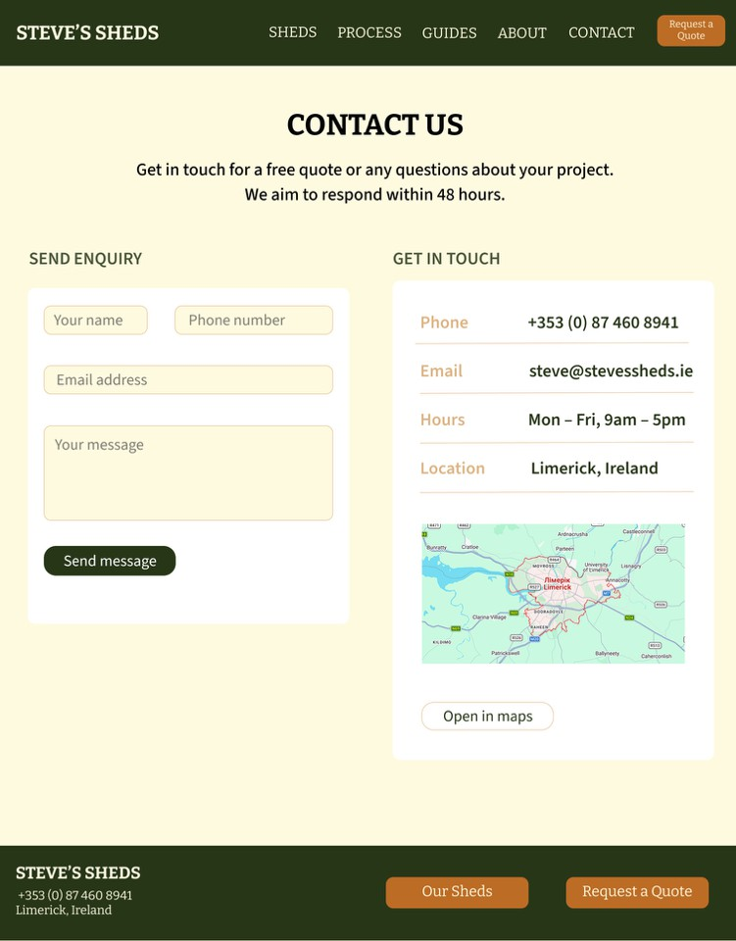
Contact Page

The Contact page layout also remained consistent with previous iterations. The Contact page now features robust Error Validation. Following Usability Heuristics, the system provides immediate, speciﬁc feedback when a form ﬁeld is ﬁlled incorrectly, using both symbols and text to ensure the error is perceived by all users, regardless of their visual abilities.

Figure 43 - Contact Page
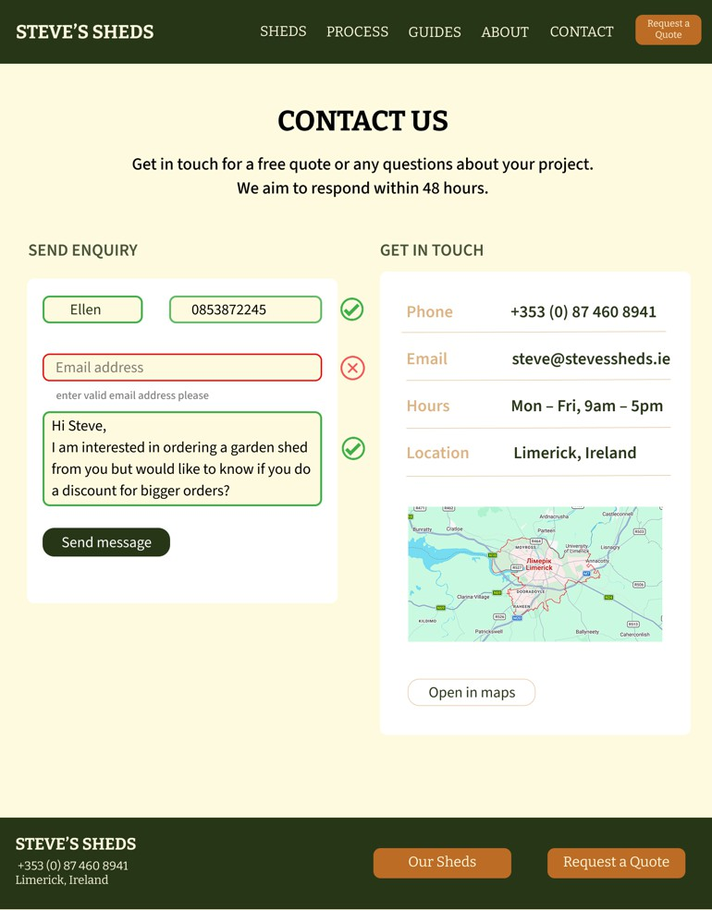
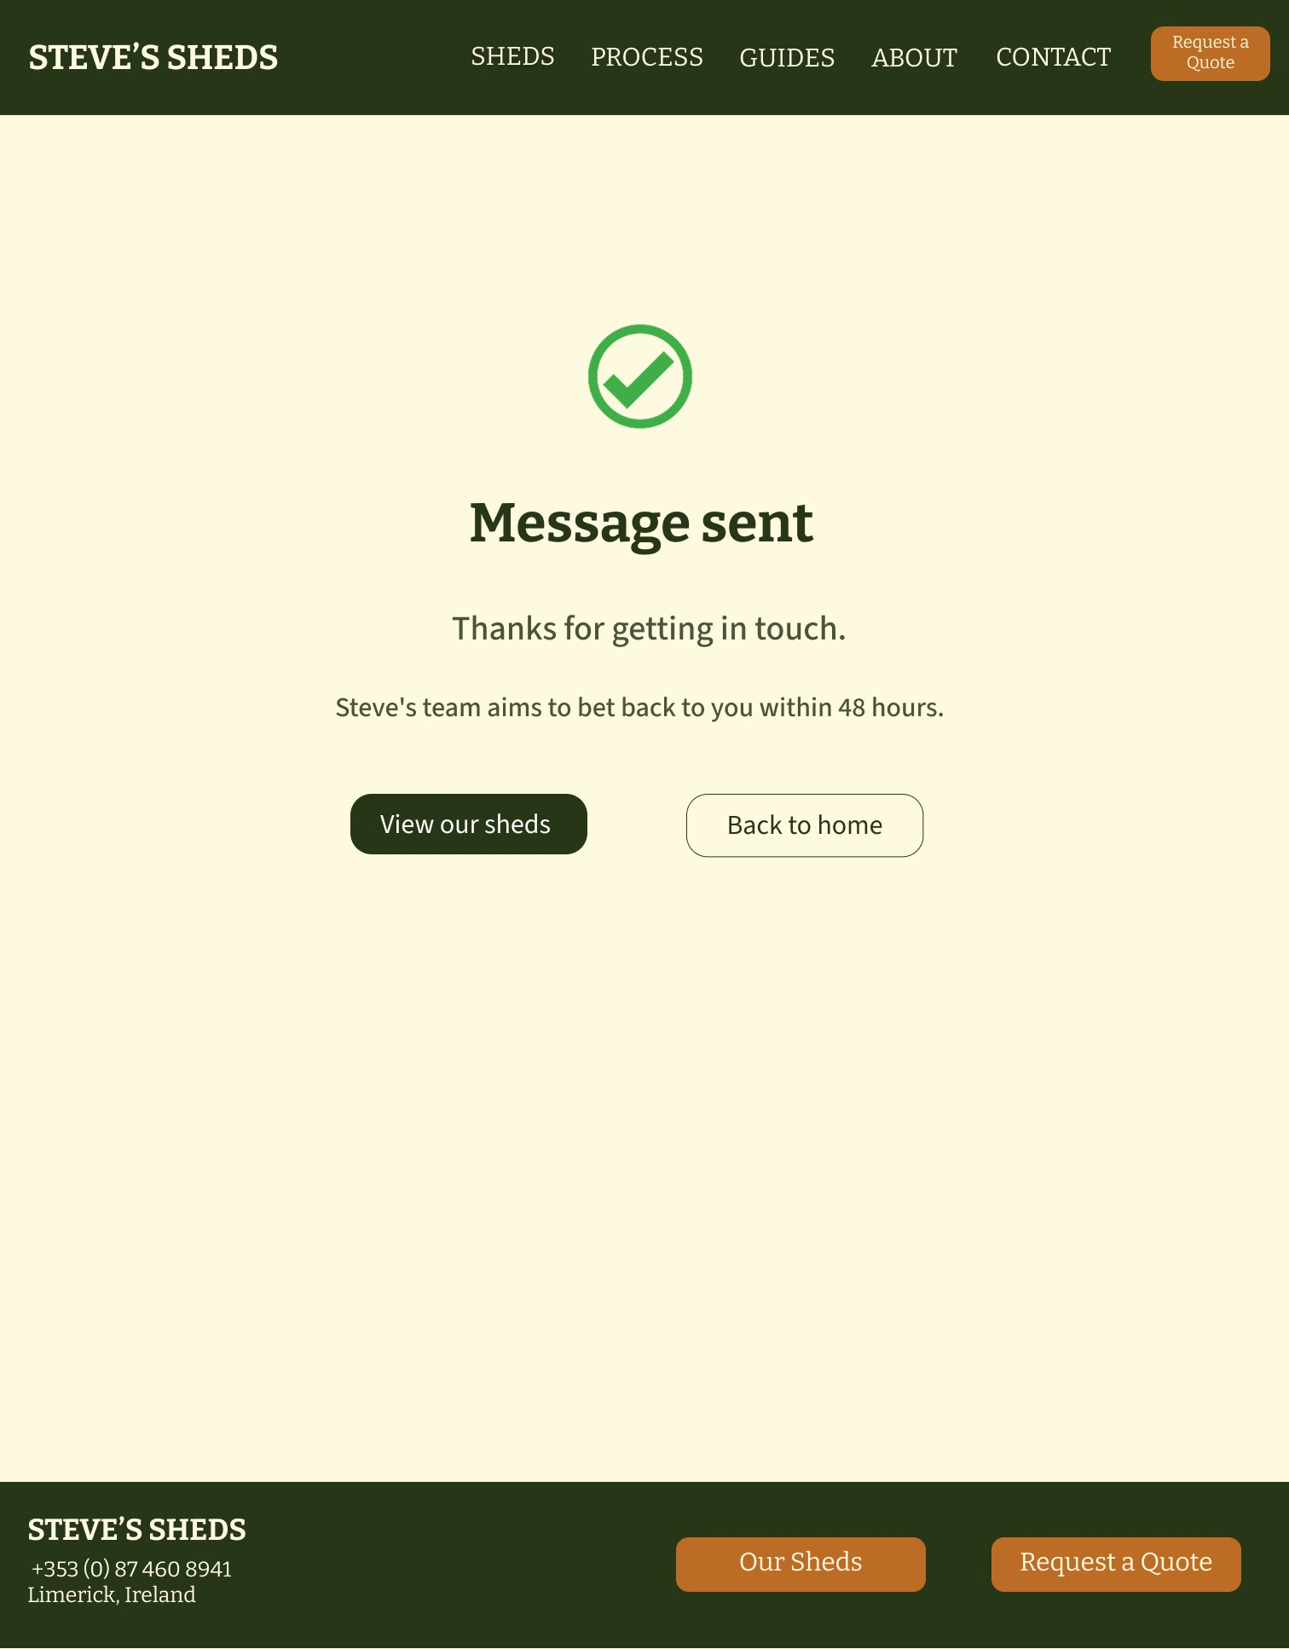
Figure 46 - Contact Page Error Message Figure 47 - Message Conrﬁmation Page

Add-Ons Pages
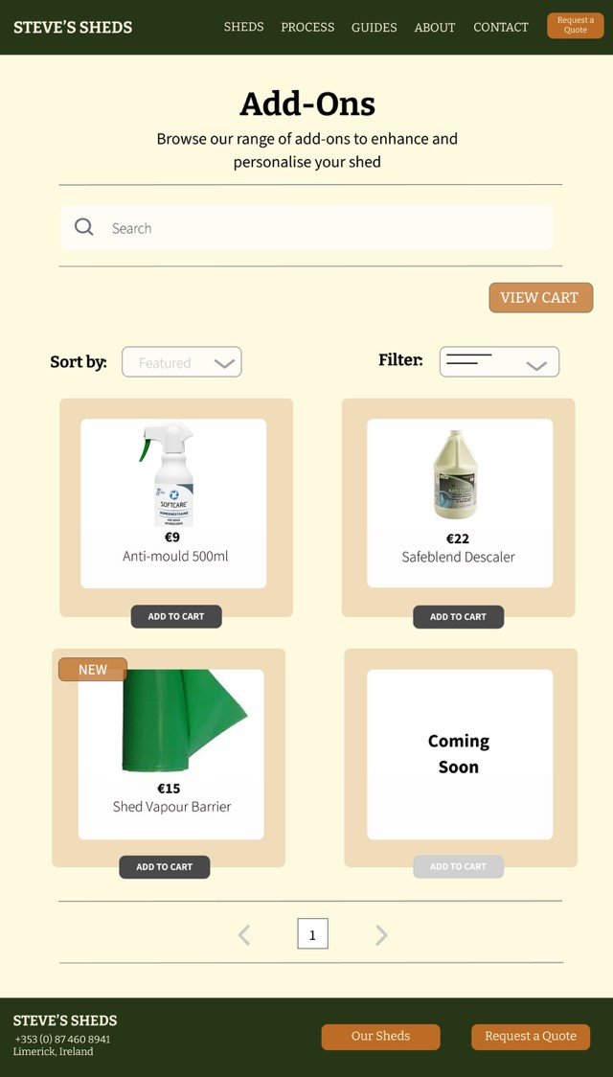
Figure 48 - Add-Ons Page

The Add-Ons section serves as a secondary "Future-Proof" feature. Reduced the product count to focus on high-quality representation and developed a Shopping Basket and Checkout ﬂow as a functional prototype. While currently disconnected from the primary global navigation to reﬂect the client’s immediate priorities, it demonstrates the site's capability for future e-commerce expansion.

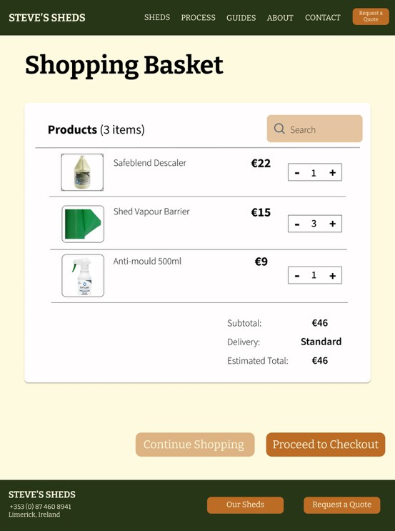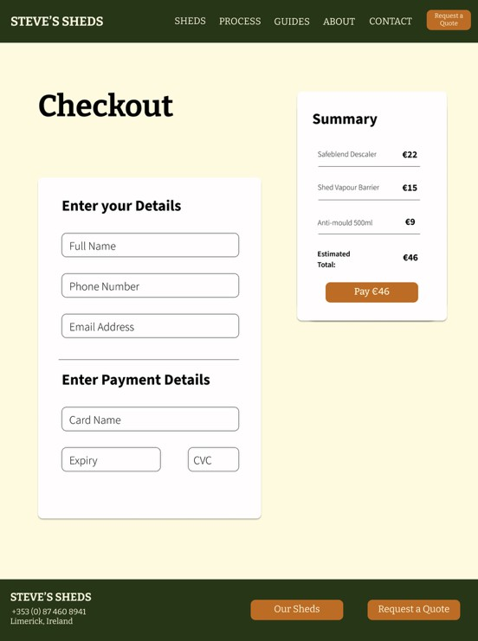
Figure 49 - Shopping Basket Page Figure 50 - Checkout Page

User Testing

Card Sorting
Simultaneously, as designed the paper wireframe sketches, it was decided to conduct a card-sorting exercise. For this, 34 cards were made within Mural. Every group member was to do two card sortings with two diﬀerent users. A total of six participants completed a Card Sorting. The results of those Card Sorting sessions are seen below.

The groupings were then analysed, and patterns were identiﬁed. Three groups became apparent immediately. Firstly, all participants had grouped “Small Shed”, “Medium Shed”, and “Large Shed” together. Additionally, all participants grouped “Available colours”, “Door Options”, “Steel Frame Speciﬁcations”, “Window Options”, “Materials” and “Insulation Options”. The last group that all participants agreed with was “Building Timelines”, “Building Process”, “Site Preparation”, “Site Clean-up”, and “Shed Installation”. This showed me that it was needed to bring these groups together on my ﬁnal website design.
A group that ﬁve to six of the participants agreed on was the “Contact” section. Most participants grouped “Contact Information”, “Request a Quote” and “Oﬃce Location” together. Additionally, ﬁve participants sorted “Shed Cleaning Supplies”, “Shed Shelving and Storage Accessories” and “Replacement Parts” together.

For the remaining cards, I reviewed the sketches and the card-sorting results and concluded that the groups outlined below would be most appropriate. Two cards on which almost none of the participants agreed were “Beneﬁts” and “Testimonials”. I decided to put them on the Home Page to make this information easy to ﬁnd.
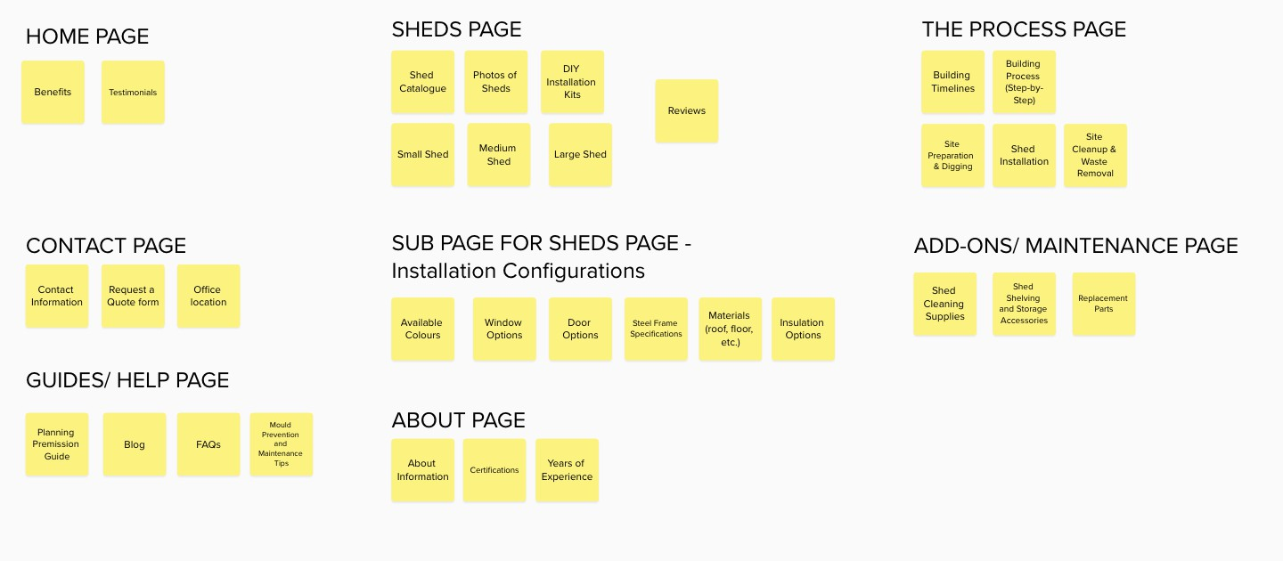
Figure 44: Card Sorting Results

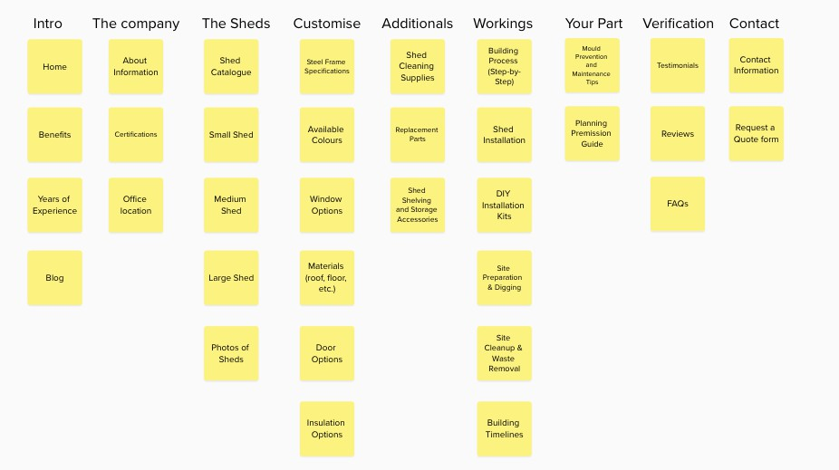
Figure 45: Participant 01
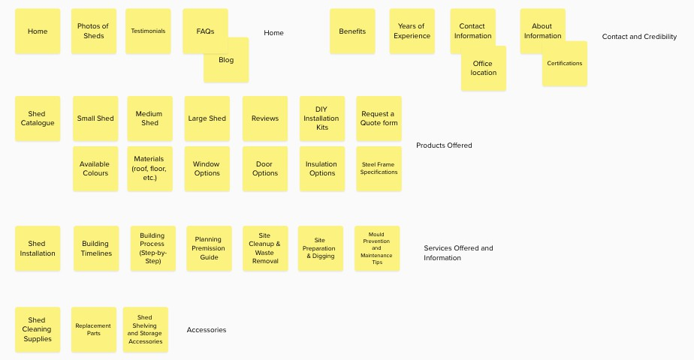
Figure 46: Participant 02

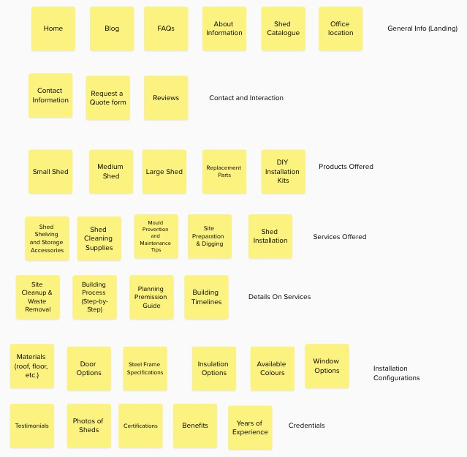
Figure 47: Participant 03
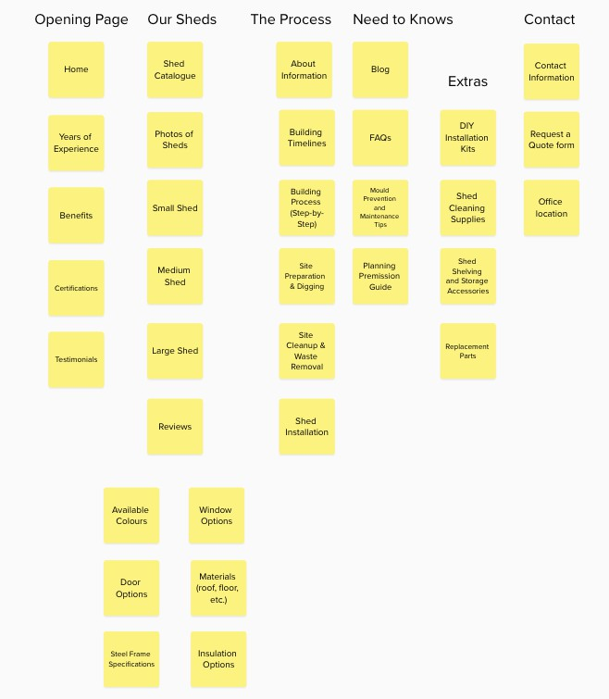
Figure 48: Participant 04

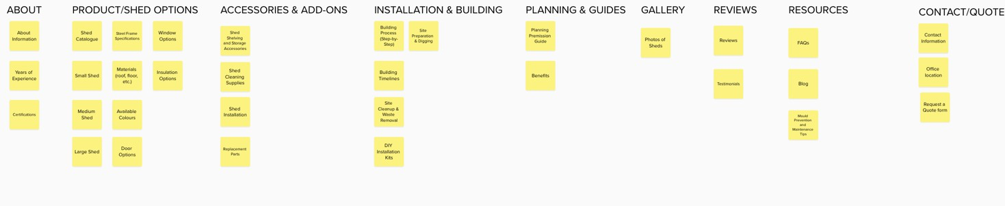
Figure 49: Participant 05
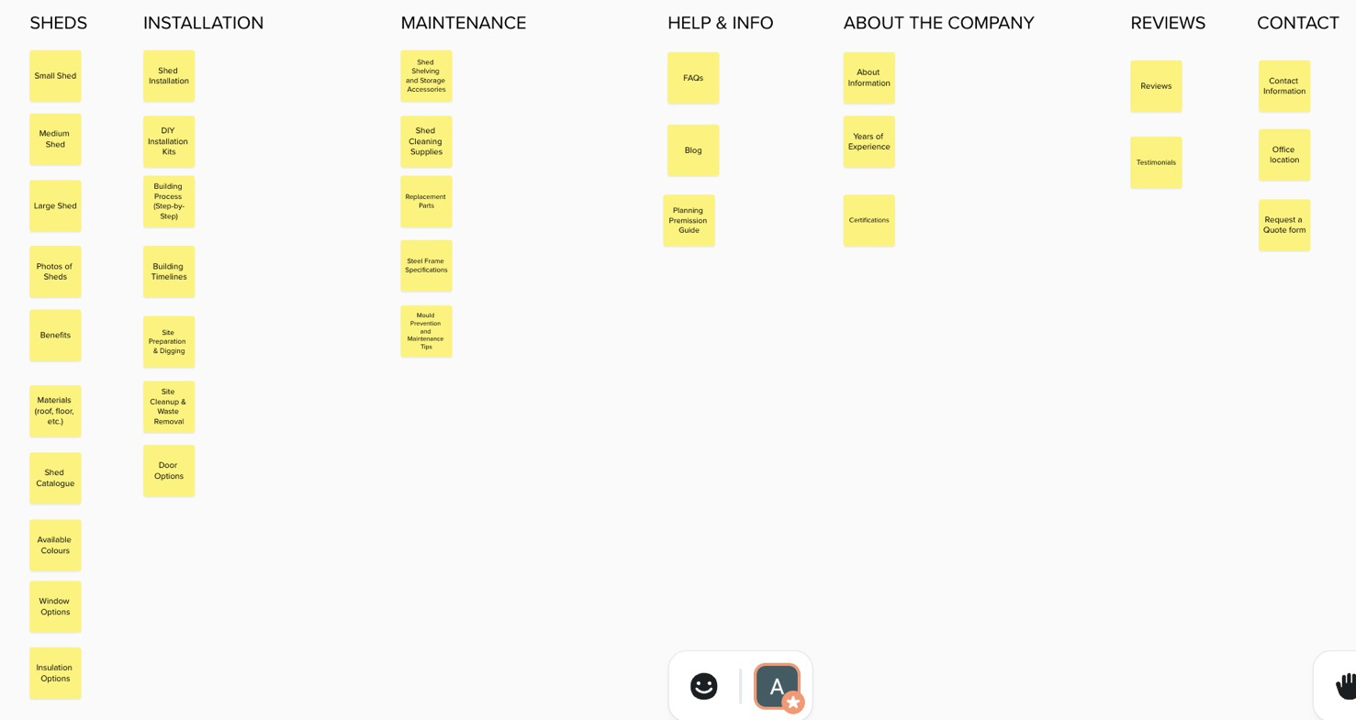
Figure 50: Participant 06

Tree Testing
The tree testing phase was conducted using the Lyssna platform, a free user testing website. Seven participants completed a total of nine tasks, which were carefully mapped to the categories identiﬁed during previous card-sorting sessions. On average, participants took between two and three minutes to complete the test.

- Find out if the company handles the foundation digging as part of their service.
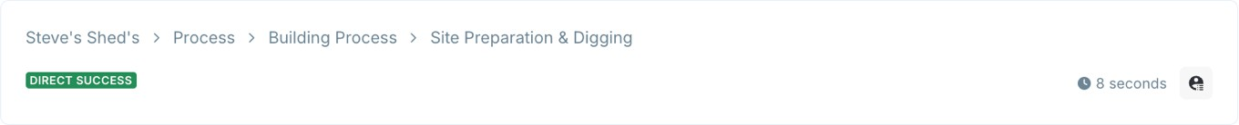
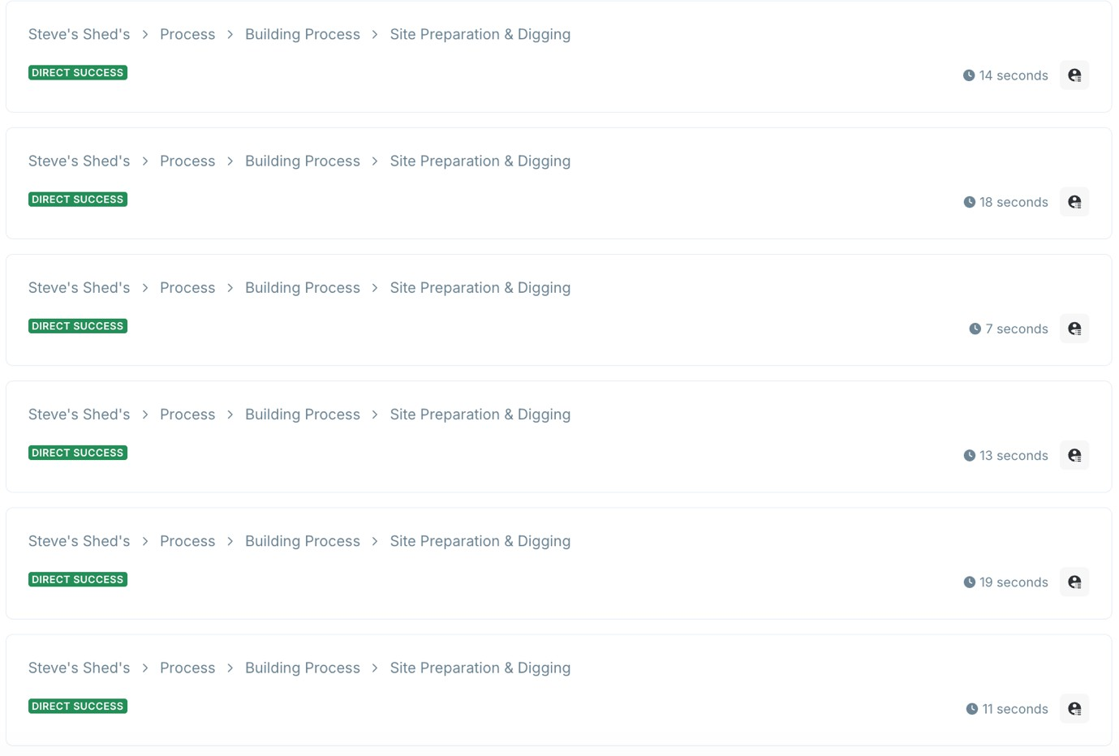

Every participant located the information directly, indicating that no changes are required for this section.

- Locate the speciﬁc measurements for a "Small Garden Shed."
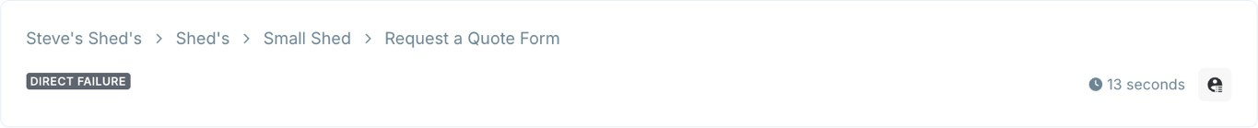

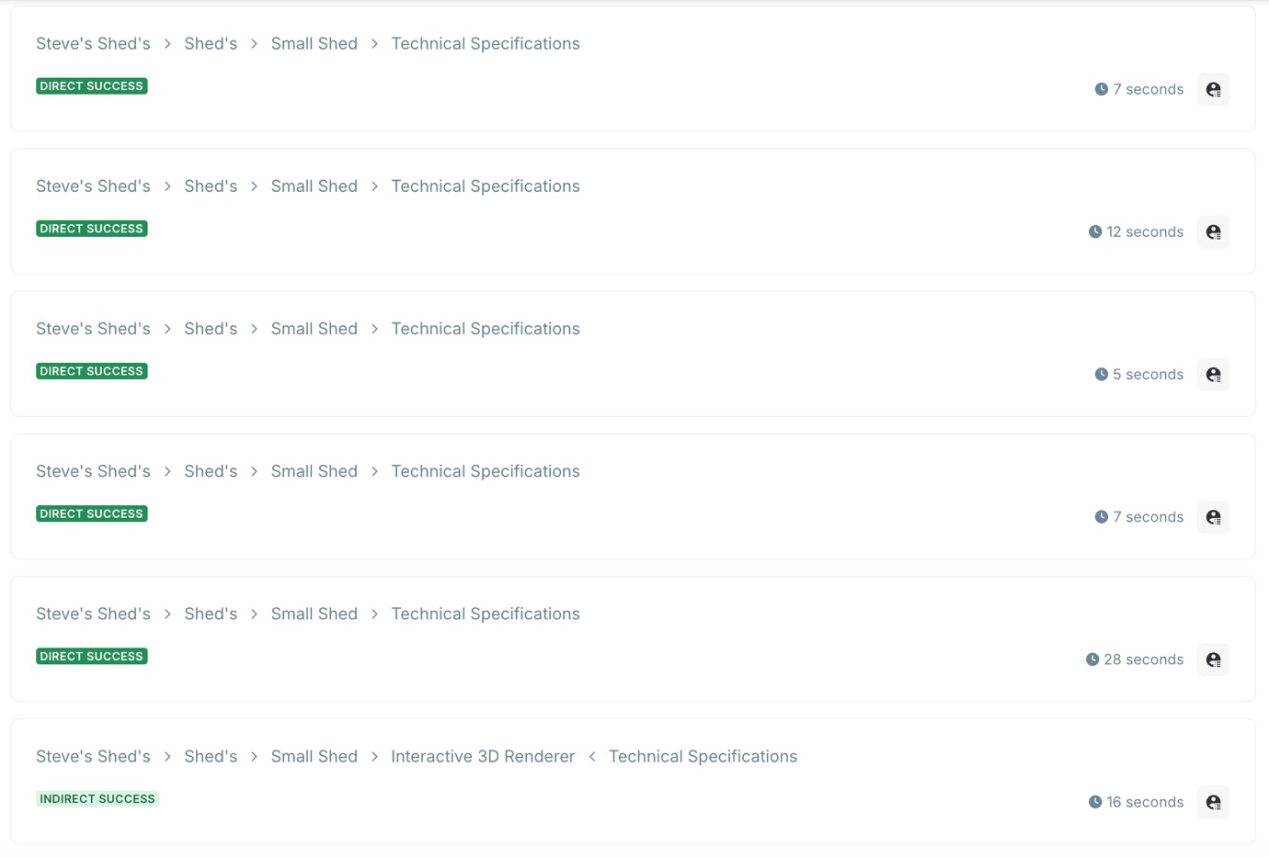

Five out of seven participants were able to ﬁnd the technical speciﬁcation immediately. One participant mistakenly clicked on the Interactive 3D Renderer before clicking on the Technical Speciﬁcation. I decided to view this entry as a Direct Success. The last participant failed to identify the correct location of the information. They mistakenly selected the “Request a Quote” form. To prevent this in the future, the individual shed pages will be updated with clearer labels to distinguish between technical specs and quote requests.

- Find a guide or article that explains the beneﬁts of shed insulation.
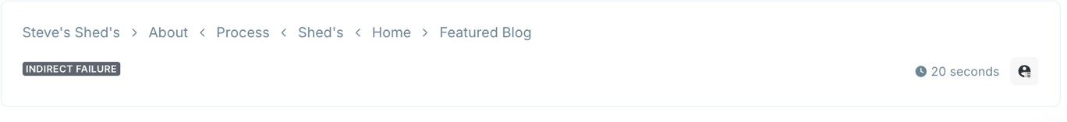

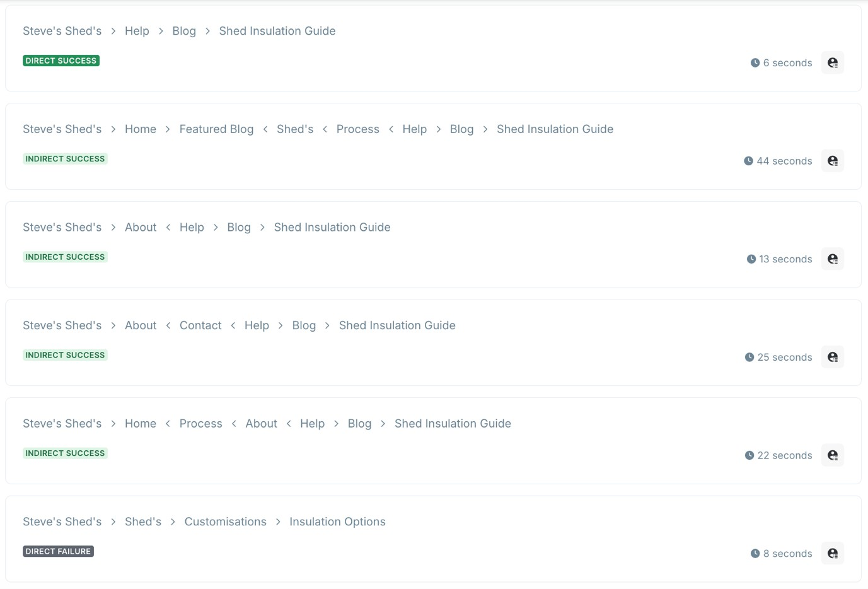

Only one participant was able to ﬁnd the correct guide immediately. However, two participants clicked on the featured blog, which could have been the correct answer if the featured blog had been about Shed Installation. I decided to count that as a Direct and Indirect Success. The remaining participants instinctively clicked on the About page or insulation options rather than the Help section. As a result, the Help page will be renamed to Guides, and relevant articles will be linked directly within the product pages.

- Find where you can purchase mould remover directly from the website.
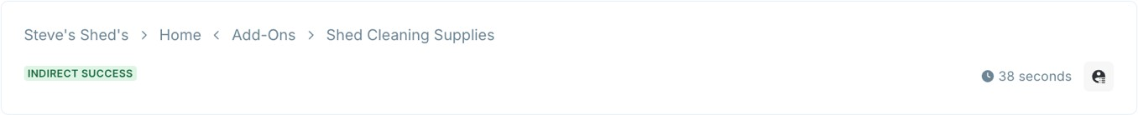

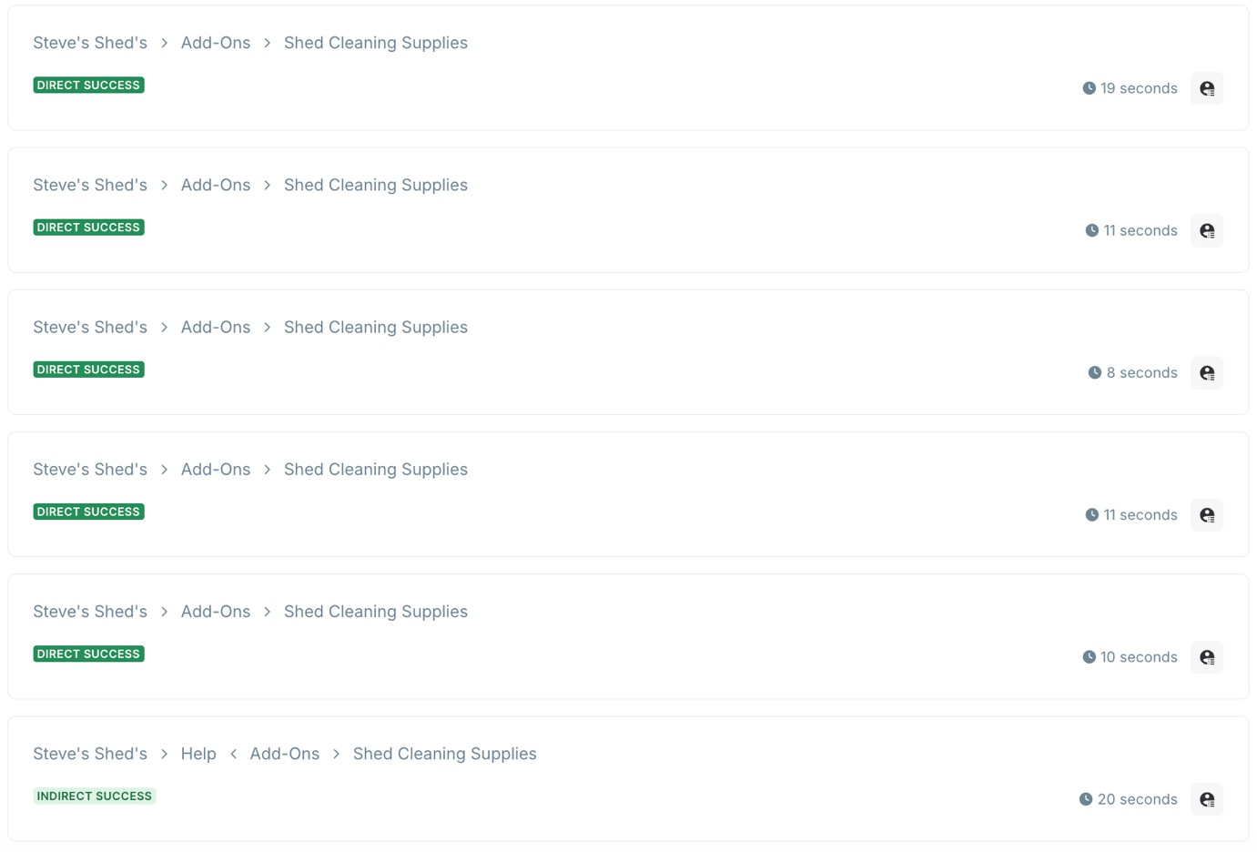
Five of the seven participants immediately found the mould remover. The remaining two participants found it indirectly. ARer renaming the Help page, this expected to further streamline the process.

- Request a Quote from Steve for a Large Shed.

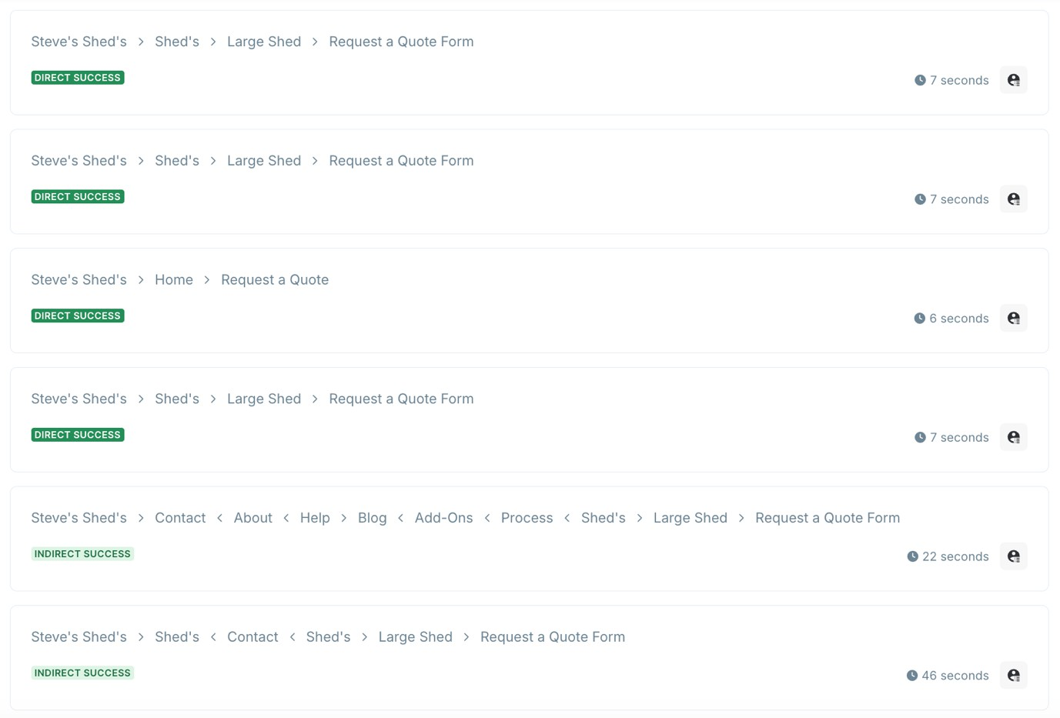
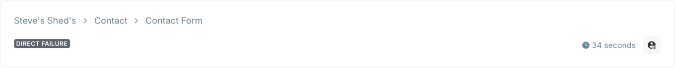

Four participants were able to ﬁnd the correct information immediately. Two participants initially visited the Contact page, while one participant ﬁrst clicked on the Shed page, which was correct. However, they changed their mind and subsequently clicked on the Contact page. To resolve this, a prominent Request a Quote buUon will be added to both the global navigation bar and the homepage.

- Find where the technical speciﬁcations for the "Heavy-Frame Steel" are located.
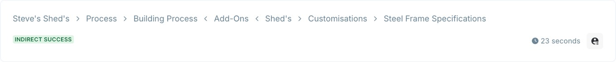

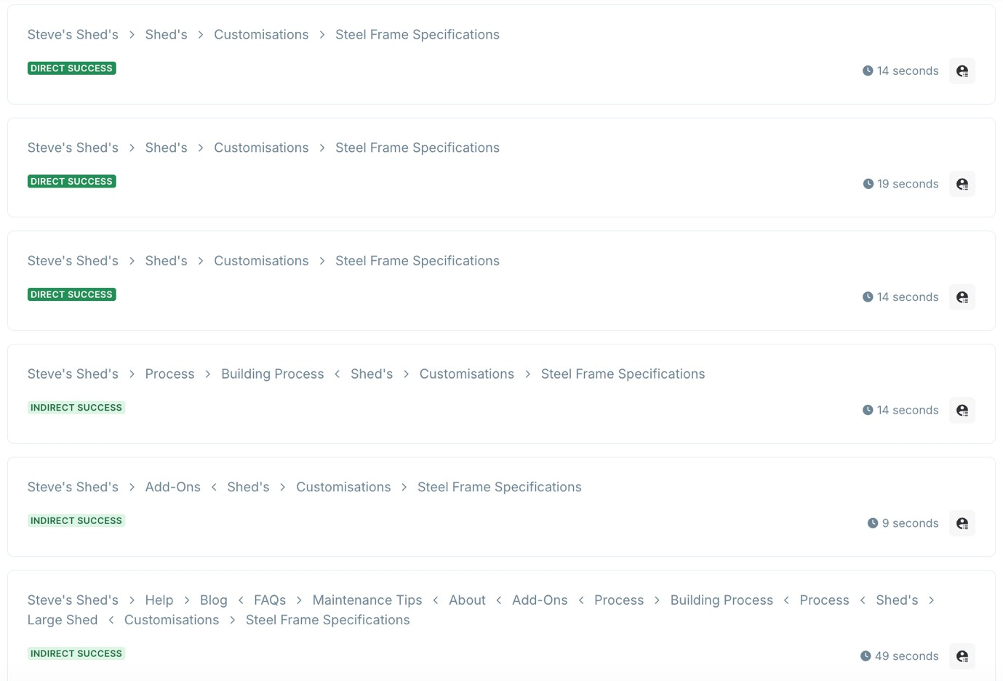

Less than half of the participants were able to ﬁnd the Steel Frame Speciﬁcations directly. Participants struggled with the Customisations subpage, so that section will be renamed to something more descriptive and moved higher in the site hierarchy. This will be a primary focus for the next round of user testing.

- Find out how many years of experience Steve has in construction.

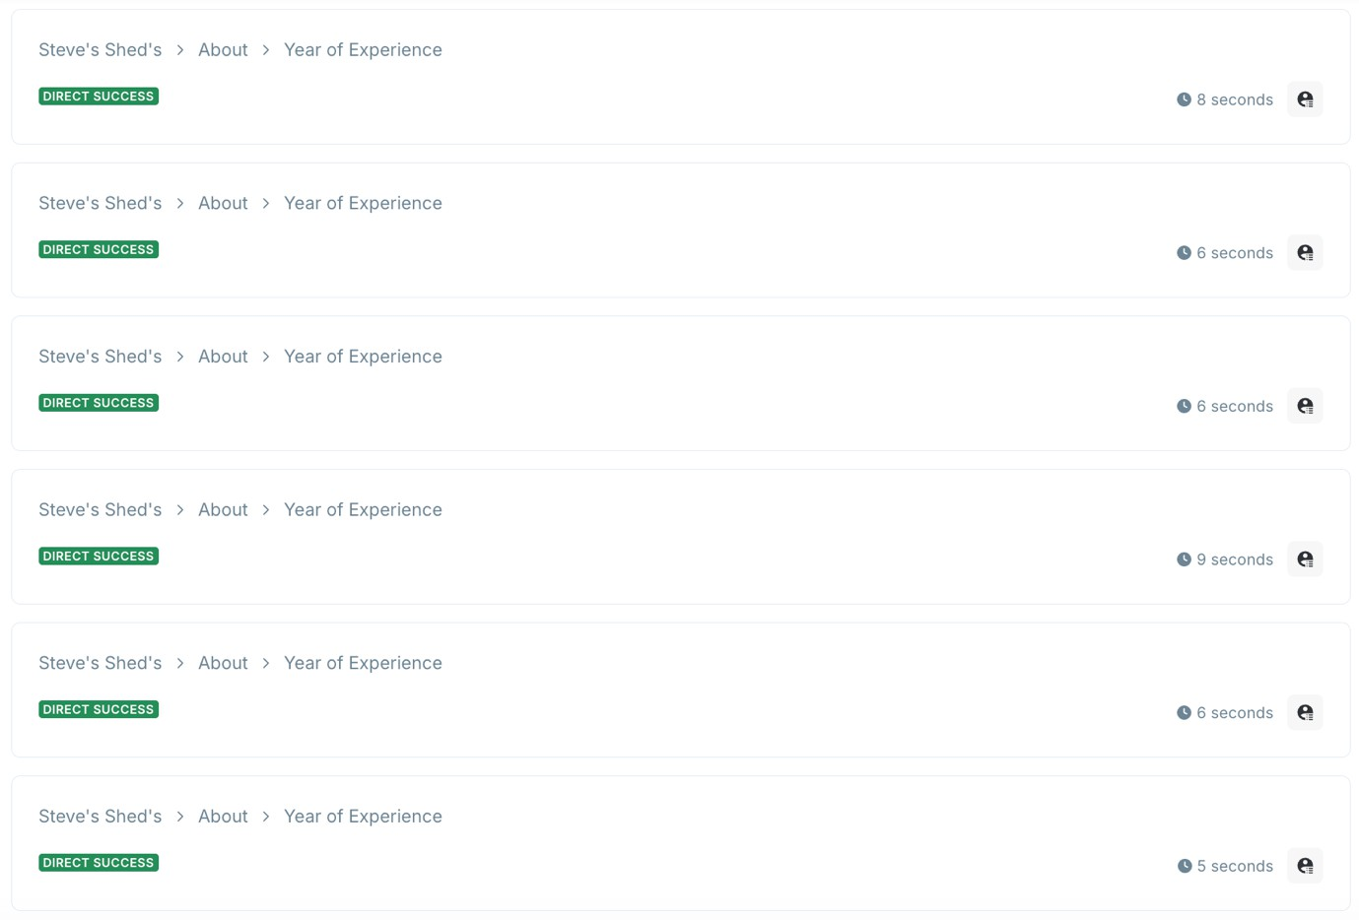

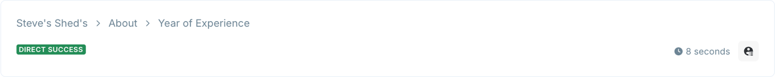
Every participant located the information directly, indicating that no changes are required for this section.

- Find Steve's oﬃce location.
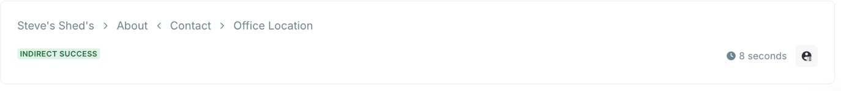

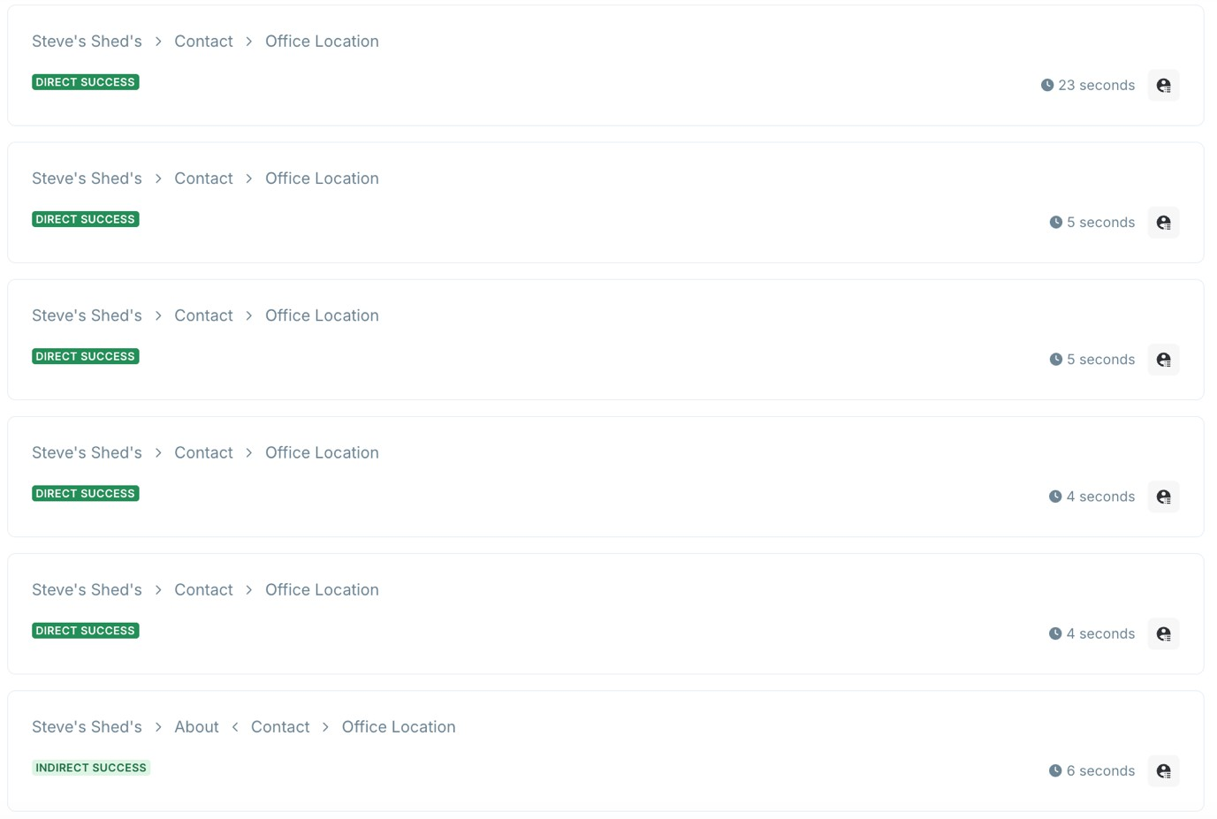
Five participants were able to ﬁnd the information directly. The remaining two clicked on the About page ﬁrst. To ensure this information is always accessible, a global footer containing contact details will be implemented on every page.

- Find the Beneﬁts of buying a Shed from Steve's Shed's.

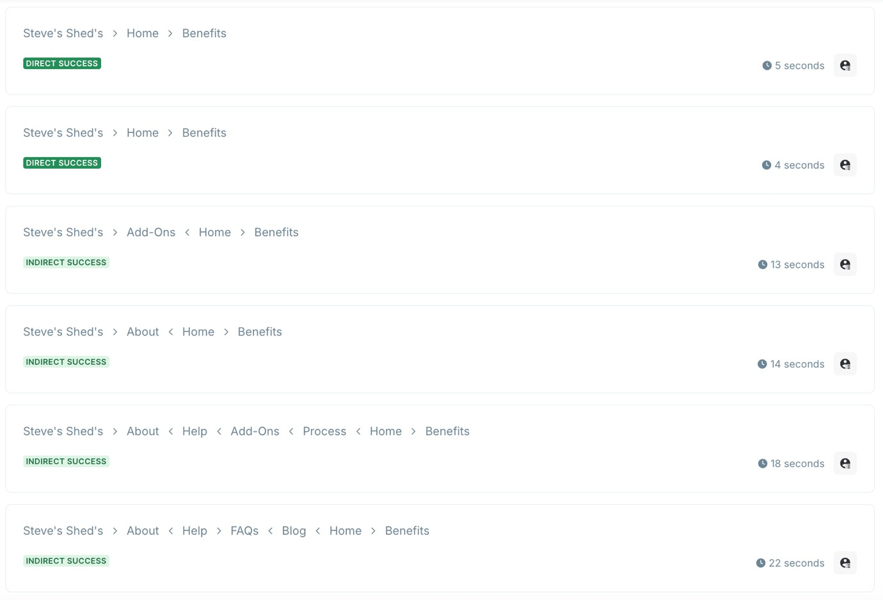
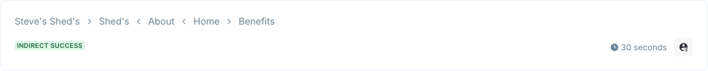
Two of the participants were able to find the benefits of the service directly. The remaining five discovered it only after overwhelmingly clicking on the About page. To address this, the value proposition will be prominently displayed on the homepage and duplicated on the About page.

Summary of Key Changes

Element | Planned Improvement
Navigation | Add "Request a Quote" button to the main nav.
Hierarchy | Rename "Help" to "Guides" and "Customizations" to a clearer technical  label.
Layout | Add a global footer with contact info; move "Beneﬁts" to the Homepage.
Internal Links | Add spec links and guides directly to product pages.

Usability Reports

Paper Wireframes User Tes6ng

User Test 1
User Type: Exploratory & Exhaustive Research.
Goal: Test if the "Total Solution" and Steve’s heritage eﬀectively justify the premium pricing. Format: Paper Wireframes (Mobile)

"You are looking for a high-quality garden room. You have been disappointed by cheap sheds in the past. You’ve heard Steve’s Sheds oﬀer premium quality and a full service.”
"Explore the homepage to ﬁnd out exactly what is included in his service. Once you understand the process, ﬁnd a shed that ﬁts your needs.”

User Testing Notes & Results:
The user successfully identiﬁed what is included in the service and requested a quote.

The user journey followed this path:
Exploration: The user began by scrolling through the homepage, demonstrating the success of the "Scroll & Catch" strategy.
Trust Building: The user prioritised "About Steve" and "Reviews," confirming that heritage and social proof are the primary drivers for high-ticket conversions.
Information Seeking: Navigated to the "Shed Overview" and "Small Shed Detail" pages. The user spent significant time on the Specifications, specifically looking for insulation details.
Conversion: Successfully reached the "Request a Quote" page. Interestingly, the user expressed a desire to use the description field to ask for expert advice on "shed appropriateness," reinforcing the website’s role as a Consultant.

Observation Notes:
- The participant stated that the Information Architecture was highly intuitive and the content under each heading felt logical, nothing was out of place, and they found every required element on the ﬁrst attempt.
- Initially, the user did not understand the purpose of the Blog section. However, once explained as an educational/expert resource, they found it valuable. This suggests a need for better labelling or "teaser" text for the blog.
- The participant repeatedly emphasised that reviews were critical. For a startup business like Steve's, this reinforces the need to highlight past construction testimonials prominently until shed-speciﬁc reviews are available.
- The user's intent to ask technical questions in the quote form validates the decision to move away from a standard "Add to Cart" e-commerce model toward a professional inquiry system.

User Test 2
User Type: Known-Item Seeking & Re-ﬁnding.
Goal: Test the navigation eﬃciency and the "Request a Quote" conversion path. Format: Paper Wireframes (Mobile)

"You have already decided you need a Small Garden Shed for storage. You don't want to read a lot of technical jargon, you just want to see the specs and get a price estimate as quickly as possible."

"Starting from the homepage, ﬁnd the Small Shed details. Once you've reviewed the basic measurements and materials, initiate the process to get a quote from Steve."

User Testing Notes & Results:
The user demonstrated a highly efficient path to completion, requiring zero interventions. The user journey was as follows:
Direct Navigation: Upon landing on the Homepage, the user bypassed all introductory text and secondary links, immediately going to the "Our Sheds" page.
Product Selection: The user identified and clicked the Small Shed card without hesitation.
Critical Information Scanning: On the detail page, the user ignored the technical information and scrolled directly to the size specifications and the "Request a Quote" call to action (CTA).
Completion: The user simulated filling out the form and hit "Submit" within a rapid timeframe.

Observation Notes:
- The speed at which the user moved through the site validates the "Minimalist Design" principle. By removing cluttered sidebars and dense paragraphs, I enabled users to find their target with zero cognitive load.
- The user’s ability to find the "Small Shed" immediately proves that the homepage visual hierarchy, placing the core product range near the top, is effective for efficiency-focused users.
- The user reported "no issues" with the path. This confirms that even without a direct "Buy Now" button or public pricing, the "Request a Quote" button is perceived as the logical and intuitive next step for a premium service.

User Test 3
User Type: Exploratory & Exhaustive Research.
Goal: To evaluate the appropriateness of content placement and the visibility of credibility markers.
Format: Paper Wireframes (Mobile)

"You have already decided you need a Garden Shed. You don't want to hire an inexperienced builder and are looking for proven experience and credibility markers."
"Starting from the homepage, find details on Steve’s experience. Once you've reviewed the experience, contact Steve via email."

User Testing Notes & Results

The user followed an exploratory path focused on veriﬁcation before moving toward conversion.
The user journey was as follows:
Credibility Search: The user initially bypassed products, scrolling the Homepage to find the "About" information, then clicking through to the full About Page to verify Steve’s construction background.
Social Proof: User scanned the reviews section to validate the quality of work.
Visual Verification: The user attempted to find a dedicated "Previous Work/Gallery" page. Upon failing to find a gallery, they returned to the "Shed Catalogue", hoping to find real-world installation photos rather than just product renders.
Navigation & Contact: Once satisfied with the brand’s professionalism, the user accessed the Contact Page via the menu and successfully simulated sending an inquiry.

Observation Notes:
- The placement of the "About" section on the Homepage was rated as appropriate. It is visible enough to build trust, but not intrusive to the product selection.
- A signiﬁcant ﬁnding was the user's diﬃculty distinguishing between a Shed Catalogue (items for sale) and a Gallery (proof of past work). This conﬁrms that for high-ticket items, users seek visual evidence of ﬁnished projects.
- The user noted that while the "About" content was good, they wouldn't naturally look for "The Process" (Foundations/Cleanup) inside the About page. They expected this technical detail elsewhere.
- The user expressed a desire for a visible phone number alongside the contact form, speciﬁcally for urgent or high-value inquiries

Figma Medium-Fidelity Wireframes User Tes6ng

User Test 1
The "Expertise & Maintenance" Discovery
Goal: Test if the new labelling for the Blog/Help section is now intuitive.
Format: Medium-Fidelity Figma Wireframes
"You’ve noticed some condensation in your current shed and want to know how Steve prevents mould in his builds before you consider buying from him."

"Find the section of the website that provides expert advice on shed maintenance and mould prevention."

User Testing Notes & Results
The user followed a generally cautious but successful path to completion. The user journey was as follows:
- The user started by quickly skimming through the main parts of the home page.
- They didn’t immediately ﬁnd the location of the guides.
- The user hovered over a few headings (sheds & products) as they connected mould prevention to build quality.
- When noticed further across the header, they chose the guide’s button.
- A]er opening the guides page, the user was conﬁdent they had chosen the correct page as the page contained advice material.

Observation Notes:
- The user comprehended the task and expected to see the correct page somewhere on the site.
- There was a slight initial hesitation about where the advice would be.
- The participant ﬁrst associated mould prevention with the shed quality, as a result, they wandered around the sheds and products page.
- The user was able to complete the task easily, but not instantly.
- The new labelling is more eﬀective than “Blog” as it suggests more practical information rather than promotional or generic articles.
- The user could still interpret the section as anything, such as support, generic reading, or other user stories.

User Test 2
The "Visual Proof" Hunt
Goal: Test the new Gallery placement and the distinction between "Catalogue" and "Past Work."
Format: Medium-Fidelity Figma Wireframes
"You like the 3D renders of the sheds, but you want to see a photo of a real shed Steve has actually installed in a customer's garden to judge the quality of the ﬁnish."

"Locate the gallery showing photos of previously completed projects. A]er viewing the photos, return to the homepage."

User Testing Notes & Results
The user followed a highly efficient and successful path to completion. The user journey was as follows:
Navigation: The user immediately identified the differences among the options and navigated to the previous section without hesitation.
Gallery Engagement: The user successfully located the photos of previous builds to judge the quality of the finish.
Product Discovery: The user transitioned to the catalogue and utilised the filter system to narrow down shed types.
Return: After viewing the relevant information, the user found the path back to the homepage to be easily accessible and intuitive.

Observation Notes:
- The user was able to distinguish between the commercial catalogue and the portfolio of work quite fast, validating the new layout and menu structure.
- A critical ﬁnding was that the user struggled to fully visualise the ﬁnal product based solely on 3D renders. They expressed a strong preference for high-quality, real-life photos of installed sheds to accurately judge the scale and ﬁnish.

The user was happy with the catalogue and was able to easily ﬁlter out the kind of shed they wanted.
The user was able to locate the photos of previous projects, and going back to the homepage was easily accessible to him.
The user was happy with the layout of everything and was able to distinguish between all the options. But he did say it would be nice to have names of the speciﬁc sheds a]er ﬁltering out what he’s looking for, as he has to press details to see the name, etc.

User Test 3
The "High-Urgency" Contact Path
Goal: Test the visibility of direct-contact methods (Phone) and the eﬀectiveness of the Contact Form.
Format: Medium-Fidelity Figma Wireframes
"You have a very speciﬁc custom size requirement, and you need an answer urgently. You want to speak to Steve directly rather than waiting for an email reply."

"Find the company's phone number to make a direct inquiry. If you can't ﬁnd it, use the fastest available method to send your custom dimensions to Steve."

User Testing Notes & Results
The user followed a highly direct and successful path to completion. The user journey was as follows:
Immediate Action: Upon landing on the Homepage, the user bypassed all scrolling and went directly to the Navigation Bar.
Navigation: The user clicked the "Contact" button immediately, showing that the header labels are clear and well-positioned.
Discovery: Once on the Contact Page, the user identified the phone number instantly. Completion: The user confirmed that their goal was met and expressed confidence that they could now reach Steve directly for an urgent inquiry.

Observation Notes:
- This user test confirms that adding a phone number has successfully addressed a major user need in "High-Urgency" scenarios.
- A significant insight was the user’s follow-up question regarding the Footer. The participant noted that if the header link hadn't been there, the footer would have been their second place to look. This reinforces the "Mental Model" that users have for professional service websites.

User Test 4
Background: Cian is not the person who would buy a shed, but his dad might ask him to look it up.
Format: Medium-Fidelity Figma Wireframes
Task 1:
Have a look at the About page and tell me what the company does. Done.
Took about 10 seconds. Said, "Yeah, it's a shed company, they do delivery and ﬁyng, seems grand."

Task 2:
Is there anything on the page that would make your dad trust them? Done.
Pointed at the 1ti+ years badge. Said, "That's the main thing, if they've been around that long, they're not going to rip you oﬀ."

Task 3:
Find the phone number. Done, but slow.
Scrolled all the way to the bomom ﬁrst, then back up. Found it a]er about 20 seconds. Said, "I thought it'd be at the bomom."
-> Phone Number will be at the bottom, but due to the lower fidelity model, it's just a label “Phone Number” without the actual caller ID.

Task ti:
Find out when they're open. Half done.
Found Mon-Fri but said "what time though? That's not helpful."
-> waiting on Steve to conﬁrm further details, put in placeholders while I wait

Observation Notes:
- He tried using the contact form but commented that "I'd just WhatsApp them or something, this form is annoying."
- No opening times, just days (Mon-Fri). He asked straight away what time they open. Someone like his dad might not bother ringing if they don't know whether the oﬃce is open.
- He understood the business in about 10 seconds from the About page. The About section is clear.
- The 1ti+ years, Certiﬁcation, and All-Ireland badges were immediately seen as proof that the company is legit.
- Navigation was ﬁne. Found the Contact page without any trouble.
- The overall look didn't put him oﬀ. He said it looked like a normal business site.

Figma High-Fidelity Interac6ve Prototype User Tes6ng

User Test 1 – Mobile
Task: Navigate to the Small Garden Shed detail page. Once you have viewed the details, return to the previous page.

User journey:
- User starts on the home page.
- Taps the “Our Service” Small Shed tile to go to the Small Shed overview.
- Clicks the back button, but nothing happens.
- Clicks the menu and selects the Sheds tab there.

Observation Notes:
- The user immediately understood where to go for the information.
- However, when the user wanted to return, the back navigation arrow was non-functional.
- The back arrow (←) displayed in the upper le] of the shed detail page does not trigger any navigation when clicked. The user has no alternative way to return to the previous page other than using the browser back button or the main navigation bar.
- This breaks the expected interaction pattern. Forcing reliance on the browser back button is inconsistent with the site's otherwise self-contained navigation model and introduces unnecessary friction at a critical point in the decision-making journey.
Recommendation: Link the back arrow to the Sheds catalogue page. In the high-fidelity prototype, this should be a fully interactive component consistent across all product detail pages.

User Test 2– Desktop
Task: Find the speciﬁc section for Standards Sheds. Identify which Sheds are available in a "Brown" ﬁnish.

User Journey:
- The user began on the home page.
- Located the "Our Standard Sheds" section by scrolling.
- Selected "View more" from the medium shed option.
- Landed on the Sheds page.
- Browsed through the ﬁlter panel located on the le].
- "Brown" was selected under the colour ﬁlter.
- Observed the most recent shed results.

Observation Notes:
  - The user immediately understood the meaning of "Standard Sheds."
  - Although the "View more" CTA was eﬀective, the user only had to brieﬂy scan before clicking.
  - The ﬁlter system was easy to use, particularly in this case with the obvious "Colour" label.
  - A]er choosing Brown, the user anticipated a visual change right away (a positive UX expectation).
  - The layout was clear; however, the user took a moment to take in the page before clicking the ﬁlters.
  - Navigation was unaﬀected by the absence of original product text or photos.

User Test 3 – Mobile
Task: Locate the Guides section and click through to the speciﬁc article about Shed Modular Homes.

User Journey:
- The mobile home screen was opened
- The hamburger menu (upper right horizontal lines) was tapped
- "Guides" chosen from the navigation
- Landed on the 'Guides' page
- Browsed the Recent Posts section
- Found the article with the title "Modular Homes."
- Successfully clicked into the article

Observation Notes:
  - Good mobile navigation patterns are evidenced by users’ instinctive use of the hamburger menu.
  - Although the user understood the title "Guides," they glanced at the other options.
  - The article’s list arrangement was clear, particularly in the pairing of image and title.
  - The user took extensive reliance on keywords in titles, in this case, "modular homes."
  - Recognition was somewhat delayed by placeholder content.
  - Scrolling was normal and anticipated behaviour.

User Test 4 – Desktop
Task: Locate the Process page and identify the speciﬁc step that deals with waste. Conﬁrm whether this service is included in the initial price or if it costs extra.

User Journey:
- The user began on the home page.
- Immediately identiﬁes “Process” on the menu bar and selects it.
- Scrolls to “Site Clean Up & Waste Removal”.
- Successfully found the information.

Observation Notes:
  - The user immediately understood where to go to ﬁnd the information.
  - The user scrolled uninterrupted to the spot on the Process page with the relevant information, demonstrating appropriate use of headers.
  - The layout was clear.

User Test ti – Mobile
Task: Navigate to the Process Page. Find the section regarding Site Preparation and identify what the customer is responsible for before Steve arrives.

User Journey:
- The user ﬁrst scrolled to the “our service” section on the home screen.
- The step 01 tile was clicked, and the information was read.
- The hamburger menu was clicked.
- "Process" was chosen from the navigation.
- Scrolled to Step 02 and read the information.
- Determined the customer didn’t have to do anything and therefore successfully found the information.

Observation Notes:
  - Good mobile navigation patterns are evidenced by users’ instinctive use of the hamburger menu.
  - Good UI as tiles were clicked by the user.
  - Scrolling was normal and anticipated behaviour.

User Test 6 – Desktop
Task: Locate the Shed section. Find the "Small Shed" option and identify if it is available in the "Olive Green" ﬁnish. Once identiﬁed, ﬁnd the dimensions for this speciﬁc shed size.

User Journey:
- The user began on the home page.
- Immediately clicked “Sheds” in the menu bar.
- Scrolls to “Small Sheds” and clicked “View More”.
- Clicked the olive-green tile in the 3D renderer.
- Scrolled down to read the speciﬁcation.

Observation Notes:
  - The user immediately navigated to the correct location.
  - The user was shortly confused by the 3D render, as a]er clicking “olive green”, only one size was highlighted.
  - However, a]er reading the specs, it became clear that the olive-green small shed was available in two sizes.
  - Navigation was unaﬀected by the absence of original product text or photos.

Design Master Template
Steve's Sheds is a Shed business that sells three standard size Sheds and a range of DIY kits. This document outlines the visual design decisions for the website, covering the colour ppalette, typography, white space, and UI conventions. Each decision has been made with the dual goal of reﬂecting the brand's identity and ensuring the site is accessible and intuitive for all users.

Colour PaleTe
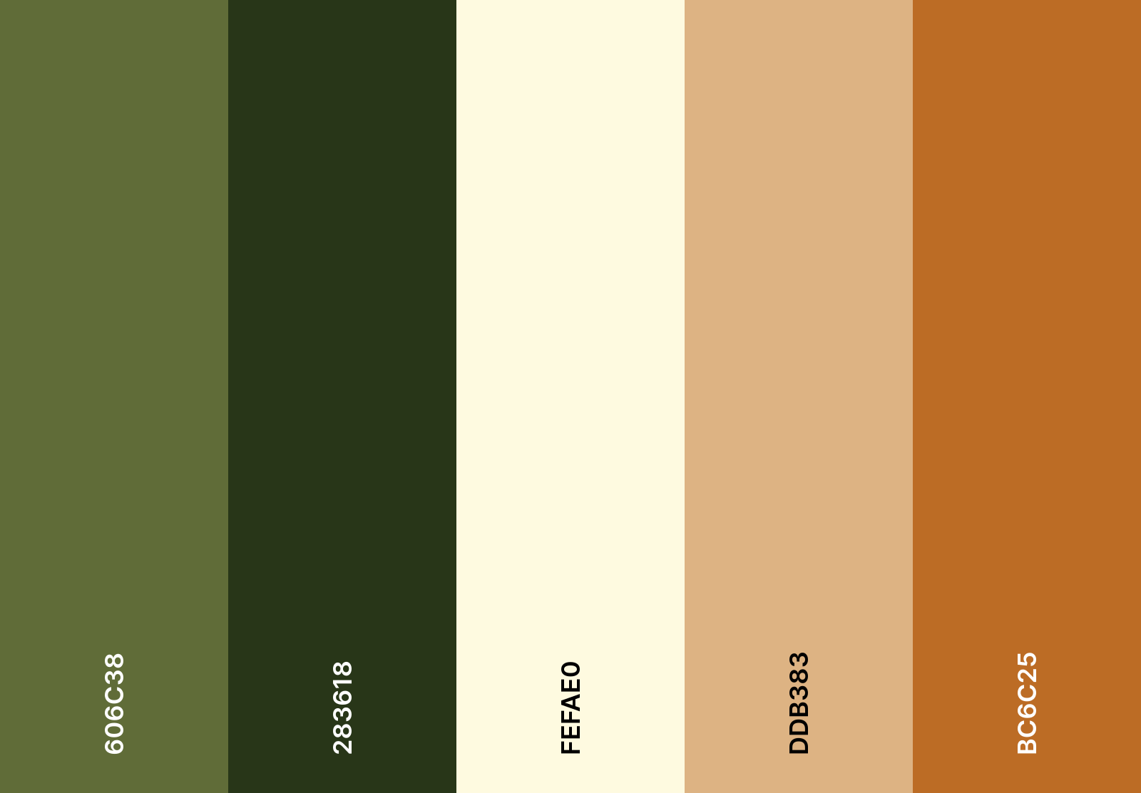
The ﬁve colours selected form a cohesive, nature-inspired ppalette that reﬂects the cra]smanship and outdoor character of Steve's Sheds.
#283618 — Black Forest is the dominant brand colour, the colour that customers will forever associate with the business. As a dark shade of green (black added to the base hue), it communicates authority, solidity and trustworthiness. It anchors the design and works powerfully as a navigation bar, header or footer, giving the site a premium, established feel.
#606C38 — Olive Leaf acts as a natural secondary accent. Being a tone of green (grey added to the hue rather than black or white), it feels muted and grounded rather than loud, evoking the outdoors, gardens and nature without demanding amention. It sits comfortably alongside the dominant dark green as the two share the same hue family.
#FEFAE0 — Cornsilk is the background colour. It is a warm tint of yellow-white, far more inviting than clinical pure white, and keeps the overall ppalette feeling natural and cohesive.
#DDB383 — Sunlit Clay introduces warmth and references natural timber, the core material of sheds. It works well as a secondary accent for cards, section dividers or image overlays, reinforcing the cra]smanship message without competing with the dominant greens.
#BC6C2ti — Copperwood is the call-to-action colour. Warm orange tones carry associations of energy, enthusiasm and action, making this ideal for buttons like "Get a Quote" or "Get in Contact." It contrasts strongly against both the cream background and the deep greens, drawing the eye exactly where conversion mamers most.

The ppalette sits within the analogous zone of the colour wheel, clustering around the green-yellow-orange arc. Analogous ppalettes feel inherently harmonious because the colours are neighbours in nature, think moss, timber, and autumn leaves. The cool greens suggest calm, reliability and the outdoors, while the warm amber and tan inject approachability and energy, preventing the design from feeling cold or corporate.

Accessibility
The primary text colour Black Forest #283618 was tested against the background colour Cornsilk #FEFAE0 using the WebAIM Contrast Checker, producing a contrast ratio of 12.24:1. This comfortably exceeds the WCAG AA requirement of 4.ti:1 for normal text and surpasses the more stringent WCAG AAA threshold of 7:1, achieving a pass across all text sizes and UI components.
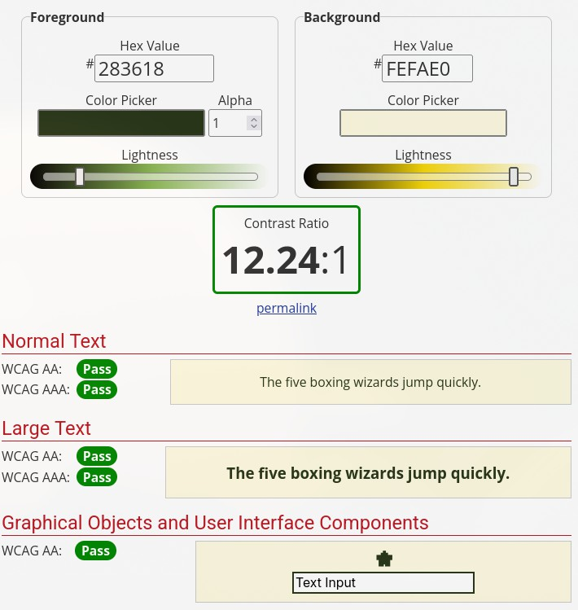
None of the ppalette colours double as error or success indicators, eliminating any risk of confusion for users with colour vision deﬁciency, which aﬀects approximately 8% of men and 0.ti% of women. Error and success states will instead pair colour with a supporting icon and descriptive text, ensuring all users receive clear, unambiguous feedback regardless of their ability to distinguish colour.
The comparisons below simulate how the ppalette appears across four common forms of colour vision deﬁciency: Protanopia and Deuteranopia, both of which aﬀect the perception of reds, greens, and yellows; Tritanopia, which causes confusion between blues and greens; and Achromatopsia, a rare condition in which colour is perceived only as shades of grey. Across all four simulations, the ppalette retains suﬃcient contrast and visual distinction, conﬁrming that the design remains coherent and functional for the broadest possible audience.

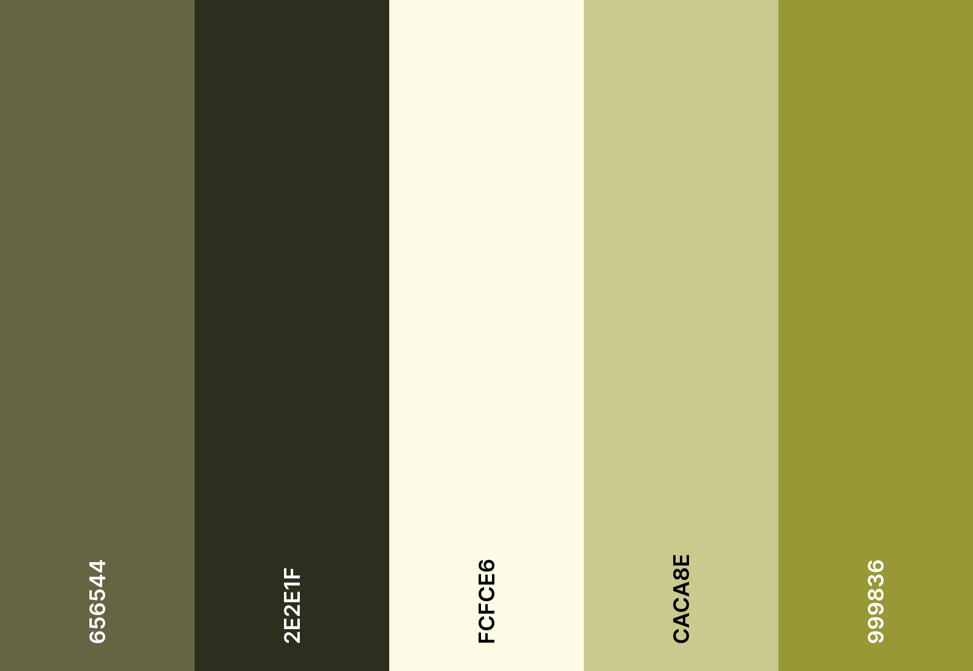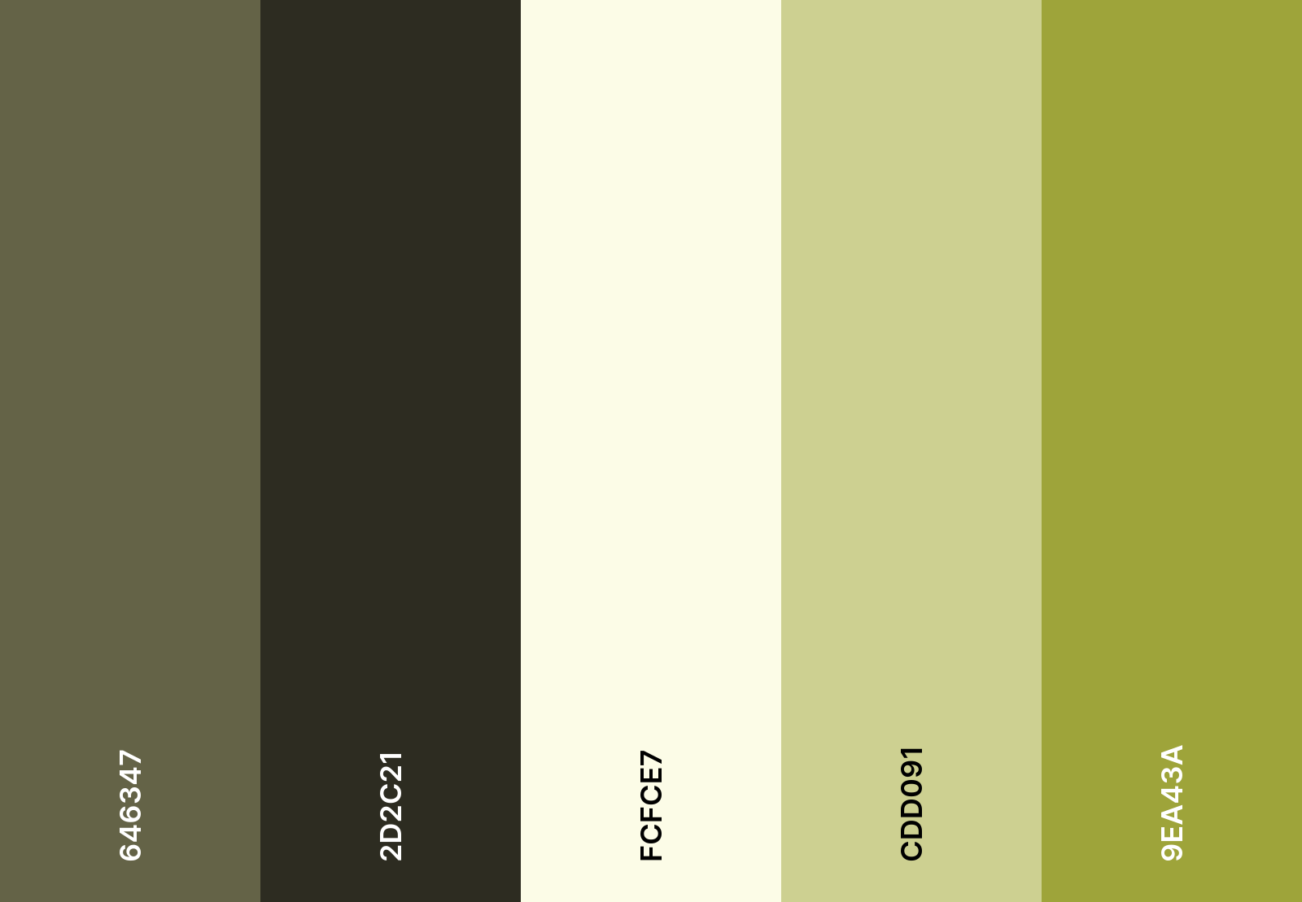
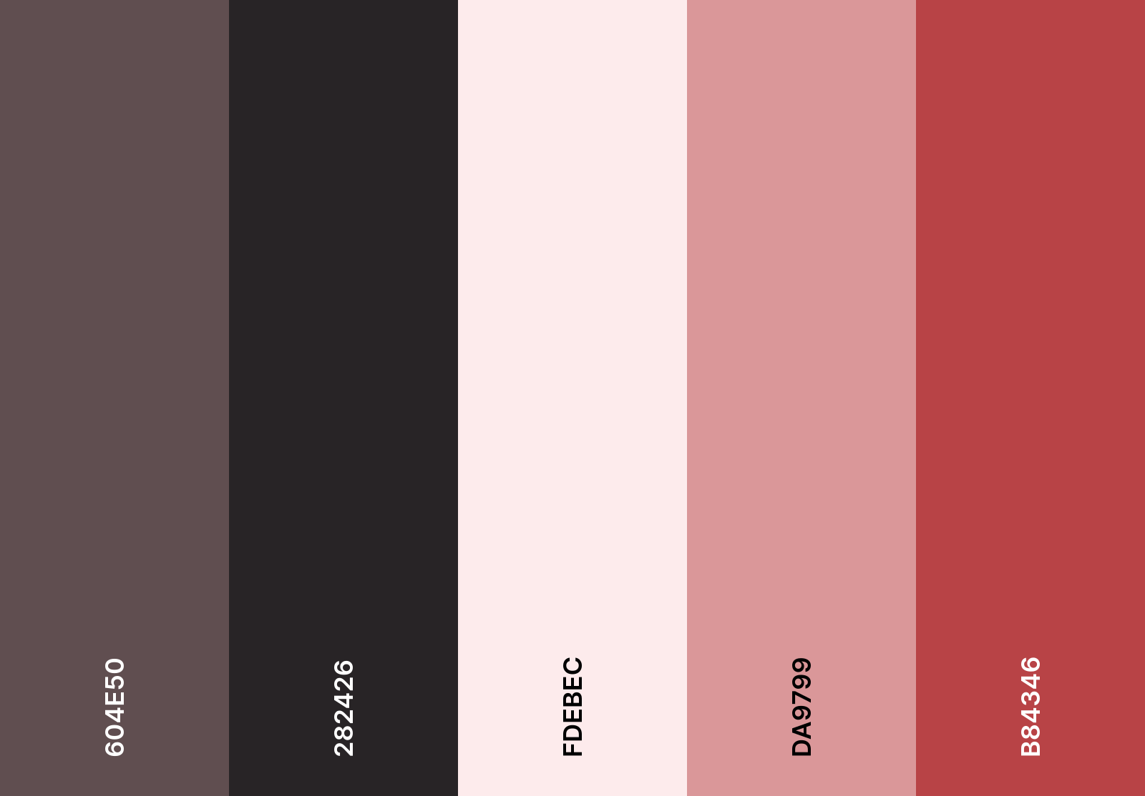
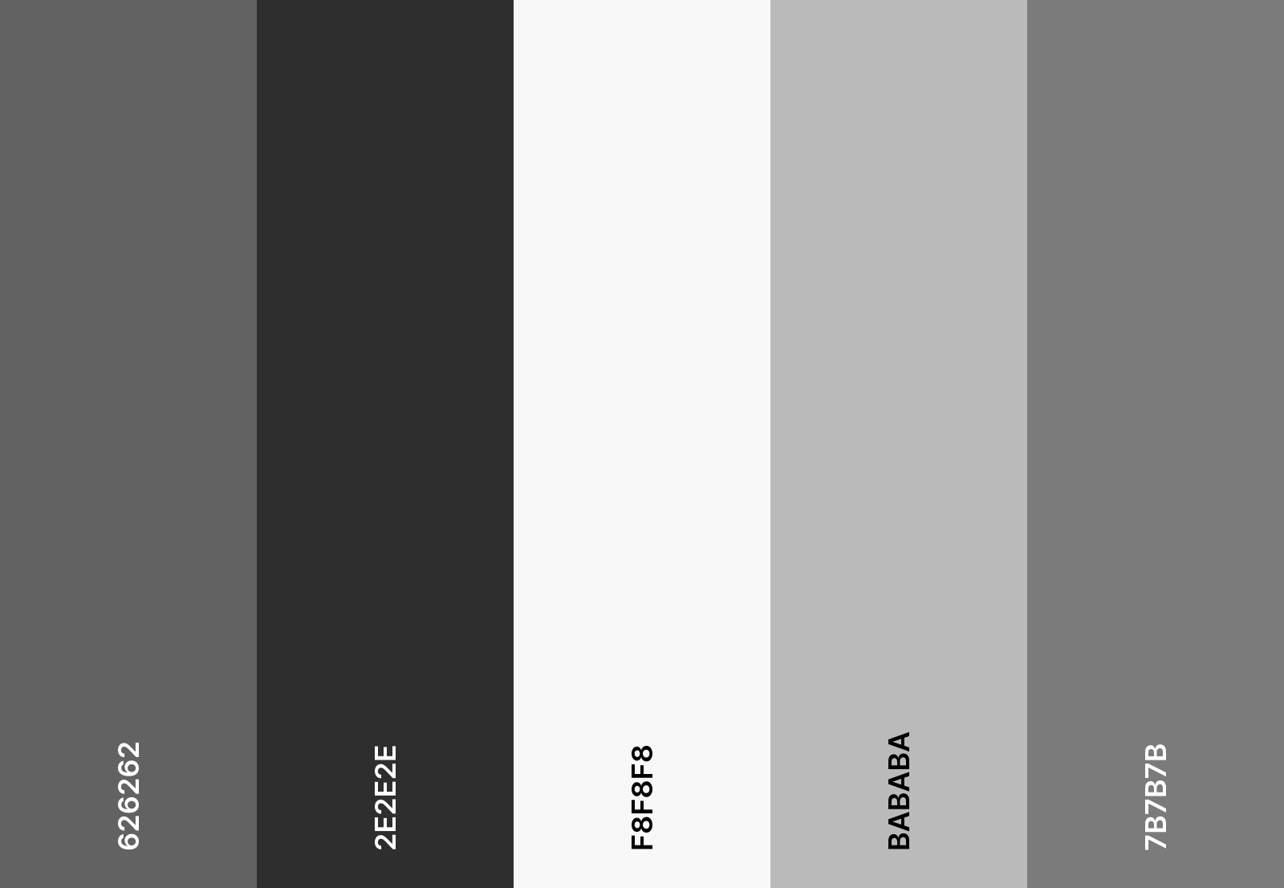
Protanopia Deuteranopia
Tritanopia Achromatopsia

Typography
The site uses two typefaces, Bitter for titles and Source Sans 3 for subtitles and body text. Bitter is a slab serif with strong, solid letterforms that suit a brand built around outdoor products. Source Sans 3 keeps subtitles and smaller text clean and easy to read without competing with the titles for attention. Together they create a clear visual hierarchy, allowing users to naturally scan the page and ﬁnd what they need, whilst both hold up well across diﬀerent screen sizes.
Line length will be kept to around 60 characters per line on desktop and 30-40 on mobile, line height will be set to at least 1.tix, and all caps will be avoided for body text as it signiﬁcantly slows reading speed. All text will appear in Black Forest #283618 against the Cornsilk background #FEFAE0, conﬁrmed to meet WCAG AAA standards.
Primary body content and descriptive blocks utilise justiﬁed orientation. This decision was made to reinforce the website's "Premium Gallery" aesthetic. By aligning both the le] and right edges of the text, I create clean, architectural lines that mirror the structural precision of Steve’s shed builds. To ensure this does not impact readability or accessibility for the users, I have implemented a generous line height and strict per-line character limits as mentioned above. This prevents the formation of irregular white-space gaps and ensures that the text

maintains a formal, sophisticated appearance that distinguishes Steve’s Sheds from lower-tier, cluttered competitor sites.

White Space and UI Conventions
White space is an active design decision that makes an interface easier to navigate and less overwhelming. Generous padding will be applied around text blocks, buttons and images to give each element room to breathe and allow users to focus on one thing at a time, particularly important for a product-focused site where cluttered layouts can discourage users from completing key actions.
The site will follow established UI conventions to reduce cognitive load and allow users to navigate intuitively, with dark text on a light background throughout and clear visual distinction between interactive and static elements.

Corner Ratios
To ensure a cohesive visual language across all devices, a tiered corner ratio system has been implemented. For mobile screens, a corner radius of 5px is utilised for buttons, images and cards. This subtler rounding maintains a structured, professional appearance within the constrained pixel real estate of handheld devices, ensuring that elements feel deﬁned without appearing "bubble-like" or losing internal padding space.
For desktop screens, the ra3o is increased to 15px. On larger displays, this more pronounced curvature softens the interface, aligning with the brand’s approachable and human-centric identity. Psychologically, rounded corners are easier for the human eye to process than sharp 90-degree angles, as they lead the eye toward the centre of the element, eﬀectively increasing the perceived clickability of my primary call-to-action buttons.

The design choices made for Steve's Sheds are grounded in both visual appeal and accessibility. The analogous colour palette draws on the natural world to reﬂect the brand's outdoor identity, whilst the typography pairing of Bitter and Source Sans 3 ensures content is readable and approachable across all devices. Accessibility has been a consideration at every stage, from contrast ratio testing to colour blindness provisions, ensuring the site is usable by the widest possible audience. Together, these decisions create a coherent visual identity that communicates salesmanship, reliability and approachability, giving Steve's Sheds a strong and trustworthy presence online.

Accessibility
This project was developed with accessibility in mind. Although these designs currently exist only as a Figma prototype, the following principles have been integrated into the interface's visual and structural foundation.

Visual and Auditory Accessibility
The design prioritises clarity for users with low vision or colour vision deﬁciencies such as Protanopia and Deuteranopia. By utilising a primary text colour of Black Forest (#283618) against a Cornsilk (#FEFAE0) background, the pages achieve a contrast ratio of 12.24:1. This comfortably surpasses the WCAG AAA requirement, ensuring maximum readability. To support those who struggle with dense text, I implemented a generous line height and avoided using all caps for body text, which can often hinder reading speed.

Furthermore, the design ensures that information is never conveyed solely through colour. The "Step" tiles on the Home page and the circular process icons on the Process page use distinct shapes and clear text labels to remain functional even in greyscale. The error messages use crosses and ticks on top of colour to convey the information accessible. All critical information about Steve and the four-stage installation journey is provided in clear, written English, eliminating reliance on audio-only cues.

Structural Logic and Screen Reader Compa3bility
While a prototype cannot be read by a screen reader in the traditional sense, the layout of all pages was structured to follow a logical, linear hierarchy. The headings, such as "Our Standard Sheds" and "Our Service," are clearly deﬁned, allowing a visually impaired user to intuitively jump between sections. Rather than using vague "Click Here" prompts, I utilised descriptive button labels such as "View More" and "Request a Quote" to provide immediate context for users of speech-to-text tools. I also ensured that most of the pages maintain a consistent vertical ﬂow, which is easier for screen readers to parse than complex, multi-column layouts.

The Layout and Labels of the Shed Page
Each shed is presented in a consistent card layout with clear images and "View more" buttons. The colour options are supported by text labels to ensure that the design does not rely solely on colour. Strong contrast throughout helps the important elements to stand out. The overall layout remains simple and predictable, even with the placeholder content. The Sheds page is designed for clear, accessible browsing, with a structured ﬁlter panel that is easy to scan and utilise.

The Layout and Labels of the Guides Page
The Guides page's standard vertical layout and distinct titles make it simple to read and navigate, allowing readers to eﬀortlessly review the content. The structure still presents the

guides, even though some content is temporarily a placeholder because the client has not provided all the necessary information. There are distinct labels for each category, and the continued colour scheme contrast helps important elements stand out while remaining clearly visible for all users.

The Layout and Labels of the Add-ons Page
A standard card-like format is used for the Add-ons page to make browsing simple and predictable. Every item has the same structure, which helps users minimise confusion. The layout still shows how users would interact with the page, even though some products are placeholders for now. For ease of use, particularly on mobile devices, ﬁlters and buttons are scaled and labelled consistently with the rest of the screens.

The Layout and Colours of the Contact Page
The form ﬁelds on the Contact page have a visible rounded border that clearly distinguishes them from the cream background, meeting the required 3:1 ratio for UI components. The primary 'Send message' button uses white text on a dark green ﬁll, which is clearly legible. The 'Request a Quote' button in the nav stands out as a warm amber against the dark green bar, making it easy to identify as the primary call to action.
Importantly, the conﬁrmation screen doesn’t rely solely on the green checkmark. It’s paired with the heading 'Message sent', the supporting line 'Thanks for staying in touch', and supporting icons, so even if a user can't perceive the green colour, they still receive the same information through the text. On the Contact page, the amber labels like 'Phone' and 'Email' add visual structure, but the meaning isn't lost without the colour. They’re plain text labels that work regardless.

Simple and Clear Written Content of the About page
The About page’s biography clearly communicates Steve's background without jargon. The beneﬁt cards are short and scannable. This is an area of the website where the content naturally supports accessibility, as the subject doesn't require complex language in the ﬁrst place.

No Flashing or Flickering
There are no animations, auto-playing videos, or ﬂashing elements anywhere in the prototype. Everything is static. This satisﬁes the guideline on seizure risk and also ensures the design is comfortable for users with vestibular disorders who may be affected by on-screen motion.

Keyboard Navigation
All the interactive elements in the prototype form ﬁelds, buttons, and nav links are laid out in a logical order that would translate directly into a sensible tab sequence in a real implementation.

Audio and Captions
There is no audio or video content in the current prototype, so this criterion doesn't apply at this stage. If multimedia were added in a future iteration, for example, a video walkthrough of the shed building process, captions would need to be included at that point.

Timed Responses and Session Timeouts
Nothing in the prototype is time-limited. The contact form has no expiry, there are no countdown timers, and no user action is pressured by a deadline. This is important because, as Tutorial 7 noted in Exercise 4, many users need more time to complete tasks, whether due to low vision, motor diﬃculties, or the additional time required by assistive technology.

Mobile Touch Targets and Interactive Elements
On the mobile screens, the interactive elements are large enough to tap comfortably. The form ﬁelds are full-width and generously tall. The footer buttons 'Our Sheds' and 'Request a Quote' are sized as proper buttons rather than small text links. Additionally, a hamburger menu for mobile navigation is a familiar pattern with a well-established, accessible implementation.

The beneﬁts section on the About page is designed as an interactive horizontal carousel rather than displaying all items at once. This was a deliberate accessibility decision. Presenting too much information at once can be overwhelming for users with cognitive disabilities or attention diﬃculties. By showing a few beneﬁts at a time and making the user swipe or tap through at their own pace, the design reduces cognitive load and gives users control over how they consume the content. This aligns with the principle of not overloading the user and keeps the interface feeling manageable rather than cluttered.

Technical Considerations for Future Development
If this prototype were to be coded and hosted, several technical accessibility features would be mandatory. Every image, such as photographs of the "Small Shed" or the "Site Preparation" phase, would require descriptive alt text (e.g., "A wooden shed base being levelled on a gravel foundation") to allow blind users to visualise the work.

The site would be built using Semantic HTML, ensuring that header tags are used correctly so that keyboard users can navigate the page using the Tab key. In this scenario, I would also implement a highly visible focus indicator, such as a bold outline, to show a user exactly which button or link they have selected. Finally, the code would be tested to ensure that if a user zooms the browser to 200%, the layout scales gracefully without text overlapping or becoming obscured, maintaining the site's professional aesthetic for all users.

Assumptions tested
Things I assumed to be true:

- Steve will provide written content for the website.
This was only partially true, as Steve unfortunately did not respond to most of my emails. He provided me with one document towards the end of the project that included some details on the Sheds he will be selling and an “About” text. However, most of the content I had to source ourselves. He also never commented on design choices.

- Steve will provide or approve final imagery before launch.
This was not true. All images were sourced by the design team with no feedback from Steve.

- I assume users prefer an initial email-based 'Request a Quote' over a phone call to allow for price contemplation.
I got mixed feedback from this, which is why I included multiple ways to contact Steve.

- Pricing will not be displayed publicly.
This is true because no prices are displayed for the large-ticket items.

- Only three standard shed sizes will be showcased initially.
This is somewhat true. There are three size categories, small, medium, and large, but there are six available sizes, two per category.

- An online payment system can be developed, but not initially integrated. As the website is not coded, I still assume that this is true.

- The business operates within Ireland only.
Steve never gave us a direct answer for this, so I still assume it is true.

Issues and Risks - Reﬂection
Risk: No Existing Photos or Reviews
There are currently no real photos of the installed shed. Lack of visual credibility at launch. Mitigation: Could use 3D renders, staged mock-ups, early installation photography, stock photos, and placeholders.

I decided to opt for a 3D render, however, due to limited skills in 3D rendering, the final prototype only offers a mock-up of this feature. Steve provided us with no photos so most images were AI-generated.

Risk: Premium Pricing Without Displaying Prices
Customers will likely hesitate if no pricing guidance is provided.
Mitigation: Emphasise the value, process transparency, and strong trust signals. This will need to be tested by Steve once the website is hosted.
Risk: Scope Creep
Steve may request some additional features during development, as it’s a new business. Mitigation: Clearly define agreed features before development.
Steve has only reached out to us once during the development, so this risk did not materialise. Risk: Limited Social Media Presence
No existing social proof.
Mitigation: Focus on testimonials from his other business and credibility messaging. I were able to source testimonials from his Snag List business to increase credibility.
Risk: DIY Section Expanding
DIY products may grow beyond the initial plan. Mitigation: Design a scalable product category layout.

I decided to integrate the DIY section into the standard Shed section due to the limited information provided by Steve. This will also allow scalability.

Risk: 3D render tools may have high load times on mobile devices, impacting the 'Aesthetic and Minimalist' heuristic.
Mitigation: Optimise assets and use lazy loading to improve performance.

As the website is not coded, I are unable to test this. However, I will inform Steve of this risk.

Competitor Benchmarking

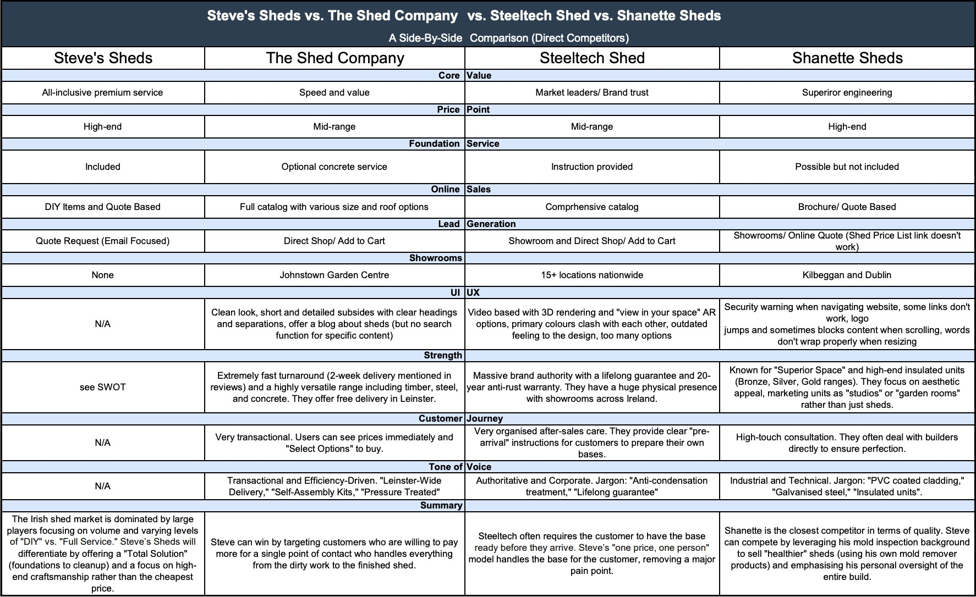
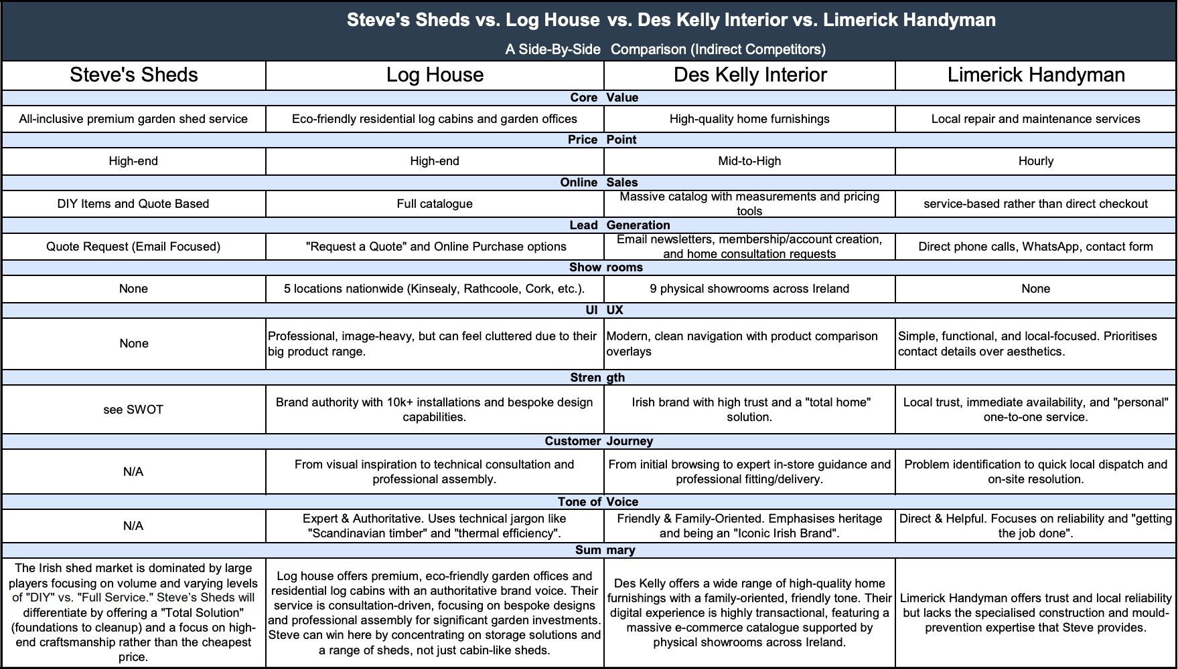

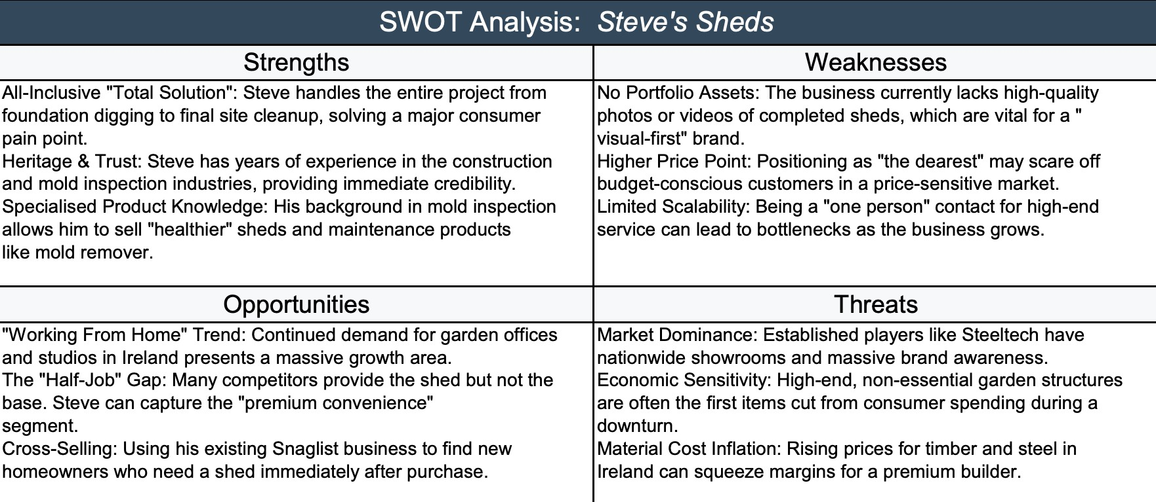
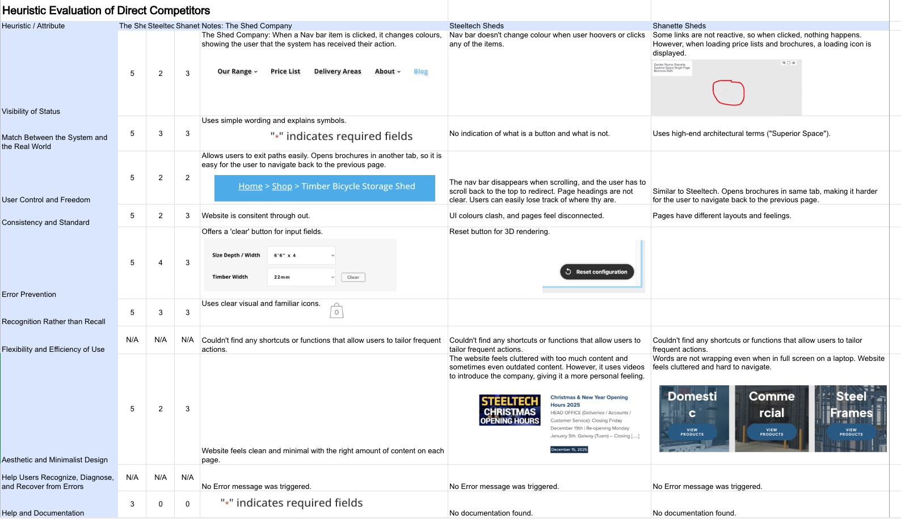

Vision Document
Vision Statement
To establish Steve’s Sheds as the premier Irish provider of high-quality, worry-free garden sheds. Unlike competitors who provide only the shed, Steve’s Sheds website will lead with visual credibility and craftsmanship, converting high-intent users into leads by emphasising a seamless, all-inclusive installation service, from foundation to clean up.

-> Shift from a “general retailer” to a “premium, high-end construction service”.
-> One-Stop Shop

Website Objectives
Steve’s Sheds allows users to explore garden shed options, helping them select the one that best fits their needs. Steve will provide a quote and support the installation process. The website’s goal is not only to attract potential customers but also to earn their trust by demonstrating credibility and quality. Once they reach out to the business, they will be in contact to help and guide them through the selection, purchase and installation of a garden shed.

Circumstances of Use
Who: Homeowners (B2C) valuing quality over price. Specifically, those who want a premium product ("I want that") and a professional who handles the entire process.
Generally, people between 30 and ti0 years of age who just bought a house or are already homeowners and do not own a garden shed yet.
What: A high-end visual catalogue showcasing three standard shed sizes, DIY kits/maintenance products, a streamlined "Request a Quote" system, helpful tips and trends and contact options.
When: Most likely through referral from Snaglist, the business owners’ other business Where: Primarily mobile scrolling. Users looking for a .ie domain who want local, Irish reliability.
Why: Users learn that this type of garden shed exists and becomes curious about whether or not they need it, how much it costs, and what type of sheds are available. Users are looking for a shed that matches the quality of their home and a builder who provides a single point of contact.

Design Criteria/ Principles
- Visuals First, Text Second: Users scroll until caught by an image. Minimalistic design with high-impact photography that triggers an emotional "I want that" response before the price is even considered.

- The "One Price, One Person" Experience: The UX must clearly communicate that the service is all-inclusive (including foundations, installation, and cleanup). The interface should feel like a premium consultancy, not a bargain bin.
- Credibility through Heritage: Use Steve’s existing construction expertise and years in business to build immediate trust for this new branch of the company.
- Frictionless Inquiry: Since the product is high-end, the goal isn't a "Buy Now" button for sheds, but a "Request a Quote" redirect to start a professional dialogue.

Success Metrics (as there is no data to compare, the success metrics are phrased broadly)
- Lead Conversion Rate: Percentage of visitors who complete the "Request a Quote" form.
- Engagement Depth: Average time spent viewing the high-quality gallery and "About" section (credibility markers).
- DIY Micro-Conversions: Successful online sales of the ~2ti DIY items.

-> I will ask Steve at the next meeting what number he is expecting within 6 months. The User Experience Framework
Category | Vision Goals
Feel | Premium, modern, straightforward, informative
Do | Browse standard sizes, view available colours, and request a personalised quote.
Think | "This is a craftsman, not just a salesman. This shed will last as long as my house".
Values | Quality over quantity, "all-in" service, and Irish-based reliability.
Action | Browse and shop.  Find answers to shed-related questions. Send an email inquiry for a quote.

Appendix
This includes articles from my research, testimonials, Creative Commons images and placeholder guides.

HC (2021) ‘Consumer Gardening Spend in 2020 - The Highest Ever’, Hor9cultureConnected.ie, 19 May. Available at: hmps://horticultureconnected.ie/news/consumer-gardening-spend-in-2020-the-highest-ever/ (Accessed: 26 March 2026).
Miller, J. (2017) ti Things Every Shed Company Needs to Succeed Online. Available at: hmps://www.idearoom.com/sell-more-sell-better/ti-things-every-shed-company-needs-succeed-online (Accessed: 26 March 2026).
Pernice, K. (2017) F-Shaped Pattern of Reading on the Web: Misunderstood, But S9ll Relevant (Even on Mobile), Nielsen Norman Group. Available at: hmps://www.nngroup.com/articles/f-shaped-pattern-reading-web-content/ (Accessed: 10 April 2026).
Warlina, L., Siddiq, F. and Valentina, T. (2019) ‘Designing website for online business in the agricultural sector’, Journal of Physics: Conference Series, 1402, p. 066080. Available at: hmps://doi.org/10.1088/1742-6ti96/1402/6/066080.
Bianchi, F. (202ti) Coolors, Coolors.co. Available at: hmps://coolors.co/. (Accessed: 24 March 2026)
Buy Insulation Online (no date) Shed Vapour Barrier. Available at: hmps://www.buyinsulationonline.co.uk/category/shed-vapour-barrier (Accessed: 30 March 2026).

GoodUI (no date) GoodUI. Available at: hmps://goodui.org/ (Accessed: 30 March 2026).

IronSite Construction (2022). Cleaning Your Metal Building in Time for Summer. IronSite Construction. Available at: hmps://ironsitetx.com/cleaning-your-metal-building/ (Accessed 29 Mar. 2026).

Wilson, J. (2026). Beds in sheds - Modular homes to be rented out tax free by landlords. Newstalk. Available at: hmps://www.newstalk.com/news/modular-homes-2249368 (Accessed 30 Mar. 2026).

Nielsen Norman Group (no date) Hamburger menu icon recognizability. Available at: hmps://www.nngroup.com/articles/hamburger-menu-icon-recognizability/ (Accessed: 2
April 2026).

Safeblend (no date) Safeblend descaler cleaner and rust remover. Available at: hmps://www.safeblend.com/en/products/safeblend-descaler-cleaner-and-rust-remover/ (Accessed: 30 March 2026).

Shed Superstore (no date) News blog. Available at: hmps://shedsuperstore.com.au/blogs/news (Accessed: 30 March 2026).

So]care (no date) SoWcare an9-mould ti00 ml. Available at: hmps://www.so]care.ﬁ/en/product/so]care-anti-mould-ti00-ml/ (Accessed: 30 March 2026).

Teagasc (202ti) Everything farmers need to know about puZng solar panels on sheds. Available at: hmps://teagasc.ie/news--events/daily/everything-farmers-need-to-know-about-puyng-solar-panels-on-sheds/ (Accessed: 30 March 2026).

Baker Home Energy (no date) Solar panels on clay 9le roofs. Available at: hmps://bakerhomeenergy.com/solar-panels-on-clay-tile-roofs-bk/ (Accessed: 3 April 2026).

Facebook (no date) Snag List Steve reviews. Available at: hmps://www.facebook.com/proﬁle.php?id=1000ti7ti72913984&sk=reviews (Accessed: 7
April 2026).

Facebook (no date) Snag List Steve gallery. Available at: hmps://www.facebook.com/photo.php?Çid=12806118ti7201233&set=pb.1000ti7ti7291398 4.-2207ti20000&type=3 (Accessed: 7 April 2026).

