

CS4078: Applied Interaction Design

Assignment 2 Report

Critical Design Approach on the Future of Remote Work and Hybrid Collaboration

HybridPal

Annika Jungfleisch (22359923)
Yelyzaveta Dolha (22311491)
Thomas Broderick (22071253)

Table of Contents
Description of Design Session- Tommy 3
Background of Design Session 3
Activity 1: Word Cloud and Scales on Mentimeter 3
Outline and analysis of the results of the collaborative design session - Liza 5
Synthesis of the results, exploration and development of a specific design concept or scenario 7
Description of the Final Design Concept or Scenario 8
Reflection on the whole process (what you learned, what went wrong, why, what surprised you, pros and cons, everything that was interesting in your opinion) - Tommy 11

Description of Design Session- Tommy
Provide a description of the settings within which the critical artefact was presented and how (participants, environment, process), a description of the activities that followed and the generated discussion/ideas/results (e.g. reaction of the participants, emerged discussions or feedbacks).
Background of Design Session
Our design session was hosted in the Kemmy Business School at the University of Limerick on Thursday, 27 March 2025, and involved ten participants. With relation to the backgrounds of our participants, we aimed to recruit a mixture of both undergraduate and postgraduate students. Six participants were undergraduate UL students, while four were postgraduate UL students. We asked our participants to meet in a pre-booked room at the Kemmy Business School at 6:00 PM, where they were seated. Annika and Thomas rearranged the seating in the room to form two group tables. This ensured that the participants would be able to work in groups effectively. Our participants all appeared eager and willing to participate in our activity, and there were no apparent signs of apprehension or any initial refusal to cooperate with any of the aspects of the activity. Before our activity was initially set to begin, there was a minor setback that occurred that delayed the beginning of our activity by approximately twenty minutes due to technical difficulties with connecting Annika’s laptop - which contained all of the necessary presentation materials we needed - to the projector in the room we conducted our activity in. In order to rectify this issue, we had to move our activity to a room next door, and our participants came with us. Once this setback was resolved and we were able to finally begin our session, we kindly asked our participants to pay attention to a screening of our fictional advertisement for our prototype device, which is a monitoring device called ‘EfficienSee’. This video advertisement features Thomas as a fictional workplace manager, and introduced our participants to the dystopian concept behind our device, as well as outline a general idea of how the device may be used in a workplace setting. Afterwards, Annika physically presented the 3D printed prototype to the group and explained its functionality to the participants.
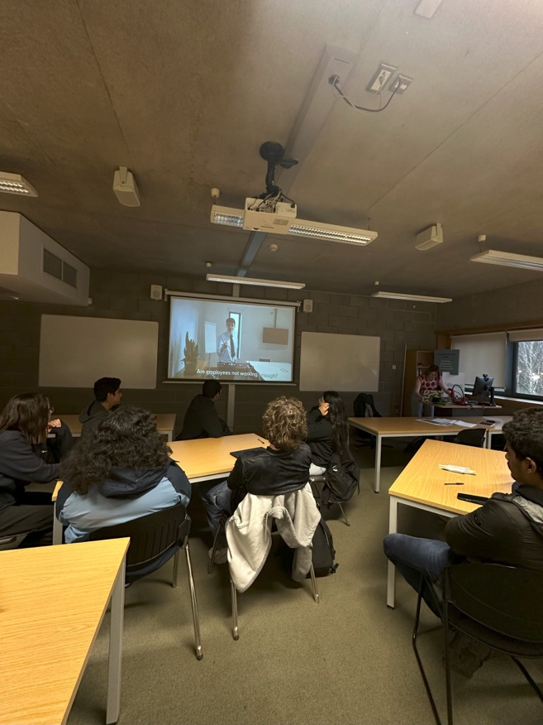

Activity 1: Word Cloud and Scales on Mentimeter
As soon as the introduction of our video advertisement was finished, and Annika explained the key functionalities of the ‘EfficienSee’ device to our participants, we immediately initiated our first activity of the session. Our group chose to conduct our first activity through the tool of Mentimeter so we could most effectively allow our participants to provide anonymous responses to both scaled questions and open-ended prompts through their own personal devices. Furthermore, we sought to gather the most immediate and authentic reactions to our concept and the product itself. We also wanted our participants to reflect on the broader implications such a product may have in the real world.
All participants used their phones to log into the Mentimeter activity and access the questions. These questions were also shown on the projector in the front of the room. As our participants answered, their responses appeared on the projector screen so that everyone in the room was able to view them. This made our activity feel more collaborative and also allowed our participants to see each other’s responses and reactions for reference or comparison. The activity had four main questions: two word clouds to collect quick and instinctive reactions, and two scale-based questions that were created in order to measure how clear and well-received our concept was.
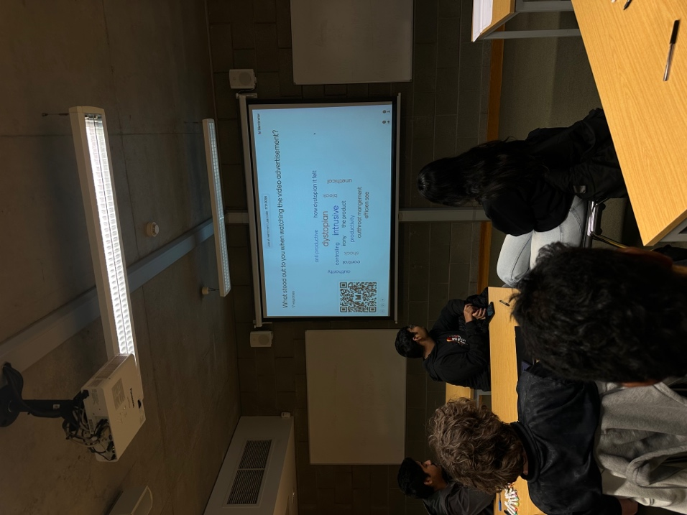

The first question that we asked our participants was in a word cloud format, and stated: ‘What stood out to you when watching the video advertisement?’ The word cloud that formed resulted in interesting responses from our participants, and it included key words such as “dystopian,” “intrusive,” “control,” “unethical,” and “cutthroat management”. This signified that our participants generally felt uncomfortable and even disturbed by our concept from our video advertisement. We also noticed words appear on the word cloud, such as “bleak,” “shock,” and “anti-productive” which also added to the idea that our participants felt a sense of disturbance when watching the video. We also noticed how the word, “irony” appeared in the word cloud, which suggested that some of our participants picked up on a satirical or even contradictory tone in our video advertisement.
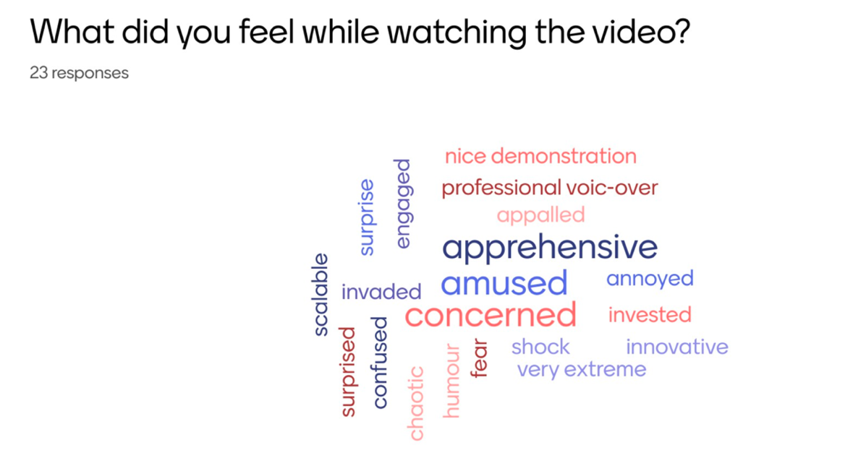
In our second Mentimeter question, we used a scale format to ask our participants how clear the video was in explaining our concept itself. This scale ranged from 1 (not clear) to 10, (very clear). The score that resulted came to be averaged at 7.1, which suggested that most of our participants understood the concept of ‘EfficienSee’, and what it was intended to convey. Nevertheless, this score suggested that there might have been some minor aspects that may have been slightly confusing or needed more explanation, as the scale did not fully reach 10 (very clear).
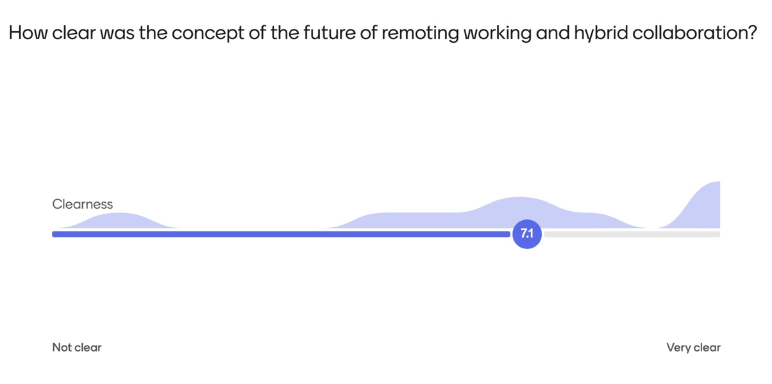

As we moved on to our third question of the activity, we switched back to a word cloud format. We then asked our participants: ‘What did you feel when watching the video?’ We asked this question with the hope that it would open up more emotional feedback from our participants concerning their personal reactions to watching the video. The word cloud then produced common words such as “apprehensive,” “concerned,” “invaded,” “annoyed,” and “fear”. We noticed that these words remained consistent with our participants’ reactions to the video itself in the first question, which alluded to the idea of discomfort. Some of our participants also provided posiitve reactions to how the presentation of the video was conducted, and included words such as “engaged,” “innovative,” “humour,” and “professional voice-over.”
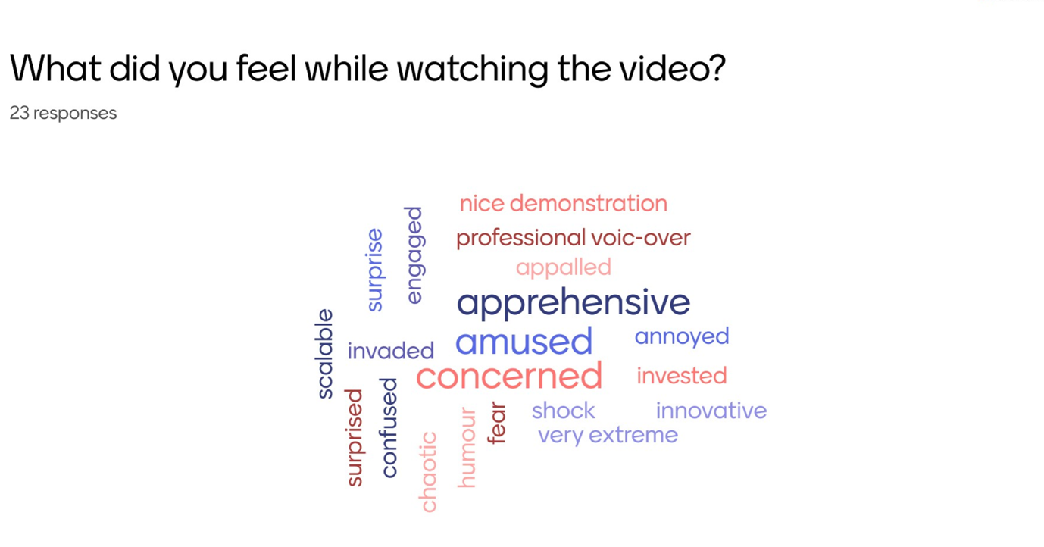
The fourth and final question that we asked our participants was: ‘How would this product be received in a real-world setting?’ This scale ranged from 1 (support) to 5 (protest). Once all of our participants finished answering, the score averaged to 4.1. This suggested that most of our participants would lean towards opposing the product in a real-world setting. This question also led to a broader group discussion among our participants with regard to the ethical and social implications of ‘EfficienSee’ being utilised in reality. Some of our participants expressed worry that governments could use similar forms of technology for malicious purposes and in a way that violates one’s privacy. Other participants thought that those in a managerial position might welcome the tool as a way to maximise results among their employees. However, the majority of our participants agreed that employees would likely push back because of how invasive such a product would feel in a workplace.
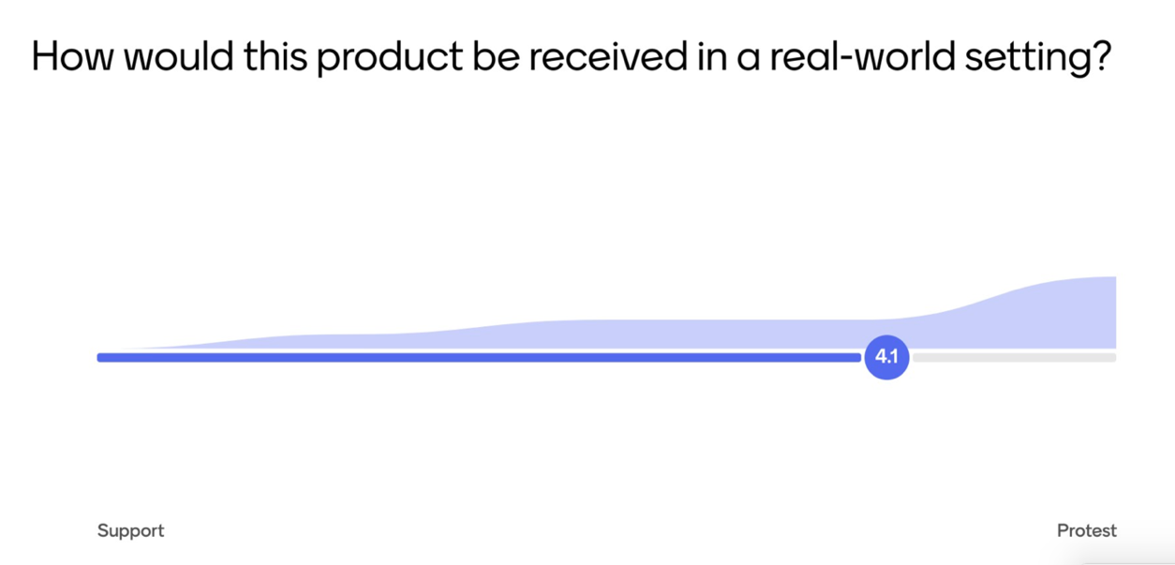

One of the biggest concerns among our participants was the shock feature in our product. Our participants recalled how it was demonstrated in our video, and felt that such a feature could be very dangerous, especially for individuals suffering from health issues. Furthermore, many of our participants stated that the ‘EfficienSee’ device overall would strongly create a fear-based work culture and disincentivise employees to carry out their work due to the product’s heavy surveillance features. Some participants stated that the product could push employees to work too fast, and therefore destroy any real passion they have for carrying out their work. Furthermore, our participants commonly agreed that the product might motivate certain individuals in the short term, but nobody believed that it would lead to lasting productivity. As a result, the general consensus among our participants was that the usage of the product - due its constant surveillance - would likely only lead to stress, burnout, and a drop in motivation for employees to carry out their work well.
After our Mentimeter session was concluded, we moved into an open-ended discussion concerning our participants’ personal experiences with workplace monitoring. When we asked our participants if they had ever been monitored while working remotely, their answers varied. One of our participants spoke up and stated that they have not - or at least they were not aware of being watched. Other participants explained how the pressure of needing to stay "active" on Microsoft Teams - just so their manager would be aware that they were online - caused them significant stress. For example, one participant stated that they would stop what they were presently working on and log in to Microsoft Teams just to move the mouse or send a quick message to notify their manager that they were still active. Interestingly, one of our participants who had previously worked in the role of a manager offered us a unique perspective. He stated that it was expected of him as a manager to monitor everything their employees were doing in order to ensure that they remained on task and focused.

Activity 2: Scenario Testing & Role Play
After completing our first activity using Mentimeter, we progressed on to the second and more immersive activity of our session. Our participants were given specific role play scenarios and asked to act them out as if they were embodying their roles. Our group created this specific activity with the intention of recreating a real-world scenario in which our device would be implemented in a hybrid work setting. From there, our goal was to then allow our participants an opportunity to step into the roles of both an employee and an employer, and critically engage with the ethical, emotional, and practical impacts of using the product of ‘EfficienSee’ in hybrid work.
In order to best make this activity feel as if it were a real-world scenario to our participants, we included interactive aspects including a 3D-printed version of our 'EfficienSee' prototype, custom role play cards for both 'Employers' and 'Employees', mock employee performance report sheets, and pre-recorded audio sounds. These audio sounds included buzzer and shocker sounds, as well as voiceover warnings from a “manager.” Our goal was to create a realistic setting that would feel like what someone might experience if this device were used in a real workplace.
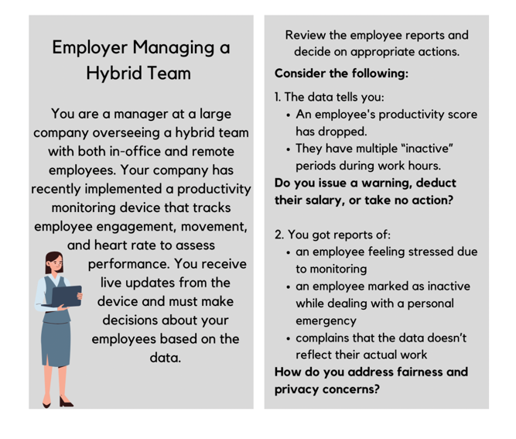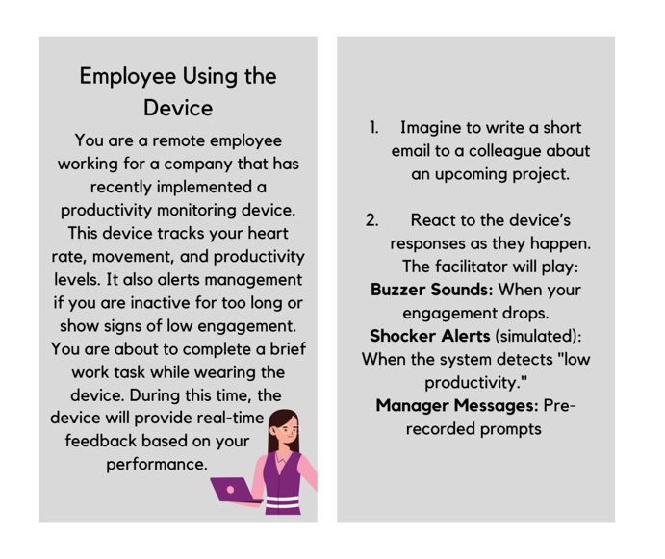
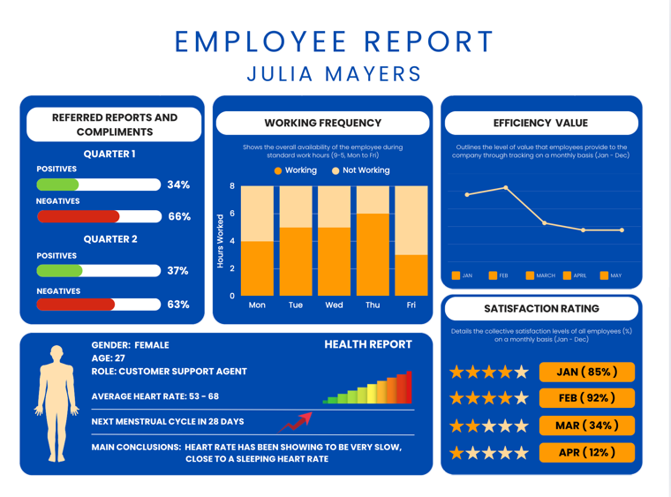

In order to set up our activity, we divided our participants into two groups: ‘Employers’ and ‘Employees’. As we had a total of 10 participants for our session, we delegated 6 of these participants to the ‘Employee’ group, while 4 participants were delegated to the ‘Employee’ group. Once we adequately split up our groups, we asked them to be seated in two different tables in the room. As soon as our participants were seated, we then distributed the role play cards and employee report sheets to both accordingly. The ‘Employee’ group were given role play cards relevant to employees, while the ‘Employer’ group were given role play cards relevant to employers. The employee report sheets were provided to both groups, and the ‘Employers’ were expected to review the report sheets in order to help better inform their understanding of their role play scenario. The reasoning behind why we provided our employees with report sheets was only so they were given the appropriate context of what their performance was in their own scenario. They were not required to analyse this information, as this would be asked of the ‘Employers’ instead.

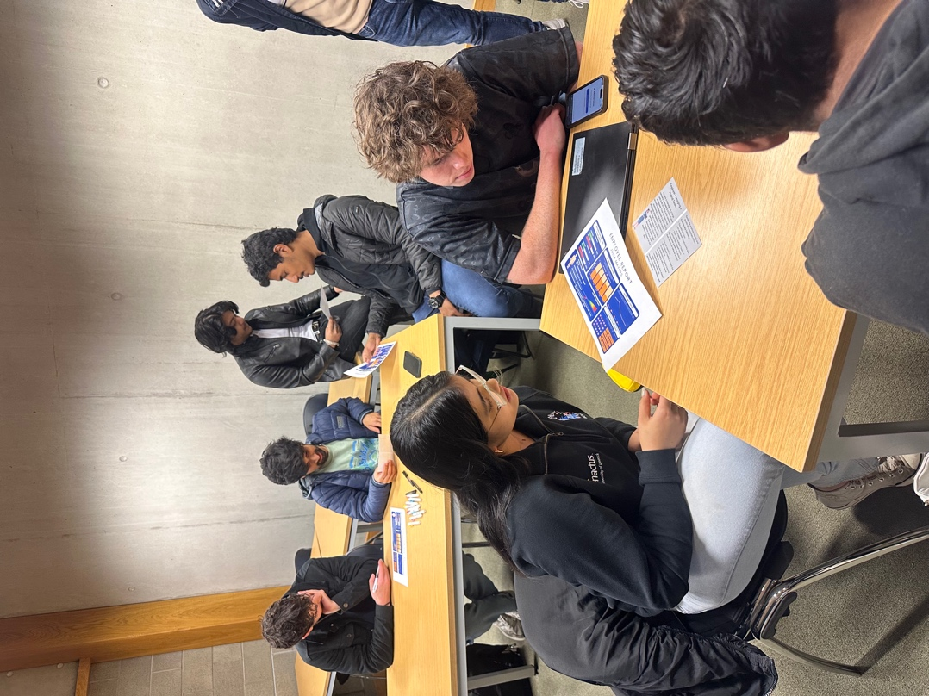
Along with having our ‘Employee’ participants engage with the scenario, we also made sure to prompt them with questions to capture their thoughts and feelings in real-time. These questions included: ‘How does the device feel?’ ‘How does it affect your focus?’ ‘Are you feeling stressed?’ We felt that prompting our participants throughout the activity was necessary for us to effectively capture immediate responses and observe any sort of changes in their reactions in their behaviour. While we conducted this role play scenario with our participants, we were able to gather important insights into their concerns in real time. We noticed that a common concern among our participants was questioning whether the use of physiological data such as heart rate to measure productivity would be truly reliable at gauging whether an employee is remaining on task or not. They questioned whether this type of data would truly be able to reflect an employees’ actual performance considering there are many nuances involved in a job where an employee’s heart rate may go up for a multitude of reasons. Many of our participants also raised another concern with regard to how the monitoring device could potentially be circumvented and tampered with if they were working from home; is the device truly fool-proof? For example, some participants highlighted how they could simply remove their device while working from home and therefore defeat its intended purpose to begin with. As we continued on, some of these participants mentioned concerns about the psychological toll that could happen as a result of being constantly monitored by the device, especially when the device itself is always wrapped around their wrists. One participant mentioned that the fear of the shocker feature alone would be enough to affect their concentration and overall ability to conduct their work. Alongside this, another participant mentioned that the anxiety of possibly being shocked would make it difficult for them to type or complete even simple tasks. Furthermore, we took note of an interesting insight from a participant who noted that random ad-hoc tasks such as answering a phone call could cause an employee to be unfairly penalised even though they were legitimately doing work. From this example, the participant noted how these types of nuances when using an employee monitoring could then lead to the device not truly serving its intended purpose. Finally, there was a strong consensus among all of our ‘Employee’ participants that the usage of a monitoring device on their wrist would only lead to causing more stress in their work environments and ironically slow down their productivity instead of enhancing it.

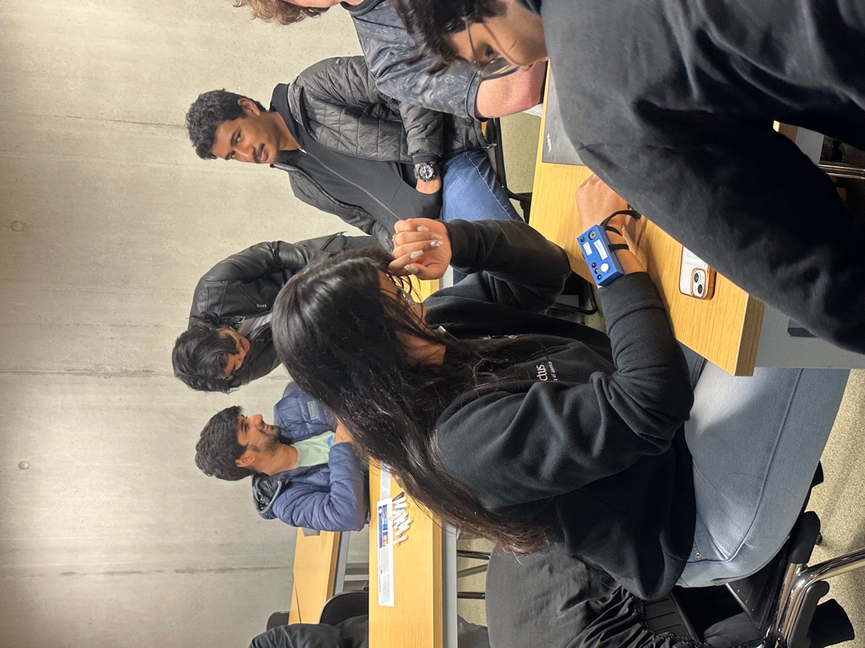

While the participants from our ‘Employee’ group were conducting the activity, we simultaneously had our participants from the ‘Employer’ group do the same. In a similar fashion as before, we gave our ‘Employer’ group role play cards, but this time the cards provided them with two scenarios. Firstly, the ‘Employer’ participants were told that they were managers in a company that oversees a hybrid team that works both in-office and out-of-office. The monitoring device that their company had recently implemented was the same monitoring device that the ‘Employees’ use, and contained the same features such as heart rate detection, movement, etc. Next, the participants were provided with their first scenario. They were tasked with reviewing a mock report that showed productivity metrics of a specific employee who had a declining productivity score and multiple periods of inactivity. Their challenge was to choose between issuing a warning, deducting the employee’s salary, or take no action on the matter at all. The responses that we gathered from our participants as a result of this scenario showed an interesting level of empathy and restraint in terms of issuing consequences to their employees. Most of our participants said that they would like to have a one-on-one conversation with the employee before they would take any disciplinary steps. Instead of presuming the worst about the employee, our participants interestingly stated that they would presume that the drop in the employee’s performance could be caused by factors such as extreme fatigue or purely the stress that is caused from wearing a monitoring device itself. None of our ‘Employer’ participants chose to immediately deduct a salary from their employees, or ever use features of the device such as the shocker or buzzer. Instead, some of our participants proposed using motivational strategies for their employees, such as offering rewards for productive work. However, one participant did suggest that if they noticed their employee’s performance continuing to decline even after they held a one-on-one intervention with them, they would be forced to consider the idea of escalating matters further.
In the second employer scenario, we had our participants consider an ethical dilemma of managing nuances and errors related to the monitoring device. These dilemmas included one employee feeling stressed because of being monitored, another employee being marked as inactive because of a personal emergency, and a third employee whose performance data was not reflective of their actual work contribution. From this scenario, we asked our ‘Employer’ participants to consider how they would ensure that there is fairness in the monitoring device’s decision-making, and how privacy concerns would also be addressed.
In response to this scenario, all 4 of our ‘Employer’ participants showed that they were deeply aware of the limitations of relying on quantitative surveillance data in order to judge if an employee was being truly productive. As a result, all of these participants commonly agreed that an employee’s productivity data alone cannot paint a full picture of their effort levels. In terms of addressing privacy concerns, some of our participants suggested building a one-on-one rapport with their employees to aid them in feeling more comfortable. All of our ‘Employer’ participants highlighted the necessity to understand the root causes of why an employee may have reduced productivity; managers have to know their employee and consider whether their reduced productivity is because of something that may be uncontrollably going on in their personal lives, if it is a psychological issue, etc. However, these participants commonly agreed that if their issue was within an employee’s control, then further action may be necessary if all other avenues taken to address the issue were exhausted.

Activity 3: Scenario Sketching

As part of the third activity for our session, we requested that our participants remain seated where they were for the previous activity. We then invited all of our participants to to engage in a scenario sketching activity, where they were tasked with illustrating what they considered to be their ideal work environment. The purpose of conducting this activity was for us to gain a qualitative insight into what kinds of preferences, values, and expectations employees have regarding their working environment, and what types conditions they would be subjected to in such an environment. As a result, by asking our participants to visualise and create their ideal workspace, we sought to gain a better understanding of what types of features and even technology might contribute to a positive productive environment for remote or hybrid work from the perspective of the employee.

In order to conduct this activity, we had our participants partner into groups of two. From there, we then provided each group of two with A3-sized paper that included a blank space for their drawings, along with a prompt clearly stating what their task was. We encouraged were encouraged to incorporate technology that they would like to see included in their hypothetical work environment.

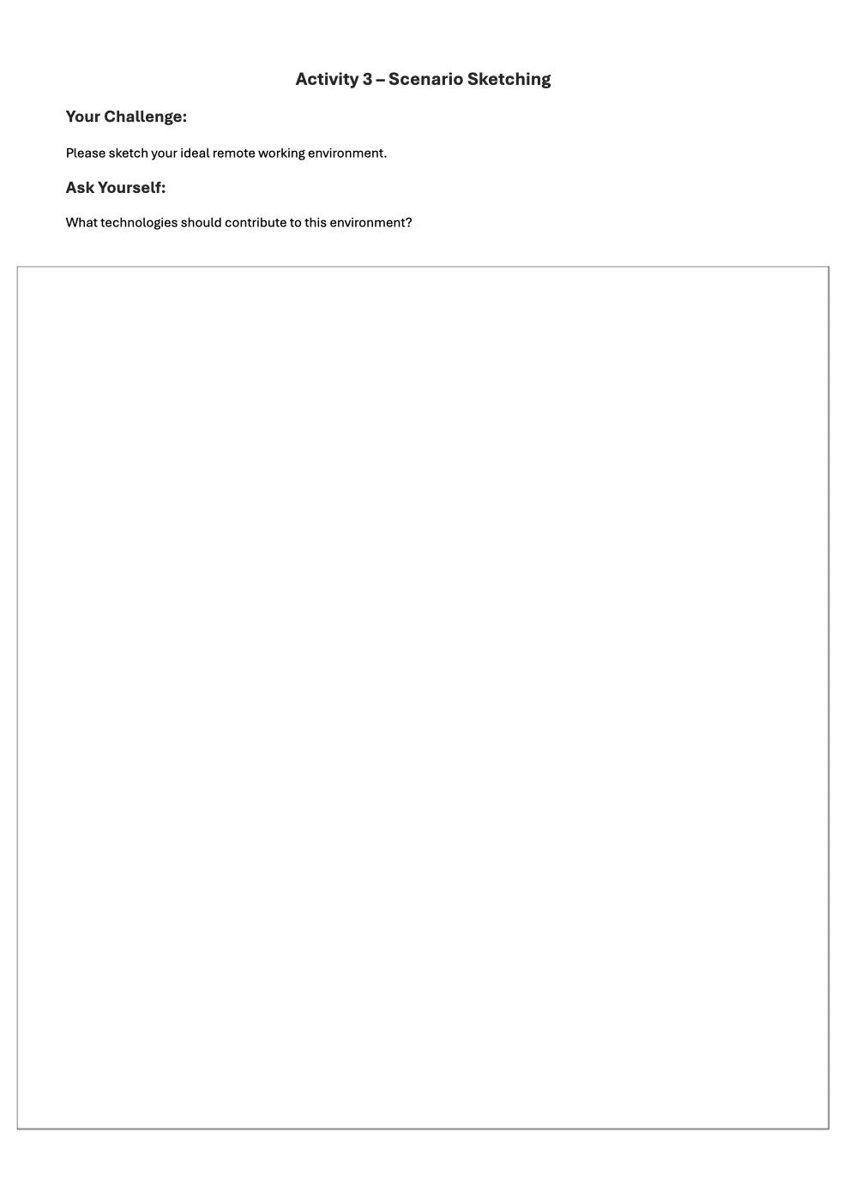

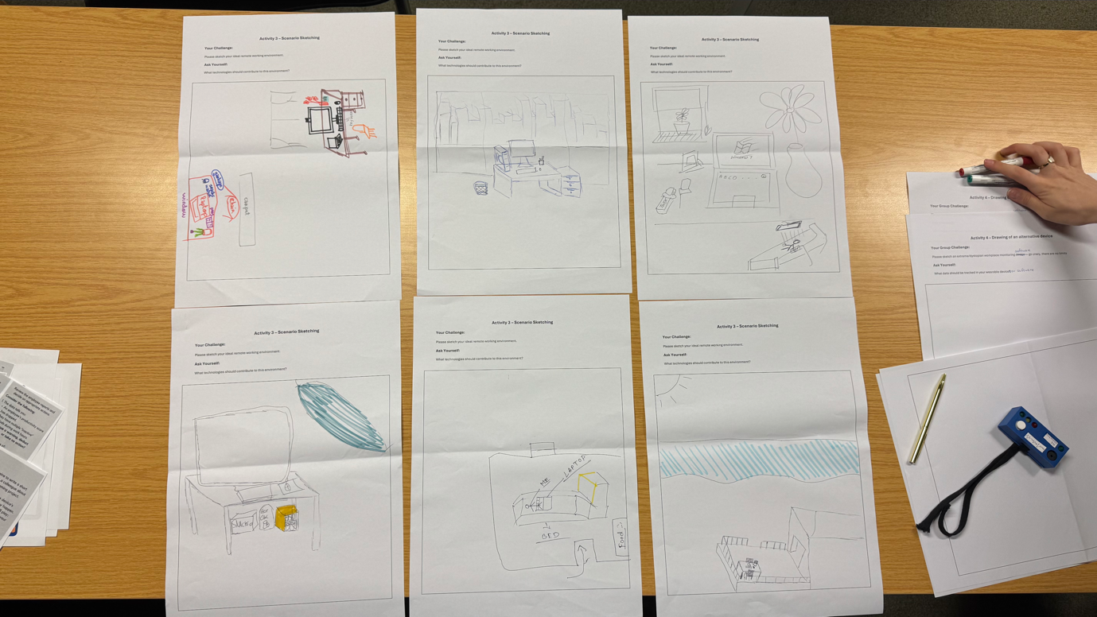

Outline and analysis of the results of the collaborative design session - Liza
Present all that was generated from reflection on the present to ideas about possible futures.
In case of material that more directly reflect the present, try to identify issues, gaps,
problems, and document your personal exploration how to make things better. In case of
material that more directly reflect aspirations, wishes, desires and ideas, try to group them,
prioritise them, integrate and refine toward a finalized design scenario.

With 5 events and 10 participants, the research provided us with valuable insights with which to move forward. First of all, the initial audience reaction to our video presentation and prototype was described as anti-utopian, accompanied by negative emotions such as rejection, irritation and stress. Participants emphasized concerns about remote working and the use of existing technologies that could be misinterpreted, leading to the perception that a person is absent from the workplace even when they are working. For example, the activity status bar in Microsoft Teams used to show “absence status” while the person was actually working. People who used to work in management expressed different views. For example, they said that managers should keep track of the factors that support the primary purpose of tracking. Role-playing in the second task allowed us to better understand empathy and communication preferences of people in everyday situations. The manager's point of view was presented as a way to gather feedback and better understand the problem by talking to the employee, so called 1:1 meetings to gain insight and better understand the problem and the way to solve it by talking to the employee. In addition, participants agreed and stated that praise was a “better source of motivation” than punishment. In addition, the employee's role highlighted the problem of increased stress levels when wearing the device. As the workshop continued and people developed their thoughts, these reflections helped us realize that the real problem was not the monitoring itself, but how it was used and perceived. Participants agreed that there should be some form of monitoring in remote working environments, but they were very sceptical of existing methods because they were not fair, honest, or concerned about the well-being of each individual. What participants felt was most important was how the data was collected, how it was analyzed, and what steps were taken as a result. Follow-up activities such as creating scenarios and utopian/anti-utopian sketches broke the last bits of ice, people became much more collaborative, and because the work took place on a physical surface with traditional pen and paper, they were more engaged in the process (as they stated in the questionnaire).

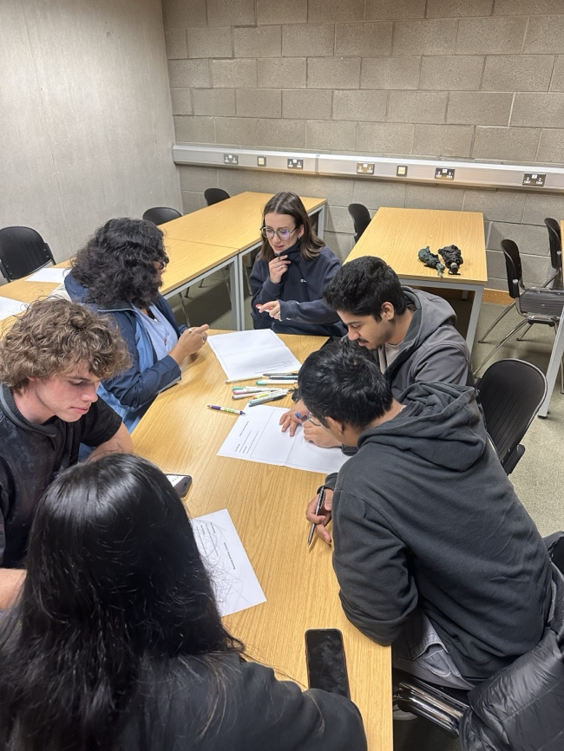
Figure 1 - Activity utopian/dystopian design drawing
They shared ideas for systems that could help rather than hurt: devices that would recognize stress and suggest taking a break rather than punish for slowing down. AI was seen as a possible support tool - something that could gently guide workers through the day, offering advice, encouragement and reminders about self-care. A recurring theme in all of these ideas was the importance of employees taking control of their own data. Participants wanted to own their personal information and decide when and how to share it, rather than having it constantly monitored without consent. In dystopias, constant surveillance was followed by tethering to the workplace, even using a workplace-only nicotine patch to build the habit of needing to come to work and making breaks shorter. From this combination of criticism and creativity, we developed a new design concept. While it still includes a wearable device, the purpose and behavior of the device has been adjusted. In the final version, the device is primarily aimed at supporting the worker. It tracks data but gives a sense of freedom combined with efficiency and productivity. If something amiss is detected, the system encourages a conversation between manager and employee rather than jumping straight to negative consequences. The device also features a voice-activated AI assistant that can suggest breathing exercises, suggest a break, or help employees shift their attention in a friendly and unobtrusive manner. Through the mobile app, users can personalize their experience, view their achievements and even receive small rewards for good work habits. Managers, on the other hand, only receive anonymized reports showing general trends in team performance, but not detailed personal data unless absolutely necessary. In developing this final prototype, we moved away from the concept of control and punishment and toward a future based on trust, support, and personal growth. Our research and design process showed that when technology is built with the individual in mind, respecting privacy, encouraging wellbeing and fostering open communication, it can help make remote working not only more productive, but also more positive and empowering for everyone involved. Work is a place to grow and contribute, not a place of stress and fear.

Synthesis of the results, exploration and development of a specific design concept or scenario
The collaborative design session helped bridge the gap between the critical reflection on present surveillance practices in remote working environments and co-creating a more human-centred approach for the future of remote work and hybrid collaboration. Through the structured workshop of five activities, we gathered layered insights that guided our redesign of our dystopian artefact into a more balanced, empowering, and ethically conscious prototype.

Initial feedback from participants emphasised the emotional toll of extreme workplace monitoring. Our critical artefact, although intentionally exaggerated, sparked a strong reaction, described as "stressful," "dystopian," and “realistic enough to feel uncomfortable.” This reinforced that many digital surveillance elements already exist in current remote work tools (e.g., MS Teams activity monitoring) and cause subtle but persistent stress. As a result, a significant issue identified was the lack of agency and control over how personal work data is interpreted or shared. Our participants feared misinterpretation of metrics like heart rate and presence indicators, and many shared stories of altering their workflows to remain visibly “active,” even if it hurt their genuine productivity.

As our workshop progressed, particularly during the scenario testing and role-play activities, deeper exploration emerged. Participants expressed a desire for tools that support employees rather than punish, and for managers to use data as a conversation starter, to check in with their team rather than as a disciplinary trigger. A recurring idea was that productivity should not be reduced to metrics alone and that any monitoring system should consider stress, health, and external factors. This shift in thinking marked a transition from simply rejecting surveillance to imagining reformulated models that integrate trust, transparency, and personal growth. Because, in one fact, everyone agreed, there has to be some monitoring in a remote work environment.

The utopian sketches and group discussions highlighted ideal environments such as intelligent systems that offer well-being support, adaptive feedback mechanisms, and reward-based motivation rather than punishment. Devices envisioned in these sessions often included emotional support features, AI assistants, and customisation for autonomy. The participants’ feedback emphasised the importance of data ownership, with participants suggesting that the primary data recipient should be the employee, not the employer.

From these reflections, we developed a new design scenario: a wearable device that tracks data but is fundamentally built on self-reporting and anonymised team-level insights. This shift directly addresses the issues raised about stress and lack of control in our initial prototype. The redesigned prototype prioritises well-being, personalisation, and open dialogue rather than discipline and comparison. The integration of AI assistants, suggested during Activity 4’s utopian sketches, was particularly well received and informed both the physical design and dashboard functionality.

Our final concept emerged from a synthesis of critique and aspiration, recognising the problematic trajectory of existing remote work surveillance while reimagining it through the lens of empathy, ethical responsibility, and supportive digital ecosystems. The scenario we developed represents not only a technological possibility but also a speculative future in which productivity and care are not in opposition but mutually reinforcing.

Description of the Final Design Concept or Scenario
Our final prototype combines design elements from our initial dystopian design with the workshop idea of the utopian robot combination.

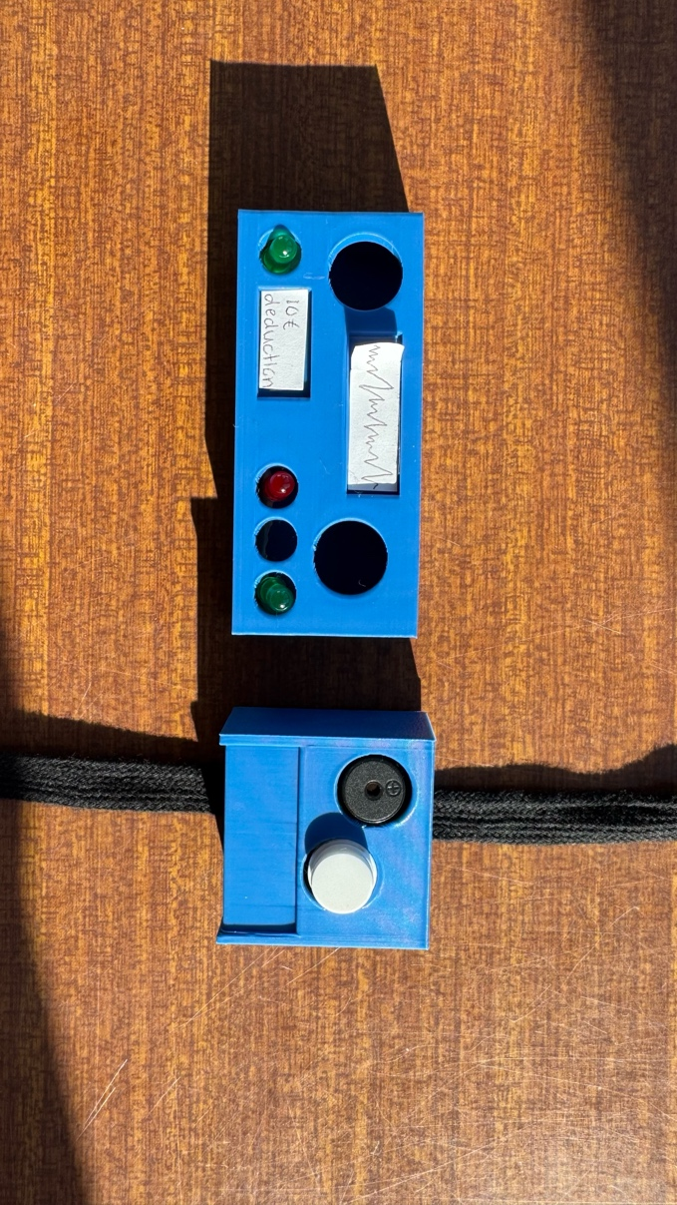
Figure 2 - Dystopian Prototype (left) and new Prototype (right)
The prototype is a wearable that functions similarly to an Apple watch. The main box is 4x4 cm big and is equipped with a speaker, a button and a touchscreen extending over the device's edge (see picture).
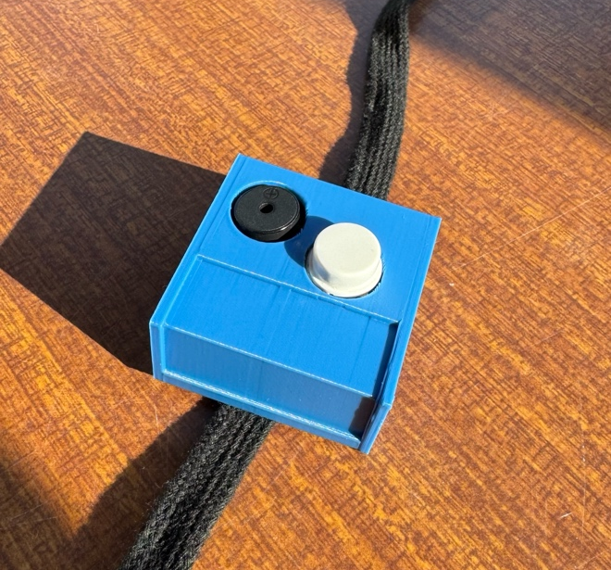
Figure 3 - Final Prototype
We decided to stick with the button and buzzer and against making everything a big touchscreen. From our experience, we still prefer wearables to have some tactile feedback. We moved the strap to the button as the touchscreen would have interfered with the strap going through the sides.
This wearable device tracks data similar to that of an aura ring or fitness watch. However, instead of the data being openly shared, as in our first design, the data is mainly shared with the employees themselves, building on self-improvement and self-reporting. Managers only get anonymised reports from their teams. This allows them to analyse work trends without prejudice. Only if one of the employees shows consistent trends of low work productivity does the message get a notification. However, the notification will be generalised to encourage an open conversation between the employee and manager before issuing any warnings or punishments.
Additionally, the device has voice-activated AI assistants like Alexa and Siri, who can answer questions and converse. The AI Assistant will also be able to suggest breaks and movement or breathing exercises at appropriate moments to increase the employee’s well-being and productivity while decreasing stress during the workday. Through the integration of a mobile application, there is also an option to create an avatar for more personalisation.
Furthermore, the system integrated into the device will reward employees automatically if they show consistent above-average work productivity.
By balancing personal well-being with workplace efficiency, this device fosters a healthier, more motivated workforce while promoting data-driven decision-making.
Beyond the physical prototype, we also developed Figma wireframes, which can be accessed here. The wireframes show the web application's dashboards that come with the device.
The employee has access to all their recorded data via the dashboard. Furthermore, the dashboard allows the employee to access and customise their AI assistant, view details of their performance, view their achievements due to good performance, and offers an opportunity to write messages between team members and their managers.
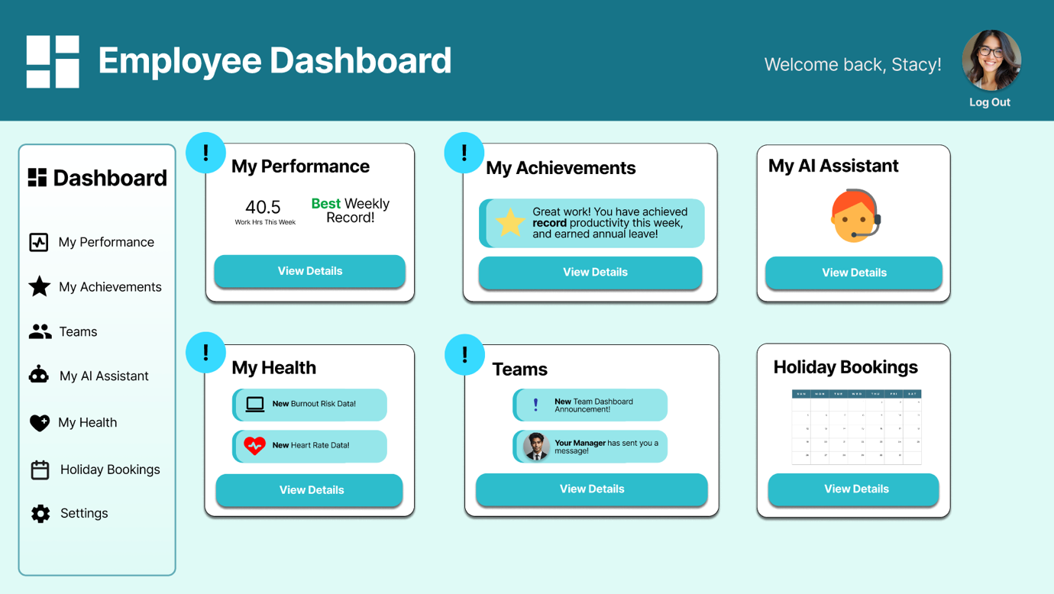
Figure 4 - Figma Screenshot of Employee Dashboard
The manager dashboard allows the manager to access the team’s performance records and follow the rewards issued by the system. Additionally, it informs the manager if an employee is underperforming and encourages them to chat about possible triggers that have caused the low performance.
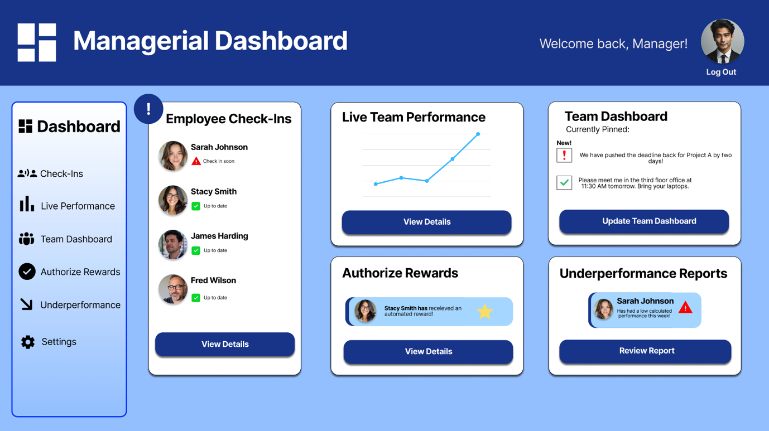
Figure 5 - Figma Screenshot of Manager Dashboard
ADD SECTION ABOUT VIDEO PROTOTYPE

Reflection on the whole process (what you learned, what went wrong, why, what surprised you, pros and cons, everything that was interesting in your opinion) - Tommy
Offer your personal reflections on the process, the PD tools, the PD session (what
worked, what did not, what was challenging) and your final design (how you think it
reflects the participants voice).

