

CS4126 - 3D Modelling and Digital Fabrication

Report

“NeuroTalki” Robot Toy Prototype

Yelyzaveta Dolha
Table of Contents
Introduction and ideation 2-3
Methodology elaboration 3
unesco stg’s alignment with the device 3
designing process 4
Development in freecad 8
material selection 13
conclusion 30

Introduction
This report explains the design and development process of the Robot prototype, a conceptual Robotic toy designed and developed in FreeCAD.
Meet “NeuroTalki”- device for communication purpose for neurodivergent audience and those who caring about them. Based on The Picture Exchange Communication System (PECS) is an augmentative /alternative communication strategy for those who display little or no speech. And Makaton – a communication programme that uses symbols (pictures), signs (gestures) and speech to enable people to communicate.
NeuroTalki is a interaction robot, presented as a toy created for both kids and adults. By bringing PECS and Makaton together on a touchscreen robot, NeuroTalki gives children new ways to express their feelings, needs, and ideas. This makes everyday communication easier and helps them feel more included at home, in school, and in society. This report explains The design process involved sketching, 3D modeling, and prototype preparation, with careful choices made regarding size, shape, materials, and manufacturing methods based on provided ESP32-24432S028 screen, also includes why it is important for autistic children, how it connects to global goals like the UNESCO Sustainable Development Goals, and the steps taken to make it safe, durable, and effective

Ideation
The design process began with several rough sketches exploring different shapes and concepts. Since I had a freedom of choices and growing skills of 3D modelling I knew I wanted to create something that I could use in the future so some standing cool looking statue. As my first degree based on education of kids , I have experienced working with neurodiverse children and know the struggle and nowadays solutions and methods of correction and integration. While I was researching and getting to know ESP32 I and found the code that allows to draw on the screen as on the well known “magnetic sketch board”, a tool used for teaching preschool kids. This led me to thinking about how might I implement it not only for entertaining but for education purposes as well. Autism Spectrum Disorder (ASD) is a condition that affects how people communicate, behave, and connect with others. In Ireland today, autism diagnoses are rising. The Department of Health reports that about one in every sixty-five children in Ireland is autistic. Many of these children — over 80% according to the Central Statistics Office — need extra help in school, especially for communication. With this wide well known condition in Ireland I decided to make a solution. Already existent methods like PECS use printed cards that can get lost or damaged, and carrying them around is not always easy. Makaton training takes time, and not every setting has quick access to resources. There is a need for a simple, friendly, and strong tool that makes using PECS and Makaton easier and more natural for children.

Lets elaborate on Pecs and Makaton collaboration in Neurotalki :
PECS is a communication method where children choose a picture to show what they want or how they feel. For example, a child might give a card with a picture of water if they are thirsty. Over time, PECS helps children build up a speech and language of pictures. Makaton adds another layer. It uses simple signs and symbols together with speech to help communication. When someone uses Makaton, they speak the word, show a sign with their hands, and sometimes show a symbol at the same time. NeuroTalki brings these two systems together in one robot. On its screen, children see PECS pictures combined with Makaton symbols. When a child taps a picture, NeuroTalki does three things: It shows the picture on the screen, It says the word out loud, It shows a simple video of the matching Makaton sign. This way, children can learn through images, sound, and movement. They can choose the method that suits them best. Some children might focus on the picture, others might listen to the word, and others might copy the sign. NeuroTalki gives flexibility and supports different styles of learning
How NeuroTalki Helps Achieve the UNESCO Sustainable Development Goals
NeuroTalki is not just about helping individuals — it also fits into bigger goals for a better world. The United Nations’ Sustainable Development Goals (SDGs) include helping people live healthy lives, access good education, and reduce inequality.
Goal 3: Good Health and Well-Being, by reducing frustration and stress in communication and promoting emotional well-being.
Goal 4: Quality Education, by making learning more accessible for children who communicate differently.
Goal 10: Reduced Inequalities, by giving autistic children better tools to take part in school, home, and community life.
Goal 9: Industry, Innovation, and Infrastructure, by using new technology and design in ways that serve real human needs

Designing process
Sketching stage: I was aiming to create something appealing to kids to stick around with, so the choice was to create an accessible toy, soft rounded edges making sure there no health threats simple design lightweights and easy to carry around, holding in the hands and strand on the desk. All ports and openings are small enough to avoid trapping fingers or posing other risks. For The inspiration was taken from the “Adventures time”, that I loved my teenage years, so I processed with robot named BMO.
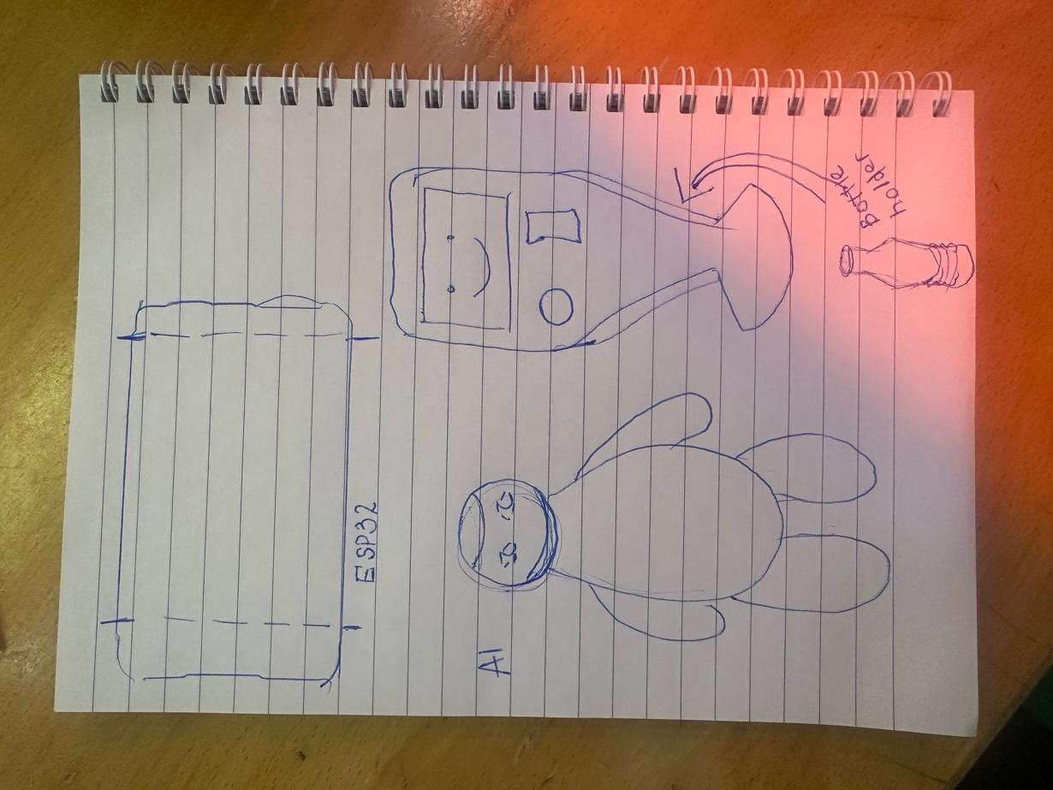
Figure 1 Sketches beginning
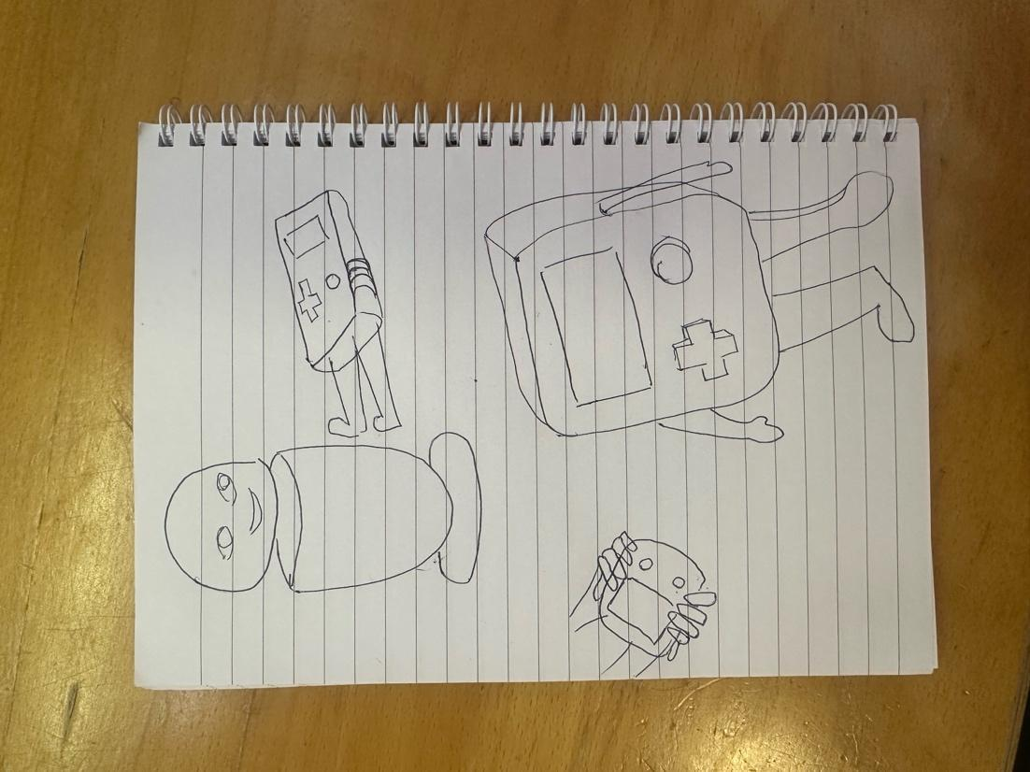
Figure 2 Sketching progress
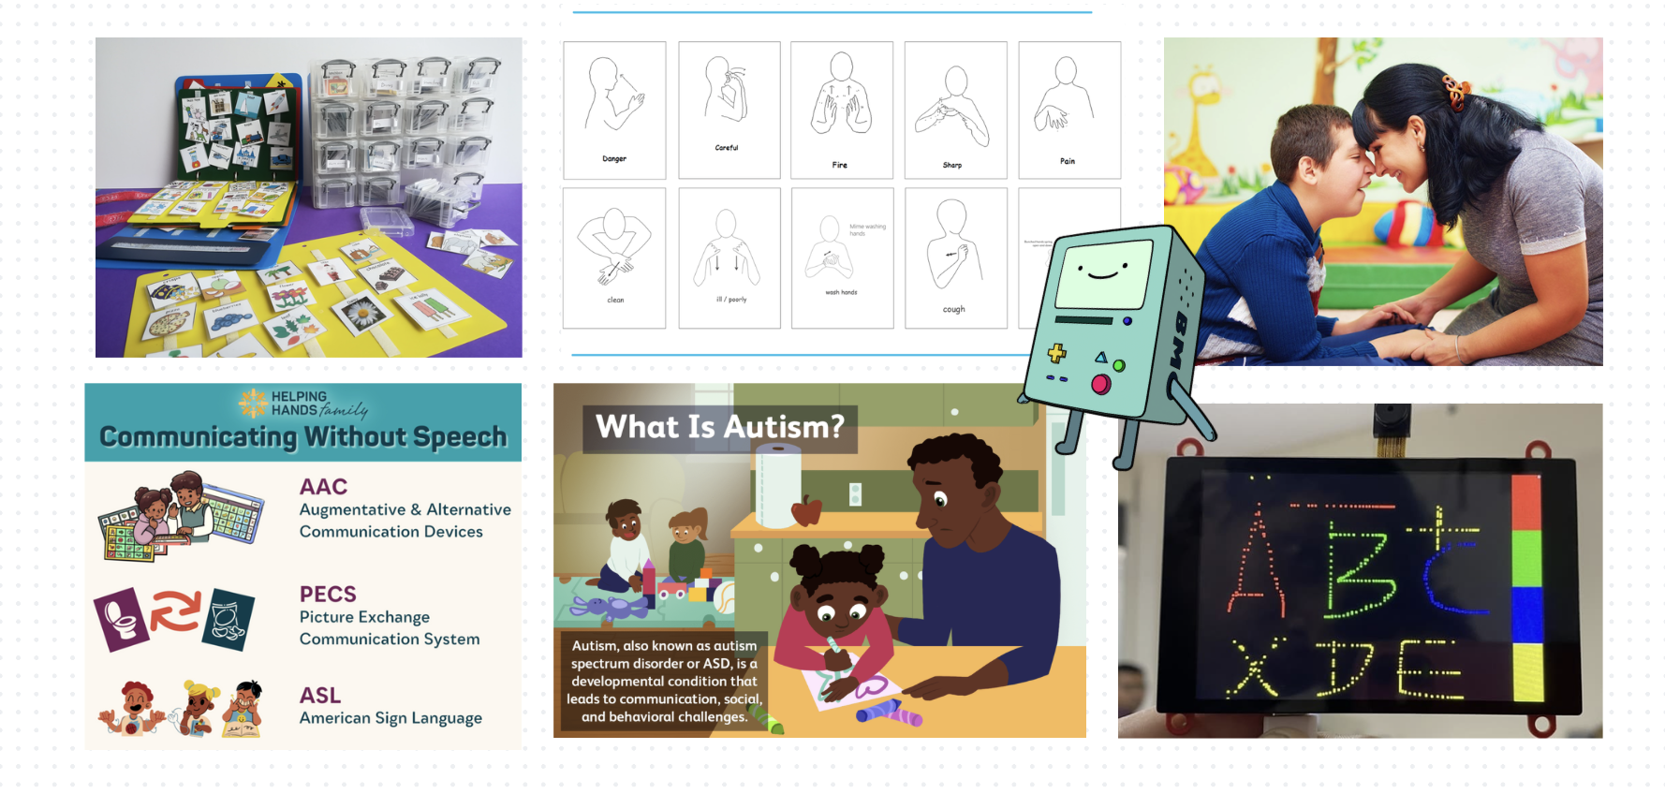
Figure 3 Brainstorming board

Low fidelity prototypes:
As part of the early design process for NeuroTalki, two low-fidelity prototypes were created using cardboard boxes.
I developed two phototypes that should allow me to finalize the decision about the design, made of cardboards.
First prototype was medium sized and involved arms for the robot. By building a rough full-size model, it became easier to judge how NeuroTalki would feel when placed on a desk or held by a child. This prototype made me give off the idea of the arms because of awkward fitting in the bags or other carrying around ways.
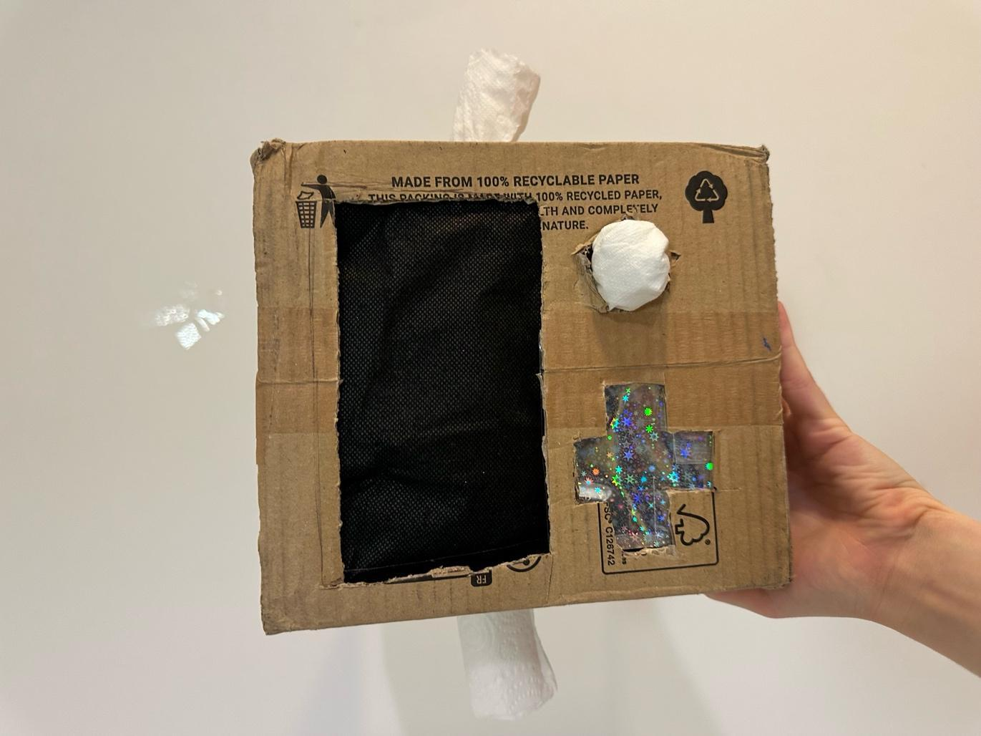
Figure 4 First cardboard prototype
A printed paper screen was attached to the front of the cardboard model to simulate the touchscreen. This allowed realistic testing of how easily a child could see, reach, and tap the images. During testing, it became clear that the screen needed to be placed slightly lower on the body than originally planned. The second prototype also gave insights into how stable the robot needed to be during use. Repeated tapping actions sometimes caused the lightweight model to move or tip slightly, showing the importance of giving NeuroTalki a low center of gravity and a stable base in the final design.
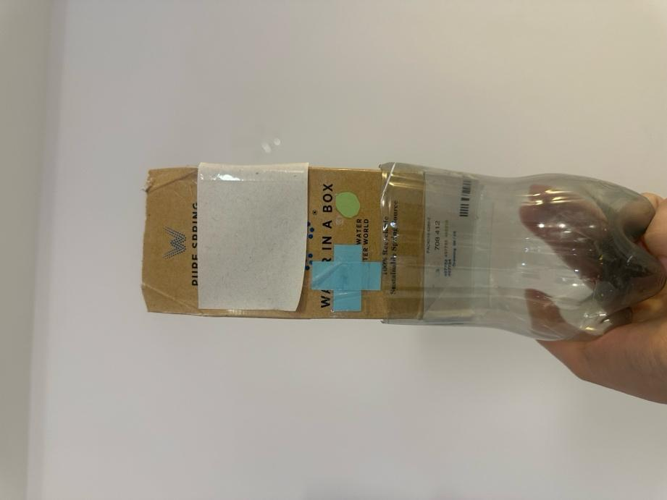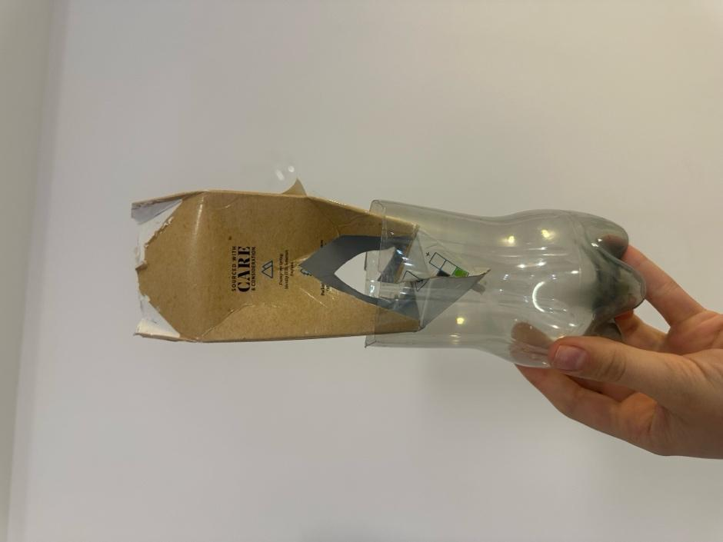
Figure 5,6 Upgraded porotype
Then I moved forward with the building the model in FreeCad. The idea was to make the overall shape compact and symmetrical, offering visual predictability and physical balance. It stands approximately 25 centimeters tall, a size that feels substantial without being intimidating. Its weight is carefully calibrated: light enough for a child to move easily, but heavy enough to feel secure and durable. The shape is based on rounded rectangles and soft curves, avoiding sharp edges. Placement of the screen on the top mimicking the sensor face of the robot. And simple two buttons turn on/off and loudness adjustment for intuitive exploitation.

Development in FreeCad process
The process of developing NeuroTalki was not always smooth. Moving from early cardboard prototypes to digital 3D modeling brought several challenges, many of which were stressful and time-consuming. The transition into using FreeCAD to create the robot’s shape and screen pocket revealed technical problems. After I created main body and first sketch of the I face in the Part Design Workbench. The challenge to correctly attaching sketches to the right faces of the body. FreeCAD often showed confusing errors like “attachment mode failed: infinite shape provided” or “input shape is null,” making it difficult to even start creating pockets and cutouts.
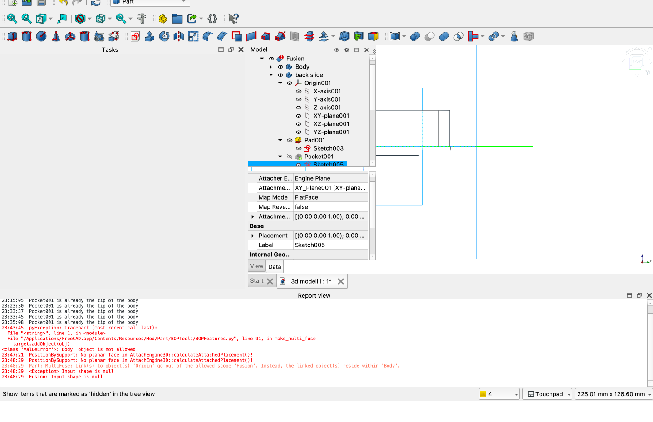
Figure 7 Issue message
Sometimes sketches would not map onto the correct face, or the reference planes would become lost, causing the model to fail.
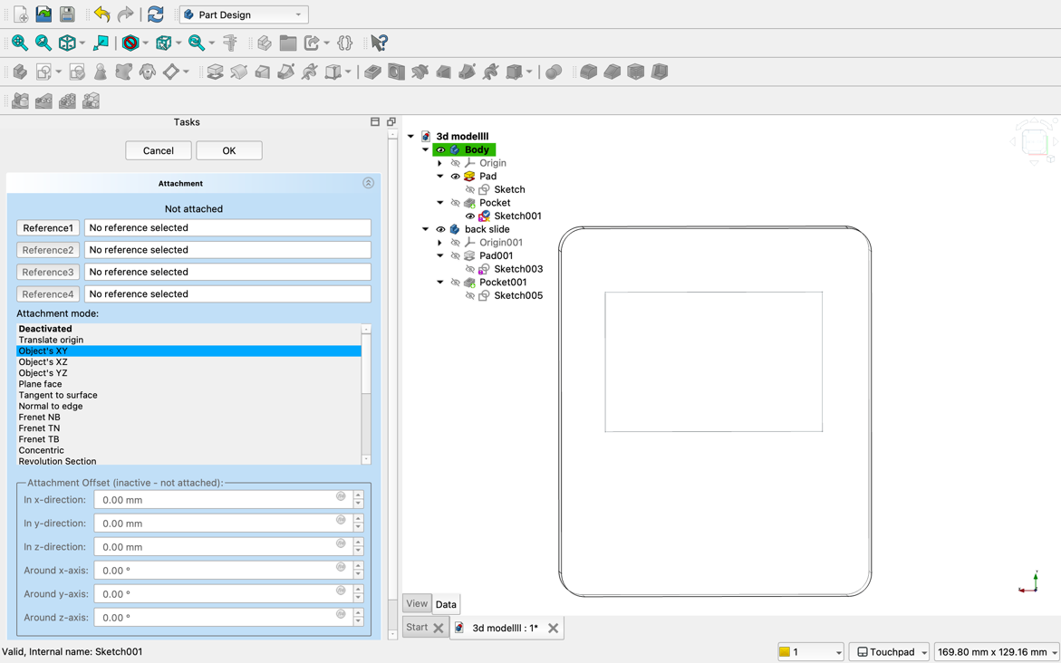
Figure 8 Face issue attachment
Sometimes, it would not recognize a flat surface, and I had to change attachment modes manually, such as using Inertia 2-3 instead of the default plane selection.
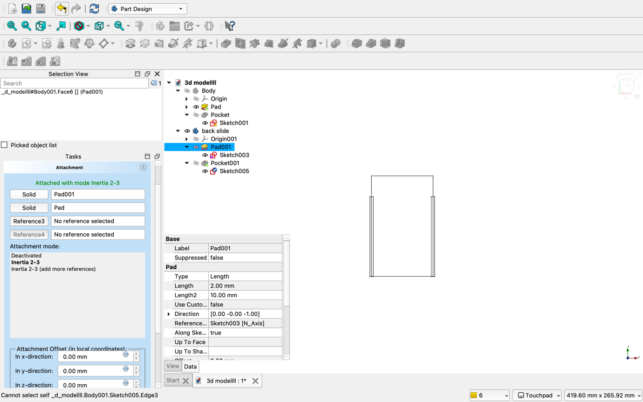
Figure 9 Inertia 2-3 mode
FreeCad would auto close and troubleshoot with bags like not reflecting the last changes of the saved work or not responding to the clicks of highlighted area or rearranging model task and view area, it made me to redo the model from the scratch 4 times. Sometimes, I had to manually move or reattach sketches by adjusting data properties instead of relying on automatic options, I had to fix the position manually because the software could not recognize the shape properly. Another major challenge was managing multiple bodies inside the same file. At some points, I accidentally tried to use sketches from one body inside another, causing "Cannot use selected object" errors. This taught me the importance of keeping one active body at a time and working systematically.
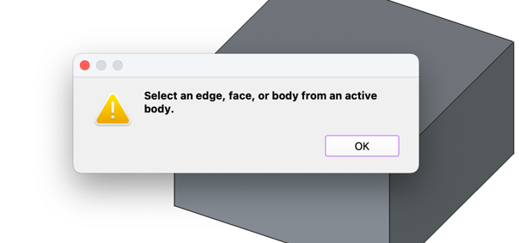
Figure 10 Issue message
Implementing my skills gained during the labs like Shape Binders and the structure of features like Origin planes, Pads, Pockets, and Sketches helped me avoid these problems over time.
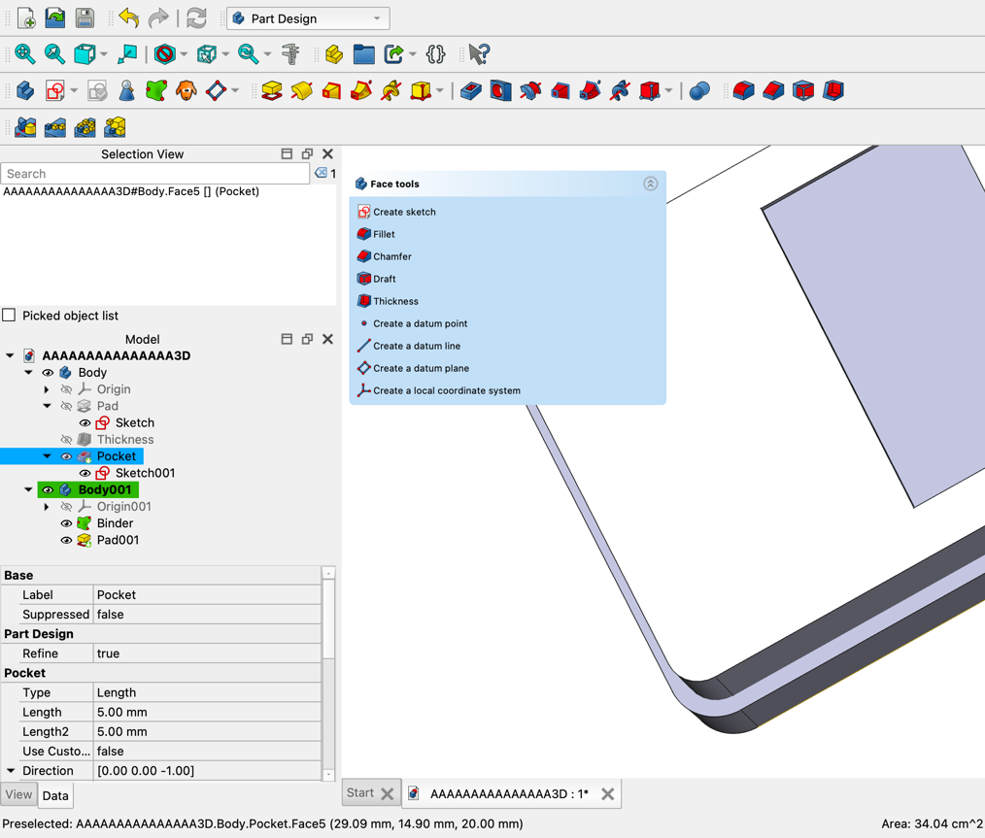
Figure 11 Blinder creation for the lid part
Major time was spent chasing the idea to create a sliding lid.
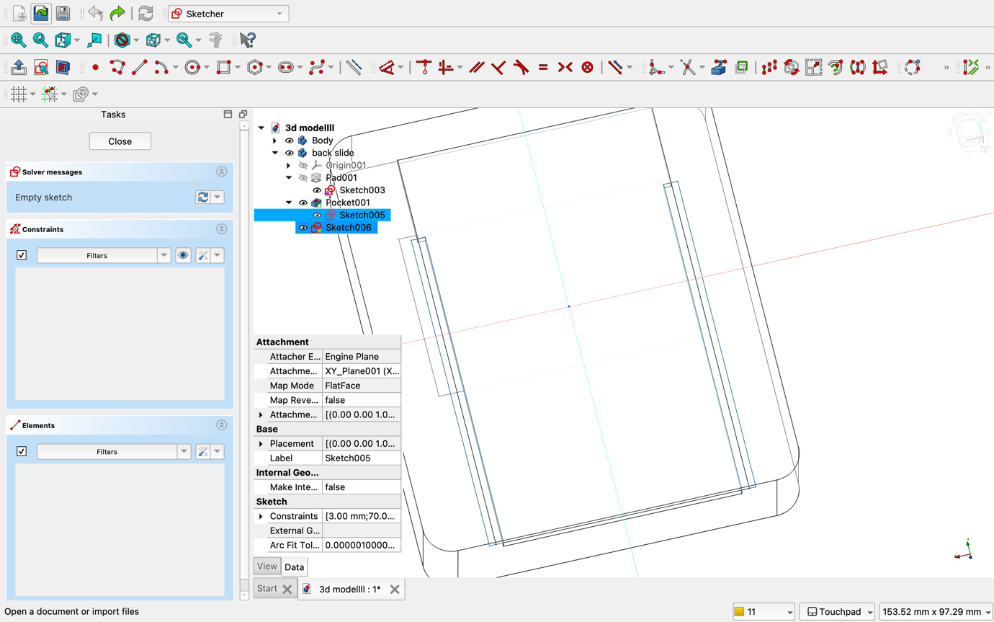
Figure 12 Creation of sliding lid
I designed to to that with groves and rails, therefore this idea failed and I decided to proceed with classic lid created through blinds and thickness sliced and made as a separate body. Decided that the idea of legs inspiring by bottle holding design for easier carrying looked unappealing and brutal I moved forward with the playful two legs model symmetrically placed , filleted for chunky appearance and stability.
Also another point created thickness created became face 9. Had to reattach it to the correct pad by hierarchy rebuilding.
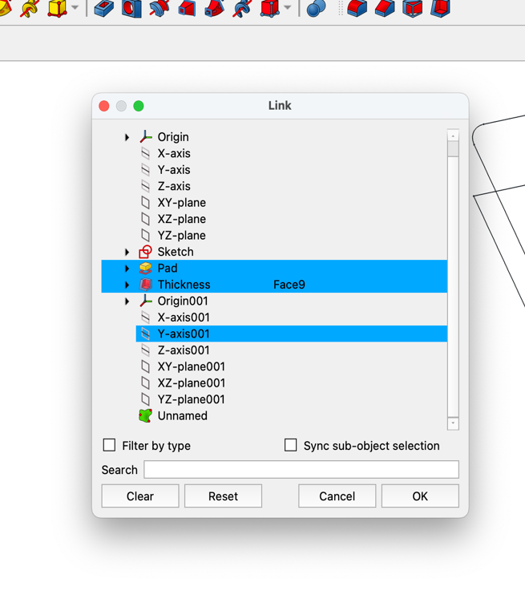
Figure 13 Thickness as a face issue
When I tried to export file in stl format It would open without cutting for the screen. The solid front would be present only in exporting file as every time I have checked the Free cad file the screen hole would be pocketed correctly though all. Sad and frustrated preparing for restarting the model I realized that I forgot to mesh up the file, after meshing up two separate bodies and using Cura the problem was solved ang the 3D model looked exactly how I wanted it to look.
This whole journey, from cutting cardboard to facing FreeCAD technical issues, reflects a real-life design development path. Low-fidelity prototypes gave me the freedom to test ideas fast and cheaply, while digital modeling forced me to think precisely about technical and manufacturing details. I learned shortcuts, validating sketch function and refreshing helped me throughout the process. Now I know more about map mode attachment and tree hierarchy as a moving objects after other objects and set tip.
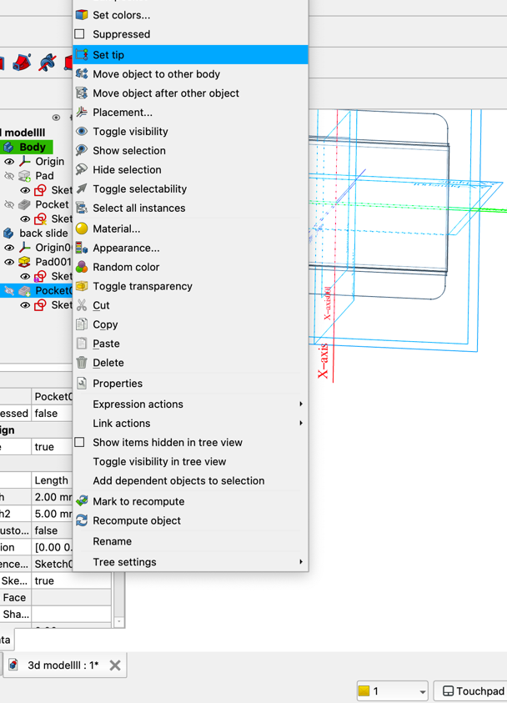
Figure 14 tree hierarchy manual handling
Even though it was stressful at times, it made the final design much stronger and helped me develop real engineering thinking and kept me in ardor by taking this challenge.

Material Selection for Strength and Safety
Children’s toys must survive drops, kicks, and daily rough handling especially for children with sensory and motor differences. The materials chosen for NeuroTalki were selected to survive these realities. The main body would be made from TPU (Thermoplastic Polyurethane) filament, a flexible, rubber-like material that absorbs impact. TPU can be 3D printed, meaning NeuroTalki can be prototyped and locally produced without heavy industrial processes. It offers excellent durability, is safe to touch, and resists tears and cracks even under pressure. The screen is protected by a cover made from PETG plastic, a strong, flexible, shatter-resistant material. PETG ensures the screen remains functional and clear even after rough use. Unfortunately, I was limited in materials so I had to proceed with Charcoal color and bioplastic, Polylactic Acid, which is not ideal but works well in portraying the idea.
Therefore, using these materials, NeuroTalki is both safe and sustainable. It can survive accidents without becoming a danger to the child, and its materials are recyclable and non-toxic. NeuroTalki can initially be produced using FDM 3D printing, allowing rapid testing and customization for individual children or settings. TPU printing settings (lower speed, higher temperature) ensure strong, flexible prints with smooth surfaces. For large-scale production, injection molding with flexible TPU could be used, offering high-volume manufacturing while keeping the durable, child-friendly properties. The design uses snap-fit parts to minimize the use of screws and small detachable pieces, making the robot safer and easier to assemble and repair. Ergonomics and sensory safety are key elements of NeuroTalki’s design. The robot’s rounded body naturally fits in a child’s arms or lap. Its weight and balance are carefully adjusted to feel substantial without being heavy or dangerous. The touchscreen is sized and placed for easy access without strain. Sound outputs are soft and customizable, respecting the needs of children sensitive to noise. Visual feedback, such as soft glows and gentle animations, is consistent and predictable, avoiding any sudden or distressing changes. Every part of the design considers how an autistic child might perceive and interact with the device, ensuring NeuroTalki feels safe, friendly, and empowering.
Printing
I used printer named Bambu Lab A1 mini and filament PLA Mage Filament with spool 1kg /Mage /Charcoal

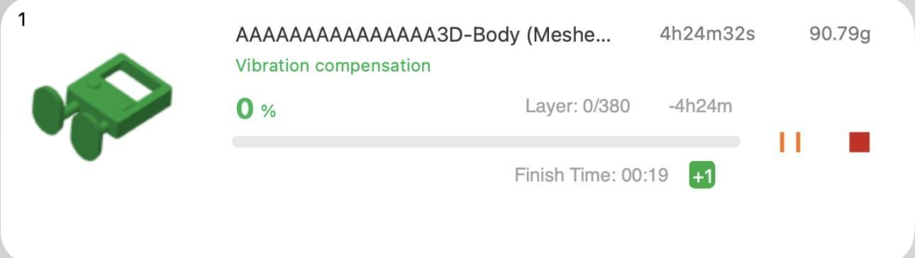
Figure 15 Printing queue
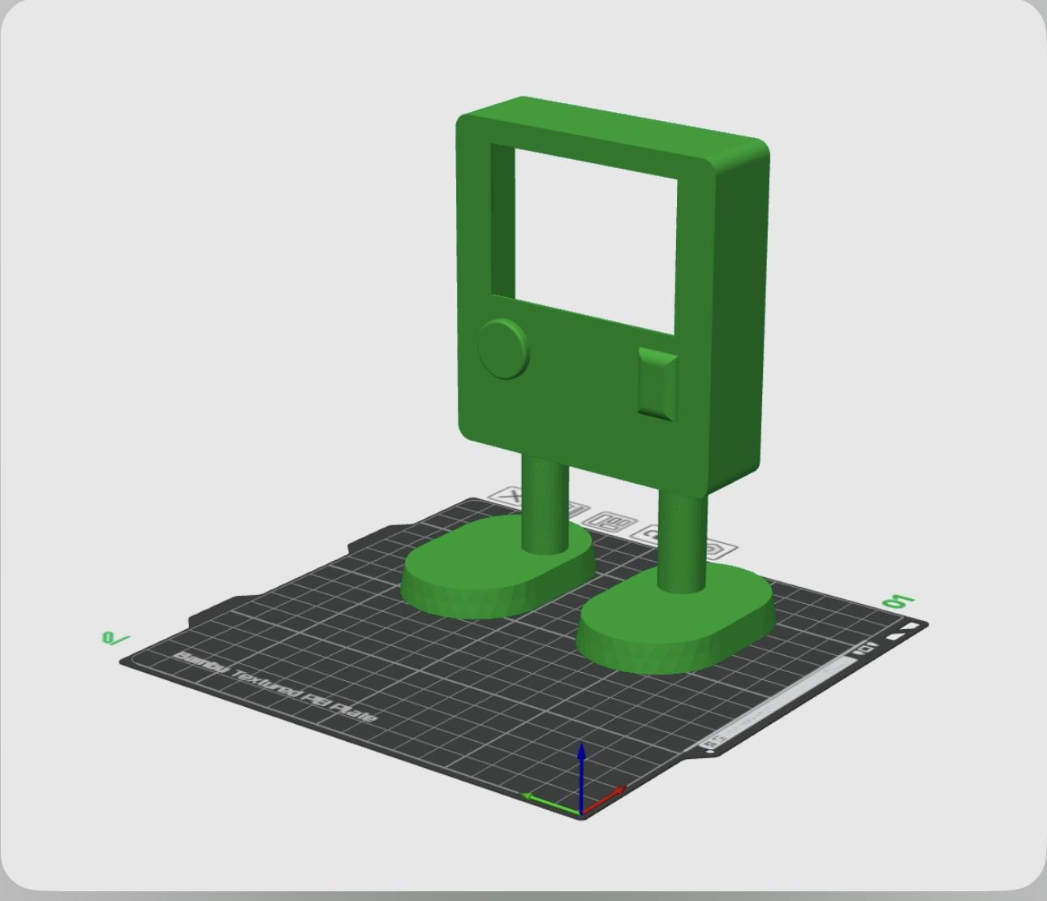
Figure 16 Positioning
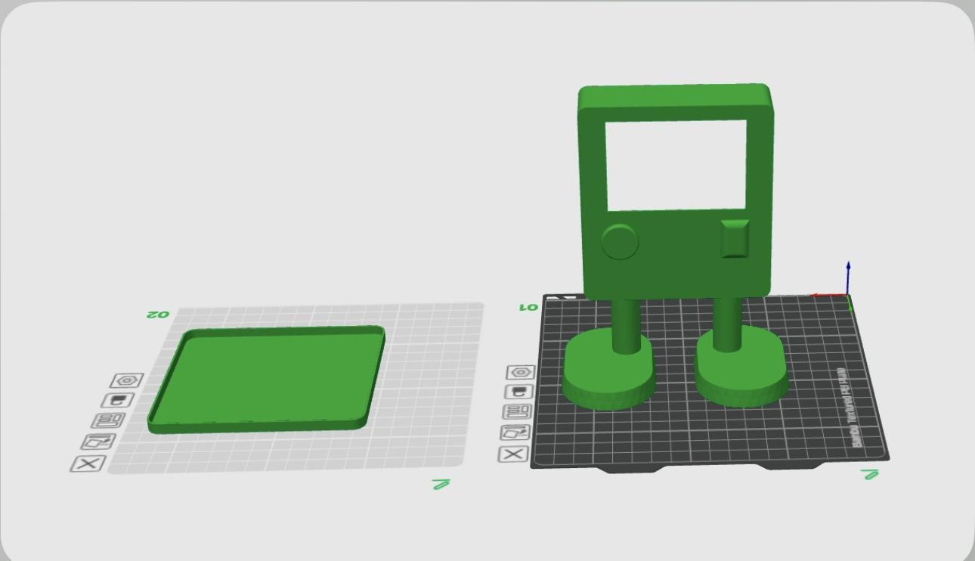
Figure 17 Positioning 2.0
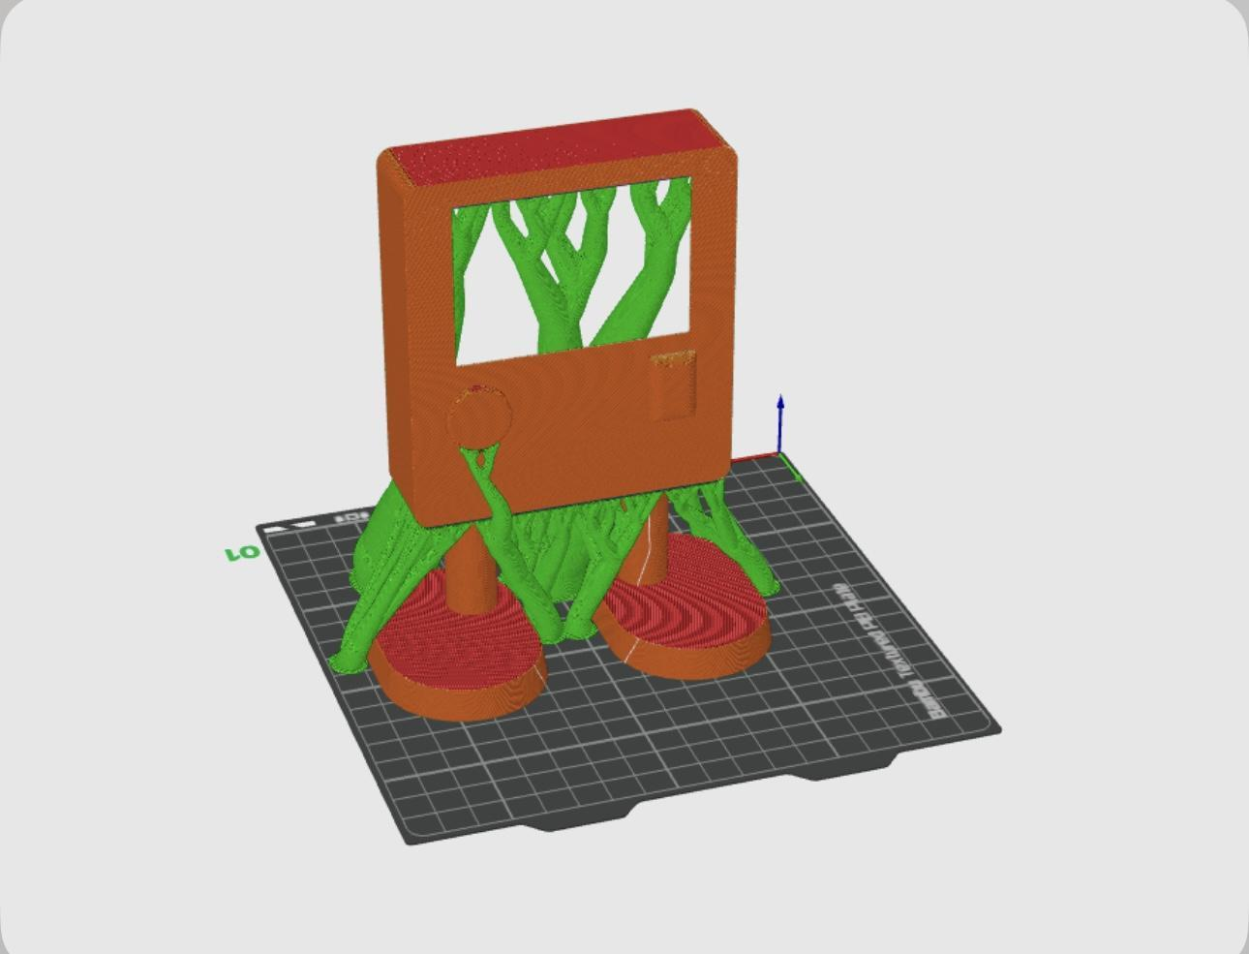
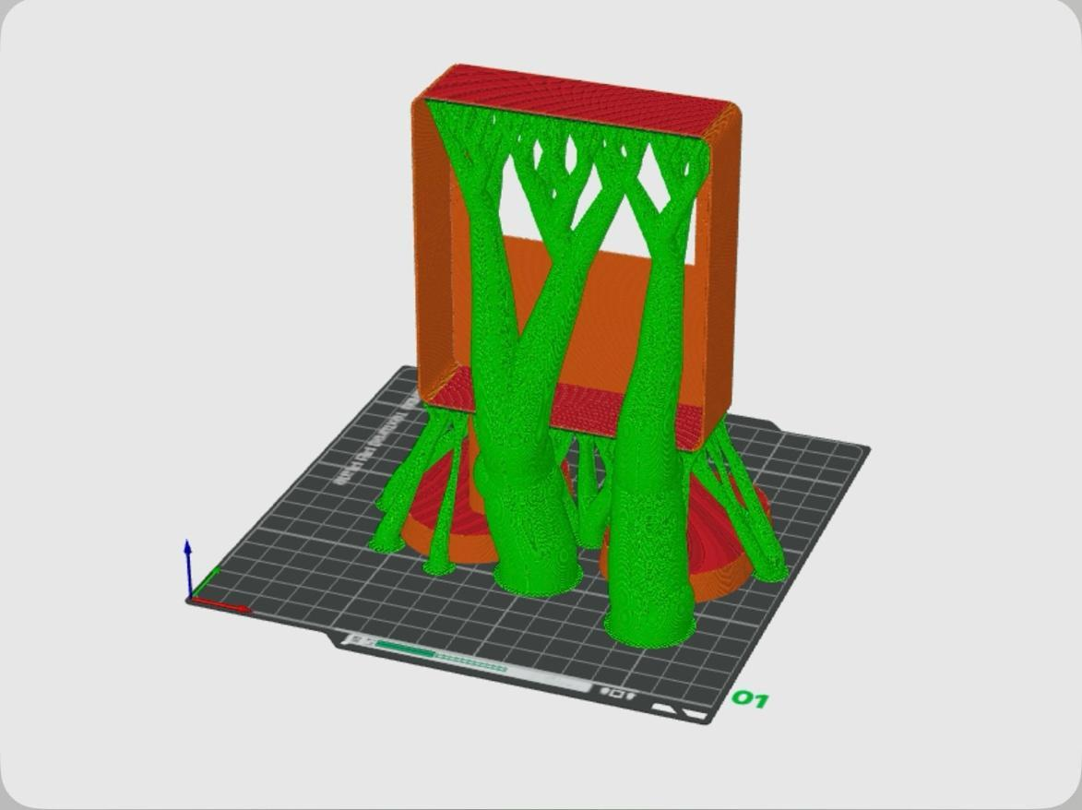
Figure 18,19 Supports adding

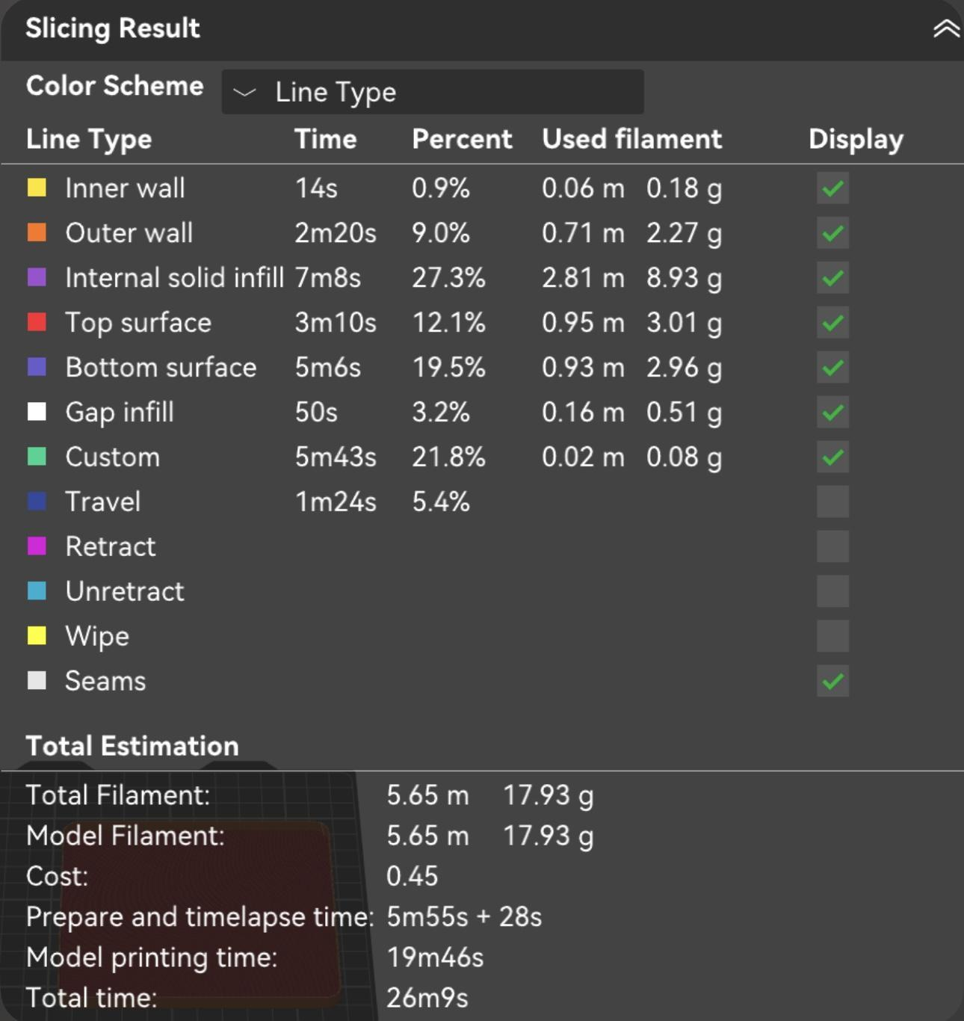
Figure 20 Settings of the print

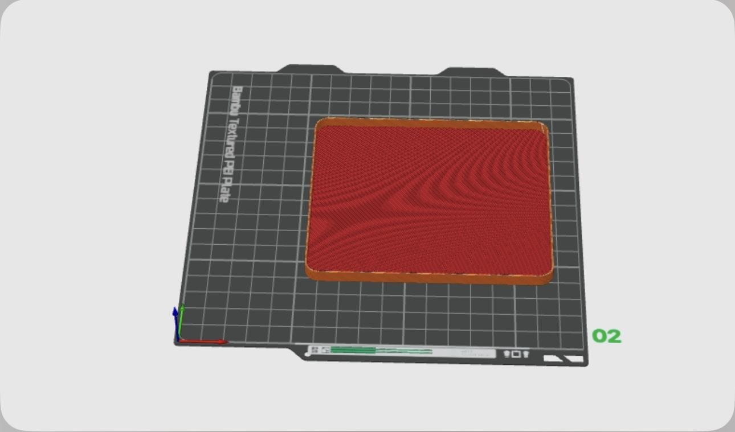
Figure 21 lid position
The First print broke so I had to reorient it and reprint.
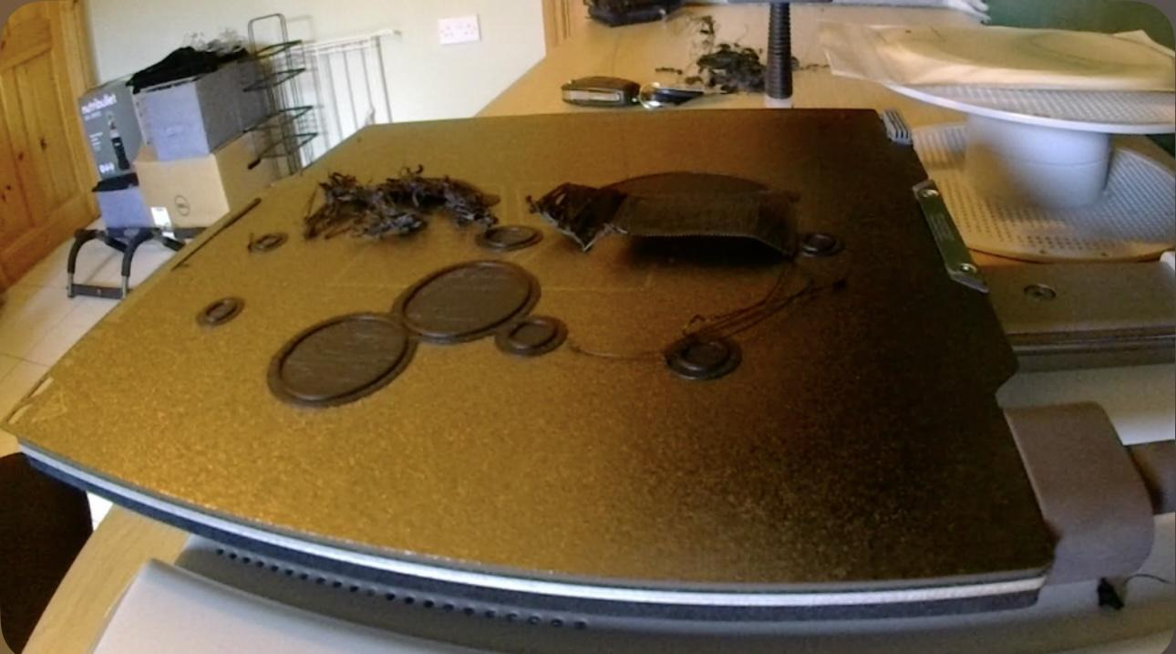
Figure 22 Broken print

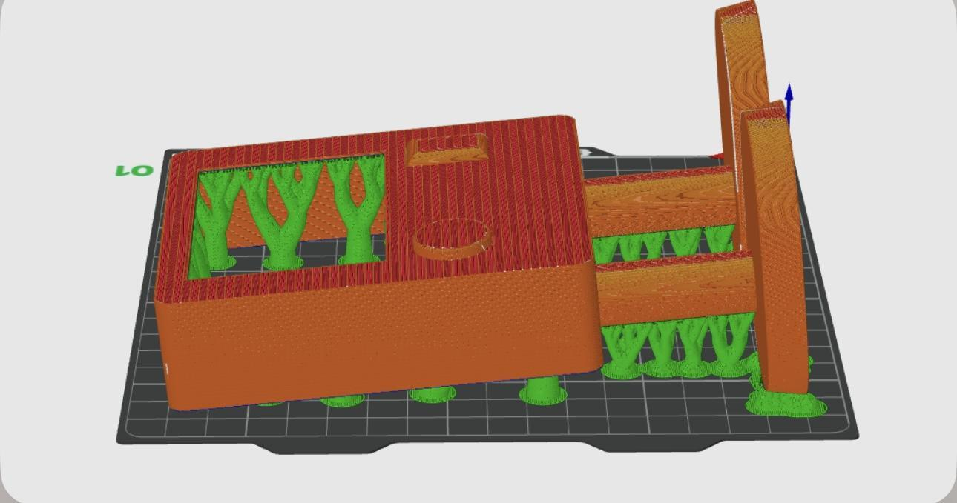
Figure 23, 24 Relocating the main body

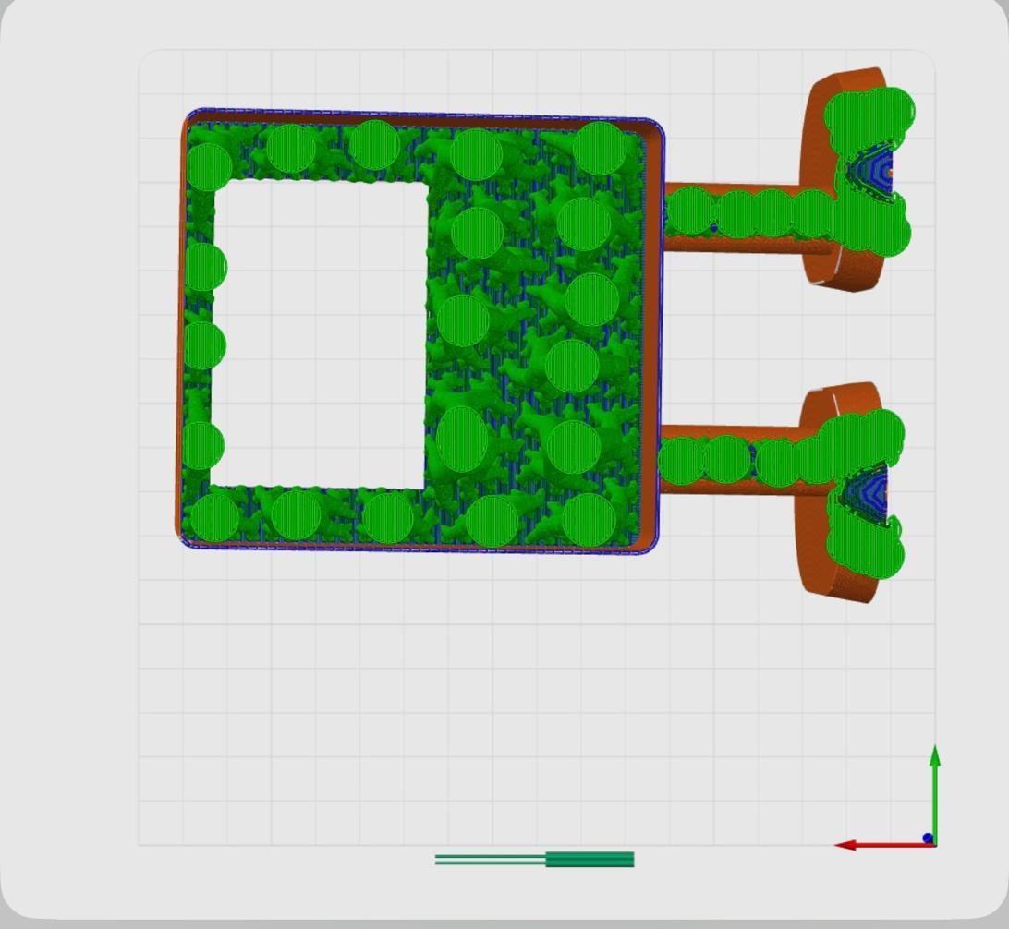
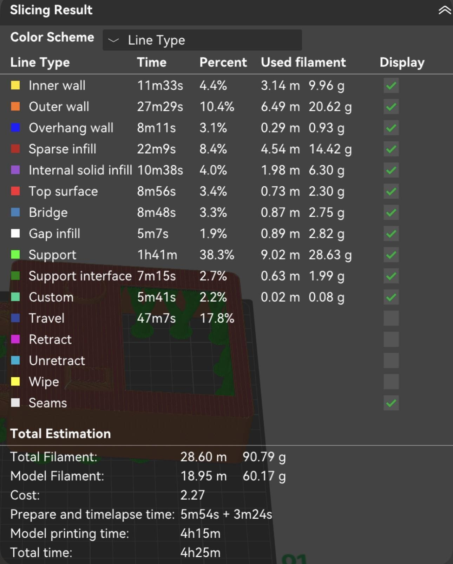
Figure 25 new settings

Finally I got this result of the first print:
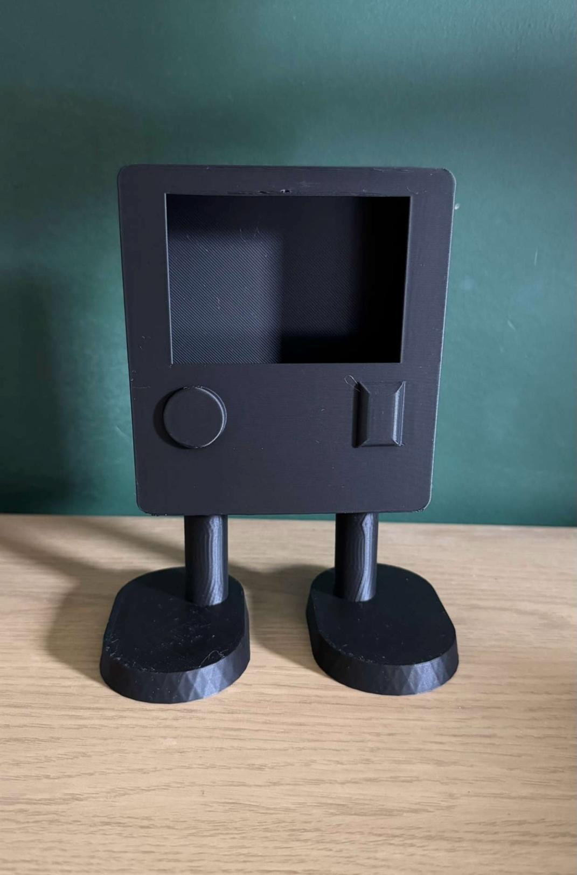
Figure 26 Result of the first print
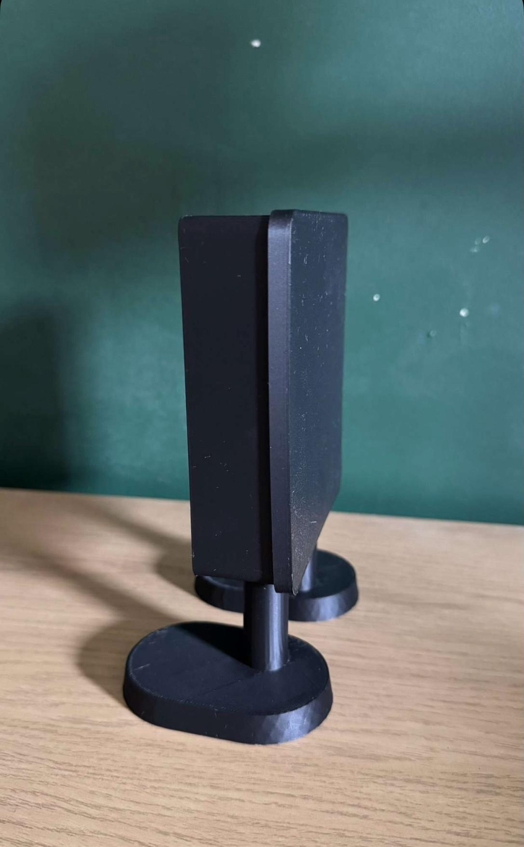
Figure 27 Side of the main print
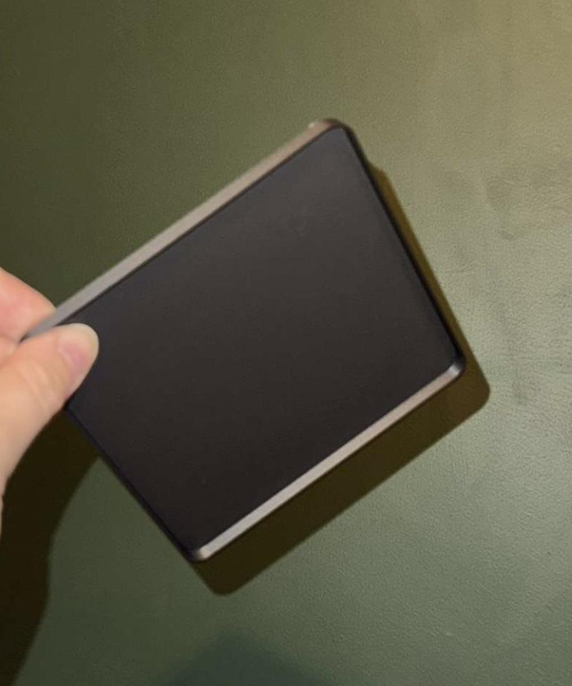
Figure 28 Lid print

After this print I proceed with adding the grip for the screen and making the lid tighter for the main body. In the end got this final result:
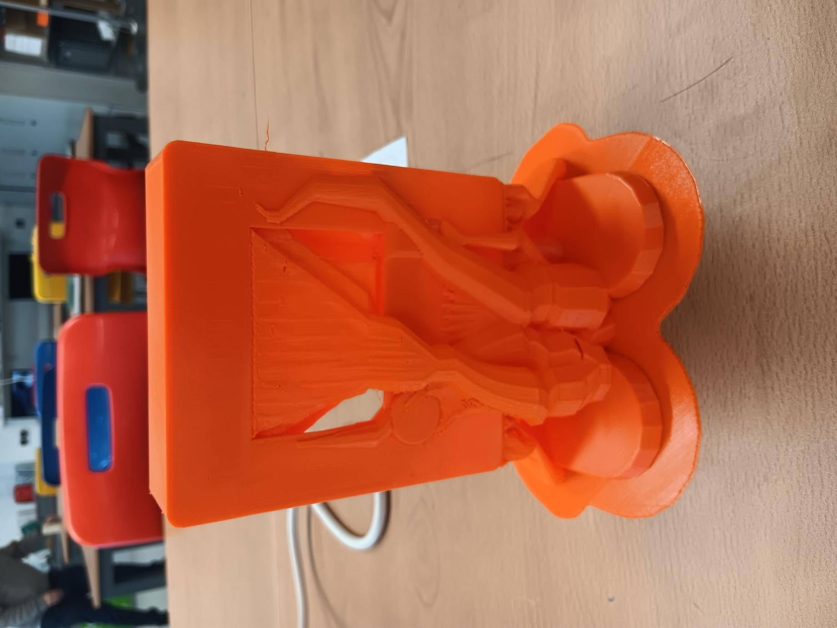
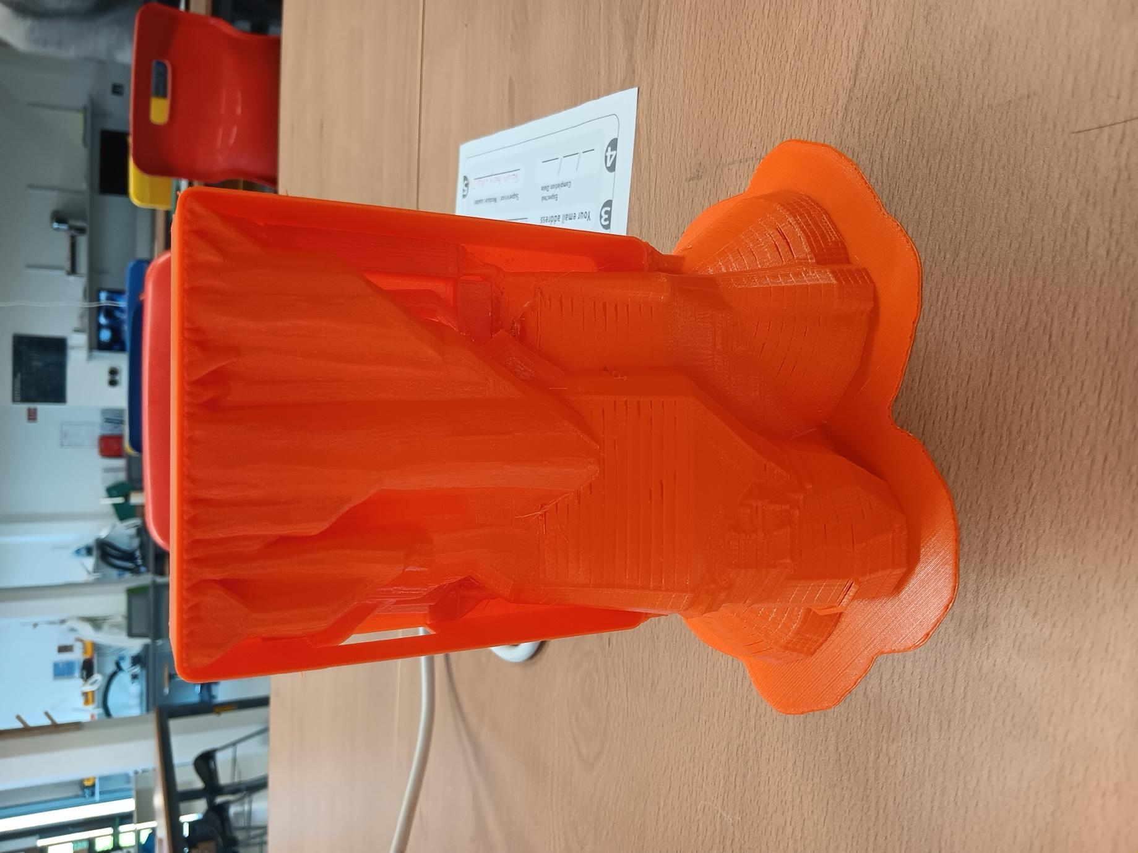Figure 29 , 30 Finalized print with supports
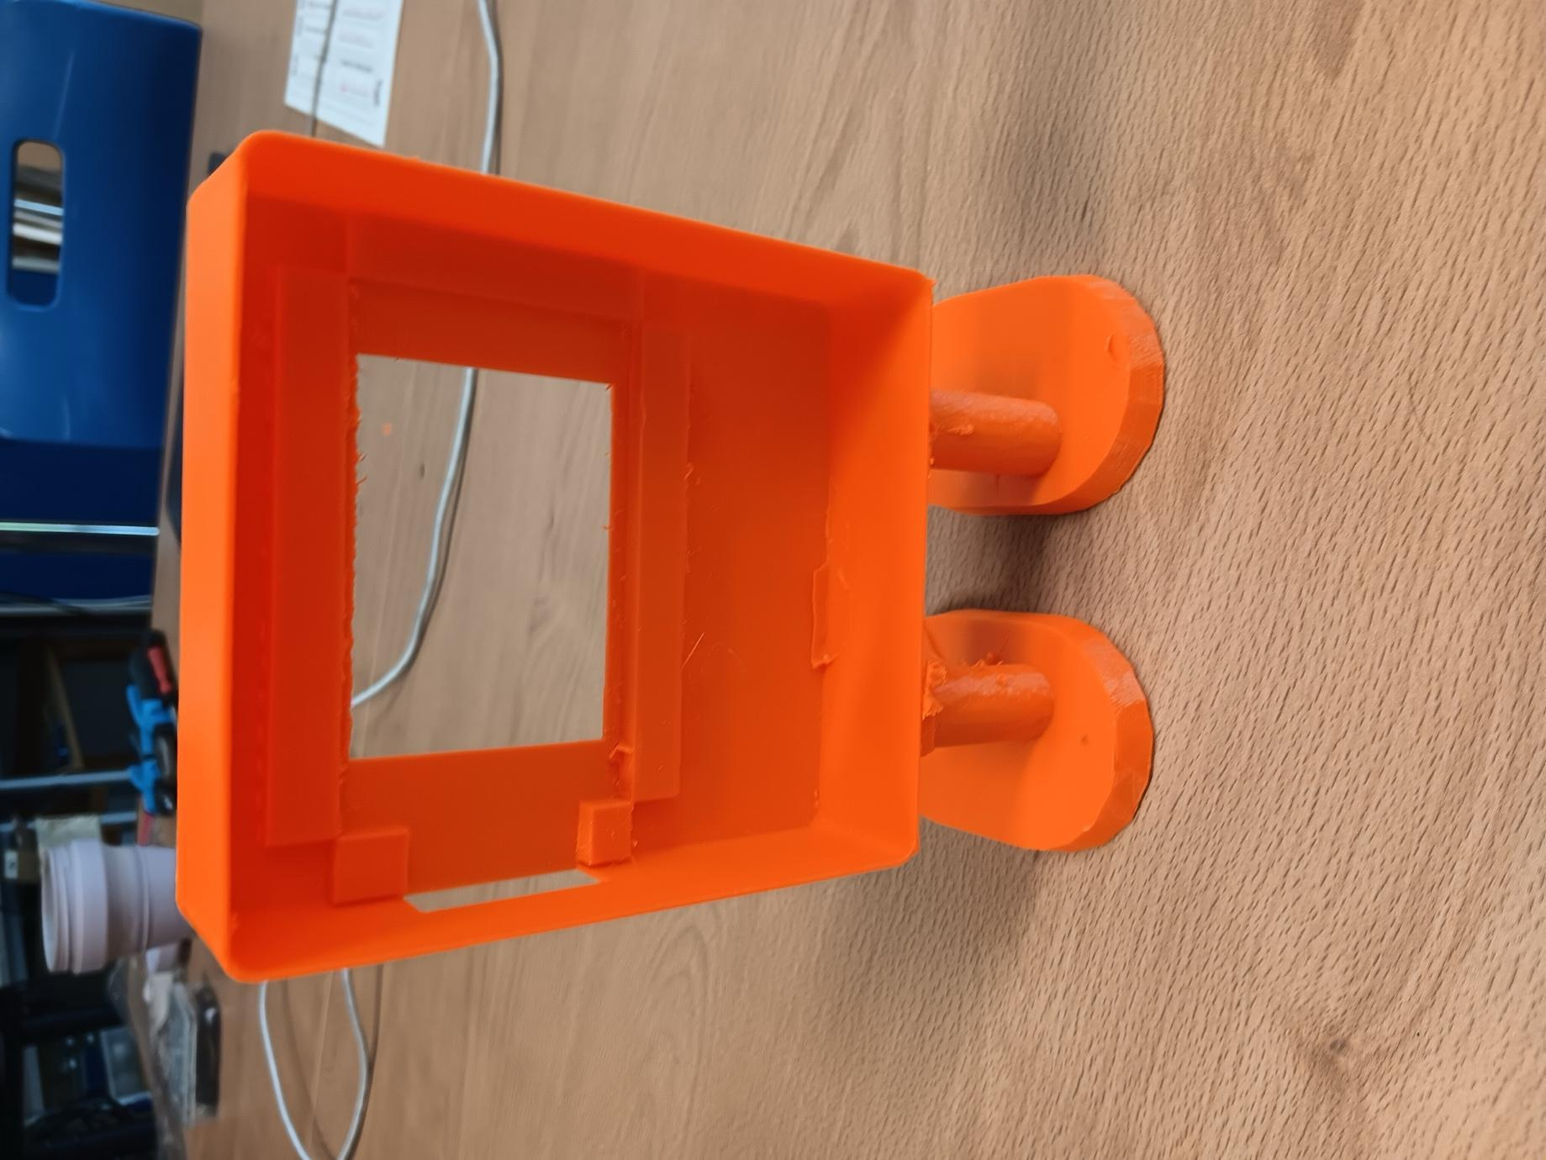
Figure 31-34 Final product
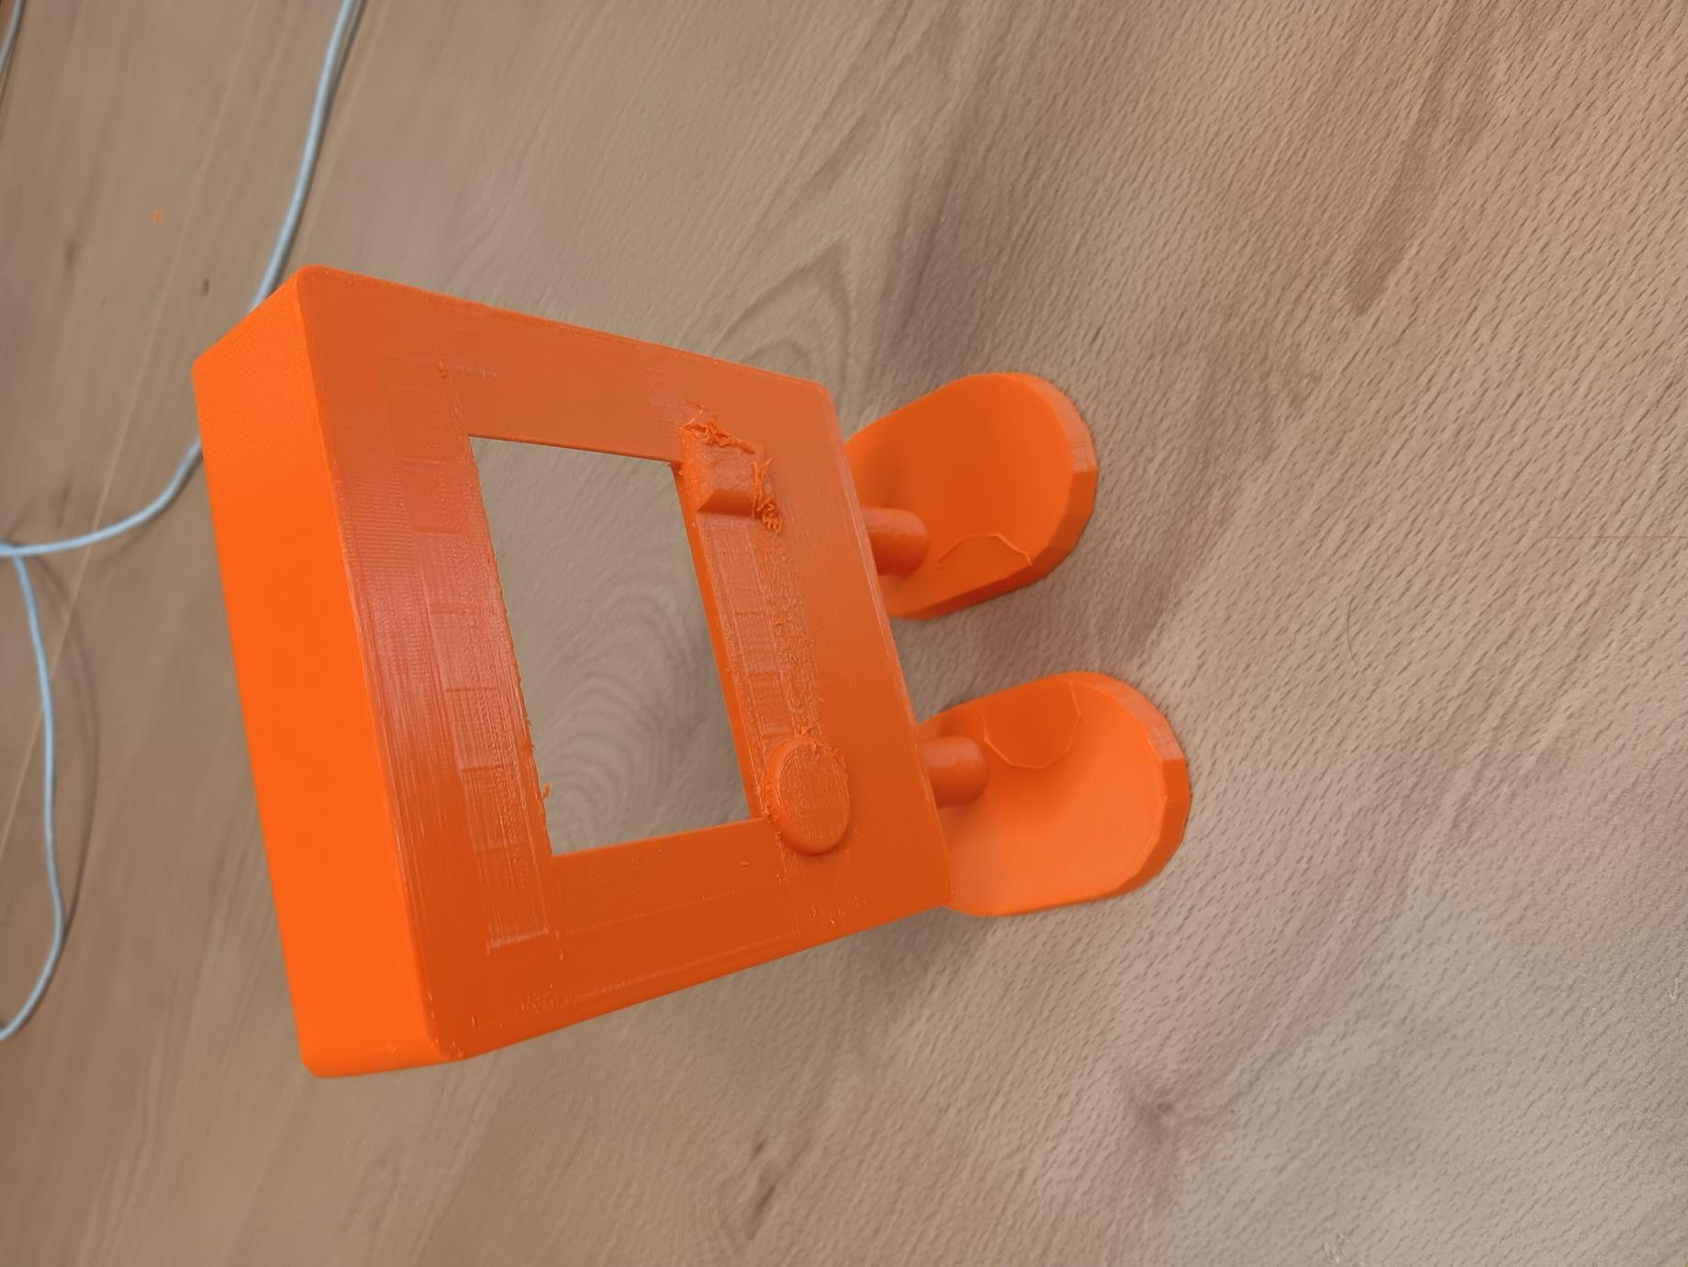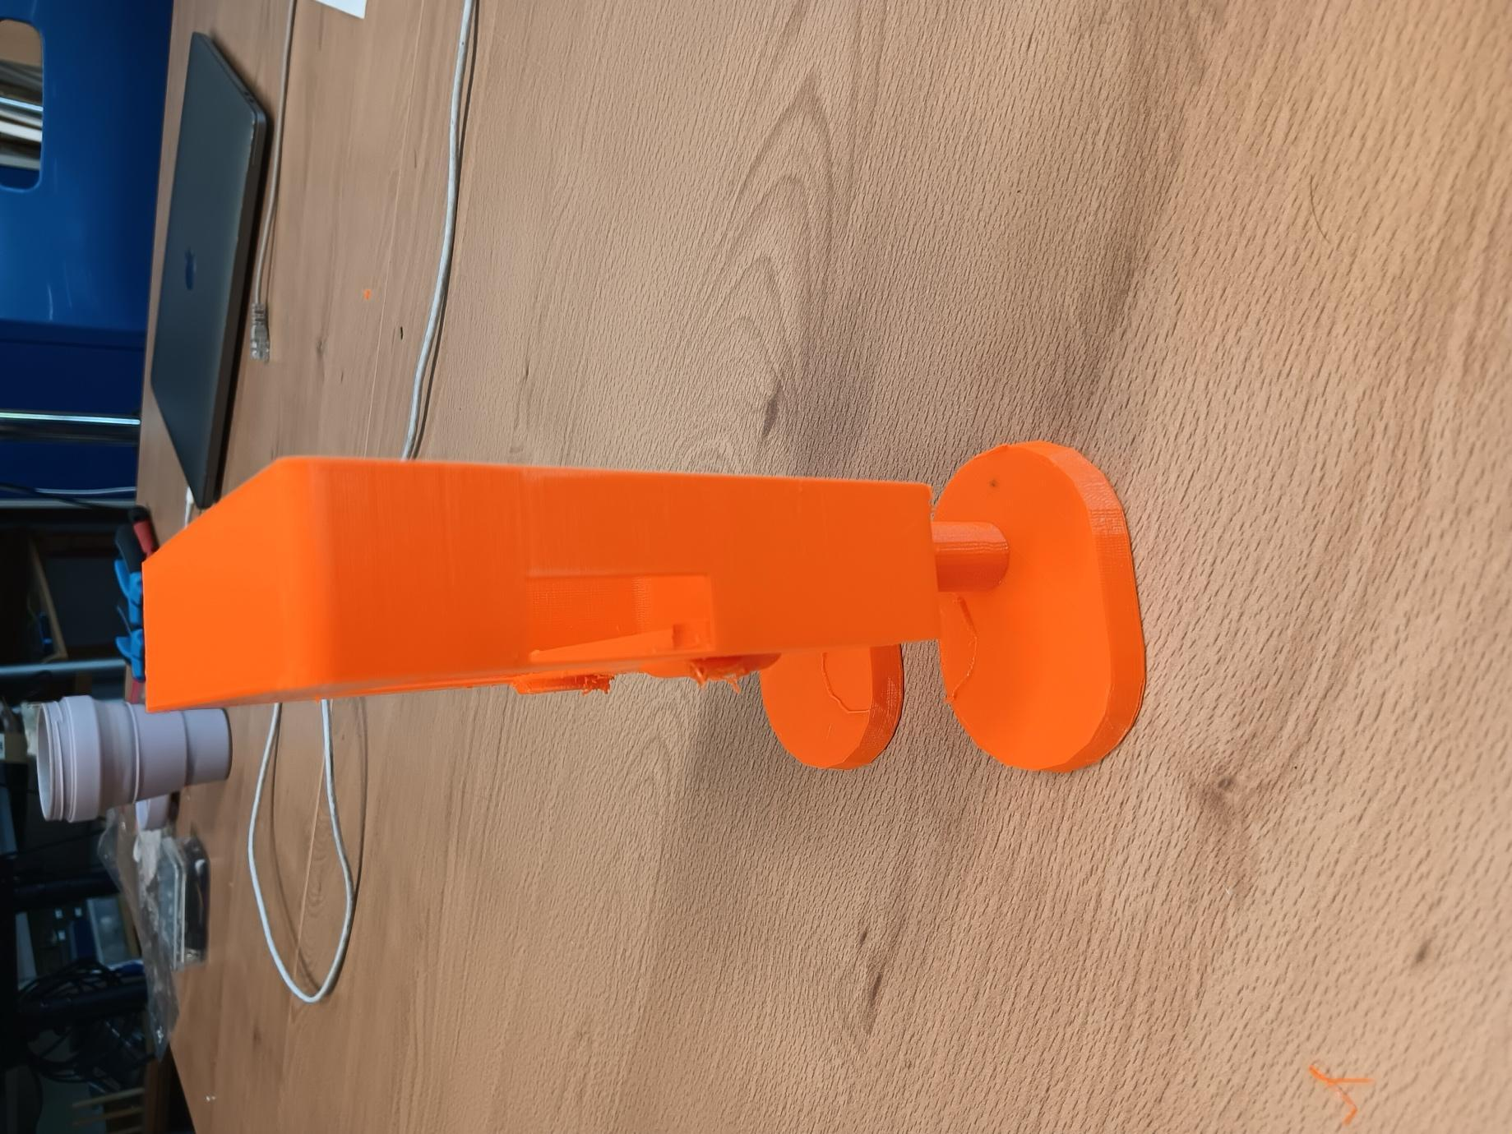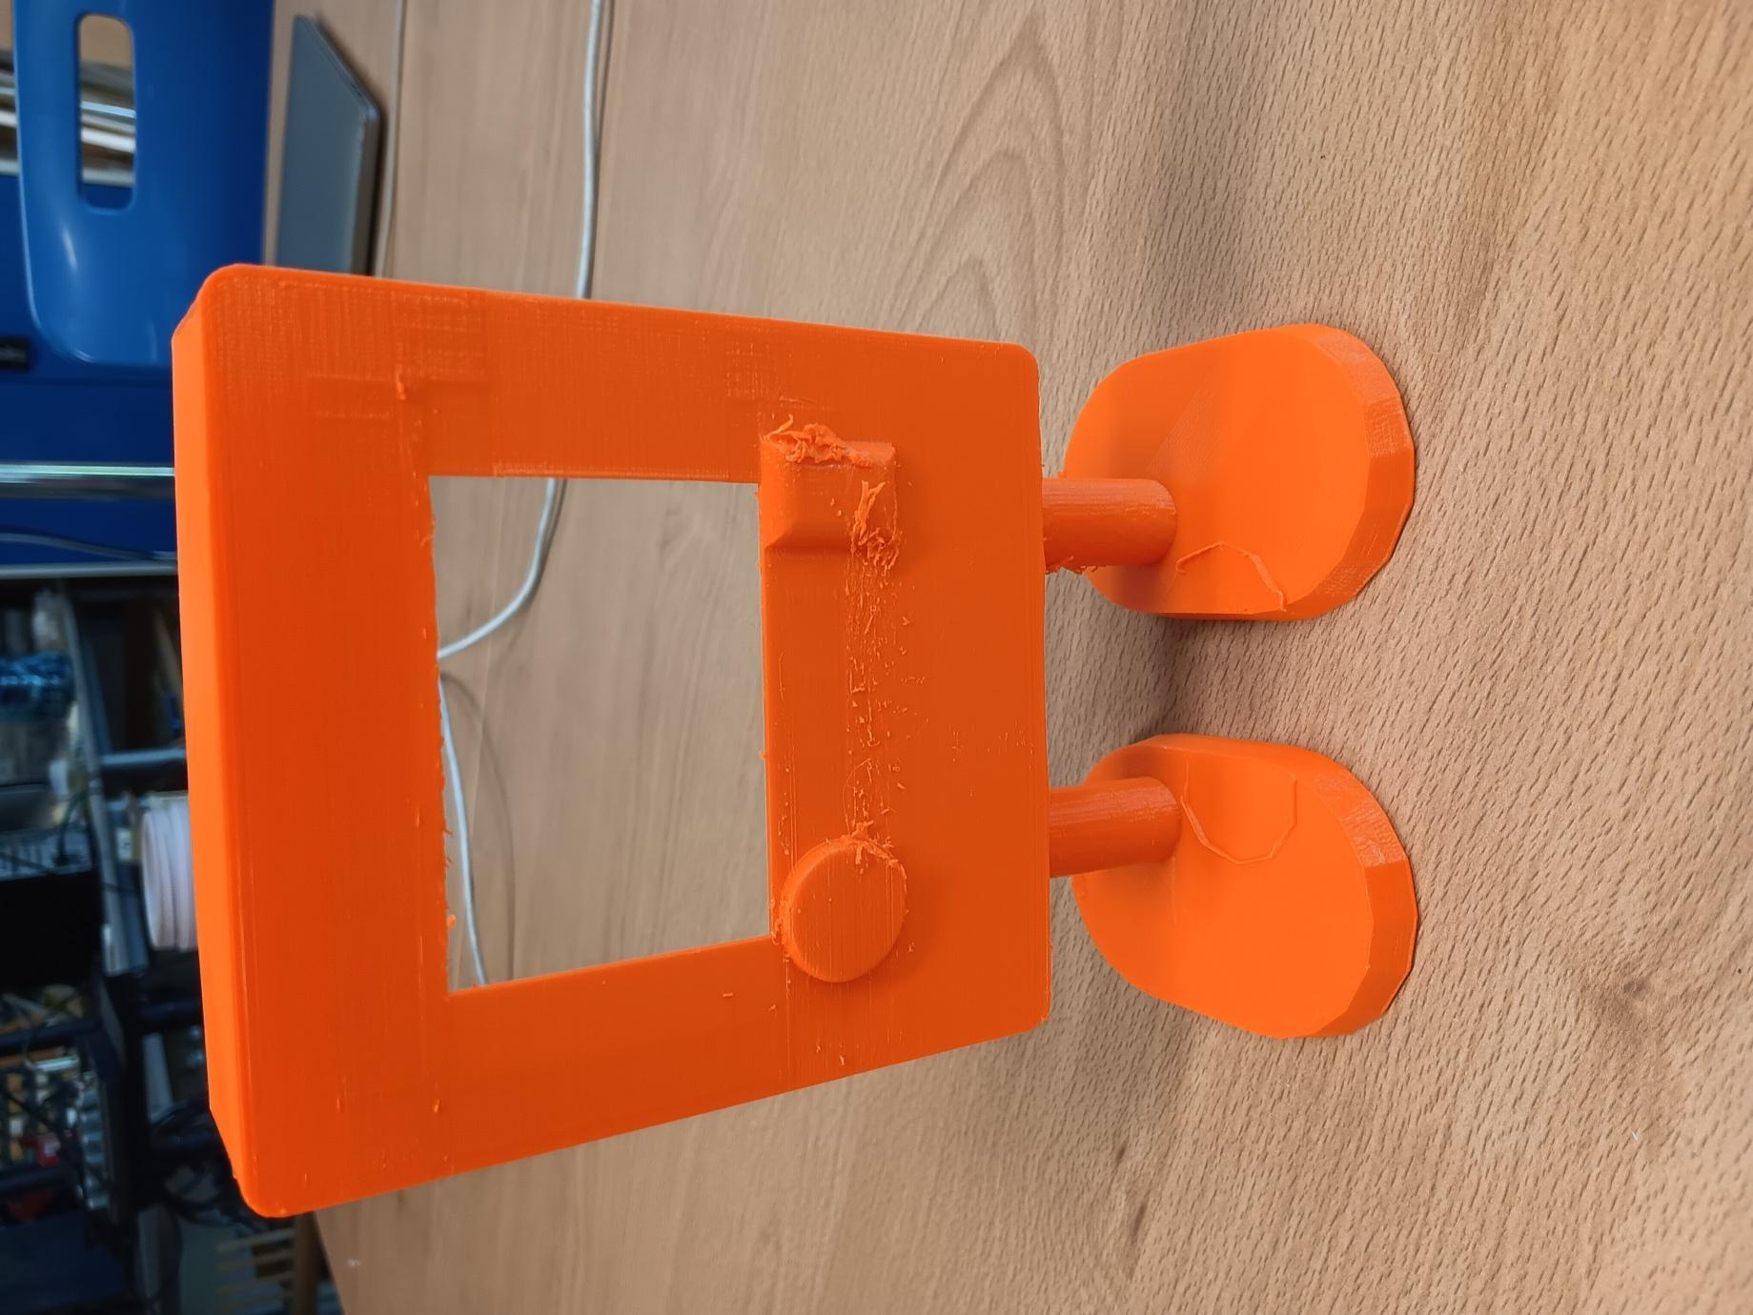

Conclusion
NeuroTalki is an innovative solution in inclusive sustainable design.
By helping autistic children express themselves more easily through a digital neuro-correction system, NeuroTalki promotes independence, education, emotional health, and smoother integration in the community. In addition to this now I am confident in my FreeCad skills modelling. I am sincerely proud and delighted with the outcome making technology that truly matters.
With NeuroTalki, every child can find their voice — and be heard.

