Final Project 3D Modelling
22311491 Dolha Yelyzaveta

- Introduction
The primary goal of my animation video was to showcase my proficiency in utilizing Blender and After Effects. This involved creating a 3D animation featuring a dancing orange set I tried to make it as close to natural look only using face features for cartoonish vibe. Oranges, with their vibrant color and dynamic shape, offer an interesting challenge for 3D modeling. In addition to this, the concept of a dancing orange adds a layer of whimsy and entertainment, making the project engaging for the audience. The repeating circulation actions made for the point of reducing stress and make the audience stick to the picture. Vibrant orange hues will be complemented by contrasting colors, a rich blue a warm green, to create a visually striking and aesthetically pleasing composition. It is in a not dynamic environment with a bumpy features and texture such as field with a blue sky background. The ground ,to my opinion, makes the image more vivid and voluminous. I aimed to demonstrate my skills in model creation, rigging, animation, color grading and creating a texture, advanced lighting techniques and animated camera movement within the Blender 3D and After Effects software.
- Resources
To make my animation video, I mainly used two computer programs: Blender and After Effects. Blender helped me create the 3D dancing orange shape and set the stage for the animation. I found the interface of Blender more understandable that why I’ve worked with this software. After Effects was handy for adjusting colors and making the final touches like colors lights and final touches to reach the perfect image and to enhance the look of the animation. After creating the main shape, I dived into texture creation. Using the referenced image, I crafted a material, connecting it to the base color for a realistic look (Pic3). UV mapping was employed to ensure the texture seamlessly covered the model. For the upper cut of the fruit, a separate material was created, incorporating bump and color ramp nodes for added texture detail. For the covering the shape and recreating the natural look of the fruit I used photos and images among Creative Common rights websites. Here is all the pictures I used in my work.

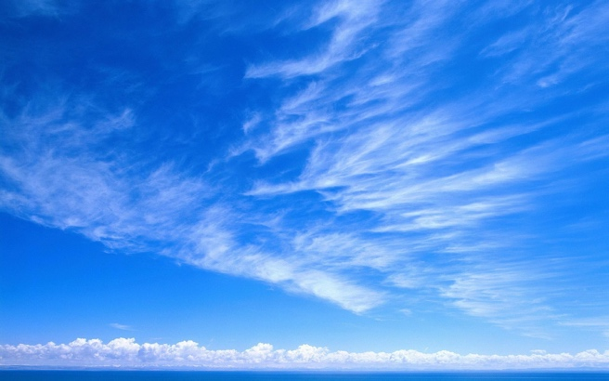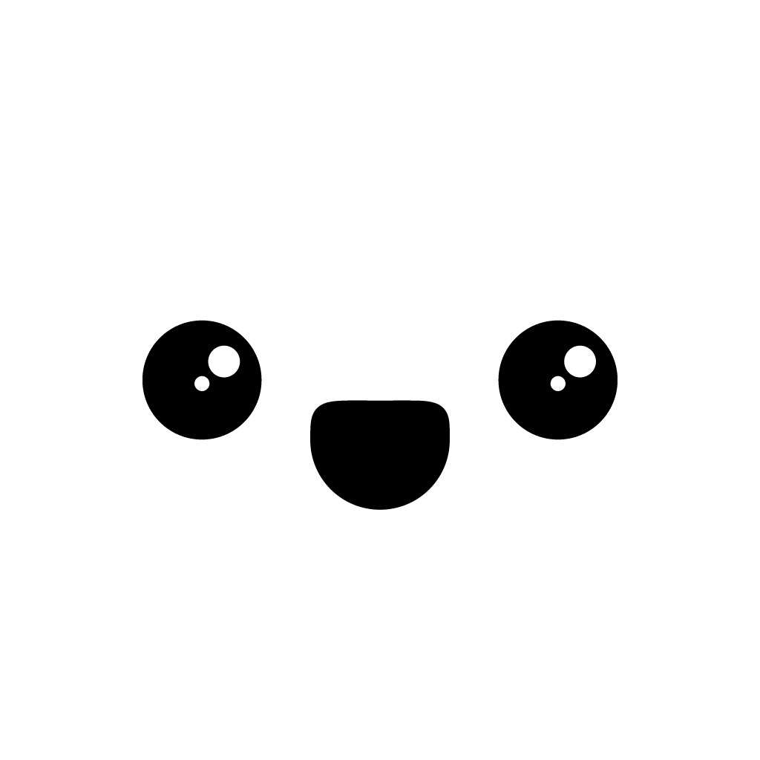
Pic1 Pic2
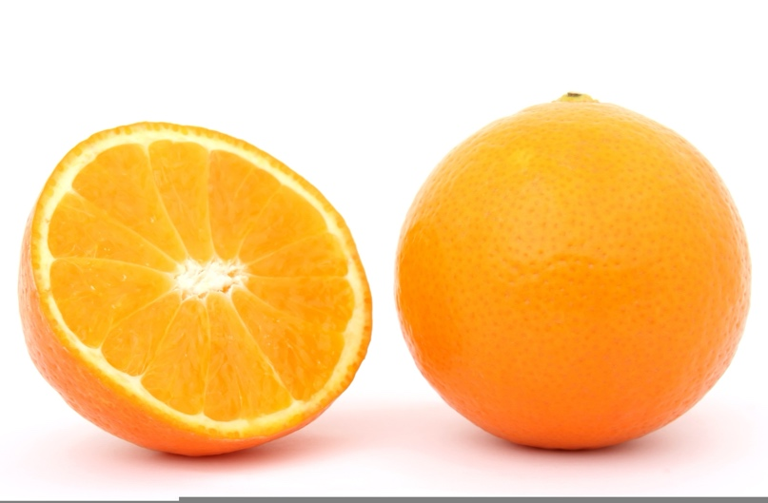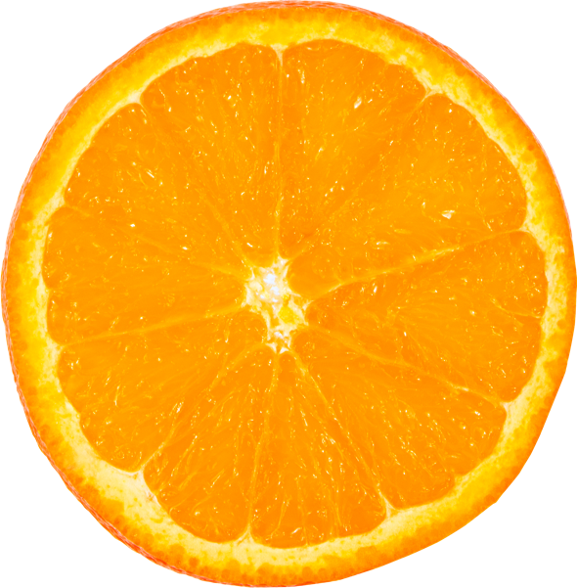
Pic 3 Pic4
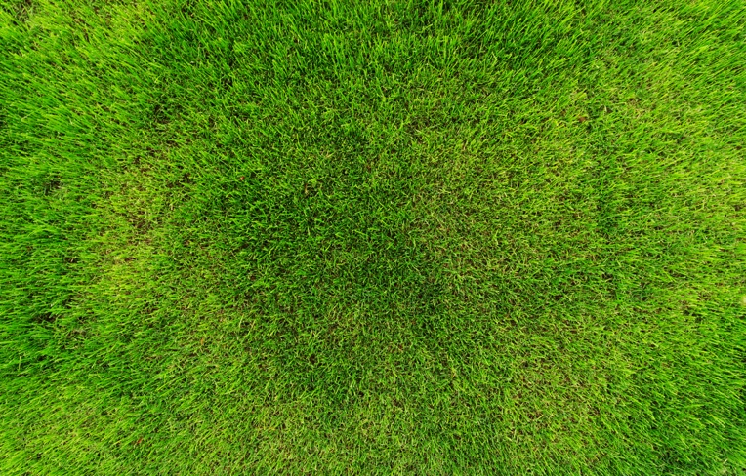
Pic5
- Process in steps for full image of work done
First things first, modeling of the object. The image from a free source is taken as a reference.
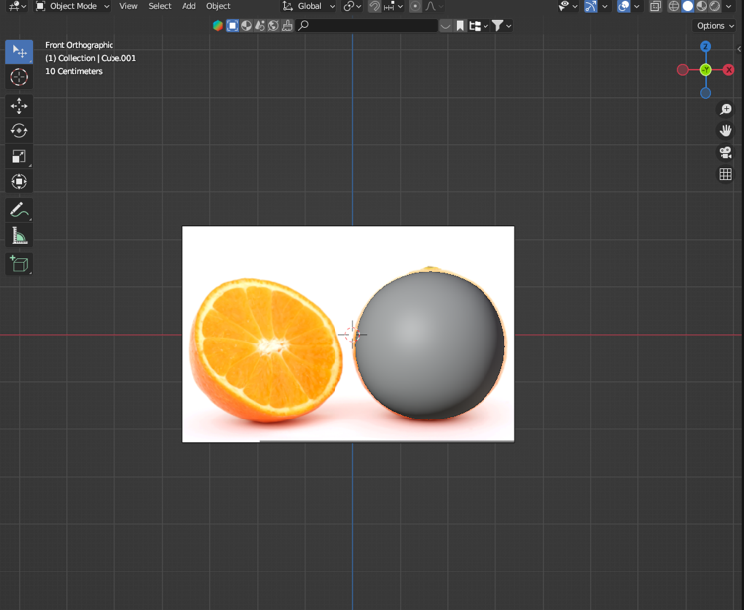
I created a cube and on it applied the modifier subdivision surface, further in edit mode build the basic shape. After creating the main shape create a cube and I adjusted it to the place of the future cut of the mesh, applying the modifier Boolean. 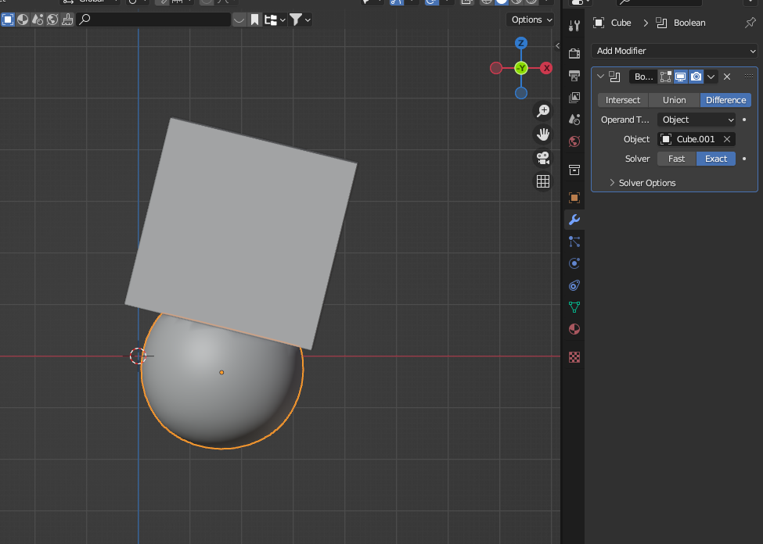
Next step is to apply the modifier, we don't need it anymore. 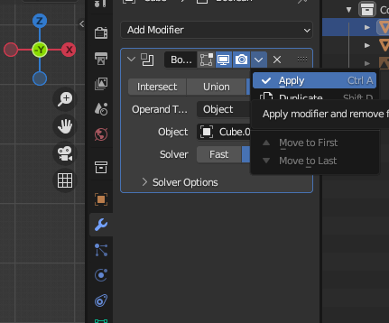
Then I created a material, for the texture we use the image from the reference, and connect it to the base color. UV sweep. From the front view create uv sweep project from view and adjust it to the image.

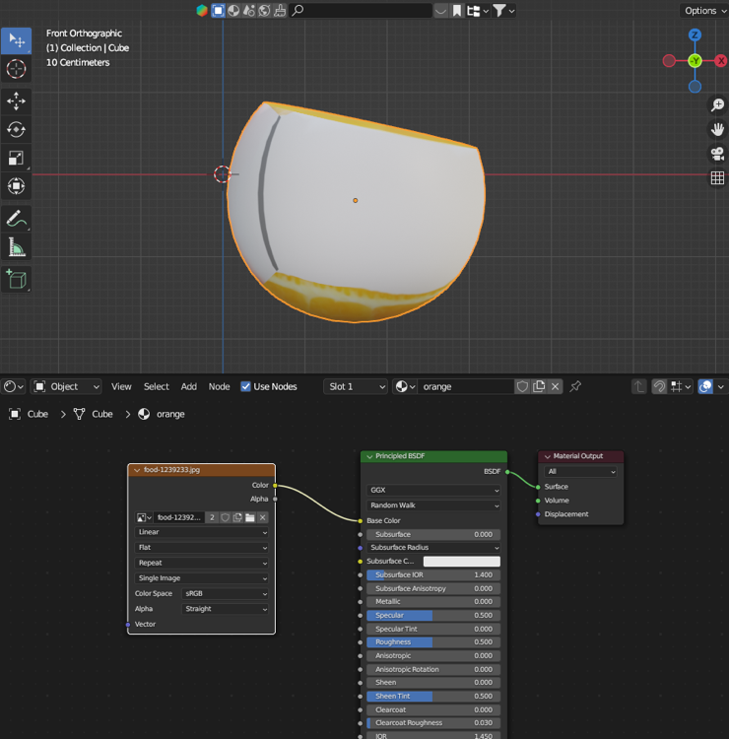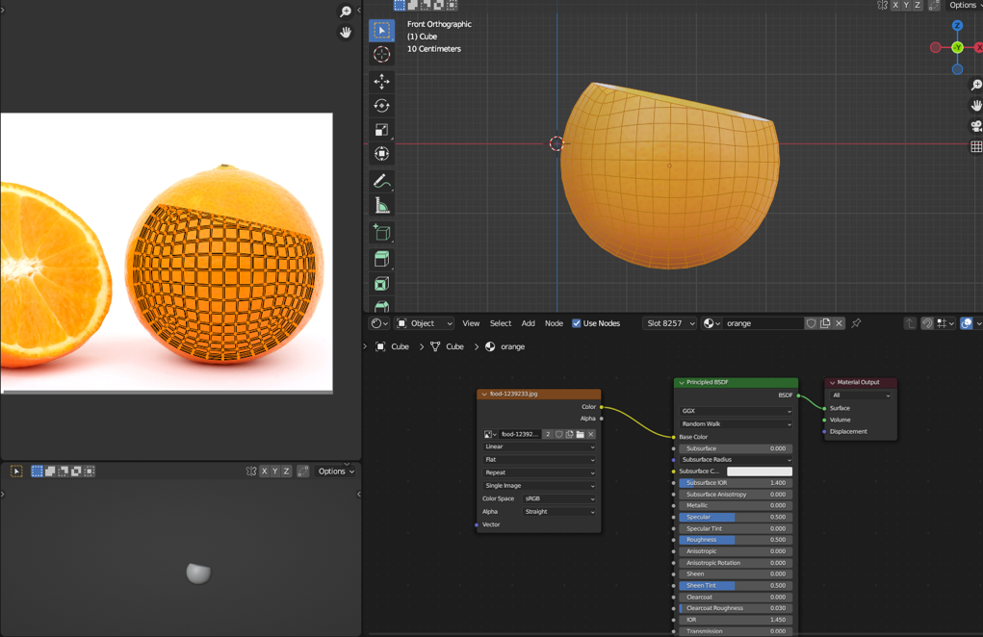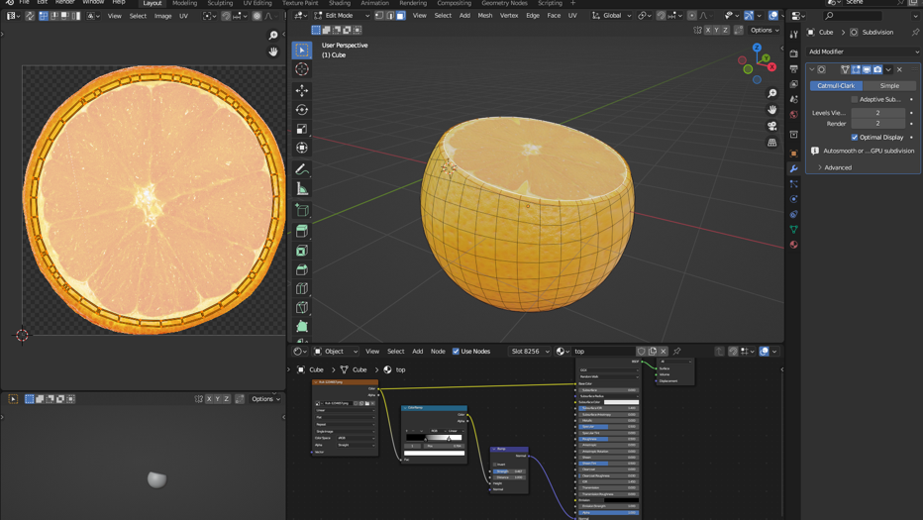

Created another material for the upper cut of the fruit, also adjust the sweep to the second image. Add bump and color ramp nodes to add detail to the textures. 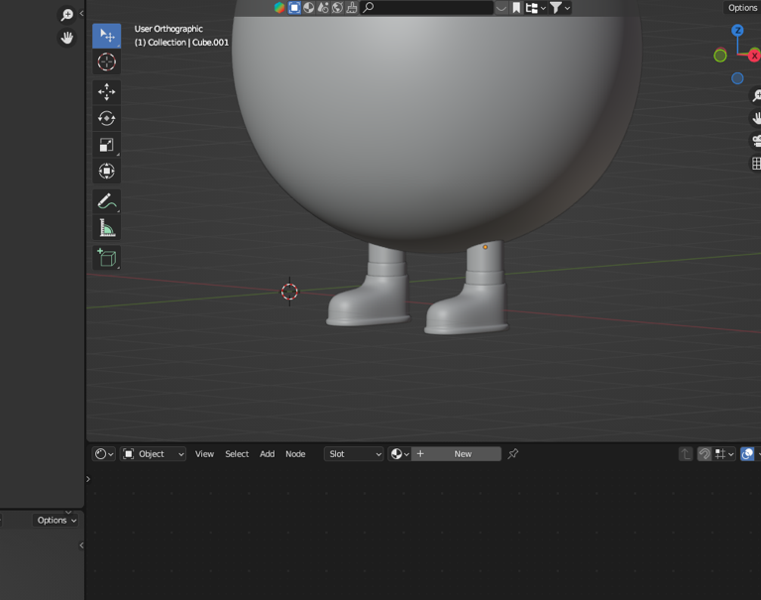
The hardest part for me was to model the legs using a cube and subdivision surface modifier. In the same way model the arms.
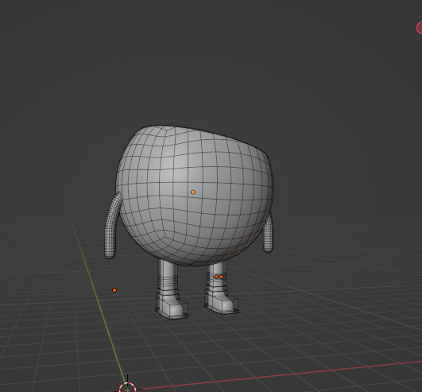
Then recreated a human skeleton using the built-in addon. Removed all the bones and add only the ones I need through the created groups (torso, arms, legs). Generated a rig for the skeleton, removed the bones and bind the mesh to the rig.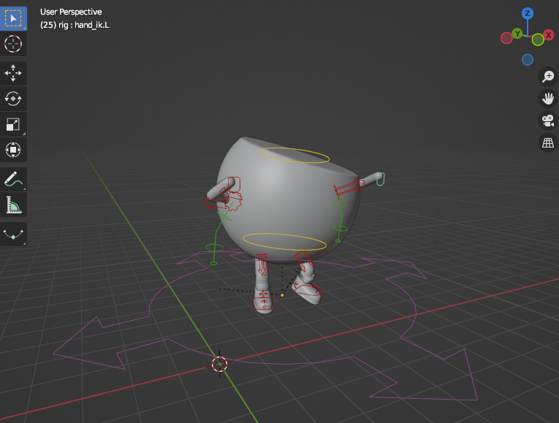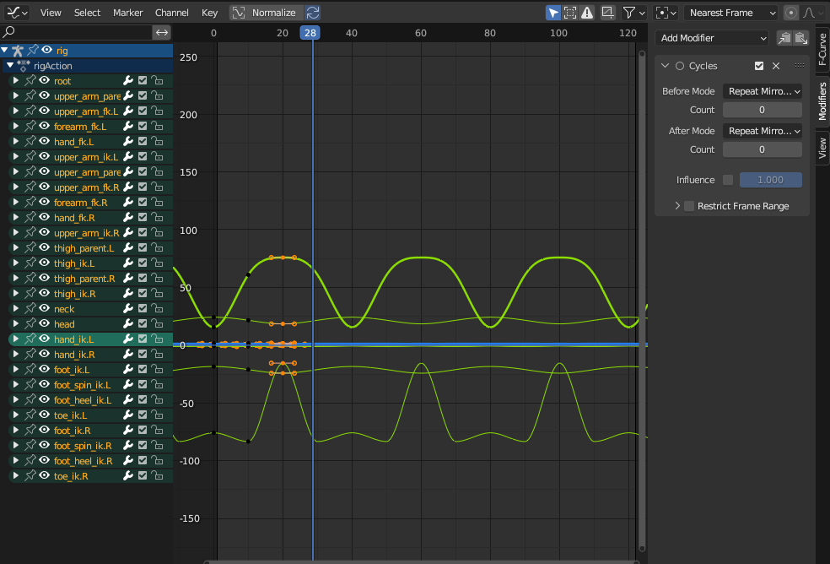
Created an animation loop for our character and make it looped using the Cycles modifier. Next I created the surface. Importing the downloaded image as planes. Adding subdivision. In edit mode pull out the mesh.
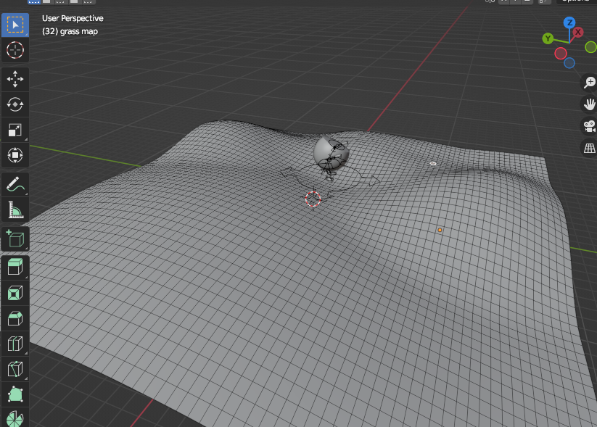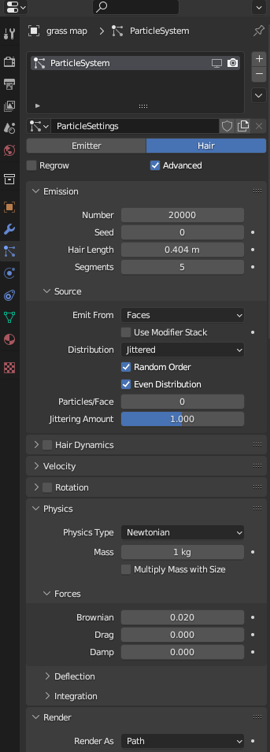
On plane add a system of particles, this works as grass. Created a camera, add focus on the object and make animation focal length.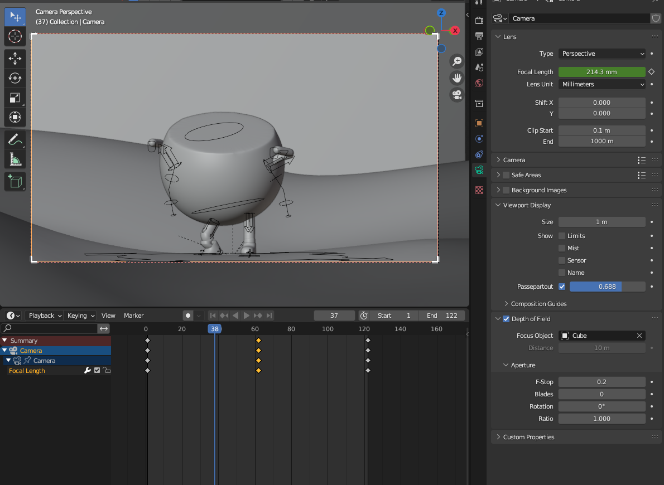
As well as the earth imported the image of the sky and scale for a beautiful picture.
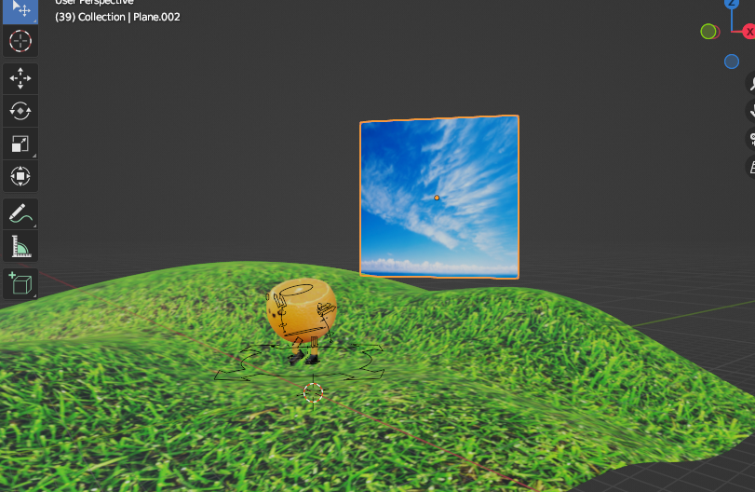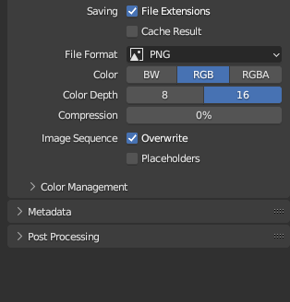
Customized the output for rendering to png sequences for further processing in After Effects. Then transferred to After Effects and imported image sequences. Last but not least is to use modifiers Hue\Saturation, Brightness&Contrast, CC Vignette for color correction.
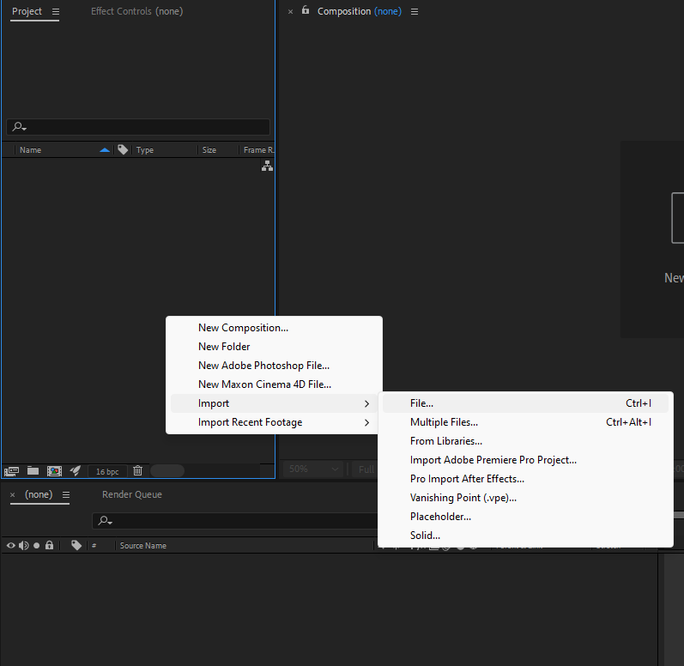

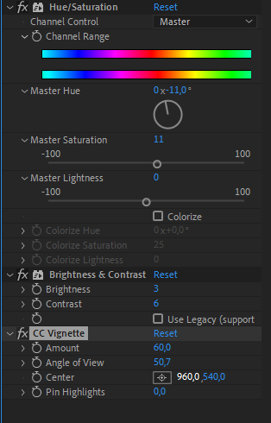

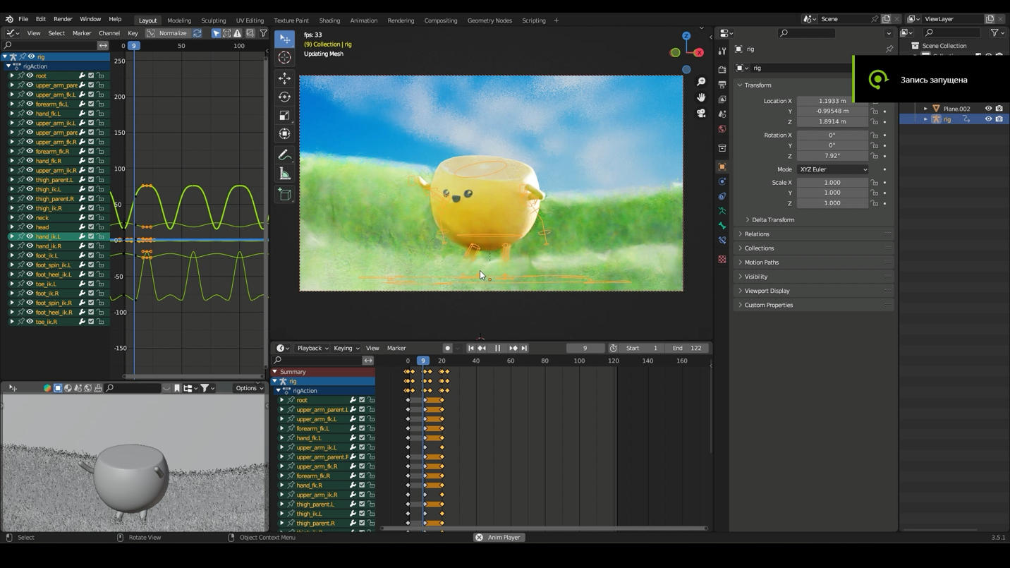
- Reflection
My project went well, and I'm happy with how the 3D animation turned out. I tried to be creative and make sure all the details looked good. But when I look back, there are a couple of things I could have done better. Earlier buy the mouse for computer. Talking seriously, the part where the character does the same actions over and over could have been smoother. I also realized that I could have planned better when cutting the shape of the fruit, so I wouldn't have to fix things later. Even though I had these things to think about, most of the project went according to my plan. After adding some final touches in After Effects, like changing colors and making things look better, I was satisfied with the result even with the fact that it took a lot of nerves and I cant say that I found it easy. For the next time, I want to plan more before starting. I learned that thinking about each step can help make things easier later on. This project was a good learning experience, and I want to keep getting better at making cool 3D animations as I see a huge perspective in this field and found this new knowledge useful.
5. Appendix
The idea of a dancing fruit was inspired by the YouTube channel “Hey bear Sensory’ the link to example will follow. The main idea was to try my skills and start with one fruit but to balance the boring background with colours and aim the funny story of Microsoft wallpaper background and cute casual fruit moving the body. The arms and legs were additionally created to show the skills of rigging. https://youtu.be/HPuD7w_TbSc?si=Pnuuu6pVYJtpaoc9

Also as it mentioned in the task here is the recording of my screen with Blender file

Link to the main video on YouTube:
https://youtu.be/Yg0JCfCKpz8?si=MsHtdVNNZvS8gsWj

