**Gas Turbine Thermal Design**

a.) You will use the given code to draw the **thermal efficiency VS Presssure ratio curve** with the engine design parameter below

      - Turbine inlet temperature **TIT = 900 C**

      - Turbine and Compressor isentropic efficiency of **80%**

      - **Ambient air of 15, 20, 25, 30, 35, and 40 C** (you will have total 6 graphs for each ambient air condition)

b.) Find the optimum pressure ratio ( best thermal efiiciency at each ambient air condition)

c.) Write the conclusion and the reason to describe result

**Ambient air temperature = $15°C or 288.15 K$**

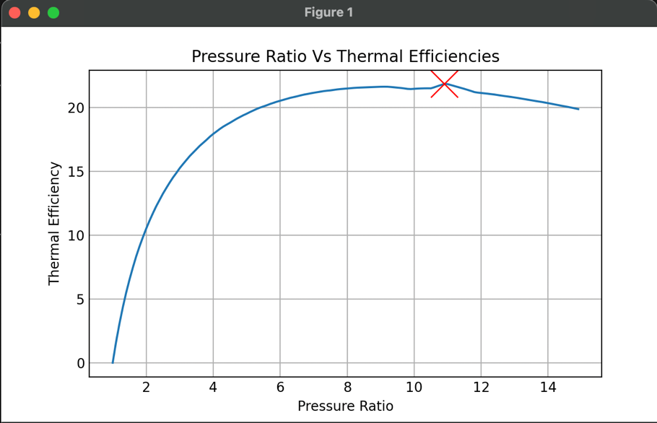

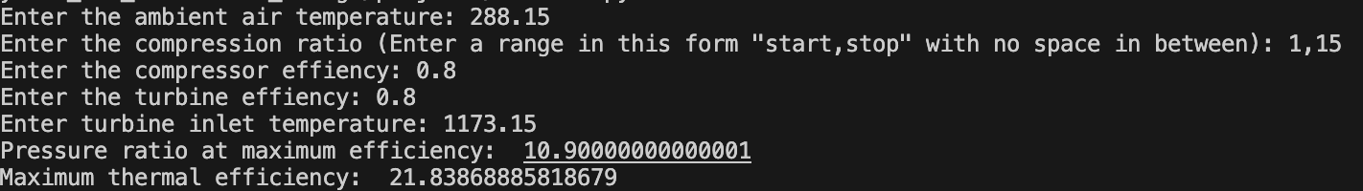

A**mbient air temperature =**

**Ambient air temperature = $25°C or 298.15 K$**

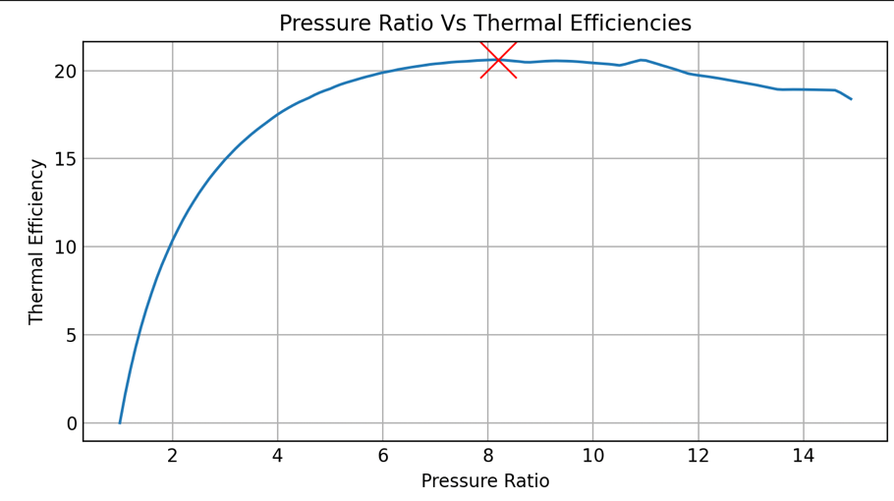

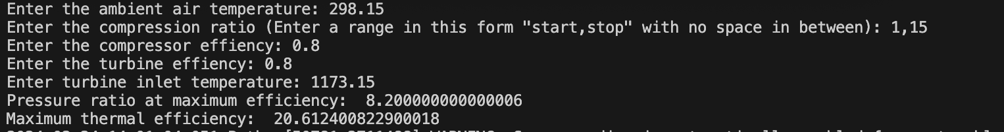

**Ambient air temperature = $30°C or 303.15 K$**

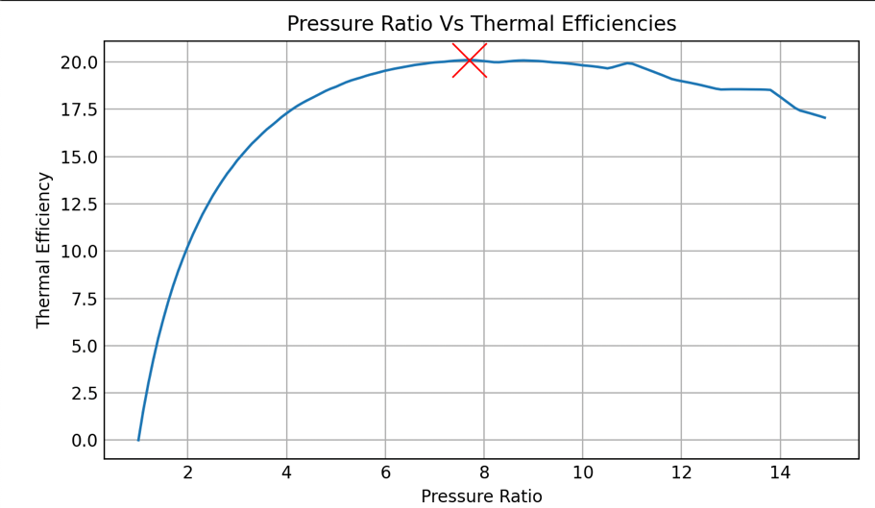

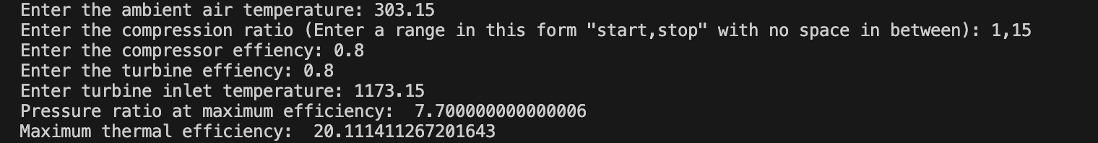

**Ambient air temperature = $35°C or 308.15 K$**

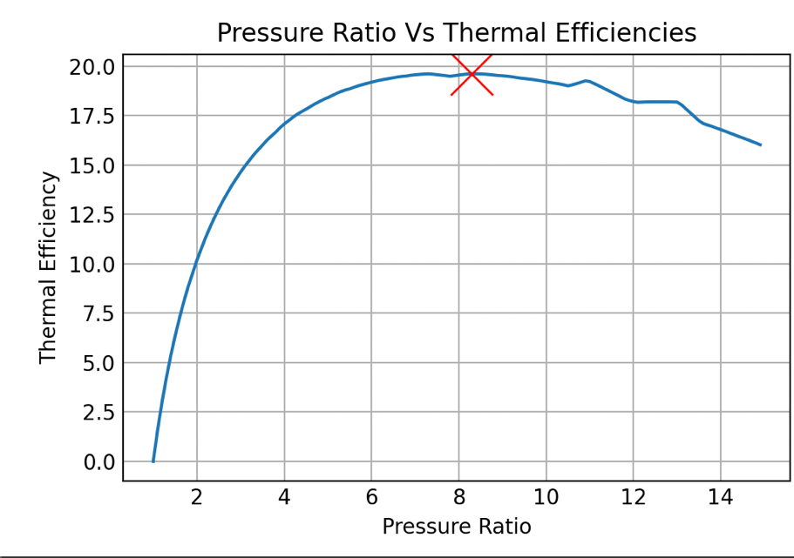

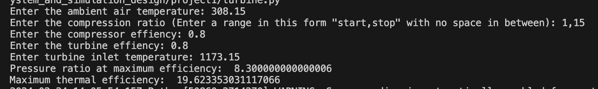

**Ambient air temperature = $40°C or 313.15 K$**

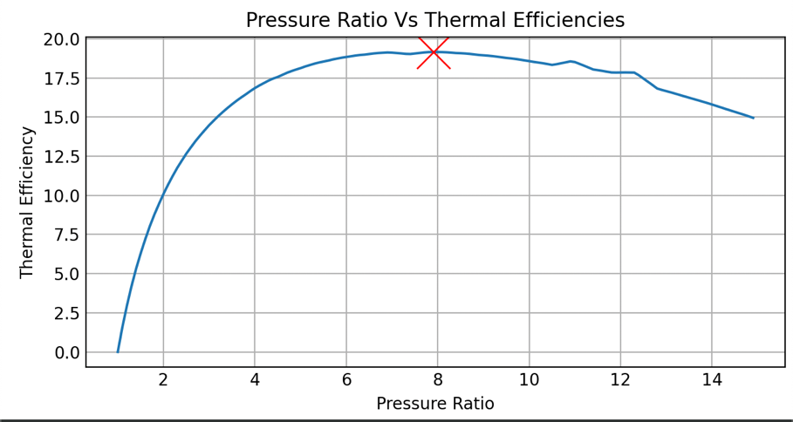

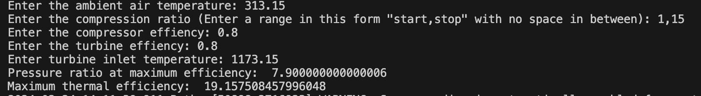

**Conclusion**

From the results, it is found that thermal efficiencies of the turbine decrease with increasing ambient air temperature. The compression ratio for best efficiencies is found mostly around between 7.9 and 11.

Ye Min Thant (65011605)