MINISTRY OF EDUCATION AND SCIENCE OF THE REPUBLIC OF KAZAKHSTAN

INTERNATIONAL INFORMATION TECHNOLOGY UNIVERSITY

FACULTY OF INFORMATION TECHNOLOGIES

**Baigasymov Y. S.**

**Amangeldiyeva A.**

**Mobile app for «Currency exchange office».**

**DIPLOMA PROJECT**

**Major 5В070300 – Information Systems**

Almaty 2020

MINISTRY OF EDUCATION AND SCIENSE OF THE REPUBLIC OF KAZAKHSTAN

INTERNATIONAL INFORMATION TECHNOLOGY UNIVERSITY

DEPARTMENT OF INFORMATION SYSTEMS

**Approved**

Head of Department,

Candidate of Technical Sciences,

Professor of Russian Academy

of Natural History

______________________ V.V.Serbin

«_____» _____________________ 2020

**DIPLOMA PROJECT**

**Development of information subsystem for currency exchange**

Major 5В070300 – Information Systems

Done by: Baigasymov Y.S. ______________

«___ » ______2020 (signature)

Amangeldiyeva A. ___________­___

«___ » ______2020 (signature)

Research advisor: Sembina G. ______________

«___ » ______2020 (signature)

Reviewer: ______________

«___ » ______2020 (signature)

Almaty 2020

International Information Technology University

Faculty of Information Technologies

Department of Information Systems

Major 5В070300 – Information Systems

Diploma Paper Assignment

Students:

Baigasymov Yernur, Amangeldiyeva Albina

Diploma paper (project) topic:

Development of information subsystem for currency exchange.

Approved by IITU order № ___ dated «____» _______ 2020

Diploma paper submission date ______________________________

Diploma paper initial data: PHP, JavaScript, jQuery, HTML, HTML5, Postman REST API, JSON, MS Office, MS Power Point

Details of computations and explanations (list of issues due to be addressed):

1. Theoretical part of the project
2. Practical part of the project
3. Economic rationale of the project.
4. Labor safety and industrial ecology.
5. Conclusion

CD containing the digital version of diploma paper and attachments:

1. Diploma project documentation
2. Diploma project presentation
3. Source code of the software/application etc.

Consultations on diploma paper (with related project chapters named)

|  |  |  |  |  |
| --- | --- | --- | --- | --- |
| Chapter | Advisor/Consultant | Signature, date | | |
| Assignment given | | Assignment received |
| Consultant on Economics |  |  |  |  |
| Consultant on labor safety and industrial ecology |  |  |  |  |
| English language consultant |  |  |  |  |
| [Compliance monitor](http://www.multitran.ru/c/m.exe?t=4330399_1_2&s1=%ED%EE%F0%EC%EE%EA%EE%ED%F2%F0%EE%EB%FC) |  |  |  |  |
|  |  |  | |  |

Date «____» __________________ 20___

Research advisor___________________________________________________

(signature)

Assignment received by______________________________________________

(signature)

Diploma paper writing schedule

Baigasymov Yernur, Amangeldiyeva Albina

IS 1601-1602k Year:4

International Information Technology University

Topic:Development of information subsystem for currency exchange

|  |  |  |  |
| --- | --- | --- | --- |
| № | Assignment | Submission date | Comments |
|  |  |
|  | Creation of the graduation paper writing schedule; submission to Department | 30 November |  |
|  | Collection, study, processing, analyzing and generalizing data | November –December |  |
|  | Drafting and submission to the Research advisor  Introduction  Theoretical part of the project  Practical part of the project  Economic rationale of the project  Labor safety and industrial ecology  Conclusion | January –February |  |
|  | Revision of the graduation paper with due consideration of the advisor’s comments | March -April |  |
|  | Submission of the completed graduation paper to the Research advisor | 15 April |  |
|  | Reporting on the graduation paper at department seminars | 21-25 January  26 February – 2 March  2-6 April |  |
|  | Pre-defence | 21-26 April |  |
|  | Submission to the reviewer for approval | 18 May |  |
|  | Compilation of the graduation paper presentation for the State Attestation Commission | 3 June |  |
|  | Graduation paper presentation to SAC | 3 June-13 June |  |

Students: Baigasymov Y.S ___________________

(signature)

Amangeldiyeva A.T _________________

(signature)

Research advisor associate professor Sembina G. __________________

(signature)

Date «____» __________________ 20___

Abstract

The theme of the diploma project is "Mobile application for currency exchange offices". The relevance of the system, among other things, is the daily monitoring of the exchange rate and recognition of prices and assets. It is an application with an optimal set of functions, a clear demonstration of foreign currency exchange, and an assistant in tracking rates. The app provides its users with various functions: tracking the exchange rate, a map of the city where you can find the closest exchange center, and an online exchange rate calculator.

The aim of the research is to develop a mobile application for the Android platform using the Android Studio based on the MVC pattern and the SQLite database. The mobile app is designed to allow simple users to easily and quickly find out the exchange rate or find out where the nearest exchange office is

To achieve this goal, we will address the following strategic objectives:

* Develop an app using speech recognition
* Develop an administrative panel
* Develop a DBMS
* Market and competition analysis (analogs)
* Data security using hash functions
* To implement the project in an open web service.

|  |  |  |
| --- | --- | --- |
|  | CONTENTS |  |
| LIST OF TERMS AND ABBREVIATIONS | | 12 |
| INTRODUCTION | | 13 |
| 1 | ANALYTICAL PART OF THE PROJECT | 14 |
| 1.1 | Analysis of currency transactions | 14 |
| 1.2 | Characteristics of the modern currency system | 15 |
| 1.3 | Mobile application operating system | 15 |
| 1.4 | Monetary system | 16 |
| 1.4.1 | National currency system | 16 |
| 1.4.2 | World currency system | 17 |
| 1.4.2 | Results of analysis | 18 |
| 2 | PROJECT PART | 19 |
| 2.1 | Used Technologies | 19 |
| 2.1.1 | Back-end Technologies | 19 |
| 2.2  2.2.1 | MVVM pattern  Web server | 19 |
| 2.3 | Firebase | 21 |
| 2.3.1 | Android Studio as development tool | 22 |
| 2.4 | Kotlin Language | 23 |
| 2.4.1 | Coroutites | 24 |
| 2.4.2 | JavaScript Object Notation (JSON) | 24 |
| 2.5 | Diagrams | 25 |
| 2.5.1 | UML diagram | 25 |
| 2.5.2 | ER diagram | 25 |
| 2.5.3 | Class diagram | 25 |
| 2.6 | IS Architecture | 25 |
| 3 | ECONOMIC RATIONALE OF THE PROJECT | 26 |
| 3.1 | Product name | 26 |
| 3.2 | Calculation of the project’s economic effectiveness | 28 |
| 3.3 | Conclusion | 34 |
| 4 | TECHNICAL PART | 35 |
| 4.1 | General characteristics of the problem solution process by means of information technologies | 35 |
| 4.2 | Analysis of exchanger applications | 35 |
| 4.3 | SWOT | 35 |
| 3.6 | CONCLUSION | 36 |
|  | REFERENCES | 37 |
|  |  |  |

LIST OF TERMS AND ABBREVIATIONS

API – Application Programming Interface

App – Application

AJAX – Asynchronous Javascript And Xml

B2B – Business to business

CSS – Cascading Style Sheets

DB – Database

DBMS – Database Management System

ER – Entity Relationship

GUI – Graphical User Interface

HTML – HyperText Markup Language

HTTP – Hypertext Transfer Protocol

JDK – Java Development Kit

JSON – Javascript Object Notation

MySQl – My Structured Query Language

OEM – Oracle Enterprise Manager

OOP – Object Oriented Programming

OS – Operating System

PHP – Hypertext Preprocessor

SDK – Software Development Kit

[SOAP](https://techterms.com/definition/soap)- Simple Object Access Protocol

SWOT – Strength, Weakness, Opportunity, Threats

[TCP/IP - Transmission Control Protocol/Internet Protocol](http://www.thefreedictionary.com/Transmission+Control+Protocol%2fInternet+Protocol)

[UDDI](https://techterms.com/definition/uddi) - [Universal Description, Discovery and Integration](http://encyclopedia.thefreedictionary.com/Universal+Description%2c+Discovery+and+Integration)

UI – User Interface

UML – Unified Modeling Language

XML – eXtensible Markup Language

WSDL – Web Services Description Language

## INTRODUCTION

Each country should have its own currency exchange rate in the course of international relations. Exchange rate - the price of a currency unit of one country expressed in monetary units of other countries. It provides a link between the national currency and other currencies, as well as a comparison of macroeconomics indicators of different countries. Ultimately, the exchange rate determines the purchasing power of a particular currency.

The relevance of this topic is that the exchange rate has a significant effect on the country's foreign trade, since its level significantly affects the competitiveness of its products in global markets. The exchange rate is used for exchanging currencies when trading products and services, the movement of capital and loans; for comparing prices on global commodity markets, as well as the cost characteristics of various States; for periodic revaluation of foreign currency accounts of companies, banks, governments and individuals.

An important element of international monetary relations is the exchange rate as a measure of the value content of currencies. International settlement or exchange operations involve mandatory comparison of prices of state and foreign currencies, since each product purchased or sold is worth the cost expressed in money. This leads to the emergence of the exchange rate and the need to determine its level. It represents the ratio between monetary units of different countries, determined by their purchasing power and a number of other factors. The exchange rate is required for international currency, settlement, and credit and financial transactions.

And thus excluding all the disadvantages and advantages of the exchange system we see how this topic is relevant in our time.

We need a normal and easy form of these complex and non-standard operations. Our goal is to make a simple and clear program where ordinary people can use it without fear of confusion

1 ANALYTICAL PART OF THE PROJECT

* 1. Analysis of currency transactions

Tracking the exchange rate can help you save money significantly if your employment is related to:

* investment, especially in long-term projects;
* purchase and sale of currency for the purpose of earning on the difference;
* investment in real estate.

In addition, if you travel frequently, conduct international business, or make purchases on foreign websites, monitoring the exchange rate should become your habit. All of the above is associated with large financial costs, so minimal fluctuations in the exchange rate can both to enrich you, and Vice versa.

Currently, a currency can actually have 3 statuses:

1. closed (non-convertible);
2. partially convertible;
3. freely convertible:

* non-convertible-a national currency that operates within one country and is not subject to exchange for other foreign currencies.
* partially convertible-this is the national currency of countries whose convertibility is more or less limited for certain holders, as well as for certain types of exchange operations.
* freely convertible-monetary units that can be freely and unrestricted exchanged for other foreign currencies and international means of payment, in any form and in all types of transactions.

With external convertibility, full freedom of exchange of money earned in a given country for settlements with foreign countries is granted only to foreigners (non-residents), while citizens and legal entities of this country (residents) do not have such freedom.

Under the internal convertibility regime, only residents of the country enjoy the freedom to exchange national monetary units for foreign currencies, while non-residents do not have this right. In fact, internal convertibility means granting the right to domestic individuals and legal entities to hold some (or all) types of currency (for example, Bank deposits) and thus freely change the national currency within the country to a freely convertible one. Internal convertibility does not negate the prohibition or restriction on making payments abroad and does not require residents to hold accounts abroad, it also implies the possibility of free transactions with foreign securities and other obligations of foreign legal entities and individuals.

Sometimes, convertibility is defined as the right of legal entities and individuals to convert national currency into other currencies for current operations related to foreign trade: export and import of goods and services, income of domestic and foreign persons from investments (dividends, interest), income from servicing foreigners within the country, expenses for services to citizens of the country outside it, air and sea freight, cargo insurance, etc., as well as unilateral transfers of funds abroad and from abroad (pensions earned in the country, which are transferred to citizens living abroad; wages of citizens who work abroad and transfer money home; lump-sum payments for assistance to foreign countries).

1.2 Characteristics of the modern currency system.

The currency system is a form of organization of currency relations, established by national legislation (national system) or an interstate agreement (world and regional systems).

Currency relations represent a version of the monetary relations arising at functioning of money in international circulation. Money that serves international relations is called a currency.

International monetary relations are a necessary element of the world economy. This is the relationship through which all settlement, credit and monetary transactions between different countries are carried out. The subjects of international monetary relations are state governments, enterprises, and individuals engaged in foreign economic activity. Currency relations are developed by special interstate bodies, agreed upon, duly formalized, and are binding on all participants in international economic transactions.

1.3 Mobile application operating system

The operating system is the main feature that distinguishes a smartphone from a mobile phone. When choosing a contact model of a smartphone, the operating system becomes the determining factor. There are two main mobile operation systems. It is Android ad IOS.

According to experts, in January-March 2018, 329.3 million Android smartphones were sold in the world. Considering that the global sales in the communicator market as a whole in the past quarter was equal to almost 384 million devices, Android’s market share was 74.82%.

The quarterly iPhone sales of 54.06 million units provided iOS with a market share of 20.13%.

Also, Gartner statistics indicate the almost complete disappearance from the market of smartphones running other operating systems. If in January-March 2017, sales of such devices were measured at 607.3 thousand units, which corresponded to a share of 0.2%, a year later, the sale of devices on alternative platforms dropped to just over 130 thousand units. With this in mind, Gartner and estimated their share of 0%.

The main players in the market of mobile operating systems today are Android and iOS from Google and Apple, respectively. Now the picture of the prevalence of OS in the world is as follows:

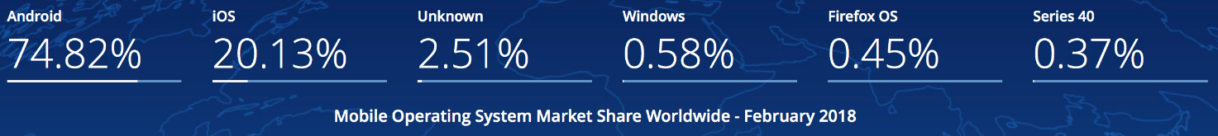

Figure 1.1 – Web service architecture

Mobile apps typically are available through [app stores](https://www.statista.com/statistics/276623/number-of-apps-available-in-leading-app-stores/) which are operated by the owners of the mobile operating systems. According to these statistics and our skills we decided to develop an application on Android platform.

1.4 Monetary system

The currency system does not stand still. As a developer of an application about the exchange rate, it is important for me to know the origins of the currency system. After all, sooner or later, every person is faced with a currency, that is, with money. After all, in our time it is impossible to live without money and it is also impossible to live without knowledge.

The dynamics of changes in the currency system, the impact of the national currency exchange rate on the economic situation in the country has become obvious even for people far from the economy. Therefore, I believe that it is important for everyone to know the origins of the formation of the currency system. It is also necessary to know the exchange rate regime in Kazakhstan in order to understand how daily changes in the exchange rate will affect the life of an individual or the life of an entire organization and to take the necessary measures in time to preserve financial well-being in an individual family or an entire organization.

The formation of the world monetary system followed the industrial revolution and the formation of the world economic system. It has passed through three stages in its development, each of which corresponds to its own type of organization of international monetary relations. The first stage in the development of the world currency system was the period from its emergence in the XIX century to the beginning of the Second world war. The transition to the second stage began in the late 30s. The world monetary system of this stage received its legal form at the Bretton woods conference (USA) in 1944. The third stage is the current world currency system, which was formed in the 70s. It was formed organizationally after the coverage of 1976 in Kingston (Jamaica).

International monetary relations arose with the beginning of the functioning of money in international payment circulation. Throughout history, the forms of world money and the terms of international settlements have changed. At the same time, the importance of the world monetary system increased and the degree of its relative independence increased. A natural desire to streamline the processes taking place in the field of international Finance has led to the formation of international monetary systems and the world monetary system. Each country conducts its own economic policy and defends its own interests in a competitive environment. The latter, in turn, depend on the exchange rate of the national currency and its role in international calculations. A currency (literally, "price, value") is the monetary unit of a country (for example, the ruble in Russia). In a narrow sense, these are monetary signs of foreign countries. Each national market has its own national currency system.

1.4.1 National currency system

The national currency system is a part of the country's monetary system, within which currency resources are formed and used, and international payment turnover is carried out. It consists of the following elements:

* National currency unit;
* Exchange rate regime;
* The conditions of invertibility of the currency;
* System the foreign exchange market and the gold market;
* Procedure for international payments of the country;
* Composition and management system of the country's gold and foreign exchange reserves;
* Status of national institutions that regulate the country's currency relations.

National currency systems are formed on the basis of national legislation, taking into account the norms of international law. Their features are determined by the conditions and level of development of the country's economy, its foreign economic relations, and the tasks of social development.

1.4.2 World currency system

On the basis of national systems, the world currency system functions – a form of organization of international monetary relations that has developed on the basis of the development of the world market and is fixed by interstate agreements. Its constituent elements are:

Main international means of payment(national currencies, gold, Euro);

* Mechanism for setting and maintaining exchange rates;
* Procedure for balancing international payments;
* The conditions of invertibility of the currency;
* Regime of international currency and gold markets;
* The status of the interstate institutes regulating currency relations.

In a market economy, the movement of money from country to country, exchange and sale of currencies is carried out primarily through the activities of large commercial banks. These banks have a network of branches in different countries or currency accounts in banks in other countries. When conducting trade and other foreign economic operations through such banks, the client has the opportunity to Deposit funds to the Bank's account in one country and, if necessary, transfer these deposits to another country in a different currency.

The main economic agents of the foreign exchange market are exporters, importers, and holders of asset portfolios. Along with the" primary "subjects of the foreign exchange market – exporters and importers, who form the basic demand and supply of currency, there are also" secondary " – those participants of the foreign exchange market who trade directly in currency. These are commercial banks, currency brokers and dealers. The definition of "secondary" is very conditional, since currently about 90% of all foreign exchange transactions on the foreign exchange market are not related to trading operations. If the daily turnover of the world's currency exchanges is 1.5 trillion. doll.,1 the daily volume of international trade is less than 2% of this value. Most of the currency trading is an ordinary exchange game, with the purpose of making a profit, where the object is the exchange rates of currencies. The largest centers of this market are located in London, Tokyo, new York, Frankfurt am main, and Brussels.

The most important subjects in the sphere of international monetary circulation are government bodies. Monetary relations in the world economy affect the national interests of States. It is natural that in the course of the evolution of these relations, rules and laws were developed that regulate these relations, which are acceptable from the point of view of national interests.

Currency and its types

Any national monetary unit is a currency, it acquires a number of additional functions and characteristics as soon as it begins to be considered not in the narrow framework of the national system of macroeconomic coordinates, but from the position of a participant in international economic relations and calculations. From the point of view of material form, currency is any payment documents or monetary obligations expressed in a particular national monetary unit that are used in international settlements. These are usually banknotes, Treasury bills, various types of Bank accounts, as well as cheques, bills of exchange, letters of credit, and other means of payment. These payment documents, expressed in various currencies, are bought and sold on a special market - the currency market. Demand and supply in the national currency market are formed as a result of the collision of monetary requirements and obligations expressed in different currencies that mediate the international exchange of goods, services and capital flows. The demand and supply of currency are also formed in connection with all other transactions that mediate international exchange and are reflected in the balance of payments of any country. We are talking about operations not only export-import (trade), but also non-trade (transport, insurance, tourism, etc.), as well as the movement of capital, both short-term and medium-and long-term (granting and repayment of loans), etc.

Main elements of the currency system

One of the most important elements of any currency system is the exchange rate, which shows the price of the currency of one country expressed in the currency of another. There are 3 modes for setting exchange rates:

* Based on gold parities " at the gold standard";
* Fixed exchange rate system;
* A system of floating exchange rates that fluctuate depending on supply and demand.

1. **PROJECT PART**

2.1 Used Technologies

2.1.1 Back-end Technologies

Back-end development (also stylized as back-end or back-end development) is a skill that keeps the network running. However, he does it modestly, without fanfare, allowing people to browse their favorite sites without even knowing about all the work done by the backend developer or team. When you make a backend with support for Android Studio, it generates a fresh App Engine application in the same way and gives your Android application the necessary libraries and a model of energy for interacting with this backend. GCM's integrated help simplifies data synchronization across multiple devices. Subsequently, such as you generated the plan, you will be able to make and run the buyer and server code together, in a single environment, including the unwinding of the personal internal code directly from Android Studio.

2.2 MVVM pattern

MVVM is one of the architectural templates that enhances the separation of tasks, it allows you to separate the user interface logic from the business (or server) logic. MVVM is a client application architecture template that was proposed by John Gossman as an alternative to MVC and MVP patterns using Data Binding technology. Model ViewModel View or MVVM, as it is commonly called, is a software design template for developing web applications. The Model ViewModel View template consists of the following three parts:

* Model – The model represents the data and business logic of the application. One of the recommended strategies for implementing this level is to provide its data through observables, which will be completely separated from ViewModel or any other observer / consumer (this will be illustrated in our example MVVM application below).
* ViewModel - ViewModel interacts with the model, and also prepares observable objects that can be observed using View. ViewModel can optionally provide hooks for the view to pass events to the model. One of the important strategies for implementing this level is to separate it from the View, i.e. ViewModel does not need to know about the view it interacts with.
* View - Finally, the role of the view in this template is to observe (or subscribe) to the ViewModel observed to receive data in order to update user interface elements accordingly.

2.2.1 Web service

Web service is a standardized medium to propagate communication between the client and server applications on the World Wide Web.

A web service is a software module which is designed to perform a certain set of tasks.

* The web services can be searched for over the network and can also be invoked accordingly.
* When invoked the web service would be able to provide functionality to the client which invokes that web service.

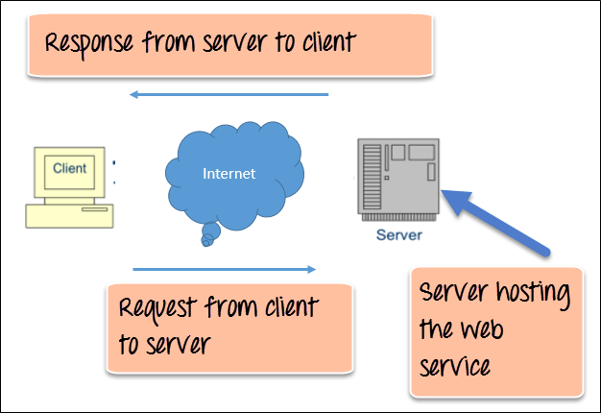

Figure 2.2.1 – Web service architecture

The Figure 2.2.1 shows a very simplistic view of how a web service would actually work. The client would invoke a series of web service calls via requests to a server which would host the actual web service.

A web service is an [application](https://techterms.com/definition/application) or [data](https://techterms.com/definition/data) source that is accessible via a standard web protocol ([HTTP](https://techterms.com/definition/http) or [HTTPS](https://techterms.com/definition/https)). Unlike [web applications](https://techterms.com/definition/web_application), web services are designed to communicate with other [programs](https://techterms.com/definition/program), rather than directly with users.

While web services can provide data in a number of different formats, [XML](https://techterms.com/definition/xml) and [JSON](https://techterms.com/definition/json) are the most common. These standard text-based formats can be easily recognized and [parsed](https://techterms.com/definition/parse) by another program that receives the data.

Web services are self-contained, modular, distributed, dynamic applications that can be described, published, located, or invoked over the network to create products, processes, and supply chains. These applications can be local, distributed, or web-based. Web services are built on top of open standards such as TCP/IP, HTTP, Java, HTML, and XML.

A JSON web service is less formally defined. The data format is described by using JSON schema notation, and it requires use of the HTTP transport protocol. JSON is a more convenient data representation format for typical mobile devices and JavaScript based applications.

2.3 Firebase

Firebase is a NoSQL-type database that uses sockets, which allows the client to receive information in real time - without having to send GET requests to the server. This requires that during setup you sign a “client” to the database / collection. In terms of how you can use it in an application, it depends on the technologies you want to use on your stack. Features of integration with applications for Android and iOS operating systems are supported, an API for Java, Node.js, Objective-C applications and, of course, JavaScript is implemented, it is also possible to work directly with a database like REST from a number of JavaScript frameworks, including an angular, react, vue, amber and others. An API for data encryption is provided. Figure 2.2 shows the application user data.

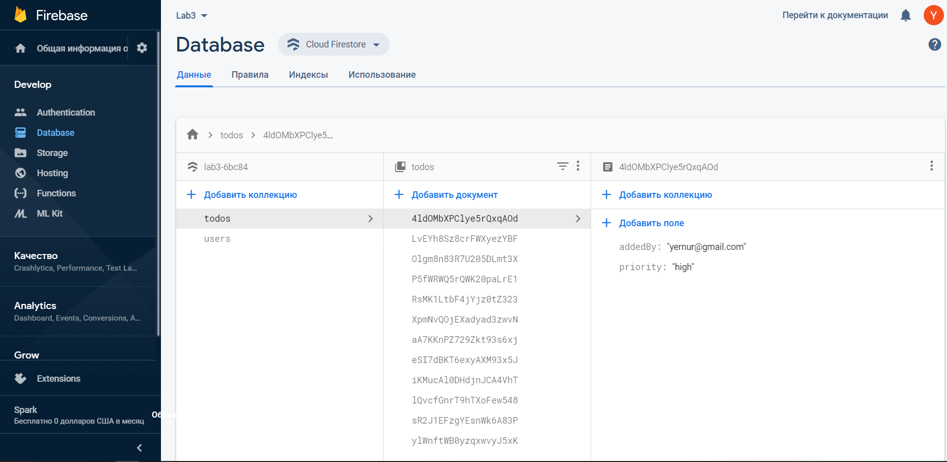

Figure 2.3 - Database

Authentication Firebase provides backend services, easy-to-use SDKs, and ready-made user interface libraries for authenticating users in your application. It supports authentication using passwords, phone numbers, popular federated identity providers such as Google, Facebook and Twitter, and others. Authentication of our users is shown on the Figure 2.3.1

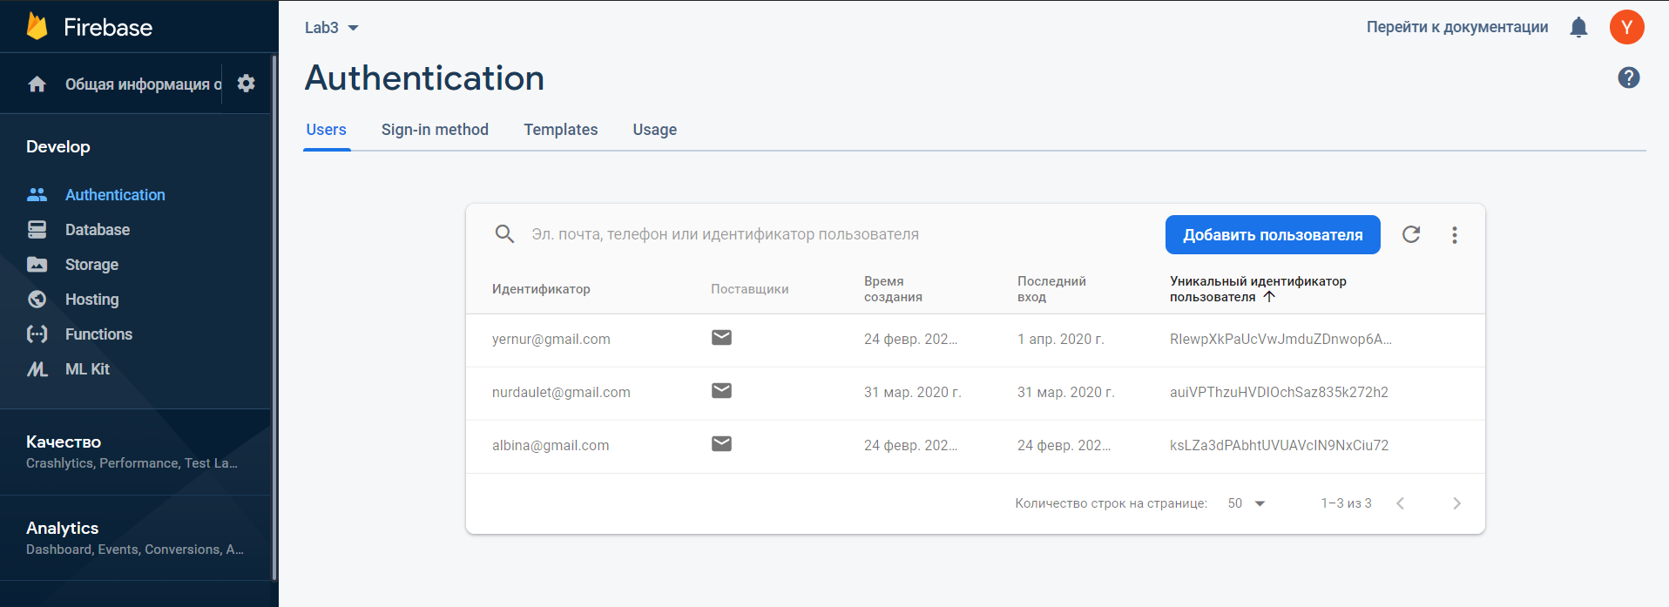

Figure 2.3.1 – Firebase Authentification

2.3.1 Android Studio as development tool

As a mobile platform we used Android. Android is based on a Linux platform for mobile phones developed by Open Handset Alliance (OHA), initiated by Google. It allows you to create Java-based applications that control the device via a Google-designed library.

Android Studio is the official integrated development environment ([IDE](https://searchsoftwarequality.techtarget.com/definition/integrated-development-environment)) for Android application development. It is based on the [IntelliJ IDEA](https://www.theserverside.com/definition/IntellJ-IDEA), a [Java](https://www.theserverside.com/definition/Java) integrated development environment for software, and incorporates its code editing and developer tools.

A few thoughts have been considered and factored in while choosing a development tool for this diploma project. One supposedly great feature of Android Studio is its layout designer with a drag-and- drop interface. Since in this very digitalized and design-oriented era everyone wants a good, usable interface, but still focus is on a serious application for serious work, most of the time is spent on code, not tweaking visuals.

To support application development within the Android operating system, Android Studio uses a Gradle-based build system, [emulator](https://whatis.techtarget.com/definition/emulator), code templates, and [Github](https://searchitoperations.techtarget.com/definition/GitHub) integration. Every project in Android Studio has one or more modalities with source code and resource files. These modalities include Android app modules, Library modules, and Google App Engine modules.

Android Studio uses an Instant Push feature to push code and resource changes to a running application. A code editor assists the developer with writing code and offering code completion, refraction, and analysis. Applications built in Android Studio are then compiled into the [APK format](https://whatis.techtarget.com/definition/APK-file-Android-Package-Kit-file-format) for submission to the Google Play Store.

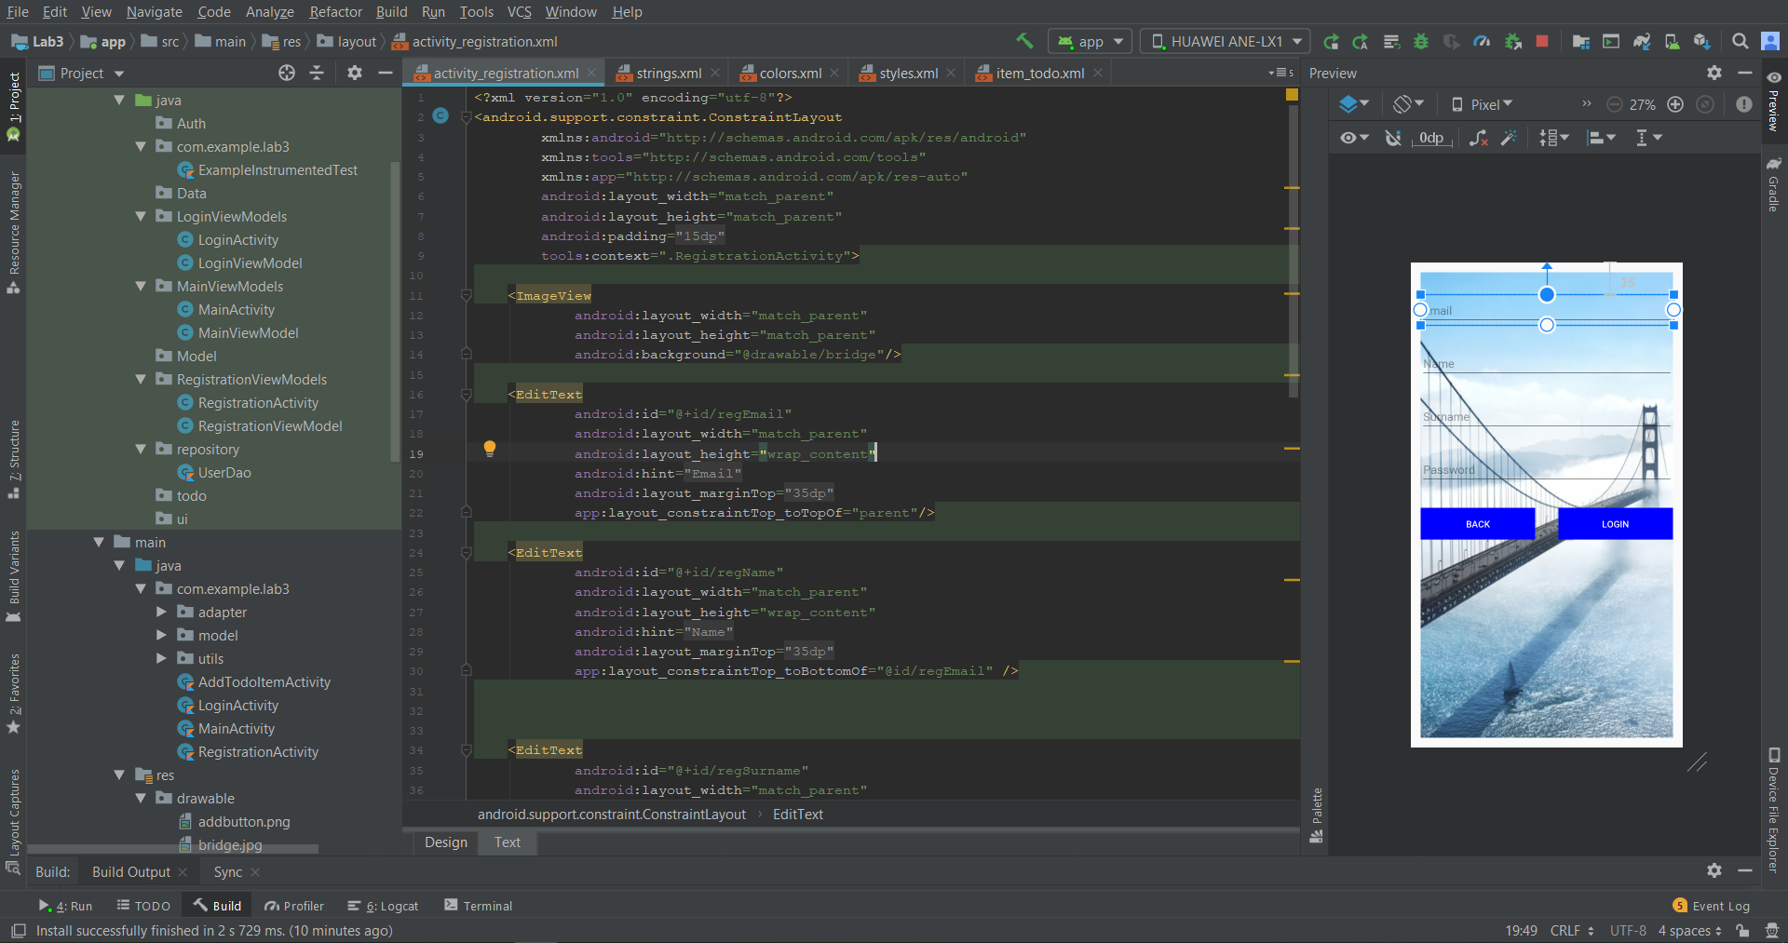

Figure 2.3.1 – Android Studio

2.4 Kotlin Language

Android Studio provides first-class support for Kotlin. It even has built-in tools to help you convert Java-based code to Kotlin. The Kotlin Show Byte Code tool allows you to see Java-based equivalent code while learning Kotlin. Figure 2.1

Figure 2.1

Kotlin has a great future since it became the official Google programming language at their IO conference. Moreover, Kotlin is open source, a modern programming language than Java, thanks to many interesting functional programming features.

Kotlin is officially supported by Google, it may be the main language for android dev, but it definitely will not surpass Java, which is used for enterprise systems or web development. (MVC)

Kotlin is a good language, but whether it rises to the mainstream, no one can say. Technical merit alone does not guarantee success. Many other factors influence the popularity of the language. You just need to bet and take a chance.

Kotlin is an open-source, pragmatic general-purpose programming language statically typed for JVM and Android that combines the functions of object-oriented and functional programming. ... JetBrains uses Kotlin in many of its products, including the flagship IntelliJ IDEA.

Learning Kotlin is easy if you know any of these programming languages. This is especially easy to learn if you know Java. Kotlin was developed by JetBrains, a company known for creating professional development tools. It is not surprising that it is convenient to use.

Yes, you can study Kotlin anytime, and here I can also recommend some online courses for learning Kotlin

2.4.1 Coroutites

Coroutines simplifies asynchronous programming by hiding all the complexity inside libraries. Coroutines are computations that can be paused without blocking the flow. “Without blocking the flow” - what does it mean? Simply put, we are talking about a function that can be started, disconnected and resumed from the same place. Coroutines is a new, convenient way to perform non-blocking asynchronous operations. In addition, creating coroutines is an “easier” operation than streams. In coroutines, the main thing is the interruption of functions. Detached functions can take parameters and return values, just like regular functions. In addition, they can be called from coroutines and other interruptible functions, as well as from function literals that are embedded in them. We tag methods using the new suspend keyword. A function labeled this way can abort coroutines. At the same time, this does not block the flow. In Figure 2.2 coroutines is using.

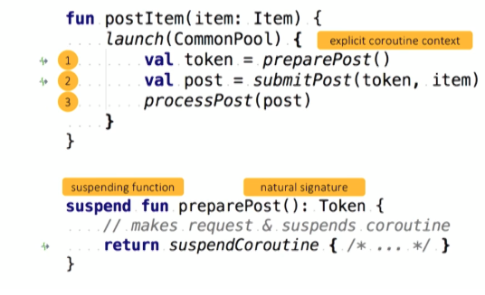

Figure 2.2 – Coroutines

In Android, each application has a main thread that processes the user interface and controls user interaction. If your application assigns too much work to the main thread, it may freeze or slow down significantly. Network requests, JSON parsing, reading or writing from a database, or even just sorting through large lists can cause your application to run slowly enough to cause a visible jerk - a slow or frozen user interface that responds slowly to touch events. These lengthy operations must be performed outside the main thread.

2.4.2 JavaScript Object Notation (JSON)

JSON is a text data format following the syntax of a JavaScript object that was popularized by Douglas Crockford. Despite the fact that it is very similar to the literal syntax of a JavaScript object, it can be used independently of JavaScript, and many programming environments have the ability to read (parse) and generate JSON.

JSON exists as a string - this is useful when you want to transfer data over a network. It must be converted to a native JavaScript object if you want to access data. It's not a big problem. JavaScript provides a global JSON object that has methods for converting between them.

2.6 Architecture of the system

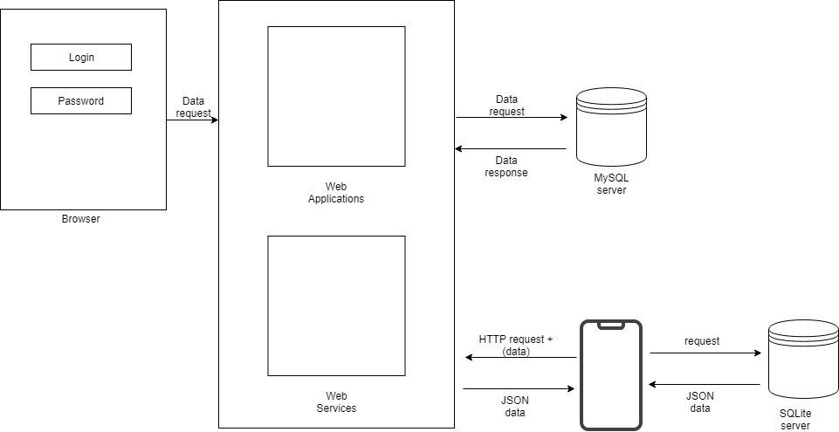

3 ECONOMIC RATIONALE OF THE PROJECT

Calculations of economic efficiency of project developing is important process that results allows to compare with analogues and evaluate its profit and necessity. To do this constantly we must to correlate benefits and costs or to put it another way, to behave rationally. Rational behavior is that the producer and consumer goods tend to highest efficiency and to maximize this benefit and minimize costs.

3.1 Product name

Our product is called ITenge. In the logo of our product, which is shown in figure 3.1, we used the image of the dollar sign and the human hand as a symbol of exchange. We used the usual word tenge in Cyrillic and put the English letter AI as a prefix denoting change from the Kazakh language. ITenge is a mobile application that allows you to accurately and accurately maintain statistics, as well as track exchange rate fluctuations, and this makes it possible to have a pocket assistant when searching for currency rates.



Figure 3.1 – Logo of product

3.2 Calculation of the project’s economic effectiveness

Nowadays, financial analysis plays significant role in any business field because it gives an objective picture of the financial state of any project.

In [economics](https://www.investopedia.com/terms/e/economics.asp), variable costs and fixed costs are the two main costs a company has when producing goods and services. A variable cost varies with the amount produced, while a [fixed cost](https://www.investopedia.com/terms/f/fixedcost.asp) remains the same no matter how much output a company produces.

A fixed cost is an expense that does not change as production volume increases or decreases within a relevant range. In other words, fixed costs are locked in place as long as operations stay within a certain size. Fixed costs are less controllable than [variable costs](https://www.myaccountingcourse.com/accounting-dictionary/variable-costs) because they aren’t based on volume or operations.

Instead, management usually sets fixed costs at predetermined rates based on company necessities. Some examples of fixed costs include rent, insurance, and property taxes. All of these expenses are completely independent from production volume.

Table 3.2 – Fixed cost

|  |  |  |  |  |
| --- | --- | --- | --- | --- |
| *№* | *Name* | *Brand/Characteristics* | *Quantity* | *Price* |
| 1 | Laptop | Asus X556UQ-DM401T | 1 | 400 000,00 KZT |
| 2 | Laptop | HP Pavilion 15 / 2.40 GHz /Intel Core i5-8250U/ RAM 12 GB | 1 | 270 000,00 KZT |
| 3 | Phone | Iphone 5s | 1 | 107 000,00 KZT |
| 4 | Phone | Iphone 5s | 1 | 180 000,00 KZT |
| *Total* | | | *4* | *957 000,00 KZT* |

A [variable cost](https://www.investopedia.com/terms/v/variablecost.asp) is a company's cost that is associated with the amount of goods or services it produces. A company's variable cost increases and decreases with its production volume. When production volume goes up, the variable costs will increase. On the other hand, if the volume goes down, so too will the variable costs.

[Direct materials](https://www.accountingtools.com/articles/what-is-direct-material.html) are considered a variable cost. [Direct labor](https://www.accountingtools.com/articles/2017/5/6/direct-labor) may not be a variable cost if labor is not added to or subtracted from the production process as production volumes change.

Generally, wages of the frontend and backend developers are calculated based on hours spent on the development software per day during all period of development time.

Table 3.3 – Wages per hour

|  |  |  |  |
| --- | --- | --- | --- |
| *№* | *Category of workers* | *Quantity* | *Salary (hour), KZT* |
| 1 | Frontend developer | 1 | 2 250,00 KZT |
| 2 | Backend developer | 1 | 2 750,00 KZT |
| Total | | | 5 000,00 KZT |

The table below expresses stages of project with calculation of spent hours on work.(Table 3.5)

Table 3.5 – Worked hours

|  |  |  |  |  |  |  |
| --- | --- | --- | --- | --- | --- | --- |
| *№* | *Stages of Development* | *Description* | *Development hours for frontend developer* | | *Development hours for backend developer* | *Total* |
| 1 | Analytical part | Requirements | 12 | | 12 | 24 |
| Analysis | 6 | | 6 | 12 |
| Specifications | 4 | | 4 | 8 |
| Total | 22 | | 22 | 44 |
| 2 | Project part | Building UML diagrams | 10 | |  | 10 |
|  |  | Constructing interface |  | | 18 | 18 |
|  |  | Creating design interface | 10 | | 16 | 26 |
|  |  | Total | 20 | | 34 | 54 |
| 3 | Implementation | Implementation of front-end | 72 | |  | 72 |
|  |  | Testing and debugging | 14 | |  | 14 |
|  |  | Implementation of back-end |  | | 96 | 96 |
|  |  | Testing and debugging |  | | 24 | 24 |
|  |  | Experimental part |  | | 24 | 24 |
|  |  | Writing of documentation | 72 | |  | 72 |
|  |  | Total | 158 | | 144 | 302 |
| Total | | | | 200 | 200 | 400 |

Table 3.6 – Wages

|  |  |  |  |  |  |
| --- | --- | --- | --- | --- | --- |
| *№* | *Category of workers* | *Quantity* | *Salary (hour), KZT* | *Quantity (hours)* | *Salary (total), KZT* |
| 1 | Frontend developer | 1 | 2 250,00 KZT | 200 | 450 000,00 KZT |
| 2 | Backend developer | 1 | 2 750,00 KZT | 200 | 550 000,00 KZT |
| Total | | | 5 000,00 KZT | 400 | 1 000 000,00 KZT |

Table 3.7 – PS Services

|  |  |  |
| --- | --- | --- |
| *№* | *PS services* | *Price per year* |
| 1 | Domain | 3 388,00 KZT |
| 2 | Virtual hosting | 3 480,00 KZT |
| Total | | 6 868,00 KZT |

Table 3.8 – Equipment list

|  |  |  |  |  |  |  |
| --- | --- | --- | --- | --- | --- | --- |
| *№* | *Name of equipment* | *Price of one kWh of electricity* | *Power of equipment(W, Pi)* | *Working hours, (Tpi)* | *Number of units of the i-th equipment* | *Cost of electricity* |
| 1 | Asus X556UQ-DM401T | 19,01 | 60 | 200 | 1 | 228,12 KZT |
| 2 | HP Pavilion 15 | 19,01 | 60 | 200 | 1 | 228,12 KZT |
| 3 | Iphone 5s | 19,01 | 2 | 200 | 1 | 7,60 KZT |
| 4 | Iphone 5s | 19,01 | 2 | 200 | 1 | 7,60 KZT |
| Total | | | | | | 471,45 KZT |

Table 3.9 – Variable cost

|  |  |  |
| --- | --- | --- |
| *№* | *Cost of elements* | *Total* |
| 1 | Wages | 1 000 000,00 KZT |
| 2 | PS Services | 6 868,00 KZT |
| 3 | Electricity | 471,45 KZT |
| Total | | 1 007 339,45 KZT |

The **Total Cost** is the actual cost incurred in the production of a given level of output. In other words, the total expenses (cost) incurred, both explicit and implicit, on the resources to obtain a certain level of output is called the total cost.

The total cost includes both the **variable cost** (that varies with the change in the total output) and the **fixed cost** (that remains fixed irrespective of the change in the total output). Thus, total cost includes the cost of all the input factors used for producing a certain level of output.

Table 3.10 – Total cost

|  |  |  |
| --- | --- | --- |
| *№* | *Cost of elements* | *Total* |
| 1 | Fixed cost | 957 000,00 KZT |
| 2 | Variable cost | 1 007 339,45 KZT |
| Total Cost | | 1 964 339,45 KZT |

An employee's labor is typically compensated in the form of wages, salary, and sometimes tips, commissions, fringe benefits, bonuses, and awards. All this compensation is subject to various taxes at both state and federal levels. Taxes are imposed on wage and salary income: Social Security tax and the Medicare tax.

Table 3.11 – Taxes

|  |  |  |
| --- | --- | --- |
| *№* | *Name* | *Total* |
| 1 | Social security contributions | 34 650,00 KZT |
| 2 | Medical insurance | 15 000,00 KZT |
| Total | | 49 650,00 KZT |

Table 3.12 – Present Value

|  |  |  |
| --- | --- | --- |
| *№* | *Cost of elements* | *Total* |
| 1 | Fixed cost | 957 000,00 KZT |
| 2 | Variable cost | 1 007 339,45 KZT |
| 3 | Taxes | 49 650,00 KZT |
| 4 | Inflation | 9 821,70 KZT |
| 5 | Sponsors | 982 169,73 KZT |
| Total | | 3 005 980,87 KZT |

3.12 Investment analysis of the project

Investment analysis helps to determine the method of investment and how it is beneficial for the investor.

The future value (FV) refers to the value of an asset or cash at a particular date in the future which is equivalent to the value of a specified sum at present. The future value can also be explained as the amount of money which will be reached by a present investment as a result of its growth in the future. As money features time value, the future value is, obviously, expected to be higher than the [present value](https://www.readyratios.com/reference/analysis/present_value.html).

The formula for determining the future value is:

|  |  |
| --- | --- |
|  | (3.1) |

where,

– (Present Value) initial amount;  – interest, expressed in shares of the unit based on the temporary basis of interest (base period)****;  – time of deposit;

– Future Value) the amount received at the end of the Deposit (accrued amount)

The estimate of the initial fee for equipment and premises is 4 000 000 KZT. The investor has provided a loan under the guarantee of payment for products in the amount of 4 000 000 KZT for 4 years. The loan rate is set at 10% per annum.

By the formula (3.2):

FV = 4 000 000 * 1.61051 = 6 442 040

The estimated Future Value is 6 442 040 KZT.

To calculate the annual profit of our project, we need to determine what subscription fee we will charge for the use of the system, as well as to make a forecast on the number of fitness centers that will implement our system. We concluded that the average price of the subscription fee will be 15000tg per month, so the annual net profit from one fitness center will be:

Net profit = 12 * 15000 = 180000KZT

We assume that in the first year the system will be installed 5 fitness centers. Also, we expect that every year, the number of fitness center will increase by 3 fitness center.

Thus, according to the Figure 8.1, we can say that in the first year the investor will earn 1200000KZT and every year the net profit will increase by 540000KZT.

Cash flow is the sum of money recorded as receipts or disbursements in a project’s financial records. A cash flow diagram presents the flow of cash as arrows on a time line scaled to the magnitude of the cash flow, where expenses are down arrows and receipts are up arrows. Year-end convention ~ expenses occurring during the year are assumed to occur at the end of the year.

Figure 3.14 – Cash flow diagram illustration

After receiving all the necessary data, we can begin to calculate the necessary parameters. We begin with the calculation of NPV. In the Figure 8.2, we can see the NPV calculation formula that we will use.

|  |  |
| --- | --- |
|  | (3.2) |

where,

Сt = net cash inflow-outflows during a single period i

r = discount rate or return that could be earned in alternative investments

i = number of time periods

Using formula of NPV, we can decide if project is acceptable or not:

* If NPV> 0, then the project should be accepted;
* If NPV <0, the project should be rejected;
* If NPV = 0, then the project is neither profitable nor unprofitable

NPV is the difference between the present value of the future cash flow and the value of the initial financial investment. The formula of calculation NPV is shown below:

|  |  |
| --- | --- |
| *NPV = R1/(1+rss) n + R2/(1+rss) n + ... + Rn/(1+rss) n - I* | (3.3) |

where,

NPV -Net present value

R - net cash flow received each period

rss - rate of return per period (deposit = 10 %)

I - initial investment

n - total period.

By the Formula 3.3, we can see that our NPV is equal to 1 217 061,68 KZT. NPV is more than zero.

The accounting rate of return (ARR) is the percentage rate of return expected on an investment or asset as compared to the initial investment cost. ARR divides the average revenue from an asset by the company's initial investment to derive the ratio or return that can be expected over the lifetime of the asset or related project. ARR does not consider the time value of money or cash flows, which can be an integral part of maintaining a business.

The formula of calculation ARR is shown below:

|  |  |
| --- | --- |
| *AAR = (R1+R2+…+Rn)/PV* | (3.4) |

where,

AAR - Accounting Rate of Return

R - net cash flow received each period

PV = Present Value.

By the Formula (3.4), ARR = 1,71. ARR>0, that why investors can consider this project.

The profitability index is an index that attempts to identify the relationship between the costs and benefits of a proposed project through the use of a ratio calculated as:

|  |  |
| --- | --- |
|  | (3.5) |

A profitability index of 1.0 is logically the lowest acceptable measure on the index, as any value lower than 1.0 would indicate that the project's [present value](https://www.investopedia.com/terms/p/presentvalue.asp) (PV) is less than the [initial investment](https://www.investopedia.com/terms/i/initialcashflow.asp). As the value of the profitability index increases, so does the financial attractiveness of the proposed project. Looking at the Table 8.2 we can seem that PI = 1.3. PI>1, then we can accept the project.

In the Table 11 we have calculated all the necessary indicators of investment analysis. Thus, the payback period was 2 years and 6 months and payback period by discount is 3 years and two months.

The payback period refers to the amount of time it takes to [recover the cost of an investment](https://www.investopedia.com/articles/financial-theory/11/corporate-project-valuation-methods.asp). Simply put, the payback period is the length of time an investment reaches a break-even point.

Payback Period =Initial Investment Net Cash Flow per Period

Figure 3.15 – Payback period

Discounted payback period is a variation of payback period which uses discounted cash flows while calculating the time an investment takes to pay back its initial cash outflow. One of the major disadvantages of [simple payback period](https://xplaind.com/849768/payback-period) is that it ignores the time value of money. To counter this limitation, discounted payback period was devised, and it accounts for the time value of money by discounting the cash inflows of the project for each period at a suitable discount rate.

Figure 3.16 – Discounted payback period

Table 3.13 – Investment analysis

|  |  |  |  |  |  |
| --- | --- | --- | --- | --- | --- |
| RSS | 0,1 |  |  | PBP | PBPD |
| 0 | 1,0000 | 4 000 000,00 | 4 000 000,00 | - 4 000 000,00 | - 4 000 000,00 |
| 1 | 0,9091 | 900 000,00 | 818 181,82 | - 3 100 000,00 | - 3 181 818,18 |
| 2 | 0,8264 | 1 440 000,00 | 1 190 082,64 | - 1 660 000,00 | - 1 991 735,54 |
| 3 | 0,7513 | 1 980 000,00 | 1 487 603,31 | 320 000,00 | - 504 132,23 |
| 4 | 0,6830 | 2 520 000,00 | 1 721 193,91 | 2 840 000,00 | 1 217 061,68 |

Continuation of the Table 3.13

|  |  |  |  |  |  |
| --- | --- | --- | --- | --- | --- |
| AAR |  | 1,71 |  | 165 000,00 | 143 432,83 |
| NPV |  | 1 217 061,68 |  | 18,79 | 13,89 |
| PI |  | 1,30 |  | 2YEAR6M | 3YEAR2M |
| IRR |  | 0,21 |  |  |  |

3.13 Conclusion

Concluding the Chapter on calculating the economic efficiency of our project, I would like to note that investments in our project are profitable. This proves the following indicators:

* NPV = 1 217 061,68 KZT;
* PBP = 2 years 6 months;
* PBPD = 3 years 2 months;
* AAR = 1,71;
* IIR = 0,21;
* PI = 1,3.

Based on the above results, we can conclude that the investment in this project is profitable. Especially if we take into account the fact that the volume of the market of medical services is increasing every year.

1. TECHNICAL PART
   1. General characteristics of the problem solution process by means of information technologies

The mobile app allows you to accurately and accurately conduct statistics, as well as track indicators of exchange rate fluctuations, and this makes it possible to have a pocket assistant when searching for currency exchange rates.

* Push notifications will not allow you to miss sharp fluctuations in quotes
* Convenient chat to discuss the market situation, trade ideas, financial situation in the country and the world
* Exchange rates of major world currencies and commodities (BRENT, GOLD, WTI, BTC) online.
* Charts of tracked currencies change in real time with available intervals from 12 hours to 1 year.
* Operational course of the Republic of Kazakhstan
* News aggregator for financial literacy

4.2 Analysis of exchanger applications

Here is the list of the most popular mobile applications used as exchanger applications, they are different from each other and vary in some functions in Table 4.2

Table 4.2 - Competitive analysis

|  |  |  |  |  |  |
| --- | --- | --- | --- | --- | --- |
| **Namе** | **Kurs.kz** | **Coinverter** | **Robinhood** | **Yahoo Finance** | **itenge** |
| Price | Free | Free | Free | Free | Free |
| Calculator | + | + | + | + | + |
| Statistics | + | + | + | + | + |
| Notifications | + | - | + | + | + |
| News aggregator | + | - | - | - | + |
| Exchange rates | + | + | + | + | + |

4.3 SWOT is acronym that stands for Strengths, Weaknesses, Opportunities and Threats. A SWOT analysis is advantageous technique, which helps to identify these four factors of the business and gain stable niche in market. SWOT analysis of CRM for healthcare industry provided in Table 4.3

Table 4.3 – SWOT analysis

|  |  |
| --- | --- |
| Strengths:  Ease of use  Own account  Free material  Visualization of the map  based on the results of collected data  System based on a real-time  platform (firebase) | Weaknesses:  Poor mobile organization  Users may not have internet  Users may not have Android smartphone  Poor development of this sphere  Users may not have Internet access |
| Opportunities:  Large target audience  The system has the ability to expand its data as it collects all kinds of information.  The use of new technologies | Threats:  Loss of users  Failure of system  Not accomplishing the goal  Another competitors  Without achieving the set goal  The inimitable feature of the app |

CONCLUSION.

The currency system is the element in the world economy that the slightest failures in its operation can today lead to economic and political shocks in the development of all countries of the world. In this regard, it becomes clear that international monetary organizations perform the functions of control, and, if necessary, assistance, which they are endowed with by the world community.

And to always stay afloat and not miss jumps and fluctuations in the exchange rate, you either need to always open the Internet and see how things are with this fragile system.

In this regard, the mobile app is considered the most convenient. Yes, there are a lot of such products in the Internet platform. But to be unique, we have come up with a mobile app that will allow you to accurately and accurately maintain statistics, as well as track exchange rate fluctuations, and this makes it possible to have a pocket assistant when searching for currency rates.

# REFERENCES

1. Деньги Кредит Банки : учебное пособие / кол. авторов ; под ред. О.И. Лаврушина. - М.: КНОРУС, 2002. - 384 с.
2. Cурен Лизелотт Валютные операции :основы теории и практики .Пер. с нем. 2-е издание.-М.:Дело,2002. -176 с.
3. Баринов Э.А., Хмыз О.В. Рынки: валютных и ценных бумаг. -М.: «Экзамен», 2002 г. -608 с.
4. Валютные отношения: Учеб. пособие для вузов / Ю. Ф. Симионов, Б. П. Носко . - Ростов-на-Дону : Феникс, 2001. - 320 с.
5. Друзик Я.С. Мировая экономика на финише века. – М., 1997.
6. Жуков Е.Ф. Деньги. Кредит, Банки. – М., 1999.
7. Международные экономические отношения. – М., 1994.
8. Сергеев П.В. Мировое хозяйство и международные экономические отношения на современном этапе. – М., 1998.
9. Экономическая теория национальной экономики и мирового хозяйства. – М., 1997.
10. Бункина М.К., Скменов А.М. Основы валютных отношений. М., 2000.
11. Шалашова Н.Т., Шалашов В.П. Валютные расчеты и бухгалтерский учет валютных операций при экспортно-импортных коммерческих операциях. М., 1998.
12. Финансы. Толковый словарь. М.. 1998.
13. Яковлев А.Л. Валютные операции и их учет. М., 1997.
14. Абрамова М.А., Александровна Л.С. Финансы, денежное обращение и кредит. М.: ИМПЭ, 2009.
15. Балабанов А.И., Балабанов И.Т. Финансы. – СПб.: Изд-во «Питер», 2006.
16. Большаков C. В. Финансовая политика и финансовое регулирование экономики переходного периода // Финансы. 2008. №11.
17. Булатова А.С. Экономика: учебник. М.: Бек. 2004. Гл. 16. С. 260 – 277.
18. Буретин Л.Н. Рынок ценных бумаг и производственных финансовых инструментов. М., 2000.