MINISTRY OF EDUCATION AND SCIENCE OF THE REPUBLIC OF KAZAKHSTAN

INTERNATIONAL INFORMATION TECHNOLOGY UNIVERSITY

FACULTY OF INFORMATION TECHNOLOGIES

**Baigasymov Y. S.**

**Amangeldiyeva A.**

**Development of the information subsystem**

**«Currency exchange office».**

**DIPLOMA PROJECT**

**Major 5В070300 – Information Systems**

Almaty 2020

MINISTRY OF EDUCATION AND SCIENSE OF THE REPUBLIC OF KAZAKHSTAN

INTERNATIONAL INFORMATION TECHNOLOGY UNIVERSITY

DEPARTMENT OF INFORMATION SYSTEMS

**Approved**

Head of Department,

Candidate of Technical Sciences,

Professor of Russian Academy

of Natural History

______________________ V.V.Serbin

«_____» _____________________ 2020

**DIPLOMA PROJECT**

**Development of the information subsystem**

**«Currency exchange office».**

Major 5В070300 – Information Systems

Done by: Baigasymov Y.S. ______________

«___ » ______2020 (signature)

Amangeldiyeva A. ___________­___

«___ » ______2020 (signature)

Research advisor: Sembina G. ______________

«___ » ______2020 (signature)

Reviewer: ______________

«___ » ______2020 (signature)

Almaty 2020

International Information Technology University

Faculty of Information Technologies

Department of Information Systems

Major 5В070300 – Information Systems

Diploma Paper Assignment

Students:

Baigasymov Yernur, Amangeldiyeva Albina

Diploma paper (project) topic:

Development of the information subsystem «Currency exchange office».

Approved by IITU order № ___ dated «____» _______ 2020

Diploma paper submission date ______________________________

Diploma paper initial data: PHP, JavaScript, jQuery, HTML, HTML5, Postman REST API, JSON, MS Office, MS Power Point

Details of computations and explanations (list of issues due to be addressed):

1. Theoretical part of the project
2. Practical part of the project
3. Economic rationale of the project.
4. Labor safety and industrial ecology.
5. Conclusion

CD containing the digital version of diploma paper and attachments:

1. Diploma project documentation
2. Diploma project presentation
3. Source code of the software/application etc.

Consultations on diploma paper (with related project chapters named)

|  |  |  |  |  |
| --- | --- | --- | --- | --- |
| Chapter | Advisor/Consultant | Signature, date | | |
| Assignment given | | Assignment received |
| Consultant on Economics |  |  |  |  |
| Consultant on labor safety and industrial ecology |  |  |  |  |
| English language consultant |  |  |  |  |
| [Compliance monitor](http://www.multitran.ru/c/m.exe?t=4330399_1_2&s1=%ED%EE%F0%EC%EE%EA%EE%ED%F2%F0%EE%EB%FC) |  |  |  |  |
|  |  |  | |  |

Date «____» __________________ 20___

Research advisor___________________________________________________

(signature)

Assignment received by______________________________________________

(signature)

Diploma paper writing schedule

Baigasymov Yernur, Amangeldiyeva Albina

IS 1601-1602k Year:4

International Information Technology University

Topic:Development of the information subsystem «Currency exchange office».

|  |  |  |  |
| --- | --- | --- | --- |
| № | Assignment | Submission date | Comments |
|  |  |
|  | Creation of the graduation paper writing schedule; submission to Department | 30 November |  |
|  | Collection, study, processing, analyzing and generalizing data | November –December |  |
|  | Drafting and submission to the Research advisor  Introduction  Theoretical part of the project  Practical part of the project  Economic rationale of the project  Labor safety and industrial ecology  Conclusion | January –February |  |
|  | Revision of the graduation paper with due consideration of the advisor’s comments | March -April |  |
|  | Submission of the completed graduation paper to the Research advisor | 15 April |  |
|  | Reporting on the graduation paper at department seminars | 21-25 January  26 February – 2 March  2-6 April |  |
|  | Pre-defence | 21-26 April |  |
|  | Submission to the reviewer for approval | 18 May |  |
|  | Compilation of the graduation paper presentation for the State Attestation Commission | 3 June |  |
|  | Graduation paper presentation to SAC | 3 June-13 June |  |

Students: Baigasymov Y.S ___________________

(signature)

Amangeldiyeva A.T _________________

(signature)

Research advisor associate professor Sembina G. __________________

(signature)

Date «____» __________________ 20___

Abstract

The theme of the diploma project is “Development of the information subsystem Currency exchange office”.

The relevance of the system, among other things, is the daily monitoring of the exchange rate and recognition of prices and assets. It is an application with an optimal set of functions, a clear demonstration of foreign currency exchange, and an assistant in tracking rates. The app provides its users with various functions: tracking the exchange rate, a map of the city where you can find the closest exchange center, and an online exchange rate calculator.

The aim of the research is to develop a mobile application for the Android platform using the Android Studio based on the MVC pattern and the SQLite database. The mobile app is designed to allow simple users to easily and quickly find out the exchange rate or find out where the nearest exchange office is

To achieve this goal, we will address the following strategic objectives:

* Develop an app using speech recognition
* Develop an administrative panel
* Develop a DBMS
* Market and competition analysis (analogs)
* Data security using hash functions
* To implement the project in an open web service.

Content

INTRODUCTION 15

1 ANALYTICAL PART OF THE PROJECT 16

1.1 Analysis of currency transactions 16

1.2 Characteristics of the modern currency system. 17

1.3 Mobile application operating system 17

1.4 Monetary system 18

1.4.1 National currency system 19

1.4.2 World currency system 19

**2** **PROJECT PART** 21

2.1 Used Technologies 21

2.1.1 Back-end Technologies 21

2.2 MVVM pattern 21

2.3 Web service 22

2.3.1 PHP as development tool 23

2.4 Firebase 24

2.4.1 Android Studio as development tool 24

2.5 Kotlin Language 26

2.5.1 Coroutites 26

2.5.2 JavaScript Object Notation (JSON) 27

2.6 Database management system 28

2.6.1 MySQL as database of web page 28

2.7 Diagrams 29

2.7.1 UML diagram 29

2.7.2 Use case diagram 29

2.7.3 ER diagram 30

2.7.4 Sequence diagram 31

2.8 IS Architecture 32

2.9 Testing 32

2.9.1 Purpose of the system testing 32

2.9.2 Functional testing 33

2.9.3 Usability testing 33

2.9.4 Testing results and conclusion 34

3 ECONOMIC RATIONALE OF THE PROJECT 35

3.1 Product name 35

3.2 Project description form users’ perspective 35

3.3 Project description form customer’s perspective 36

3.4 Project description from developers’ perspective 36

3.4.1 Website development 36

3.4.2 Mobile application development 36

3.5 Project description form investors’ perspective 37

3.6 Current state of the market 37

3.7 Competitive advantage 38

3.8 Efficiency 38

3.9 Focus groups 38

3.10 Analysis of Currency exchange applications 40

3.11 Calculation of the project’s economic effectiveness 40

3.12 Investment analysis of the project 44

3.13 Conclusion 48

4 LABOR SAFETY AND ENVIRONMENTAL IMPACT 49

4.1 General information on the labor protection of the enterprise. 49

4.2 Analysis of dangerous and harmful factors 50

4.3 Occupational sanitation and hygiene 52

4.4 Electrical safety 54

4.5 Fire safety 54

4.6 Safety during working with equipment 55

4.7 Calculations 56

4.7.1 Engineering calculations on noise 56

4.7.2 Engineering calculations on lighting 61

4.8 Anthropogenic impact of the object on the environment and environmental safety measures 63

CONCLUSION. 65

REFERENCES 66

APPENDIX 67

LIST OF TERMS AND ABBREVIATIONS

API – Application Programming Interface

App – Application

AJAX – Asynchronous Javascript And Xml

B2B – Business to business

CSS – Cascading Style Sheets

DB – Database

DBMS – Database Management System

ER – Entity Relationship

GUI – Graphical User Interface

HTML – HyperText Markup Language

HTTP – Hypertext Transfer Protocol

JDK – Java Development Kit

JSON – Javascript Object Notation

MySQl – My Structured Query Language

OEM – Oracle Enterprise Manager

OOP – Object Oriented Programming

OS – Operating System

PHP – Hypertext Preprocessor

SDK – Software Development Kit

[SOAP](https://techterms.com/definition/soap)- Simple Object Access Protocol

SWOT – Strength, Weakness, Opportunity, Threats

[TCP/IP - Transmission Control Protocol/Internet Protocol](http://www.thefreedictionary.com/Transmission+Control+Protocol%2fInternet+Protocol)

[UDDI](https://techterms.com/definition/uddi) - [Universal Description, Discovery and Integration](http://encyclopedia.thefreedictionary.com/Universal+Description%2c+Discovery+and+Integration)

UI – User Interface

UML – Unified Modeling Language

XML – eXtensible Markup Language

WSDL – Web Services Description Language

## INTRODUCTION

Each country should have its own currency exchange rate in the course of international relations. Exchange rate - the price of a currency unit of one country expressed in monetary units of other countries. It provides a link between the national currency and other currencies, as well as a comparison of macroeconomics indicators of different countries. Ultimately, the exchange rate determines the purchasing power of a particular currency.

The relevance of this topic is that the exchange rate has a significant effect on the country's foreign trade, since its level significantly affects the competitiveness of its products in global markets. The exchange rate is used for exchanging currencies when trading products and services, the movement of capital and loans; for comparing prices on global commodity markets, as well as the cost characteristics of various States; for periodic revaluation of foreign currency accounts of companies, banks, governments and individuals.

An important element of international monetary relations is the exchange rate as a measure of the value content of currencies. International settlement or exchange operations involve mandatory comparison of prices of state and foreign currencies, since each product purchased or sold is worth the cost expressed in money. This leads to the emergence of the exchange rate and the need to determine its level. It represents the ratio between monetary units of different countries, determined by their purchasing power and a number of other factors. The exchange rate is required for international currency, settlement, and credit and financial transactions.

And thus excluding all the disadvantages and advantages of the exchange system we see how this topic is relevant in our time.

We need a normal and easy form of these complex and non-standard operations. Our goal is to make a simple and clear program where ordinary people can use it without fear of confusion

# ANALYTICAL PART OF THE PROJECT

## Analysis of currency transactions

Tracking the exchange rate can help you save money significantly if your employment is related to:

* investment, especially in long-term projects;
* purchase and sale of currency for the purpose of earning on the difference;
* investment in real estate.

In addition, if you travel frequently, conduct international business, or make purchases on foreign websites, monitoring the exchange rate should become your habit. All of the above is associated with large financial costs, so minimal fluctuations in the exchange rate can both to enrich you, and Vice versa.

Currently, a currency can actually have 3 statuses:

1. closed (non-convertible);
2. partially convertible;
3. freely convertible:

* non-convertible-a national currency that operates within one country and is not subject to exchange for other foreign currencies.
* partially convertible-this is the national currency of countries whose convertibility is more or less limited for certain holders, as well as for certain types of exchange operations.
* freely convertible-monetary units that can be freely and unrestricted exchanged for other foreign currencies and international means of payment, in any form and in all types of transactions.

With external convertibility, full freedom of exchange of money earned in a given country for settlements with foreign countries is granted only to foreigners (non-residents), while citizens and legal entities of this country (residents) do not have such freedom.

Under the internal convertibility regime, only residents of the country enjoy the freedom to exchange national monetary units for foreign currencies, while non-residents do not have this right. In fact, internal convertibility means granting the right to domestic individuals and legal entities to hold some (or all) types of currency (for example, Bank deposits) and thus freely change the national currency within the country to a freely convertible one. Internal convertibility does not negate the prohibition or restriction on making payments abroad and does not require residents to hold accounts abroad, it also implies the possibility of free transactions with foreign securities and other obligations of foreign legal entities and individuals.

Sometimes, convertibility is defined as the right of legal entities and individuals to convert national currency into other currencies for current operations related to foreign trade: export and import of goods and services, income of domestic and foreign persons from investments (dividends, interest), income from servicing foreigners within the country, expenses for services to citizens of the country outside it, air and sea freight, cargo insurance, etc., as well as unilateral transfers of funds abroad and from abroad (pensions earned in the country, which are transferred to citizens living abroad; wages of citizens who work abroad and transfer money home; lump-sum payments for assistance to foreign countries).

## Characteristics of the modern currency system.

The currency system is a form of organization of currency relations, established by national legislation (national system) or an interstate agreement (world and regional systems).

Currency relations represent a version of the monetary relations arising at functioning of money in international circulation. Money that serves international relations is called a currency.

International monetary relations are a necessary element of the world economy. This is the relationship through which all settlement, credit and monetary transactions between different countries are carried out. The subjects of international monetary relations are state governments, enterprises, and individuals engaged in foreign economic activity. Currency relations are developed by special interstate bodies, agreed upon, duly formalized, and are binding on all participants in international economic transactions.

## Mobile application operating system

The operating system is the main feature that distinguishes a smartphone from a mobile phone. When choosing a contact model of a smartphone, the operating system becomes the determining factor. There are two main mobile operation systems. It is Android ad IOS.

According to experts, in January-March 2018, 329.3 million Android smartphones were sold in the world. Considering that the global sales in the communicator market as a whole in the past quarter was equal to almost 384 million devices, Android’s market share was 74.82%.

The quarterly iPhone sales of 54.06 million units provided iOS with a market share of 20.13%.

Also, Gartner statistics indicate the almost complete disappearance from the market of smartphones running other operating systems. If in January-March 2017, sales of such devices were measured at 607.3 thousand units, which corresponded to a share of 0.2%, a year later, the sale of devices on alternative platforms dropped to just over 130 thousand units. With this in mind, Gartner and estimated their share of 0%.

The main players in the market of mobile operating systems today are Android and iOS from Google and Apple, respectively. Now the picture of the prevalence of OS in the world is as follows:

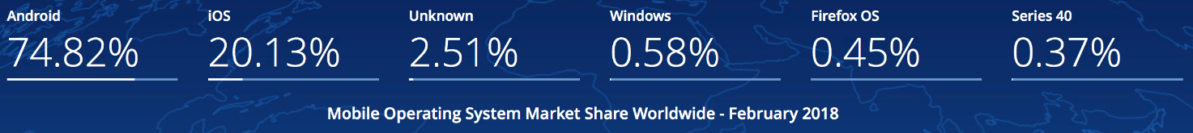

Figure 1.1 – Web service architecture

Mobile apps typically are available through [app stores](https://www.statista.com/statistics/276623/number-of-apps-available-in-leading-app-stores/) which are operated by the owners of the mobile operating systems. According to these statistics and our skills we decided to develop an application on Android platform.

1.4 Monetary system

The currency system does not stand still. As a developer of an application about the exchange rate, it is important for me to know the origins of the currency system. After all, sooner or later, every person is faced with a currency, that is, with money. After all, in our time it is impossible to live without money and it is also impossible to live without knowledge.

The dynamics of changes in the currency system, the impact of the national currency exchange rate on the economic situation in the country has become obvious even for people far from the economy. Therefore, I believe that it is important for everyone to know the origins of the formation of the currency system. It is also necessary to know the exchange rate regime in Kazakhstan in order to understand how daily changes in the exchange rate will affect the life of an individual or the life of an entire organization and to take the necessary measures in time to preserve financial well-being in an individual family or an entire organization.

The formation of the world monetary system followed the industrial revolution and the formation of the world economic system. It has passed through three stages in its development, each of which corresponds to its own type of organization of international monetary relations. The first stage in the development of the world currency system was the period from its emergence in the XIX century to the beginning of the Second world war. The transition to the second stage began in the late 30s. The world monetary system of this stage received its legal form at the Bretton woods conference (USA) in 1944. The third stage is the current world currency system, which was formed in the 70s. It was formed organizationally after the coverage of 1976 in Kingston (Jamaica).

International monetary relations arose with the beginning of the functioning of money in international payment circulation. Throughout history, the forms of world money and the terms of international settlements have changed. At the same time, the importance of the world monetary system increased and the degree of its relative independence increased. A natural desire to streamline the processes taking place in the field of international Finance has led to the formation of international monetary systems and the world monetary system. Each country conducts its own economic policy and defends its own interests in a competitive environment. The latter, in turn, depend on the exchange rate of the national currency and its role in international calculations. A currency (literally, "price, value") is the monetary unit of a country (for example, the ruble in Russia). In a narrow sense, these are monetary signs of foreign countries. Each national market has its own national currency system.

1.4.1 National currency system

The national currency system is a part of the country's monetary system, within which currency resources are formed and used, and international payment turnover is carried out. It consists of the following elements:

* National currency unit;
* Exchange rate regime;
* The conditions of invertibility of the currency;
* System the foreign exchange market and the gold market;
* Procedure for international payments of the country;
* Composition and management system of the country's gold and foreign exchange reserves;
* Status of national institutions that regulate the country's currency relations.

National currency systems are formed on the basis of national legislation, taking into account the norms of international law. Their features are determined by the conditions and level of development of the country's economy, its foreign economic relations, and the tasks of social development.

1.4.2 World currency system

On the basis of national systems, the world currency system functions – a form of organization of international monetary relations that has developed on the basis of the development of the world market and is fixed by interstate agreements. Its constituent elements are:

Main international means of payment(national currencies, gold, Euro);

* Mechanism for setting and maintaining exchange rates;
* Procedure for balancing international payments;
* The conditions of invertibility of the currency;
* Regime of international currency and gold markets;
* The status of the interstate institutes regulating currency relations.

In a market economy, the movement of money from country to country, exchange and sale of currencies is carried out primarily through the activities of large commercial banks. These banks have a network of branches in different countries or currency accounts in banks in other countries. When conducting trade and other foreign economic operations through such banks, the client has the opportunity to Deposit funds to the Bank's account in one country and, if necessary, transfer these deposits to another country in a different currency.

The main economic agents of the foreign exchange market are exporters, importers, and holders of asset portfolios. Along with the" primary "subjects of the foreign exchange market – exporters and importers, who form the basic demand and supply of currency, there are also" secondary " – those participants of the foreign exchange market who trade directly in currency. These are commercial banks, currency brokers and dealers. The definition of "secondary" is very conditional, since currently about 90% of all foreign exchange transactions on the foreign exchange market are not related to trading operations. If the daily turnover of the world's currency exchanges is 1.5 trillion. doll.,1 the daily volume of international trade is less than 2% of this value. Most of the currency trading is an ordinary exchange game, with the purpose of making a profit, where the object is the exchange rates of currencies. The largest centers of this market are located in London, Tokyo, new York, Frankfurt am main, and Brussels.

The most important subjects in the sphere of international monetary circulation are government bodies. Monetary relations in the world economy affect the national interests of States. It is natural that in the course of the evolution of these relations, rules and laws were developed that regulate these relations, which are acceptable from the point of view of national interests.

Currency and its types

Any national monetary unit is a currency, it acquires a number of additional functions and characteristics as soon as it begins to be considered not in the narrow framework of the national system of macroeconomic coordinates, but from the position of a participant in international economic relations and calculations. From the point of view of material form, currency is any payment documents or monetary obligations expressed in a particular national monetary unit that are used in international settlements. These are usually banknotes, Treasury bills, various types of Bank accounts, as well as cheques, bills of exchange, letters of credit, and other means of payment. These payment documents, expressed in various currencies, are bought and sold on a special market - the currency market. Demand and supply in the national currency market are formed as a result of the collision of monetary requirements and obligations expressed in different currencies that mediate the international exchange of goods, services and capital flows. The demand and supply of currency are also formed in connection with all other transactions that mediate international exchange and are reflected in the balance of payments of any country. We are talking about operations not only export-import (trade), but also non-trade (transport, insurance, tourism, etc.), as well as the movement of capital, both short-term and medium-and long-term (granting and repayment of loans), etc.

Main elements of the currency system

One of the most important elements of any currency system is the exchange rate, which shows the price of the currency of one country expressed in the currency of another. There are 3 modes for setting exchange rates:

* Based on gold parities " at the gold standard";
* Fixed exchange rate system;
* A system of floating exchange rates that fluctuate depending on supply and demand.

# PROJECT PART

## Used Technologies

### Back-end Technologies

Back-end development (also stylized as back-end or back-end development) is a skill that keeps the network running. However, he does it modestly, without fanfare, allowing people to browse their favorite sites without even knowing about all the work done by the backend developer or team. When you make a backend with support for Android Studio, it generates a fresh App Engine application in the same way and gives your Android application the necessary libraries and a model of energy for interacting with this backend. GCM's integrated help simplifies data synchronization across multiple devices. Subsequently, such as you generated the plan, you will be able to make and run the buyer and server code together, in a single environment, including the unwinding of the personal internal code directly from Android Studio.

## MVVM pattern

MVVM is one of the architectural templates that enhances the separation of tasks, it allows you to separate the user interface logic from the business (or server) logic. MVVM is a client application architecture template that was proposed by John Gossman as an alternative to MVC and MVP patterns using Data Binding technology. Model ViewModel View or MVVM, as it is commonly called, is a software design template for developing web applications. The Model ViewModel View template consists of the following three parts:

* Model – The model represents the data and business logic of the application. One of the recommended strategies for implementing this level is to provide its data through observables, which will be completely separated from ViewModel or any other observer / consumer (this will be illustrated in our example MVVM application below).
* ViewModel - ViewModel interacts with the model, and also prepares observable objects that can be observed using View. ViewModel can optionally provide hooks for the view to pass events to the model. One of the important strategies for implementing this level is to separate it from the View, i.e. ViewModel does not need to know about the view it interacts with.
* View - Finally, the role of the view in this template is to observe (or subscribe) to the ViewModel observed to receive data in order to update user interface elements accordingly.

## Web service

Web service is a standardized medium to propagate communication between the client and server applications on the World Wide Web.

A web service is a software module which is designed to perform a certain set of tasks.

* The web services can be searched for over the network and can also be invoked accordingly.
* When invoked the web service would be able to provide functionality to the client which invokes that web service.

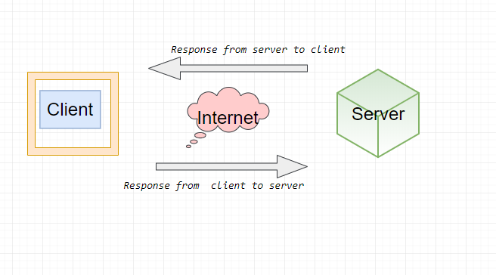

Figure 2.2.1 – Web service architecture

The Figure 2.2.1 shows a very simplistic view of how a web service would actually work. The client would invoke a series of web service calls via requests to a server which would host the actual web service.

A web service is an [application](https://techterms.com/definition/application) or [data](https://techterms.com/definition/data) source that is accessible via a standard web protocol ([HTTP](https://techterms.com/definition/http) or [HTTPS](https://techterms.com/definition/https)). Unlike [web applications](https://techterms.com/definition/web_application), web services are designed to communicate with other [programs](https://techterms.com/definition/program), rather than directly with users.

While web services can provide data in a number of different formats, [XML](https://techterms.com/definition/xml) and [JSON](https://techterms.com/definition/json) are the most common. These standard text-based formats can be easily recognized and [parsed](https://techterms.com/definition/parse) by another program that receives the data.

Web services are self-contained, modular, distributed, dynamic applications that can be described, published, located, or invoked over the network to create products, processes, and supply chains. These applications can be local, distributed, or web-based. Web services are built on top of open standards such as TCP/IP, HTTP, Java, HTML, and XML.

A JSON web service is less formally defined. The data format is described by using JSON schema notation, and it requires use of the HTTP transport protocol. JSON is a more convenient data representation format for typical mobile devices and JavaScript based applications.

### PHP as development tool

Application is developed by PHP. It is a server scripting language, and a powerful tool for making dynamic and interactive Web pages. PHP is a widely-used, free, and efficient alternative to competitors such as Microsoft's ASP.

PHP is a open source, interpreted and object-oriented scripting language i.e. executed at server side. It is used to develop web applications (an application i.e. executed at server side and generates dynamic page).

* PHP is a server side scripting language.
* PHP is an interpreted language, i.e. there is no need for compilation.
* PHP is an object-oriented language.
* PHP is an open-source scripting language.
* PHP is simple and easy to learn language.

There are given many features of PHP.

* Easy to learn: PHP is easy to learn and use. For beginner programmers who just started out in web development, PHP is often considered as the preferable choice of language to learn.
* Open source: PHP is an open-source project. It is developed and maintained by a worldwide community of developers who make its source code freely available to download and use.
* Portability: PHP runs on various platforms such as Microsoft Windows, Linux, Mac OS, etc. and it is compatible with almost all servers used today such Apache, IIS, etc.
* Fast Performance: Scripts written in PHP usually execute or runs faster than those written in other scripting languages like ASP, Ruby, Python, Java, etc.
* Vast Community: Since PHP is supported by the worldwide community, finding help or documentation related to PHP online is extremely easy.

## Firebase

Firebase is a NoSQL-type database that uses sockets, which allows the client to receive information in real time - without having to send GET requests to the server. This requires that during setup you sign a “client” to the database / collection. In terms of how you can use it in an application, it depends on the technologies you want to use on your stack. Features of integration with applications for Android and iOS operating systems are supported, an API for Java, Node.js, Objective-C applications and, of course, JavaScript is implemented, it is also possible to work directly with a database like REST from a number of JavaScript frameworks, including an angular, react, vue, amber and others. An API for data encryption is provided. Figure 2.2 shows the application user data.

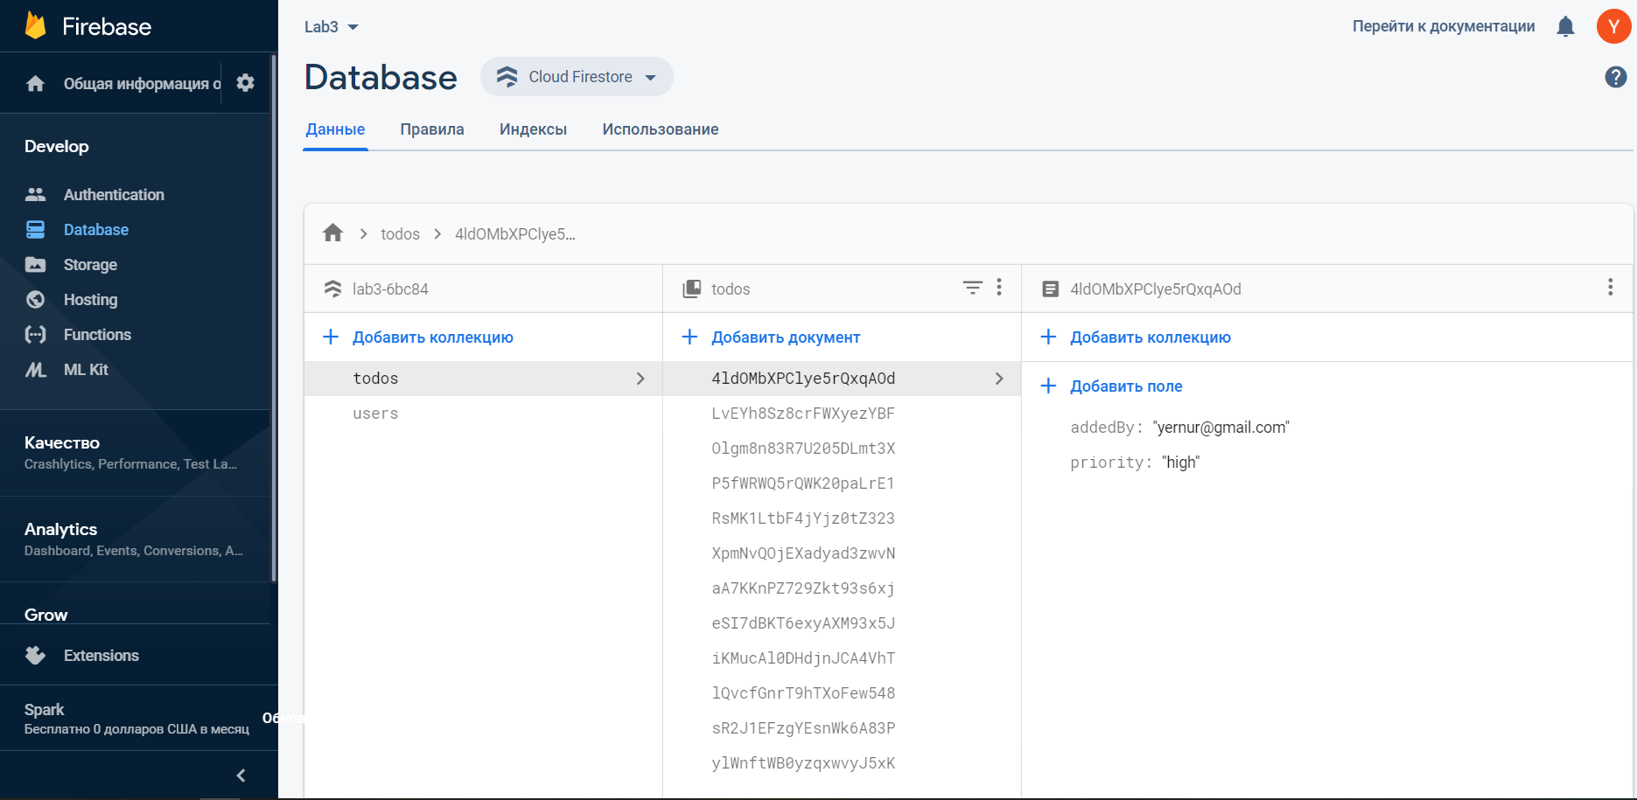

Figure 2.3 - Database

Authentication Firebase provides backend services, easy-to-use SDKs, and ready-made user interface libraries for authenticating users in your application. It supports authentication using passwords, phone numbers, popular federated identity providers such as Google, Facebook and Twitter, and others. Authentication of our users is shown on the Figure 2.3.1

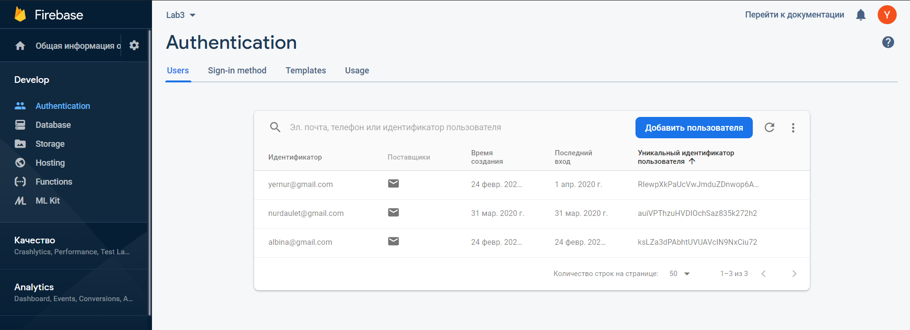

Figure 2.3.1 – Firebase Authentification

### Android Studio as development tool

As a mobile platform we used Android. Android is based on a Linux platform for mobile phones developed by Open Handset Alliance (OHA), initiated by Google. It allows you to create Java-based applications that control the device via a Google-designed library.

Android Studio is the official integrated development environment ([IDE](https://searchsoftwarequality.techtarget.com/definition/integrated-development-environment)) for Android application development. It is based on the [IntelliJ IDEA](https://www.theserverside.com/definition/IntellJ-IDEA), a [Java](https://www.theserverside.com/definition/Java) integrated development environment for software, and incorporates its code editing and developer tools.

A few thoughts have been considered and factored in while choosing a development tool for this diploma project. One supposedly great feature of Android Studio is its layout designer with a drag-and- drop interface. Since in this very digitalized and design-oriented era everyone wants a good, usable interface, but still focus is on a serious application for serious work, most of the time is spent on code, not tweaking visuals.

To support application development within the Android operating system, Android Studio uses a Gradle-based build system, [emulator](https://whatis.techtarget.com/definition/emulator), code templates, and [Github](https://searchitoperations.techtarget.com/definition/GitHub) integration. Every project in Android Studio has one or more modalities with source code and resource files. These modalities include Android app modules, Library modules, and Google App Engine modules shown on the Figure 2.4

Android Studio uses an Instant Push feature to push code and resource changes to a running application. A code editor assists the developer with writing code and offering code completion, refraction, and analysis. Applications built in Android Studio are then compiled into the [APK format](https://whatis.techtarget.com/definition/APK-file-Android-Package-Kit-file-format) for submission to the Google Play Store.

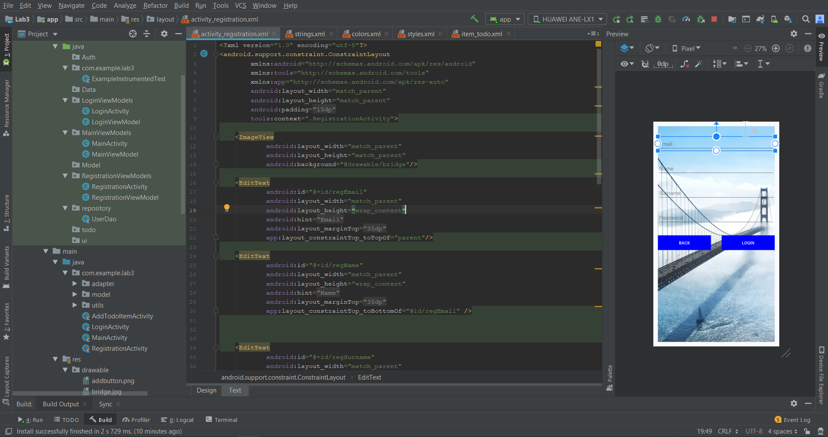

Figure 2.4 – Android Studio

## Kotlin Language

Android Studio provides first-class support for Kotlin. It even has built-in tools to help you convert Java-based code to Kotlin. The Kotlin Show Byte Code tool allows you to see Java-based equivalent code while learning Kotlin. Figure 2.5

Figure 2.5

Kotlin has a great future since it became the official Google programming language at their IO conference. Moreover, Kotlin is open source, a modern programming language than Java, thanks to many interesting functional programming features.

Kotlin is officially supported by Google, it may be the main language for android dev, but it definitely will not surpass Java, which is used for enterprise systems or web development. (MVC)

Kotlin is a good language, but whether it rises to the mainstream, no one can say. Technical merit alone does not guarantee success. Many other factors influence the popularity of the language. You just need to bet and take a chance.

Kotlin is an open-source, pragmatic general-purpose programming language statically typed for JVM and Android that combines the functions of object-oriented and functional programming. ... JetBrains uses Kotlin in many of its products, including the flagship IntelliJ IDEA.

Learning Kotlin is easy if you know any of these programming languages. This is especially easy to learn if you know Java. Kotlin was developed by JetBrains, a company known for creating professional development tools. It is not surprising that it is convenient to use.

Yes, you can study Kotlin anytime, and here I can also recommend some online courses for learning Kotlin

### Coroutites

Coroutines simplifies asynchronous programming by hiding all the complexity inside libraries. Coroutines are computations that can be paused without blocking the flow. “Without blocking the flow” - what does it mean? Simply put, we are talking about a function that can be started, disconnected and resumed from the same place. Coroutines is a new, convenient way to perform non-blocking asynchronous operations. In addition, creating coroutines is an “easier” operation than streams. In coroutines, the main thing is the interruption of functions. Detached functions can take parameters and return values, just like regular functions. In addition, they can be called from coroutines and other interruptible functions, as well as from function literals that are embedded in them. We tag methods using the new suspend keyword. A function labeled this way can abort coroutines. At the same time, this does not block the flow. In Figure 2.5.1 coroutines is using.

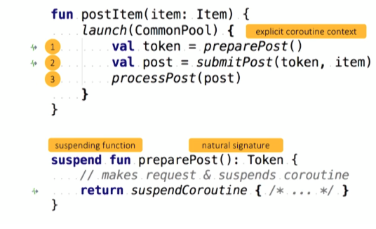

Figure 2.5.1– Coroutines

In Android, each application has a main thread that processes the user interface and controls user interaction. If your application assigns too much work to the main thread, it may freeze or slow down significantly. Network requests, JSON parsing, reading or writing from a database, or even just sorting through large lists can cause your application to run slowly enough to cause a visible jerk - a slow or frozen user interface that responds slowly to touch events. These lengthy operations must be performed outside the main thread.

### JavaScript Object Notation (JSON)

JSON is a text data format following the syntax of a JavaScript object that was popularized by Douglas Crockford. Despite the fact that it is very similar to the literal syntax of a JavaScript object, it can be used independently of JavaScript, and many programming environments have the ability to read (parse) and generate JSON.

JSON exists as a string - this is useful when you want to transfer data over a network. It must be converted to a native JavaScript object if you want to access data. It's not a big problem. JavaScript provides a global JSON object that has methods for converting between them.

## Database management system

A database management system (DBMS) is a software package designed to define, manipulate, retrieve and manage data in a database. A DBMS generally manipulates the data itself, the data format, field names, record structure and file structure. It also defines rules to validate and manipulate this data. The illustration of DBMS is shown in the Figure 2.6

The DBMS manages three important things: the data, the database engine that allows data to be accessed, locked and modified, and the database schema, which defines the database’s logical structure. These three foundational elements help provide concurrency, security, data integrity and uniform administration procedures. Typical database administration tasks supported by the DBMS include change management, performance monitoring/tuning and backup and recovery.

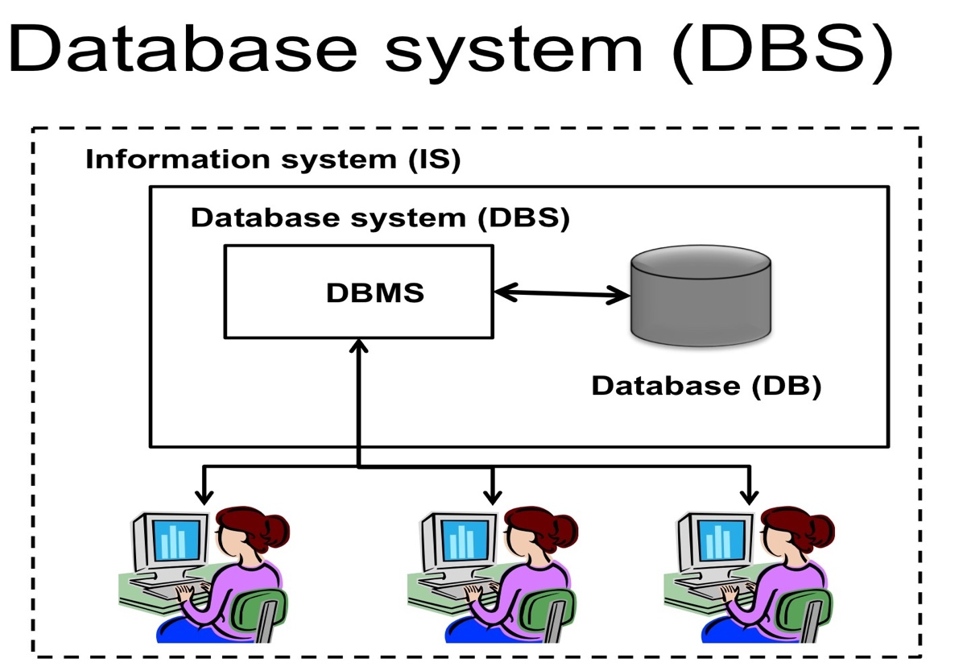

Figure 2.6 – DBMS Illustration

A database management system receives instruction from a database administrator (DBA) and accordingly instructs the system to make the necessary changes. These commands can be to load, retrieve or modify existing data from the system.

### MySQL as database of web page

MySQL provides an implementation of a SQL database very well suited for small to medium web pages.

* MySQL is a database system used on the web:
* MySQL is a database system that runs on a server
* MySQL is ideal for both small and large applications
* MySQL is very fast, reliable, and easy to use
* MySQL uses standard SQL
* MySQL compiles on a number of platforms

MySQL has some issues with stability and clustering, it is very difficult to install a consistent database cluster with MySQL with the regular version. Depending on the database storage, MySQL will support transactions or not, so the requirements of the application have to be taken into account when creating the database tables.

For large, heavy loaded databases, it is a major operation problem that changing the database structure is only possible when locking the complete tables. This will mean that the database cannot be accessed during that operation so that this can only be done during low traffic times.

Also, MySQL supports most of the SQL standard and offers many modern features:

* Complex queries
* Foreign Keys
* Triggers
* Representations (views)
* Transactional integrity
* Multi-version concurrency control
* Since MySQL database available under a liberal license, it can be free to use, modify, and distribute for any purpose, including personal, commercial, or academic.

## Diagrams

### UML diagram

UML, short for Unified Modeling Language, is a standardized modeling language consisting of an integrated set of diagrams, developed to help system and software developers for specifying, visualizing, constructing, and documenting the artifacts of software systems, as well as for business modeling and other non-software systems. Using the UML helps project teams communicate, explore potential designs, and validate the architectural design of the software. In this article we will give you detailed ideas about what is UML, the history of UML and a description of each UML diagram type, along with UML examples.

The goal of UML is to provide a standard notation that can be used by all object-oriented methods and to select and integrate the best elements of precursor notations. UML has been designed for a broad range of applications. Hence, it provides constructs for a broad range of systems and activities (e.g., distributed systems, analysis, system design and deployment).

### Use case diagram

A use case diagram is a dynamic or behavior diagram in UML. Use case diagrams model the functionality of a system using actors and use cases. Use cases are a set of actions, services, and functions that the system needs to perform. In this context, a "system" is something being developed or operated, such as a web site. The "actors" are people or entities operating under defined roles within the system.

Use case diagram, illustrated in Figure 2.7, that illustrates simple representation of user's interaction with the system where relationship between user and different use cases are shown:

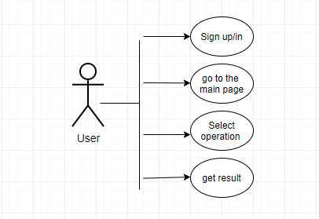

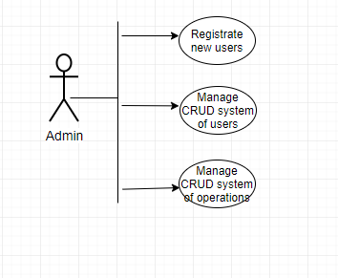

Figure 2.7

### ER diagram

An Entity Relationship (ER) Diagram is a type of flowchart that illustrates how “entities” such as people, objects or concepts relate to each other within a system. ER diagrams are most often used to design or debug relational databases in the fields of software engineering, business information systems, education and research. Also known as ERDs or ER Models, they use a defined set of symbols such as rectangles, diamonds, ovals and connecting lines to depict the interconnectedness of entities, relationships and their attributes. They mirror grammatical structure, with entities as nouns and relationships as verbs.

ER diagrams are related to data structure diagrams (DSDs), which focus on the relationships of elements within entities instead of relationships between entities themselves. ER diagrams also are often used in conjunction with data flow diagrams (DFDs), which map out the flow of information for processes or systems. In the ER diagram, which is provided below in Figure 2.2, shown the relationships, that illustrates logical structure of a database.

### Sequence diagram

When the user logs in using the Login activity their information is checked in a database. A response is then send to the Login activity telling the user if their login attempt has been successful. It shown in Figure 2.7.1

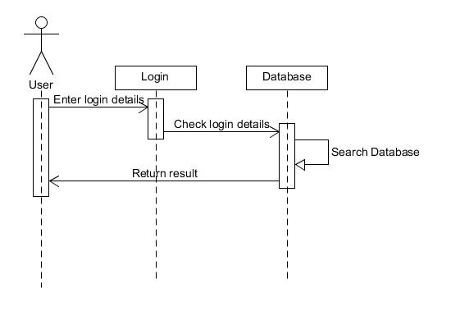

Figure 2.7.1 Sequence diagram for log in

When a new user registers, the data they enter is validated in the Register activity. Their information is then send to the database. The database will then send a response letting them know if it was successfully entered. It shown in Figure 2.7.2

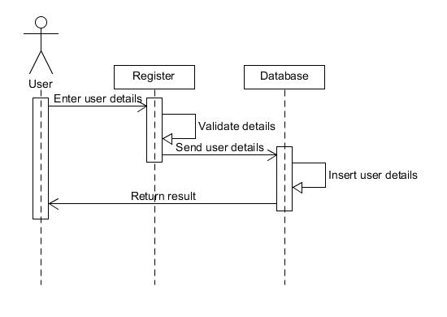

Figure 2.7.2 Sequence diagram for register

## IS Architecture

A system architecture or systems architecture is the conceptual model that defines the structure, behavior, and more views of a system. An architecture description is a formal description and representation of a system, organized in a way that supports reasoning about the structures and behaviors of the system.

An information system architecture is a formal definition of the business processes and rules, systems structure, technical framework, and product technologies for a business or organizational information system. An information system architecture usually consists of four layers: business process architecture, systems architecture, technical architecture, and product delivery architecture.  
The architecture of an information system encompasses the hardware and software used to deliver the solution to the final consumer of services. The architecture is a description of the design and contents of a computerized system.

A system architecture can consist of system components and the sub-systems developed, that will work together to implement the overall system. There have been efforts to formalize languages to describe system architecture, collectively these are called architecture description languages (ADLs).

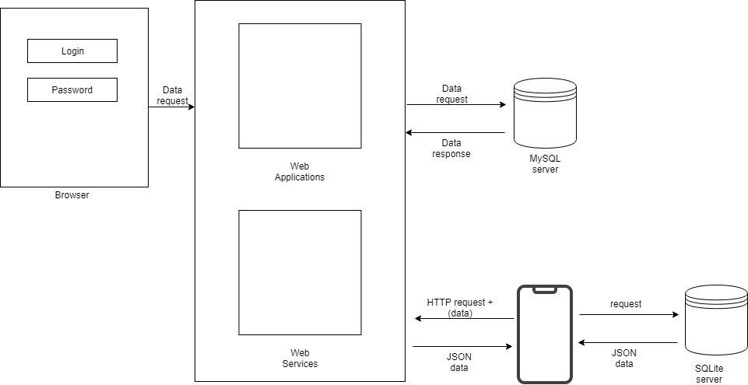

Figure 2.8 – IS Architecture

## Testing

### Purpose of the system testing

Software testing enables making objective assessments regarding the degree of conformance of the system to stated requirements and specifications.

Testing verifies that the system meets the different requirements including, functional, performance, reliability, security, usability and so on. This verification is done to ensure that we are building the system right.

In addition, testing validates that the system being developed is what the user needs. In essence, validation is performed to ensure that we are building the right system. Apart from helping make decisions, the information from software testing helps with risk management.

### Functional testing

Considering the scope of the project and the time limitations, we will perform following tests:

* Unit Test – test that verifies the program logic and is based on the knowledge of the program structure;
* Integration Test – test that verifies the entire system’s functionality according to the design specification;
* Business Requirements – test that verifies whether specific requirements of the customer are met;
* Acceptance Testing – test that verifies whether the system needs to meet the initial objectives and customer’s expectations.

Functional testing results are shown in the Table 2.9

Table 2.9 – Functional testing items, expectations and results

|  |  |  |  |
| --- | --- | --- | --- |
| Feature | Date | Tested by | Status |
| Registration | 22/03/2019 | Baigasymov Yernur | OK |
| Sign Up/Sign In | 28/03/2019 | Amangeldiyeva Albina | OK |
| Add calculator | 05/04/2019 | Amangeldiyeva Albina | OK |
| Menu of currency | 05/04/2019 | Amangeldiyeva Albina | OK |
| News list | 14/04/2019 | Baigasymov Yernur | OK |
| Add notification | 17/04/2019 | Baigasymov Yernur | OK |

### Usability testing

Usability testing involves testing software for usability. There are a lot of usability testing methods, but we have resorted to the easiest and most effective method that will help us to develop our product.

As the main testing method, we chose questionnaires. Questionnaires are not as numerically grounded and precise as other forms of testing, but they do provide general feedback from user groups. And because they allow you to collect a large amount of information in a short amount of time, they can be a more economical solution.

After an interview with the customer, we have identified the following errors in our application:

- the calculator was unavailable when displaying the list of currencies and after selecting it

### Testing results and conclusion

After the tests, our team realized that it is impossible to meet the needs of the customer immediately. Need long tests to achieve a satisfactory result. All detected errors will be eliminated in the course of system improvement.

We concluded that we should conduct regular tests to identify errors and further improve the system.

# ECONOMIC RATIONALE OF THE PROJECT

Calculations of economic efficiency of project developing is important process that results allows to compare with analogues and evaluate its profit and necessity. To do this constantly we must to correlate benefits and costs or to put it another way, to behave rationally. Rational behavior is that the producer and consumer goods tend to highest efficiency and to maximize this benefit and minimize costs.

## Product name

Our product is called ITenge. In the logo of our product, which is shown in figure 3.1 we used the image of the dollar sign and the human hand as a symbol of exchange. We used the usual word tenge in Cyrillic and put the English letter AI as a prefix denoting change from the Kazakh language. ITenge is a mobile application that allows you to accurately and accurately maintain statistics, as well as track exchange rate fluctuations, and this makes it possible to have a pocket assistant when searching for currency rates.



Figure 3.1 – Logo of product

## Project description form users’ perspective

The "iTENGE" application has several significant differences from most existing analogues on the market.

* First, the app is not limited to searching for optimal exchange rates only for the us dollar and Euro, which are familiar to most people. The selection area includes all currencies available for purchase and sale in the city selected by the user.
* Secondly, with the help of the app, users will be able to find out the current exchange rates in exchange offices and Bank branches of the Republic of Kazakhstan.
* Third, thanks to the use of GPS, the app will indicate to the user the nearest exchange point with the best exchange rate, as well as prompt the shortest path to it by 2gis
* Fourth, the app" ITENGE " implemented the search for the optimal exchange rate on the map.
* Fifth, if you are interested in news about the stock market, you can find out in the news feed.
* Sixth, the app will notify you of any changes in the exchange rate.

## Project description form customer’s perspective

With this mobile app, they can increase their customer base.

## Project description from developers’ perspective

3.4.1 Website development

HTML, CSS and JS were used for fronted development. AJAX was used for automatic update of the database and for convenient display of new users. MD5 hashing was used to protect against hacking. PHP was used to process all requests and the functional part. Many services support Apache. All web services were written in PHP. All queries were written with protection against SQL-injection, to protect against hacking. As a database we use MySQL.

3.4.2 Mobile application development

Java was used to write an android application. The REST API was created to communicate with the database, the format was JSON, it is very convenient and easy to read. SQLITE was used to store all user data in its own device, thus we do not load our database with unnecessary information. TTS library was used to create commands and process them. The MVC-pattern has been used in many solutions in the application. In the Model - View - Controller pattern, the model represents application data and associated business logic. Easy to implement and convenient to change. PicassoClient was used to download data from the database. MPAndroidChart was used to create graphs in the application.

Also, our system has a complex architecture, which is shown in Figure 3.10.



Figure 3.10 – IS Architecture

## Project description form investors’ perspective

Even the simplest application can become very popular and bring profits. Convenient navigation and concise content distinguish our mobile app from similar counterparts. There is nothing superfluous in it, only the most necessary: quickly and quickly. In addition, convenient functionality in the understandable language of ordinary people.

## Current state of the market

SWOT is acronym that stands for Strengths, Weaknesses, Opportunities and Threats. A SWOT analysis is advantageous technique, which helps to identify these four factors of the business and gain stable niche in market. SWOT analysis of CRM for healthcare industry provided in Table 3.1

Table 3.1 – SWOT analysis

|  |  |
| --- | --- |
| Strengths:  Ease of use  Own account  Free material  Visualization of the map  based on the results of collected data  System based on a real-time  platform (firebase) | Weaknesses:  Poor mobile organization  Users may not have internet  Users may not have Android smartphone  Poor development of this sphere  Users may not have Internet access |
| Opportunities:  Large target audience  The system has the ability to expand its data as it collects all kinds of information.  The use of new technologies | Threats:  Loss of users  Failure of system  Not accomplishing the goal  Another competitors  Without achieving the set goal  The inimitable feature of the app |

## Competitive advantage

The advantage of our product is that it is the first product that includes all the most important functions together. The novelty of the study is the ability to teach people to be financially literate. So that you are always up to date with everything in the currency world.

## Efficiency

In recent years, many different types of technologies have appeared that help users keep up with the exchange rate in the present time. Apps have become the most popular technological tool that people use for their own purposes. The advantage of this app is that it not only shows currency rates in real time, but also has a calculator and news aggregator that helps you correctly read and keep up with news about any changes. The mobile app will replace all the Google searches that you spent when you were looking for information about a particular currency exchange rate. After all, all you want to know is collected in one place and users can use it anywhere and how they want.

## Focus groups

Our target audience is those people who are always on the move and want to save their precious time. An audience that is financially literate or wants to become financially literate. Usually these are people aged 18 to pensioners who want to be aware of everything new.

The Currency exchange offices

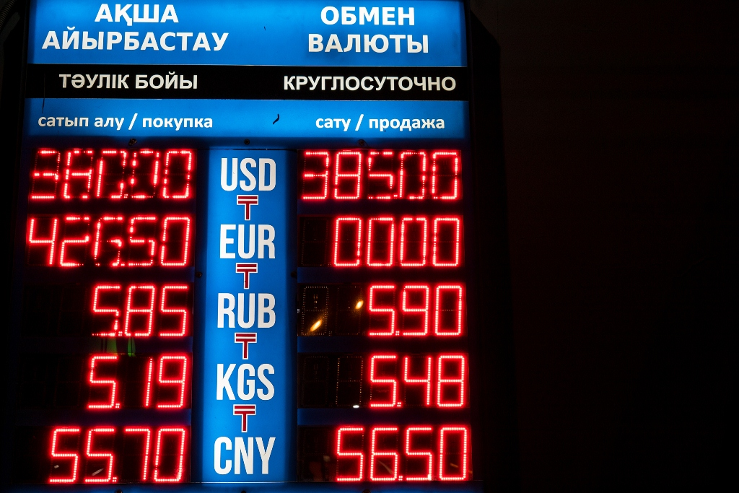

Figure 3.12 – Street exchanges pages

People who know how to use modern technologies and who do not want to waste time and do everything online at home, as is customary in the 21st century. It includes all groups of people, from busy mothers to disabled people.

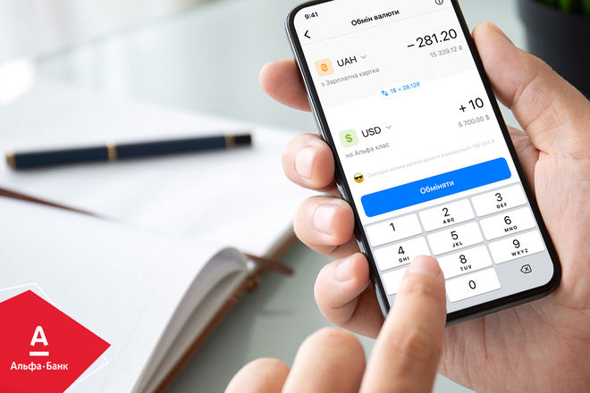

Figure 3.13 – mobile app pages

## Analysis of Currency exchange applications

Here is the list of the most popular mobile applications used as Currency exchange applications, they are different from each other and vary in some functions.

Table 3.2 – Functional characteristics of similar applications

|  |  |  |  |  |  |
| --- | --- | --- | --- | --- | --- |
| **Namе** | **Kurs.kz** | **Coinverter** | **Robinhood** | **Yahoo Finance** | **itenge** |
| Price | Free | Free | Free | Free | Free |
| Calculator | + | + | + | + | + |
| Statistics | + | + | + | + | + |
| Notifications | + | - | + | + | + |
| News aggregator | + | - | - | - | + |
| Exchange rates | + | + | + | + | + |

All mobile applications presented in this study had the same goal: to provide information about the course in the present time and at the same time provide the greatest functionality and reliability of information.

* The top three sites can be organized as follows:
* High performance speed: Coinverter
* Maximum functionality and the most reliable information: Yahoo Finance
* Ease of use: Kurs.kz
* Attractive design:Coinverter and Yahoo Finance

3.11 Calculation of the project’s economic effectiveness

Nowadays, financial analysis plays significant role in any business field because it gives an objective picture of the financial state of any project.

In [economics](https://www.investopedia.com/terms/e/economics.asp), variable costs and fixed costs are the two main costs a company has when producing goods and services. A variable cost varies with the amount produced, while a [fixed cost](https://www.investopedia.com/terms/f/fixedcost.asp) remains the same no matter how much output a company produces.

A fixed cost is an expense that does not change as production volume increases or decreases within a relevant range. In other words, fixed costs are locked in place as long as operations stay within a certain size. Fixed costs are less controllable than [variable costs](https://www.myaccountingcourse.com/accounting-dictionary/variable-costs) because they aren’t based on volume or operations.

Instead, management usually sets fixed costs at predetermined rates based on company necessities. Some examples of fixed costs include rent, insurance, and property taxes. All of these expenses are completely independent from production volume.

Table 3.2 – Fixed cost

|  |  |  |  |  |
| --- | --- | --- | --- | --- |
| *№* | *Name* | *Brand/Characteristics* | *Quantity* | *Price* |
| 1 | Laptop | Asus X556UQ-DM401T | 1 | 400 000,00 KZT |
| 2 | Laptop | HP Pavilion 15 / 2.40 GHz /Intel Core i5-8250U/ RAM 12 GB | 1 | 270 000,00 KZT |
| 3 | Phone | Iphone 5s | 1 | 107 000,00 KZT |
| 4 | Phone | Iphone 5s | 1 | 180 000,00 KZT |
| *Total* | | | *4* | *957 000,00 KZT* |

A [variable cost](https://www.investopedia.com/terms/v/variablecost.asp) is a company's cost that is associated with the amount of goods or services it produces. A company's variable cost increases and decreases with its production volume. When production volume goes up, the variable costs will increase. On the other hand, if the volume goes down, so too will the variable costs.

[Direct materials](https://www.accountingtools.com/articles/what-is-direct-material.html) are considered a variable cost. [Direct labor](https://www.accountingtools.com/articles/2017/5/6/direct-labor) may not be a variable cost if labor is not added to or subtracted from the production process as production volumes change.

Generally, wages of the frontend and backend developers are calculated based on hours spent on the development software per day during all period of development time.

Table 3.3 – Wages per hour

|  |  |  |  |
| --- | --- | --- | --- |
| *№* | *Category of workers* | *Quantity* | *Salary (hour), KZT* |
| 1 | Frontend developer | 1 | 2 250,00 KZT |
| 2 | Backend developer | 1 | 2 750,00 KZT |
| Total | | | 5 000,00 KZT |

The table below expresses stages of project with calculation of spent hours on work.(Table 3.5)

Table 3.5 – Worked hours

|  |  |  |  |  |  |  |
| --- | --- | --- | --- | --- | --- | --- |
| *№* | *Stages of Development* | *Description* | *Development hours for frontend developer* | | *Development hours for backend developer* | *Total* |
| 1 | Analytical part | Requirements | 12 | | 12 | 24 |
| Analysis | 6 | | 6 | 12 |
| Specifications | 4 | | 4 | 8 |
| Total | 22 | | 22 | 44 |
| 2 | Project part | Building UML diagrams | 10 | |  | 10 |
|  |  | Constructing interface |  | | 18 | 18 |
|  |  | Creating design interface | 10 | | 16 | 26 |
|  |  | Total | 20 | | 34 | 54 |
| 3 | Implementation | Implementation of front-end | 72 | |  | 72 |
|  |  | Testing and debugging | 14 | |  | 14 |
|  |  | Implementation of back-end |  | | 96 | 96 |
|  |  | Testing and debugging |  | | 24 | 24 |
|  |  | Experimental part |  | | 24 | 24 |
|  |  | Writing of documentation | 72 | |  | 72 |
|  |  | Total | 158 | | 144 | 302 |
| Total | | | | 200 | 200 | 400 |

Table 3.6 – Wages

|  |  |  |  |  |  |
| --- | --- | --- | --- | --- | --- |
| *№* | *Category of workers* | *Quantity* | *Salary (hour), KZT* | *Quantity (hours)* | *Salary (total), KZT* |
| 1 | Frontend developer | 1 | 2 250,00 KZT | 200 | 450 000,00 KZT |
| 2 | Backend developer | 1 | 2 750,00 KZT | 200 | 550 000,00 KZT |
| Total | | | 5 000,00 KZT | 400 | 1 000 000,00 KZT |

Table 3.7 – PS Services

|  |  |  |
| --- | --- | --- |
| *№* | *PS services* | *Price per year* |
| 1 | Domain | 3 388,00 KZT |
| 2 | Virtual hosting | 3 480,00 KZT |
| Total | | 6 868,00 KZT |

Table 3.8 – Equipment list

|  |  |  |  |  |  |  |
| --- | --- | --- | --- | --- | --- | --- |
| *№* | *Name of equipment* | *Price of one kWh of electricity* | *Power of equipment(W, Pi)* | *Working hours, (Tpi)* | *Number of units of the i-th equipment* | *Cost of electricity* |
| 1 | Asus X556UQ-DM401T | 19,01 | 60 | 200 | 1 | 228,12 KZT |
| 2 | HP Pavilion 15 | 19,01 | 60 | 200 | 1 | 228,12 KZT |
| 3 | Iphone 5s | 19,01 | 2 | 200 | 1 | 7,60 KZT |
| 4 | Iphone 5s | 19,01 | 2 | 200 | 1 | 7,60 KZT |
| Total | | | | | | 471,45 KZT |

Table 3.9 – Variable cost

|  |  |  |
| --- | --- | --- |
| *№* | *Cost of elements* | *Total* |
| 1 | Wages | 1 000 000,00 KZT |
| 2 | PS Services | 6 868,00 KZT |
| 3 | Electricity | 471,45 KZT |
| Total | | 1 007 339,45 KZT |

The **Total Cost** is the actual cost incurred in the production of a given level of output. In other words, the total expenses (cost) incurred, both explicit and implicit, on the resources to obtain a certain level of output is called the total cost.

The total cost includes both the **variable cost** (that varies with the change in the total output) and the **fixed cost** (that remains fixed irrespective of the change in the total output). Thus, total cost includes the cost of all the input factors used for producing a certain level of output.

Table 3.10 – Total cost

|  |  |  |
| --- | --- | --- |
| *№* | *Cost of elements* | *Total* |
| 1 | Fixed cost | 957 000,00 KZT |
| 2 | Variable cost | 1 007 339,45 KZT |
| Total Cost | | 1 964 339,45 KZT |

An employee's labor is typically compensated in the form of wages, salary, and sometimes tips, commissions, fringe benefits, bonuses, and awards. All this compensation is subject to various taxes at both state and federal levels. Taxes are imposed on wage and salary income: Social Security tax and the Medicare tax.

Table 3.11 – Taxes

|  |  |  |
| --- | --- | --- |
| *№* | *Name* | *Total* |
| 1 | Social security contributions | 34 650,00 KZT |
| Total | | 34 650,00 KZT |

Table 3.12 – Present Value

|  |  |  |
| --- | --- | --- |
| *№* | *Cost of elements* | *Total* |
| 1 | Fixed cost | 957 000,00 KZT |
| 2 | Variable cost | 1 007 339,45 KZT |
| 3 | Taxes | 34 650,00 KZT |
| 4 | Inflation | 9 821,70 KZT |
| 5 | Sponsors | 982 169,73 KZT |
| Total | | 3 005 980,87 KZT |

3.12 Investment analysis of the project

Investment analysis helps to determine the method of investment and how it is beneficial for the investor.

The future value (FV) refers to the value of an asset or cash at a particular date in the future which is equivalent to the value of a specified sum at present. The future value can also be explained as the amount of money which will be reached by a present investment as a result of its growth in the future. As money features time value, the future value is, obviously, expected to be higher than the [present value](https://www.readyratios.com/reference/analysis/present_value.html).

The formula for determining the future value is:

|  |  |
| --- | --- |
|  | (3.1) |

where,

– (Present Value) initial amount;  – interest, expressed in shares of the unit based on the temporary basis of interest (base period)****;  – time of deposit;

– Future Value) the amount received at the end of the Deposit (accrued amount)

The estimate of the initial fee for equipment and premises is 4 000 000 KZT. The investor has provided a loan under the guarantee of payment for products in the amount of 4 000 000 KZT for 4 years. The loan rate is set at 10% per annum.

By the formula (3.2):

FV = 4 000 000 * 1.61051 = 6 442 040

The estimated Future Value is 6 442 040 KZT.

Net profit = 12 * 15000 = 180000KZT

Thus, according to the Figure 8.1, we can say that in the first year the investor will earn 1200000KZT and every year the net profit will increase by 540000KZT.

Cash flow is the sum of money recorded as receipts or disbursements in a project’s financial records. A cash flow diagram presents the flow of cash as arrows on a time line scaled to the magnitude of the cash flow, where expenses are down arrows and receipts are up arrows. Year-end convention ~ expenses occurring during the year are assumed to occur at the end of the year.

Figure 3.14 – Cash flow diagram illustration

After receiving all the necessary data, we can begin to calculate the necessary parameters. We begin with the calculation of NPV. In the Figure 8.2, we can see the NPV calculation formula that we will use.

|  |  |
| --- | --- |
|  | (3.2) |

where,

Сt = net cash inflow-outflows during a single period i

r = discount rate or return that could be earned in alternative investments

i = number of time periods

Using formula of NPV, we can decide if project is acceptable or not:

* If NPV> 0, then the project should be accepted;
* If NPV <0, the project should be rejected;
* If NPV = 0, then the project is neither profitable nor unprofitable

NPV is the difference between the present value of the future cash flow and the value of the initial financial investment. The formula of calculation NPV is shown below:

|  |  |
| --- | --- |
| *NPV = R1/(1+rss) n + R2/(1+rss) n + ... + Rn/(1+rss) n - I* | (3.3) |

where,

NPV -Net present value

R - net cash flow received each period

rss - rate of return per period (deposit = 10 %)

I - initial investment

n - total period.

By the Formula 3.3, we can see that our NPV is equal to 1 217 061,68 KZT. NPV is more than zero.

The accounting rate of return (ARR) is the percentage rate of return expected on an investment or asset as compared to the initial investment cost. ARR divides the average revenue from an asset by the company's initial investment to derive the ratio or return that can be expected over the lifetime of the asset or related project. ARR does not consider the time value of money or cash flows, which can be an integral part of maintaining a business.

The formula of calculation ARR is shown below:

|  |  |
| --- | --- |
| *AAR = (R1+R2+…+Rn)/PV* | (3.4) |

where,

AAR - Accounting Rate of Return

R - net cash flow received each period

PV = Present Value.

By the Formula (3.4), ARR = 1,71. ARR>0, that why investors can consider this project.

The profitability index is an index that attempts to identify the relationship between the costs and benefits of a proposed project through the use of a ratio calculated as:

|  |  |
| --- | --- |
|  | (3.5) |

A profitability index of 1.0 is logically the lowest acceptable measure on the index, as any value lower than 1.0 would indicate that the project's [present value](https://www.investopedia.com/terms/p/presentvalue.asp) (PV) is less than the [initial investment](https://www.investopedia.com/terms/i/initialcashflow.asp). As the value of the profitability index increases, so does the financial attractiveness of the proposed project. Looking at the Table 8.2 we can seem that PI = 1.3. PI>1, then we can accept the project.

In the Table 11 we have calculated all the necessary indicators of investment analysis. Thus, the payback period was 2 years and 6 months and payback period by discount is 3 years and two months.

The payback period refers to the amount of time it takes to [recover the cost of an investment](https://www.investopedia.com/articles/financial-theory/11/corporate-project-valuation-methods.asp). Simply put, the payback period is the length of time an investment reaches a break-even point.

Payback Period =Initial Investment Net Cash Flow per Period

Figure 3.15 – Payback period

Discounted payback period is a variation of payback period which uses discounted cash flows while calculating the time an investment takes to pay back its initial cash outflow. One of the major disadvantages of [simple payback period](https://xplaind.com/849768/payback-period) is that it ignores the time value of money. To counter this limitation, discounted payback period was devised, and it accounts for the time value of money by discounting the cash inflows of the project for each period at a suitable discount rate.

Figure 3.16 – Discounted payback period

Table 3.13 – Investment analysis

|  |  |  |  |  |  |
| --- | --- | --- | --- | --- | --- |
| RSS | 0,1 |  |  | PBP | PBPD |
| 0 | 1,0000 | 4 000 000,00 | 4 000 000,00 | - 4 000 000,00 | - 4 000 000,00 |
| 1 | 0,9091 | 900 000,00 | 818 181,82 | - 3 100 000,00 | - 3 181 818,18 |
| 2 | 0,8264 | 1 440 000,00 | 1 190 082,64 | - 1 660 000,00 | - 1 991 735,54 |
| 3 | 0,7513 | 1 980 000,00 | 1 487 603,31 | 320 000,00 | - 504 132,23 |
| 4 | 0,6830 | 2 520 000,00 | 1 721 193,91 | 2 840 000,00 | 1 217 061,68 |

Continuation of the Table 3.13

|  |  |  |  |  |  |
| --- | --- | --- | --- | --- | --- |
| AAR |  | 1,71 |  | 165 000,00 | 143 432,83 |
| NPV |  | 1 217 061,68 |  | 18,79 | 13,89 |
| PI |  | 1,30 |  | 2YEAR6M | 3YEAR2M |
| IRR |  | 0,21 |  |  |  |

3.13 Conclusion

Concluding the Chapter on calculating the economic efficiency of our project, I would like to note that investments in our project are profitable. This proves the following indicators:

* NPV = 1 217 061,68 KZT;
* PBP = 2 years 6 months;
* PBPD = 3 years 2 months;
* AAR = 1,71;
* IIR = 0,21;
* PI = 1,3.

Based on the above results, we can conclude that the investment in this project is profitable. Especially if we take into account the fact that the volume of the market is increasing every year.

# LABOR SAFETY AND ENVIRONMENTAL IMPACT

Modern production must be characterized by safe working conditions, since in any civilized society the person is one of the greatest value. The development of any civilization is associated with the improvement of production processes in various sectors of the economy.

The concept of labor protection reflects the main directions of functioning of the system of preserving the life and health of workers in the process of their work. This system includes legal, socioeconomic, organizational, technical, sanitary and hygienic, therapeutic and preventive, rehabilitation and other measures that (individually or in aggregate) are aimed at creating of labor conditions that meets the requirements of preserving the lives and health of workers in the course of their work activities.

## General information on the labor protection of the enterprise.

A safe work environment is a productive one. No matter the size or type of the business, procedures for safety in the workplace are a necessity for all staff. Safety measures protect employees as well as equipment and business property. Avoiding or minimizing injuries and damage to equipment and facilities will result in fewer expenses and more profit for a business.

Workplace safety is very important for each and every employee in the industry because all the workers desire to work in a safe and protected atmosphere. Health and safety is the key factor for all the industries in order to promote the wellness of both employees and employers. It is a duty and moral responsibility of the company to look after the employee’s protection.

These days, workplace health and safety procedures are important for the well-being of both employees and employers because human loss is immeasurable and intolerable. As, such loss or injuries can employ major loss to the families.

Workplace where is planned to perform a graduate work is located in Almaty city, Manasa st. 34 “A” “IITU”. Main work and research carried out at ninth cabinet.

A cabinet has following size:

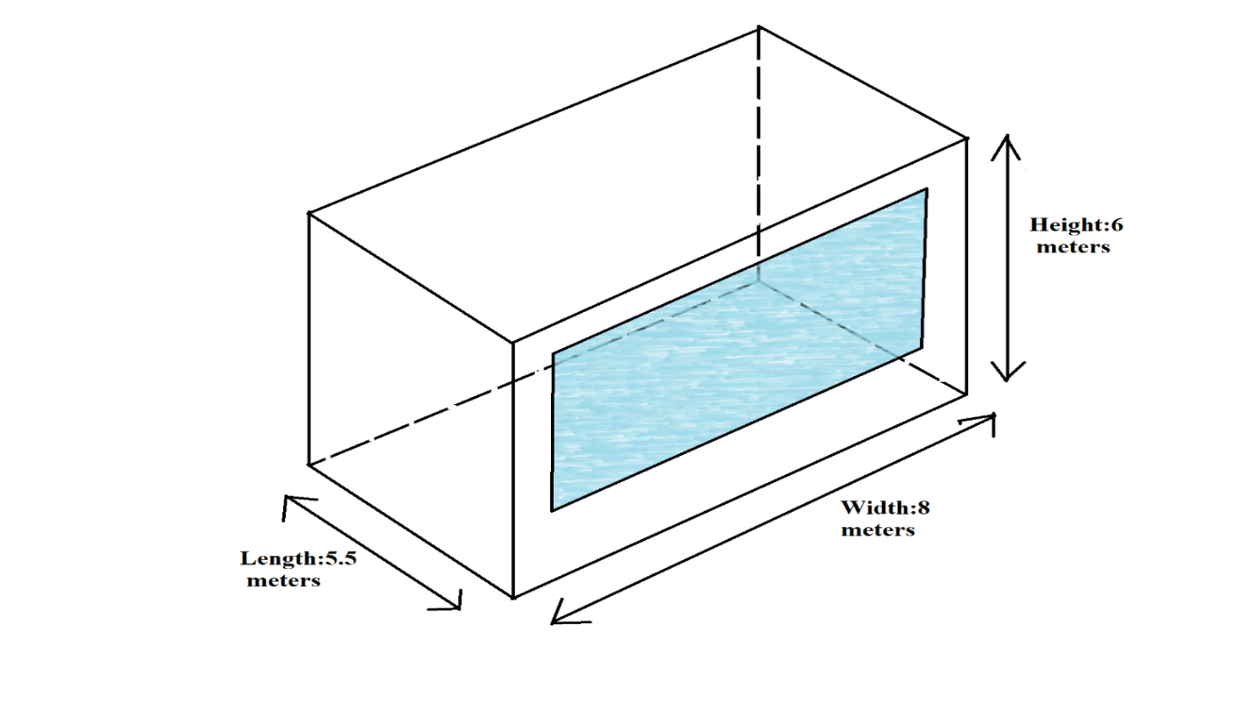

Figure 4.1 - Cabinet size

A cabinet has 1(one) entry door, 3(three) personal computers (PC), 2(two) printers, 4(four) tables, 5(five) chairs, 3(three) cupboards and one(1) air conditioner.

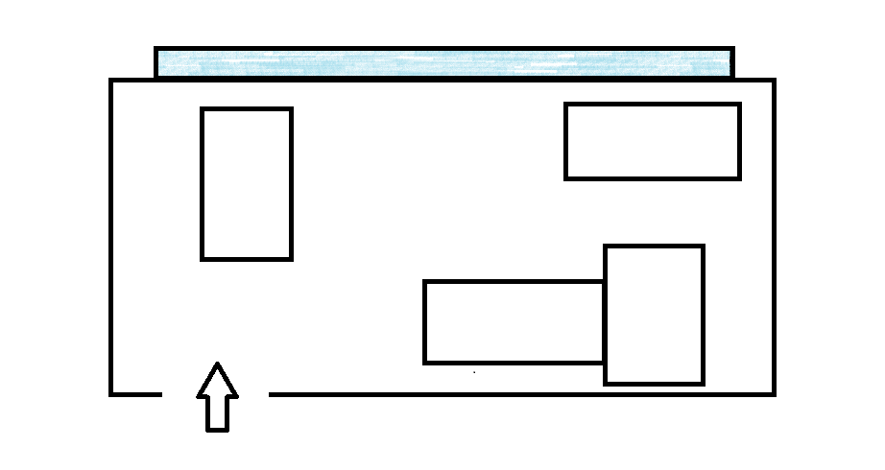

Figure 4.2 - Cabinet schema

## Analysis of dangerous and harmful factors

Safe working conditions are working conditions under which the possible impact on the workers of harmful and hazardous production factors or levels of exposure does not exceed the established limits.

Harmful and difficult working conditions are those conditions and the nature of labor in which the adverse effects of harmful and hazardous factors cause persistent functional changes in the body work and which are characterized by an increased risk of developing the disease.

Depending on the time of exposure and the intensity of production factors can be dangerous or harmful. In the case of instantaneous actions, depending on the time of exposure and the intensity of production factors can be dangerous or harmful. In the case of snap-acting factor becomes dangerous, and prolonged exposure to it is harmful.

In accordance with the state standard of harmful and hazardous factors by the nature of their impact are divided into physical, chemical, biological and psychophysiological.

Working with computer belongs to the category of works related to hazardous and harmful working conditions. During the work with the computer the following dangerous and harmful production factors affect the users:

Physical dangerous and harmful factors include:

* moving of machines and mechanisms, unprotected movable elements of the equipment moving the work piece, construction, moving or crumble; high level of dustiness and gas contamination of air;
* high or low air temperature, surfaces, humidity, air pressure or the speed of movement of air;
* elevated levels of noise or vibration, ultrasound and ionizing radiation.
* a dangerous level of voltage in an electrical network circuit which may occur through the human body, elevated levels of static electricity, the increased strength of the electric or magnetic fields;
* missing or inadequate natural lighting, inadequate illumination of the working area, increased brightness of light, lack of contrast between the background and the object of distinction, brilliance, increased pulsation of the luminous flux, elevated levels of ultraviolet or infrared radiation;
* sharp edges, graininess and roughness of surfaces of workpieces, tools and equipment;
* the location of the workplace at a considerable height relative to the ground or floor;

Table 4.1 - Analysis of dangerous and harmful production factors

|  |  |  |
| --- | --- | --- |
| *№* | *Name of dangerous and harmful production factor* | *Types of work, equipment, technological operations in which this production factor occurs* |
| 1 | Mechanical injuries | There is a possibility of injury by touching the corner of the desktop, using kitchen utensils in the kitchen of the office and stumbling over wires |
| 2 | Noise | The source of noise can be a phone call and PC |
| 3 | Vibration | Absent |
| 4 | Increased or lowered air temperature | Absent. The enterprise has an automatic system for maintaining air temperature with the help of air conditioners and heaters. |

Continuation of Table 4.1

|  |  |  |
| --- | --- | --- |
| *№* | *Name of dangerous and harmful production factor* | *Types of work, equipment, technological operations in which this production factor occurs* |
| 5 | High humidity and air speed | Absent. The height of the cabinet is six meters. Therefore, there is no barrier to normal air circulation. |
| 6 | Severity and intensity of work | Possible neuro-psychological overload (mental overstrain, monotony of work, emotional overload) |
| 7 | Risk of electric shock | Non-closed electrical shield |
| 8 | Toxicity in the enterprise | Absent |
| 9 | Fire and explosion hazard | There is a possibility of fire and explosion hazard |
| 10 | Risk of deterioration of health | Stresses, eye strain, immobility and monotony of work |

## Occupational sanitation and hygiene

Sanitary and hygienic conditions at enterprises have a great impact on human health. To these conditions include temperature regime, the humidity and purity of the air include cleanliness of premises, equipment, inventory and personal hygiene of trade workers.

To meet sanitary and hygienic requirements, in each enterprise there must be washbasins with hot and cold water supply and a mixer device. Shells should be provided with soap, electro towels, paper rolls - towels or individual napkins.

All premises of enterprises should be kept clean, for which daily thorough cleaning is necessary: wet sweeping and washing floors, dust removal, wiping furniture, radiators, window sills, washing and disinfection of sinks and toilet bowls.

Weekly with the use of detergents, it is necessary to wash the walls, lighting fixtures, to clean the glass of dust and soot. Once a month the enterprise should be closed on a sanitary day for general cleaning, disinfection of premises. Dressing rooms should be equipped with lockers or hangers for open storage of home and work clothes, a table, chairs in the required quantity, and windows have curtains and curtains. In addition, in the dressing rooms should provide a washbasin, a towel and a mirror.

Each employee must have a personal medical book with the results of all medical examinations and examinations, information on the transferred infectious diseases, on the passage of hygienic training, attestation.

Table 4.2 - Occupational sanitation and occupational health

|  |  |  |
| --- | --- | --- |
| Factor | Allowable rates | Estimation |
| Noise level+ | 0 db-80db | 80db - normal, because level does not exceed the allowable |

Continuation of Table 4.2

|  |  |  |
| --- | --- | --- |
| Factor | Allowable rates | Estimation |
| Vibration level |  | Low, because there are no obvious sources of vibration |
| Industrial lighting |  | Normal, because there are sources of artificial and natural lighting |
| Air speed | In the cold season: no more than 0,3m/s  In the warm season: 0,25m/s | In the cold season: 0,2 m/s  In the warm season: 0,21 m/s  Normal |
| Temperature | In the cold season: 19-23oC  In the warm season:18-25oC | In the cold season: 23oC  In the warm season: 21oC  Normal, because the air conditioner is used in the summer, the building is heated by a central heating system in the winter, and in the remaining seasons it is possible to ventilate the premises. |
| Humidity | In the cold season: no more than 60%  In the warm season: no more than 65% | In the cold season: 41%  In the warm season: 52%  Normal, because the office is ventilated every day and wet cleaning is conducted |
| Ventilation |  | Normal, because there is a ventilation system (natural ventilation from open windows, mechanical ventilation from blower and refrigerators) |
| Thermal radiation |  | A little above the norm, because there is a large number of personal computers emitting heat |
| Cleaning |  | Two times a day in toilets, and everyday cleaning of rooms |

## Electrical safety

Electrical safety is a system of organizational and technical measures and means to protect people from the dangerous and harmful effects of electric current, electric arc, electromagnetic field and electrostatic discharges.

Organizational measures for electrical safety - the correct organization and implementation of safe working methods; training and briefing of electrical personnel; control and supervision of compliance with safety regulations, work methods; mechanization and automation of technological processes.

Technical measures for electrical safety - ensuring normal meteorological conditions in the work area, normalized illumination, applying the necessary protective measures and means; the use of safe hand-held electric machines (electric tools), as well as fences, locks of switching electrical devices, instrumentation, work clothes, special footwear, etc.

Measures to prevent electric shock include the enclosure and insulation of any parts of electrical equipment and installations that are under voltage. Also, enterprises should be organized, where it is possible and where necessary in accordance with the rules and regulations, the application of low voltage. A mandatory measure is the grounding or zeroing of all metal structures and cables, as well as the use of means of individual and collective electrical protection. Also organizational measures include measures for admission to work with electricity and supervision during the work of specialists on electrical installations.

In the room to ensure electrical safety of electrical installations in operation, along with these activities, technological protection measures, which include: current-carrying parts, neutral grounding and isolation network, reduce the voltage, dual insulation.

## Fire safety

Fire safety is the set of practices intended to reduce the destruction caused by fire. Fire safety measures include those that are intended to prevent ignition of an uncontrolled fire, and those that are used to limit the development and effects of a fire after it starts.

Fire safety measures include those that are planned during the construction of a building or implemented in structures that are already standing, and those that are taught to occupants of the building.

The causes of fires can be violation of technological processes and problems, in particular, untimely repair of equipment, violation of technological instructions, introduction to the production technology of materials without taking into account their fire-hazardous properties, the formation of significant electrostatic charges. Fires are possible in case of violation of the rules of technical operation of electrical installations, for example, transitions in the network, as well as in conductors, violations, violations in the field of security.

In accordance with the Technical Regulations "General Fire Safety Requirements" (hereinafter referred to as Technical Regulations) approved by the Government of the Republic of Kazakhstan No. 14 dated January 14, 2009, buildings and structures are classified according to fire and explosive hazards in accordance with section 7 of Appendix 1 to the Technical regulations.

As for the explosion and fire hazards, the premises, regardless of their functional purpose, are divided into the following categories:

* A (increased risk of explosion / fire);
* B (danger of explosion / fire);
* B1-B4 (fire hazard);
* G (moderate fire hazard);
* D (fire risk reduction).

One of the most important tasks of fire prevention is the protection of building structures from destruction and to ensure their adequate strength at high temperatures in a fire. Building structures must be made of brick, concrete, glass, metal and other non-combustible materials. To prevent the spread of fire from one part of the building to another fire barriers in the form of fire walls, partitions and ceilings.

For fighting fires in the early stages of primary fire extinguishing equipment used in requires: manual and portable fire extinguishers and fire, etc.

In buildings, the fire hydrants are installed on staircases, doorways, site that is accessible and visible locations.

On the territory of the building there are the following fire extinguishing means:

* equipment for primary fire extinguishing (fire extinguishers, boxes with sand and shovels);
* technical means of fire protection (automatic detection and extinguishing installations, fire alarm systems);

## Safety during working with equipment

Before you start, make sure of serviceability of wiring, switches, socket-outlets with which the equipment is included in the network, there is a computer grounding his health.

During the work with computer:

* Adjust the chair so that you can sit evenly but comfortably. Your back should rest slightly on the back of the chair.
* To avoid unnecessary strain on your shoulders, neck and waist, lift the seat of the chair so that your elbows are bent at an angle of 90 degrees, and your wrists are comfortably on the table top.
* Place the monitor and keyboard in front of you. When working with on the keyboard, position it so that the keyboard is directly in front of you. When working with numbers, position the keyboard so that the panel of numbers is in front of your working hand. Your body should be located at a distance of 20 cm from the keyboard.
* Your elbows should be bent and conveniently located on the armrests of the chair or on the tabletop.
* Position the computer mouse so that you can control it, keeping the elbow bent and lying on the arm of the chair or the table top. In this case, your wrist should be relaxed and forward. For convenience, you can put a special ergonomic pad under it.
* Place the items on your desktop so that you can reach the right things without extending your elbow. Things that you do not use, it is recommended to remove from the table.
* Straighten your legs and comfortably place them on a hard surface (floor or special support), but do not place them bent under the chair.
* Extend your hand in front of you: if you cannot reach the top edge of the screen with your fingertips, move it closer to you.
* The top of the screen should be located at the level of your eyes. If you wear glasses, then tilt the screen at about the same angle from which you usually read a book with glasses.
* Every hour, rise from your workplace for a few minutes and do a little exercise to relax and stretch.

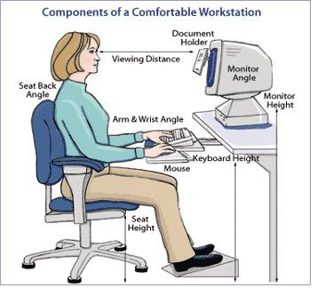

Figure 4.3 – Components of comfortable workstation

After the end of all means of computers and peripheral equipment must be shut down. You must remain only the necessary equipment in case of a continuous production process.

## Calculations

### Engineering calculations on noise

Sound is what we hear. Noise is unwanted sound. The difference between sound and noise depends upon the listener and the circumstances. Rock music can be pleasurable sound to one person and an annoying noise to another. In either case, it can be hazardous to a person's hearing if the sound is loud and if he or she is exposed long and often enough.

Sound is produced by vibrating objects and reaches the listener's ears as waves in the air or other media. When an object vibrates, it causes slight changes in air pressure. These air pressure changes travel as waves through the air and produce sound.

Table 4.3 - Approximate Speed of Sound in Common Materials

|  |  |  |
| --- | --- | --- |
| *Medium* | *Sound Velocity (ft/s)* | *m/s* |
| Air, dry (0°C and 760 mm Hg) | 1,100 | 330 |
| Wood (soft - along the fibre) | 11,100 | 3,400 |
| Water (15°C) | 4,700 | 1,400 |

Continuation of Table 4.3

|  |  |  |
| --- | --- | --- |
| *Medium* | *Sound Velocity (ft/s)* | *m/s* |
| Concrete | 10,200 | 3,100 |
| Steel | 16,000 | 5,000 |
| Lead | 3,700 | 1,200 |
| Glass | 18,500 | 5,500 |
| Hydrogen (0°C and 760 mm Hg) | 4,100 | 1,260 |

The hearing mechanism of the ear senses the sound waves and converts them into information which it relays to the brain. The brain interprets the information as sound. Even very loud sounds produce pressure fluctuations which are extremely small (1 in 10,000) compared to ambient air pressure (i.e., atmospheric pressure). The hearing mechanism in the ear is sensitive enough to detect even small pressure waves.

Noise - a collection of sounds that adversely affect the human body and hinder his work and leisure.

Noise is one of the most common occupational health hazards. In heavy industrial and manufacturing environments, as well as in farms, cafeterias, permanent hearing loss is the main health concern. Annoyance, stress and interference with speech communication are the main concerns in noisy offices, schools and computer rooms.

Noise can be continuous, variable, intermittent or impulsive depending on how it changes over time. Continuous noise is noise which remains constant and stable over a given time period. The noise of boilers in a power house is relatively constant and can therefore be classified as continuous.

Most manufacturing noise is variable or intermittent. Different operations or different noise sources cause the sound changes over time. Noise is intermittent if there is a mix of relatively quiet and noisy periods. Impulse or impact noise is a very short burst of loud noise which lasts for less than one second. Gun fire or the noise produced by punch presses are examples of such noise.

Decibel levels are important to you because they tell you how loud or quiet a sound is and this is very important as if something is too loud it can damage your hearing permanently. We usually measure how loud sound is through the use of a measure called the decibel, one decibel being one tenth of a bel, a very infrequently used measure. It is a measure of the sound pressure level or loudness.

The decibel scale is not a linear scale, it is a logarithmic scale. A doubling of your Decibel reading does not mean a doubling of the noise, for every 10dB increase in sound our perception of loudness doubles. So 60dB is twice as loud as 50dB and 70dB is four rimes as loud as 50dB.

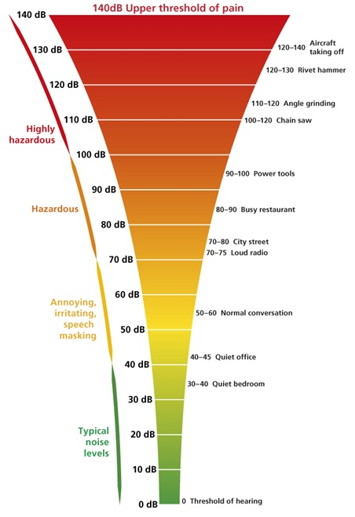

Figure 4.4 – Decibel levels

To prevent adverse outcomes of noise exposure, noise levels should be reduced to acceptable levels. The best method of noise reduction is to use engineering modifications to the noise source itself, or to the workplace environment. Where technology cannot adequately control the problem, personal hearing protection (such as ear muffs or plugs) can be used. Personal protection, however, should be considered as an interim measure while other means of reducing workplace noise are being explored and implemented.

As a first step in dealing with noise, workplaces need to identify areas or operations where excessive exposure to noise occurs.

The noise is perceived very subjectively. In this matter the specific situation, state of health, mood, environment. The main physiological effect of noise is that the damaged inner ear, to change the electrical conductivity of the skin, brain activity, heart and respiratory rate, total motor activity and change the size of some endocrine glands, blood pressure, vasoconstriction, expansion pupils of the eyes.

Working in conditions of prolonged noise exposure experienced irritability, headache, dizziness, memory loss, fatigue, loss of appetite, sleep disturbance. In a noisy background of deteriorating communication between people, as a result sometimes there is a feeling of loneliness and frustration, which can lead to accidents.

Prolonged exposure to noise levels exceeding the allowable value can cause human disease noise disease – sensorineural hearing loss. Based on all the above noise should be considered as a cause of hearing loss, certain nerve diseases, loss of productivity at work and sometimes loss of life.

One of the adverse factors of industrial environment on the PC is a high level of noise generated by the printing devices, air-conditioning equipment, fans, cooling themselves in the PC.

To calculate the noise level at the workplace from several non-coherent sources, the method of energy summation of emissions of individual sources is used.

|  |  |
| --- | --- |
|  | (4.1) |

Where,

Li is the sound pressure level of the i-th noise source;

n is the number of noise sources.

The obtained results of the calculation is compared with the permissible value of noise for a given workplace. If the calculation results above the permissible noise levels, the need for special measures to reduce noise. These include: lining the walls and ceiling of the hall sound-absorbing materials, noise reduction at source, proper layout of the equipment and the rational organization of the operator's station.

Sound pressure levels of noise sources acting on the operator in the workplace are presented in Table 4.4.

Table 4.4 – Noise source and level

|  |  |
| --- | --- |
| *Noise source* | *The noise level (dB)* |
| HDD | 40 |
| Fan | 45 |
| Monitor | 17 |
| Keyboard | 10 |
| Printer | 45 |
| Scanner | 42 |

Typically, the operator's station is equipped with the following equipment: a hard drive in the system unit, the fan (s) cooling the PC, monitor, keyboard, printer and scanner.

Substituting the values ​​of sound pressure level for each type of equipment in the formula, we get:

L = 10 · lg (104 + 104.5 + 101.7 + 101 + 104.5 + 104.2) = 49.5 dB

The resulting value does not exceed the permissible noise level for the operator's workplace, equal to 65 dB. And if we consider that hardly peripheral devices such as a scanner and a printer will be used at the same time, this figure will be even lower. Besides the immediate presence of optional operator at the printer, because the printer is equipped with a mechanism of auto sheets. Created conditions should ensure comfortable work. Compliance with the conditions that determine the optimal organization of the workplace of a software engineer will help to maintain good performance throughout the entire working day, and increase labor productivity in both quantitative and qualitative terms.

### Engineering calculations on lighting

Light is a type of [energy](https://simple.wikipedia.org/wiki/Energy). It is a form of [electromagnetic radiation](https://simple.wikipedia.org/wiki/Electromagnetic_radiation) of a [wavelength](https://simple.wikipedia.org/wiki/Wavelength) which can be detected by the human [eye](https://simple.wikipedia.org/wiki/Eye).

Natural light is the light generated naturally. The most common source of natural light on Earth is the Sun. We receive natural light throughout our sunlight hours, whether we want it or not. That is, we cannot control the amount, duration and intensity of the natural light. The light we obtain from Sun covers the entire visible spectrum, with violet at one end and red at the other. This light is good for our health and is necessary for plants to carry out photosynthesis. Fire is another source of natural light.

Artificial light is generated by artificial sources, such as incandescent lamps, compact fluorescent lamps (CFLs), LEDs, etc. We can control the quality, quantity and duration of this light by controlling a number of factors. Artificial light is necessary for us to work during hours of low lighting (evening and/or night). The artificial light does not cover the entire light spectrum and is not too conducive to photosynthesis or health of life forms.

The premises where employees work on personal computers should have natural and artificial lighting.

At production sites with a permanent stay of people provides natural lighting. Changes in natural lighting at the level of light parts or caused by meteorological conditions should not cause a decrease in illumination in the working area below the values of the conditions of normative artificial lighting for relevant types of work. At the same time, the decrease in natural light is compensated by artificial lighting by automatically turning on lighting installations in work areas with insufficient lighting.

Artificial lighting is a system of general uniform lighting. According to paragraph 33 of the Sanitary and Epidemiological Requirements No. 1430, in the production and administrative-public premises at the workplace, the combined lighting systems are used.

Fluorescent lamps are used as light sources in artificial light. In lamps of local lighting it is allowed to use incandescent lamps, including energy-saving ones.

To ensure the normalized values of illumination in the premises for the use of personal computers is carried out timely replacement of blown lamps. Window panes and fixtures are cleaned at least twice a year. In the organization of artificial lighting provides working and emergency mode.

When performing work of medium accuracy, the combined illumination at the workplace should be at least 500 lux, low accuracy and rough work - at least 200 lux.

Illumination of working premises with displays is recommended in the range of 300–500 lux. In the field of view working with the display should not be windows and lighting. Luminaires should be with diffusers, the reflection on the screen from the light source is removed by the installation of protective screens. The brightness of the glow should not be less than the illumination of the working surface with documents, since jumps in brightness when changing fields of view (from document to screen and vice versa) should be minimal. Window openings in rooms with personal computers should be equipped with adjustable light-protective devices (blinds, curtains, external visors, etc.).

Required illumination: 300 lux. Premises dimensions are 4x3 m2; height is 3.5 m. LPO 12-2 × 40-904, fluorescent lamp 36 W in a lamp bulb 2, F = 2850 lm (PHILIPS production). Norma E = illuminance of 300 lux at 0.8 m from the floor. Safety factor K_s= 0.8. Reflectance ceiling - 0.5, walls - 0.5, floor - 0.3. Define necessary number of fixtures to create a comfortable working lighting (formula 11.1):

|  |  |
| --- | --- |
| *N=(E⋅S)/(U⋅n⋅Ф⋅K_s)* | (4.2) |

where

E - required illumination of horizontal plane, lux;

S - area of the premises, m2;

K_s - safety factor;

U - utilization factor of lighting system;

F - one lamp luminous flux, lm;

n - number of lamps in one fixture.

Define area of the premises, m2

S_p=4⋅3=12

Define premises index (formula 11.2):

|  |  |
| --- | --- |
| *φ=S/((h-K_s)⋅P)* | (4.3) |

where

S - area of the premises, m2;

h - height of the work surface to the light fixture, m;

P - perimeter of the premises, m

Premises index is:

φ=12⁄(((3.5-0.8)⋅(4+3)))=0.64

Determine utilization factor on the basis of values of the reflection coefficients and premises index:

U=0.51

Calculate required number of fixtures:

N=(300⋅12)/(0.51⋅2⋅2850⋅0.8)=1.55

For premises, 7 lighting fixtures are required.

Based on calculations made on artificial lighting shown that artificial lighting meet the necessary requirements / standards.

## Anthropogenic impact of the object on the environment and environmental safety measures

One of the most important problems of the 21st century is the problem of protecting the environment from the increasing anthropogenic impact. Due to the development of technology in our daily life, a huge number of devices, devices, devices have emerged that radically changed the microenvironment affecting us. In everyday life, we increasingly began to pay attention to electromagnetic fields, noise, various radiations, as well as air, water and soil pollution with various harmful substances.

The main and most common type of negative human impact on the biosphere is pollution. Pollution refers to the entry into the surrounding environment of any solid, liquid and gaseous substances, microorganisms or energies (in the form of sounds, noises, radiations) in quantities harmful to human health, animals, plants and ecosystems.

Pollution of surface groundwater, pollution of atmospheric air, soil contamination, etc., are distinguished for pollution objects. By the way, the surfaces of the surfaces are separated from the submerged submersible water vapor, the atmospheric airflow, the exposure to the surface, etc.

A qualitative leap in the development of science and technology over the past two centuries, and especially nowadays, has led to the fact that human activity has become a factor of the planetary scale, guiding force in the further evolution of the biosphere. Now mankind uses for its needs an increasing part of the planet's territory and increasingly large amounts of mineral resources. Over time, the anthropogenic impact has become global. Anthropogenes replaced virgin landscapes. Territories that are not affected by human beings are practically nonexistent. There, where the human foot has not set foot, the products of its activity come with streams of air, river and groundwater.

Anthropogenic impact - any kind of human activity in its relation to nature, man-made - purposeful process of technical (including geological) human activity in the biosphere and near-Earth space.

Negative impact on leaving the environment: unwanted papers, idle computers or old items that are no longer in use should be given to recycling waste in order to safely destroy them or ensure the reuse of raw materials, energy, products and materials in the national economy.

In developing such activities, the following principles should be considered:

* measures should be sufficiently effective and feasible;
* measures must take into account the specifics of a particular enterprise;
* implementation of the developed measures, if possible, should not be accompanied by a decrease in labor productivity.

The company implemented the following measures: city Saturday work, recycling of used paper, recycling of old equipment, energy-saving system, the use of environmentally friendly transport.

CONCLUSION.

The currency system is the element in the world economy that the slightest failures in its operation can today lead to economic and political shocks in the development of all countries of the world. In this regard, it becomes clear that international monetary organizations perform the functions of control, and, if necessary, assistance, which they are endowed with by the world community.

And to always stay afloat and not miss jumps and fluctuations in the exchange rate, you either need to always open the Internet and see how things are with this fragile system.

In this regard, the mobile app is considered the most convenient. Yes, there are a lot of such products in the Internet platform. But to be unique, we have come up with a mobile app that will allow you to accurately and accurately maintain statistics, as well as track exchange rate fluctuations, and this makes it possible to have a pocket assistant when searching for currency rates.

# 

# REFERENCES

1. The labor code of the Republic of Kazakhstan of November 23, 2015 No. 414-V (with changes and additions of 06.04.2016).
2. Definition of categories of premises and buildings by explosion and fire hazard (Union-wide engineering standards).
3. Building regulations and rules of the Republic of Kazakhstan, 2.04-02-2011.
4. Health regulations the "Sanitary and epidemiologic requirements to ensuring radiation safety" approved by the order of the Acting Minister of national economy of the Republic of Kazakhstan of March 27, 2015 No. 261.
5. GOST 30494-2011 - Residential and public buildings. Microclimate . parameters for indoor enclosures.
6. Building code of RK about Heating, ventilation and air conditioning - 4.02-01-2011.
7. Building code of RK about Occupational safety standards system. Noise. General safety requirements - 4.02-03-2012.
8. “The Law of the Republic of Kazakhstan about Civil Protection” from   
   April 11, 2014 of No. 188-V ZRK (with changes and amendments dated   
   08-04-2016).
9. Sanitary regulations "Sanitary-epidemiological requirements to operate and personal computers, video terminals and the conditions of work with them", approved by order of the Minister of Health of Kazakhstan dated April 25, 2011 № 217.
10. The Republic of Kazakhstan "About fire safety" Law of November 22, 1996 № 48-I
11. Sanitary regulations "Sanitary-and-Epidemiological Requirements for Heating, Ventilation and Air Conditioning", approved by order of the Republic of Kazakhstan Minister of Health on April 2, 2005 № 91.

# APPENDIX