# Database

2 tables: books, genre

1 view: book_list

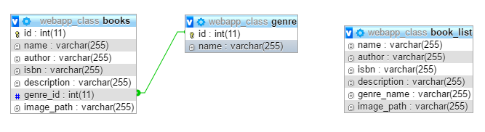

The SQL script to create the DB is attached below:



FYI, host: localhost, user/password: webapp, database: webapp

For example, $DB = new mysqli("localhost", "webapp", "webapp", "webapp_class");

# Webpage

* Related.php is for listing all books from the same genre.
* JS form validation locates at create.php.
* Unique ISBN checking locates at confirm.php.
* Images would be uploaded to folder “images”. To view the image, click “View” in the book list. If user didn’t upload a picture for the book, “View” won’t be shown.
* If user picked a genre when creating a book, “related books” will be in the book list. Otherwise, it won’t display.

# Test result

Functions work as required. No risk or bug was found.