Yahya Khan

Creative Coding

Vector Run

Final Project Documentation

Vector Run

Introducing Vector Run. Vector Run is an all-new infinite platforming game developed in p5.js by Yahya Khan. It is a very simple, interactive, and straightforward game, easy to learn and difficult to master. Featuring simple, neon 2D graphics and 3 levels of difficulty, Vector Run can be played my anyone.

The title ‘Vector Run’ is inspired by the simple appearance and use of flat geometric shapes. The word vector also reminds me of a futuristic environment, which is the direction I went for with my art design using neon colors. The background features a parallax effect that resemble a futuristic cityscape.

Vector Run can be played using only the mouse, or keyboard buttons like the spacebar or up arrow key. The program can also be resized to any window size. I plan on adding touch as an input method to support mobile devices in the future, since the display size is already supported.

*See next page for screenshots of the program running.*

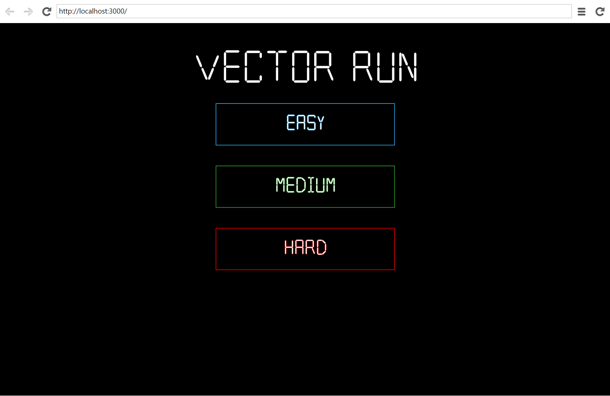

*Main menu screen, with title and 3 difficulty options. Select using mouse.*

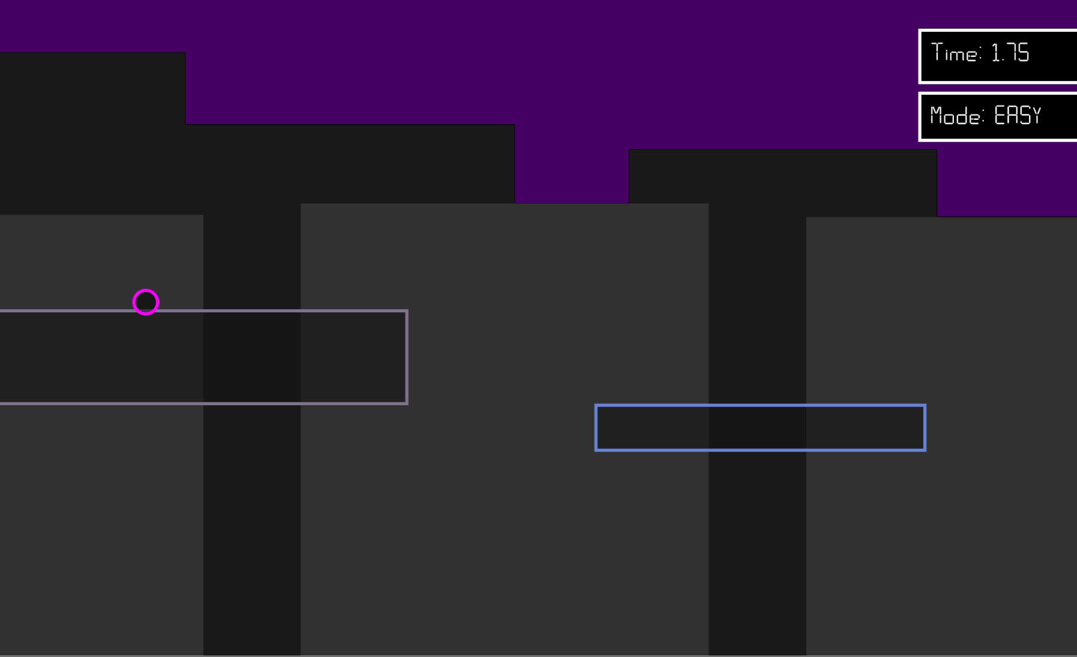

*Starts off on a long platform, followed by randomly generated platforms with varying height and length.*

*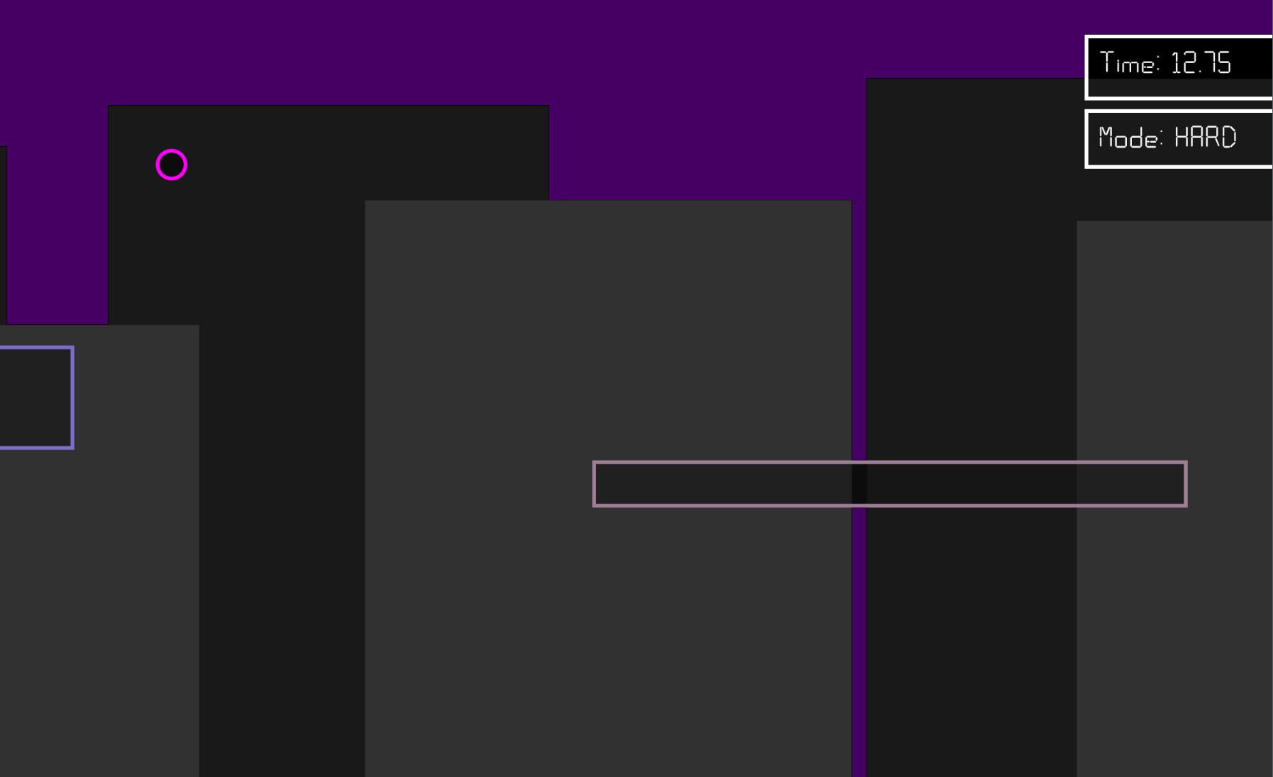*

*Time and difficulty are always displayed in top-right corner. The 3 difficulty options change the speed of the game, and the time is the score.*

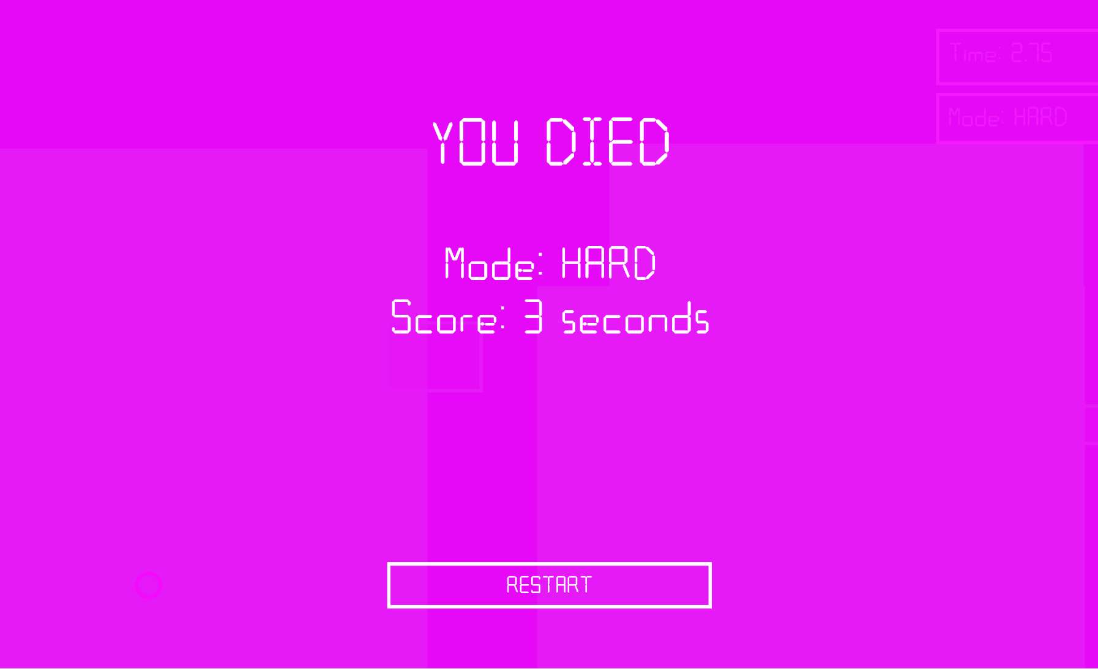

*The game over screen. Shows your final score and allows you to restart by returning to main menu.*

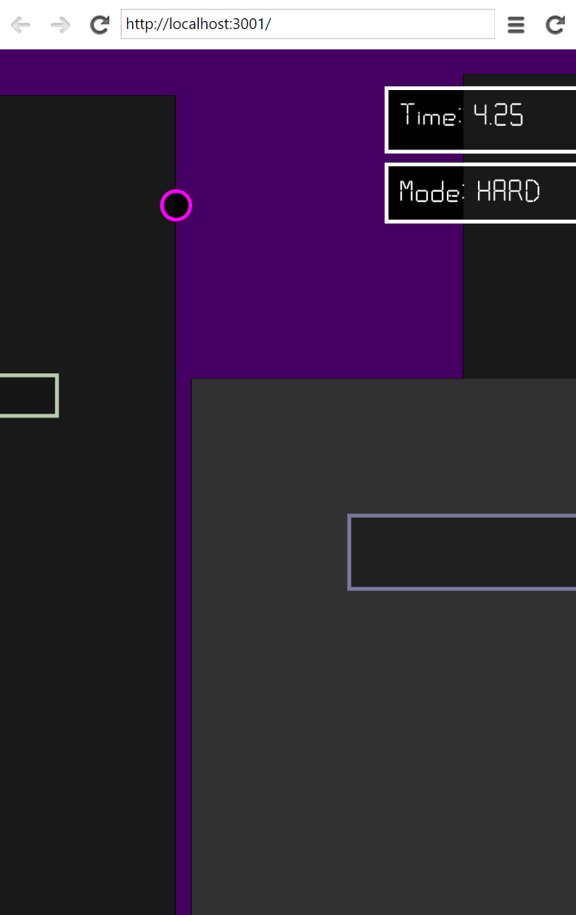

*Game can be resized to almost any screen size perfectly.*

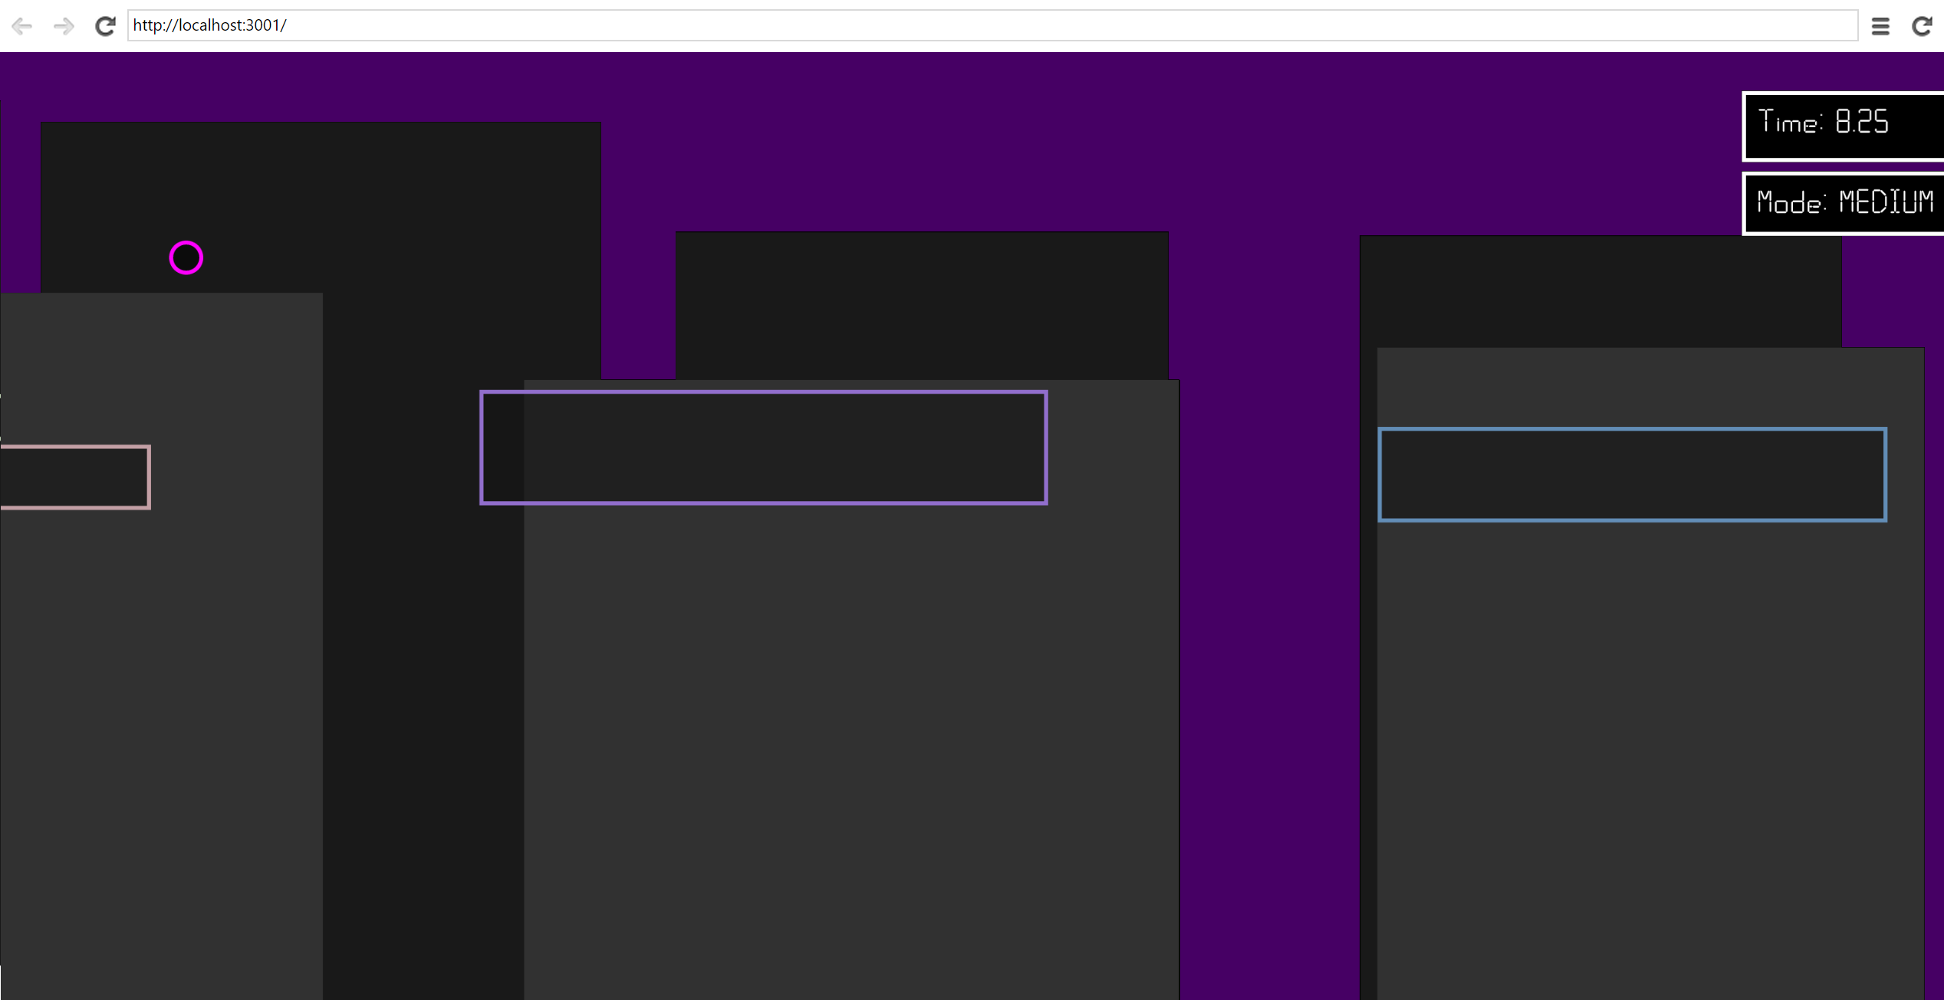

Code Screenshots

*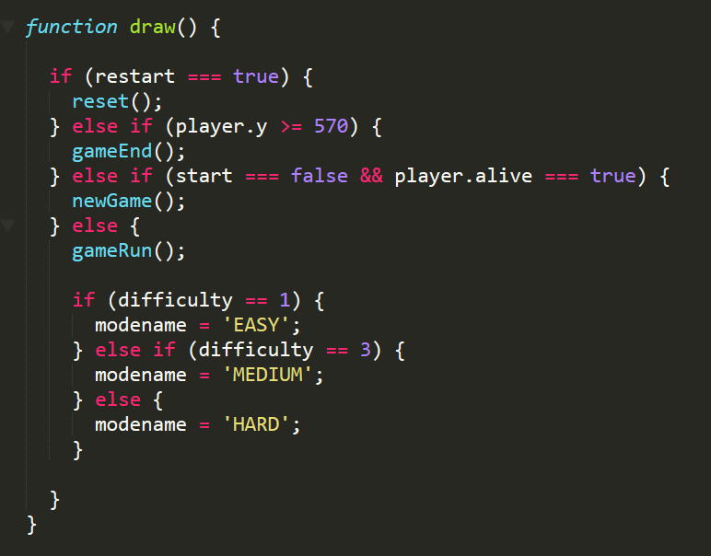Controls sections of game (main menu, game, game over scre*

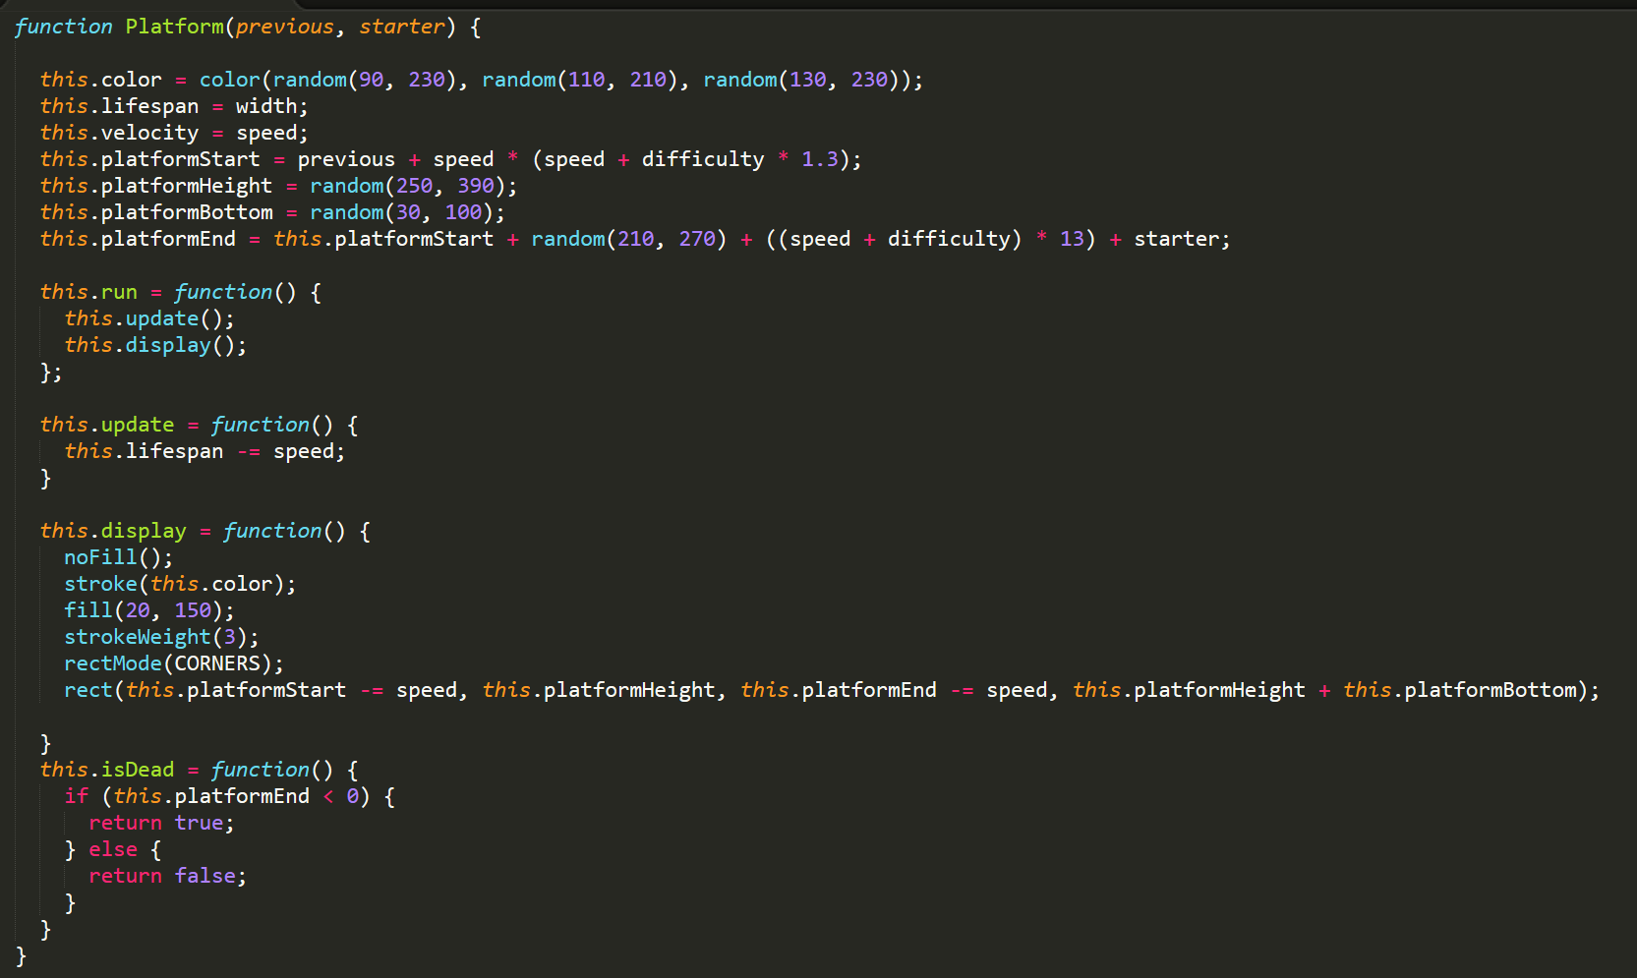*en)*

*Class for generating platforms, takes in x value of previous platform*

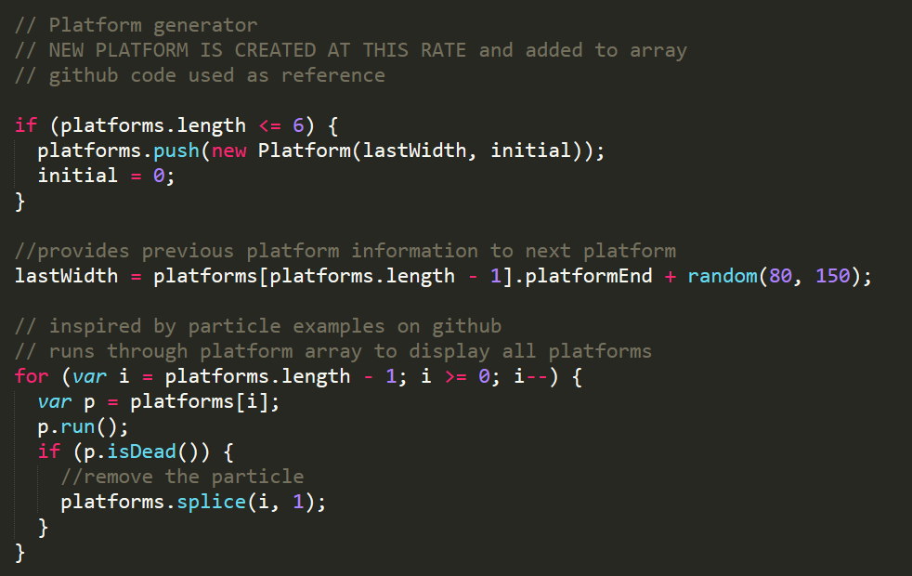

*For loop and array for generating, storing, and deleting platforms*

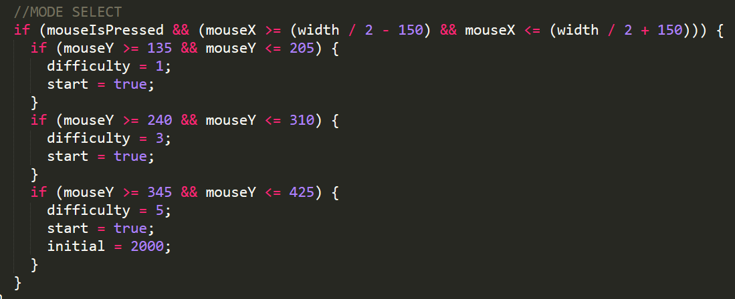

*Main menu code for selecting difficulty*

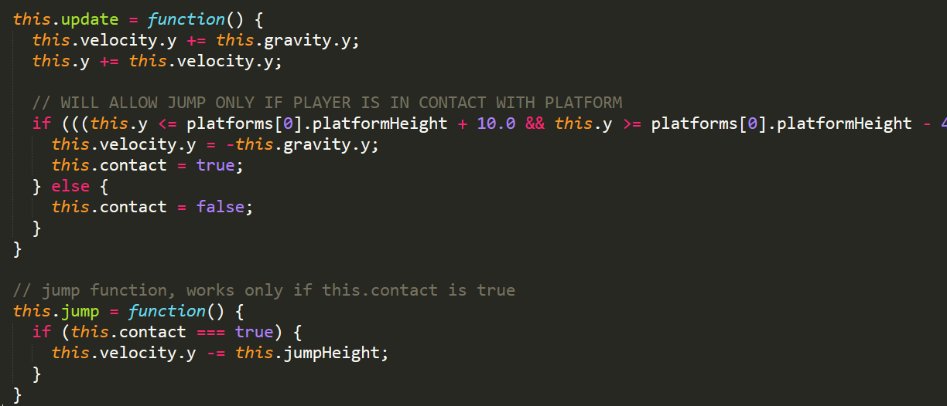

*Code that controls player class, jump and physics and platform detection (to be replaced with p5.play library and colliders)*