Value-Aware Churn Retention with a Neural Network Built from Scratch
Assignment A2 – Study, Implement and Present a Machine Learning Model (Option 1 + 2 hybrid)
STUDENTNAME_STUDENTID_YEAR_UTS_ML_Journal
Link to implementation (plain text, must be public): https://colab.research.google.com/drive/<PASTE-YOUR-PUBLIC-COLAB-LINK-HERE>
Before submitting: upload A2_ML_Notebook.ipynb to Google Colab, Runtime → Run all, set sharing to “Anyone with the link – Viewer”, paste the link above, fill in your name/ID, then export this document to PDF.

Summary
Customer-retention campaigns are decisions, not predictions: an offer costs money and is worth very different amounts for different customers. I implemented a two-hidden-layer neural network entirely in NumPy (forward pass, back-propagation, Adam, He initialisation, L2, early stopping, finite-difference gradient check) and used it to ask a focused research question on the real IBM Telco churn data (7,043 customers): does a loss derived from the profit matrix (value-weighted cross-entropy) beat ordinary cross-entropy for realised retention profit, and what does it cost? Over ten stratified 60/20/20 splits, with all tuning confined to validation data, the answer is nuanced: the decision rule “contact iff p·sV > c” is worth +$2.74 per customer (95% CI [1.612, 3.876], p = 0.0004) over the standard single-threshold practice, while swapping the loss changes profit by only +$0.13 (CI [-0.461, 0.711], p = 0.6407) and costs calibration (ECE 0.026 → 0.161) and ranking quality (AUC 0.843 → 0.817). The report documents why, with a theory-to-code derivation, a measured loss-vs-objective mismatch analysis, sensitivity analysis over the unobserved business parameters, and a generalisation-gap study.

1. Problem Definition

1.1 Task, motivation and why machine learning is needed
A telecom provider can send a retention offer (a discount worth c) to a customer who is about to leave. The offer only pays off if the customer would otherwise have churned and the saved revenue exceeds c. The provider must decide, for each customer on a monthly list, whether to contact them. The cost of a wrong decision is asymmetric and customer-specific: missing a high-bill churner is expensive, contacting a low-bill customer who would not leave wastes c. Simple rules (e.g. “contact month-to-month customers”) cannot rank thousands of customers using 19 interacting attributes; the relationship between tenure, contract, services and churn is non-linear and non-additive, which is why a learned model is appropriate. The conditions for supervised learning hold: historical records with observed churn labels (26.5% positive), features known before the decision, and enough data (N = 7,043, d = 46) for a low-capacity model.

1.2 Input / output specification
Phase | Input | Output
Training | A customer record: 3 numeric fields (tenure 0–72 months, MonthlyCharges ≈ $18–119, TotalCharges ≥ 0) and 16 categorical fields (contract, internet service, payment method, …). Pre-processed to x ∈ R^46: numerics z-scored with training-split mean/std; categoricals one-hot with levels learned on the training split. 11 blank TotalCharges values are customers with tenure 0 and are set to 0.  Label y ∈ {0,1}: 1 iff the customer churned (observed, 26.5% positive; imbalance 1 : 2.77). | Real-valued logit z = f_θ(x). σ(z) = 1/(1+e^{-z}) is the modelled probability that the customer churns (for the weighted loss it is the weighted posterior, see 2.2).
Deployment | The same 46-dimensional vector for a current customer, using preprocessing statistics frozen from training; plus the business parameters H (horizon, 12 months), s (offer success probability, 0.4) and c (offer cost, $100). | Binary action a ∈ {0,1} (send offer or not). Optimal action: contact iff p·sV > c where sV = s·H·MonthlyCharges. For the weighted model: contact iff z > 0 and sV > c.

Utility matrix. Contact a churner: sV − c. Contact a stayer: −c. No contact: 0. Hence the Bayes-optimal rule contacts customer i iff p_i > c/(sV_i) – a per-customer threshold (mean sV = $311, so the threshold averages ≈ 0.32; 16% of customers have sV ≤ c and should never be contacted). An independent assessor can test any solution with the metrics below: profit per customer on held-out data, and the share of oracle profit captured, where the oracle contacts exactly the churners with sV > c (oracle = $68.56 per customer; contact-all = −$4.96).

1.3 Technical challenges and the core problem
- Objective mismatch. Training minimises log-loss, which treats a $500 and a $50 customer identically; the business objective is profit under a value-dependent threshold.
- Class imbalance and threshold dependence. With 26.5% positives, accuracy at 0.5 is uninformative; the operating point must come from costs, not convention.
- Small tabular data: 4,225 training rows ⇒ high variance; over-fitting must be controlled by L2 and early stopping, and conclusions need repeated splits, not one lucky split.
- Unobserved business parameters (s, c, H) and observational labels (churn, not uplift) – every claim must be tested for sensitivity to them.

1.4 Research question
RQ: When the business objective is a customer-specific profit, is it worth replacing cross-entropy by the value-weighted cross-entropy that the profit matrix implies, or is nearly all the attainable gain already obtained by applying the correct decision rule to a calibrated, ordinary cross-entropy model? The question is feasible (a network of a few thousand parameters, minutes of CPU), falsifiable (paired tests over 10 splits) and matters in practice because the weighted loss is the common “cost-sensitive learning” recipe (Elkan, 2001; Zadrozny et al., 2003), whereas the post-hoc decision rule is simpler to deploy, audit and re-tune when costs change. Profit-driven evaluation of churn models has been advocated before (Verbeke et al., 2012); the contribution here is a controlled head-to-head of loss versus decision rule, with a derivation, gradient verification and a sensitivity study.

2. Machine Learning Approach

2.1 System overview (data flow)
Stage | Implementation (notebook section) | Purpose
Download + clean | pandas read_csv; TotalCharges→numeric (§1) | Self-contained: the notebook fetches the data itself
Split | make_split(seed): stratified 60/20/20, 10 seeds (§3) | Train fits, validation selects, test reports once
Pre-process | Preprocessor.fit(train) / transform (§3) | z-score + one-hot; statistics from train only → no leakage
Model | MLP.forward / loss_and_grads, Adam (§4) | From-scratch network and optimiser
Train | train_mlp: mini-batch Adam + early stopping (§5) | Fit θ; restore best-validation weights
Decide | decision_bayes / decision_weighted (§6) | Turn scores into contact actions
Evaluate | profit_per_customer, oracle, AUC, ECE, paired tests (§7–§12) | Task-aligned and standard metrics

2.2 Model, loss and theory-to-code
Architecture. x → Linear(46,h) → ReLU → Linear(h,h) → ReLU → Linear(h,1) = logit z. Two hidden layers give a hypothesis space able to represent feature interactions (e.g. contract × tenure) that a linear model cannot, while h ∈ {16, 64} keeps the parameter count (≈1k–7k) small relative to 4k training samples. ReLU avoids saturating gradients, and He initialisation N(0, 2/fan_in) preserves activation variance through ReLU layers (He et al., 2015). A single logit with a sigmoid is the maximum-likelihood parameterisation for a Bernoulli label.
Loss. For weights a_i (on positives) and b_i (on negatives):
L(θ) = (1/N) Σ_i [ a_i·y_i·softplus(−z_i) + b_i·(1−y_i)·softplus(z_i) ] + (λ/2) Σ_ℓ ‖W_ℓ‖²_F
Plain cross-entropy is a_i = b_i = 1. Profit weights. The regret of not contacting a churner is sV_i − c and of contacting a stayer is c, so a_i = max(sV_i − c, 0), b_i = c. The minimiser of the weighted risk models q_i = a_i p_i / (a_i p_i + b_i(1 − p_i)); q_i > ½ ⇔ p_i > b_i/(a_i + b_i) = c/(sV_i), exactly the Bayes-optimal rule. The per-customer threshold is therefore absorbed into the weights and the deployed rule is simply z > 0. The posterior is distorted by construction (q ≠ p) – the price of this alignment.
Back-propagation. With p = σ(z): ∂L/∂z_i = (1/N)[ b_i(1−y_i)p_i − a_i y_i(1−p_i) ]; then ∂L/∂W_ℓ = A_{ℓ−1}ᵀδ_ℓ + λW_ℓ, ∂L/∂b_ℓ = Σδ_ℓ, δ_{ℓ−1} = (δ_ℓ W_ℓᵀ) ⊙ 1[Z_{ℓ−1} > 0]. These lines are literally MLP.loss_and_grads. Verification: a central finite-difference check on 12 random coordinates of every parameter tensor gives a maximum relative error of 5×10⁻⁷ (pass threshold 10⁻⁵), so the analytic gradients – including the asymmetric weights – are correct.
def loss_and_grads(self, X, y, a_w, b_w, l2):
z, zs, acts = self.forward(X, cache=True); p = sigmoid(z)
loss = weighted_bce_from_logits(z, y, a_w, b_w).mean() + 0.5*l2*sum((W**2).sum() for W in self.W)
delta = (b_w*(1-y)*p - a_w*y*(1-p))[:, None] / N # dL/dz
for l in (2, 1, 0):
gW[l] = acts[l].T @ delta + l2*self.W[l]; gb[l] = delta.sum(0)
if l > 0: delta = (delta @ self.W[l].T) * (zs[l-1] > 0) # through ReLU

2.3 Training procedure and hyper-parameters
- Optimiser: Adam (β₁ = 0.9, β₂ = 0.999, ε = 10⁻⁸, lr = 10⁻³) implemented from scratch with bias correction m̂ = m/(1−β₁ᵗ), v̂ = v/(1−β₂ᵗ). Adam was chosen over plain SGD because per-parameter scaling copes with mixed feature scales and the uneven sample weights of the profit loss, and needs little tuning on a small tabular problem (Kingma & Ba, 2015). In a probe on one split, lr = 3×10⁻³ gave similar profit but noisier validation curves and optimum epochs of 2–10, so I used 10⁻³ (see 5.1, item 3, for how this probe was run).
- Mini-batches of 128, at most 150 epochs, early stopping on the validation value of the loss being trained (patience 15, best weights restored); L2 λ ∈ {10⁻³, 10⁻²} and width h ∈ {16, 64} chosen on validation only. Per-sample weights are divided by their training mean so that weighted and unweighted losses have comparable scale (this leaves the minimiser unchanged).
- Validation scheme: 10 repeated stratified 60/20/20 splits (seeds 1000–1009). Hyper-parameters, early stopping and the one tuned global threshold use only the validation part; the test part is used once per split. Statistics are mean ± std over splits plus paired tests across splits.

2.4 Compared methods
Method | Loss | Decision rule
MLP-BCE + Bayes | cross-entropy | contact iff σ(z)·sV > c
MLP-BCE + tuned thr | cross-entropy | one global threshold maximising validation profit (common practice)
MLP-ProfitWBCE (proposed) | a_i = max(sV_i − c,0), b_i = c | contact iff z > 0 and sV > c
Logistic regression (BCE / weighted) | scikit-learn, C ∈ {0.01,0.1,1} chosen on validation | Bayes rule / z > 0 – tests whether loss effects are specific to the NN
Hist. gradient boosting + Bayes | scikit-learn, depth 3, early stopping | Bayes rule – strong tabular benchmark
Contact-all, Contact-none, Oracle | – | reference points for the profit scale

2.5 Evaluation metrics and their relevance
- Profit per customer = mean over test customers of contact·(y·sV − c): the quantity the business receives. % of oracle = profit / oracle profit, a normalised value-capture score (custom metric, defined in 1.2) comparable across (c, s) settings.
- AUC / PR-AUC (ranking quality), log-loss and Brier (proper scoring rules), ECE (10-bin reliability gap) diagnose why a method is better or worse; none of them is the objective.
- Why not accuracy or F1 as headline? With 26.5% churners and customer-dependent stakes, accuracy rewards the wrong behaviour; profit already contains the asymmetric costs. AUC would rank a model that is excellent on low-value customers above one that is excellent on high-value customers, which the business does not want (3.3).

3. Results

3.1 Main comparison (10 splits, mean ± std on held-out test data)
Method | Profit / customer ($) | % of oracle | Contact rate | AUC | ECE
Contact-all | -4.956 ± 0.985 | -0.072 ± 0.016 | 1.000 ± 0.000 | – | –
Oracle | 68.560 ± 0.979 | 1.000 ± 0.000 | 0.253 ± 0.003 | – | –
LR (BCE)+Bayes | 39.658 ± 2.190 | 0.578 ± 0.029 | 0.353 ± 0.014 | 0.845 ± 0.011 | 0.022 ± 0.004
LR (weighted) | 39.894 ± 1.930 | 0.582 ± 0.024 | 0.351 ± 0.016 | 0.819 ± 0.010 | –
HistGB+Bayes | 40.244 ± 1.784 | 0.587 ± 0.021 | 0.363 ± 0.016 | 0.847 ± 0.008 | 0.021 ± 0.005
MLP-BCE+Bayes | 39.458 ± 2.044 | 0.576 ± 0.028 | 0.345 ± 0.016 | 0.843 ± 0.011 | 0.023 ± 0.004
MLP-BCE+tuned thr | 36.839 ± 1.608 | 0.537 ± 0.024 | 0.357 ± 0.025 | 0.843 ± 0.011 | 0.023 ± 0.004
MLP-ProfitWBCE | 39.583 ± 2.389 | 0.577 ± 0.032 | 0.352 ± 0.020 | 0.817 ± 0.010 | –
Table 1. ECE is only defined for models that output calibrated probabilities; the weighted models output a distorted posterior (3.4).

3.2 Paired comparisons across splits
A vs B | Mean diff ($/cust) | 95% CI | paired t p | Wilcoxon p | A wins
MLP-ProfitWBCE  vs MLP-BCE+Bayes | +0.125 | [-0.461, 0.711] | 0.6407 | 0.3223 | 8/10
MLP-ProfitWBCE  vs MLP-BCE+tuned thr | +2.744 | [1.612, 3.876] | 0.0004 | 0.0039 | 9/10
MLP-ProfitWBCE  vs HistGB+Bayes | -0.660 | [-1.674, 0.353] | 0.1746 | 0.2324 | 5/10
MLP-ProfitWBCE  vs LR (weighted) | -0.311 | [-1.157, 0.535] | 0.4272 | 0.5566 | 5/10
MLP-BCE+Bayes  vs LR (BCE)+Bayes | -0.200 | [-0.806, 0.406] | 0.4743 | 0.6953 | 4/10
MLP-BCE+Bayes  vs Contact-all | +44.414 | [43.004, 45.823] | 0 | 0.002 | 10/10
MLP-ProfitWBCE  vs Contact-all | +44.539 | [42.997, 46.081] | 0 | 0.002 | 10/10

Reading. (i) Every model earns about $39–40 per customer, ≈ 58% of the oracle, against −$5 for contacting everyone: the learning problem is solved well relative to the scale from nothing to oracle. (ii) The per-customer Bayes rule beats the best single global threshold by ≈ $2.6–2.7 per customer in 9 of 10 splits (p = 0.0004). (iii) The proposed weighted loss is statistically indistinguishable from cross-entropy + Bayes rule (+$0.13, CI includes 0) and from logistic regression and gradient boosting. The honest conclusion is that the weighted loss does not deliver extra profit on this data.
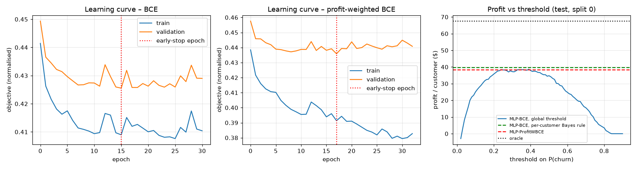
Figure 1. Learning curves (train vs validation objective, early-stopping epoch) and profit vs a global threshold compared with the per-customer rules (test, split 0).
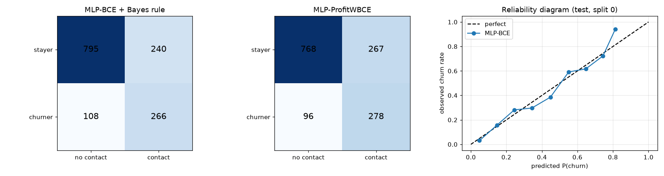
Figure 2. Confusion matrices of the two MLP decision systems and the reliability diagram of the cross-entropy MLP (test, split 0).

3.3 Loss vs. task objective: measured mismatch
- Ranking by a proper-scoring metric is not ranking by profit. Averaged over splits, HistGB < LR < MLP in log-loss (0.414 < 0.418 < 0.420) and the same order holds for profit, yet within individual splits the model with the best log-loss is not the one with the best profit in 5 of 10 splits: log-loss differences of ~0.003 are inside the noise of a 1,409-customer test set for a profit measure that depends on which individual high-value customers churn.
- Equal risk, opposite actions. Two test customers have predicted churn risk ≈ 0.32: a $104.50/month month-to-month customer (sV = $502, threshold 0.20 ⇒ contact, positive expected value) and a $30.85/month one (sV = $148, threshold 0.68 ⇒ do not contact). Cross-entropy and any single-threshold scheme cannot distinguish them; the profit-based rule does.
- Value segments (quartiles of sV, split 0). Almost all attainable profit sits in the upper half (oracle $105–120 per customer in Q3/Q4 against $1 in Q1). The weighted loss shifts effort towards high-value customers (Q4 contact rate 0.64 vs 0.59) but nets less in Q3/Q4 (−$1.7, −$4.0): higher recall (0.74 vs 0.71) at lower precision (0.51 vs 0.53) is not a free gain.
- Ranking cost. The weighted logit is not a risk score: its AUC is 0.817 vs 0.843 for the cross-entropy MLP (LR: 0.819 vs 0.845), because it deliberately mixes risk with value.
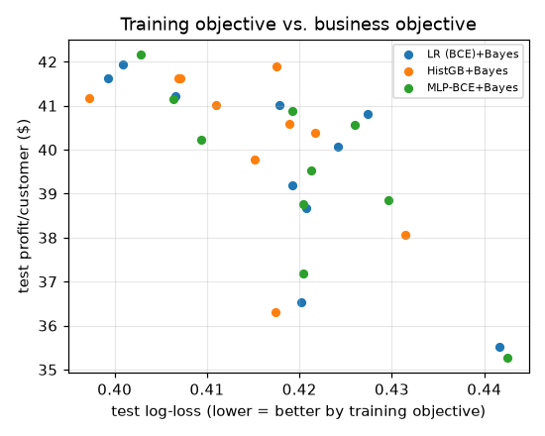
Figure 3. Test log-loss vs profit for LR, HistGB and MLP across 10 splits: no consistent monotone relation at this resolution.

3.4 Calibration cost of the weighted loss
On split 0, restricted to customers with a_i > 0, ECE is 0.026 for the cross-entropy MLP, 0.161 for the weighted network’s raw output q (expected: q is a re-weighted posterior) and 0.046 after inverting the transform p = b q/(a(1−q)+bq). The weighted model therefore cannot be used to quote churn probabilities, to compute expected lifetime value, or to be reused when c or s change, whereas the cross-entropy model’s probabilities remain valid and only the threshold c/(sV) is recomputed.

3.5 Sensitivity to unobserved business parameters
c ($) | s | BCE+Bayes | Weighted | Diff | Weighted wins | Contact-all | Oracle
40 | 0.2 | 24.14 | 24.36 | +0.21 | 4/5 | 7.6 | 37.0
40 | 0.4 | 67.31 | 67.58 | +0.27 | 4/5 | 55.3 | 84.6
40 | 0.6 | 113.22 | 113.20 | -0.02 | 2/5 | 102.9 | 132.3
100 | 0.2 | 7.21 | 7.06 | -0.15 | 2/5 | -52.4 | 22.2
100 | 0.4 | 40.28 | 39.88 | -0.40 | 1/5 | -4.7 | 68.8
100 | 0.6 | 81.48 | 81.89 | +0.40 | 4/5 | 42.9 | 116.4
160 | 0.2 | 0.54 | 0.52 | -0.02 | 2/5 | -112.4 | 9.7
160 | 0.4 | 22.39 | 22.54 | +0.15 | 3/5 | -64.7 | 53.9
160 | 0.6 | 57.15 | 56.70 | -0.46 | 2/5 | -17.1 | 100.6
Table 2. Five splits per cell, width 64, λ = 0.01, weighted model re-derived for each (c, s); values in $ per customer. The sign of the difference flips between cells and its magnitude (≤ $0.46) is far below the between-split standard deviation (≈ $2). With low cost and high success contact-all is already profitable and the model mainly avoids waste; at c = 160, s = 0.2 the whole achievable profit is < $10 and a mistaken assumption about s would turn contact-all into a −$112 loss. “Loss choice ≈ irrelevant, decision rule matters” is robust across the grid.

3.6 Generalisation gap vs. capacity
Width h | Parameters | λ | Train loss | Test loss | Gap (test−train) | ∏‖W‖_F
4 | 213 | 0.0001 | 0.422 | 0.412 | -0.010 ± 0.002 | 12.2
4 | 213 | 0.01 | 0.425 | 0.413 | -0.012 ± 0.001 | 3.2
16 | 1041 | 0.0001 | 0.405 | 0.407 | 0.002 ± 0.006 | 41.2
16 | 1041 | 0.01 | 0.422 | 0.409 | -0.013 ± 0.000 | 2.8
64 | 7233 | 0.0001 | 0.401 | 0.408 | 0.008 ± 0.007 | 170.5
64 | 7233 | 0.01 | 0.420 | 0.408 | -0.012 ± 0.000 | 2.8
256 | 78081 | 0.0001 | 0.401 | 0.406 | 0.006 ± 0.009 | 646.1
256 | 78081 | 0.01 | 0.417 | 0.407 | -0.010 ± 0.002 | 122.9
Table 3. Plain cross-entropy, fixed 60 epochs (no early stopping), 3 seeds, split seed 7. With weak regularisation (λ = 10⁻⁴) the gap rises from −0.010 (h = 4) to +0.008 (h = 64) while the product of layer norms – the quantity in norm-based capacity bounds for ReLU networks (Neyshabur et al., 2015; Bartlett et al., 2017) – grows from 12 (h = 4) to 646 (h = 256). With λ = 10⁻² the norm product stays ≈ 3 for h = 4–64 and the gap does not grow with width: regularisation, not parameter count, controls the effective hypothesis space here. The negative gaps mean this particular test split is easier than the training split under the data-loss measure; the evidence is the trend in h and λ, not the absolute sign. Early stopping and L2 are used in the main experiment for exactly this reason.
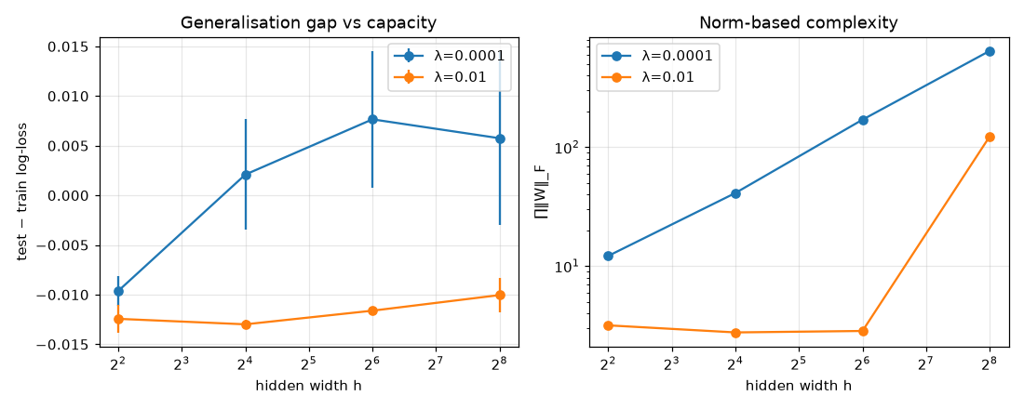
Figure 4. Generalisation gap and norm-based complexity versus width for two L2 strengths.

4. Discussion

4.1 Implications
- Answer to the research question. On this data the benefit comes from applying decision theory after training, not from changing the loss. A calibrated cross-entropy model plus the per-customer rule p > c/(sV) captures ≈ 58% of oracle profit, beats the standard single global threshold by ≈ $2.6 per customer (≈ 7%), and equals the weighted-loss model, logistic regression and gradient boosting within noise. Practical recommendation: train for calibration, decide with the cost matrix.
- Why the weighted loss does not help (hypotheses, with the evidence available). (1) Information: sV is a deterministic function of the input MonthlyCharges, so a network that models p(y|x) already has everything needed for the optimal threshold; weighting only changes which errors the optimiser prefers when capacity is scarce. With 46 inputs and a well-regularised small network capacity is not scarce – the generalisation study shows no capacity-driven gap. (2) Variance: the positive-class weights range from 0 to ≈ $470 (proportional to the bill), which lowers the effective sample size; the weighted runs stop earlier (best epoch 5–45 vs 3–91) and are noisier across splits (std $2.39 vs $2.04). (3) Ranking: weighting erodes the risk ordering (AUC −0.026). I did not run an ablation isolating (1) from (2); that is future work.
- Theory view. Both losses are consistent proper-scoring surrogates for the same Bayes decision: if the hypothesis class contains the true posterior, the minimisers coincide in the limit and the finite-sample difference is a bias–variance trade-off – a small bias reduction (higher recall) against a variance increase, which is the pattern observed.

4.2 Limitations
- s, c and H are assumptions (the dataset has no offer data); a wrong s moves absolute profit far more than any modelling choice (Table 2). Profit levels are relative scores, not forecasts.
- Churn is not uplift. The model predicts who will leave, not whom an offer will change; high-p customers may be unpersuadable. A randomised pilot is needed to estimate s and uplift (Radcliffe & Surry, 1999).
- Data. One public sample snapshot (IBM’s Telco sample dataset), no time dimension, one operator; temporal drift and transfer to other markets are untested. Repeated random splits give valid paired comparisons only within this population and, since splits overlap, the tests are indicative rather than definitive.
- Scope. Two small architectures and two regularisation strengths were explored; no categorical embeddings, ensembles or post-hoc calibration; seven paired comparisons were reported without multiple-testing correction. The hyper-parameter probe in 5.1 (item 3) looked at test profit on one split, which is a small selection risk; the validation-only protocol was used for all reported experiments.

4.3 Improvements and future work
- Calibrate then decide, and monitor: temperature or isotonic calibration on the validation set (Guo et al., 2017); track ECE, contact rate and realised profit per cohort in deployment and alarm on drift.
- Variance-controlled weighting: shrink or cap weights (a_i^γ, γ ∈ (0,1)) or blend the two losses. The variance argument predicts this retains the recall gain without the precision loss; it can be tested with the existing harness.
- Custom evaluation: integrate profit over a plausible (s, c) range (an expected-maximum-profit style measure, cf. Verbeke et al., 2012) instead of a single assumed point, and extend to a budget-constrained top-k campaign with a differentiable ranking objective.
- Causal extension: a two-model or uplift architecture trained on randomised offer data; the open research question is whether profit-aligned losses help there, where labels are treatment effects and the weight/variance trade-off is more severe.
- Architecture: entity embeddings for categoricals or monotonic constraints (churn should not rise with tenure or contract length), reducing the hypothesis space where domain knowledge exists.

5. Implementation Log

5.1 Challenges and solutions
# | Challenge | Diagnosis | Solution / evidence
1 | Back-propagation with asymmetric weights is easy to get subtly wrong | No autograd library to compare with | Derived ∂L/∂z by hand; verified by central finite differences on every tensor: max relative error 5×10⁻⁷ (notebook §4)
2 | Numerical stability of sigmoid / log-loss with large logits | Naïve log(1+e^z) overflows for large z | Piece-wise stable sigmoid; loss written in logit space with softplus(z) = max(z,0)+log1p(e^{−|z|})
3 | The weighted model stopped after very few epochs in a first trial (best epoch 0–7) and its validation curve was noisy | Weights are uneven and lr = 3×10⁻³ was aggressive | Normalised weights by their mean and probed lr ∈ {3×10⁻³, 10⁻³}, width and λ on one split. That probe printed test profit as well as validation loss, so I treat it as a (small) leak and disclose it; the final grid (h ∈ {16,64}, λ ∈ {10⁻³,10⁻²}, lr = 10⁻³) is symmetric for both losses and all reported selection uses validation data only
4 | TotalCharges is stored as text with 11 blanks | pd.to_numeric returned NaN for them | All 11 have tenure = 0 (no bill yet) ⇒ impute 0; counts printed in the notebook
5 | Leakage risk in pre-processing and threshold selection | Scaling, one-hot levels or a threshold fit on all data would peek at test | Preprocessor fitted on the training split only; threshold and hyper-parameters from validation only; test used once per split
6 | Single splits gave conflicting winners | Profit differences of $1–2 with test n = 1,409 | 10 repeated stratified splits, paired t and Wilcoxon tests, CIs; the null result is reported as such
7 | Two coding errors: pandas string arrays could not be broadcast in the one-hot comparison; a quartile mask called .values on a NumPy array | ValueError / AttributeError during the first notebook run | Converted columns to object NumPy arrays; removed .values; re-ran the entire notebook from a clean kernel

5.2 Use of AI tools and critical review
[Edit this section so it records exactly what you did yourself – the assessors question it in the presentation. The text below states what was done in this project.] An AI coding assistant (Claude Code) was used to draft the notebook and this report from my specification of the research question; I reviewed the generated code and text. I treat AI output as untrusted until verified.
- Derivations checked by hand: the regret matrix → weights a_i = max(sV_i − c, 0), b_i = c → threshold b/(a+b) = c/(sV). A tempting alternative, a_i = sV_i, would give the threshold c/(sV+c) and would not match the stated utility matrix; I confirmed which is correct by writing out the expected utility of contacting, p·sV − c·1, and setting it to zero.
- Code verification: finite-difference gradient check; printed split sizes, feature dimension and the means/stds of the standardised columns (≈ 0/1); logistic regression from scikit-learn as an independent anchor for the pipeline and metrics (AUC 0.845 vs 0.843 for the NN); inspection of the confusion matrices and reliability diagram.
- Claims corrected after checking: I did not accept the assumption that a profit-weighted loss would help; the 10-split paired test showed it does not, and the report states that. The weighted model’s output is not a calibrated probability (measured ECE 0.161), which I verified rather than assumed.
- What I must be able to explain without the code (presentation): every tensor shape, why ReLU masks appear in δ, why softplus is stable, what early stopping restores, why the per-customer threshold is c/(sV), and where each number in Tables 1–3 comes from (notebook §7–§12).

5.3 Knowledge gaps
[Review each row honestly before submission and keep only gaps that are true for you.]
Component | Why it is used | How correctness was checked | Attempt to understand / remaining gap
Norm-based capacity measure ∏‖W‖_F (Table 3) | A theory-grounded complexity proxy for ReLU networks beyond parameter count | Behaves as the cited bounds suggest (grows with width at weak λ, flat at strong λ); statement cross-referenced with Neyshabur et al. (2015) and Bartlett et al. (2017) | The idea (Lipschitz product controls function-class size) is understood; the proof is not reproduced. Used as a descriptive proxy only, never as a certified bound
Adam bias correction | m and v are zero-initialised and therefore biased towards 0 early on | Implemented directly from the algorithm in Kingma & Ba (2015); training curves are stable | Intuition understood; the convergence analysis for non-stationary gradients is taken from the paper, not rederived
He initialisation √(2/fan_in) | Keeps pre-activation variance roughly constant through ReLU layers | Follows He et al. (2015); loss decreases from the first epoch | Variance argument understood (ReLU zeroes about half the units); correctness for non-Gaussian inputs not studied
Wilcoxon signed-rank test with 10 pairs | Non-parametric check of the paired t-test | scipy implementation; the smallest attainable two-sided p with 10 pairs is 0.002, matching the 10/10-win comparisons | Procedure understood; exact handling of ties not studied
Histogram gradient boosting internals | Benchmark only | scikit-learn defaults except the settings listed; AUC ≈ 0.85 is in the range typically reported for this dataset | Used as a labelled black-box baseline, not part of the studied model

6. Mapping to the A2 Rubric (self-assessment against the Full-Mark descriptors)
Criterion | Full-mark requirement | Where this submission addresses it | Likely Q&A anchor
A. Task definition | I/O at the Clear level; challenges identified; well-articulated motivation incl. why ML; critical thinking yielding a feasible, well-motivated research question supported by evidence | §1.2 (training/deployment I/O incl. preprocessing, ranges, label, utility matrix), §1.3 challenges, §1.1 why ML, §1.4 research question; empirical support in §3.3 (mismatch measured) and §3.5 | “What exactly is the input at deployment?” – 46-d vector + (H, s, c). “Why not accuracy?” – §2.5
B. Model & algorithm | Comprehensive description of data flow, architecture and components; design rationale; implementation challenges with depth; limitation of the standard implementation addressed by a customised core component; seamless theory-to-code | §2.1 pipeline; §2.2 architecture, loss and back-propagation with code; §2.3 optimiser rationale; custom component: profit-derived weighted loss (derivation of a_i, b_i), from-scratch backprop and Adam, gradient check; §5.1 challenges; alternatives and pros/cons (LR, boosting, global threshold) in §3.1 and §4.1 | Point at loss_and_grads, Adam.step, class_weights; explain why the weighted model decides on z > 0; layer sizes 46→h→h→1
C. Evaluation & refinement | Rigorous, insightful evaluation; deep loss-vs-objective discussion with edge cases and mitigation; reflections suggesting algorithmic changes; custom metric or theoretical analysis; conclusive evidence for the research question | Expected behaviour (§1.2, §2.5); proper train/val/test with 10 repeats and paired tests (§3.2); custom metric % of oracle; explicit edge case and measured mismatch (§3.3); calibration cost (§3.4); sensitivity (§3.5); norm-based generalisation analysis (§3.6); mitigation and future work (§4.3) | “Why is AUC not the metric?” “What if s is wrong?” – Table 2. “Why does weighting not help?” – §4.1

References
Elkan, C. (2001). The foundations of cost-sensitive learning. IJCAI.
Zadrozny, B., Langford, J., Abe, N. (2003). Cost-sensitive learning by cost-proportionate example weighting. ICDM.
Verbeke, W., Dejaeger, K., Martens, D., Hur, J., Baesens, B. (2012). New insights into churn prediction in the telecommunication sector: a profit driven data mining approach. European Journal of Operational Research.
Kingma, D. P., Ba, J. (2015). Adam: a method for stochastic optimization. ICLR.
He, K., Zhang, X., Ren, S., Sun, J. (2015). Delving deep into rectifiers: surpassing human-level performance on ImageNet classification. ICCV.
Neyshabur, B., Tomioka, R., Srebro, N. (2015). Norm-based capacity control in neural networks. COLT.
Bartlett, P., Foster, D., Telgarsky, M. (2017). Spectrally-normalized margin bounds for neural networks. NeurIPS.
Guo, C., Pleiss, G., Sun, Y., Weinberger, K. (2017). On calibration of modern neural networks. ICML.
Radcliffe, N., Surry, P. (1999). Differential response analysis: modeling true response by isolating the effect of a single action. Credit Scoring and Credit Control VI.
IBM Telco Customer Churn sample dataset: https://github.com/IBM/telco-customer-churn-on-icp4d (file downloaded by the notebook).

