**Project Report**

**Bangladesh Army University of Science Technology (BAUST)**



**Group members**:

Md. yeamin islam sakib (200201015)

Musharrat Binte Alam Mithy (200201006)

**Course Cod**e: CSE 3200

**Course Titl**e: Web Engineering Project

**Supervisor :**

Md. Mahadi Hasan

Lecturer

Department of Computer Science and Engineering (BAUST)

|  |
| --- |
| remarks |
|  |

**Content**

1. **Intro** 3

1.1Abstract 3

1.2Introduction 4

1.3 Objective 4-5

1.4 problem defination 5

1.5 Modules of gaming website 5-6

1.6 Features of gaming website 6-7

**2. Diagram** 8

2.1 Use Case Diagram 8

2.2 Data Flow Diagram 9

2.3 Activity diagram 10-11

2.4 Class diagram 12

**3. Implementation** 13

3.1 Signup 13

3.2 login 13

3.3 Home 14

3.4 About 14

3.5 Game section 15

3.6 contact 15

3.7 Snake game 16

3.8 Admin login 16

3.9 Admin Panel 17

**4.Tool used** 18

**5.Conclusion** 19

**6.Reference** 19

**1.1**

**Abstract :** This gaming website is designed to provide users with a fun and engaging Snake game experience. The website offers classic gameplay, multiplayer modes, power-ups, high scores, customizable snakes, different levels, achievements and rewards, social sharing, and tournaments and competitions. With a responsive design, the website can be accessed on various devices and screen sizes, providing a seamless and enjoyable gaming experience. By incorporating these features, the website aims to attract and retain users, increase engagement and loyalty, and generate revenue through virtual currency, ads, or in-game purchases. Overall, this gaming website offers a platform for players of all ages and backgrounds to enjoy the classic Snake game and compete with others for the top scores and rewards.

here are some additional points that could be included in the abstract of a gaming website with Snake game:

1. The website's user interface is designed to be intuitive and user-friendly, with clear instructions and easy-to-navigate menus.
2. The Snake game can be played in different modes, such as single-player, multiplayer, or against computer-controlled opponents.
3. The website provides a range of power-ups that can help the player's snake grow faster, become immune to obstacles, or even attack other snakes.
4. The high scores feature allows players to compete with each other and see who can achieve the highest score, either globally or within their local community.
5. The customizable snake feature allows players to personalize their snake's appearance, making it unique and distinctive.
6. The website provides a range of achievements and rewards that incentivize players to keep playing and aim for higher scores, such as unlocking new levels or earning virtual currency.
7. Social sharing features enable players to share their achievements and scores with their friends and followers on social media platforms, which can help increase engagement and attract new users to the website.
8. Tournaments and competitions

**1.2**

**Introduction**: Gaming has become an essential part of modern-day entertainment, and classic games like Snake continue to captivate players worldwide. Slither and Score is a gaming website that aims to provide a new and exciting gaming experience through the Snake game. The website will feature various game modes and levels, user accounts, and a high score system that motivates players to achieve their best scores. Snake is a simple yet addictive game that involves controlling a snake as it moves around the game board, eating food, and growing longer. As the snake grows longer, the game becomes more challenging, and the player must avoid hitting the walls or the snake's body. This classic game has been played by millions of people worldwide and continues to be a popular choice among gamers of all ages.

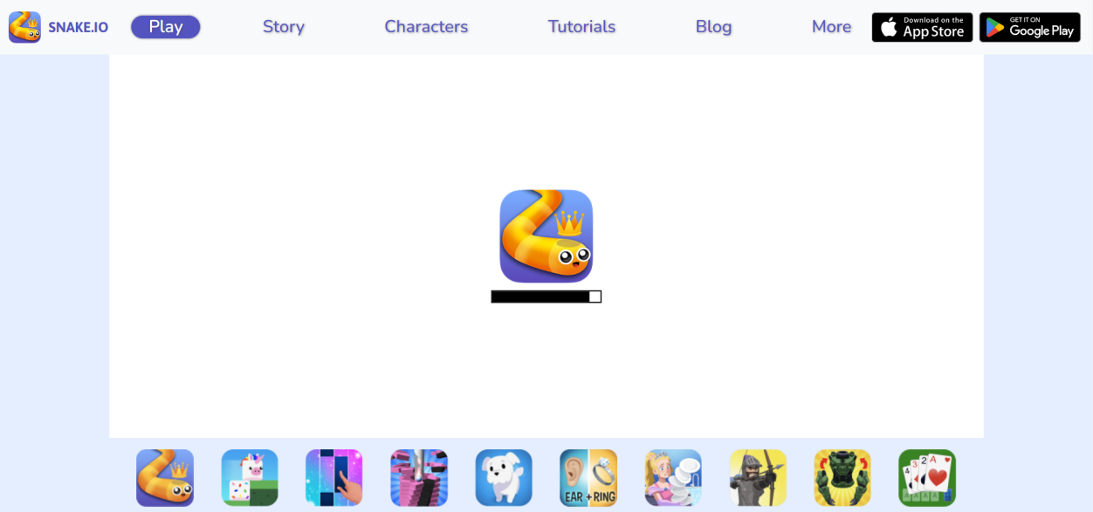

Figure 1.1.1: snake game in snake.io website

**1.3**

**Objectives**: This game aims to change the way people think of traditional snake game. It will offer the experience of commercial multilayer games to the player retaining the simplicity of traditional snake game.

* To design and develop a gaming website with a Snake game that is enjoyable and user-friendly.
* To provide multiple game modes and levels to challenge users of different skill levels.
* To allow users to create accounts and save their game progress.
* To implement a high score system that motivates users to beat their own and others' scores.
* To ensure the website is responsive and compatible with different devices and browsers.

**1.4**

**Problem Definition** :

* The development of a visually appealing and user-friendly design that is easy to navigate.
* Ensuring that the website is responsive and compatible with different devices and browsers.
* Developing multiple game modes and levels that cater to different skill levels. Creating game mechanics that are precise and responsive, ensuring that players can control the snake with ease.
* Developing a user account system that allows users to save their progress and compete with others on the high score leaderboard.
* Storing user data and game statistics on the website.
* Ensuring that the high score system accurately tracks and displays the top scores achieved by users in each game mode and level.
* Encouraging competition among users by providing a high score system and leaderboard.
* Ensuring that the website is secure and that user data is protected.
* Developing a website that is scalable and can handle a large number of users and game data.

**1.5**

**Modules of gaming website:** Here are some possible modules that could be included in a gaming website:

1. User Registration: A module that allows users to create an account on the website, including login credentials, profile information, and preferences.
2. Game Catalog: A module that provides a list of available games on the website, including descriptions, screenshots, and ratings.
3. Search and Filtering: A module that enables users to search for specific games and filter results by various criteria such as genre, platform, developer, or price.
4. Shopping Cart: A module that allows users to add games to their cart, review their selections, and complete purchases.
5. Payment Gateway: A module that integrates with third-party payment services to process transactions securely.
6. Social Sharing: A module that enables users to share games and their achievements on social media platforms.
7. Community Forum: A module that provides a platform for users to interact with each other, ask questions, share tips, and discuss gaming-related topics.
8. Support Center: A module that provides customer support and assistance, including FAQs, contact information, and troubleshooting guides.
9. Game Reviews and Ratings: A module that allows users to rate and review games, which can help other users make informed decisions.
10. News and Updates: A module that provides news and updates about upcoming games, events, and promotions on the website.

**1.6**

**features for snake game website**

Here are some possible features that could be included in a Snake game website:

1. Classic Gameplay: A feature that provides users with the classic Snake game experience, where the player controls a snake that grows longer as it eats food and tries to avoid crashing into walls or its own tail.
2. Multiplayer Mode: A feature that allows users to play Snake with other players in real-time, either locally or remotely.
3. Power-ups: A feature that provides users with power-ups that can increase the snake's speed, length, or immunity, or hinder the opponents.
4. High Scores: A feature that keeps track of the top scores achieved by players, either on a global or local leaderboard.
5. Customizable Snake: A feature that allows users to customize the snake's appearance, including colors, patterns, and skins.
6. Different Levels: A feature that provides users with different levels of difficulty, where the speed of the snake and the complexity of the game increases as the player progresses.
7. Achievements and Rewards: A feature that provides users with achievements and rewards for completing tasks, reaching milestones, or performing well in the game.
8. Social Sharing: A feature that enables users to share their scores and achievements on social media platforms.
9. Tournaments and Competitions: A feature that allows users to participate in tournaments and competitions, either solo or as part of a team, with prizes and rewards for winners.
10. Responsive Design: A feature that ensures the website is mobile-friendly and optimized for different screen sizes and resolutions.
11. **Diagram**

**2.1**

**Usecase diagram:**

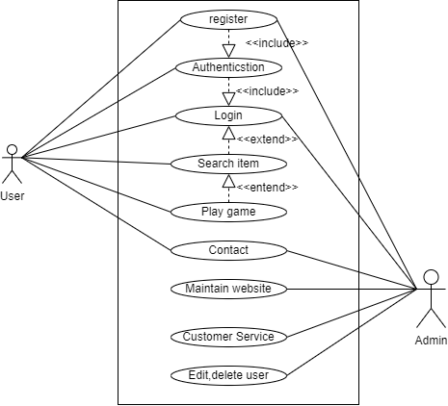

Figure 2.1.1 : Usecase diagram for gaming website

A use case diagram is a powerful tool for visualizing the various ways in which users interact with a gaming website. The primary actor is the player, who interacts with the website through actions such as browsing games, creating an account, and playing games. Other actors include game developers, publishers, and customer service representatives, each with their own set of associated use cases. Additionally, system-level use cases are included for maintaining the website's functionality. By using a use case diagram, developers can ensure that the website runs smoothly and efficiently, providing an optimal user experience for players.

**2.2**

**Data Flow Diagram:**

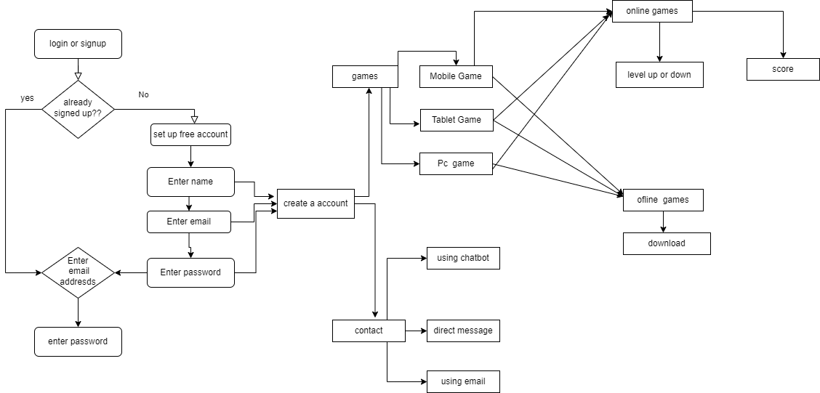

Figure 2.2.1: data flow diagram for gaming website

A data flow diagram (DFD) for a gaming website shows how data flows through the system, from the player to the website and external systems such as payment processors or game developers. The player interacts with the website by performing actions such as browsing, purchasing, and playing games. The data generated by these interactions flows into the website's internal systems, where it is transformed and processed by components such as data validation and user authentication. The resulting data is then sent back to the player. By creating a DFD, developers can identify potential areas for optimization and improvement.

**2.3**

**Activity Diagram :**

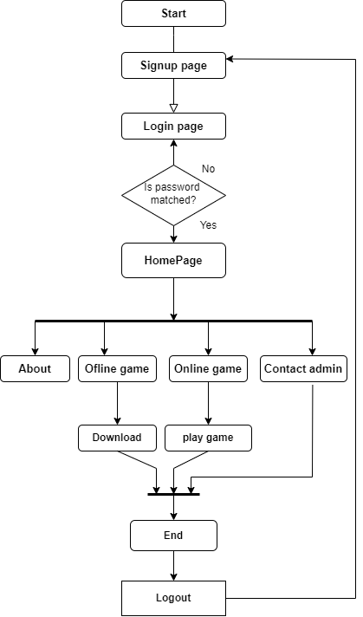

Figure : 2.3.1 Activity diagram for user in gaming website

An activity diagram is a type of UML diagram that models the behavior of a system. In the context of a gaming website, an activity diagram can be used to visualize the different tasks that a user performs while interacting with the website, such as browsing for games, creating an account, purchasing a game, and playing a game. Each task is represented as an activity in the diagram, with arrows indicating the order in which they are completed. By using an activity diagram, developers can gain a clear understanding of the user's actions and design the website to provide a seamless and enjoyable user experience.

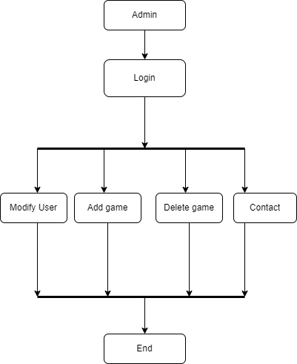

Figure : 2.3.2 Activity diagram for admin in gaming website

An activity diagram for an admin in a gaming website would show the tasks they perform, such as managing user accounts, uploading and updating games, and monitoring website activity. This diagram would provide a clear visual representation of the admin's actions and how they interact with the website's internal systems.

**2.4**

**Class diagram**

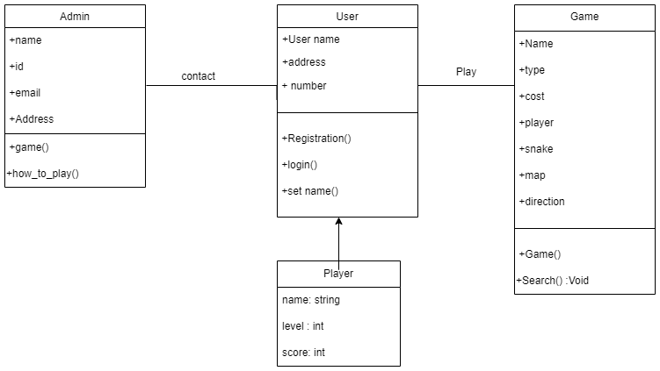

Figure 2.2.1: Class diagram for gaming website

A class diagram is a graphical representation used in object-oriented programming to depict the classes, interfaces, and their relationships within a system or application. It provides a clear visual understanding of the system structure and helps developers to plan, design and implement their software. By illustrating the hierarchy of the classes and their interactions, a class diagram facilitates communication among stakeholders and ensures a shared understanding of the system architecture.

1. **Implementation**

**3.1**

**Signup page :**

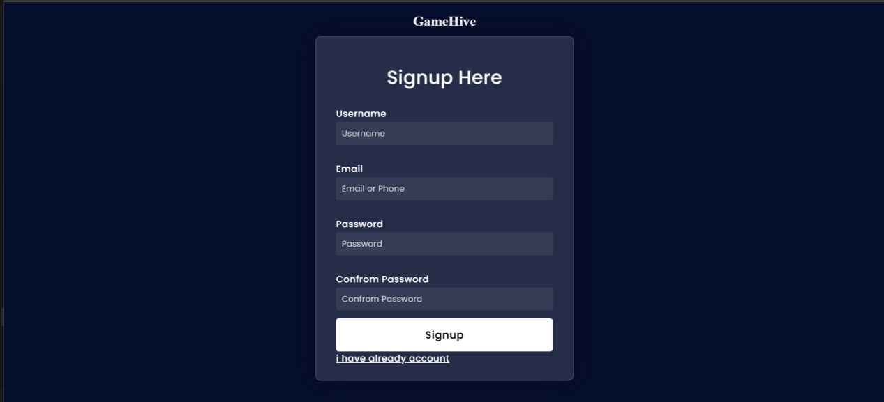

Figure : 3.1.1 Signup page for gaming website

**3.2**

**Login page:**

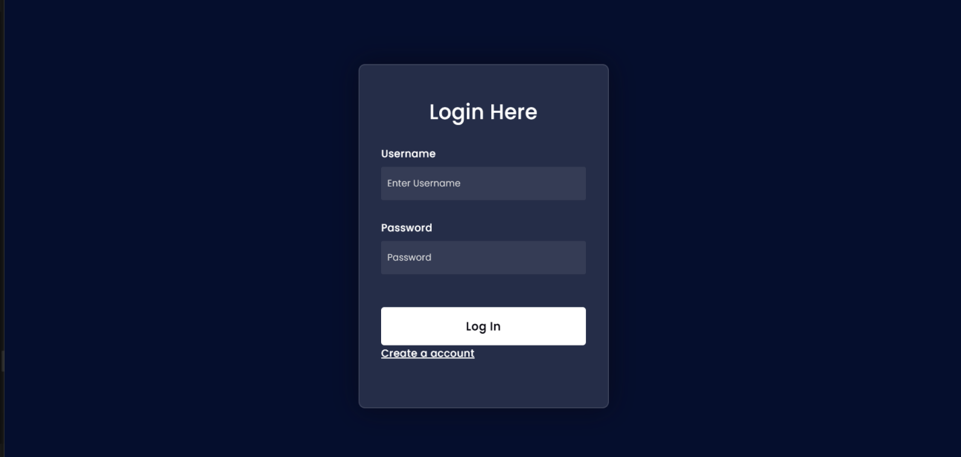

Figure :3.2 login page for gaming website

**3.3**

**Home page:**

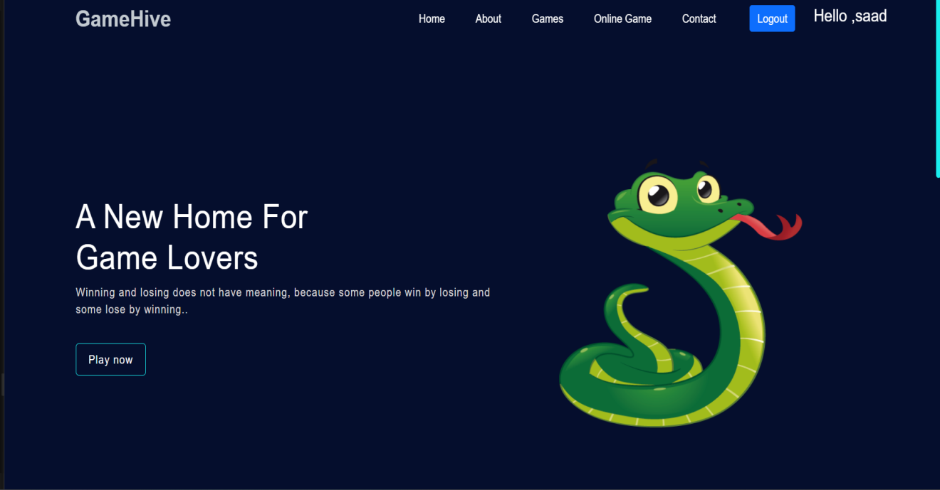

Figure : 3.3.1 Home page for gaming website

**3.4 About us:**

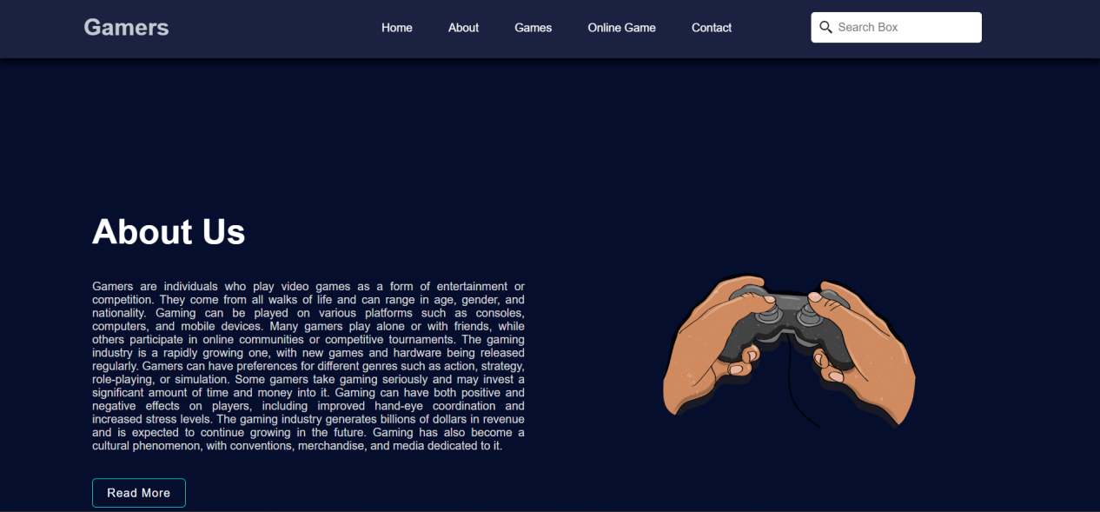

Figure : 3.4.1 About us page for gaming websit

**3.5**

**Game section**

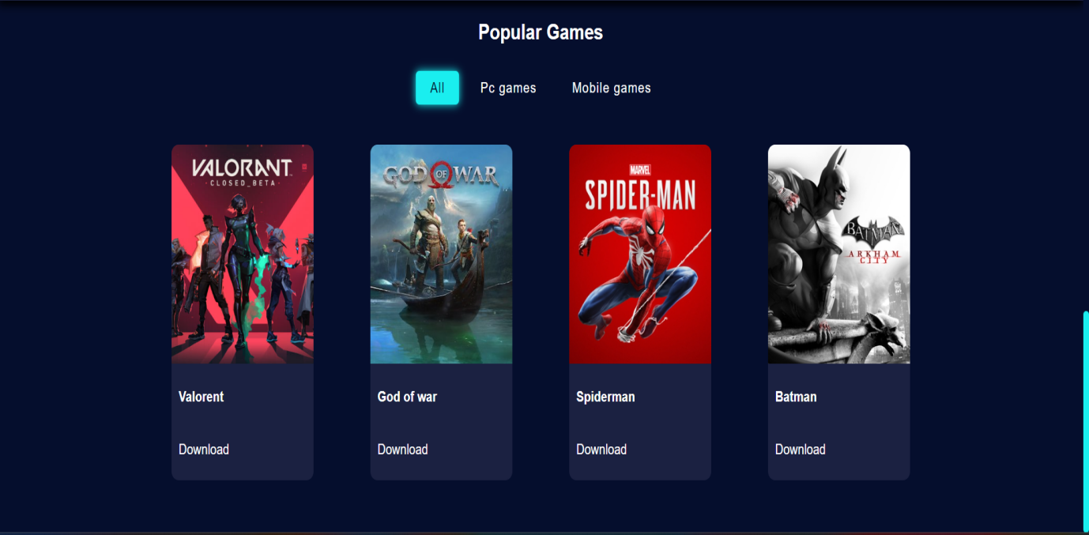

Figure : 3.5.1 Game section for gaming website

**3.6**

**Contact us:**

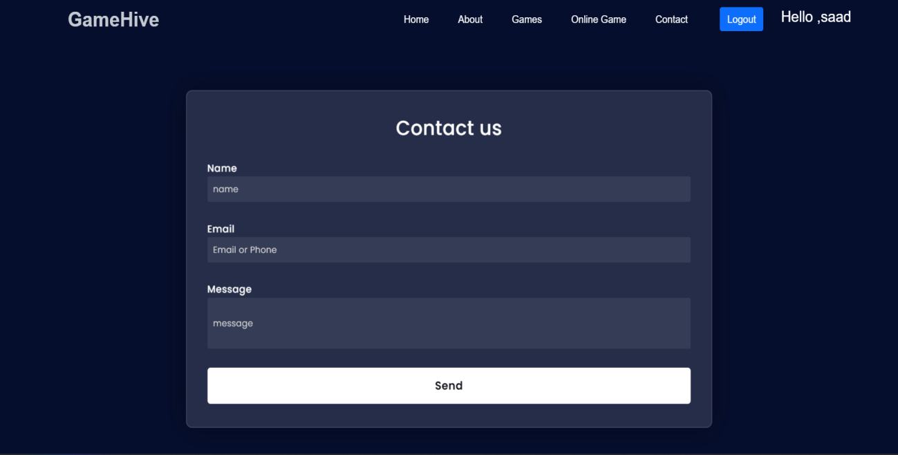

Figure : 3.6.1 Contact us page for gaming website

**3.7**

**Snake game Page :**



Figure : 3.7.1 Snake game for gaming website

**3.8**

**Admin login Page :**

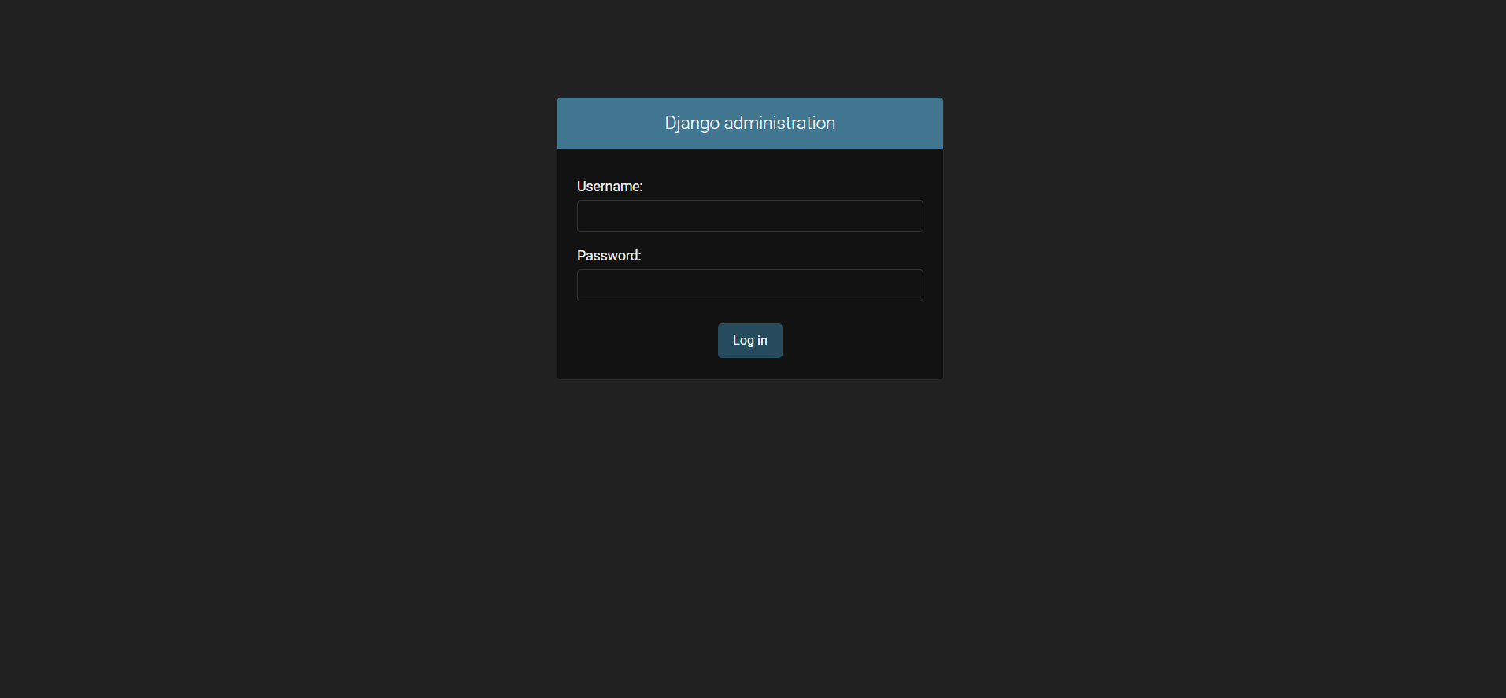

Figure : 3.8.1 Admin login for gaming website

**3.9**

**Admin login Page :**

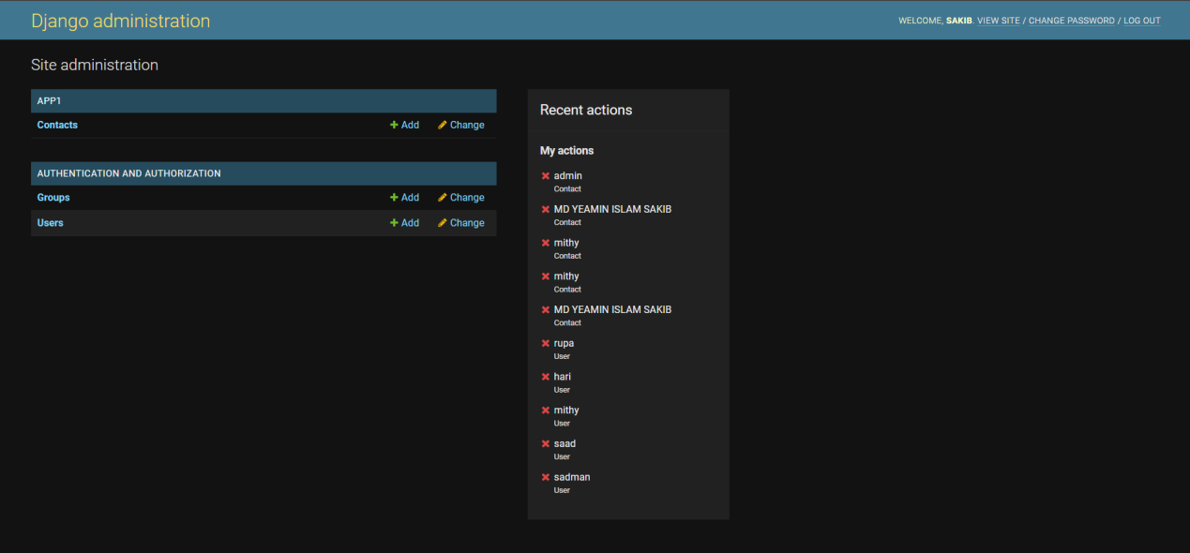

Figure : 3.9.1 Admin panel for gaming website

**4 .Tools Used:**

The Slither and Score gaming website was developed using a variety of web development tools, including HTML, CSS, and JavaScript.

* HTML, or Hypertext Markup Language, is the foundation of the website and is used to create the basic structure and content of the website. HTML tags are used to define the various elements of the website, including the header, footer, navigation menu, and content.
* CSS, or Cascading Style Sheets, is used to control the presentation and styling of the website. CSS is used to define the fonts, colors, layout, and other visual elements of the website. The website uses a combination of CSS and HTML to create a visually appealing and responsive design that is easy to navigate.
* JavaScript is used to create the game mechanics and functionality of the website. JavaScript is a programming language that is used to create interactive and dynamic elements on a website. In the case of Slither and Score, JavaScript is used to create the snake game, including the movement of the snake, the food, and the collision detection. JavaScript is also used to create the user account system and high score leaderboard, which allows users to track their progress and compete with others.

In addition to these core web development tools, other tools were used to aid in the development of the website. These include:

* Bootstrap, a popular front-end development framework, which provides pre-built HTML and CSS templates that can be used to create responsive and mobile-friendly websites.
* jQuery, a JavaScript library that simplifies the development of web applications by providing a range of pre-built functions and utilities.
* Django: Django is a Python web framework following the MVC architecture, offering built-in features like ORM, URL routing, templating, and an admin interface. Its scalability, reusability, and security make it a preferred choice for creating web applications. It is widely used and supported by a strong community.

Git, a version control system that allows developers to track and manage changes to the codebase over time. This makes it easier to collaborate with other developers and maintain the website over time.

Overall, the combination of HTML, CSS, and JavaScript, along with other web development tools, allowed the development team to create a responsive, visually appealing, and engaging gaming website that meets the needs of the target audience.

**5.Conclusion :** In conclusion, a gaming website with Snake game can be a fun and engaging platform for players of all ages and backgrounds. The website can offer classic gameplay, multiplayer modes, power-ups, high scores, customizable snakes, different levels, achievements and rewards, social sharing, and tournaments and competitions. With a responsive design, the website can be accessible on various devices and screen sizes, providing a seamless and enjoyable gaming experience. By incorporating these features, a Snake game website can attract and retain users, increase engagement and loyalty, and generate revenue through virtual currency, ads, or in-game purchases.

1. **Reference :**

* https://snake.io/
* https://www.crazygames.com/