JavaScript & Node.js Assignment

Q1. JavaScript Coding Practice

1. Check whether a number is even or odd

Problem Statement
Write a JavaScript program that takes a number and determines whether it is even or odd, using the modulus (%) operator.

Source Code
// 1. Check whether a number is even or odd
let num1 = 15;

if (num1 % 2 === 0) {
console.log(num1 + " is Even");
} else {
console.log(num1 + " is Odd");
}

Output
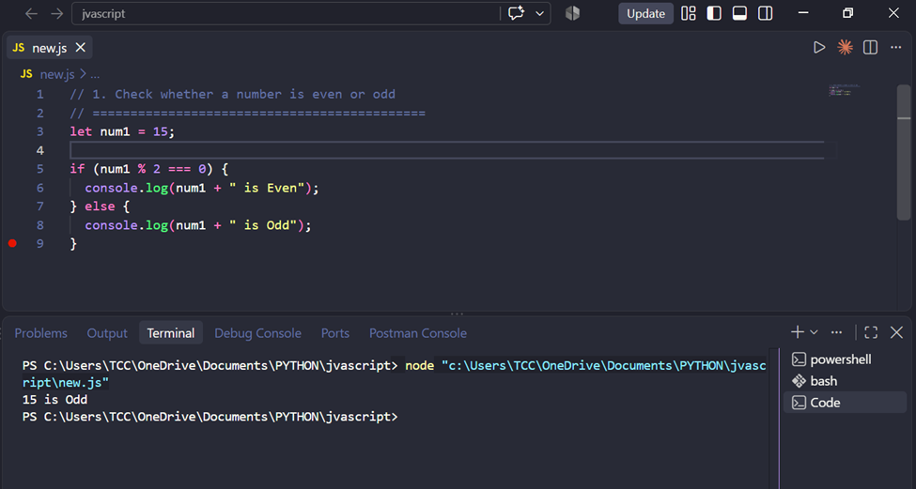

Explanation
The program checks the remainder when num1 is divided by 2 using the % (modulus) operator. If the remainder is exactly 0, the number is even; otherwise it is odd. Since 15 % 2 leaves a remainder of 1, the program correctly prints "15 is Odd".

2. Find the largest of three numbers

Problem Statement
Write a JavaScript program that compares three numbers and finds the largest among them using conditional statements.

Source Code
// 2. Find the largest of three numbers
let a = 10, b = 25, c = 18;
let largest;

if (a >= b && a >= c) {
largest = a;
} else if (b >= a && b >= c) {
largest = b;
} else {
largest = c;
}

console.log("The largest number is: " + largest);

Output
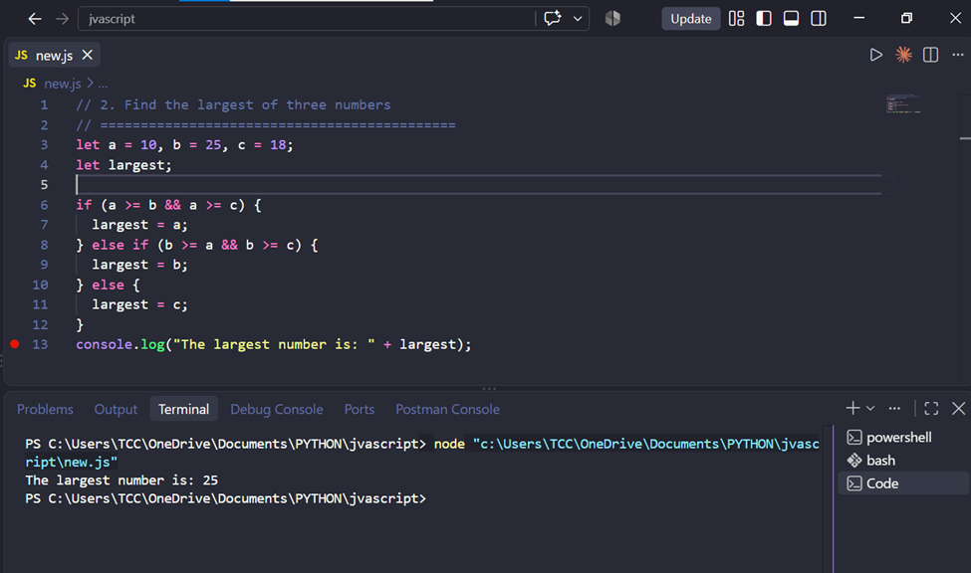

Explanation
The program uses an if...else if...else chain to compare each variable against the other two. Only one condition can be true at a time, so exactly one branch runs and assigns that value to largest. Since b (25) is greater than or equal to both a and c, the second branch executes and 25 is printed as the largest number.

3. Reverse a string

Problem Statement
Write a JavaScript program that reverses a given string without using the built-in reverse() method.

Source Code
// 3. Reverse a string
let str1 = "hello";
let reversed = "";

for (let i = str1.length - 1; i >= 0; i--) {
reversed = reversed + str1[i];
}

console.log("Reversed string: " + reversed);

Output
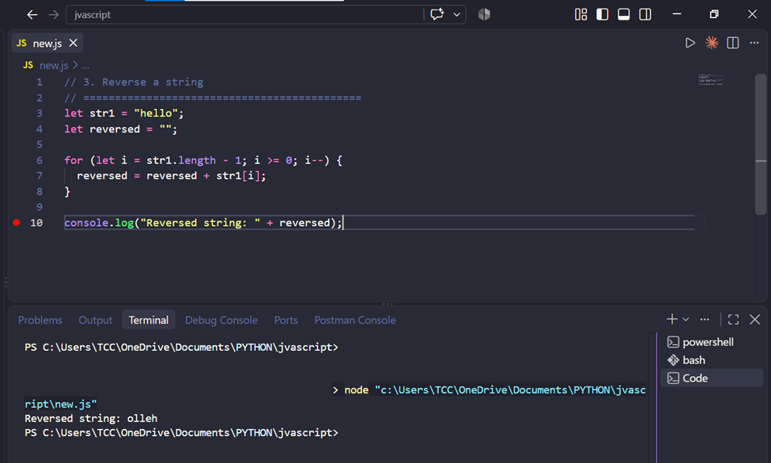

Explanation
The for loop starts at the last index of the string (str1.length - 1) and counts backward to index 0. On each pass, the current character is appended to an empty string called reversed. Because the loop reads the original string back to front, the characters end up in reverse order — "hello" becomes "olleh".

4. Count vowels in a string

Problem Statement
Write a JavaScript program that counts the number of vowels (a, e, i, o, u — both uppercase and lowercase) in a given string.

Source Code
// 4. Count vowels in a string
let str2 = "Programming";
let vowels = "aeiouAEIOU";
let count = 0;

for (let i = 0; i < str2.length; i++) {
if (vowels.includes(str2[i])) {
count++;
}
}

console.log("Number of vowels in \"" + str2 + "\": " + count);

Output
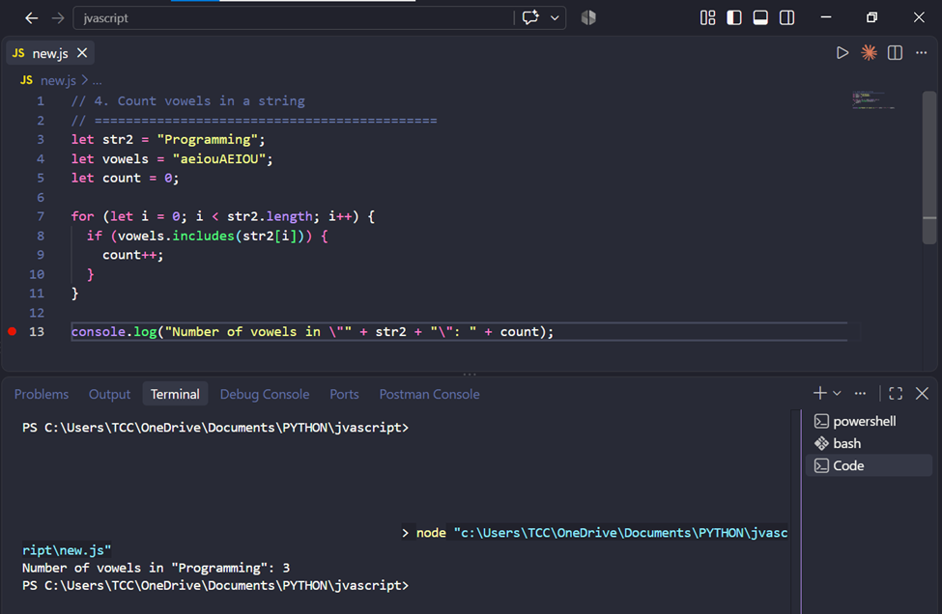

Explanation
The program loops through every character of str2 and checks whether that character appears inside the vowels string using .includes(). Each time a match is found, the count variable is incremented. "Programming" contains three vowels — o, a, and i — so the program prints a count of 3.

5. Remove duplicate values from an array

Problem Statement
Write a JavaScript program that removes duplicate values from an array without using built-in structures like Set.

Source Code
// 5. Remove duplicate values from an array
let arr = [1, 2, 2, 3, 4, 4, 5, 1];
let unique = [];

for (let i = 0; i < arr.length; i++) {
if (!unique.includes(arr[i])) {
unique.push(arr[i]);
}
}

console.log("Original array: " + arr);
console.log("Array without duplicates: " + unique);

Output
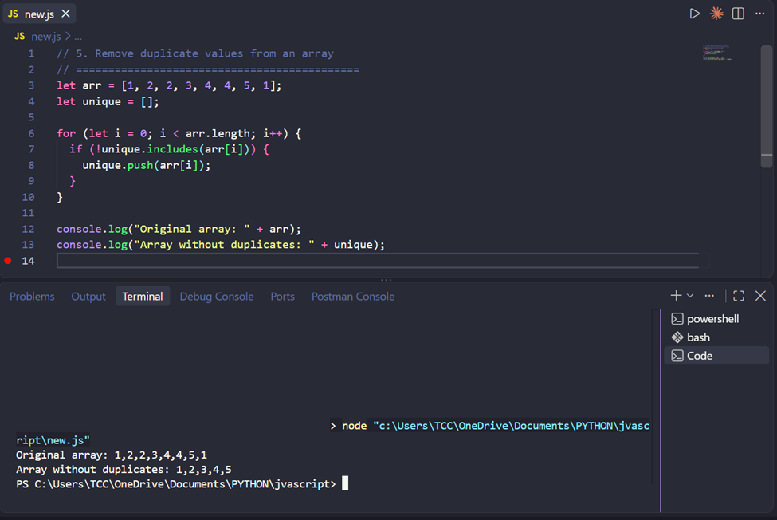

Explanation
The program loops through the original array and, for each value, checks whether it already exists in the unique array using .includes(). If it does not, the value is pushed into unique. This way only the first occurrence of each value is kept, so [1, 2, 2, 3, 4, 4, 5, 1] becomes [1, 2, 3, 4, 5].

Q2. Introduction to Node.js

What is Node.js?
Node.js is a runtime environment that lets JavaScript run outside a web browser — on a server, a personal computer, or inside automation scripts. It is built on Google Chrome's V8 engine, which compiles JavaScript directly into fast machine code. Before Node.js existed, JavaScript could only run inside a browser tab; Node made it possible to use the same language for backend servers, command-line tools, and test automation.

How does Node.js work?
Node.js runs on a single-threaded, event-driven architecture with non-blocking I/O. Instead of creating a new thread for every task the way older server technologies do, Node uses an event loop: whenever it encounters something slow — reading a file, calling an API, querying a database — it hands that job off in the background (through libuv's thread pool or the operating system) and immediately continues to the next line of code. Once the background task finishes, a callback function is triggered and Node picks up the result. This design lets a single Node process handle thousands of concurrent operations without being blocked by any one of them.

Advantages of Node.js for QA Automation
- Same language across the stack — testers can write automation scripts in the same JavaScript/TypeScript that developers use, making collaboration and code review easier.
- Speed at scale — the non-blocking model suits running many tests in parallel, such as multiple API calls or multiple browser instances, without long wait times.
- Mature testing ecosystem — frameworks such as Jest, Mocha, Playwright, Cypress, and WebdriverIO are all Node-based and widely used for unit, integration, and end-to-end testing.
- Large npm ecosystem — a huge library of ready-made packages exists for HTTP requests, assertions, mocking, and reporting.
- CI/CD friendly — Node test runners plug easily into tools like Jenkins, GitHub Actions, and GitLab CI.
- Cross-platform — the same test scripts run on Windows, macOS, and Linux with little to no changes.

Difference between Browser JavaScript and Node.js
Aspect | Browser JavaScript | Node.js
Runs in | A web browser (Chrome, Firefox, etc.) | Directly on the operating system, outside any browser
Main use | UI behavior, DOM manipulation, user interaction | Server-side logic, APIs, file handling, automation
DOM / window access | Yes — document, window, browser APIs | No DOM; instead has OS-level modules (fs, http, path, etc.)
Module system | ES modules / <script> tags | CommonJS (require) or ES modules, plus npm packages
File system access | Blocked for security reasons | Full read/write access to files and folders
Global object | window | global

