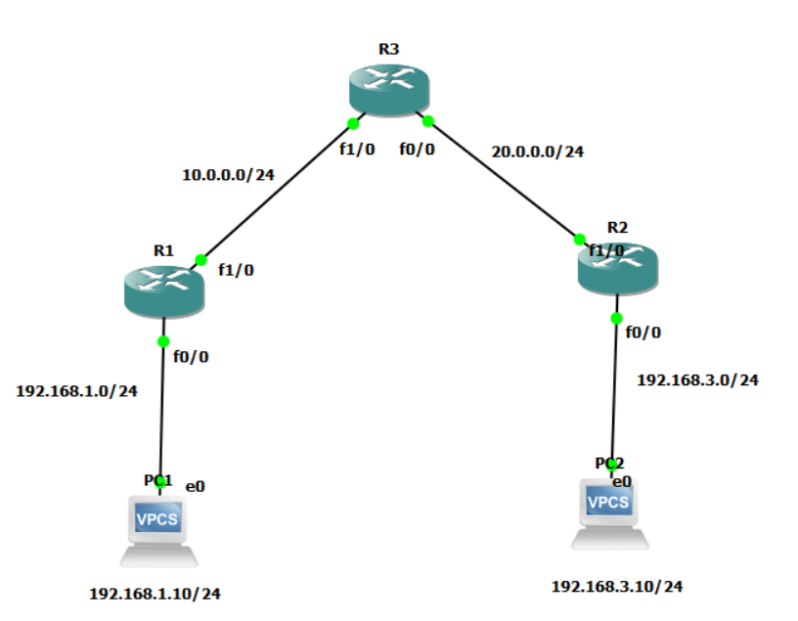

**pc1>** ip 192.168.1.10 255.255.255.0 192.168.1.1

**pc2>** ip 192.168.3.10 255.255.255.0 192.168.3.1

**R1 Configuration:**

enable

configure terminal

hostname R1

interface f0/0

ip address 192.168.1.1 255.255.255.0

no shutdown

interface f1/0

ip address 10.0.0.1 255.255.255.0

no shutdown

exit

ip route 192.168.3.0 255.255.255.0 10.0.0.2

Check with:

show ip interface brief

**R2 Configuration:**

enable

configure terminal

hostname R2

interface f0/0

ip address 192.168.3.1 255.255.255.0

no shutdown

interface f1/0

ip address 20.0.0.2 255.255.255.0

no shutdown

exit

ip route 192.168.1.0 255.255.255.0 20.0.0.1

Check with:

show ip interface brief

**R3 Configuration:**

enable

configure terminal

hostname R3

interface f1/0

ip address 10.0.0.2 255.255.255.0

no shutdown

interface f0/0

ip address 20.0.0.1 255.255.255.0

no shutdown

exit

ip route 192.168.1.0 255.255.255.0 10.0.0.1

ip route 192.168.3.0 255.255.255.0 20.0.0.2

Check with:

show ip interface brief