Cd Downloads

Mkdir lab_final

Cd lab_final

type nul > md5.txt

type md5.txt

code md5.txt

**Hash Using CMD**

certutil -hashfile C:\Users\yeami\Downloads\lab_final\md5. txt

certutil -hashfile C:\Users\yeami\Downloads\lab_final\md5.txt MD5 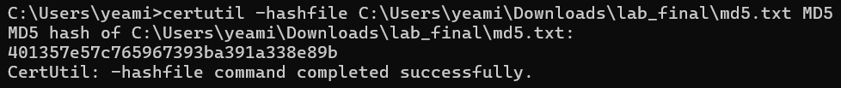

certutil -hashfile C:\Users\yeami\Downloads\lab_final\md5.txt SHA256 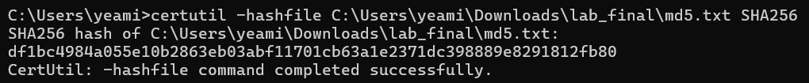

certutil -hashfile C:\Users\yeami\Downloads\lab_final\md5.txt SHA512

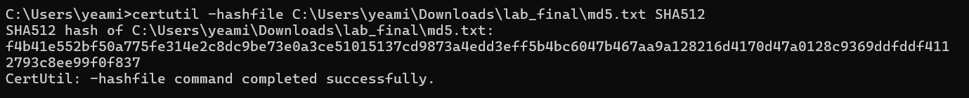

**Hash Using Powershell**

get-filehash "md5.txt" -A sha1

get-filehash "md5.txt" -A md5

get-filehash "md5.txt" -A sha256

get-filehash "md5.txt" -A sha512

Hash-identify Using kali linux

**Md5 in kali**

md5sum lab_final.txt

sha1sum lab_final.txt

sha256sum lab_final.txt

sha512sum lab_final.txt

**Using Openssl**

openssl sha256 lab_final.txt



openssl sha512 lab_final.txt



openssl md5 lab_final.txt

sudo openssl dgst -sha256 lab_final.txt

