We can run multiple commands in a single line using these “&”, “|”, “;” characters.

1. “&”-The ampersand: We can use it two different ways for two different reasons.

* When used in the way “ping localhost & whoami”

In the following line there are two commands separated by &. The first one is ping localhost and second one is whoami. When two different commands are separated by “&”, second command won’t wait for the first command to finish.

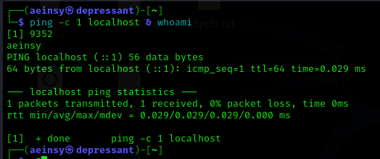

As we can see, whoami is executed before the ping is finished.

* When used in the way “ping -c 1 8.8.8.8 && traceroute 8.8.8.8”

When used in the way then its used as AND logical operator. In the command, traceroute only run if and only if ping is successful. We can sum up in the following way. Sometimes we need to know if the machine is on or off. If off then there is no need to run traceroute on it.

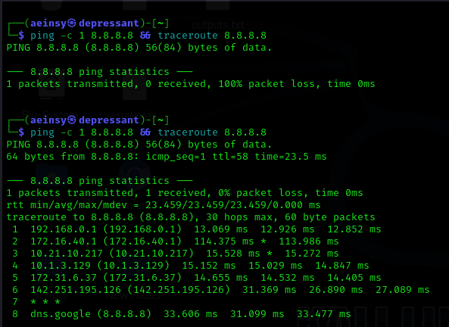

As we can see, in the first command ping was not successful and tracroute didn’t run. But in second command ping was successful following it traceroute also ran.

1. “|”- Vertical bar: We can also use it two different ways.

* A screenshot of a computer screen

  Description automatically generatedSingle pipe: It is used to transfer one command output to another command. For example, if we use “ps aux | grep root“. “ps aux” command will list the all of running process with some details. One of the details contains user of each process and “grep root” will filter out the processes which are owned by root.
* Double pipe: It is used as OR logical operator similar to “&&”. As “&&” will run the second command only if the first command executes successfully. The double pipe does the work in reverse way. It will run the second command only if the first one is failed to run.

In the first command ping was successful and echo is ignored. But in the second command ping was not successful, meaning the machine is not running hence executed the ping command.

1. “;”-Semicolon: It will separate two commands and run the command in the given sequence. The commands will run even if one is failed.

