**Iot Based Weather Station Using Raspberry Pi**

Md. Shajalal Yeasin Rhaman Nusrat Rimu

Student of Student of Student of

Computer Science &Eng. Computer Science& Eng. Computer science & Eng.

Southeast University Southeast University Southeast University

Email: [Shah.jalal0894@gmail.com](mailto:Shah.jalal0894@gmail.com) Email:yeasinrahman96@gmail.com Email: [nusratrimu143@gmail.com](mailto:nusratrimu143@gmail.com)

Abstract

Weather station by using raspberry pi, in this project we have used some weather related sensor that measure weather atmosphere and write some code for displaying the weather situation on screen. We can access our data and show our data from anywhere of the world because of using IOT.

Introduction

Weather condition plays an important role in our daily life as weather and climate are the most ubiquitous factors for home and environment planning. Moreover, the tremendous development of Internet nowadays made possible to monitor weather conditions and collect the respective data in-situ. All the objects, sensors and devices can be linked through Internet to share and analyze the data collected at various locations. The Internet of Things (IoT) can be much more extensive in predicting and knowing the weather conditions in particular place by connecting this weather station to the Internet.

The climate in general is capricious that is hard to predict now a days . With advanced technology to help humanity and bring convenience to the society, it is now the time for the weather broadcasting to be implemented into mobile phone instead of keep checking through only television or radio. However, with the mobile weather checking system we have in this era still often we see people rushing for schedule under the rain without umbrella; lauan-dries are still showering by rain; home planted plants are wilted due to the hot and dry weather.

Hardware Components:

Weather is the state of the atmosphere describing for example the degree to which it’s hot or cold, wet or dry, clear or cloudy.in this research using raspberry pi and some sensor which is related to measure weather atmosphere we make weather station. Rain sensor, DHT22 sensor, MQ135 are some sensor that have been used in this project. That works right way and we measure the atmosphere. The DHT22 sensor is great way to get temp and humidity reading in our project. Air sensor is one switching device which is used to detect the rainfall.MQ135 sensor are used in air quality control equipment’s and are suitable for the detecting and measuring of poison gas

Working principle

For measuring humidity and temperature required connection are:

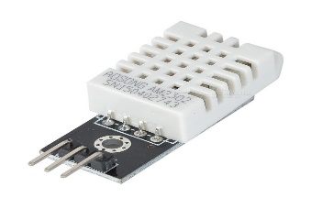

Fig 1: DHT22 sensor

* DHT22 sensor VCC to raspberry pi 5v
* DHT22 GND to raspberry pi GND
* DHT22 Sensor Signal to Raspberry Pi PIN 7 (GPIO PIN 4)
* 10k ohm resistor between DHT22 pin1 and pin2

DHT22 sensor consists of two components for measuring; Humidity sensing component and the NTC temperature sensor (or a thermistor). There is an IC on the back side which makes the readings to be able to read by the Raspberry pi. While measuring the humidity, the humidity sensor comes into play. The humidity sensor consists of two electrodes with moisture holding substrate between them. So, when the humidity changes, the conductivity of substrate changes or you can say that the resistance between the electrode’s changes. This change in resistance is then given to IC which makes it to read by the Raspberry pi.

to detect rainfall the required connections are:

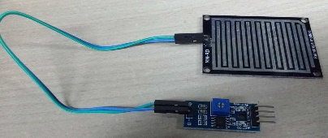

Fig 2: Raindrop Module.

* Rain sensor VCC to raspberry pi 3.3v
* Rain sensor GND to raspberry pi GND
* Rain sensor DO to raspberry pi 12(GPIO18)

when no rain drop are on the sensor the sensor controller DO pin is high (3.3 in our case). when rain drops are detect this change to low(0v). By connecting DO to a GPIO port on the pi (GPIO18) we can read the status rain is detected.

Finding the air quality, the require connections are:

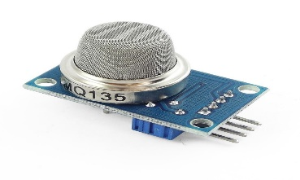

Fig 3: MQ-135 gas sensor

* MQ-135 sensor VCC to raspberry pi 5v
* MQ-135 sensor GND to raspberry pi GND
* MQ-135 sensor to raspberry pi 38(GPIO 20)
* 10k ohm resistor

The air quality sensor has a small potentiometer that permits the adjustment of the load resistance of the sensor circuit. The 5V power supply is used for air quality sensor. The air quality sensor is a signal output indicator instruction. It has two outputs: analog output and TTL output. The TTL output is low signal light which can be accessed through the IO ports on the Microcontroller. The analog output is a concentration, i.e. increasing voltage is directly proportional to increasing concentration. This sensor has a long life and reliable stability as well.

Result

In our project all sensor worked properly and we got our desire output. After the sensor measurements are uploaded to the cloud. As we are running codes, we got temperature and humidity, when sensor detect rain, we got the output as is raining and when sensor detecting gas we got output as gas detect.

For using IOT we are using firebase server. Our project is better than other due to the use of firebase server as we are getting real time live date.

Conclusion

IoT based temperature and humidity detecting device provides an efficient and definitive system for monitoring agricultural parameters. The system also provides a corrective movement or decision-making system. It is inexpensive and consumes much less electricity. The implementation of weather station system using Raspberry Pi is done as per the specifications above and the data insights are generated in web based portal. The access to this data is available in the intranet with the current level of implementation and it could be made public when the data is made to store in cloud servers or other sources in the internet..

##### References

1. Rain Sensor:

<https://raspi.tv/2017/make-a-rain-alert-system-with-raspberry-pi?fbclid=IwAR2d5f2bcIJ_S-IUQ4hmGKSqbODRJgQmZpF_tb_xst2mxFtOKZZvs18mcE>8

2. Air quality:

<https://tutorials-raspberrypi.com/configure-and-read-out-the-raspberry-pi-gas-sensor-mq-x/>

3. dht22 Sensor:

<https://www.thegeekpub.com/236867/using-the-dht11-temperature-sensor-with-the-raspberry-pi/>

4. firebase:

<https://raspberrypi4u.blogspot.com/2017/12/raspberry-pi-iot-firebase-realtimedatabase.html>